**DEPARTMENT OF COMPUTER SCIENCE**

**SRI SAI BABA NATIONAL DEGREE COLLEGE**

**ANANTAPURAMU**

**MAY -2022**



##### **MORSE_CODE_TRANSLATOR**

##### Submitted as CE component of the VI semester of Bachelor of Science

##### in

Computer Science

###### ***by***

**1. POSA HEMESHWAR - (SSBN201729)**

**2. MANUKURI KIRAN - (SSBN201738)**

**3. GADHAM SETTY VENKATESH - (SSBN201762)**

**BONAFIDE CERTIFICATE**

This is to certify that this project report entitled **“MORSE_CODE_TRANSLATOR”** submitted to **MASTER OF COMPUTER APPLICATIONS , SIR M.VISVESVARAYA INSTITUTE OF TECHNOLOGY**,is a bonafide record of work done by “**GADHAM SETTY VENKATESH”** under my supervision.

**Signature of the Evaluator/Supervisor**

Place : BENGALURU

Date : 05-06-2022

**ACKNOWLEDGEMENT**

Presentation, Inspiration and motivation have been always played a key role in the success of any venture

I express my sincere thanks to the principle Dr. RAKESH S.G. Garu and HOD of the computer department Smt Dr.C.H VANIPRIYA Garu of our college of encouraging us to the highest peak and for providing us the opportunity to prepare project.

We immensely obliged to my lecturer Mr.B.MUTHRAMALINGAM for the completion, encouragement, guidance and kind supervision in the completion of my project.

Finally this project is the combined effort of all the group members and we are happy to work together, without team efforts this project could not have completed successfully.

**PROJECT :**

GADHAM SETTY VENKATESH : 1M22MC012

INDEX

|  |  |  |
| --- | --- | --- |
| **S.No** | **PARTICULRS** | **PAGE NUMBER** |
| 1 | ABSTRACTION | 1 |
| 2 | INTRODUCTION TO HTML | 2 to 13 |
| 3 | CASCADING STYLE SHEET | 14 to 17 |
| 4 | JAVASCRIPT | 18 to 23 |
| 5 | SOURCE CODE | 24 to 71 |
| 6 | OUTPUT | 72 to 84 |

**ABSTRACTION**

Morse code is represented by the form of

dits and dahs. Here dits refer to dots and dahs refer to dash.

Morse code used to transmit only numerals at first. After that,

Alfred Vail included letters and characters. Morse code can be

transmitted by using electric telegraph wire, light, and sound,

through a different medium in different ways. Tap code is used

by American prisoners. Morse code is used for long-distance

communication. International Morse code was devised by

European nations in 1851. It is the base for the morse code to

transmit or receive. Morse code is a character encoding and

decoding scheme.

**Introduction to HTML**

HTML is the standard markup language for creating Web pages.

What is HTML?

* HTML stands for Hyper Text Markup Language
* HTML is the standard markup language for creating Web pages
* HTML describes the structure of a Web page
* HTML consists of a series of elements
* HTML elements tell the browser how to display the content
* HTML elements label pieces of content such as "this is a heading", "this is a paragraph", "this is a link", etc.

A Simple HTML Document

<!DOCTYPE html>  
<html>  
<head>  
<title>Page Title</title>  
</head>  
<body>  
  
<h1>My First Heading</h1>  
<p>My first paragraph.</p>  
  
</body>  
</html>

* The <!DOCTYPE html> declaration defines that this document is an HTML5 document
* The <html> element is the root element of an HTML page
* The <head> element contains meta information about the HTML page
* The <title> element specifies a title for the HTML page (which is shown in the browser's title bar or in the page's tab)
* The <body> element defines the document's body, and is a container for all the visible contents, such as headings, paragraphs, images, hyperlinks, tables, lists, etc.
* The <h1> element defines a large heading
* The <p> element defines a paragraph

**HTML Element**

An HTML element is defined by a start tag, some content, and an end tag:

<tagname> Content goes here... </tagname>

The HTML **element** is everything from the start tag to the end tag:

<h1>My First Heading</h1>

<p>My first paragraph.</p>

## Nested HTML Elements

HTML elements can be nested (this means that elements can contain other elements).

All HTML documents consist of nested HTML elements.

### Example

<!DOCTYPE html>  
<html>  
<body>  
  
<h1>My First Heading</h1>  
<p>My first paragraph.</p>  
  
</body>  
</html>

### Example Explained

The <html> element is the root element and it defines the whole HTML document.

It has a start tag <html> and an end tag </html>.

Then, inside the <html> element there is a <body> element:

<body>  
  
<h1>My First Heading</h1>  
<p>My first paragraph.</p>  
  
</body>

The <body> element defines the document's body.

It has a start tag <body> and an end tag </body>.

Then, inside the <body> element there are two other elements: <h1> and <p>:

<h1>My First Heading</h1>  
<p>My first paragraph.</p>

The <h1> element defines a heading.

It has a start tag <h1> and an end tag </h1>:

<h1>My First Heading</h1>

The <p> element defines a paragraph.

It has a start tag <p> and an end tag </p>:

<p>My first paragraph.</p>

HTML Attributes

* All HTML elements can have **attributes**
* Attributes provide **additional information** about elements
* Attributes are always specified in **the start tag**
* Attributes usually come in name/value pairs like: **name="value"**

The href Attribute

The <a> tag defines a hyperlink. The href attribute specifies the URL of the page the link goes to.

## The src Attribute

The <img> tag is used to embed an image in an HTML page. The src attribute specifies the path to the image to be displayed.

## The width and height Attributes

The <img> tag should also contain the width and height attributes, which specifies the width and height of the image (in pixels).

**Example**

<img src="img_girl.jpg" width="500" height="600">

## The style Attribute

The style attribute is used to add styles to an element, such as color, font, size, and more.

**Example**

<p style="color:red;">This is a red paragraph.</p>

## The title Attribute

The title attribute defines some extra information about an element.

The value of the title attribute will be displayed as a tooltip when you mouse over the element:

**Example**

<p title="I'm a tooltip">This is a paragraph.</p>

# **HTML Headings**

HTML headings are titles or subtitles that you want to display on a webpage.

HTML headings are defined with the <h1> to <h6> tags.

<h1> defines the most important heading. <h6> defines the least important heading.

## HTML Paragraphs

The HTML <p> element defines a paragraph.

A paragraph always starts on a new line, and browsers automatically add some white space (a margin) before and after a paragraph.

## HTML Line Breaks

The HTML <br> element defines a line break.

Use <br> if you want a line break (a new line) without starting a new paragraph:

## The HTML Style Attribute

Setting the style of an HTML element, can be done with the style attribute.

The HTML style attribute has the following syntax:

<tagname style="property:value;">

The ***property*** is a CSS property. The ***value*** is a CSS value.

You will learn more about CSS later in this tutorial.

## Background Color

The CSS background-color property defines the background color for an HTML element.

**Example**

Set the background color for a page to powderblue:

<body style="background-color:powderblue;">  
  
<h1>This is a heading</h1>  
<p>This is a paragraph.</p>  
  
</body>

## Text Color

The CSS color property defines the text color for an HTML element:

**Example**

<h1 style="color:blue;">This is a heading</h1>  
<p style="color:red;">This is a paragraph.</p>

## Fonts

The CSS font-family property defines the font to be used for an HTML element:

**Example**

<h1 style="font-family:verdana;">This is a heading</h1>  
<p style="font-family:courier;">This is a paragraph.</p>

## Text Size

The CSS font-size property defines the text size for an HTML element:

**Example**

<h1 style="font-size:300%;">This is a heading</h1>  
<p style="font-size:160%;">This is a paragraph.</p>

## Text Alignment

The CSS text-align property defines the horizontal text alignment for an HTML element:

**Example**

<h1 style="text-align:center;">Centered Heading</h1>  
<p style="text-align:center;">Centered paragraph.</p>

## HTML <b> and <strong> Elements

The HTML <b> element defines bold text, without any extra importance.

**Example**

<b>This text is bold</b>

The HTML <strong> element defines text with strong importance. The content inside is typically displayed in bold.

**Example**

<strong>This text is important!</strong>

**HTML Tables**

## Table Cells

Each table cell is defined by a <td> and a </td> tag.

td stands for table data.

Everything between <td> and </td> are the content of the table cell.

**Example**

<table>  
  <tr>  
    <td>Emil</td>  
    <td>Tobias</td>  
    <td>Linus</td>  
  </tr>  
</table>

## Table Rows

Each table row starts with a <tr> and end with a </tr> tag.

tr stands for table row

**Example**

<table>  
  <tr>  
    <td>Emil</td>  
    <td>Tobias</td>  
    <td>Linus</td>  
  </tr>  
  <tr>  
    <td>16</td>  
    <td>14</td>  
    <td>10</td>  
  </tr>  
</table>

## Table Headers

Sometimes you want your cells to be headers, in those cases use the <th> tag instead of the <td> tag:

**Example**

Let the first row be table headers:

<table>  
  <tr>  
    <th>Person 1</th>  
    <th>Person 2</th>  
    <th>Person 3</th>  
  </tr>  
  <tr>  
    <td>Emil</td>  
    <td>Tobias</td>  
    <td>Linus</td>  
  </tr>  
  <tr>  
    <td>16</td>  
    <td>14</td>  
    <td>10</td>  
  </tr>  
</table>

# **HTML Lists**

HTML lists allow web developers to group a set of related items in lists.

**Example**

An unordered HTML list:

* Item
* Item
* Item
* Item

## Unordered HTML List

An unordered list starts with the <ul> tag. Each list item starts with the <li> tag.

The list items will be marked with bullets (small black circles) by default:

**Example**

<ul>  
  <li>Coffee</li>  
  <li>Tea</li>  
  <li>Milk</li>  
</ul>

## Ordered HTML List

An ordered list starts with the <ol> tag. Each list item starts with the <li> tag.

The list items will be marked with numbers by default:

**Example**

<ol>  
  <li>Coffee</li>  
  <li>Tea</li>  
  <li>Milk</li>  
</ol>

**CASCADING STYLE SHEET**

Cascading Style Sheets (CSS) is used to format the layout of a webpage.

With CSS, you can control the color, font, the size of text, the spacing between elements, how elements are positioned and laid out, what background images or background colors are to be used, different displays for different devices and screen sizes, and much more!

Using CSS

CSS can be added to HTML documents in 3 ways:

* **Inline** - by using the style attribute inside HTML elements
* **Internal** - by using a <style> element in the <head> section
* **External** - by using a <link> element to link to an external CSS file

The most common way to add CSS, is to keep the styles in external CSS files. However, in this tutorial we will use inline and internal styles, because this is easier to demonstrate, and easier for you to try it yourself.

## Inline CSS

An inline CSS is used to apply a unique style to a single HTML element.

An inline CSS uses the style attribute of an HTML element.

The following example sets the text color of the <h1> element to blue, and the text color of the <p> element to red:

**Example**

<h1 style="color:blue;">A Blue Heading</h1>  
  
<p style="color:red;">A red paragraph.</p>

## Internal CSS

An internal CSS is used to define a style for a single HTML page.

An internal CSS is defined in the <head> section of an HTML page, within a <style> element.

The following example sets the text color of ALL the <h1> elements (on that page) to blue, and the text color of ALL the <p> elements to red. In addition, the page will be displayed with a "powderblue" background color:

**Example**

<!DOCTYPE html>  
<html>  
<head>  
<style>  
body {background-color: powderblue;}  
h1   {color: blue;}  
p    {color: red;}  
</style>  
</head>  
<body>  
  
<h1>This is a heading</h1>  
<p>This is a paragraph.</p>  
  
</body>  
</html>

## External CSS

An external style sheet is used to define the style for many HTML pages.

To use an external style sheet, add a link to it in the <head> section of each HTML page:

**Example**

<!DOCTYPE html>  
<html>  
<head>  
  <link rel="stylesheet" href="styles.css">  
</head>  
<body>  
  
<h1>This is a heading</h1>  
<p>This is a paragraph.</p>  
  
</body>  
</html>

The external style sheet can be written in any text editor. The file must not contain any HTML code, and must be saved with a .css extension.

## CSS Colors, Fonts and Sizes

Here, we will demonstrate some commonly used CSS properties. You will learn more about them later.

The CSS color property defines the text color to be used.

The CSS font-family property defines the font to be used.

The CSS font-size property defines the text size to be used.

**Example**

Use of CSS color, font-family and font-size properties:

<!DOCTYPE html>  
<html>  
<head>  
<style>  
h1 {  
  color: blue;  
  font-family: verdana;  
  font-size: 300%;  
}  
p {  
  color: red;  
  font-family: courier;  
  font-size: 160%;  
}  
</style>  
</head>  
<body>  
  
<h1>This is a heading</h1>  
<p>This is a paragraph.</p>  
  
</body>  
</html>

**Link to External CSS**

External style sheets can be referenced with a full URL or with a path relative to the current web page.

**Example**

This example links to a style sheet located in the html folder on the current web site:

<link rel="stylesheet" href="/html/styles.css">

## HTML Links - Hyperlinks

HTML links are hyperlinks.

You can click on a link and jump to another document.

When you move the mouse over a link, the mouse arrow will turn into a little hand.

**HTML Links - Syntax**

The HTML <a> tag defines a hyperlink. It has the following syntax:

<a href="*url*">*link text*</a>

The most important attribute of the <a> element is the href attribute, which indicates the link's destination.

The link text is the part that will be visible to the reader.

Clicking on the link text, will send the reader to the specified URL address.

**JAVASCRIPT**

JavaScript is the world's most popular programming language.

JavaScript is the programming language of the Web.

JavaScript is easy to learn.

This tutorial will teach you JavaScript from basic to advanced.

## The HTML <script> Tag

The HTML <script> tag is used to define a client-side script (JavaScript).

The <script> element either contains script statements, or it points to an external script file through the src attribute.

Common uses for JavaScript are image manipulation, form validation, and dynamic changes of content.

To select an HTML element, JavaScript most often uses the document.getElementById() method.

This JavaScript example writes "Hello JavaScript!" into an HTML element with id="demo":

**Example**

<script>  
document.getElementById("demo").innerHTML = "Hello JavaScript!";  
</script>

JavaScript is one of the **3 languages** all web developers **must** learn:

   1. [**HTML**](https://www.w3schools.com/html/default.asp) to define the content of web pages

   2. [**CSS**](https://www.w3schools.com/css/default.asp) to specify the layout of web pages

   3. **JavaScript** to program the behavior of web pages

## JavaScript Can Change HTML Content

One of many JavaScript HTML methods is getElementById().

The example below "finds" an HTML element (with id="demo"), and changes the element content (innerHTML) to "Hello JavaScript":

**Example**

document.getElementById("demo").innerHTML = "Hello JavaScript";

## JavaScript in <head> or <body>

You can place any number of scripts in an HTML document.

Scripts can be placed in the <body>, or in the <head> section of an HTML page, or in both.

## JavaScript in <head>

In this example, a JavaScript function is placed in the <head> section of an HTML page.

The function is invoked (called) when a button is clicked:

**Example**

<!DOCTYPE html>  
<html>  
<head>  
<script>  
function myFunction() {  
  document.getElementById("demo").innerHTML = "Paragraph changed.";  
}  
</script>  
</head>  
<body>

<h2>Demo JavaScript in Head</h2>  
  
<p id="demo">A Paragraph</p>  
<button type="button" onclick="myFunction()">Try it</button>

</body>  
</html>

## JavaScript in <body>

In this example, a JavaScript function is placed in the <body> section of an HTML page.

The function is invoked (called) when a button is clicked:

**Example**

<!DOCTYPE html>  
<html>  
<body>  
  
<h2>Demo JavaScript in Body</h2>  
  
<p id="demo">A Paragraph</p>  
  
<button type="button" onclick="myFunction()">Try it</button>  
  
<script>  
function myFunction() {  
  document.getElementById("demo").innerHTML = "Paragraph changed.";  
}  
</script>  
  
</body>  
</html>

## JavaScript in <body>

In this example, a JavaScript function is placed in the <body> section of an HTML page.

The function is invoked (called) when a button is clicked:

**Example**

<!DOCTYPE html>  
<html>  
<body>  
  
<h2>Demo JavaScript in Body</h2>  
  
<p id="demo">A Paragraph</p>  
  
<button type="button" onclick="myFunction()">Try it</button>  
  
<script>  
function myFunction() {  
  document.getElementById("demo").innerHTML = "Paragraph changed.";  
}  
</script>  
  
</body>  
</html>

# **HTML DOM Element innerHTML**

Using innerHTML

To access an HTML element, JavaScript can use the document.getElementById(id) method.

The id attribute defines the HTML element. The innerHTML property defines the HTML content.

# **JavaScript Array map()**

Definition and Usage

map() creates a new array from calling a function for every array elements.

map() calls a function once for each element in an array.

map() does not execute the function for empty elements.

map() does not change the original array.

# **JavaScript String split()**

The split() method splits a string into an array of substrings.

The split() method returns the new array.

The split() method does not change the original string.

If (" ") is used as separator, the string is split between words.

# **JavaScript Array join()**

The join() method returns an array as a string.

The join() method does not change the original array.

Any separator can be specified. The default is comma (,).

Syntax

array.join(separator)

# **HTML DOM Document getElementById()**

The getElementById() method returns an element with a specified value.

The getElementById() method returns null if the element does not exist.

The getElementById() method is one of the most common methods in the HTML DOM. It is used almost every time you want to read or edit an HTML element

**SOURCE CODE**

Morse_Code.html:

<html>

<head>

<title>HOME</title>

<link rel="stylesheet" href="style.css"/>

<style>

h1{text-align: center;}

.first-word::first-letter{

font-size: 40px;

}

h2{text-align: center;}

img{display: block;

margin-left: auto;

margin-right: auto;

width: 25%;}

a:link {

background-color: #00ffff;

color:black;

text-align: center;

text-decoration: none;

}

p{text-indent:50px;font-size: 20px; color:black;}

body{background-color: #00ffff;}

</style>

</head>

<body>

<nav>

<div class="logo"></div>

<input type="checkbox" id="click">

<label for="click" class="menu-btn">

<i class="fas fa-bars"></i>

</label>

<ul>

<li><a href="Morse.html">MORSE</a></li>

<li><a href="Translator.html">TRANSLATOR</a></li>

<li><a href="History.html">HISTORY</a></li>

<li><a href="about.html">ABOUT</a></li>

</ul>

</nav>

<br>

<br><br><br>

<br>

<h1>MORSE_CODE</h1>

<p class="first-word"> Morse code is a coding method that uses an arrangement of dashes, dots, and spaces. In the 19th century, scientists were keen on transmitting wireless signals. In its original form, it used spaces and dots to represent a few letters. However, the Morse code became so popular with time that in 1851 a new code was devised, which was later called as International Morse Code. The purpose was to use dots and dashes for all the letters and to make it more inclusive of other languages.

With the MorseTranslator tool, you can easily translate any text into Morse code and Morse code into text. This translating tool also allows you to listen to the Morse code audio. To translate Morse code manually you'll need to have basic knowledge of dit/dots and dahs/dashes. These dits and dahs are similar to the alphabets in the English language.

The Morse Code was invented in 1830 by Samuel F.B Morse to send wireless messages through signals over telegraph machines.</p>

<p>

Morse code is a method used in telecommunication to encode text characters as standardized sequences of two different signal durations, called dots and dashes, or dits and dahs. Morse code is named after Samuel Morse, one of the inventors of the telegraph.

International Morse Code encodes the 26 basic Latin letters a through z, one accented Latin letter , the Arabic numerals, and a small set of punctuation and procedural signals. There is no distinction between upper and lower case letters. Each Morse code symbol is formed by a sequence of dits and dahs. The dit duration is the basic unit of time measurement in Morse code transmission. The duration of a dah is three times the duration of a dit. Each dit or dah within an encoded character is followed by a period of signal absence, called a space, equal to the dit duration. The letters of a word are separated by a space of duration equal to three dits, and words are separated by a space equal to seven dits.

Morse code can be memorized and sent in a form perceptible to the human senses, e.g. via sound waves or visible light, such that it can be directly interpreted by persons trained in the skill. Morse code is usually transmitted by on-off keying of an information-carrying medium such as electric current, radio waves, visible light, or sound waves. The current or wave is present during the time period of the dit or dah and absent during the time between dits and dahs.

Since many natural languages use more than the 26 letters of the Latin alphabet, Morse alphabets have been developed for those languages, largely by transliteration of existing codes.

To increase the efficiency of encoding, Morse code was designed so that the length of each symbol is approximately inverse to the frequency of occurrence of the character that it represents in text of the English language. Thus the most common letter in English, the letter e, has the shortest code: a single dit. Because the Morse code elements are specified by proportion rather than specific time durations, the code is usually transmitted at the highest rate that the receiver is capable of decoding. Morse code transmission rate is specified in groups per minute, commonly referred to as words per minute

<h2>International Morse Code</h2>

<img src="https://images.saymedia-content.com/.image/t_share/MTc0NjQwMDYzNjkzNjYyMTk4/morse_code.jpg"></img>

</p>

<p>

Morse code has been in use for more than 160 years — longer than any other electrical coding system. What is called Morse code today is actually somewhat different from what was originally developed by Vail and Morse. The Modern International Morse code, or continental code, was created by Friedrich Clemens Gerke in 1848 and initially used for telegraphy between Hamburg and Cuxhaven in Germany. Gerke changed nearly half of the alphabet and all of the numerals, providing the foundation for the modern form of the code. After some minor changes, International Morse Code was standardized at the International Telegraphy Congress in 1865 in Paris and was later made the standard by the International Telecommunication Union (ITU). Morse's original code specification, largely limited to use in the United States and Canada, became known as American Morse code or "railroad code". American Morse code is now seldom used except in historical re-enactments.

</p>

<h2>Aviation</h2>

<img src="https://upload.wikimedia.org/wikipedia/commons/1/1a/VFR_Chart_Cayo_Largo_Del_Sur_VOR-DME.png">

<p>

In aviation, pilots use radio navigation aids. To ensure that the stations the pilots are using are serviceable, the stations transmit a set of identification letters (usually a two-to-five-letter version of the station name) in Morse code. Station identification letters are shown on air navigation charts. For example, the VOR-DME based at Vilo Acuña Airport in Cayo Largo del Sur, Cuba is coded as "UCL", and UCL in Morse code is transmitted on its radio frequency. In some countries, during periods of maintenance, the facility may radiate a T-E-S-T code ( ▄▄▄ ▄ ▄ ▄ ▄ ▄▄▄ ) or the code may be removed which tells pilots and navigators that the station is unreliable. In Canada, the identification is removed entirely to signify the navigation aid is not to be used. In the aviation service, Morse is typically sent at a very slow speed of about 5 words per minute. In the U.S., pilots do not actually have to know Morse to identify the transmitter because the dot/dash sequence is written out next to the transmitter's symbol on aeronautical charts. Some modern navigation receivers automatically translate the code into displayed letters.

</p>

<h2>Amateur Radioa</h2>

<img src="https://upload.wikimedia.org/wikipedia/commons/8/88/VibroplexBug.jpg">

<p>International Morse code today is most popular among amateur radio operators, in the mode commonly referred to as "continuous wave" or "CW". (This name was chosen to distinguish it from the damped wave emissions from spark transmitters, not because the transmission is continuous.) Other keying methods are available in radio telegraphy, such as frequency-shift keying.

The original amateur radio operators used Morse code exclusively since voice-capable radio transmitters did not become commonly available until around 1920. Until 2003, the International Telecommunication Union mandated Morse code proficiency as part of the amateur radio licensing procedure worldwide. However, the World Radiocommunication Conference of 2003 made the Morse code requirement for amateur radio licensing optional. Many countries subsequently removed the Morse requirement from their licence requirements.

Until 1991, a demonstration of the ability to send and receive Morse code at a minimum of five words per minute (wpm) was required to receive an amateur radio license for use in the United States from the Federal Communications Commission. Demonstration of this ability was still required for the privilege to use the HF bands. Until 2000, proficiency at the 20 wpm level was required to receive the highest level of amateur license (Amateur Extra Class); effective April 15, 2000, the FCC reduced the Extra Class requirement to 5 wpm. Finally, effective on February 23, 2007, the FCC eliminated the Morse code proficiency requirements from all amateur radio licenses.

While voice and data transmissions are limited to specific amateur radio bands under U.S. rules, Morse code is permitted on all amateur bands — LF, MF, HF, VHF, and UHF. In some countries, certain portions of the amateur radio bands are reserved for transmission of Morse code signals only.

Because Morse code transmissions employ an on-off keyed radio signal, it requires less complex transmission equipment than other forms of radio communication. Morse code also requires less signal bandwidth than voice communication, typically 100–150 Hz, compared to the roughly 2,400 Hz used by single-sideband voice, although at a slower data rate.

Morse code is usually received as a high-pitched audio tone, so transmissions are easier to copy than voice through the noise on congested frequencies, and it can be used in very high noise / low signal environments. The fact that the transmitted power is concentrated into a very limited bandwidth makes it possible to use narrow receiver filters, which suppress or eliminate interference on nearby frequencies. The narrow signal bandwidth also takes advantage of the natural aural selectivity of the human brain, further enhancing weak signal readability.[citation needed] This efficiency makes CW extremely useful for DX (distance) transmissions, as well as for low-power transmissions (commonly called "QRP operation", from the Q-code for "reduce power"). There are several amateur clubs that require solid high speed copy, the highest of these has a standard of 60 wpm. The American Radio Relay League offers a code proficiency certification program that starts at 10 wpm.

The relatively limited speed at which Morse code can be sent led to the development of an extensive number of abbreviations to speed communication. These include prosigns, Q codes, and a set of Morse code abbreviations for typical message components. For example, cq is broadcast to be interpreted as "seek you" (I'd like to converse with anyone who can hear my signal). om (old man), yl (young lady) and xyl ("ex-young lady" – wife) are common abbreviations. yl or om is used by an operator when referring to the other operator, xyl or om is used by an operator when referring to his or her spouse. qth is "transmitting location" (spoken "my Q.T.H." is "my location"). The use of abbreviations for common terms permits conversation even when the operators speak different languages.

Although the traditional telegraph key (straight key) is still used by some amateurs, the use of mechanical semi-automatic keyers (known as "bugs") and of fully automatic electronic keyers is prevalent today. Software is also frequently employed to produce and decode Morse code radio signals. </p>

<br>

<p>Whenever we heard about something,first question that comes to our mind is What? and Why?<br>

So here we wanted to let you all know,<br>

<br>

<b> What is morse?</b><br>

Morse code is a system of dots and dashes which when combined make meaningful words. It can be transmitted through light and sound signals. It can be understood quickly by a skilled person who knows the morse codes.<br>

<br>

<b>What is Morse code used For?</b><br>

Morse Code is still a famous way to send wireless messages long-distance for example in NAVY where water limits communication, or in intelligence where spies are taught to master the code in stressful situations. However, children learn it for fun sometimes. Code Talkers are the talk of the town, who have adopted Morse Code as a spoken language among their circles.<br>

<br>

<b>How to write Morse code?</b><br>

Morse Code has its own alphabetical chart consisting of dots and dashes. When Morse Code was devised, it was made such that the letters with the most common occurrence in the English language were assigned the shorter code and vice versa. For example, the letter E is the most commonly occurring letter and hence is assigned a DOT "." and "-" as a "DASH". Morse_code_translator will help you learn, read and write Morse Code.<br>

<br>

<b>How to read Morse code?</b><br>

In order to be able to read Morse code, an individual requires learning of the combinations of Dits and Dahs that make up alphabets, sentences, and paragraphs. Once you are an expert in identifying the dits, dahs, and spaces; it gets easier to read the Morse code.<br>

<br>

<b>How does Morse code work?</b><br>

Morse Code works with the combination of dits and dahs. Once dits and dahs are combined, they make alphabets. Once a Morse signal is transmitted, the "code talkers" can listen and identify between the words and sentences through the longer and shorter beeps.<br></p>

</body>

</html>

**Morse.html:**

<html>

<head>

<title>MORSE CODE</title>

<link rel="stylesheet" href="style.css"/>

<style>

h1{text-align: center;font-size: 25px;}

p{font-size: 20px;text-indent: 50px;}

a:link{

background-color: aqua;

text-decoration: none;

text-align: center;

}

body{background-color:aqua}

table {

font-size:20px;

font-family: arial, sans-serif;

border-collapse: collapse;

width: 100%;

}

td, th {

border: 1px solid #111010;

text-align: center;

padding: 8px;

}

</style>

</head>

<body>

<nav>

<div class="logo"></div>

<input type="checkbox" id="click">

<label for="click" class="menu-btn">

<i class="fas fa-bars"></i>

</label>

<ul>

<li><a href="MORSE_CODE.html">HOME</a></li>

<li><a href="Translator.html">TRANSLATOR</a></li>

<li><a href="History.html">HISTORY</a></li>

<li><a href="about.html">ABOUT</a></li>

</ul>

</nav>

<br><br>

<br><br>

<h1>Character -> MORSE</h1>

<br>

<p>

The very important fact about morse is that it can be used not only in letters (or)text.Actually we can understand MORSE by the way it sound and flashes and etc.,a dot and dash is easily understandable to our ears, we men the way it sounds and ,we can also understand MORSE through our eyes by means of a dim light for dot and bright light for dash.

</p>

<table>

<tr>

<th>S.No</th>

<th>Character</th>

<th>Morse_code</th>

</tr>

<tr>

<td>01</td>

<td>A</td>

<td><b>.-</b></td>

</tr>

<tr>

<td>02</td>

<td>B</td>

<td><b>-...</b></td>

</tr>

<tr>

<td>03</td>

<td>C</td>

<td><b>-.-.</b></td>

</tr>

<tr>

<td>04</td>

<td>D</td>

<td><b>-..</b></td>

</tr>

<tr>

<td>05</td>

<td>E</td>

<td><b>.</b></td>

</tr>

<tr>

<td>06</td>

<td>F</td>

<td><b>..-.</b></td>

</tr>

<tr>

<td>07</td>

<td>G</td>

<td><b>--.</b></td>

</tr>

<tr>

<td>08</td>

<td>H</td>

<td><b>....</b></td>

</tr>

<tr>

<td>09</td>

<td>I</td>

<td><b>..</b></td>

</tr>

<tr>

<td>10</td>

<td>J</td>

<td><b>.---</b></td>

</tr>

<tr>

<td>11</td>

<td>K</td>

<td><b>-.-</b></td>

</tr>

<tr>

<td>12</td>

<td>L</td>

<td><b>.-..</b></td>

</tr>

<tr>

<td>13</td>

<td>M</td>

<td><b>--</b></td>

</tr>

<tr>

<td>14</td>

<td>N</td>

<td><b>-.</b></td>

</tr>

<tr>

<td>15</td>

<td>O</td>

<td><b>---</b></td>

</tr>

<tr>

<td>16</td>

<td>P</td>

<td><b>.--.</b></td>

</tr>

<tr>

<td>17</td>

<td>Q</td>

<td><b>--.-</b></td>

</tr>

<tr>

<td>18</td>

<td>R</td>

<td><b>.-.</b></td>

</tr>

<tr>

<td>19</td>

<td>S</td>

<td><b>...</b></td>

</tr>

<tr>

<td>20</td>

<td>T</td>

<td><b>-</b></td>

</tr>

<tr>

<td>21</td>

<td>U</td>

<td><b>..-</b></td>

</tr>

<tr>

<td>22</td>

<td>V</td>

<td><b>...-</b></td>

</tr>

<tr>

<td>23</td>

<td>W</td>

<td><b>.--</b></td>

</tr>

<tr>

<td>24</td>

<td>X</td>

<td><b>-..-</b></td>

</tr>

<tr>

<td>25</td>

<td>Y</td>

<td><b>-.--</b></td>

</tr>

<tr>

<td>26</td>

<td>Z</td>

<td><b>--..</b></td>

</tr>

<tr>

<td>27</td>

<td>1</td>

<td><b>.----</b></td>

</tr>

<tr>

<td>28</td>

<td>2</td>

<td><b>..---</b></td>

</tr>

<tr>

<td>29</td>

<td>3</td>

<td><b>...--</b></td>

</tr>

<tr>

<td>30</td>

<td>4</td>

<td><b>....-</b></td>

</tr>

<tr>

<td>31</td>

<td>5</td>

<td><b>.....</b></td>

</tr>

<tr>

<td>32</td>

<td>6</td>

<td><b>-....</b></td>

</tr>

<tr>

<td>33</td>

<td>7</td>

<td><b>--...</b></td>

</tr>

<tr>

<td>34</td>

<td>8</td>

<td><b>---..</b></td>

</tr>

<tr>

<td>35</td>

<td>9</td>

<td><b>----.</b></td>

</tr>

<tr>

<td>36</td>

<td>10</td>

<td><b>-----</b></td>

</tr>

<tr>

<td>37</td>

<td>.(dot)</td>

<td><b>.-.-.-</b></td>

</tr>

<tr>

<td>38</td>

<td>,(comma)</td>

<td><b>--..--</b></td>

</tr>

<tr>

<td>39</td>

<td>?(question mark)</td>

<td><b>..--..</b></td>

</tr>

<tr>

<td>40</td>

<td>/(slash)</td>

<td><b>-..-.</b></td>

</tr>

<tr>

<td>41</td>

<td>@</td>

<td><b>...-.-</b></td>

</tr>

</table>

</body>

</html>

**Translator.html:**

<html>

<head>

<title>TRANSLATOR</title>

<link rel="stylesheet" href="style.css"/>

<style>

div a{

color:black;

text-align: center;

font-size:30px;

background-color:aqua;

}

a:link{

background-color: aqua;

color: black;

text-decoration: none;

text-align: center;

}

</style>

</head>

<body>

<nav>

<div class="logo">

</div>

<input type="checkbox" id="click">

<label for="click" class="menu-btn">

<i class="fas fa-bars"></i>

</label>

<ul>

<li><a href="MORSE_CODE.html">HOME</a></li>

<li><a href="Morse.html">MORSE</a></li>

<li><a href="History.html">HISTORY</a></li>

<li><a href="about.html">ABOUT</a></li>

</ul>

</nav>

<br><br>

<br><br>

<br><br>

<br><br>

<br><br>

<div>

<a href="Translator1.html" font-size:20px;><b>ENGLISH TO MORSE</b></a>

<br><br>

<br><br>

<a href="Translator2.html"><b>MORSE TO ENGLISH</b></a>

</div>

</body>

</html>

**Translator1.html:**

<html>

<head>

<title>English</title>

</head>

<div class=jai>

<body>

<style>

p{font-size:20px;}

body{background-color:aquamarine;}

.button {

--color: #00A97F;

padding: 0.8em 1.7em;

background-color: transparent;

border-radius: .3em;

position: relative;

overflow: hidden;

cursor: pointer;

transition: .5s;

font-weight: 400;

font-size: 17px;

border: 1px solid;

font-family: inherit;

text-transform: uppercase;

color: var(--color);

z-index: 1;

}

.button::before, .button::after {

content: '';

display: block;

width: 50px;

height: 50px;

transform: translate(-50%, -50%);

position: absolute;

border-radius: 50%;

z-index: -1;

background-color: var(--color);

transition: 1s ease;

}

.button::before {

top: -1em;

left: -1em;

}

.button::after {

left: calc(100% + 1em);

top: calc(100% + 1em);

}

.button:hover::before, .button:hover::after {

height: 410px;

width: 410px;

}

.button:hover {

color: rgb(10, 25, 30);

}

.button:active {

filter: brightness(.8);

}

</style>

<h1>Text to Morse Code Converter</h1>

<p>Just type letters, numbers into the input box and click on the convert button then the Morse code will appear in the output box . </p>

<div class=balayya>

<b>Input</b><br>

<textarea id="input" cols="50" rows="20"></textarea>

</div>

<script src="main.js"></script>

<br><br>

<br><br>

<button class="button" onclick="text2morse()"> convert

</button>

</body>

<br><br>

<br><br>

<div>

<b>Output</b><br>

<textarea id="output" cols="50" rows="20"></textarea>

</div>

</div>

</body>

</html>

**Translator2.html:**

<html>

<head>

<title>English</title>

<style>

p{font-size: 20px;}

body{background-color:aquamarine;}

div{font-size:16px;}

.button {

--color: #00A97F;

padding: 0.8em 1.7em;

background-color: transparent;

border-radius: .3em;

position: relative;

overflow: hidden;

cursor: pointer;

transition: .5s;

font-weight: 400;

font-size: 17px;

border: 1px solid;

font-family: inherit;

text-transform: uppercase;

color: var(--color);

z-index: 1;

}

.button::before, .button::after {

content: '';

display: block;

width: 50px;

height: 50px;

transform: translate(-50%, -50%);

position: absolute;

border-radius: 50%;

z-index: -1;

background-color: var(--color);

transition: 1s ease;

}

.button::before {

top: -1em;

left: -1em;

}

.button::after {

left: calc(100% + 1em);

top: calc(100% + 1em);

}

.button:hover::before, .button:hover::after {

height: 410px;

width: 410px;

}

.button:hover {

color: rgb(10, 25, 30);

}

.button:active {

filter: brightness(.8);

}

</style>

</head>

<body>

<h1><b>MORSE CODE TO TEXT </b></h1>

<p>

You can type Morse code into the input box using "." for a dot and "-" for a dash and click on convert button.The text translation will appear in the output box. If a letter cannot be translated, the code you entered will appear in the output</p>

<br><br>

<div><b>Input</b><br>

<textarea id="input" cols="50" rows="20"></textarea>

</div>

<script src="main1.js"></script>

<br><br>

<button class="button" onclick="morse2text()"> convert

</button>

</body>

<br><br>

<br><br>

<div>

<b>Output</b><br>

<textarea id="output" cols="50" rows="20"></textarea>

</div>

</div>

<button></button>

</body>

</html>

**History.html:**

<html>

<head>

<title>

HISTORY

</title>

<link rel="stylesheet" href="style.css"/>

<style>

#h1{font-size: 35px;text-align: center;}

h1{text-align: center;}

h2{text-align: center;}

img{display: block;

margin-left: auto;

margin-right: auto;

width: 25%;}

p{text-indent: 70px;text-align: center;}

a:link{

background-color: aqua;

text-align: center;

text-decoration: none;

}

</style>

</head>

<body>

<nav>

<div class="logo"></div>

<input type="checkbox" id="click">

<label for="click" class="menu-btn">

<i class="fas fa-bars"></i>

</label>

<ul>

<li><a href="MORSE_CODE.html">HOME</a></li>

<li><a href="Morse.html">MORSE</a></li>

<li><a href="Translator.html">TRANSLATOR</a></li>

<li><a href="about.html">ABOUT</a></li>

</ul>

</nav>

<br><br><br><br><br>

<h1 id="h1">History Of Morse_Code</h1>

<p>

International Morse Code encodes the 26 basic Latin letters a through z, one accented Latin letter , the Arabic numerals, and a small set of punctuation and procedural signals (prosigns). There is no distinction between upper and lower case letters. Each Morse code symbol is formed by a sequence of dits and dahs. The dit duration is the basic unit of time measurement in Morse code transmission. The duration of a dah is three times the duration of a dit. Each dit or dah within an encoded character is followed by a period of signal absence, called a space, equal to the dit duration. The letters of a word are separated by a space of duration equal to three dits, and words are separated by a space equal to seven dits.

Morse code can be memorized and sent in a form perceptible to the human senses, e.g. via sound waves or visible light, such that it can be directly interpreted by persons trained in the skill. Morse code is usually transmitted by on-off keying of an information-carrying medium such as electric current, radio waves, visible light, or sound waves. The current or wave is present during the time period of the dit or dah and absent during the time between dits and dahs.

Since many natural languages use more than the 26 letters of the Latin alphabet, Morse alphabets have been developed for those languages, largely by transliteration of existing codes.

To increase the efficiency of encoding, Morse code was designed so that the length of each symbol is approximately inverse to the frequency of occurrence of the character that it represents in text of the English language. Thus the most common letter in English, the letter e, has the shortest code: a single dit. Because the Morse code elements are specified by proportion rather than specific time durations, the code is usually transmitted at the highest rate that the receiver is capable of decoding. Morse code transmission rate (speed) is specified in groups per minute, commonly referred to as words per minute.

</p>

<br>

<br>

<h1><b>SAMUEL MORSE</b></h1>

<img src="https://upload.wikimedia.org/wikipedia/commons/thumb/2/20/Samue%3B_Morse_1845.jpg/220px-Samue%3B_Morse_1845.jpg" float="center">

<p>Samuel Finley Breese Morse (April 27, 1791 – April 2, 1872) was an American inventor and painter. After having established his reputation as a portrait painter, in his middle age Morse contributed to the invention of a single-wire telegraph system based on European telegraphs. He was a co-developer of Morse code and helped to develop the commercial use of telegraphy.</p>

<p>Samuel F. B. Morse was born in Charlestown, Massachusetts, the first child of the pastor Jedidiah Morse (1761–1826), who was also a geographer, and his wife Elizabeth Ann Finley Breese (1766–1828). His father was a great preacher of the Calvinist faith and supporter of the American Federalist party. He thought it helped preserve Puritan traditions (strict observance of Sabbath, among other things), and believed in the Federalist support of an alliance with Britain and a strong central government. Morse strongly believed in education within a Federalist framework, alongside the instillation of Calvinist virtues, morals, and prayers for his first son. His first ancestor in America was Anthony Morse, of Marlborough, in Wiltshire, who had emigrated to America in 1635, and settled in Newbury, Massachusetts.

After attending Phillips Academy in Andover, Massachusetts, Samuel Morse went on to Yale College to receive instruction in the subjects of religious philosophy, mathematics, and science of horses. While at Yale, he attended lectures on electricity from Benjamin Silliman and Jeremiah Day and was a member of the Society of Brothers in Unity. He supported himself by painting. In 1810, he graduated from Yale with Phi Beta Kappa honors.

Morse married Lucretia Pickering Walker on September 29, 1818, in Concord, New Hampshire. She died on February 7, 1825, of a heart attack shortly after the birth of their third child. (Susan b. 1819, Charles b. 1823, James b. 1825). He married his second wife, Sarah Elizabeth Griswold on August 10, 1848, in Utica, New York and had four children (Samuel b. 1849, Cornelia b. 1851, William b. 1853, Edward b. 1857).</p>

<p></p>

<br>

<br>

<h1>Alfred Vail</h1>

<img src="https://upload.wikimedia.org/wikipedia/commons/4/42/Alfred_Vail.jpg">

<br>

<p>Alfred Lewis Vail (September 25, 1807 – January 18, 1859) was an American machinist and inventor. Along with Samuel Morse, Vail was central in developing and commercializing American telegraphy between 1837 and 1844.

Vail and Morse were the first two telegraph operators on Morse's first experimental line between Washington, D.C., and Baltimore, and Vail took charge of building and managing several early telegraph lines between 1845 and 1848. He was also responsible for several technical innovations of Morse's system, particularly the sending key and improved recording registers and relay magnets. Vail left the telegraph industry in 1848 because he believed that the managers of Morse's lines did not fully value his contributions.

His last assignment, superintendent of the Washington and New Orleans Telegraph Company, paid him only $900 a year, leading Vail to write to Morse,

"I have made up my mind to leave the Telegraph to take care of itself, since it cannot take care of me. I shall, in a few months, leave Washington for New Jersey, ... and bid adieu to the subject of the Telegraph for some more profitable business."</p>

<p>Visiting his alma mater on September 2, 1837, Vail happened to witness one of Samuel Morse's early telegraph experiments. He became fascinated by the technology and negotiated an arrangement with Morse to develop the technology at Speedwell Ironworks, at his own expense, in return for 25% of the proceeds. Alfred split his share with his brother George Vail. After having secured his father's financial backing, and being a skilled machinist, Vail refined Morse's crude prototype telegraph to make it suitable for public demonstration and commercial operation.

The first successful completion of a transmission with this system was at the Speedwell Iron Works on January 6, 1838, across two miles (3 km) of wire. The message read "A patient waiter is no loser." Over the next few months Morse and Vail demonstrated the telegraph to Philadelphia's Franklin Institute, members of Congress, and President Martin Van Buren and his cabinet. Demonstrations such as these were crucial to Morse's obtaining a Congressional appropriation of $30,000 to build his first line in 1844 from Washington to Baltimore.</p>

<p>Alfred Vail and Samuel Morse collaborated in the invention of Morse code.

The "Morse code" that went into operational use after Vail had become involved was very different from Morse's original plan. A controversy exists over the role of each in the invention. The argument for Vail being the original inventor is laid out by several scholars.

The argument offered by supporters of Morse claims that Morse originally devised a cipher code similar to that used in existing semaphore line telegraphs, by which words were assigned three- or four-digit numbers and entered into a code book. The sending operator converted words to these number groups and the receiving operator converted them back to words through the same code book.

Morse spent several months compiling this code dictionary. It is said by Morse supporters that Vail, in public and private writings, never claimed the code for himself. According to one researcher, in a February 1838 letter to his father, Judge Stephen Vail, Alfred wrote,

"Professor Morse has invented a new plan of an alphabet, and has thrown aside the Dictionaries."

In an 1845 book Vail wrote describing Morse's telegraph, he also attributed the code to Morse.</p>

<h1>Pre-Morse telegraphs and codes</h1>

<img src="https://upload.wikimedia.org/wikipedia/commons/thumb/b/b2/Single_needle_telegraph_%28Rankin_Kennedy%2C_Electrical_Installations%2C_Vol_V%2C_1903%29.jpg/200px-Single_needle_telegraph_%28Rankin_Kennedy%2C_Electrical_Installations%2C_Vol_V%2C_1903%29.jpg">

<p>

Early in the nineteenth century, European experimenters made progress with electrical signaling systems, using a variety of techniques including static electricity and electricity from Voltaic piles producing electrochemical and electromagnetic changes. These experimental designs were precursors to practical telegraphic applications.[12]

Telegraph key and sounder. The signal is "on" when the knob is pressed, and "off" when it is released. Length and timing of the dits and dahs are entirely controlled by the telegraphist.

Following the discovery of electromagnetism by Hans Christian Ørsted in 1820 and the invention of the electromagnet by William Sturgeon in 1824, there were developments in electromagnetic telegraphy in Europe and America. Pulses of electric current were sent along wires to control an electromagnet in the receiving instrument. Many of the earliest telegraph systems used a single-needle system which gave a very simple and robust instrument. However, it was slow, as the receiving operator had to alternate between looking at the needle and writing down the message. In Morse code, a deflection of the needle to the left corresponded to a dit and a deflection to the right to a dah. By making the two clicks sound different with one ivory and one metal stop, the single needle device became an audible instrument, which led in turn to the Double Plate Sounder System.

<img src="https://upload.wikimedia.org/wikipedia/commons/e/e4/Telegraph_key_and_sounder%2C_L.C.T._%28L._C._Tillotson%29_and_Co.%2C_8_Dey_Street%2C_NY_-_Bennington_Museum_-_Bennington%2C_VT_-_DSC08636.JPG" width="300px">

<h2>"Telegraph key and sounder"</h2>>

William Cooke and Charles Wheatstone in Britain developed an electrical telegraph that used electromagnets in its receivers. They obtained an English patent in June 1837 and demonstrated it on the London and Birmingham Railway, making it the first commercial telegraph. Carl Friedrich Gauss and Wilhelm Eduard Weber (1833) as well as Carl August von Steinheil (1837) used codes with varying word lengths for their telegraph systems. In 1841, Cooke and Wheatstone built a telegraph that printed the letters from a wheel of typefaces struck by a hammer.

</p>

<br><br><br><br>

</body>

</html>

**About.html:**

<html>

<head>

<title>ABOUT</title>

<link rel="stylesheet" href="style.css"/>

<style>

#h1{font-size:25px;text-align:center;}

P{text-indent: 50px;font-size: 20px;font-weight: bold;}

h1{text-align: center;}

h2{text-align: center;}

a:link{

background-color: aqua;

color: black;

text-decoration: none;

text-align: center;

}

</style>

</head>

<body>

<nav>

<div class="logo"></div>

<input type="checkbox" id="click">

<label for="click" class="menu-btn">

<i class="fas fa-bars"></i>

</label>

<ul>

<li><a href="MORSE_CODE.html">HOME</a></li>

<li><a href="Morse.html">MORSE</a></li>

<li><a href="Translator.html">TRANSLATOR</a></li>

<li><a href="History.html">HISTORY</a></li>

</ul>

</nav>

<br><br>

<br><br>

<h1>SIR M.VISVESVARAYA INSTITUTE OF TECHNOLOGY </h1>

<h2>BENGALURU</h2>

<br><br>

<h1 id="h1">PROJECT DETAILS</h1>

<br>

<P>Project title : MORSE_CODE_TRANSLATOR</P>

<p>MASTER OF COMPUTER APPLICATIONS</p>

<p>Tools used:HTML,CSS,Java script</p>

<p><u>Project by</u> :</

<P>GADHAM SETTY VENKATESH - SSBN201762</P>

</body>

</html>

**Main.js:**

const mapping = {

"A" : ".-", "B" : "-...","C" : "-.-.", "D" : "-..",

"E" : ".", "F" : "..-.", "G" : "--.", "H" : "....",

"I" : "..", "J" : ".---", "K" : "-.-", "L" : ".-..",

"M" : "--", "N" : "-.", "O" : "---", "P" : ".--.",

"Q" : "--.-", "R" : ".-.", "S" : "...", "T" : "-",

"U" : "..-", "V" : "...-", "W" : ".--", "X" : "-..-",

"Y" : "-.--", "Z" : "--..",

"0" : "-----",

"1" : ".----", "2" : "..---", "3" : "...--",

"4" : "....-", "5" : ".....", "6" : "-....",

"7" : "--...", "8" : "---..", "9" : "----."

}

function text2morse()

{

let input = document.getElementById("input").value;

input = input.toUpperCase();

let arr1 = input.split("");

let arr2 = arr1.map(x => {

if(mapping[x])

{

return mapping[x];

}

else{

return x;

}

});

let code = arr2.join(" ");

document.getElementById("output").value = code;

}

**Main1.js:**

const mapping = {

".-" : "A", "-..." : "B","-.-." : "C", "-.." : "D",

"." : "E", "..-." : "F", "--." : "G", "...." : "H",

".." : "I", ".---" : "J", "-.-" : "K", ".-.." : "L",

"--" : "M", "-." : "N", "---" : "O", ".--." : "P",

"--.-" : "Q", ".-." : "R", "..." : "S", "-" : "T",

"..-" : "U", "...-" : "V", ".--" : "W", "-..-" : "X",

"-.--" : "Y", "--.." : "Z",

"-----" : "0",

".----" : "1", "..---" : "2", "...--" : "3",

"....-" : "4", "....." : "5", "-...." : "6",

"--..." : "7", "---.." : "8", "----." : "9",

}

function morse2text()

{

let code = document.getElementById("input").value;

let arr1 = code.split(" ");

let arr2 = arr1.map(x=>{

if(mapping[x])

{

return (mapping[x]);

}

else if(x==""){

return " ";

}

else{

return x;

}

});

let text = arr2.join("").replace(/\s\s+/g, ' ');

document.getElementById("output").value = text;

}

**OUTPUT**

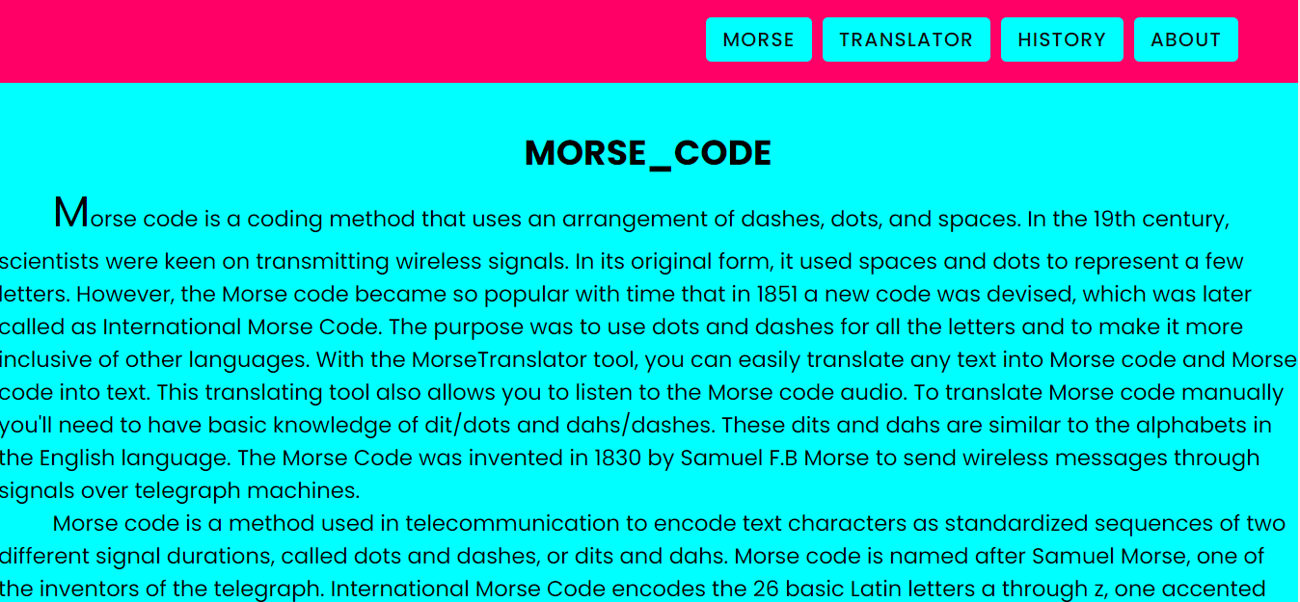

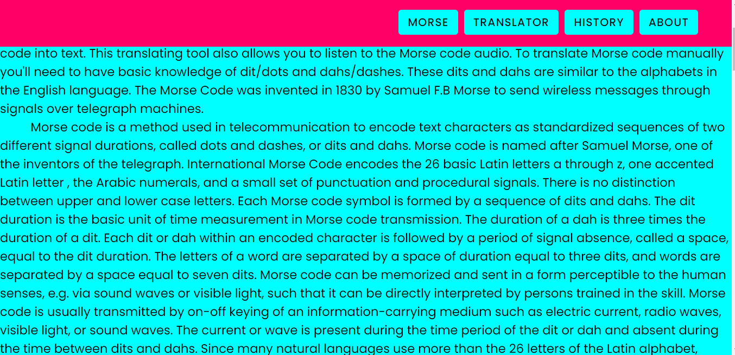

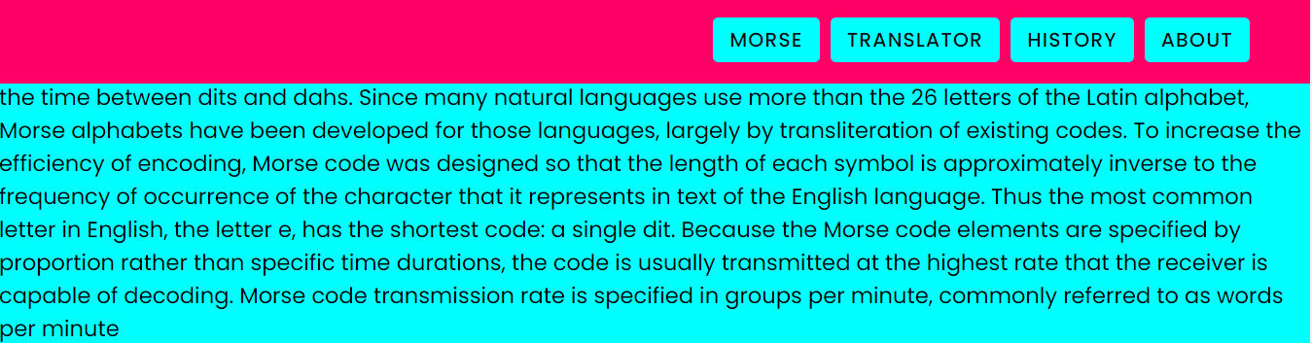

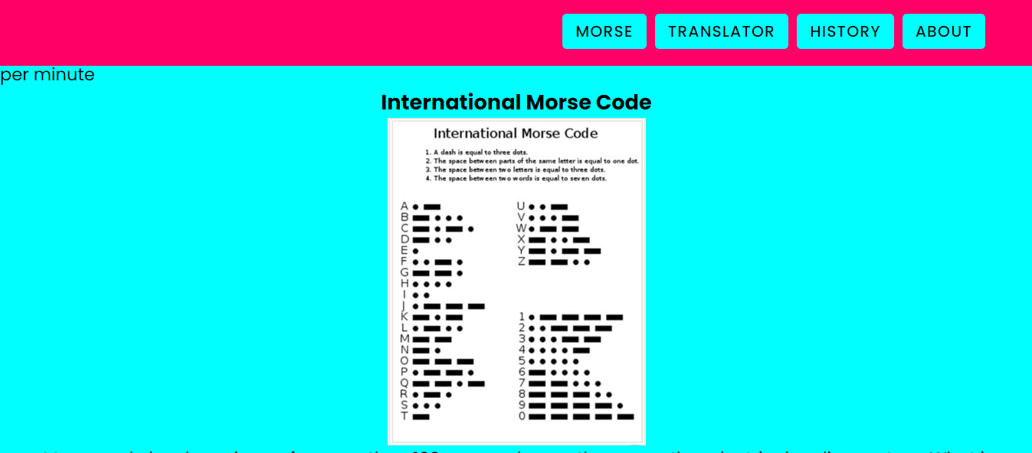

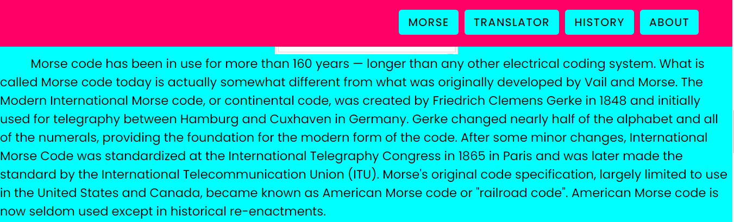

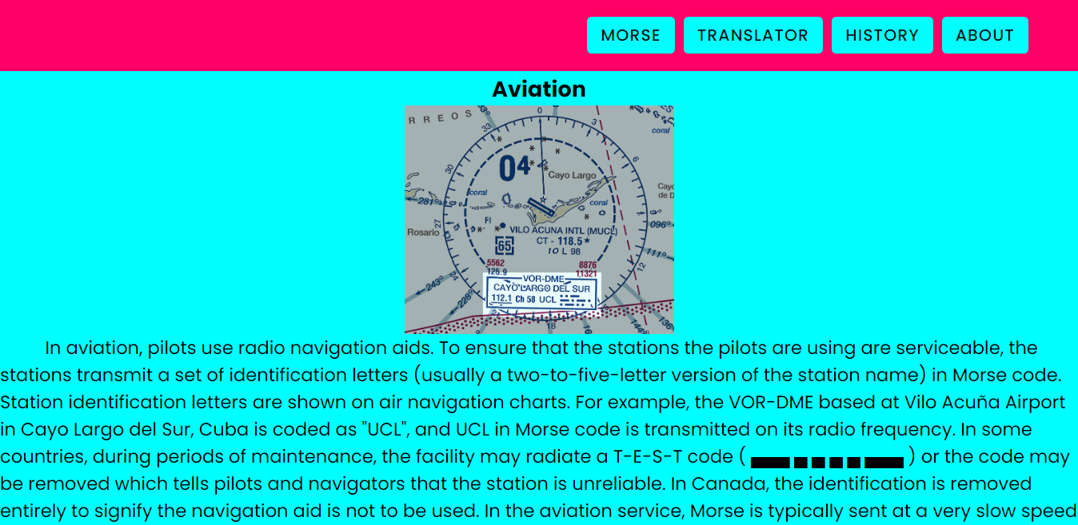

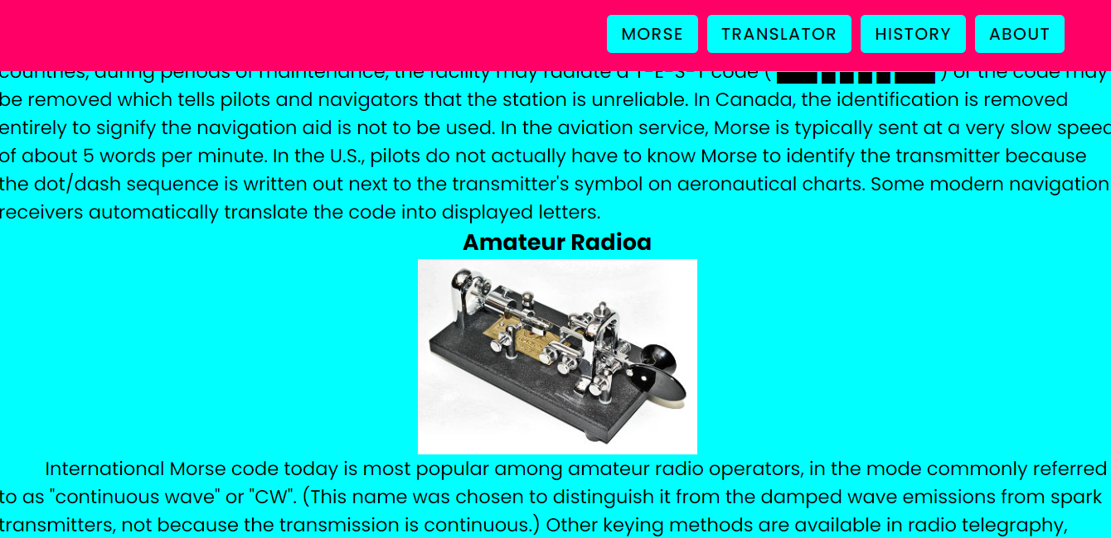

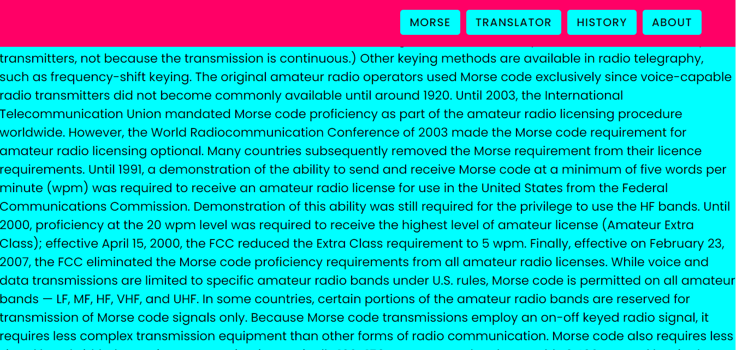

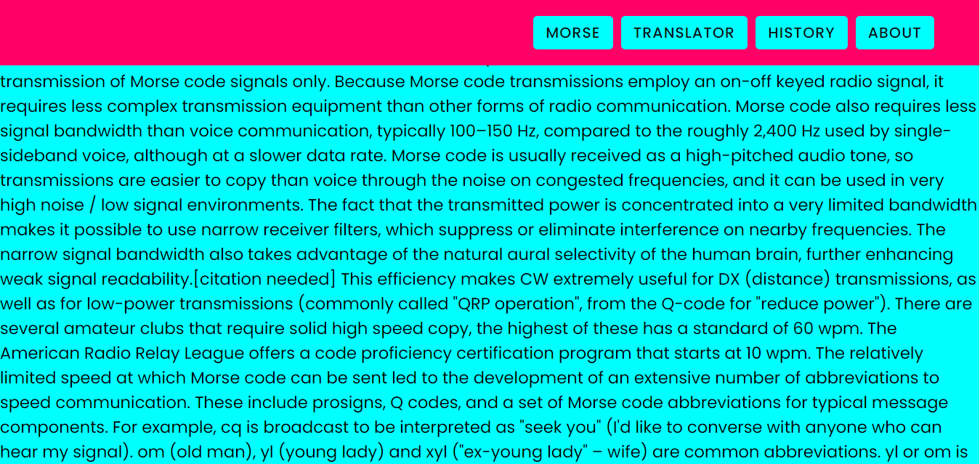

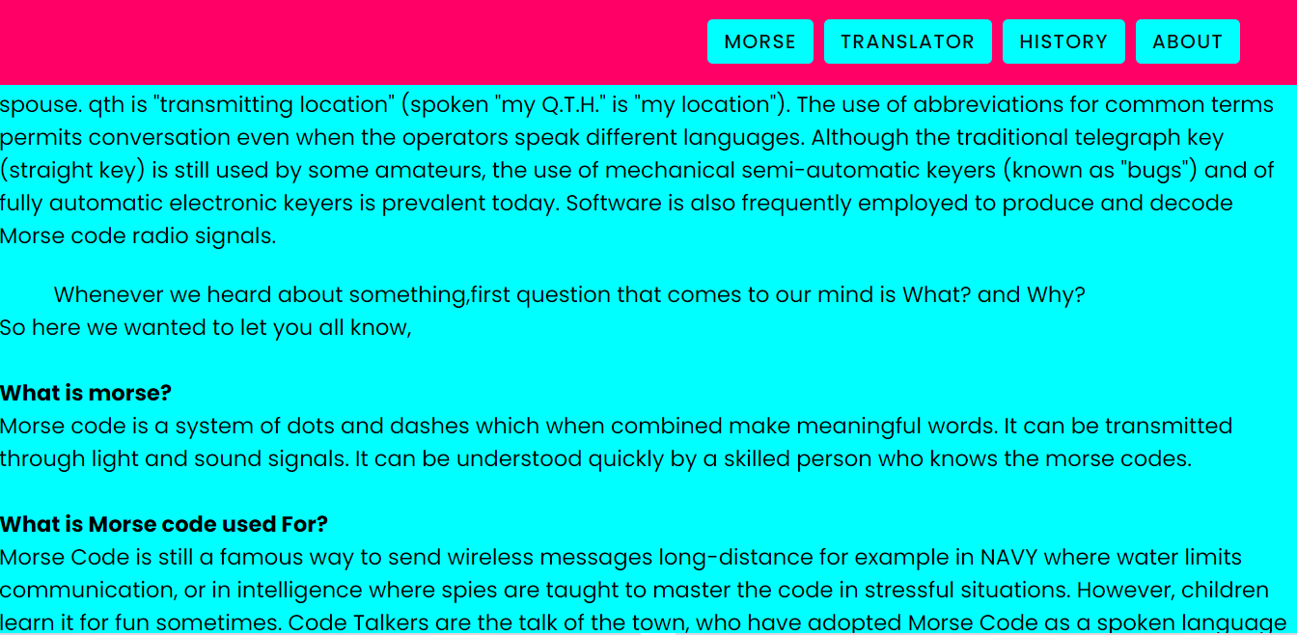

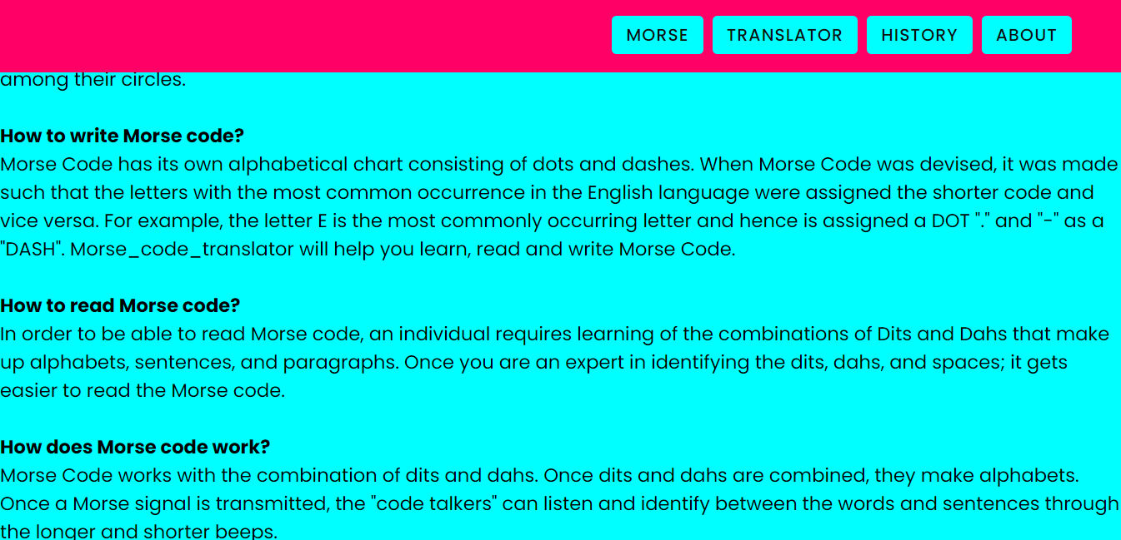

**MORSE.html**

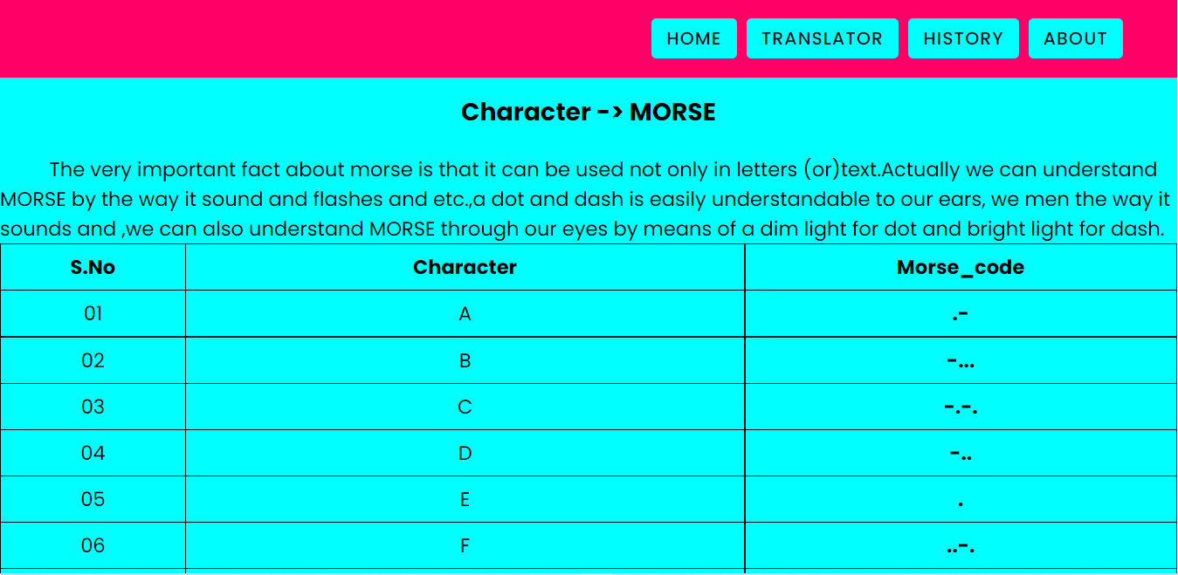

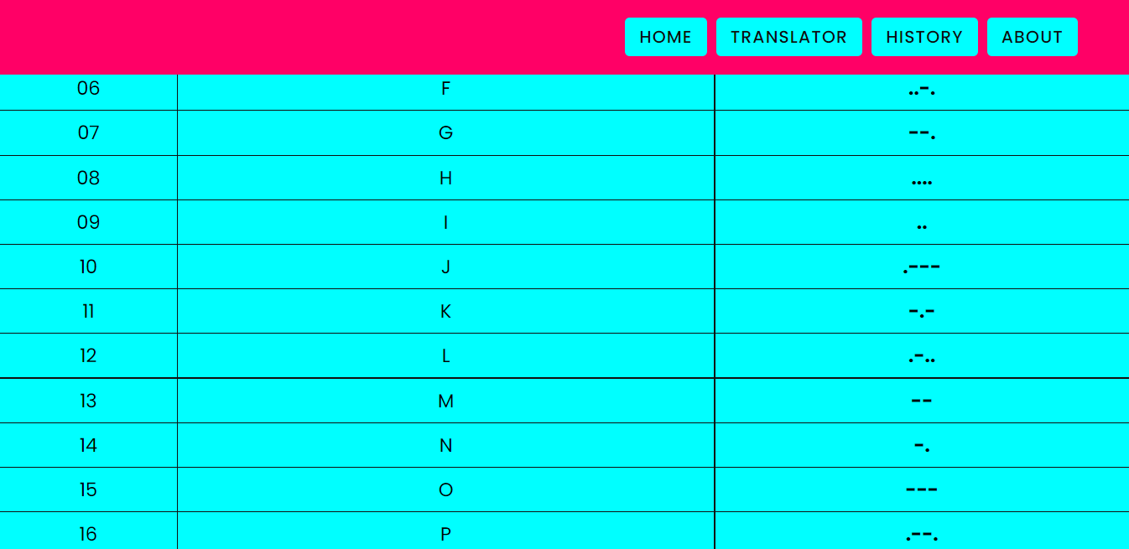

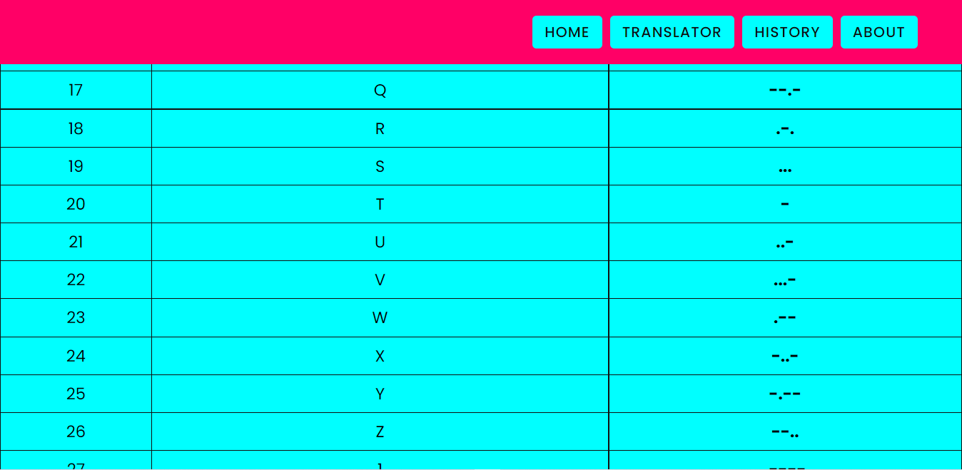

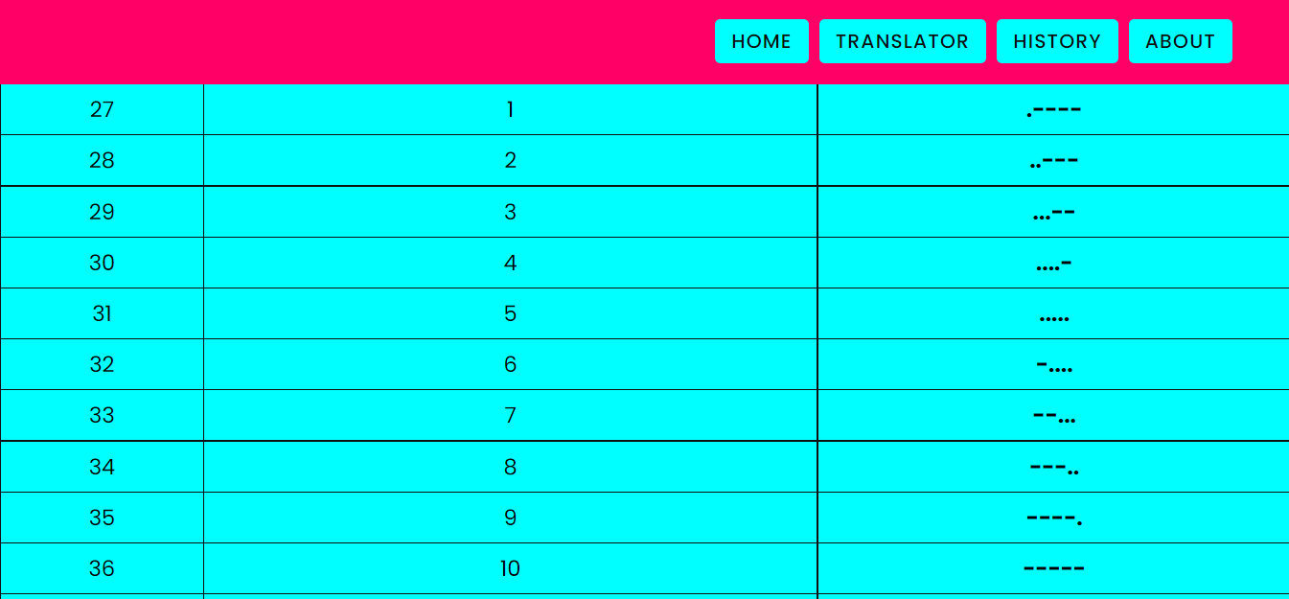

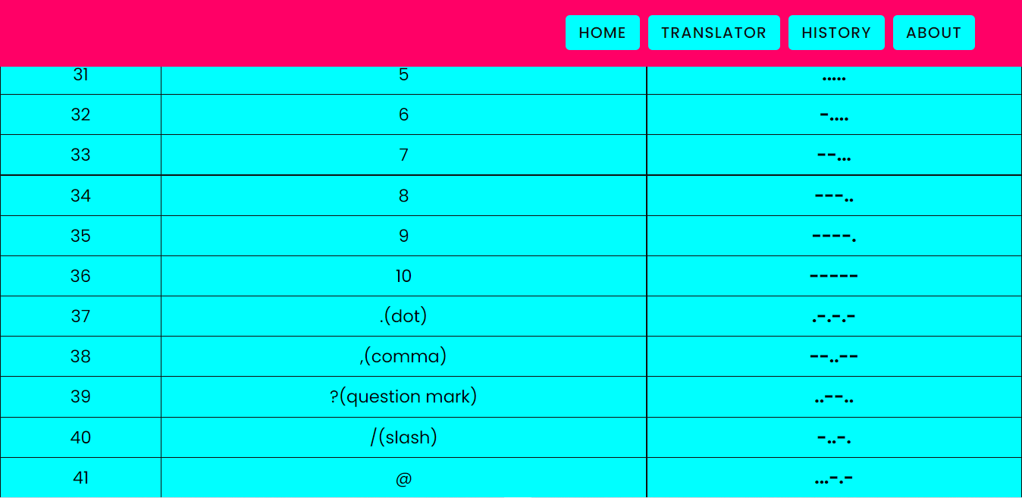

**Translator.html**

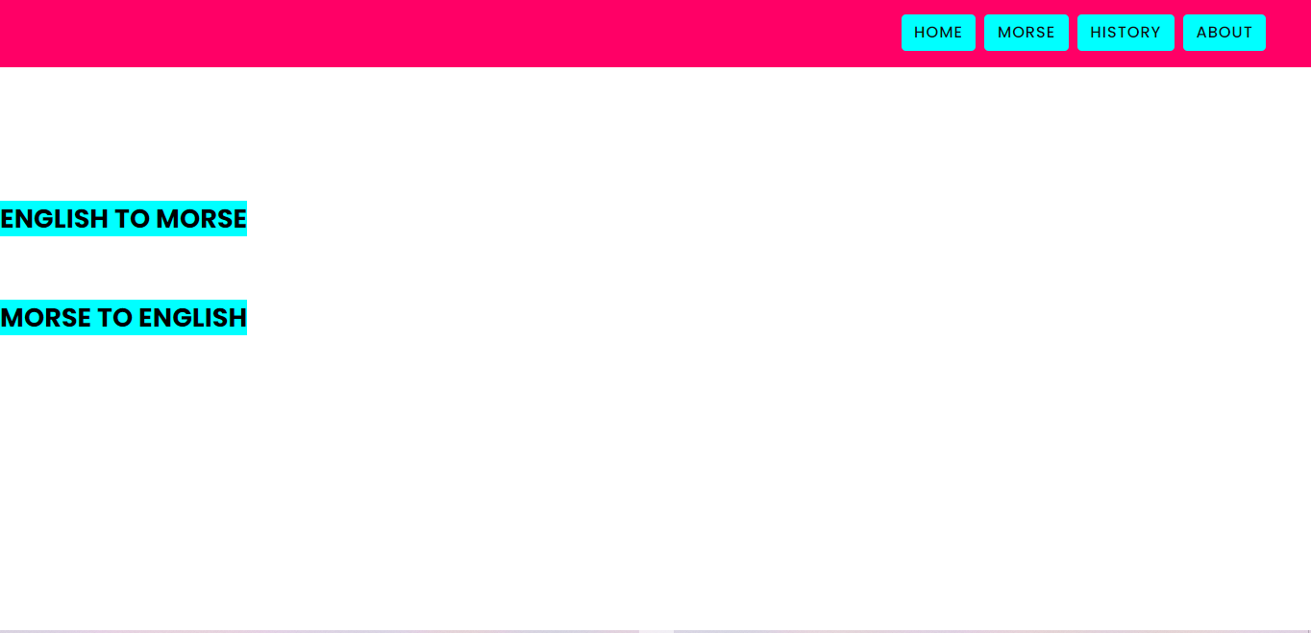

**Translator1.html**

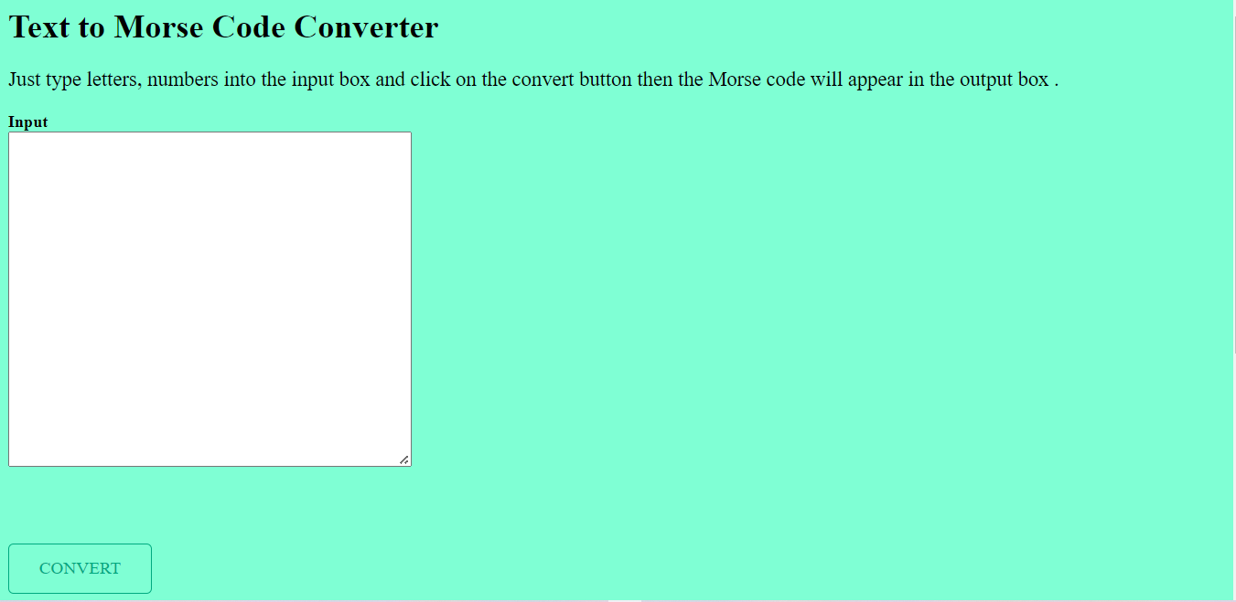

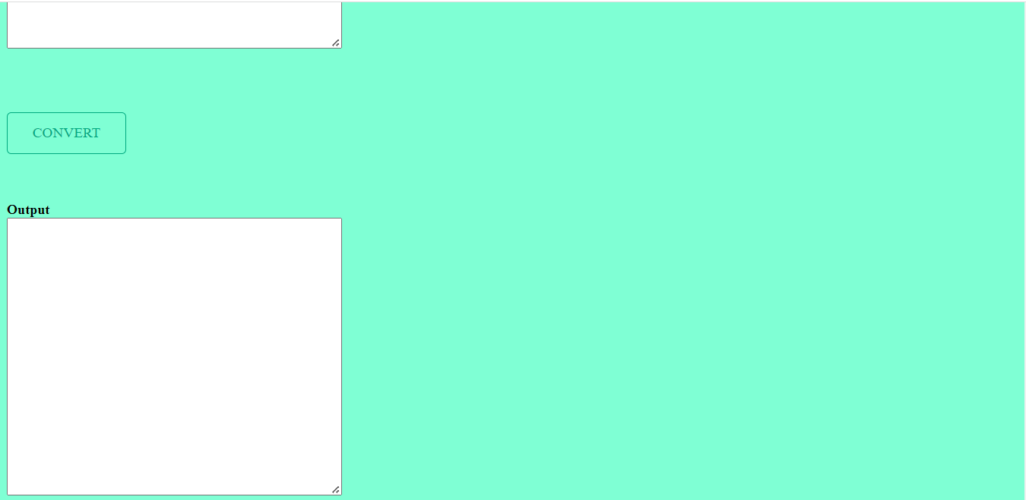

**Translator2.html**

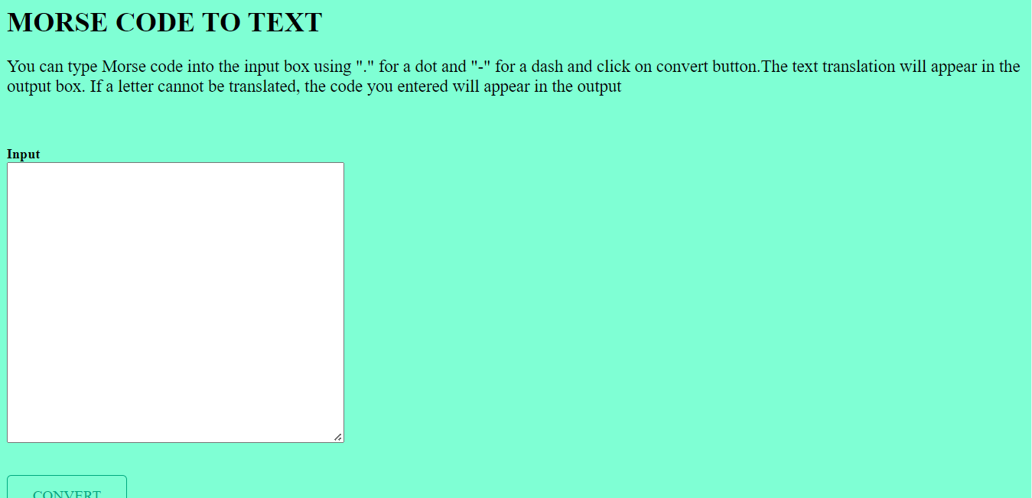

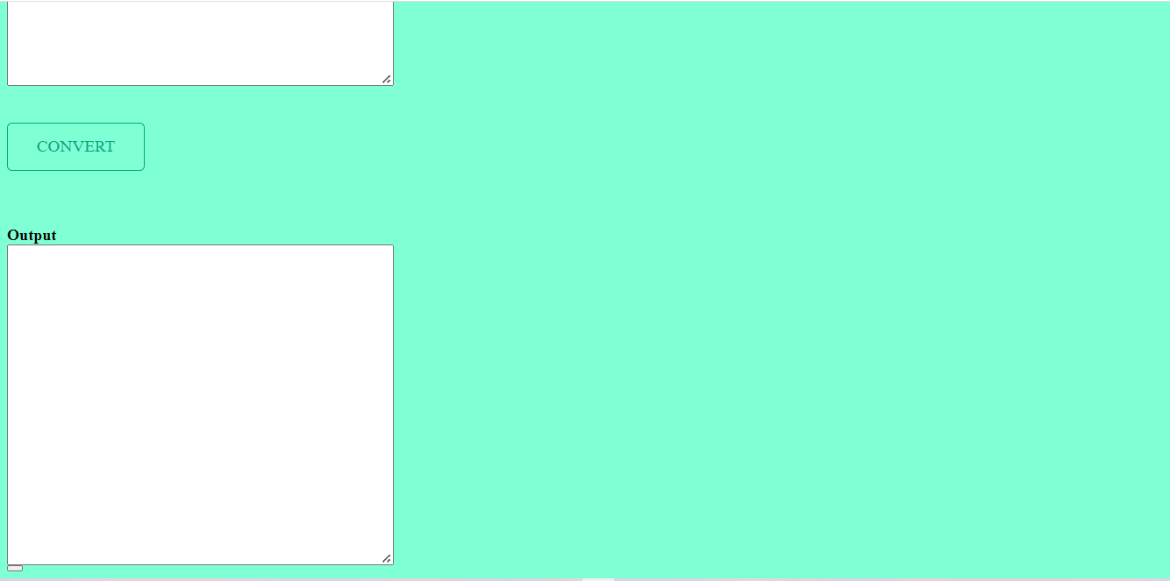

**History.html**

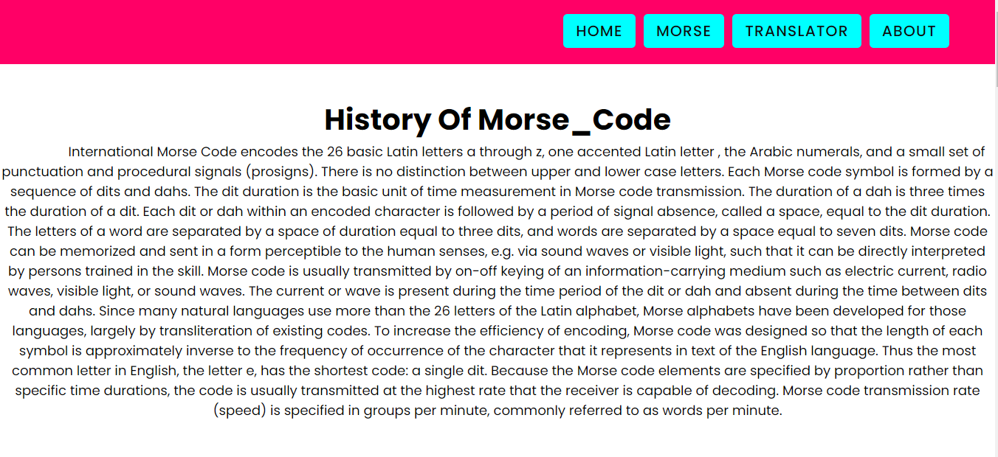

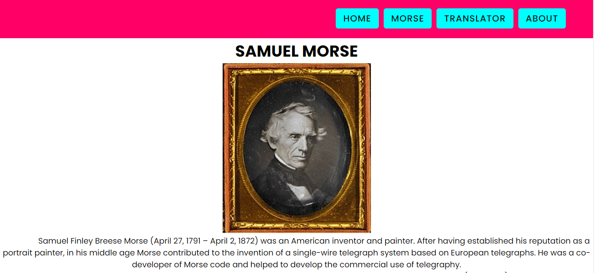

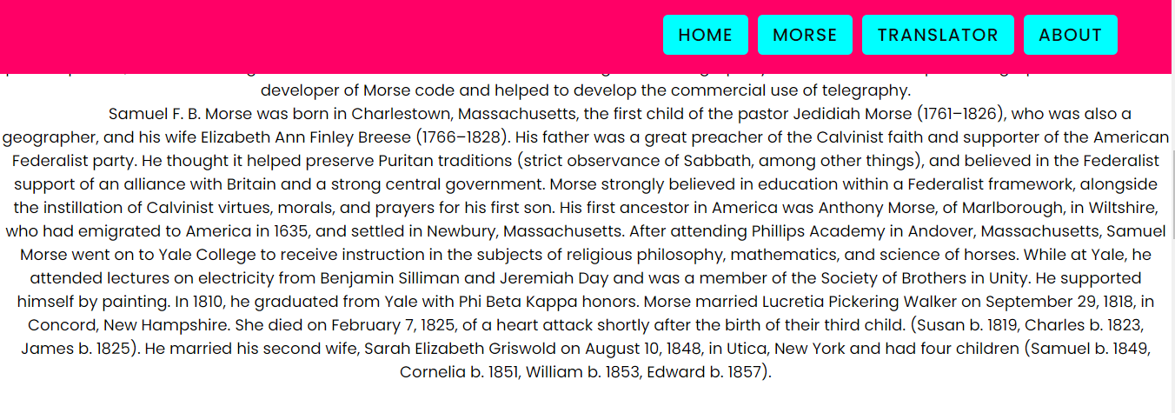

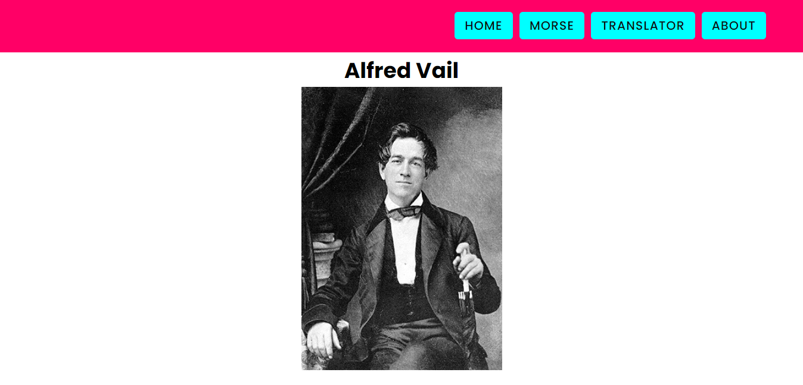

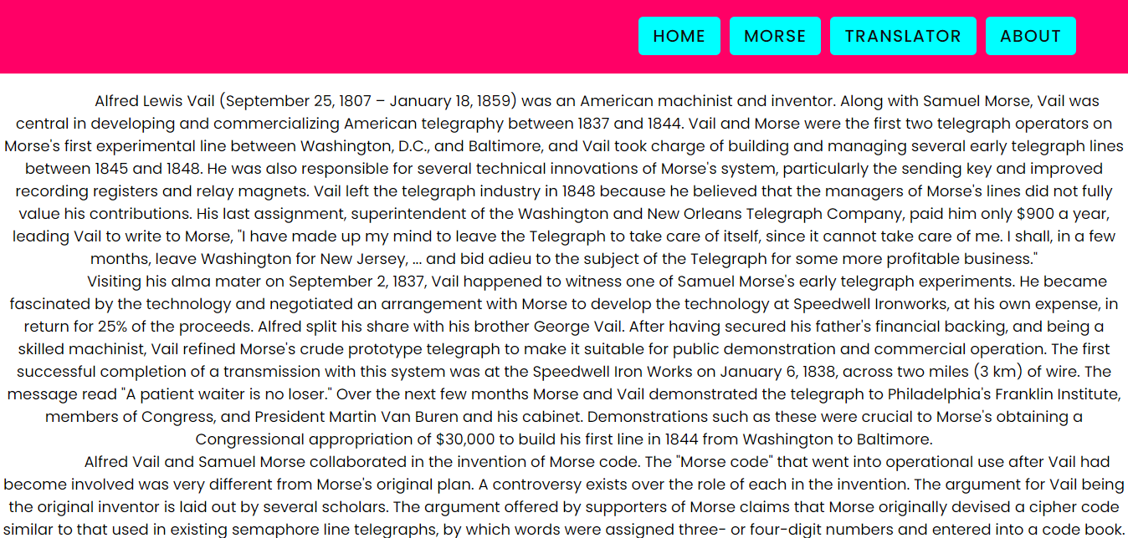

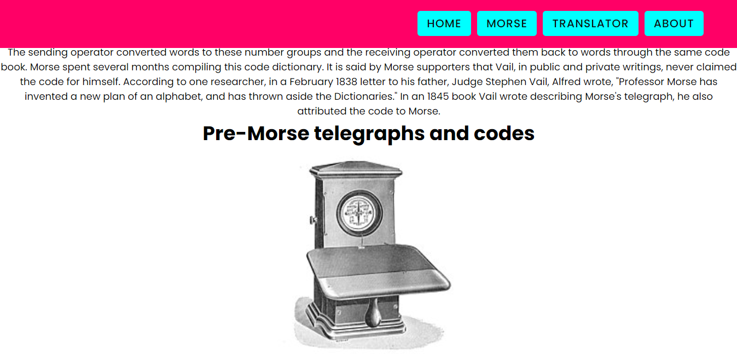

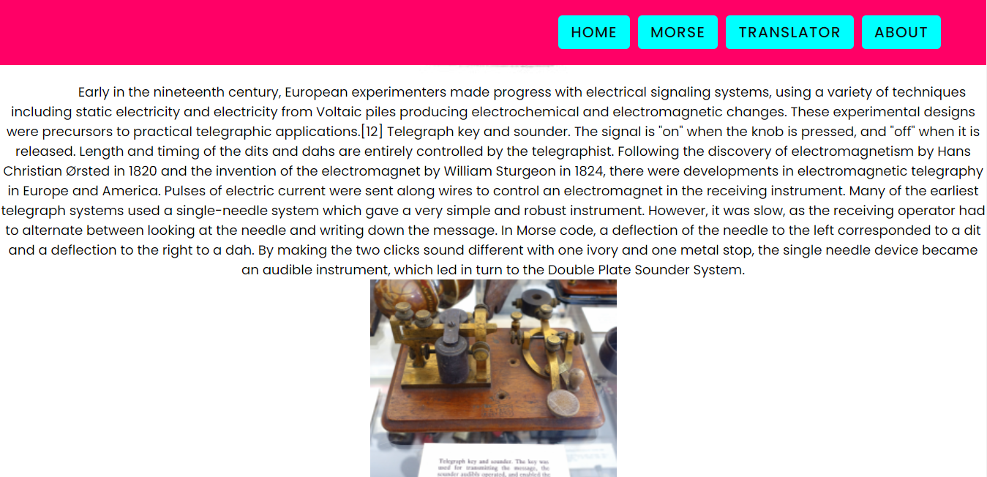

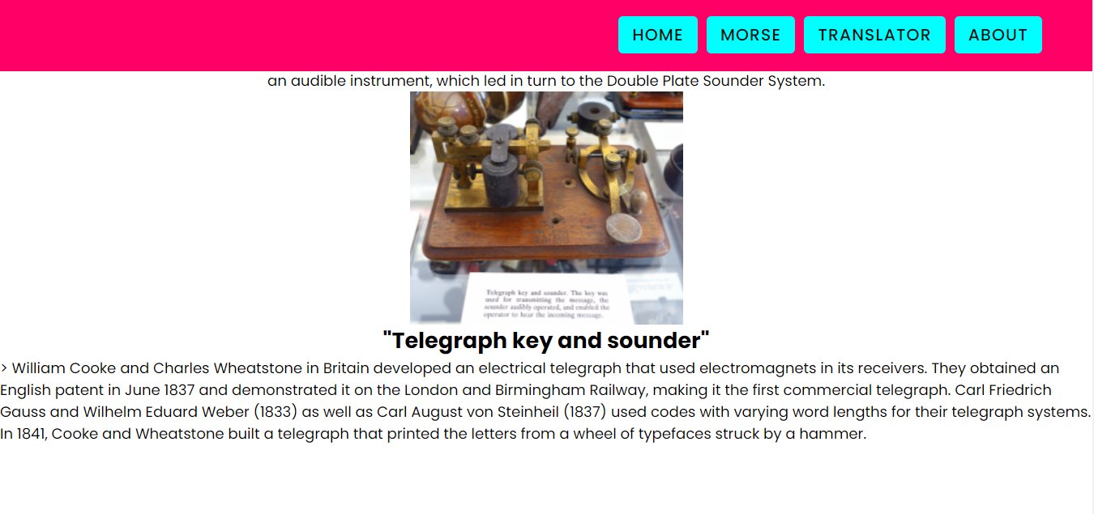

**About.html**

