Council of LLMs
Project Documentation
A 7-Phase Adversarial Multi-Agent Legal Reasoning Pipeline
7 Phase pipeline, 23 LLM Calls, Citation verified, 3 AI Providers

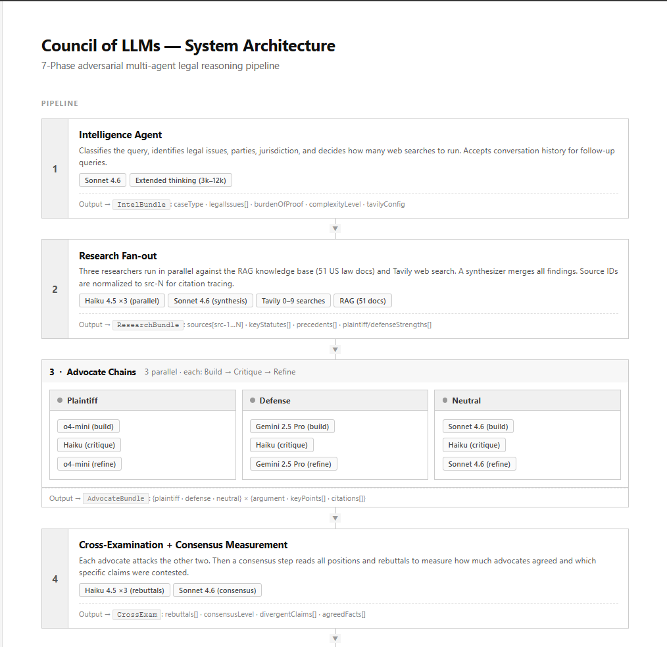
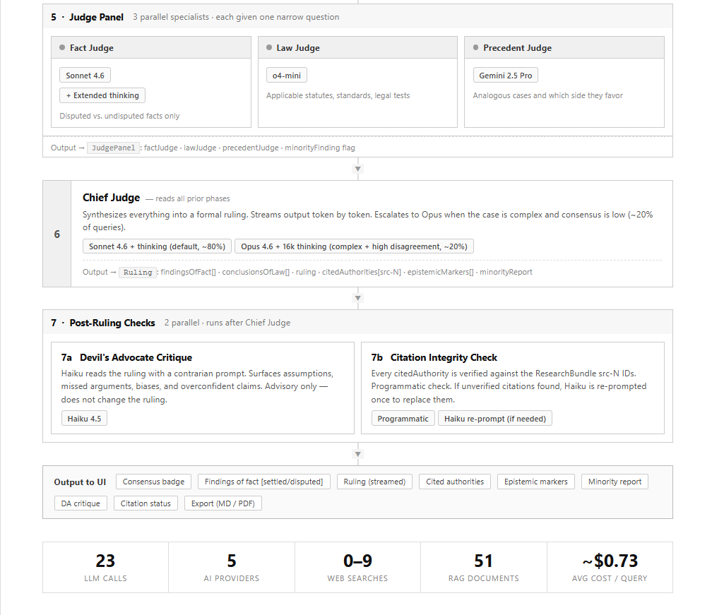

1. What This Is and Why It Exists
Legal AI is a domain where hallucinations are not just wrong, they are dangerous. A model that confidently cites a non-existent statute or misattributes a legal precedent can lead users to make consequential decisions on false grounds. Most legal AI tools ask a single model a question and return whatever it generates. That model has no adversary, no fact-checker, and no one to call out its assumptions.
Council of LLMs is built on a different premise: structured adversarial disagreement produces more reliable output than any single model's confident answer. The system makes three AI agents argue opposing legal positions, forces them to cross-examine each other, sends their work to a specialist judge panel, and then has a Chief Judge synthesize everything into a final ruling, with every factual claim traced back to a verified source.

CORE DESIGN PRINCIPLE
The goal is not to replace legal counsel. It is to reason about legal situations with a level of rigor, source-tracing, and epistemic transparency that a single AI model cannot achieve on its own. Every claim in the output carries a provenance marker: settled, disputed, or single-source.

The problem with single-model legal AI
- No adversarial pressure — a model arguing one side with no opponent will not surface its own weakest points
- No citation discipline — without enforcement, models invent case names, statute numbers, and holdings
- No epistemic grading — output doesn't distinguish "everyone agrees" from "this is contested"
- No self-correction loop — the first draft is the final draft

What Council of LLMs does instead
- Three different AI models argue plaintiff, defense, and neutral positions from the same research base
- Each argument goes through a Build → Critique → Refine loop before being used
- All three positions face cross-examination by opposing advocates
- A dedicated consensus measurement step quantifies how much the advocates agreed
- Three specialist sub-judges (Fact, Law, Precedent) analyze different dimensions in parallel
- The Chief Judge only reads structured outputs from all prior phases — not the raw query
- Every citation in the final ruling is programmatically verified against the research bundle
- A Devil's Advocate runs after the ruling to surface what the Chief Judge might have missed

2. Architecture
The pipeline is sequential at the phase level but parallel within phases. Each phase produces a structured JSON bundle that becomes the input for the next phase. No phase receives the raw user query directly except Phase 1 — downstream phases only see what prior phases have already structured and validated.

Pipeline Overview

PHASE | NAME | MODELS | OUTPUT BUNDLE
1 | Intelligence Agent | Sonnet 4.6 + extended thinking | IntelBundle
2 | Research Fan-out | Haiku ×3 parallel · Sonnet synth · Tavily 0–9 searches | ResearchBundle (src-1…N)
3 | Advocate Chains | o4-mini (Plaintiff) · Gemini 2.5 Pro (Defense) · Sonnet (Neutral) | AdvocateBundle ×3
4 | Cross-Examination | Haiku ×3 rebuttals · Sonnet consensus | CrossExam + consensusLevel
5 | Judge Panel | Sonnet+thinking (Fact) · o4-mini (Law) · Gemini (Precedent) | JudgePanel + minorityFinding
6 | Chief Judge | Sonnet 4.6 (~80%) / Opus 4.6 (~20%, complex+high disagreement) | Ruling (JSON, streamed)
7 | Post-Ruling Checks | Haiku DA Critique · Programmatic citation check | Critique + CitationStatus

Data Flow: How Each Phase Feeds the Next
The architecture was designed so that every LLM call sees only the output of prior phases — never raw free-text from earlier models. Fields that don't parse correctly trigger fallback logic or surface an explicit error. This prevents "reasoning drift" where one model's confident prose becomes the unquestioned premise for all subsequent models.

PHASE | READS | PRODUCES | DOWNSTREAM CONSUMERS
1 — Intel | Raw user query + conversation history | IntelBundle (JSON) | All phases
2 — Research | IntelBundle + RAG + Tavily | ResearchBundle (JSON) | Phases 3, 4, 5, 6, 7b
3 — Advocates | IntelBundle + ResearchBundle | AdvocateBundle (JSON) | Phases 4, 5, 6
4 — Cross-exam | AdvocateBundle + ResearchBundle | CrossExam + consensusLevel | Phases 5, 6
5 — Judge Panel | All prior bundles | JudgePanel (JSON) | Phase 6
6 — Chief Judge | Everything above | Ruling (JSON, streamed) | Phase 7
7 — Checks | Ruling + ResearchBundle | DA critique + citation status | UI display

Why Different Models for Different Roles
Each model was chosen because of a genuine strength match — not because one model is "better" in general. Using the same model for every role would create blind spots: the same reasoning patterns, the same failure modes, the same latent biases.

MODEL | ROLE IN PIPELINE | WHY THIS MODEL
Sonnet 4.6 | Intel Agent, Neutral Advocate, Synthesis, Consensus, Fact Judge, Chief Judge (default) | Best general reasoning at mid cost; extended thinking enables slow deliberate analysis
Haiku 4.5 | Research ×3, Critique steps ×3, Rebuttals ×3, DA Critique, Citation re-prompt | Fast, cheap, reliable JSON; no over-generation; ideal for structural grounding tasks
Opus 4.6 | Chief Judge (escalation path only, ~20% of queries) | Most capable model for complex synthesis; 16k thinking budget for hardest cases
o4-mini | Plaintiff Advocate, Law Judge | OpenAI native reasoning; different failure modes than Anthropic; strong formal doctrinal analysis
Gemini 2.5 Pro | Defense Advocate, Precedent Judge | Strong analogical reasoning; third independent perspective breaks Anthropic/OpenAI duopoly

3. The Seven Phases

1 | Intelligence Agent  Sonnet 4.6 + adaptive extended thinking · Reads query + conversation history

Before any research or argumentation begins, the Intelligence Agent reads the user's query and converts it into a structured IntelBundle. This is the most important phase for the quality of everything that follows — if case classification is wrong, every downstream phase inherits that error.
Extended thinking is enabled here with an adaptive budget (3,000–12,000 tokens depending on complexity). For a straightforward landlord-tenant dispute, the model gets 3,000 thinking tokens. For a multi-party constitutional case with conflicting precedent, it gets 12,000. This allows the model to reason through ambiguous multi-part queries before committing to a classification, rather than pattern-matching on surface features.
The phase also accepts conversation history (last 10 exchanges). If a user asked about a contract dispute and then follows up with "what if the defendant was a minor?", the Intel Agent detects this is a follow-up, carries forward the existing legalIssues[], and sets isFollowUp: true — preventing the pipeline from re-researching facts it already knows.

OUTPUT FIELD | DESCRIPTION
caseType | contract | tort | employment | criminal | constitutional | regulatory | property | other
legalIssues[] | Array of specific legal issues identified in the query
parties | Identified plaintiff and defendant
burdenOfProof | preponderance | clear_and_convincing | beyond_reasonable_doubt
complexityLevel | simple | moderate | complex — drives thinking budgets downstream
tavilyConfig | fire: bool, searchCount: 0|3|6|9, reason: string
isFollowUp | Whether this is a follow-up to a prior session query

DESIGN DECISION: ADAPTIVE THINKING BUDGETS
Adaptive thinking budgets reduce Phase 1 cost by ~60% for simple queries. A question about the statute of limitations for contract breach does not need the same reasoning depth as a multi-party constitutional case with conflicting precedent.

2 | Research Fan-out  Haiku ×3 parallel · Sonnet synthesis · Tavily 0–9 web searches

Three Haiku models run simultaneously, each tasked with researching from a different perspective: one looking for plaintiff-favorable authorities, one for defense-favorable, and one for neutral procedural standards. This parallel fan-out is why the research phase doesn't take three times as long as a single call.
Each researcher draws from two sources: the RAG knowledge base (51 real US law documents covering 11 legal domains) and optionally Tavily web search (0–9 real-time searches, decided by Phase 1). The RAG provides stable doctrine — statute text, landmark case holdings, foundational legal tests. Tavily provides recency — recent rulings, regulatory updates, jurisdiction-specific developments.
After the three researchers return, Sonnet 4.6 synthesizes all three perspectives plus the Tavily results into a unified ResearchBundle. Crucially, all source IDs are normalized at this step to src-1, src-2, etc. — stable, predictable identifiers that every downstream phase can cite without inventing new IDs.

WHY SOURCE ID NORMALIZATION MATTERS
Before this normalization step existed, the synthesizer would generate IDs like "testerman-moulton-1923", and the Chief Judge would later reference something like "testerman1923". The programmatic citation checker would correctly flag this mismatch as an invented source. By normalizing to src-N immediately after synthesis, every downstream model gets clear, unambiguous citation targets that can be verified programmatically.

The ResearchBundle is also prompt-cached using Anthropic's cache_control API. This means the ~17 downstream LLM calls that read the ResearchBundle pay only 10% of the normal input token cost for that cached content. For a bundle of ~4,000 tokens read 17 times, this saves approximately $0.34 per query.

3 | Advocate Chains  3 parallel chains · Each: Build (reasoning model) → Critique (Haiku) → Refine (reasoning model)

This is the core of the adversarial design. Three advocates build arguments from the same ResearchBundle — but they are different AI systems with different underlying training, different reasoning approaches, and different tendencies.
The Plaintiff advocate (o4-mini) leans toward formal argumentation. The Defense advocate (Gemini 2.5 Pro) excels at analogical reasoning and finding alternative framings. The Neutral advocate (Sonnet 4.6) focuses on procedural correctness and what the law actually says.

Each advocate goes through a three-step chain:
- Build — the advocate constructs the strongest argument it can, citing only sources present in the ResearchBundle
- Critique — a Haiku model reads the argument against the ResearchBundle and flags any factual inaccuracies, unsupported claims, or sources that don't actually say what the advocate claimed
- Refine — the original advocate reads its own argument plus the critique and produces a corrected, strengthened version

WHY THREE DIFFERENT AI PROVIDERS
If all three advocates were Anthropic models, they would share the same fine-tuning biases, the same RLHF tendencies, and potentially the same systematic errors. Using o4-mini (OpenAI), Gemini 2.5 Pro (Google), and Sonnet 4.6 (Anthropic) as advocates means disagreements between them are more likely to reflect genuine legal uncertainty rather than coincidental agreement from shared training data.

4 | Cross-Examination + Consensus Measurement  Each advocate attacks the other two · Sonnet measures how much they agreed

Each advocate is shown the key points from the other two positions and asked to produce targeted rebuttals — short, specific attack points, each under 20 words. The three rebuttals run in parallel using Haiku. The brevity constraint is deliberate: it forces the model to identify the single most damaging attack rather than producing verbose paragraph-length rebuttals that can drift off-topic.
After the rebuttals, Sonnet 4.6 performs a Consensus Measurement step. It reads all three advocate positions plus all three rebuttals and produces a consensusLevel enum (STRONG_CONSENSUS through FUNDAMENTAL_DISAGREEMENT), a divergentClaims[] array, and agreedFacts[].
The consensusLevel serves two purposes: it directly feeds the Chief Judge's escalation decision in Phase 6, and it appears in the UI as a color-coded badge so the user immediately understands whether the AI advocates reached a clear conclusion or found genuine disagreement.

5 | Judge Panel  3 parallel specialists · Each given a single narrow question

Instead of asking one judge to handle facts, law, and precedent simultaneously, the pipeline separates these concerns into three specialists running in parallel:
- Fact Judge (Sonnet 4.6 + extended thinking): Determines which facts are undisputed and which are genuinely contested. Extended thinking helps distinguish disputed from undisputed facts by carefully reading what each advocate actually claimed versus assumed.
- Law Judge (o4-mini): Identifies applicable legal standards, statutes, and formal legal tests. Explicitly instructed not to determine facts.
- Precedent Judge (Gemini 2.5 Pro): Finds analogous cases from the ResearchBundle and assesses which side each precedent favors. Gemini's strength at analogical pattern-matching makes it well-suited for this role.

If the three sub-judges diverge significantly, a minorityFinding flag is set. The Chief Judge sees this flag and must address the disagreement explicitly in its ruling.

6 | Chief Judge  Hybrid Sonnet/Opus · Reads every prior phase · Streams output token by token

The Chief Judge is the only model in the pipeline that reads everything. Its input is a structured context block containing: the IntelBundle, the ResearchBundle (prompt-cached), all three advocate arguments and rebuttals, the consensusLevel and divergentClaims from Phase 4, and the three sub-judge findings from Phase 5.
The model selection is adaptive. For most queries (~80%), Sonnet 4.6 with a moderate thinking budget is used. Opus 4.6 with a 16,000-token thinking budget is only invoked when two conditions are both true: the case was classified as complex by Phase 1, and the consensus level reached SIGNIFICANT_DISAGREEMENT or FUNDAMENTAL_DISAGREEMENT in Phase 4.

CITATION ENFORCEMENT IN THE PROMPT
The Chief Judge's system prompt explicitly lists every valid source ID: "You MUST use ONLY these exact IDs in citedAuthorities and findingsOfFact.sources. Valid IDs: src-1, src-2, src-3... Do NOT invent new IDs. If evidence is thin, state low confidence rather than fabricate." This is the first line of citation defense — before any programmatic check.

Output schema — the ruling explicitly structures every claim with its epistemic state:

{
"findingsOfFact": [{ "fact": "...", "status": "settled|disputed", "sources": ["src-N"] }],
"conclusionsOfLaw": [{ "conclusion": "...", "basis": "...", "advocateAttribution": "plaintiff|defense|neutral|all" }],
"ruling": "who prevails and on what grounds",
"rationale": "detailed reasoning",
"citedAuthorities": [{ "id": "src-N", "title": "...", "proposition": "..." }],
"epistemicMarkers": [{ "claim": "...", "status": "settled|disputed|single_source" }],
"minorityReport": "string or null",
"modelUsed": "anthropic/claude-sonnet-4.6",
"escalated": false
}

7 | Post-Ruling Checks  Two parallel tasks · Neither modifies the ruling except to replace invalid citations

7a. Devil's Advocate Critique — Haiku is given the ruling with a contrarian system prompt: "Aggressively challenge this ruling. Find every weakness, assumption, and potential error." It produces four categories: unquestioned assumptions, missed counterarguments, framing biases, and overconfident claims. This appears as a red-bordered advisory block in the UI. It does not change the ruling.

7b. Citation Integrity Check — Every citedAuthority in the ruling is checked against the ResearchBundle's source IDs. The check is programmatic: exact ID match first, then title substring fuzzy match as a fallback. If any citation cannot be verified, Haiku is re-prompted once with the list of valid source IDs and asked to replace the unverified citations with correct ones.

WHY THE RE-PROMPT WORKS
Rather than failing when the Chief Judge invents a citation, the system has a recovery path: the re-prompt gives Haiku an explicit list of valid IDs and asks it to substitute. This is dramatically cheaper than re-running the Chief Judge (Haiku re-prompt: ~$0.001 vs. Chief Judge: ~$0.30–$1.20).

4. How Hallucinations Are Reduced
Hallucination in LLMs is not binary — it exists on a spectrum from subtle over-confidence to outright fabrication. The Council of LLMs pipeline addresses this spectrum with multiple overlapping mechanisms rather than any single fix.

DEFENSE-IN-DEPTH PHILOSOPHY
No single mechanism is sufficient. Extended thinking helps but doesn't eliminate hallucinations. Citation enforcement helps but doesn't prevent confident-but-wrong legal analysis. The approach is defense-in-depth: every layer reduces the probability that the output contains a claim that is both wrong and unchallenged.

The 10 Mechanisms

MECHANISM | PHASE | WHAT IT PREVENTS
Adversarial architecture | 3–4 | Wrong claims survive if they go unchallenged. Cross-examination forces every advocate position to be attacked.
Extended thinking on critical phases | 1, 3, 5, 6 | Reduces confident-but-wrong pattern. Models reason through conflicting information before committing.
Source ID normalization (src-N) | 2 | Prevents citation drift where the same source gets different IDs across phases.
Citation enforcement in Chief Judge prompt | 6 | Tells the model exactly which IDs exist before generation. First line of citation defense.
Programmatic citation integrity check | 7b | Verifies citations mechanically — no LLM involved. Either the ID matches or it does not.
Epistemic markers on every claim | 6 | Labels each claim settled/disputed/single_source from pipeline data — not the model's self-assessment.
Haiku critique step in each advocate chain | 3 | Factual inaccuracies introduced in Build step are caught before they reach Phase 4.
Three-provider independence | 3–5 | Systematic biases in one provider are contested by two others trained on different data.
Devil's Advocate post-ruling critique | 7a | Makes the ruling's own weaknesses explicit. User sees what the system thinks might be wrong.
Structured JSON at every phase boundary | All | Free-text reasoning cannot propagate unchecked. Must be parsed into a schema to continue.

Robust JSON Parsing — 7-Strategy Fallback
LLMs frequently produce nearly-valid JSON: markdown code fences, trailing commas, literal newline characters inside string values, and truncated output when token limits are hit. Rather than failing on any of these, the pipeline uses a sequential 7-strategy parser:

STRATEGY | HANDLES
1. Strip markdown fences, direct parse | Clean JSON with ``` wrappers
2. Fix literal newlines inside strings | Unescaped \n in string values (common LLM output)
3. Remove trailing commas | [...,] and {...,} patterns
4. Extract embedded ```json fence | Thinking models that wrap JSON in a code block within their response
5. Extract outermost { } or [ ] | Prose before/after the JSON object
6. Truncation repair: close open strings + brackets | Token-limit truncation mid-JSON string (e.g., cut off at position 649)
7. Throw with first 120 characters | Surfaces the actual content for debugging

The truncation repair strategy (step 6) was added after encountering a real production error: the Precedent Judge's response was cut off mid-string when the model hit its token limit. The repair function walks the JSON character-by-character tracking bracket depth and string state, then closes any open structures to produce parseable output.

5. Cost Engineering
The first design of this pipeline would have cost approximately $1.96 per query with Opus 4.6 and 16k extended thinking on every call. Through a series of targeted optimizations, the average cost was reduced to approximately $0.73 per query — a 63% reduction — without removing any of the anti-hallucination mechanisms.

Optimization 1 — Prompt Caching
The ResearchBundle and IntelBundle are wrapped with Anthropic's cache_control: { type: "ephemeral" } header after Phase 2. Every subsequent LLM call that reads these bundles — 17 calls across Phases 3, 4, 5, and 6 — pays only 10% of the normal input token cost for that cached content. For a typical ResearchBundle of ~4,000 tokens at Sonnet's input rate, this saves approximately $0.34 per query.

Optimization 2 — Adaptive Thinking Budgets
Extended thinking is expensive: each token in the thinking budget costs the same as an output token. Rather than using a fixed budget for all queries, the pipeline ties the budget to the complexityLevel that Phase 1 assigns:

COMPLEXITY | SONNET THINKING BUDGET | OPUS THINKING BUDGET | TYPICAL USE CASE
Simple | 3,000 tokens | 6,000 tokens | Single legal issue, settled doctrine
Moderate | 6,000 tokens | 10,000 tokens | Multiple issues, some uncertainty
Complex | 12,000 tokens | 16,000 tokens | Novel doctrine, multi-party, conflicting precedent

Most legal queries are simple or moderate. An easy question about negligence elements gets 3,000 thinking tokens at Phase 1 instead of 16,000 — a 5× cost reduction for that call alone.

Optimization 3 — Hybrid Chief Judge
Opus 4.6 with a 16k thinking budget costs approximately $1.20 per call — the single largest cost item in the pipeline. Rather than using it for every query, Opus is only invoked when both conditions are true:
- Phase 1 classified the case as complex
- Phase 4 measured consensus at SIGNIFICANT_DISAGREEMENT or FUNDAMENTAL_DISAGREEMENT
For approximately 80% of queries, Sonnet 4.6 serves as Chief Judge. This brings the average cost of Phase 6 from $1.20 to approximately $0.30 per query.

Optimization 4 — Haiku for All Structural Tasks
Haiku 4.5 is approximately 20× cheaper per token than Sonnet 4.6 for input and 12× cheaper for output. The pipeline uses Haiku for every task that is mechanical rather than creative: the three research fan-out calls, three critique steps, three cross-examination rebuttals, the Devil's Advocate critique, and the citation re-prompt. Nine of the 23 LLM calls are Haiku.

Optimization 5 — Smart Tavily Routing
Tavily web search is billed per request. Phase 1's Intel Agent explicitly decides how many searches to fire based on domain volatility. Classical tort law, established constitutional doctrine, and common-law contract rules are stable — for these cases, searchCount: 0 saves the Tavily cost entirely. Volatile areas (regulatory, immigration, recent legislation) get up to 9 searches.

Full Cost Breakdown Per Query

PHASE | CALLS | MODEL(S) | AVG COST | MAX COST
1 — Intel | 1 | Sonnet 4.6 + thinking | $0.04 | $0.12
2 — Research ×3 | 3 | Haiku 4.5 | $0.02 | $0.03
2 — Synthesis | 1 | Sonnet 4.6 | $0.05 | $0.08
2 — Tavily | 0–9 | Tavily API | $0.02 | $0.05
3 — Advocate Builds ×3 | 3 | o4-mini · Gemini · Sonnet | $0.12 | $0.20
3 — Critiques ×3 | 3 | Haiku 4.5 | $0.01 | $0.02
3 — Refines ×3 | 3 | o4-mini · Gemini · Sonnet | $0.10 | $0.18
4 — Rebuttals ×3 | 3 | Haiku 4.5 | $0.01 | $0.02
4 — Consensus | 1 | Sonnet 4.6 | $0.03 | $0.05
5 — Judge Panel ×3 | 3 | Sonnet+thinking · o4-mini · Gemini | $0.15 | $0.25
6 — Chief Judge | 1 | Sonnet (80%) / Opus (20%) | $0.15 | $1.20
7a — DA Critique | 1 | Haiku 4.5 | $0.01 | $0.01
7b — Citation check | 0–1 | Programmatic + Haiku (if needed) | $0.00 | $0.01
TOTAL | 23 LLM calls | 5 providers | ~$0.73 | ~$1.75

All costs are approximate and based on OpenRouter pricing as of Q2 2025. Prompt caching discounts (90% on cached tokens) are already reflected in the averages.

6. Technical Infrastructure

OpenRouter as the Unified LLM Gateway
All five AI providers (Anthropic, OpenAI, Google, Tavily) are accessed through a single OpenRouter API key. OpenRouter exposes an OpenAI-compatible endpoint, so every model call in the pipeline uses identical request structure regardless of provider. This eliminates five separate SDK dependencies and means the pipeline can be updated to use a newer model version by changing a single string in the model constants map.

// All models via one endpoint, one key
const M = {
SONNET: 'anthropic/claude-sonnet-4.6',
HAIKU: 'anthropic/claude-haiku-4.5',
OPUS: 'anthropic/claude-opus-4.6',
O4_MINI: 'openai/o4-mini',
GEMINI: 'google/gemini-2.5-pro-preview',
};

Server-Sent Events for Live Streaming
The API endpoint uses SSE (Server-Sent Events) to push pipeline progress to the browser in real time. Each phase emits a phase_start event when it begins and a phase_complete event with structured data when it finishes. The Chief Judge's ruling is streamed token-by-token via stream_token events — the pipeline doesn't go silent for 30 seconds and then dump everything at once.

The response_format + Extended Thinking Conflict
Anthropic models do not allow response_format: { type: "json_object" } to be used simultaneously with extended thinking. When both are requested, the model ignores the JSON constraint and generates a markdown document instead. The llmOnce() function handles this by only setting response_format when thinking === 0:

// response_format and thinking are mutually exclusive on Anthropic
...(json && thinking === 0 && { response_format: { type: 'json_object' } }),
...(thinking > 0 && model.startsWith('anthropic/') && {
thinking: { type: 'enabled', budget_tokens: thinking },
}),

Retry Logic and Network Resilience
OpenRouter connections occasionally terminate mid-request (ECONNRESET, ETIMEDOUT). Every non-streaming LLM call is wrapped in a retry handler that attempts up to 2 retries with exponential backoff (1.5s, 3s). Streaming calls are not retried because partial output cannot be replayed cleanly — instead, Phase 6 falls back to a non-streaming Sonnet call if the stream fails.

RAG Knowledge Base — 51 US Law Documents
The embedded knowledge base covers 11 legal domains with real statute text, landmark case holdings, and key legal tests. The search function scores every document against the query using keyword matching, term frequency in content and title, and a 3-point bonus when the document's legal area matches the case type. The top 6 by score are provided to Phase 2 researchers.

DOMAIN | DOCUMENTS | KEY SOURCES
Property / Landlord-Tenant | 6 | CA Civil Code § 1950.5, FHA, adverse possession, Fifth Amendment takings, unlawful detainer
Contract Law | 6 | UCC Article 2, Hadley v. Baxendale, unconscionability (Williams v. Walker-Thomas), parol evidence
Tort Law | 6 | Palsgraf, Hand formula, Greenman products liability, NYT v. Sullivan, comparative fault
Employment | 6 | Title VII, EEOC McDonnell Douglas, Faragher/Ellerth, FLSA, CA AB-5, FMLA
Constitutional | 4 | Brandenburg incitement test, Katz/Carpenter 4th Amendment, Bruen 2nd Amendment
Criminal | 4 | MPC mens rea, Miranda, Gideon right to counsel, Brady disclosure
Civil Procedure | 5 | Twombly/Iqbal pleading, Celotex summary judgment, Rule 23 class actions, Int'l Shoe
Family | 3 | Community property division, child custody best-interests, UPAA prenuptials
Consumer Protection | 3 | FCRA, FTC § 5 / CA UCL, TILA/RESPA mortgage disclosures
Intellectual Property | 2 | Copyright fair use (Campbell v. Acuff-Rose), DTSA trade secrets
General / Procedure | 6 | Statute of limitations, burden of proof standards, hearsay FRE 801, § 1983 civil rights, injunctions

Technology Stack
- Backend: Node.js (ESM), Express 4, native fetch — no LLM SDK dependency
- Frontend: Vanilla JavaScript, SSE EventSource, no framework
- APIs: OpenRouter (all LLMs), Tavily (web search)
- Dev server: node --watch server.js with graceful SIGTERM/SIGINT shutdown
- Total dependencies: 2 (express, dotenv) — by design; the pipeline is self-contained

7. UI and Output Format

Interface Layout
The interface is split into two panels. The left panel handles input (text query or .txt/.md file upload) and shows the live pipeline progress. The right panel streams the ruling in real time, with structured sections for each output component.

Output Components
COMPONENT | DESCRIPTION | VISUAL TREATMENT
Consensus badge | Color-coded from STRONG_CONSENSUS (green) to FUNDAMENTAL_DISAGREEMENT (red). First thing the user sees. | Pill badge at top of ruling
Findings of fact | Each finding labeled settled (green border) or disputed (red border), sourced to specific ResearchBundle entries | Left-bordered cards
Conclusions of law | Each conclusion attributed to the advocate that originally raised it | Plain list with attribution tag
Ruling text | Who prevails and on what grounds — streamed live token by token | Purple-bordered text box with blinking cursor
Epistemic markers | Inline [settled], [disputed], [single_source] tags on key claims | Color-coded inline badges
Cited authorities | Each source with its proposition; all verified against ResearchBundle | Citation cards with src-N ID badge
Minority report | If sub-judges diverged, the dissenting analysis | Amber-bordered block
Devil's Advocate critique | What the system itself thinks might be wrong with the ruling | Red-bordered advisory block
Citation integrity status | Green if all verified; amber if citations were auto-corrected by re-prompt | Status bar at bottom of citations
Export | Markdown (.md) download or PDF (via print stylesheet) | Two buttons below the ruling

File Upload
Users can upload .txt or .md files instead of typing a query. The FileReader API reads the file client-side and populates the query textarea. This is useful for uploading contract documents, legal notices, case descriptions, or any document to be analyzed without manual copy-pasting.

Export
Markdown export generates a structured .md file with all ruling sections — findings of fact, conclusions of law, rationale, cited authorities, epistemic markers, minority report, and Devil's Advocate critique. PDF export calls window.print() against a dedicated print stylesheet that hides the UI chrome and renders the ruling black-on-white for clean document output.
8. Summary: What Makes This Different
Most AI systems for legal questions are wrappers around a single model call. The Council of LLMs is fundamentally different in four ways:

- Adversarial architecture — truth is tested under cross-examination, not asserted by a single confident voice
- Model diversity — three AI providers, each with different training and failure modes, reduce the risk that systematic model bias goes unchallenged
- Programmatic verification — citations are not trusted because a model said they exist; they are verified against a known source set
- Epistemic transparency — the output tells you what the AI agreed on, what it disputed, and what it thinks it might have gotten wrong

The result is a system where the final ruling has been argued for, argued against, critiqued by the original advocate, cross-examined by opponents, evaluated by three specialist judges, synthesized by a Chief Judge who read all of it, programmatically fact-checked, and then challenged by a contrarian critic — all before the user sees it.

WHAT THE OUTPUT IS NOT
This is not legal advice. The output of the Council of LLMs is structured reasoning about a legal situation based on available information. It should be used to understand the legal landscape of a situation, identify the strongest arguments on each side, and prepare informed questions for actual legal counsel — not to substitute for it.

Council of LLMs · Built with Express, Node.js, OpenRouter, and Tavily · 23 LLM calls per query across 5 AI providers

