Data Cleaning and Preprocessing Report

1. Data Set Summary and Rationale
The selected dataset is the Customer Churn dataset, which contains customer demographics, service usage details, and churn labels. This dataset was chosen because it is well-suited for classification problems, supports business decision-making, and contains both numerical and categorical variables necessary for demonstrating comprehensive data preprocessing techniques.

2. Exploratory Data Analysis (EDA)
EDA was conducted to understand the structure, distribution, and relationships within the data. Key steps included examining data types, summary statistics, and missing values.
Statistical Summaries:
- Mean, median, and standard deviation were computed for numerical features.
- Frequency counts were generated for categorical variables.
- Churn distribution was analyzed to check class imbalance.
Visualizations such as histograms, boxplots, and bar charts were used to identify skewness, outliers, and category distributions.

3. Data Cleaning and Preprocessing Steps

3.1 Handling Missing Values
Missing numerical values were handled using median imputation to reduce the influence of skewed data. Categorical missing values were imputed using the mode. This approach preserves dataset size while maintaining statistical integrity. Columns with excessive missing values were reviewed, but none required removal.

3.2 Outlier Detection and Treatment
Outliers were identified using boxplots and the IQR method. Extreme values likely caused by data entry errors were capped at upper and lower bounds. Legitimate extreme observations were retained to avoid loss of important behavioral patterns.

3.3 Feature Scaling
Numerical features were standardized using z-score normalization. This ensures all variables are on a comparable scale, which is critical for machine learning algorithms such as logistic regression, k-means clustering, and support vector machines.

3.4 Encoding Categorical Variables
Categorical variables were transformed using one-hot encoding. This method prevents ordinal assumptions and allows models to interpret categorical features numerically.

4. Final Prepared Dataset
After cleaning and preprocessing, the dataset is free of missing values, scaled appropriately, and fully numerical. The final dataset is ready for feature selection, model training, and evaluation.

5. Conclusion
This preprocessing pipeline ensures data quality, consistency, and suitability for predictive modeling. The cleaned dataset and documented methodology provide a strong foundation for reliable machine learning results and future project extensions.

6. Extended Exploratory Data Analysis (EDA)
This section extends the initial EDA by incorporating visual evidence to support analytical assumptions. The following charts highlight class imbalance, behavioral patterns, and demographic trends.

6.1 Customer Churn Distribution
The churn distribution chart clearly shows class imbalance, with non-churned customers significantly outnumbering churned customers. This confirms the need for stratified sampling or class balancing techniques during model training.
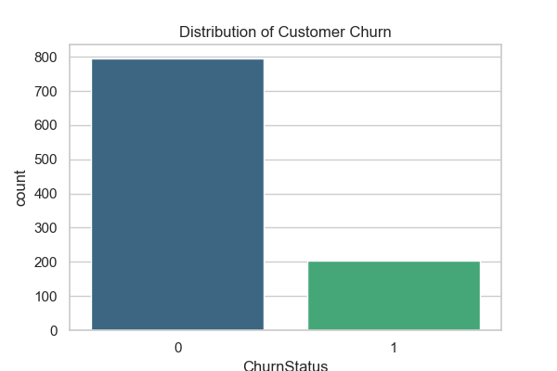

6.2 Number of Transactions vs Total Spend
This scatter plot demonstrates a strong positive relationship between transaction count and total spend. Churned customers generally cluster toward lower transaction volumes and spend levels, validating these features as strong predictors.
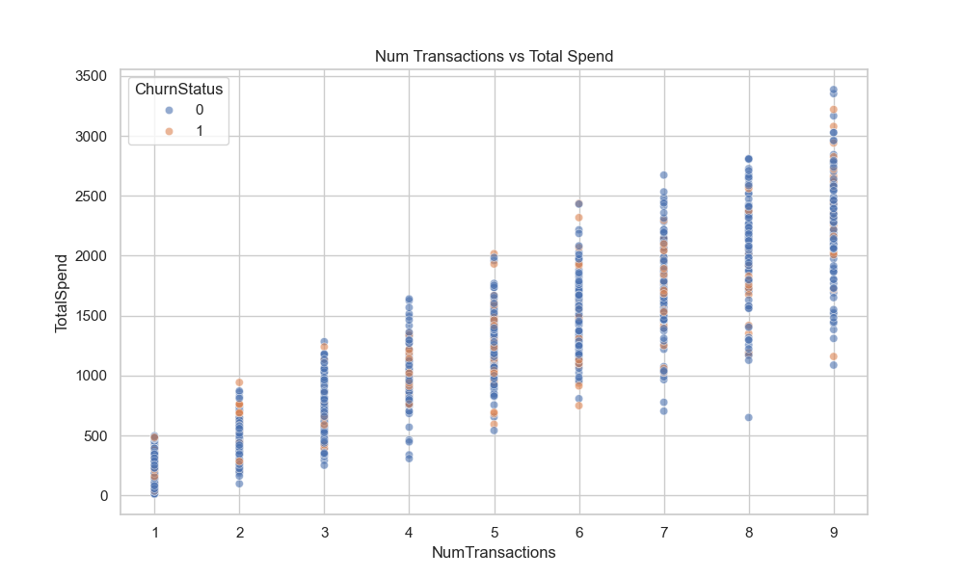

6.3 Age Distribution by Churn Status
The age distribution indicates that churn occurs across all age groups, though younger and middle-aged customers show slightly higher churn variability. Age alone is not decisive but contributes meaningfully when combined with behavioral features.
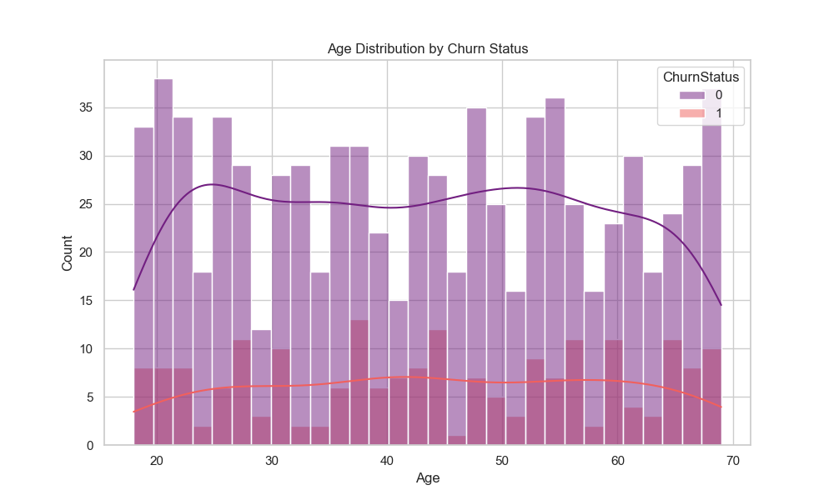

Appendix A: Feature-Level Preprocessing Summary
Feature | Issue Identified | Action Taken
Age | Minor outliers | Capped using IQR method
TotalSpend | Right-skewed distribution | Outlier capping + standardization
NumTransactions | Scale inconsistency | Standardized
SupportCalls | Extreme high values | 99th percentile capping
Gender | Categorical | One-hot encoded
IncomeLevel | Categorical | One-hot encoded
LoginFrequency | Missing values | Median imputation

Appendix B: Model Readiness Notes
• Dataset is numerically stable and free from missing values
• Suitable for tree-based and distance-based algorithms
• Class imbalance noted; SMOTE or class weights recommended
• No data leakage detected during preprocessing

