Understanding Cyber Security Basics & Attack Surface

CIA triad
Confidentiality - making sure that only the authorized users have access to the data. It can be maintained by using encryption methods such as AES, TLS, role-based access control etc
Integrity - making sure that only the authorized users can make changes to the data. It can be maintained using hashing, input validation etc.
Availability - Making sure that the data is available and accessibly when required. It can be maintained by backups, redundancy etc
Attacks
The attempts made by unauthorized people to gain access to data, resource or system for viewing, modifying or destroying it.
Types of attacks:
- Passive attacks
- Active attacks
- Insider attacks
- Automated attacks
Passive attacks – When the attacker tries to get access to the system or data and is just viewing it and not making any changes to it. Confidentiality is not maintained
Active attacks – When the attacker tries to get access to the system or data and also modifies or destroys the data. Confidentiality, integrity and availability are not maintained
Insider attacks – Attacks carried out by the employees of the organization, misusing privilege provided to them for carrying out any malicious activities.
Automated attacks – Attacks carried out by automation or with the help of bots, robots etc.

Attack surface
The point or interface which the attackers can make use of to perform the attack. The common attack surfaces include – Network ports, login forms, databases, file uploads, cloud infrastructure etc. The possible attack surfaces in the daily-use applications are:
- Email – login page
- Whatsapp – Whatsapp web
- Banking apps – Login page, database, money transfer page
In any application, the data flow can be generalised as:
User -> Application -> Server -> Database
The possible attacks surfaces in the flow of data includes – login form, user input, data transfer, database etc.
OWASP Top 10
Defined by OWASP, The OWASP Top 10 is the list of top 10 attacks which is carried out worldwide.
- Broken access control – the users have more privilege than required
- Cryptographic failures – weak or no encryption
- Injection – sql injection and lack of input validation
- Insecure design – security not planned properly in the design of the application
- Security misconfiguration – leaving admin panels open, default credentials
- Vulnerable and outdated components – using old components which can be easily breached, lack of patches
- Identification and authentication failures – usage of weak or common passwords
- Software and data integrity failures – untrusted updates and patches
- Security logging and monitoring failures – security logs and admin activity logs not maintained
- Server-side request forgery – server makes the request for the attacker, provides full access to the services.

OS Security Checklist Document

An Operating System (OS) Security Checklist is a structured list of security controls, configurations, and best practices used to secure an operating system against threats. It is required because default OS installations are not secure. The checklist helps to reduce vulnerabilities, prevent misconfigurations, ensure consistency across systems and meet compliance.
User and account management – disable or rename default accounts and passwords, enforce strong password policies, use role-based access
Authentication and Authorization – Use Multi-Factor Authentication, secure login methods
Services and process hardening – Remove unnecessary software, packages and disable unused services.
Secure configuration and hardening – Apply industry-recommended security baselines, align with NIST frameworks
OS hardening practices
Principle of least privilege – assigning role-based permissions, using sudo instead of full admin access.
Strong authentication and password policies – enforce strong passwords, Multi-Factor Authentication should be enabled
Firewall and network hardening – configure firewall rules, allow only required ports and block unused protocols
File system and permission hardening – strict file permissions should be set, sensitive files should be encrypted.
Malware and exploit protection – Install anti-virus and enable real-time scanning
Linux commands
Chmod – Used to change the mode or permissions for a particular file or directory.
Chown – Used to change the owner of a particular file.
Ls – Used to list the files and sub-directories present in a directory.
Ls -l - Used to display the permissions provided for each file and directory.
Ls -a – Used to display the hidden files and directories.
Ls -la – Used to display the permissions provided for each file and directory including the hidden ones

Wireshark Capture Analysis Report

Capture File: capture1.pcapng
Tool Used: Wireshark
1. Overview
The capture shows normal network activity generated by a client system communicating with external servers. The traffic includes DNS resolution, ARP requests, UDP-based QUIC traffic, and encrypted HTTPS communication.

2. Observed Hosts
- Client (Local Host): 192.168.70.130
- External Servers:
  - 142.251.221.110
  - 172.217.24.10
  - 142.250.77.99
- DNS Server: 192.168.70.2

3. Protocols Identified
- DNS (UDP/53):
  - DNS queries are observed for domain name resolution.
- ARP:
  - ARP requests are used to resolve the MAC address of 192.168.70.2.
  - Indicates normal local network address resolution.
- UDP / QUIC:
  - QUIC traffic is observed over UDP port 443, indicating modern encrypted web communication.
- TCP:
  - Encrypted HTTPS traffic is observed between the client and external servers.
  - Normal TCP connection termination using FIN and ACK flags is present.

4. Traffic Characteristics
- Use of ephemeral source ports (e.g., 45762, 53299).
- Encrypted payloads prevent inspection of application data.
- No packet loss, retransmissions, or malformed packets are visible.
- TCP session teardown appears normal and orderly.
5. Conclusion
The captured traffic represents legitimate and secure network communication, including DNS resolution and encrypted web traffic using TLS and QUIC protocols. No abnormal or malicious behavior is evident in the observed packets. This capture is suitable for demonstrating basic protocol analysis and encrypted traffic inspection using Wireshark.

Password Security Analysis Report
Password is a string that is used to secure our digital resources and accounts. Certain companies suggest plans for creating strong passwords.
Encryption – Converting the plaintext password into an unreadable ciphertext using an algorithm and a key. It can be decrypted by using the same or another key.
Hashing – Converting plaintext password into fixed-size string using a mathematical hash function. It cannot be decrypted using any key.
Hashing is preferred over encryption because the encryption technique is reversible, while the hashing technique is irreversible.
There are different hash types –
MD5 (Message Direct 5) – Processes a given input through a series of complex mathematical functions and gives an output of 128-bit hash. It is not secure due to the possibility of collision attacks.
SHA-1 – It is difficult to revert back to the original message. The output is 160-bit hash.
Bcrypt – It is a hashing algorithm which used salting to prevent the brute-force attacks

- “password”
MD5 - 5f4dcc3b5aa765d61d8327deb882cf99
SHA-1 - 5baa61e4c9b93f3f0682250b6cf8331b7ee68fd8
Bcrypt - $2a$10$99yxbhYotXsmvhZUINhXfuNp3468vPoQ4RTQoP1VSoUKQ2g6cSOgO
- “password123”
MD5 – 482c811da5d5b4bc6d497ffa98491e38
SHA-1 – cbfdac6008f9cab4083784cbd1874f76618d2a97
Bcrypt - $2a$10$GBla0t9qL0M4snEXmwKZyuVC9gFQuV0/TYze5UXkrvktewNG8EDRu
- “admin123”
MD5 – 0192023a7bbd73250516f069df18b500
SHA-1 – f865b53623b121fd34ee5426c792e5c33af8c227
Bcrypt - $2a$10$KtgRWxkqoxUnBtwwyaKk/OZFitPBwzcnFxJZJtD6E.81.dWYf8k8W

The passwords hashed using MD5 are found to be easy to crack, while those hashed using bcrypt are found to be difficult to crack.
Weak passwords fail due to various reasons including –
- Short length
- Absence of uppercase letters
- Lack of usage of numbers
- Absence of any symbols
Brute force attacks – The type of attack in which attackers use various combinations of characters to try and guess the passwords. Increasing the length of the password can make it more difficult for the attackers to guess it.
Dictionary attacks – The type of attack in which the attackers use a dictionary containing the hashes of the commonly used passwords. When the hash of the password is known, they compare it with the hashes in the dictionary and try to find the actual password associated with the hash. Therefore, commonly known passwords should be avoided and more tricky and personal passwords should be used.

Multi-Factor Authentication (MFA) – The technique in which two or more ways are used for the authentication of the user. It includes various techniques such as biometric, security questions, password, OTP etc., Using MFA instead of the passwords can highly reduce the possibility of the account or system being compromised.

Malware Classification report

Malware – The files, URLs or hashes which are malicious and can cause harm to the computers when downloaded or loaded.
Malware types –
- Virus - A virus is a malicious program that attaches itself to legitimate files or programs. It spreads when the infected file is opened or executed. Viruses can corrupt data, slow down systems, or cause programs to malfunction, and they usually need human action to spread.
- Worm - A worm is a self-replicating malware that spreads automatically across networks without user interaction. It exploits system or network vulnerabilities and can quickly consume bandwidth, slow down networks, and cause widespread damage.
- Trojan - A Trojan (Trojan Horse) is malware disguised as legitimate software. Once installed, it can open backdoors, steal sensitive information, or allow attackers remote access. Unlike viruses and worms, Trojans do not self-replicate.
- Ransomware - Ransomware is malware that encrypts a victim’s files or locks the system and demands a ransom to restore access. It often spreads through phishing emails or malicious downloads and can cause severe financial and data loss.
Example Malware hash
84c82835a5d21bbcf75a61706d8ab549 – WannaCry
Hash type – SHA-256
Detection reports
On analysing the given hash using VirusTotal, it is found that the hash is malicious as 64 out of 69 security vendors have flagged this hash as malicious and also it has a highly negative community score. It is classified under the threat categories ransomware and trojan. The given hash is popularly known as WannaCry.
It is found to drop a lot of different types of files in the systems in which it is being downloaded. It matches many IDS rules and also has some mitre signatures.

Malware Cycle includes various stages –
- Creation - The attacker develops malware to steal data, disrupt systems, or gain unauthorized access.
- Distribution/Infection - Malware is delivered to victims through emails, malicious websites, infected USB drives, or software downloads.
- Execution - The malware activates when the user opens a file, installs a program, or when a vulnerability is exploited.
- Propagation - Some malware spreads further by copying itself to other files, systems, or networks.
- Payload Activation - The malware performs its intended malicious action, such as data theft, file deletion, spying, or encryption.
- Persistence & Control - Malware may hide itself, maintain long-term access, and communicate with the attacker for updates or commands.
Methods to prevent malware –
- Install anti-virus and anti-malware software
- Keep systems updated
- Avoid suspicious emails and links
- Download software only form trusted sources
- Use firewalls
- Use password authentication

Summary
By using VirusTotal to analyse the sample malware hash, it is found that the hash is flagged malicious by most of the security vendors and it is classified under ransomware and trojan. These malwares work by getting access to the sensitive data and making use of it to gain money. To prevent these kinds of malware, suspicious emails and links should not be opened, firewalls should be used, giving out sensitive information should be avoided etc.

Introduction to Cryptography
Encryption
The process of converting human-readable plaintext to incomprehensible text, also known as ciphertext, preventing the possibility of unauthorized people being able to view it or know it. Encryption is done using encryption algorithms, which transform the plaintext into ciphertext by using different techniques. It requires the use of a cryptographic key - a set of mathematical values that both the sender and the recipient of an encrypted message agree on.
The two types of encryption are:
- Symmetric encryption
- Asymmetric encryption
Symmetric encryption – The process of encryption in which both the sender and the receiver use the same key for encryption and decryption. The type of key used in this scenario is the private key, which only the sender and receiver know. While encrypting the human-readable plaintext, the sender uses an encryption algorithm with the private key. After receiving it, the receiver uses the same encryption algorithm with the same private key.
Asymmetric encryption – The process of encryption in which the sender and the receiver use different keys for encryption and decryption. While encrypting the human-readable plaintext, the sender uses an encryption algorithm with a publicly known key (public key). After receiving it, the receiver uses an encryption algorithm with a different key. The key used for decryption is a private key.
The importance of encryption includes –
- Privacy
- Security
- Data integrity
Some common encryption algorithms are –
Symmetric encryption algorithms
- AES
- 3-DES
Asymmetric encryption algorithms
- RSA
Advanced Encryption Standard (AES)
AES is an symmetric encryption algorithm developed by National Institute of Standards and Technology (NIST). It replaced the older DES standard. It performs various operations to encrypt a given plaintext. It is commonly used for securing web traffic, encrypting files and databases, protecting data in Virtual Private Networks (VPNs) etc.
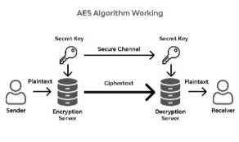
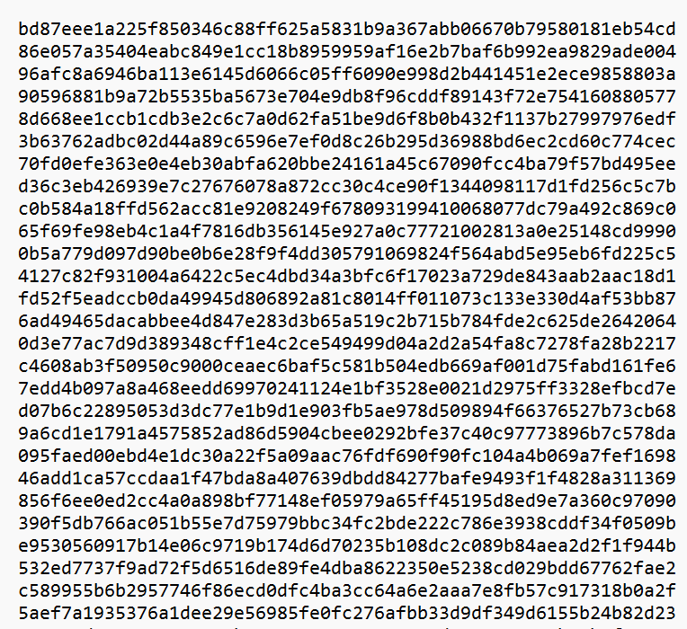

AES encryption
---------------

Original file

Encrypted file

RSA
RSA is an asymmetric cryptographic algorithm, which relies on mathematical difficulty of factoring large prime numbers.
Being an asymmetric cryptographic algorithm, it uses two keys –
Public key – Consists of n – modulus, e – public exponent.
Private key – Consists of n – same modulus, d – private exponent.

Encryption $\boxed{C=M^{ e} mod n}$
Decryption $\boxed{M=C^{ d} mod n}$
Generating RSA keys
Let p=3, q=5
N = p*q
= 3*5
= 15
ϕ(n) = (p-1)(q-1)
= 2*4
= 8
Gcd(3,8) = 1
e=3
D*3 = 1(mod 8)
d=17
Public key: (3,15)
Private key: (17,15)

Digital Signatures
A digital signature is a cryptographic technique used to verify the authenticity, integrity, and non-repudiation of a digital message or document. Instead of signing the data directly, a hash of the message is created and then encrypted using the sender’s private key. The receiver verifies it using the sender’s public key.
Encryptions algorithms
AES – Symmetric, fast data encryption, used for bulk data encryption.
DES – Symmetric, legacy encryption, outdated and used only in legacy systems.
3-DES – Symmetric, improved DES, outdates and used only in legacy systems.
RSA – Asymmetric, secure key exchange, best for digital signatures
Real-world usage
AES –
HTTPS: Encrypts actual web data after handshake
VPN: Encrypts all VPN traffic tunnels
3-DES –
VPN: Legacy VPN systems only
RSA –
HTTPS: Used in TLS handshake to exchange session keys
VPN: Used for authentication & key exchange

Web Application Vulnerability Report
OWASP Top 10
According to the 2025 version, the OWASP Top 10 Web Application Security Vulnerabilities are:
- Broken Access Control
- Security Misconfiguration
- Software Supply Chain Failures
- Cryptographic Failures
- Injection
- Insecure Design
- Authentication Failures
- Software or Data Integrity Failures
- Security Logging and Alerting Failures
- Mishandling of Exceptional Conditions
Burpsuite:
It is a powerful web application security testing tool developed by PortSwigger. It acts like a proxy between the browser and the target web application, allowing to inspect, modify and analyze every request and response.
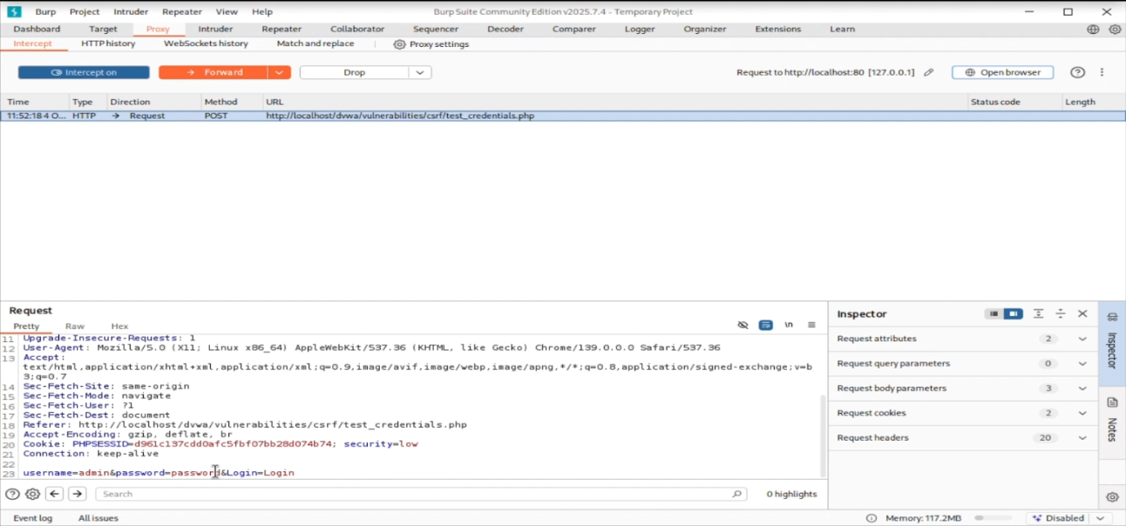
SQL Injection:
SQL Injection is a web security vulnerability that allows an attacker to interfere with the queries that an application makes to its database. It happens when user input is not properly validated or sanitized, and the attacker inserts malicious SQL commands into input fields which are then executed by the database.
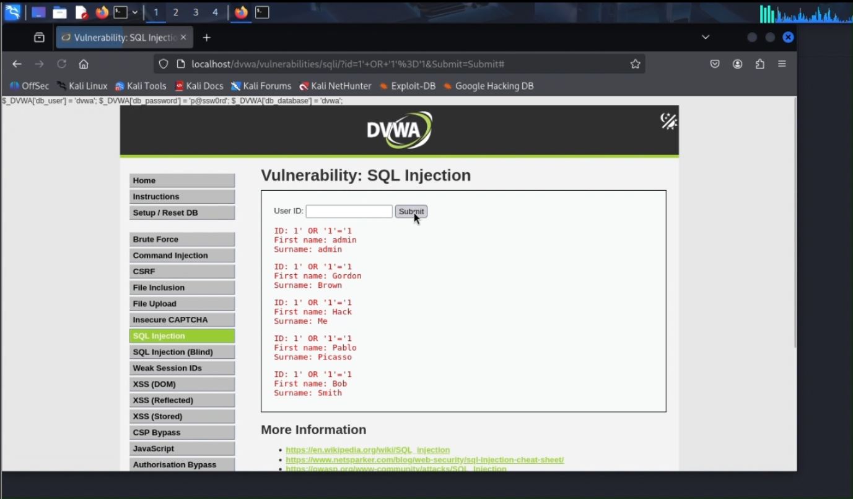

Cross-Site Scripting (XSS):
XSS (Cross Site Scripting) is a web security vulnerability that allows an attacker to inject malicious scripts (usually JavaScript) into web pages that are viewed by other users. These scripts run inside the victim’s browser, making it possible for attackers to steal information, hijack sessions, or alter the appearance or behavior of a website. There are two types of XSS
- Stored
The script is saved in the database. It executes whenever another user views the affected page. More dangerous because it affects many users over time.

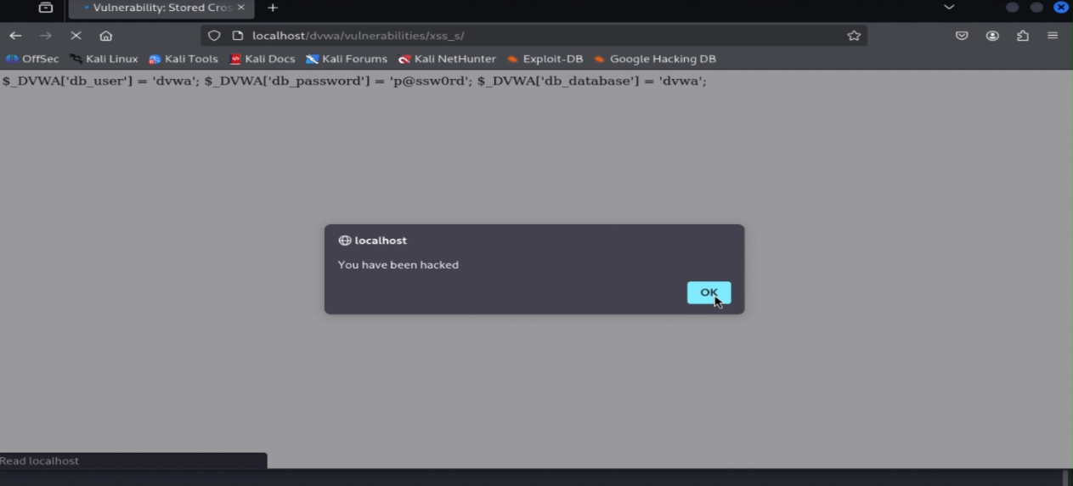

- Reflected
Malicious script comes from the current HTTP request. Triggered when the server reflects untrusted input back in the response.
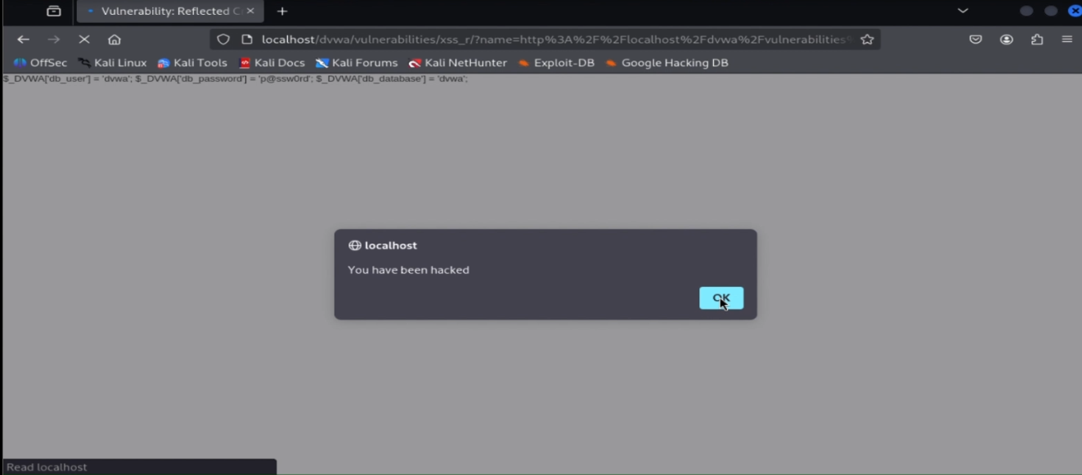
Results:
To test the security of the web application DVWA, Burpsuite was used. Burpsuite is generally used to intercept the requests and responses made by the web application. During the testing, it was found that the login requests made by the users can be intercepted by Burpsuite. In addition, the login requests can be modified and the correct password can be identified through this technique. The password is not stored securely, making the web application highly insecure as the attackers can gain access to the web application without knowing the password.
The next step was to test the web application against SQL Injection. Using the SQL Injection technique, harmful commands be executed and can be used to gather sensitive information. The SQL Injection run on the application, and it is possible to access sensitive information through it. It is possible to access the data without knowing the credentials.
In the test against the XSS (Cross-Site Scripting), it was found that the web application can be manipulated using this technique. Both the Stored and Reflected XSS are possible to be carried out on the website. This can be taken advantage by the attackers to hack the website and prevent others from accessing it. They can also use this technique to gain the credentials from the users by tricking them into entering their credentials in a malicious website.
Summary:
With the given results, it is evident that the web application is highly insecure. The DVWA is a web application designed to be highly insecure, for students to practice various techniques required for vulnerability testing.
The methodologies to be carried out to prevent such kind of attacks include:
The web application uses the input from the users directly, leading to the possibility harmful commands being executed – Input sanitation should be carried out.
The web application should ensure proper cookie security, avoid dangerous javascript functions, content security policy etc.

SQL Injection Assessment Report

1. Introduction
This report documents the process of identifying and exploiting a SQL Injection vulnerability in Damn Vulnerable Web Application (DVWA) using SQLMap. The test was conducted in a controlled lab environment for educational purposes.
2. Target Environment
Application: Damn Vulnerable Web Application (DVWA)
URL: http://127.0.0.1/DVWA/
Module Tested: SQL Injection
Security Level: Low
Testing Tool: SQLMap
3. Objective
- Identify injectable parameters
- Exploit SQL Injection using SQLMap
- Extract database information
- Analyze the security impact
- Suggest remediation measures
4. Identification of Injectable Parameter
The vulnerable page was:
http://127.0.0.1/DVWA/vulnerabilities/sqli/
The GET parameter 'id' was identified as injectable by observing SQL error messages when special characters were appended.
5. SQLMap Execution
Authenticated session cookies were captured and used with SQLMap.
Command used:
sqlmap -u "http://127.0.0.1/DVWA/vulnerabilities/sqli/?id=1" --cookie="PHPSESSID=xxxx; security=low"
SQLMap confirmed that the parameter 'id' is injectable and the backend database is MySQL.
6. Database Enumeration
Command used:
sqlmap -u "http://127.0.0.1/DVWA/vulnerabilities/sqli/?id=1" --cookie="PHPSESSID=xxxx; security=low" --dbs
Databases discovered:
- information_schema
- dvwa
7. Table Enumeration
Command used:
sqlmap -u "http://127.0.0.1/DVWA/vulnerabilities/sqli/?id=1" --cookie="PHPSESSID=xxxx; security=low" -D dvwa --tables
Tables identified:
- users
- guestbook
8. Data Extraction
Command used:
sqlmap -u "http://127.0.0.1/DVWA/vulnerabilities/sqli/?id=1" --cookie="PHPSESSID=xxxx; security=low" -D dvwa -T users -C user,password --dump
Sensitive data such as usernames and password hashes were successfully extracted.
9. Impact Analysis
- Exposure of sensitive user credentials
- Potential account takeover
- Complete database compromise
- High security risk if exploited in real-world applications
10. Mitigation and Recommendations
- Use prepared statements and parameterized queries
- Validate and sanitize user inputs
- Disable detailed database error messages
- Apply least-privilege principles to database accounts
- Deploy Web Application Firewalls (WAF)
11. Conclusion
The DVWA application is vulnerable to SQL Injection attacks when proper security measures are not implemented. This assessment demonstrates the importance of secure coding practices and regular security testing.

Cybersecurity Network Scanning and Vulnerability Assessment Title 1. Scanning the Local Network Scanning the local network is the initial step in a cybersecurity assessment. It involves identifying all active devices within a given IP range. This helps in understanding the network layout and detecting unauthorized or unknown hosts. 2. Identifying Open Ports Open port identification determines which communication ports are accessible on a target system. Open ports may expose services to external access and can become potential entry points for attackers. 3. Detecting Services Service detection identifies the applications or services running on open ports. Knowing the services helps assess whether they are necessary, properly configured, and up to date. 4. Identifying the Operating System Operating system identification determines the OS running on a target machine. This information is useful for understanding system behavior and potential OS-specific vulnerabilities. 5. Analyzing Vulnerabilities Vulnerability analysis involves checking identified services and systems for known security weaknesses. This step helps in recognizing exploitable flaws that could be targeted by attackers. 6. Saving Scan Results Saving scan results ensures that assessment data is preserved for future reference. Stored results can be used for comparison, reporting, and auditing purposes. 7. Interpreting Risks Risk interpretation evaluates the severity and impact of identified vulnerabilities. This step helps prioritize issues based on the level of threat they pose to the organization. 8. Documenting Findings Documenting findings involves creating a formal report summarizing the assessment process, results, and recommendations. Proper documentation is essential for remediation planning and academic evaluation.

Firewall Configuration and Testing

Firewall:
It is a network security system which monitors and controls the incoming and outgoing network traffic based on the predefined rules. In the network architecture, it is placed between the trusted internal network and internet or the untrusted external network. It protects the system from unauthorized access, hackers and malware, network-based attacks.
The firewall checks each packet of data and decides whether to allow it through or not based on several factors. The factors which play a major role in the decision of the firewall include:
- IP address
- Port number
- Protocol used
- Content (in some advanced firewall)
There are different types of firewalls based on type of deployment – Host-based and network-based firewall.
The firewalls can also be classified based on the OSI layers in which it works on.
Configure rule:
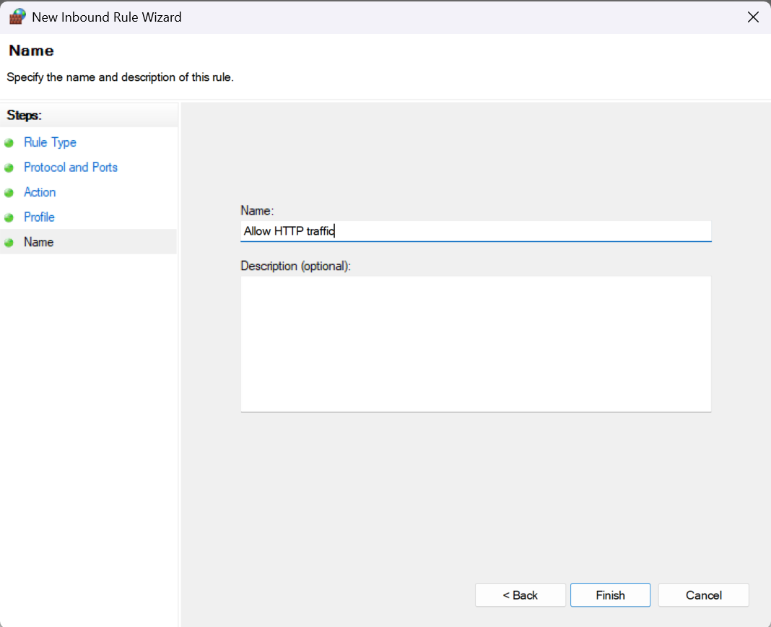

Allow/deny ports:
The firewall rules can be configured in such a way that, it can allow or deny the network traffic based on certain port numbers. The port numbers correspond to certain protocols or kinds of traffic. For example, port 80 corresponds to HTTP traffic, 22 corresponds to SSH, 21 corresponds to FTP etc.
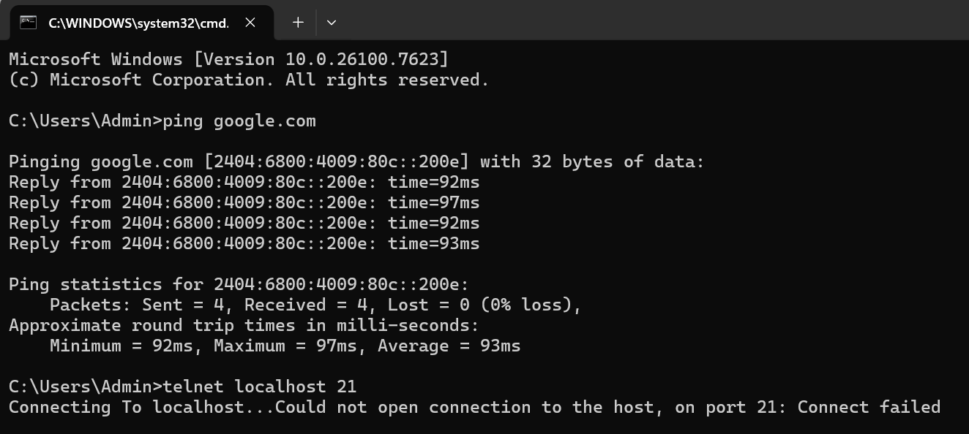
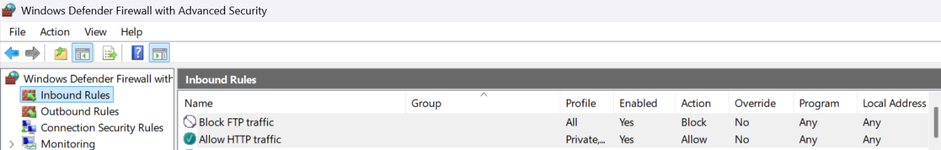
Observe logs:
The operations carried out by the firewall such as allowing or denying the traffic, will be logged and can be access through the log files. The log files will include information such as the source IP, destination IP, port number and action taken.
Block malicious IP:
The firewall rules can also be configured in such a way that, it can either allow or deny the traffic based on given specific IP address. If an IP address is found to be malicious, a new firewall rule can be created such that it denies the packets which have the exact source IP address.
Document rules:
- Name – Allow HTTP traffic
Port – 80
Action – Allow
Purpose – To allow HTTP traffic

- Name – Block FTP traffic
Port – 21
Action – Deny
Purpose – To prevent unathorized FTP traffic
By configuring the firewall rules, we can try and secure our system or network from the external insecure network. We can allow or block specific ports and IP, and by configuring this, it is easier to maintain the security of the system and can ensure smooth functioning.

