1. Terraform configuration
[ ] Project folder structure and reusable modules
[ ] Terraform variables and outputs
[ ] Networking and compute module code
[ ] S3 security configuration and IAM role
[ ] Terraform User Data and Nginx landing page
[ ] .gitignore and README.md

2. Remote state and security
[ ] S3 remote state bucket in AWS Console
[ ] State locking configuration and successful lock behavior
[ ] S3 versioning, encryption and public access protection
[ ] IAM role, instance profile and least-privilege policy
[ ] Security Group inbound and outbound rules

3. GitHub Actions CI/CD
[ ] GitHub repository and workflow YAML
[ ] Automatic workflow trigger after a Git push
[ ] Successful terraform fmt, init and validate logs
[ ] Terraform plan output and downloadable artifact
[ ] Manual approval waiting screen and approval evidence
[ ] Successful Terraform apply logs
[ ] Terraform outputs displayed in workflow logs

4. AWS deployment and validation
[ ] VPC and two public subnets
[ ] Internet Gateway, route table and subnet associations
[ ] Running EC2 instance and Elastic IP
[ ] EC2 IAM role attached successfully
[ ] Application S3 bucket security settings
[ ] Nginx landing page accessible through Elastic IP
[ ] Infrastructure validation results
- Network Module
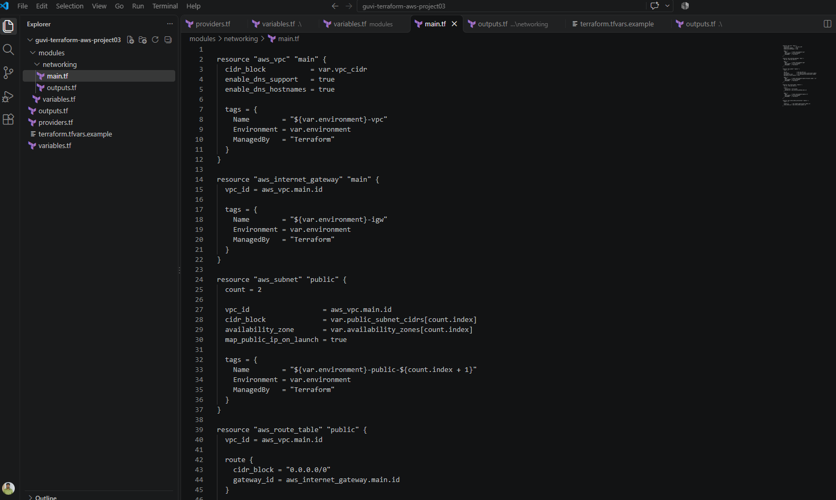

- Compute Module:
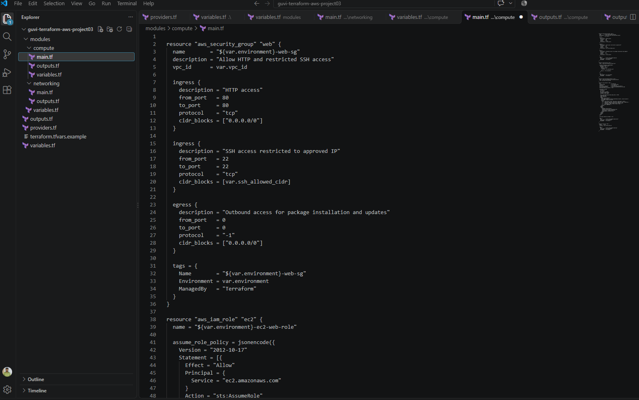

- Root Infrastructure:
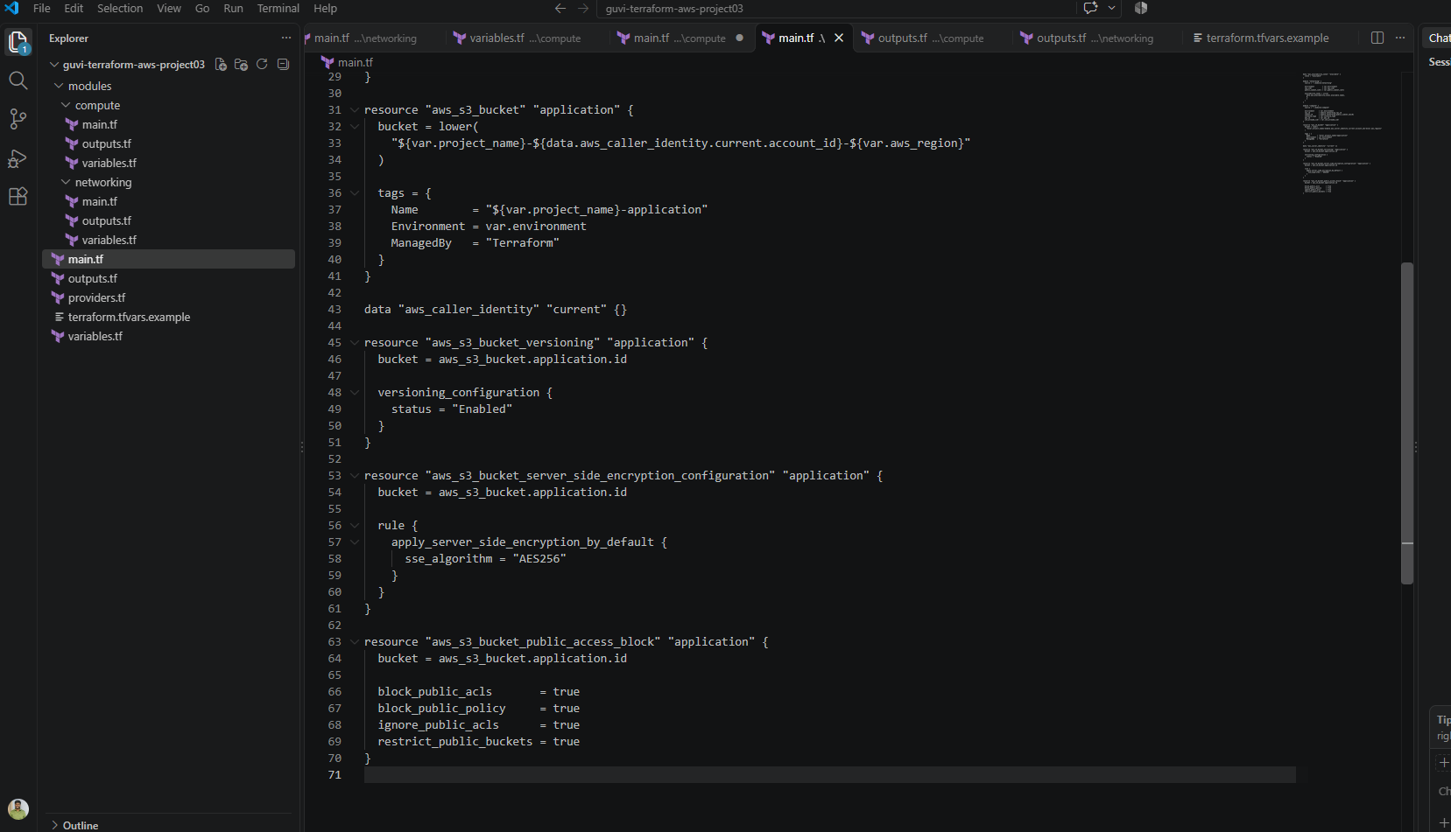

- S3 State-bucket
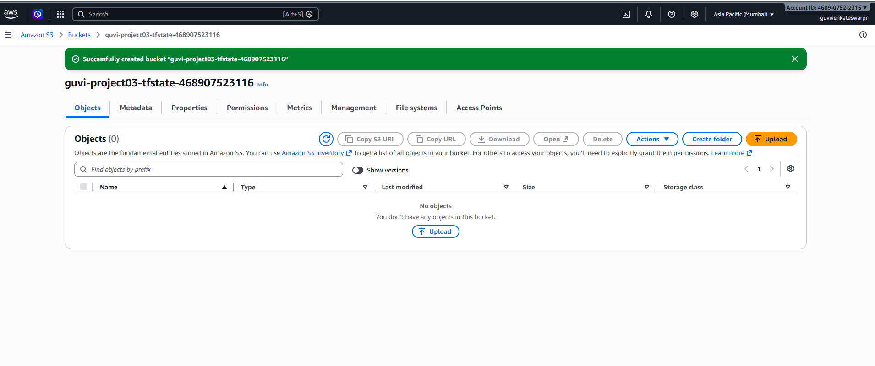

- Backend Config:
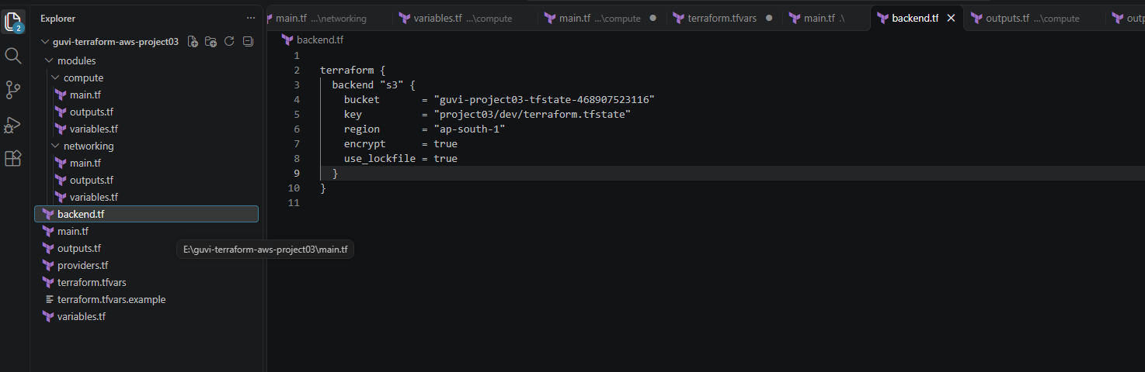
- AMI Selection:
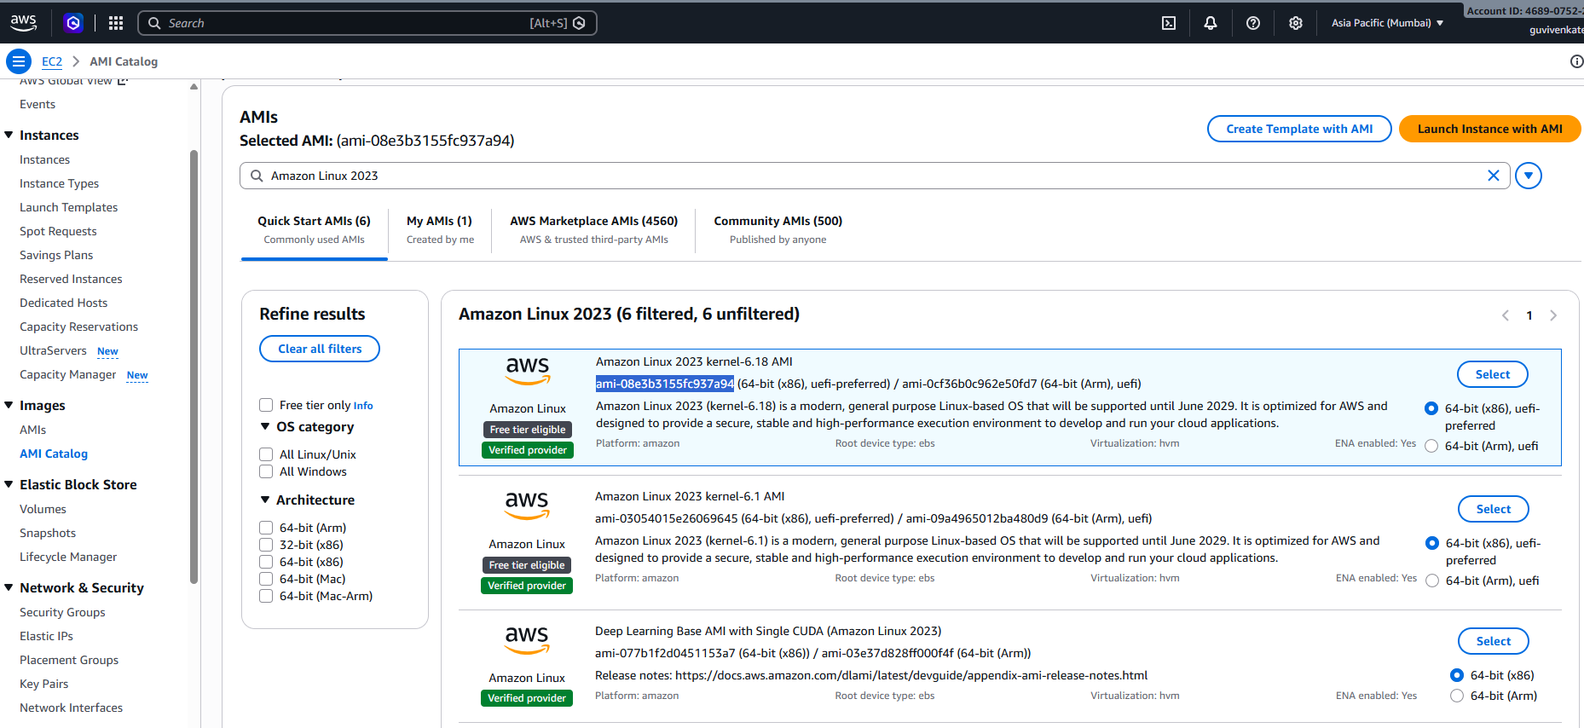

- Terraform Project Structure

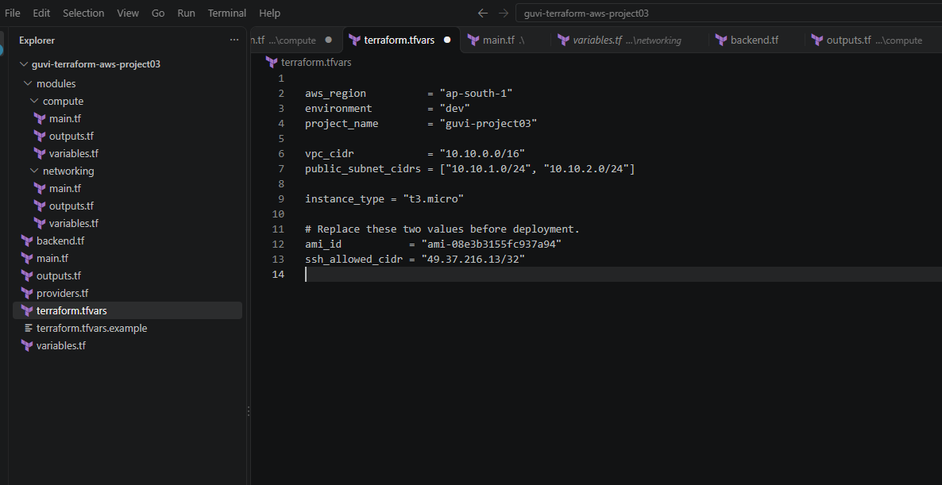

- Terroform validation is success in cloudshell
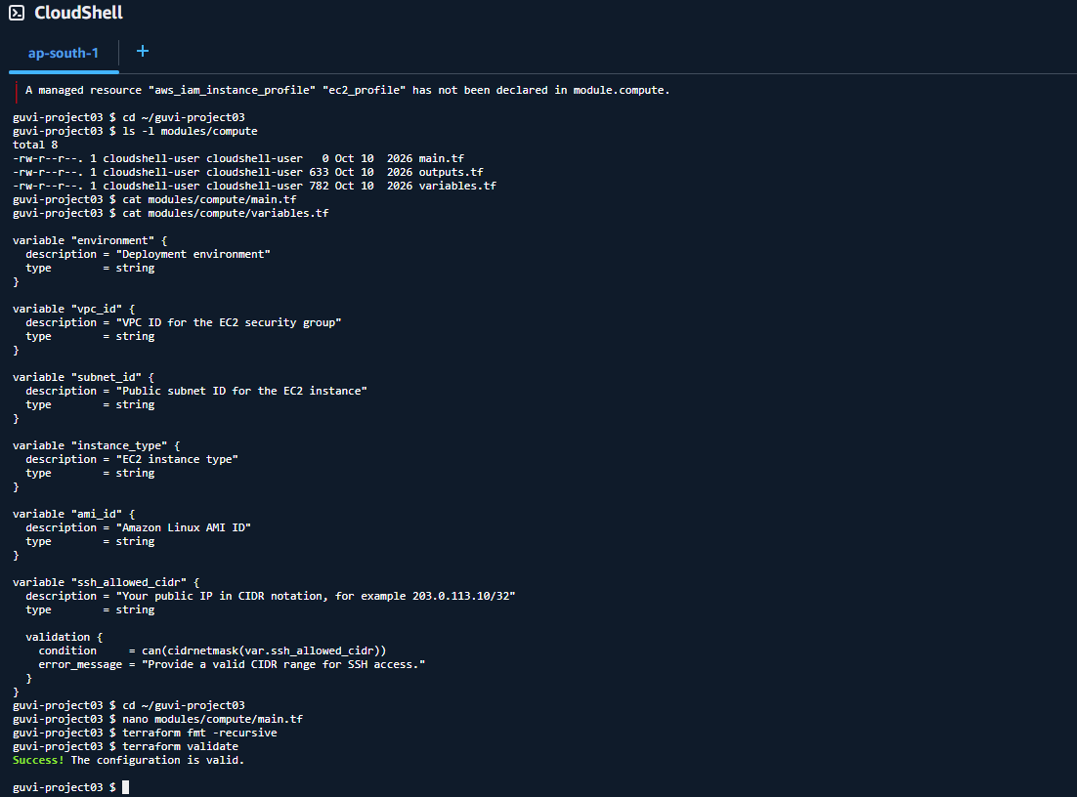

- Terraform Apply: 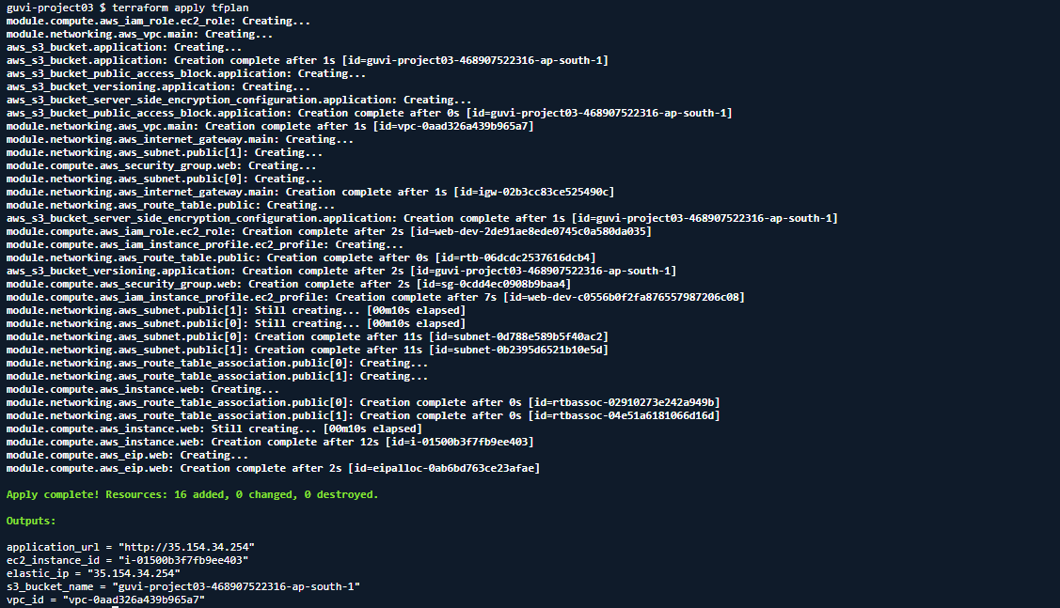

- Website is running successfully:
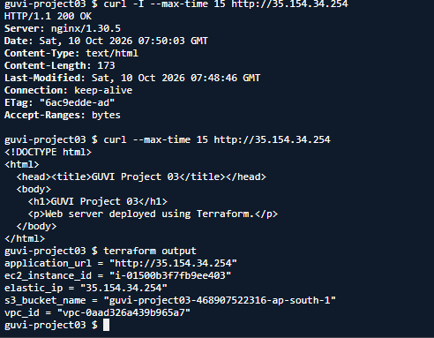

- GitHub Action Workflow:
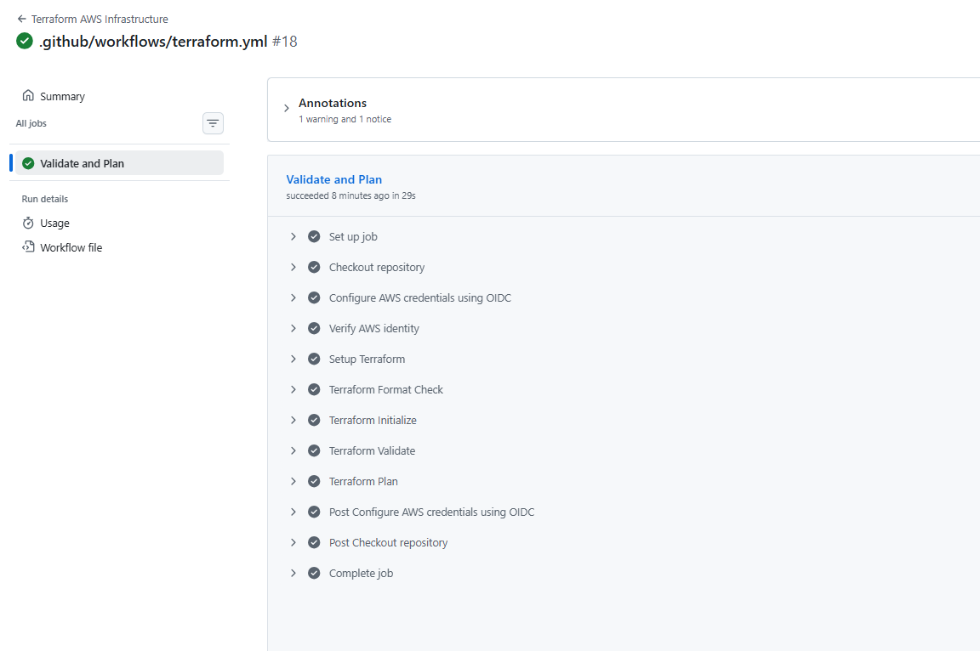
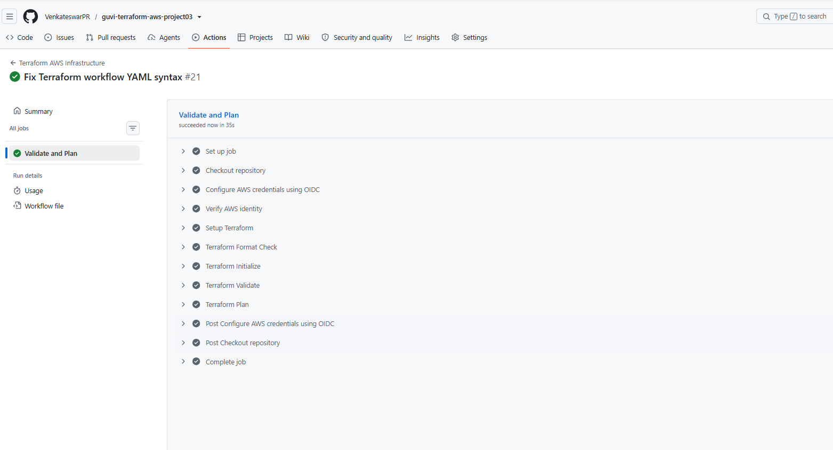

- Deployment done:
website: http://35.154.34.254

 