Project 03: AWS Infrastructure Automation Using Terraform & GitHub Actions

1. What I did
I created the AWS infrastructure for this project with Terraform and set up a GitHub Actions workflow to deploy it. Whenever I push to the main branch, the workflow checks the format, runs init and validate, makes a plan and uploads it as an artifact. After that it stops and waits for my approval. Only after I approve does it run terraform apply, show the outputs and test the website.
Flow: GitHub -> GitHub Actions -> Format -> Init -> Validate -> Plan -> Plan Artifact -> Approval -> Apply -> AWS Infrastructure -> Outputs -> Validation
The resources are a VPC, two public subnets, an internet gateway, a route table with associations, a security group, an EC2 instance with an Elastic IP, an S3 bucket, and an IAM role with an instance profile. The AWS login in GitHub Actions uses OIDC with an IAM role, so no access keys are saved anywhere.

2. Terraform project and modules
Project folder structure
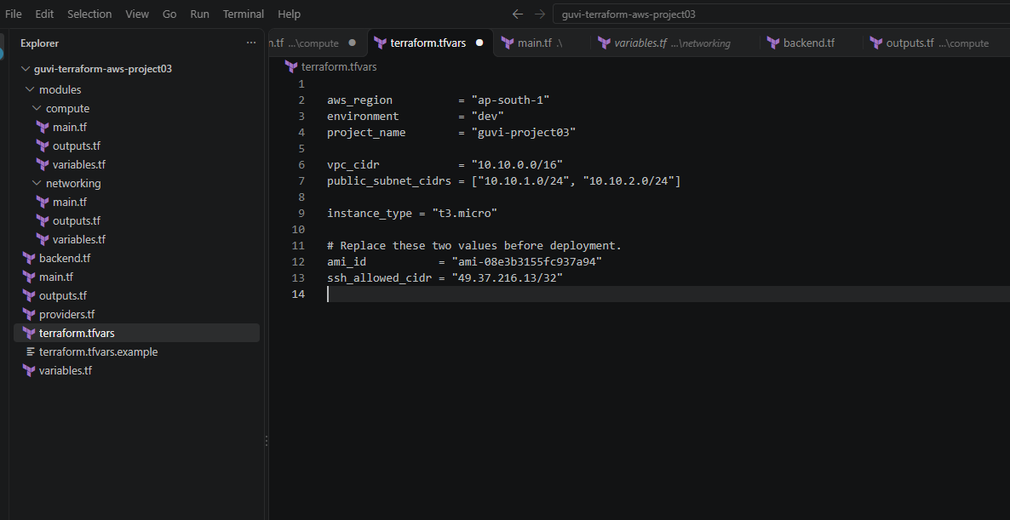
The networking and compute parts are in two modules (modules/networking and modules/compute). The root main.tf calls both of them. The full module code is in the GitHub repository.
Root main.tf
data "aws_caller_identity" "current" {}

data "aws_availability_zones" "available" {
state = "available"
}

module "networking" {
source = "./modules/networking"

environment = var.environment
vpc_cidr = var.vpc_cidr
public_subnet_cidrs = var.public_subnet_cidrs
availability_zones = data.aws_availability_zones.available.names
}

module "compute" {
source = "./modules/compute"

project_name = var.project_name
environment = var.environment
vpc_id = module.networking.vpc_id
subnet_id = module.networking.public_subnet_ids[0]
ami_id = var.ami_id
instance_type = var.instance_type
ssh_allowed_cidr = var.ssh_allowed_cidr
s3_bucket_arn = aws_s3_bucket.application.arn
}

resource "aws_s3_bucket" "application" {
bucket = "${var.project_name}-${data.aws_caller_identity.current.account_id}-${var.aws_region}"
force_destroy = true

tags = {
Name = "${var.project_name}-application"
Environment = var.environment
}
}

resource "aws_s3_bucket_versioning" "application" {
bucket = aws_s3_bucket.application.id

versioning_configuration {
status = "Enabled"
}
}

resource "aws_s3_bucket_server_side_encryption_configuration" "application" {
bucket = aws_s3_bucket.application.id

rule {
apply_server_side_encryption_by_default {
sse_algorithm = "AES256"
}
}
}

resource "aws_s3_bucket_public_access_block" "application" {
bucket = aws_s3_bucket.application.id

block_public_acls = true
block_public_policy = true
ignore_public_acls = true
restrict_public_buckets = true
}

3. Variables and outputs
The region, environment, VPC CIDR, subnet CIDRs, instance type and AMI ID are all variables. The AMI ID and my SSH IP are given to the workflow from GitHub repository variables (AMI_ID and SSH_ALLOWED_CIDR), so they are not hardcoded.
Root outputs.tf
output "vpc_id" {
description = "ID of the VPC"
value = module.networking.vpc_id
}

output "ec2_instance_id" {
description = "ID of the EC2 instance"
value = module.compute.instance_id
}

output "elastic_ip" {
description = "Public Elastic IP address"
value = module.compute.elastic_ip
}

output "application_url" {
description = "URL of the Nginx landing page"
value = "http://${module.compute.elastic_ip}"
}

output "s3_bucket_name" {
description = "Name of the application S3 bucket"
value = aws_s3_bucket.application.bucket
}

output "security_group_id" {
description = "ID of the web server security group"
value = module.compute.security_group_id
}

output "iam_role_name" {
description = "Name of the EC2 IAM role"
value = module.compute.iam_role_name
}

4. Remote state and locking
The state is stored in an S3 bucket with versioning, encryption and public access blocked. I used use_lockfile = true for state locking. State files and plan files are in .gitignore so they are never committed.
backend.tf
terraform {
backend "s3" {
bucket = "guvi-project03-tfstate-468907522316"
key = "project03/dev/terraform.tfstate"
region = "ap-south-1"
encrypt = true
use_lockfile = true
}
}

.gitignore
# Terraform working directory
.terraform/

# Terraform state files
*.tfstate
*.tfstate.*

# Saved Terraform plans (the CI plan file is named "tfplan" with no extension)
tfplan
*.tfplan
plan.txt
outputs.json

# Local variable files and secrets
terraform.tfvars
*.auto.tfvars
*.auto.tfvars.json
.env
.env.*

# Crash logs
crash.log
crash.*.log

# Private keys
*.pem
*.key

# Editor and OS files
.vscode/
.idea/
.DS_Store
Thumbs.db

# Local evidence and helper files
Terraform.docx
project03-code.txt

S3 buckets (application bucket and state bucket)
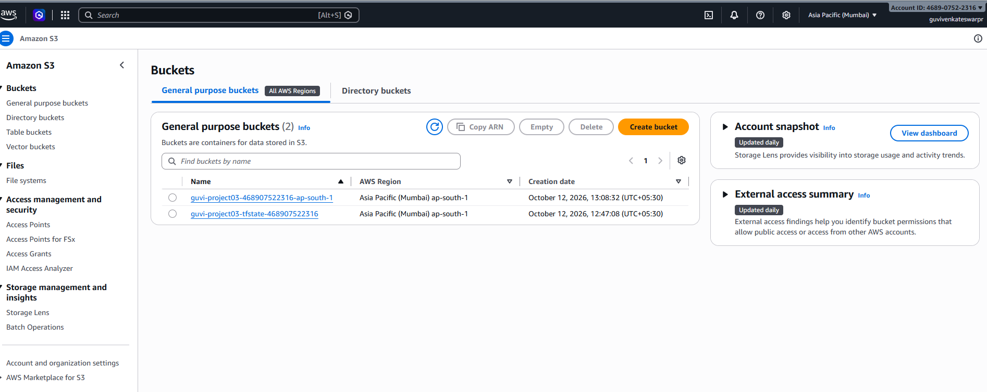

s3://guvi-project03-tfstate-468907522316/project03/dev/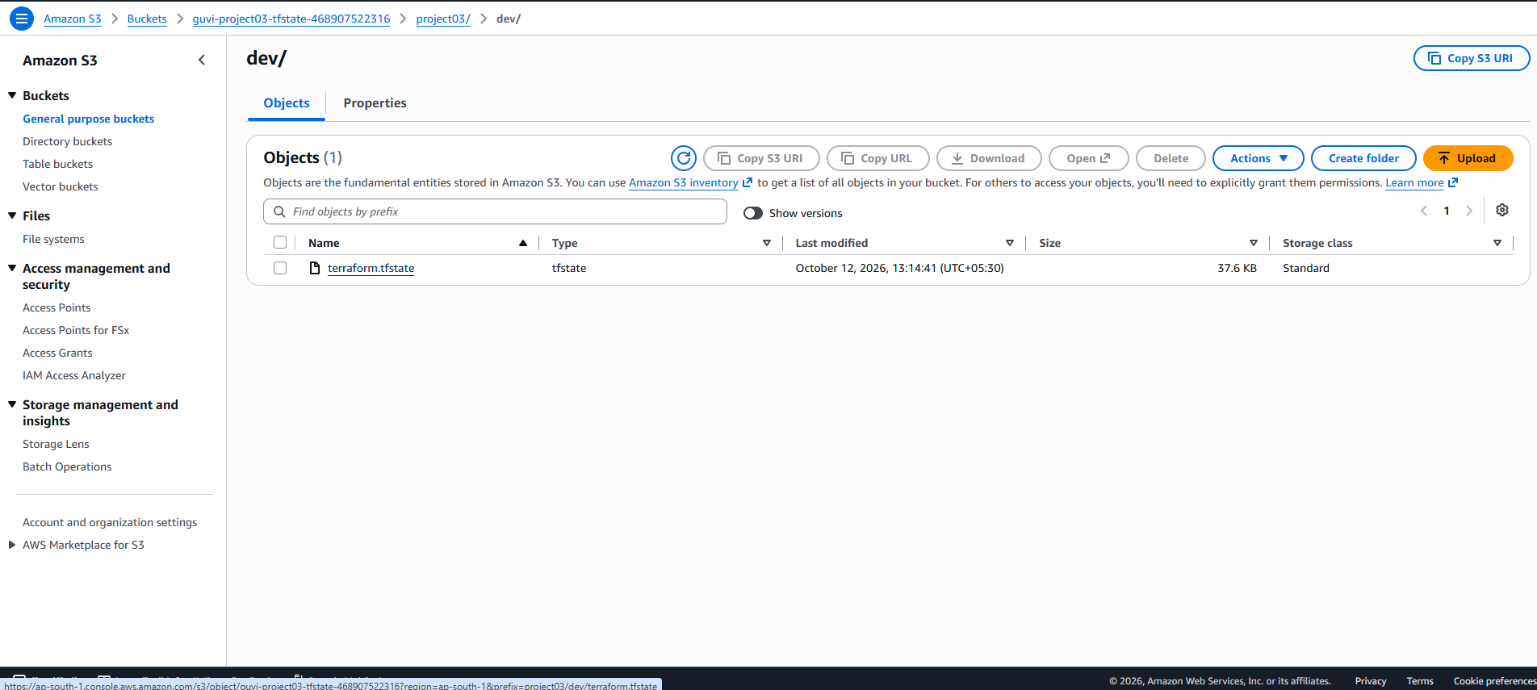5. EC2 web server
Nginx is installed and started by the User Data script, which also writes the landing page. Because of this, a new instance becomes a web server by itself.
User Data (modules/compute/main.tf)
user_data = <<-EOF
#!/bin/bash
dnf install -y nginx
systemctl enable --now nginx
cat > /usr/share/nginx/html/index.html <<'HTML'
<!DOCTYPE html>
<html>
<head><title>GUVI Project 03</title></head>
<body>
<h1>GUVI Project 03</h1>
<p>Web server deployed using Terraform and GitHub Actions.</p>
</body>
</html>
HTML
EOF

Landing page through the Elastic IP (http://43.204.222.130)
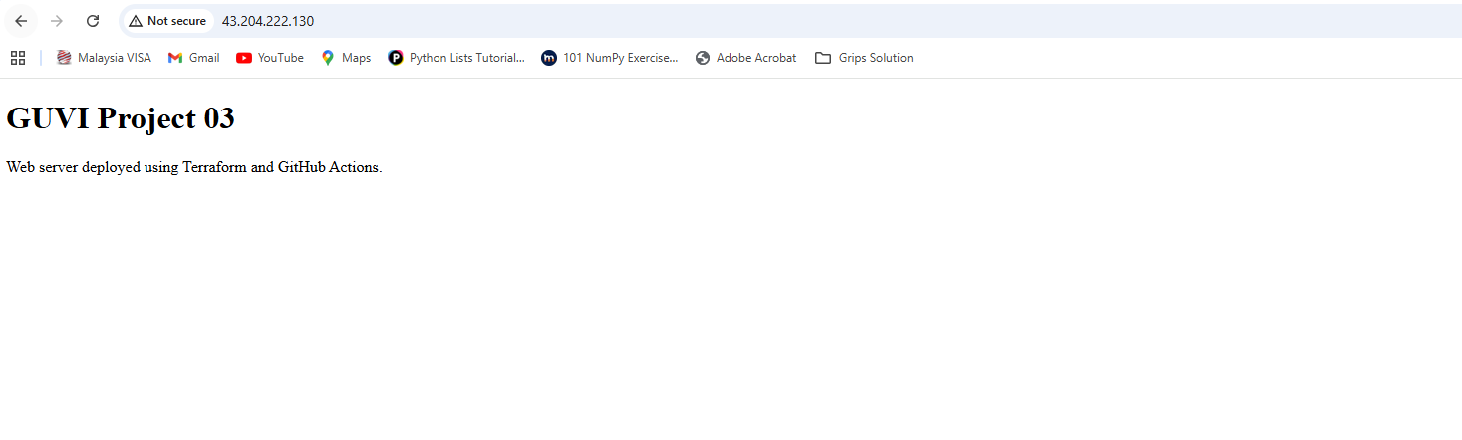

6. S3 bucket
The application bucket is guvi-project03-468907522316-ap-south-1. It has versioning enabled, AES256 encryption and all public access blocked. The Terraform code for this is in the root main.tf above.
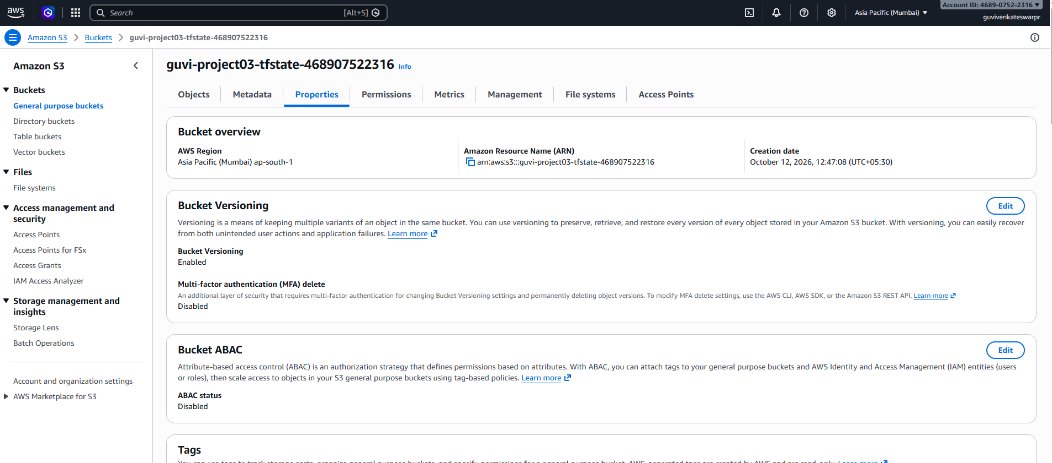
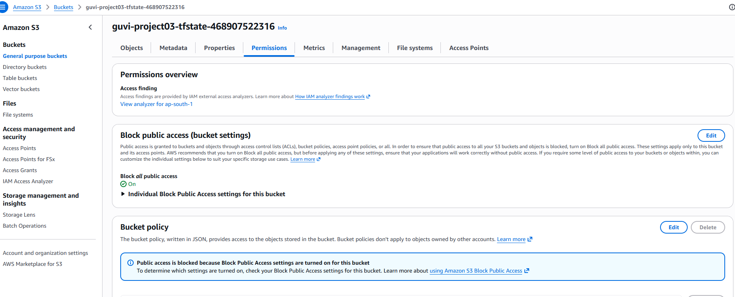

7. IAM and security group
The EC2 instance uses an IAM role and instance profile. The role has one inline policy that only allows ListBucket, GetObject and PutObject on the application bucket. The security group allows port 80 from anywhere and port 22 only from my IP. I also turned on IMDSv2 and an encrypted root volume.
Security group inbound rules
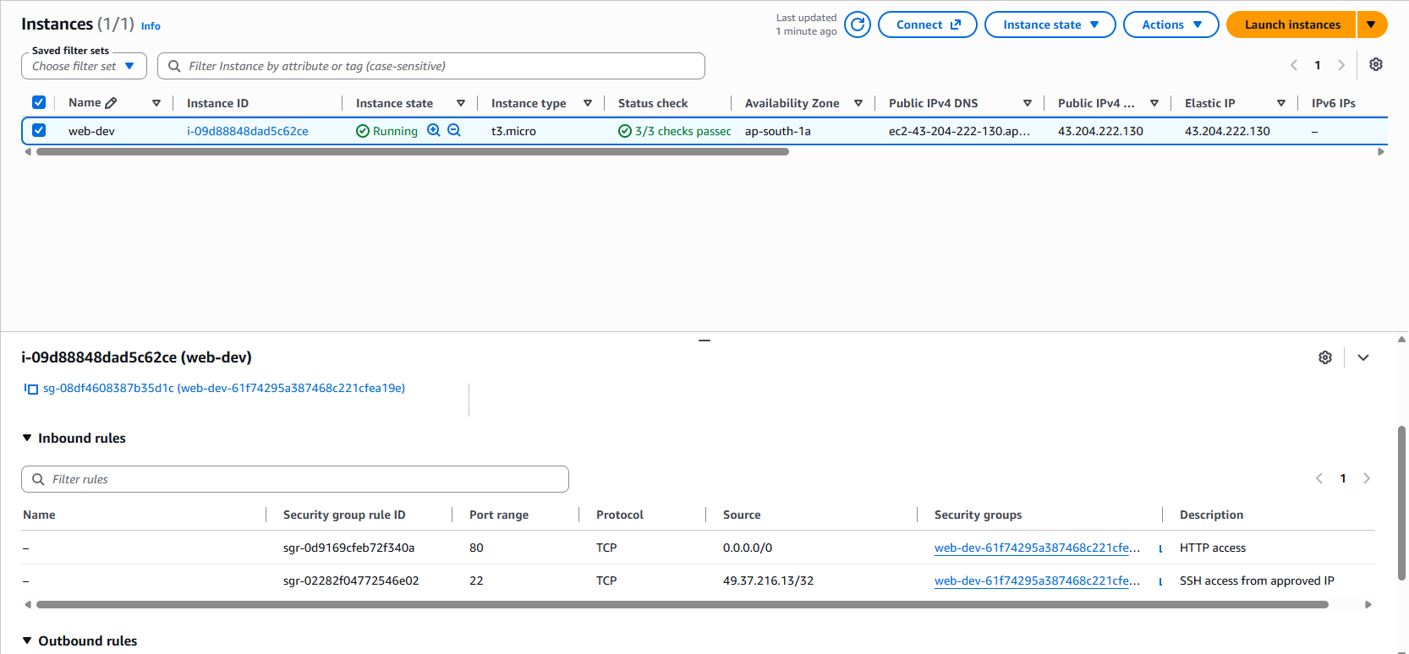
Permission Tab:
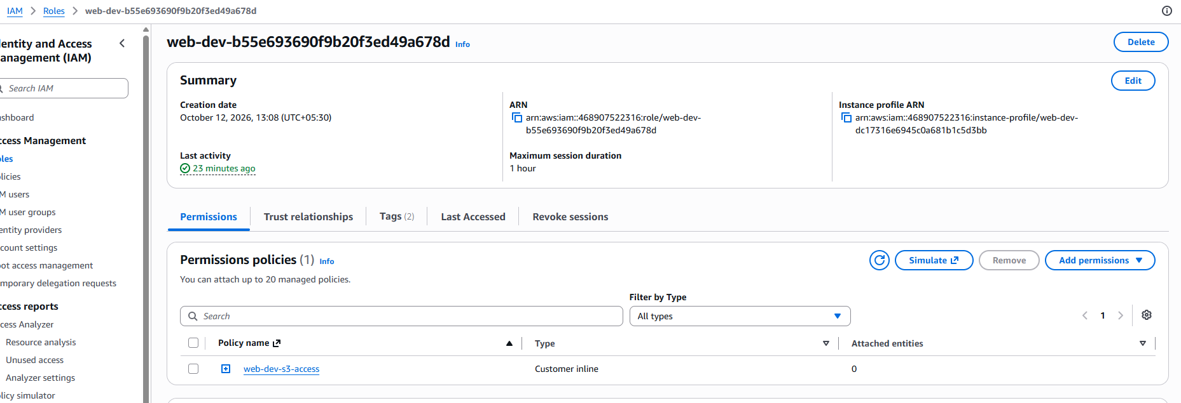

8. GitHub Actions workflow
The workflow file is .github/workflows/terraform.yml. The apply job uses the production environment, and I set myself as a required reviewer, so it cannot run without approval.
terraform.yml
name: Terraform AWS Infrastructure

on:
push:
branches:
- main
workflow_dispatch:

permissions:
contents: read
id-token: write

# Never run two Terraform jobs against the same state at once
concurrency:
group: terraform-${{ github.ref }}
cancel-in-progress: false

env:
AWS_REGION: ap-south-1
TF_IN_AUTOMATION: "true"
TF_VERSION: 1.13.5
TF_VAR_ami_id: ${{ vars.AMI_ID }}
TF_VAR_ssh_allowed_cidr: ${{ vars.SSH_ALLOWED_CIDR }}

jobs:
terraform-plan:
name: Format, Init, Validate, Plan
runs-on: ubuntu-latest
steps:
- name: Checkout repository
uses: actions/checkout@v4

- name: Configure AWS credentials using OIDC
uses: aws-actions/configure-aws-credentials@v4
with:
role-to-assume: ${{ secrets.AWS_ROLE_ARN }}
aws-region: ${{ env.AWS_REGION }}

- name: Verify AWS identity
run: aws sts get-caller-identity

- name: Setup Terraform
uses: hashicorp/setup-terraform@v3
with:
terraform_version: ${{ env.TF_VERSION }}
terraform_wrapper: false

- name: Terraform Format Check
run: terraform fmt -check -recursive

- name: Terraform Init
run: terraform init -input=false

- name: Terraform Validate
run: terraform validate

- name: Terraform Plan
run: terraform plan -input=false -no-color -lock-timeout=60s -out=tfplan

- name: Save readable plan
run: terraform show -no-color tfplan | tee plan.txt

- name: Upload Plan Artifact
uses: actions/upload-artifact@v4
with:
name: terraform-plan
path: |
tfplan
plan.txt
if-no-files-found: error
retention-days: 7

terraform-apply:
name: Apply Approved Plan
runs-on: ubuntu-latest
needs: terraform-plan
if: github.ref == 'refs/heads/main'
# Manual approval: configure Required reviewers on this environment
environment: production
steps:
- name: Checkout repository
uses: actions/checkout@v4

- name: Configure AWS credentials using OIDC
uses: aws-actions/configure-aws-credentials@v4
with:
role-to-assume: ${{ secrets.AWS_ROLE_ARN }}
aws-region: ${{ env.AWS_REGION }}

- name: Setup Terraform
uses: hashicorp/setup-terraform@v3
with:
terraform_version: ${{ env.TF_VERSION }}
terraform_wrapper: false

- name: Terraform Init
run: terraform init -input=false

- name: Download Plan Artifact
uses: actions/download-artifact@v4
with:
name: terraform-plan
path: .

- name: Terraform Apply
run: terraform apply -input=false -auto-approve -lock-timeout=60s tfplan

- name: Terraform Outputs
run: |
echo "===== TERRAFORM OUTPUTS ====="
terraform output -no-color
terraform output -json > outputs.json

- name: Infrastructure Validation
run: |
set -euo pipefail

# Required outputs must exist (names must match your root outputs.tf)
for k in vpc_id ec2_instance_id elastic_ip application_url s3_bucket_name security_group_id iam_role_name; do
jq -e --arg k "$k" 'has($k)' outputs.json > /dev/null \
|| { echo "Missing Terraform output: $k"; exit 1; }
done

IP=$(terraform output -raw elastic_ip)
URL=$(terraform output -raw application_url)
INSTANCE=$(terraform output -raw ec2_instance_id)
BUCKET=$(terraform output -raw s3_bucket_name)
SG=$(terraform output -raw security_group_id)
ROLE=$(terraform output -raw iam_role_name)

echo "--- EC2 instance ---"
STATE=$(aws ec2 describe-instances --instance-ids "$INSTANCE" \
--query 'Reservations[0].Instances[0].State.Name' --output text)
echo "State: $STATE"
[ "$STATE" = "running" ]

echo "--- Elastic IP ---"
aws ec2 describe-addresses --public-ips "$IP" \
--query 'Addresses[0].[PublicIp,InstanceId]' --output text

echo "--- S3 bucket ---"
aws s3api get-bucket-versioning --bucket "$BUCKET"
aws s3api get-bucket-encryption --bucket "$BUCKET"
aws s3api get-public-access-block --bucket "$BUCKET"

echo "--- IAM role and security group ---"
aws iam get-role --role-name "$ROLE" --query 'Role.RoleName' --output text
aws ec2 describe-security-groups --group-ids "$SG" \
--query 'SecurityGroups[0].IpPermissions[].[FromPort,ToPort]' --output text

echo "--- Web server (waiting for user data to finish) ---"
for i in $(seq 1 24); do
CODE=$(curl -s -o /dev/null -w "%{http_code}" --max-time 10 "$URL" || true)
echo "Attempt $i: HTTP $CODE"
if [ "$CODE" = "200" ]; then
echo "Web server is UP at $URL"
exit 0
fi
sleep 15
done
echo "Web server did not respond at $URL"
exit 1

- name: Upload Outputs Artifact
if: always()
uses: actions/upload-artifact@v4
with:
name: terraform-outputs
path: outputs.json
if-no-files-found: ignore

Format, init, validate and plan steps (all green)
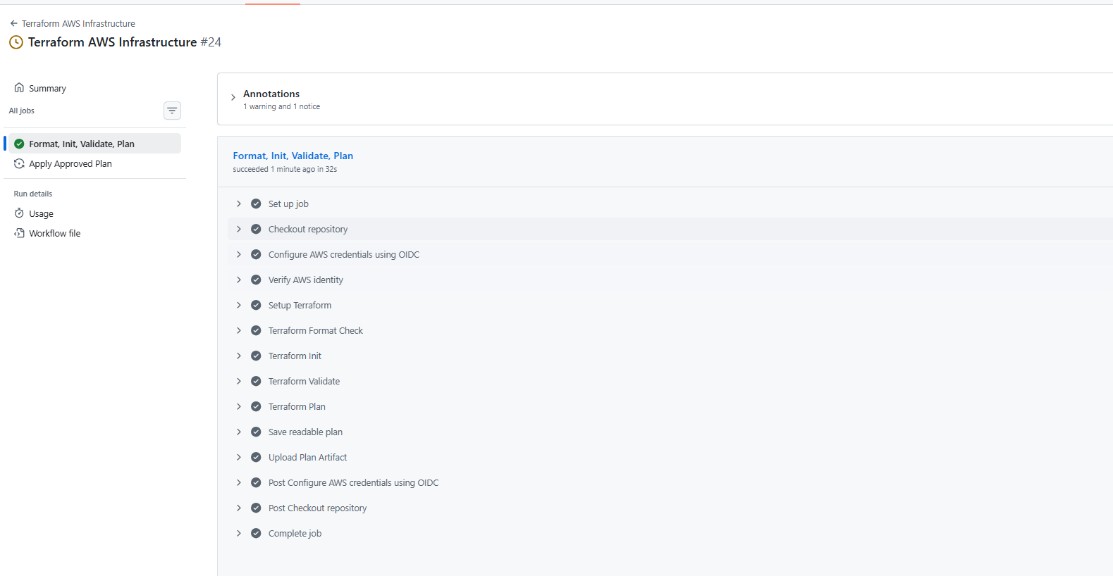
Plan artifact (terraform-plan)
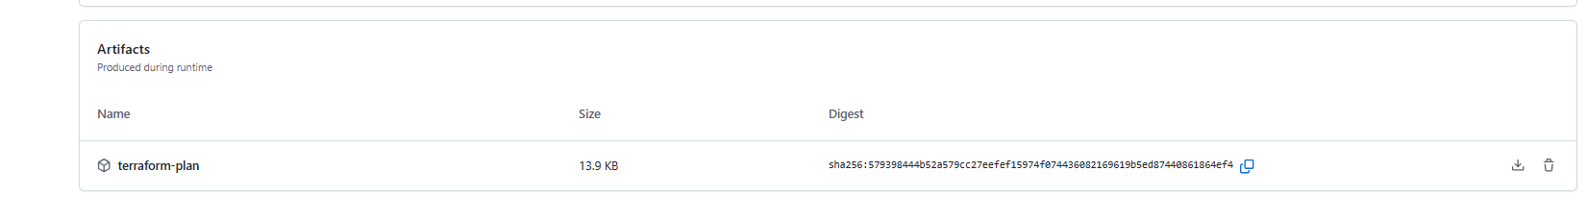
Approval for the production deployment
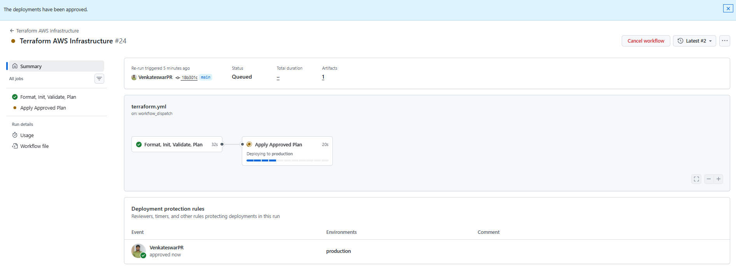
Run #25 finished successfully
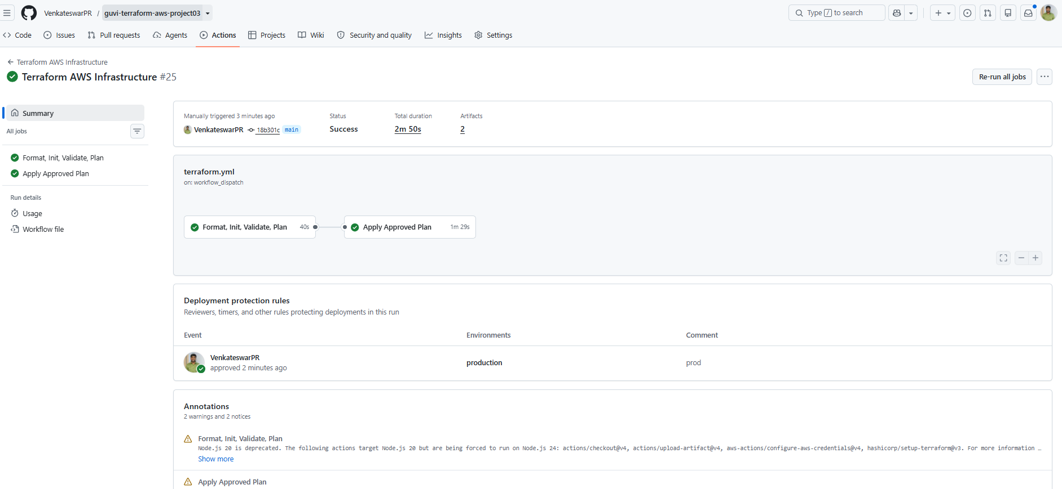
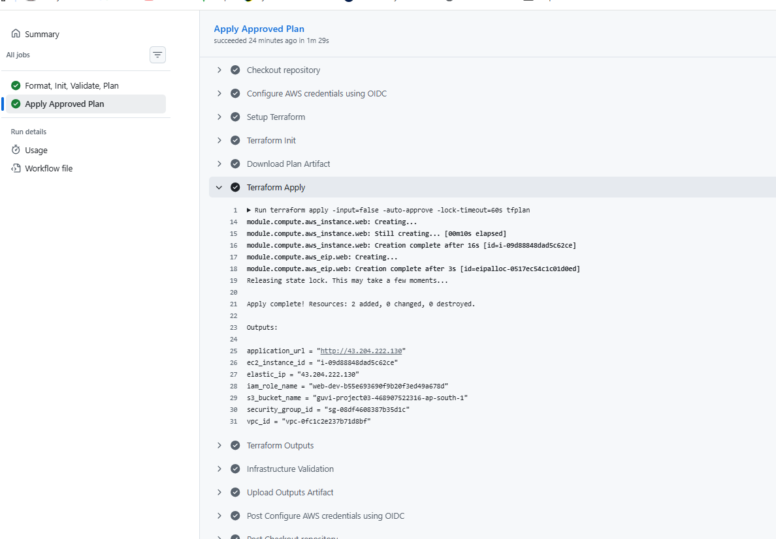
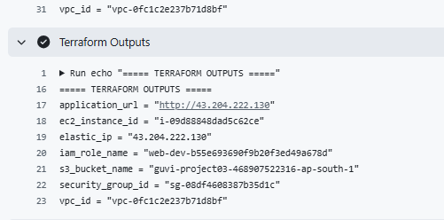
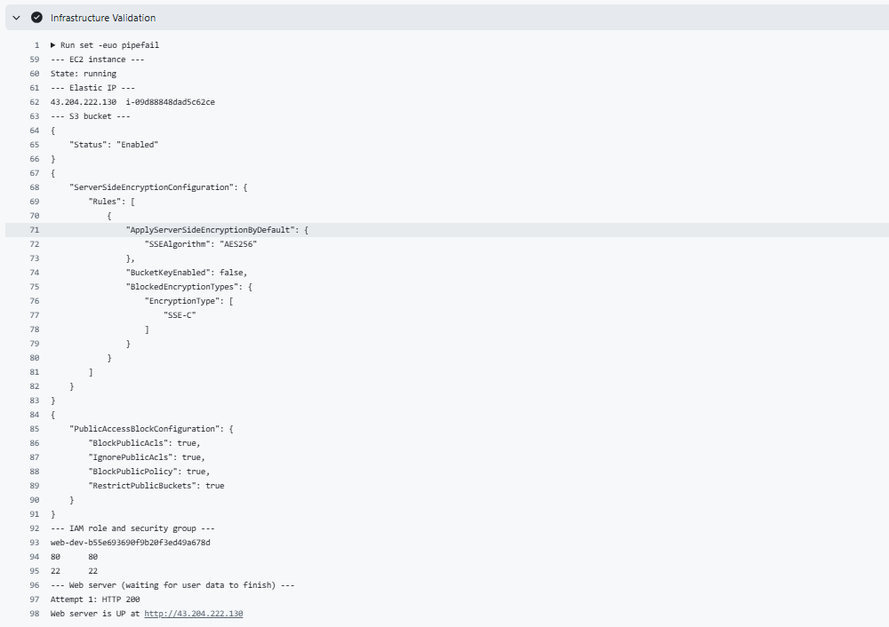Terraform outputs from the workflow log
application_url = "http://43.204.222.130"
ec2_instance_id = "i-09d88848dad5c62ce"
elastic_ip = "43.204.222.130"
iam_role_name = "web-dev-b55e693690f9b20f3ed49a678d"
s3_bucket_name = "guvi-project03-468907522316-ap-south-1"
security_group_id = "sg-08df4608387b35d1c"
vpc_id = "vpc-0fc1c2e237b71d8bf"

9. Rectification
After the review comments I reworked the workflow to add the plan artifact, manual approval, apply, outputs and validation. While running it I hit two problems:
Run #23 failed at the AWS login. The IAM role trust policy did not match the OIDC subject from GitHub, because it includes numeric IDs for the user and the repository. I updated the trust policy.
Run #24 failed at apply because the AMI_ID variable was not created in GitHub, so the instance had no AMI. I added the variable and ran the workflow again.
Run #25 passed with the approval step, apply, outputs and validation.

10. AWS Console
EC2 instance
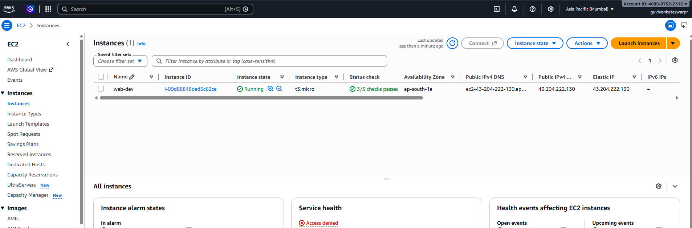
Elastic IP
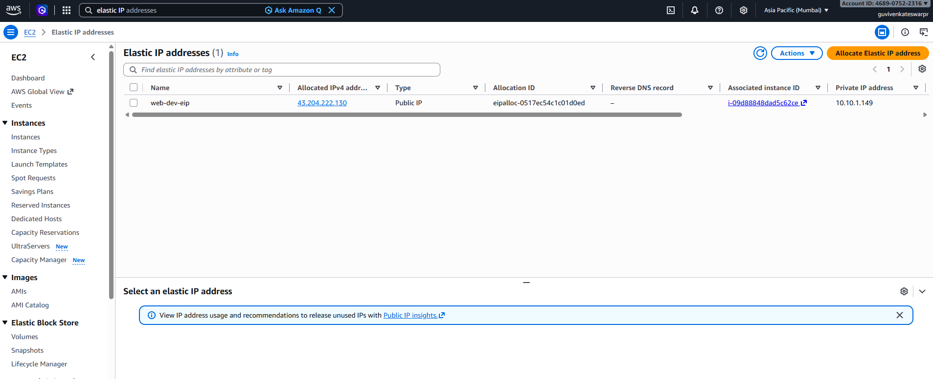
VPC (dev-vpc)
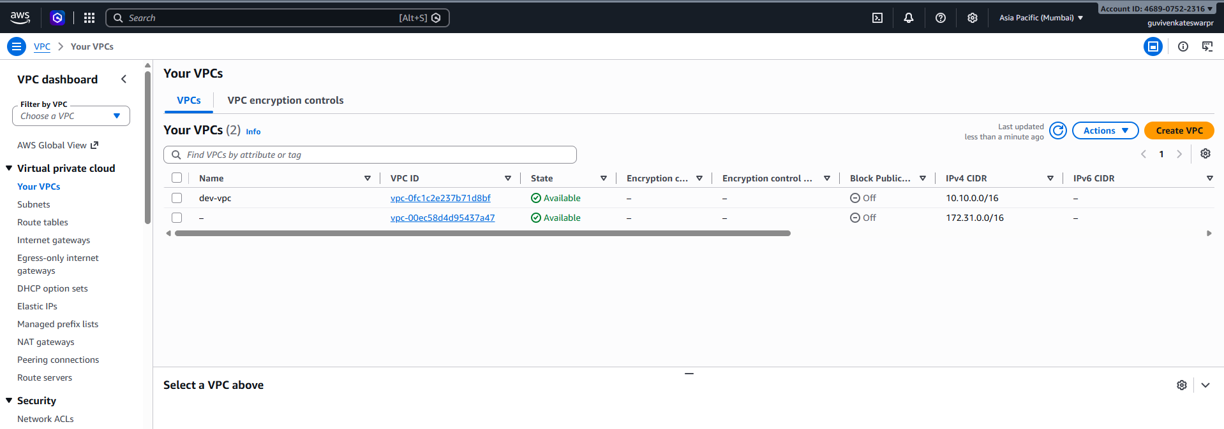
Subnets
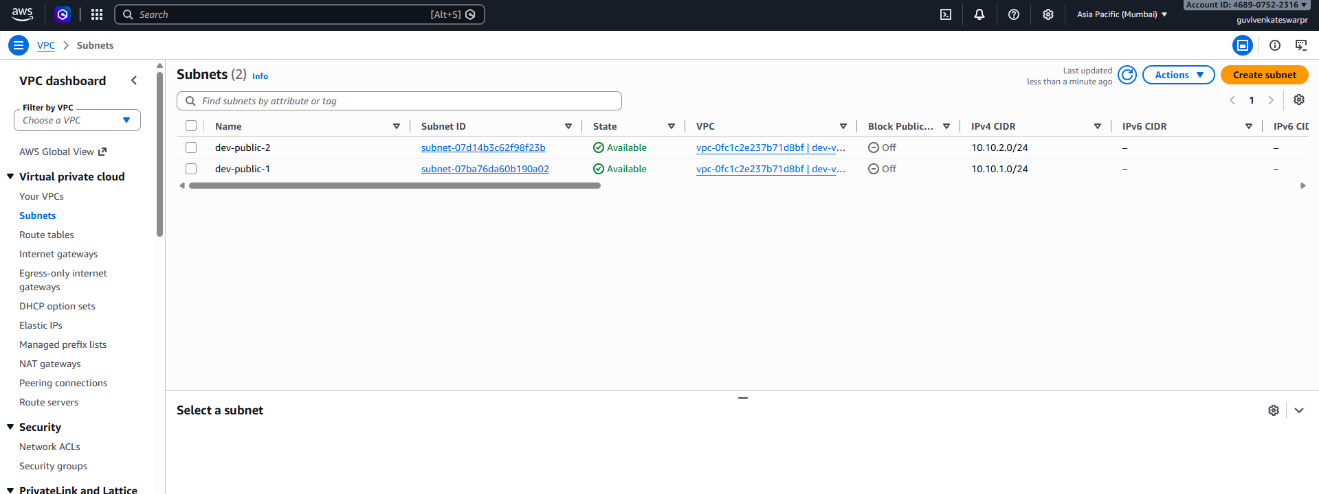
Internet gateway
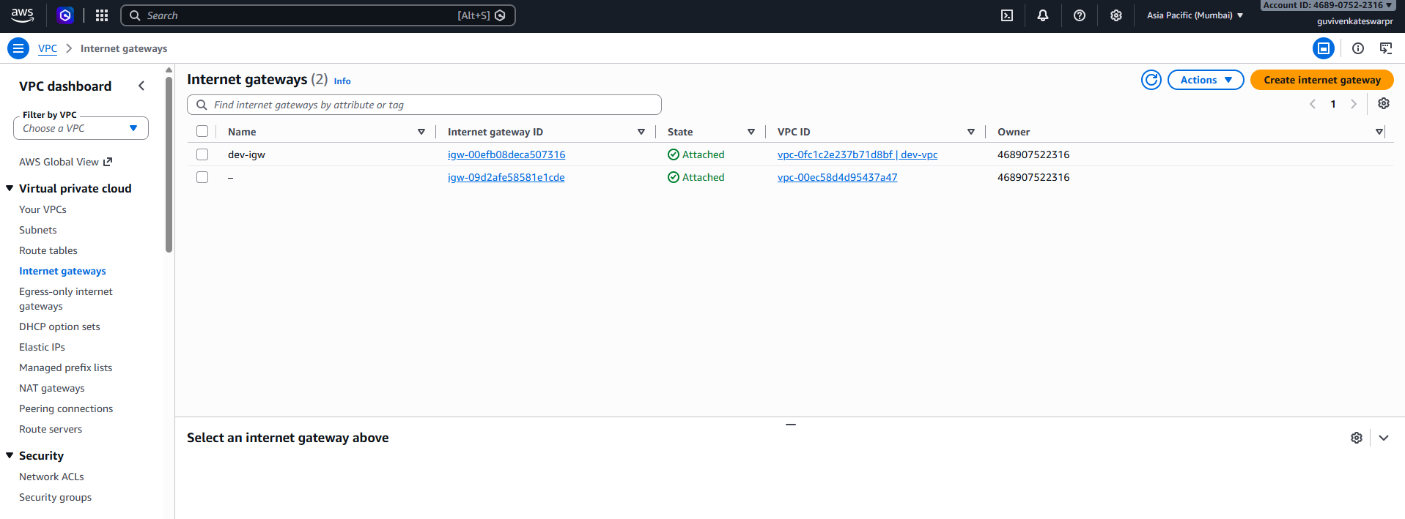
Route table
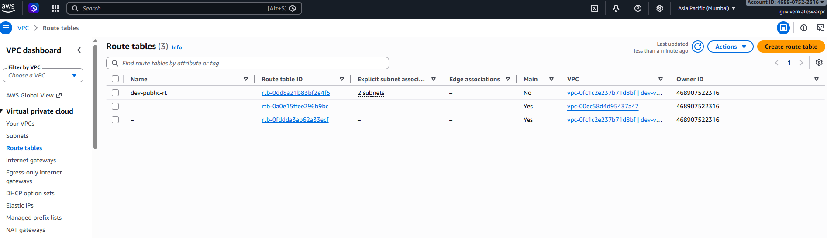

Submission details
GitHub repository: https://github.com/VenkateswarPR/guvi-terraform-aws-project03
Application URL: http://43.204.222.130
The repository has the Terraform configuration, the modules, the workflow YAML, .gitignore and README.md. The plan artifact can be downloaded from run #25.

