PAAIM
Policy-Aware Agentic Intelligence Manager

A Manufacturing Decision Intelligence System

Version: 1.0 — Phase 1 Demo
Date: June 2026
Factory: Factory 001 · Austin, TX
Stack: FastAPI · Next.js · Gemini 2.0 Flash · SQLite

1. Introduction
A typical manufacturing plant generates several hundred sensor alerts every day. Operators are expected to review each one, decide whether it is serious, and act — all while keeping the line running. In practice, alert fatigue sets in quickly. Important signals get missed, decisions are made under time pressure with incomplete information, and when something goes wrong, there is rarely a clear record of why a particular course of action was chosen.
PAAIM was built to address this directly. When a sensor signal arrives — a vibration spike, a quality defect, an energy anomaly — PAAIM passes it through a seven-layer pipeline: specialist AI agents analyse the event, a policy engine checks what actions are permitted, a simulation estimates the cost of each option, a red-team module questions the recommendation, and then the decision is routed to the right human for approval. Every step is recorded.
The result is not a system that replaces operators. It is one that gives them better information, faster, with a clear audit trail behind every decision.

1.1 The core problem
- Operators receive too many alerts to process carefully, so they prioritise by habit rather than by evidence.
- When a decision is made, the reasoning behind it often exists only in someone's head — not in a log.
- There is no consistent process for deciding which role (operator, supervisor, safety officer) should approve a given action.
- Predictive signals (bearing wear, quality drift) are available but rarely acted on before failure occurs.

1.2 What PAAIM does differently
- Runs every incoming signal through a structured seven-layer pipeline before a recommendation reaches a human.
- Enforces an 'Industrial Constitution' — a YAML policy file that defines what actions are allowed, who must approve them, and what evidence is required.
- Logs every agent analysis, policy evaluation, and approval decision to a searchable audit trail.
- Lets engineers add new monitoring agents without writing code — configure a data source, define threshold rules, and the agent is live.

2. System Architecture
PAAIM consists of three main parts: a Next.js frontend that operators use to review decisions and run scenarios, a FastAPI backend that hosts the orchestration pipeline, and a SQLite database (PostgreSQL in production) that stores events, decisions, and audit logs. The Gemini 2.0 Flash API is called by each specialist agent during the analysis layer.
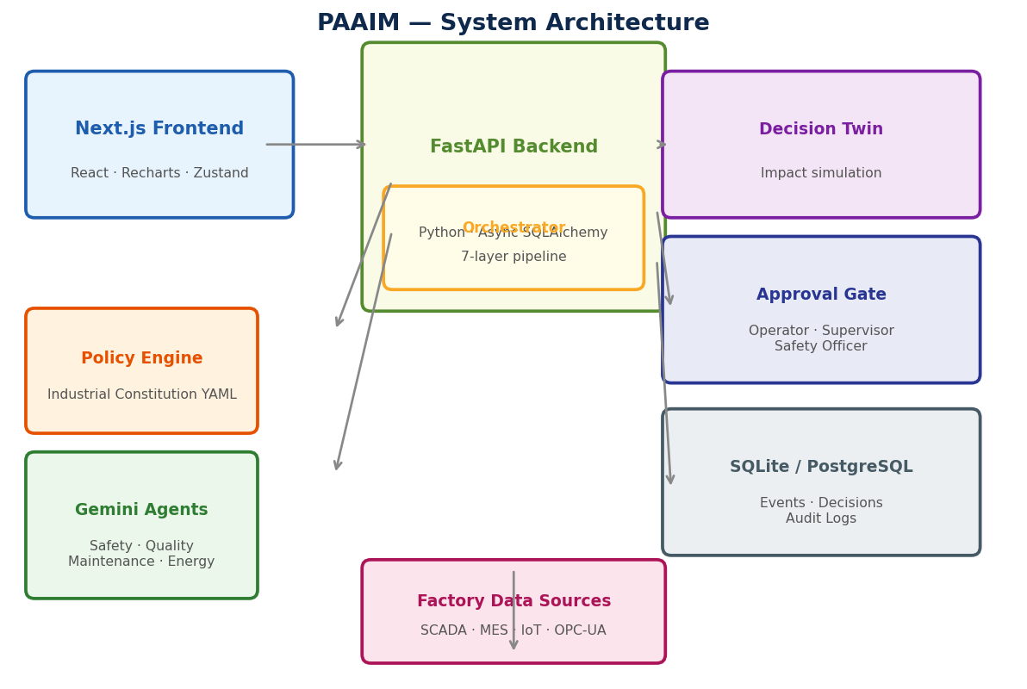
Figure 1 — High-level system architecture

2.1 Technology stack
Layer | Technology | Purpose
Frontend | Next.js 14, React, Tailwind CSS, Recharts | Operator dashboard, analytics, agent builder
State mgmt | Zustand, TanStack Query | Client state and server data caching
Backend | Python 3.11, FastAPI, Uvicorn | API server, orchestration pipeline
ORM | SQLAlchemy 2 (async), Alembic | Database models and migrations
Database (dev) | SQLite + aiosqlite | Local development and demo
Database (prod) | PostgreSQL + asyncpg | Production deployment
AI | Google Gemini 2.0 Flash | Agent reasoning and recommendation
Streaming | WebSocket (FastAPI native) | Real-time pipeline progress to UI

3. The 7-Layer Pipeline
Every manufacturing event — regardless of type — passes through the same seven layers before a decision is stored. The layers run sequentially so that each one builds on the output of the previous. Typical end-to-end latency is under 1,500 ms.
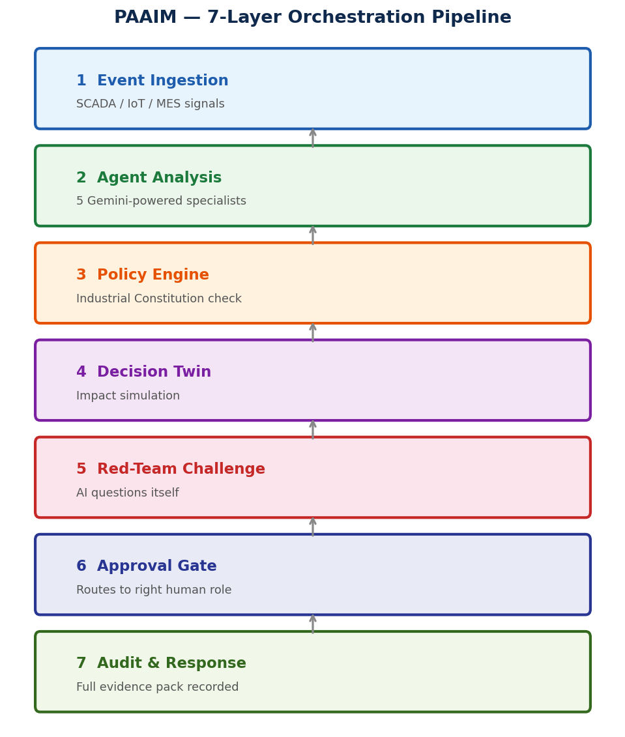
Figure 2 — The 7-layer PAAIM pipeline

Layer 1 — Event Ingestion
Raw signals arrive from SCADA systems, IoT sensors, MES platforms, or the built-in scenario simulator. Each event carries a type (safety, quality, maintenance, production, energy), a signal name, a value, a confidence score, and factory context. The event is written to the database before processing begins.

Layer 2 — Agent Analysis
Five specialist agents run in parallel against the incoming event. Each agent sends the event data to Gemini 2.0 Flash with a domain-specific context prompt and receives back a structured JSON response: a confidence score, reasoning, and a list of recommended actions with risk levels. If Gemini is unavailable, each agent falls back to a deterministic rule set. Custom agents — defined through the no-code builder — also run at this stage.

Layer 3 — Policy Evaluation
Each recommended action is checked against the Industrial Constitution, a YAML file that defines which actions are allowed, which approval level they require, what evidence signals must be present, and which actions conflict with each other. Actions not defined in the constitution are blocked. The policy engine returns an approval level (auto, operator, supervisor, manager, or safety_officer) for each action.

Layer 4 — Decision Twin
For each candidate action, the Decision Twin estimates the operational impact before anything is executed: expected downtime hours, scrap units, OEE change, and cost impact. This gives the approving human concrete numbers rather than a vague recommendation.

Layer 5 — Red-Team Challenge
A separate module reviews the top recommendation and actively tries to find problems with it. It checks whether the confidence is justified, whether the evidence could support an alternative interpretation, and whether a safer or cheaper action exists. Its output appears in the decision detail view alongside the recommendation.

Layer 6 — Approval Gate
The highest-priority permitted action is selected and routed to the appropriate approver. Actions with approval_required: auto in the constitution are approved immediately (currently only acknowledge_estop). All others generate a 'recommended' decision that waits for a human to approve or reject through the dashboard. Risk level determines escalation: critical actions go to both the safety officer and plant manager.

Layer 7 — Audit Trail
Four audit log entries are written for every decision: event detected, agent analysed, policy evaluated, and decision outcome. A fifth entry is added when a human approves or rejects. Every log entry records who acted, when, and what the data showed at that moment. This trail satisfies ISO 45001 evidence requirements.

4. Event to Decision — A Worked Example
The following trace shows a real vibration anomaly from the demo dataset passing through the full pipeline. The sensor reading is 0.87 (above the 0.80 threshold) with a confidence score of 0.91.
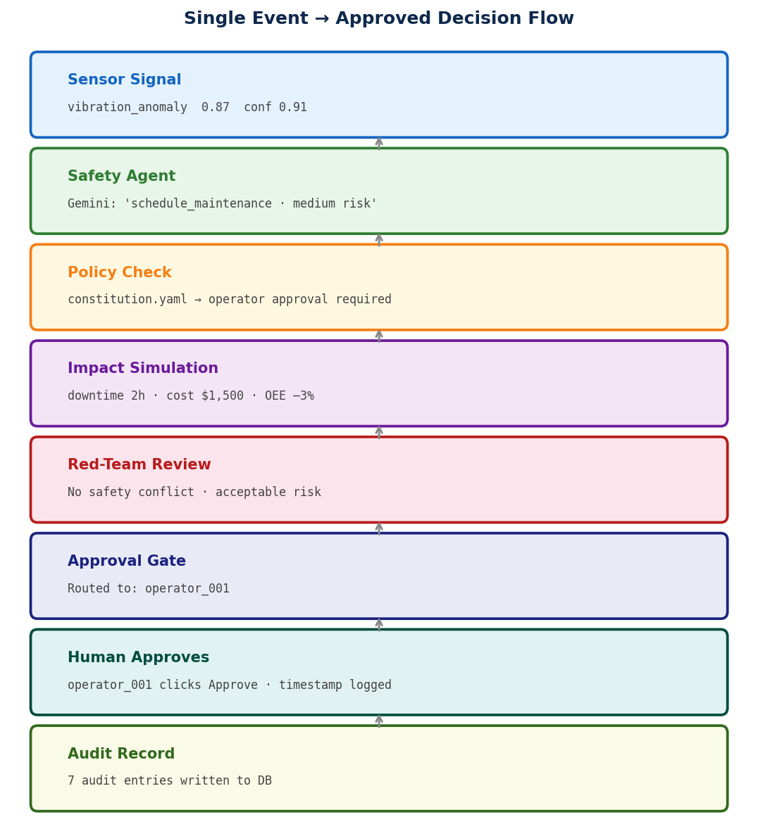
Figure 3 — Single event flowing from sensor signal to approved decision
The operator sees the recommendation in the dashboard, reads the agent reasoning, the impact estimate (2 hours downtime, $1,500 cost), and the red-team assessment. They click Approve. The decision status changes from 'recommended' to 'approved', the approval is timestamped, and two additional audit entries are written.

5. Key Components

5.1 Specialist Agents
Five agents cover the primary event domains found in discrete manufacturing. Each agent has a domain-specific system prompt that frames the Gemini analysis in the right operational context.
Agent | Domain | Key signals | Key actions
Safety Agent | Worker and equipment safety | zone_intrusion, e_stop_signal | stop_line, acknowledge_estop
Quality Agent | Defect detection and containment | defect_detection, surface_finish | contain_batch, inspect_root_cause
Maintenance Agent | Predictive maintenance | vibration_anomaly, bearing_wear | schedule_maintenance, escalate_critical
Production Agent | Order fulfilment and throughput | order_at_risk, throughput_drop | propose_recovery_plan, adjust_schedule
Energy Agent | Energy cost optimisation | peak_pricing_window, idle_load | shift_non_critical_load, reduce_consumption

5.2 The Industrial Constitution
The Industrial Constitution is a YAML file that acts as the single source of truth for what the system is allowed to do. It is not code — it is a policy document that anyone on the team can read and edit. Each action entry specifies the approval level required, the minimum confidence threshold, which actions it conflicts with, and the expected operational impact.
This design keeps policy separate from application logic. Changing who must approve a line stop does not require a code deployment — it requires editing one line in the YAML and restarting the backend. The constitution currently defines twelve actions across five categories: safety, quality, maintenance, production, and energy.

5.3 Custom Agent Framework
The no-code agent builder allows engineers to extend PAAIM without writing Python. An agent definition has four parts: a name and domain, one or more data source connections (SCADA, REST API, IoT, OPC-UA), a set of threshold rules, and a list of actions the agent can recommend.
Once created, the agent is saved to a JSON file on disk and loaded automatically on startup. It runs alongside the built-in agents during Layer 2 of every pipeline execution. The Thermal Monitor Agent in the demo was created through the UI in about 60 seconds and immediately appeared in the decision detail view of the next scenario run.

5.4 Approval Workflow
Role | Approval threshold | Deadline | Example action
Auto (system) | auto | Immediate | acknowledge_estop
Operator | LOW / MEDIUM | 60 minutes | schedule_maintenance
Supervisor | MEDIUM / HIGH | 15 minutes | contain_batch
Plant Manager | CRITICAL | 5 minutes | escalate_critical
Safety Officer | CRITICAL / IMMEDIATE | 1 minute | stop_line

6. Frontend and Operator Experience
The dashboard is built with Next.js 14 and styled with Tailwind CSS. It uses a dark sidebar navigation — a design pattern familiar from industrial monitoring tools — with a white content area for readability. All data is loaded via React Query with automatic background refresh.

6.1 Pages
Page | Path | What it shows
Login | /login | Authentication with demo credentials
Landing | / | Project overview and feature summary
Operations | /dashboard | Live incidents, test scenarios, decisions list with approve/reject
Decision Detail | /dashboard/[id] | Full pipeline trace, agent analyses, impact, red-team, approval panel
Analytics | /analytics | KPI cards, event timeline, agent performance, pipeline latency
Agents | /custom-agents | Custom agent list and no-code builder
Audit Trail | /audit | Searchable log of all pipeline events
Knowledge | /knowledge | Factory model and KPI definitions

6.2 Real-time streaming
The decision detail page connects to a WebSocket endpoint on the backend. As the pipeline processes an event, each layer emits a progress event that appears in the live pipeline view in real time — agents routing, policy checking, simulation complete. A keepalive ping runs every 20 seconds to prevent connection timeout.

7. Demo Dataset and Metrics
The demo database is pre-seeded with 30 days of realistic manufacturing activity using the seed_demo.py script. The dataset reflects a maintenance-heavy factory with the following distribution.
Metric | Value | Notes
Total events | 130 | 30-day period
Total decisions | 130 | One per event
Approved decisions | 108 | Status: approved
Pending (recommended) | 14 | Awaiting operator action
Rejected | 8 | Operator rejected recommendation
Approval rate | 83.1% | Approved ÷ total decisions
Estimated cost savings | $486,000 | Approved decisions × $4,500 avg value
Audit log entries | 520 | 4 entries per decision
Avg pipeline latency | 1,457 ms | Across all 7 layers

7.1 Event distribution
Event type | Count | Share
Maintenance | 45 | 34.6%
Quality | 35 | 26.9%
Safety | 26 | 20.0%
Production | 20 | 15.4%
Energy | 4 | 3.1%

8. API Reference (key endpoints)
Method | Endpoint | Description
POST | /api/events/orchestrate | Run one event through the full 7-layer pipeline
POST | /api/events/orchestrate/scenario/{name} | Run a named scenario (multiple events)
GET | /api/events/decisions | List all decisions for a factory
GET | /api/events/decisions/{id} | Get full detail for one decision
POST | /api/events/decisions/{id}/approve | Approve or reject a decision
GET | /api/events/audit/search | Search audit logs with filters
GET | /api/analytics/summary | KPI summary (approval rate, savings, latency)
GET | /api/analytics/timeline | Event activity over N days
GET | /api/custom-agents/list | List registered custom agents
POST | /api/custom-agents/create | Create a new custom agent
WS | /api/events/ws/orchestrate/{decision_id} | Real-time pipeline progress stream

9. Related Research
PAAIM draws on several distinct bodies of work. What is novel is the combination — no published system applies all of these ideas together in a manufacturing context.

Constitutional AI — Bai et al., Anthropic (2022)
Introduced the idea of giving an AI a written set of principles (a 'constitution') that it must follow. PAAIM applies this directly: the industrial_constitution.yaml is enforced at runtime by the policy engine rather than baked into model training. The difference is that runtime enforcement is guaranteed — a trained model can still violate its constitution under the right conditions.

ReAct — Yao et al., Princeton/Google (2022)
Demonstrated that LLMs can interleave reasoning steps with actions (tool calls). PAAIM's agents follow this pattern: Gemini reasons about the event, then outputs a structured action recommendation. The pipeline then acts on that recommendation through the downstream layers.

AutoGen — Wu et al., Microsoft (2023)
Multi-agent framework where specialist agents collaborate on a shared task. PAAIM's five parallel agents follow the same principle, with the key difference that agent routing is deterministic (event type determines which agents run) rather than LLM-driven.

Digital Twin — Grieves (2014)
Established the concept of simulating a physical system in software to evaluate decisions before execution. PAAIM's Layer 4 implements this as a decision gate: no action reaches the approval queue without an impact estimate.

Human-in-the-Loop ML — Monarch (2021)
Covers when and how to involve humans in machine learning pipelines. PAAIM's approval gate is a direct implementation of HITL principles, with the additional constraint that the required approval role scales with the risk level of the action.

10. Competitive Landscape
System | LLM agents | Policy enforcement | HITL approval | Audit trail | Open / configurable
Siemens Industrial Copilot | Partial | No | No | Partial | No
IBM Maximo AI | No | Partial | Partial | Yes | No
Rockwell FactoryTalk | No | Rules | Partial | Yes | Partial
Palantir AIP | Yes | Partial | Yes | Yes | No
PAAIM | Yes | Yes | Yes | Yes | Yes

The key differentiator is the combination of open architecture, runtime policy enforcement via a human-readable YAML file, and the no-code custom agent builder. A mid-size manufacturer can deploy and configure PAAIM without an enterprise software contract.

11. Future Work

Phase 2 — Agent Memory
Each agent call is currently stateless. Phase 2 will inject recent event history (last 5 events for the same machine) and past decision outcomes into the Gemini prompt. This allows the maintenance agent to notice that it has issued the same recommendation three times in 48 hours without it being acted on, and escalate accordingly.

Phase 2 — Task Management
When a decision is approved, a work order should be created, assigned to the right team, and tracked to completion. Closing the feedback loop — recording whether the maintenance was actually done, and whether the predicted failure was prevented — enables the agents to improve their recommendations over time.

Phase 3 — Production Deployment
Replace SQLite with PostgreSQL, add OAuth2 authentication with real user roles, complete the Docker Compose configuration, and add Kubernetes manifests for cloud deployment. The backend is already written with async SQLAlchemy so the database swap requires no application code changes.

Phase 3 — Real Connector Integration
The connector framework (SCADA, OPC-UA, REST API, message queue) is architecturally complete but connects to simulated data. Phase 3 will add tested integrations for common industrial protocols used in the target factory.

Phase 4 — Learning Loop
Use the growing database of approved and rejected decisions as a feedback signal. Track which agent recommendations have the highest long-term approval rates and adjust confidence thresholds accordingly. This moves PAAIM from a static advisory tool to one that improves with use.

12. Running the System

12.1 Prerequisites
- Python 3.11+ with pip
- Node.js 18+
- A Google Gemini API key (free tier is sufficient for demo)

12.2 Quick start
The start_demo.sh script handles everything — virtual environment, dependencies, database seeding, and both servers:
cd PAAIM
./start_demo.sh # first run
./start_demo.sh --seed # wipe and re-seed demo data

12.3 Manual start
Two terminals:
# Terminal 1 — backend
cd backend && source venv/bin/activate
uvicorn paaim.main:app --reload --port 8000
# Terminal 2 — frontend
cd frontend && npm run dev
Demo login: demo@paaim.io / demo123

13. Conclusion
PAAIM demonstrates that the combination of large language model reasoning, runtime policy enforcement, and structured human-in-the-loop approval produces a manufacturing decision tool that is both more capable and more accountable than current alternatives.
The architecture has a clear separation of concerns: the AI reasons about what to do, the policy engine decides whether it is permitted, the simulation shows what it will cost, and a human with the appropriate authority makes the final call. Nothing is executed without that approval, and nothing happens without a record.
The Phase 1 demo shows a working end-to-end system: events processed through all seven layers, decisions stored and reviewable, approvals tracked, and analytics that update in real time. The no-code agent builder lets the team extend coverage to new machines and signal types without modifying the core pipeline.
The most important next step is closing the feedback loop — tracking whether approved actions actually prevented the predicted failures, and feeding that outcome data back into the agents. That is what will turn PAAIM from a decision support tool into one that learns from its own history.

