FactoryOps Next-Version Prototype
Interactive Decision Twin, Facility Gate, and Factory Memory
Final refined version for a modern US manufacturing factory demo | July 2026
Build intent: Upgrade the current Line 3 rescue prototype from evidence-backed diagnosis into agentic manufacturing decision intelligence: interactive what-if recovery, facility-grade gates, reviewable action drafts, and recurrence prevention.

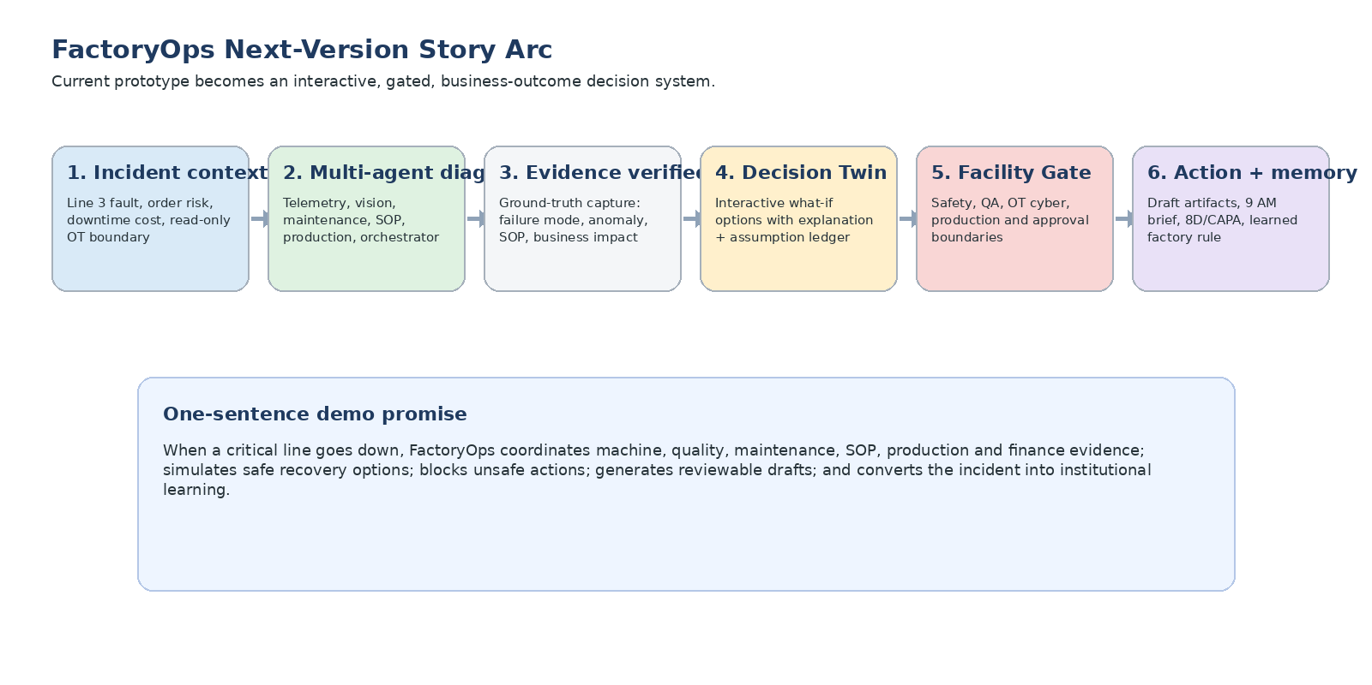
Figure 1. Next-version story arc from incident diagnosis to safe recovery decision and factory learning.

1. Executive Summary
The current prototype already tells a strong incident-response story: Line 3 stops, specialized agents coordinate telemetry, vision, maintenance history, SOPs, and business impact, and the app answers whether Line 3 can safely restart while protecting Apex Motors PO-4817.
The next version should add one decisive product layer: interactive decision intelligence. The plant manager must be able to change critical assumptions, observe how recovery outcomes change, see why the recommendation changed, and still see that safety and quality gates cannot be overridden.
The demo should feel like the best plant leadership team compressed into one agentic operating layer: reliability, maintenance, quality, production, safety, OT, and finance reasoning together with source-backed explanations.
Priority | Feature | Why it matters | Build outcome
1 | Interactive Recovery Decision Twin | Turns diagnosis into business recovery choices under changing factory constraints. | User can change 5-8 factors and see option metrics, recommendation, explanation, and next-best action update instantly.
2 | Facility Readiness and Approval Gate | Makes the app acceptable in real plants by visibly protecting safety, quality, OT cybersecurity, production approvals, and customer-impact decisions. | Safety/QA gates block restart but allow draft action preparation with audit trail.
3 | Factory Memory / 8D Recurrence Loop | Shows strategic value beyond one incident: the system learns, prevents repeat failures, and preserves tribal knowledge. | Generates 8D/CAPA draft, verification plan, and pending learned rule for human approval.

2. Final Storyline for the Next Demo
Demo question: Can we safely recover Line 3 and still protect Apex Motors PO-4817 if the underlying conditions change?

Opening scene: 8:17 AM. Line 3 / Station C3 has faulted. The existing agents already conclude: do not restart immediately; inspect Station C3, hold the last 47 units, and prepare Line 2 fallback if inspection exceeds the 25-minute threshold.
New management moment: the plant manager asks realistic what-if questions:
What if maintenance is 30 minutes away?
What if Line 2 only has 40% capacity?
What if the QA hold increases from 47 to 80 units?
What if the customer deadline buffer drops to 30 minutes?
What if the spare actuator is unavailable?
The app updates the recovery option, explains why the recommendation changed, shows assumptions and sources, preserves non-bypassable gates, and generates a management-ready action plan.

3. Feature A - Interactive Recovery Decision Twin
Purpose: Let users run operational what-if scenarios in a controlled, safe, explainable way. This is not a full physics simulator; it is a deterministic decision-support engine for the demo.

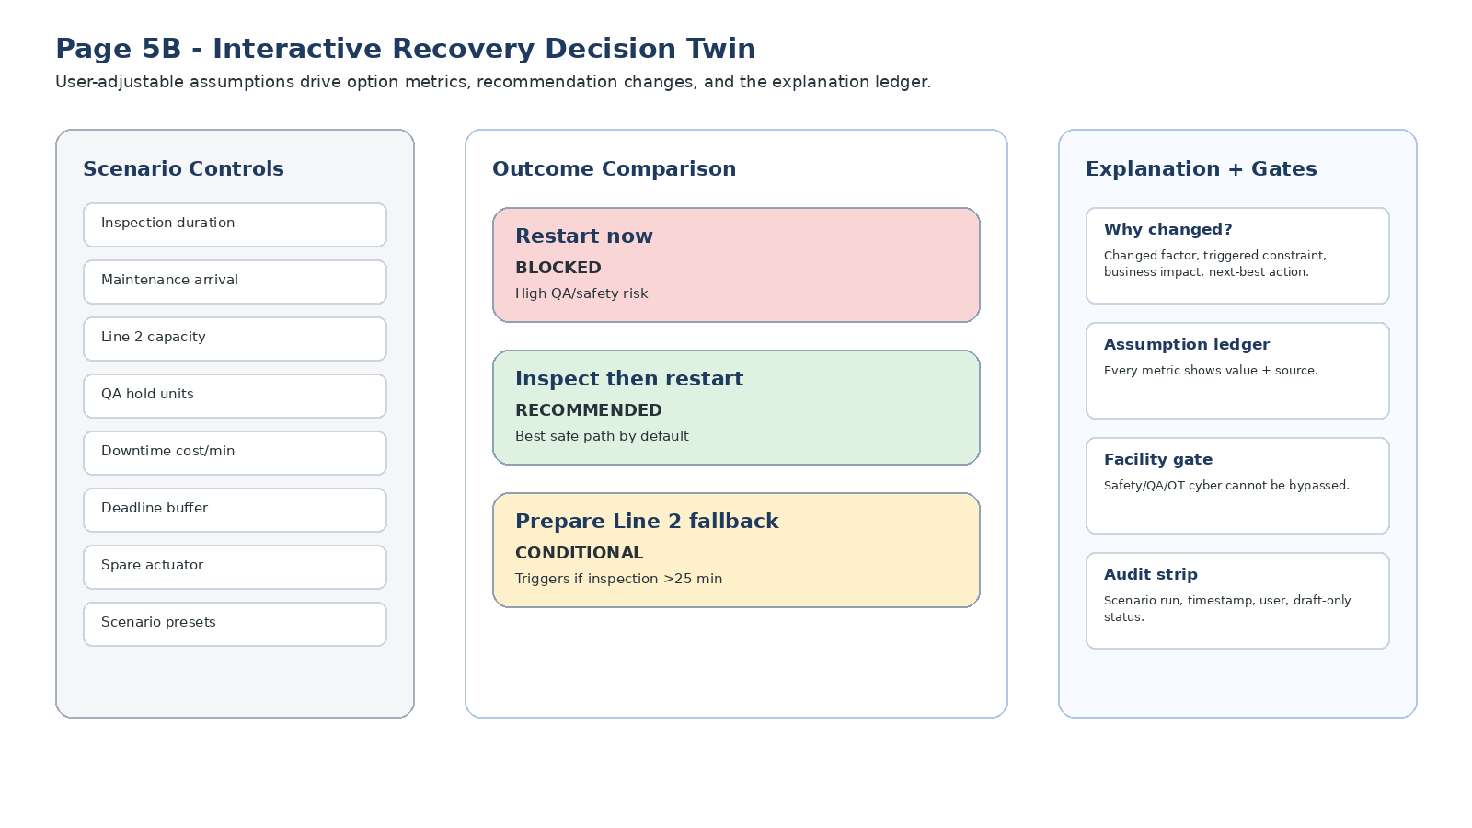
Figure 2. Target layout for Page 5B: controls, option comparison, and explanation/gate panel.

3.1 Page 5B: Required UI
Area | What to show | Exact behavior
Top banner | Decision required before 8:45 AM. Apex Motors PO-4817 is at risk. Adjust assumptions to compare safe recovery paths. | Always visible. Show read-only OT tag in the banner.
Left: Scenario controls | Inspection duration, maintenance arrival, Line 2 capacity, QA hold units, downtime cost/min, deadline buffer, spare actuator availability, QA risk tolerance. | Use sliders/selectors/toggles. Avoid free-form text for factors in the demo.
Preset buttons | Protect shipment, Protect quality, Maintenance delayed, Line 2 unavailable, Customer deadline compressed, Spare unavailable. | Each preset changes multiple factors at once and triggers explanation.
Center: Option cards | Restart now, Inspect then restart, Prepare/reroute Line 2. | Cards update ship probability, loss, QA escape risk, safety/SOP status, owner, and recommendation badge.
Right: Explanation panel | Why the recommendation changed, assumption ledger, facility gate status, audit strip. | The explanation must cite changed factor, triggered constraint, business effect, and next-best action.
Bottom CTA | Prepare recommended path, Prepare fallback, Generate management explanation, Continue to drafts. | All CTAs remain draft-only; no real system write-back.

3.2 User-adjustable factors
Factor | Default | Range / options | Business reason
Inspection duration | 20 min | 10-45 min | Determines whether Line 2 fallback should be prepared now.
Maintenance tech arrival | Now | Now / 15 / 30 / 45 min | Shows workforce availability constraint.
Line 2 capacity | 70% | 0-100% | Determines whether reroute is feasible.
QA hold quantity | 47 units | 20-100 units | Changes inspection burden and release timing.
Downtime cost/min | $1,300 | 500-2,500 | Lets a plant map ROI to its own economics.
Customer deadline buffer | 90 min | 0-120 min | Controls shipment risk urgency.
Spare actuator available | Yes | Yes / No | Changes expected repair and fallback path.
QA escape risk tolerance | Low | Low / Medium / High | Shows that quality-first plants may reject fast restart.

3.3 Option metrics and deterministic rules
Use a deterministic scenario engine so the demo is repeatable. The LLM may summarize the computed results, but it should not invent metrics. Use simple transparent rules that are easy to explain.
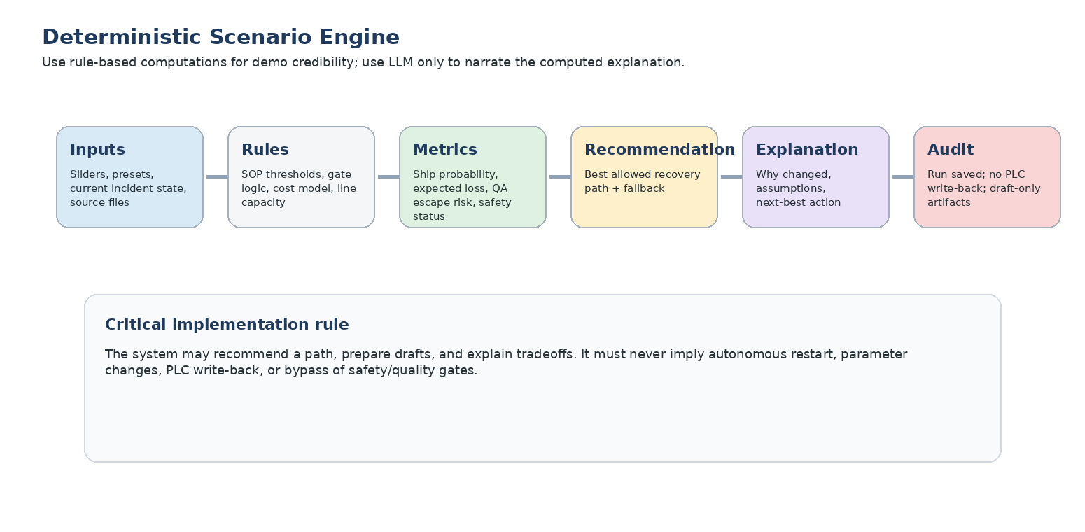
Figure 3. Deterministic scenario engine: inputs -> rules -> metrics -> recommendation -> explanation -> audit.
Metric | Recommended computation for demo | Notes
Loss so far | downtime_minutes * cost_per_min | At default: 14 * 1300 = $18.2K.
Expected total downtime | current downtime + option-specific delay + maintenance arrival penalty | For restart now, delay may be low but blocked; for reroute, include setup time.
Expected loss | expected_total_downtime * cost_per_min + expected_penalty | Penalty only applies if projected shipment risk crosses threshold.
Ship probability | base probability adjusted by inspection duration, deadline buffer, Line 2 capacity, spare availability | Keep formula transparent; show in assumption ledger.
QA escape risk | base anomaly risk adjusted by QA hold completion and restart decision | Restart now remains high risk when camera anomaly is high.
Safety/SOP status | gate output, not user-adjustable | Safety and QA gates must override optimization.
Recommendation | highest ship probability among allowed options, with safety/quality constraints applied | Unsafe or policy-blocked options cannot become recommended.

3.4 Required explanation layer
Trigger | Explanation example
Inspection duration increases from 20 to 35 min | Recommendation updated: prepare Line 2 fallback now because inspection exceeds the 25-minute fallback threshold and PO-4817 has limited shipment buffer. Continue inspection, but prepare reroute in parallel.
Line 2 capacity drops to 0% | Recommendation updated: inspect then restart remains the only feasible path. Reroute is unavailable. Escalate maintenance priority and notify operations that shipment risk is rising.
QA hold increases from 47 to 80 units | Quality release time increased; restart remains blocked until containment review. Prepare additional QA staffing or adjust shipment expectation.
Spare actuator unavailable | Repair duration risk increased. Prepare Line 2 fallback earlier and escalate spare-parts procurement.
Deadline buffer drops to 30 min | Shipment probability falls; generate customer-impact note and activate fallback planning immediately.

3.5 JSON contract: simulation output
{
"scenario_id": "line3_rescue_default",
"changed_factors": [
{"factor": "inspection_duration_min", "old": 20, "new": 35}
],
"recommended_option": "prepare_line2_fallback",
"next_best_action": "Continue inspection and prepare Line 2 reroute in parallel.",
"options": [
{
"option_id": "restart_now",
"label": "Restart now",
"allowed": false,
"blocked_by": ["SOP-MNT-007", "SOP-QA-014"],
"ship_probability": 0.62,
"expected_loss": 61000,
"qa_escape_risk": 0.31,
"safety_status": "blocked"
},
{
"option_id": "inspect_then_restart",
"label": "Inspect then restart",
"allowed": true,
"ship_probability": 0.71,
"expected_loss": 42000,
"qa_escape_risk": 0.08,
"safety_status": "review"
},
{
"option_id": "prepare_line2_fallback",
"label": "Prepare Line 2 fallback",
"allowed": true,
"ship_probability": 0.86,
"expected_loss": 28000,
"qa_escape_risk": 0.07,
"safety_status": "review"
}
],
"explanation": {
"summary": "Recommendation changed because inspection duration exceeds the fallback threshold.",
"triggered_constraints": ["SOP-PLAN-003 fallback threshold: 25 min"],
"business_impact": "Waiting for Line 3 alone reduces shipment probability.",
"non_bypassable_gates": ["Safety / LOTO", "Quality release"]
},
"assumptions": [
{"name": "cost_per_min", "value": 1300, "source": "downtime_cost_model.csv"},
{"name": "fallback_threshold_min", "value": 25, "source": "SOP-PLAN-003.md"}
]
}

4. Feature B - Facility Readiness and Approval Gate
Purpose: Make the prototype credible in a real US manufacturing environment. The gate makes it obvious that the app does not bypass safety, quality, OT cyber, production, or customer-impact approvals.

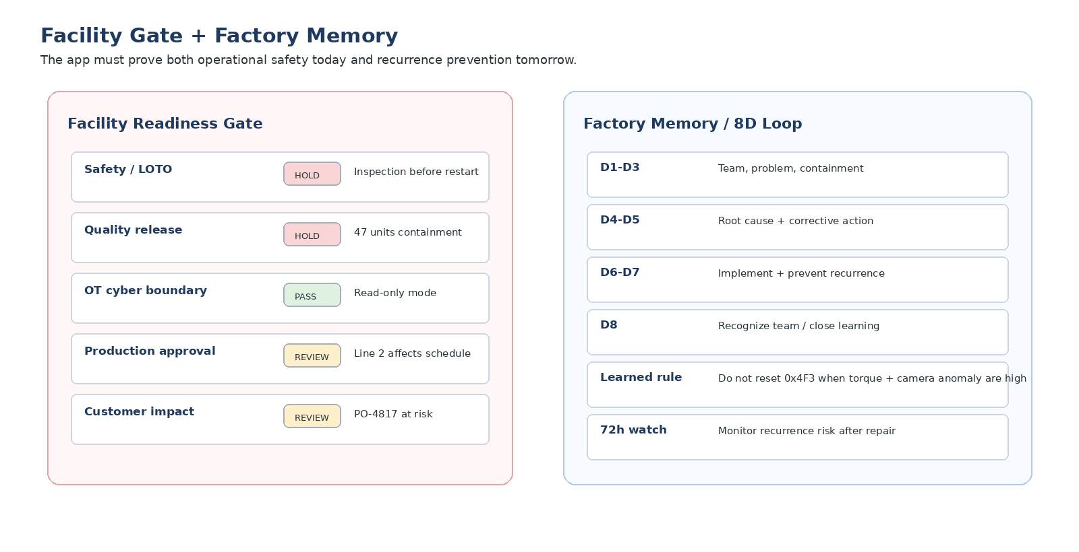
Figure 4. The Facility Gate blocks unsafe restart while the Factory Memory loop prevents recurrence after the incident.

4.1 Persistent gate board
Gate | Default status | Reason | Owner | Allowed action
Safety / LOTO | HOLD | Inspection required before restart when interlock + torque + temperature risk are active. | Maintenance Lead | Draft work order; do not restart.
Quality release | HOLD | Last 47 units require containment due to high camera anomaly. | QA Lead | Draft QA hold and inspection checklist.
OT cyber boundary | PASS | Read-only OT mode; no PLC write-back; no parameter change. | OT Engineer | Read and explain data only.
Production approval | REVIEW | Line 2 fallback may affect schedule. | Production Manager | Draft fallback plan; no schedule write-back.
Customer impact | REVIEW | Apex Motors PO-4817 at risk. | Operations Manager | Draft customer-impact note.
Action approval | REVIEW | Human review required before any external action. | Plant Manager | Approve drafts in demo state only.

4.2 Required gate behaviors
Restart now must remain BLOCKED while Safety / LOTO or Quality release status is HOLD.
The user may prepare maintenance, QA, production, and communication drafts even while restart is blocked.
Every draft must display: source evidence, SOP reference, owner, urgency, approval checkbox, and draft-only banner.
Every scenario run must write an audit event with timestamp, changed factors, recommended option, blocked actions, and generated drafts.
If a user tries to force a blocked option, show: "This action is blocked by facility gate rules. Generate an escalation note instead?"

4.3 JSON contract: gate output
{
"gate_run_id": "gate_line3_0817_001",
"overall_status": "blocked_for_restart_drafts_allowed",
"gates": [
{
"gate_id": "safety_loto",
"label": "Safety / LOTO",
"status": "hold",
"reason": "Inspection required before restart when torque + temperature + interlock are active.",
"owner": "Maintenance Lead",
"source": "SOP-MNT-007.md",
"allowed_actions": ["draft_work_order", "escalate_maintenance"]
}
],
"blocked_actions": ["restart_line3", "clear_interlock", "change_plc_parameter"],
"allowed_draft_actions": ["maintenance_work_order", "qa_hold_notice", "line2_fallback_plan", "management_brief"],
"trust_banner": "Read-only OT mode. No PLC write-back. No autonomous restart. Human approval required."
}

5. Feature C - Factory Memory / 8D Recurrence Loop
Purpose: Close the story by showing that FactoryOps does not only resolve today's incident; it converts the incident into recurrence prevention and institutional knowledge.

5.1 Page 7: Required UI
Panel | What to show | Exact behavior
Incident converted to learning | Top banner: Incident converted into recurrence-prevention plan. | Show after drafts or as optional final demo click.
8D draft | D1-D8 table with owner, draft content, evidence source, status. | Keep D1-D5 populated; D6-D8 can be pending verification.
Similar incidents | 3 prior related events: same station, similar torque/camera anomaly, reset failed. | Click opens CMMS excerpts and outcomes.
Learned rule | Pending rule: Do not reset 0x4F3 when torque and camera anomaly are both high; inspect clamp and QA hold first. | User can accept as pending; never auto-enforce without approval.
Verification plan | 72-hour watch, recurrence-risk score, owner, next check-in. | Creates operational follow-up story.
Recurrence-risk chart | 38% current -> 18% after corrective action -> 7% after verified rule. | Use simple line or bar chart; mark assumptions.

5.2 8D / CAPA output structure
Discipline | Demo content | Status
D1 Team | Maintenance Lead, QA Lead, Production Manager, OT Engineer. | Draft
D2 Problem | Line 3 / Station C3 fault 0x4F3 during Apex Motors PO-4817; active torque/interlock/camera anomaly. | Draft
D3 Containment | Hold last 47 units from 8:03-8:17; do not restart before inspection. | In progress
D4 Root cause hypothesis | Clamp binding / torque tool overload; possible air-line issue; visual anomaly requires QA review. | Draft
D5 Corrective action | Inspect clamp actuator, torque tool calibration, and air-line; replace actuator seal if confirmed. | Draft
D6 Implement | Assign maintenance work order; prepare Line 2 fallback if inspection exceeds 25 minutes. | Pending approval
D7 Prevent recurrence | Add learned rule and watch 0x4F3 + high torque + camera anomaly pattern for 72 hours. | Pending validation
D8 Close / recognize | Review outcome in 9 AM meeting and close after verification. | Pending

5.3 JSON contract: factory memory output
{
"memory_run_id": "memory_line3_0817_001",
"similar_incidents_found": 3,
"recurrence_pattern": "0x4F3 + high torque + camera anomaly + reset failed",
"learned_rule": {
"rule_text": "Do not reset 0x4F3 when torque and camera anomaly are both high. Inspect clamp/torque tool and hold affected units first.",
"status": "pending_human_approval",
"applies_to": ["Line 3", "Station C3", "MTR03_TORQUE", "CAM02_ANOMALY"]
},
"recurrence_risk": {
"before_action": 0.38,
"after_corrective_action": 0.18,
"after_verified_rule": 0.07
},
"verification_plan": [
{"window": "next_72_hours", "metric": "0x4F3 recurrence", "owner": "Maintenance Lead"},
{"window": "next_shift", "metric": "QA anomaly rate", "owner": "QA Lead"}
]
}

6. New Data Files to Add
File | Purpose | Minimum fields
scenario_controls.json | Default values and allowed ranges for Decision Twin controls. | factor_id, label, type, default, min, max, options, unit, source
scenario_presets.json | One-click story presets. | preset_id, label, description, factor_overrides
decision_options.json | Static option definitions. | option_id, label, allowed_by_default, owner, base_delay, base_risk
simulation_rules.json | Deterministic business rules for metrics and recommendation. | rule_id, formula_or_logic, inputs, outputs, priority
assumption_ledger.json | Source-backed assumptions shown in UI. | assumption_id, value, unit, source_file, editable, confidence
line_capacity.csv | Line 2 fallback feasibility. | line_id, capacity_percent, setup_time_min, products_supported, current_load
facility_gate_rules.json | Safety/quality/OT/approval gates. | gate_id, trigger_condition, status, owner, blocked_actions, allowed_drafts
approval_matrix.csv | Who must approve what. | action_type, owner_role, required_status, escalation_role
demo_audit_log.json | Scenario and gate run audit. | timestamp, user, scenario_id, changed_factors, recommendation, blocked_actions
similar_incidents.csv | Prior cases for Factory Memory. | incident_id, asset, symptoms, action_taken, outcome, recurrence
factory_memory.json | Learned rules and watch windows. | rule_id, rule_text, status, applies_to, source_incidents, watch_window
corrective_action_template_8d.md | 8D draft template. | D1-D8 headings with placeholders
verification_plan.csv | Post-action monitoring plan. | metric, threshold, owner, window, status

7. Agent Additions and Orchestration
Agent | Inputs | Output | UI placement
Recovery Planning Agent | Agent diagnosis outputs, scenario controls, decision options, simulation rules. | Option metrics, recommended option, fallback, next-best action. | Page 5B option cards.
Scenario Explanation Agent | Changed factors, triggered rules, output metrics, assumption ledger. | Plain-English why-change explanation. | Page 5B right panel.
Facility Gate Agent | SOP rules, gate rules, approval matrix, scenario recommendation. | Allowed/blocked actions, owners, gate statuses. | Persistent right panel + modal.
Audit Agent | Scenario run, gate output, draft generation events. | Append-only demo audit events. | Audit strip on Page 5B/6.
Factory Memory Agent | Similar incidents, CMMS snippets, 8D template, verification plan. | 8D draft, learned rule, recurrence-risk plan. | Page 7.

7.1 Orchestration flow
Existing Orchestrator output
-> Recovery Planning Agent computes option metrics
-> Facility Gate Agent blocks / allows each option
-> Scenario Explanation Agent writes why recommendation changed
-> User prepares recommended path or fallback drafts
-> Audit Agent logs scenario + drafts
-> Factory Memory Agent generates 8D + learned rule after decision pack

8. Exact Copy and Interaction Requirements
Moment | Exact copy
Page 5B header | Interactive Recovery Decision Twin - compare safe recovery paths for Apex Motors PO-4817.
Default recommendation | Recommended: inspect then restart. This protects safety and quality while preserving shipment probability. Prepare Line 2 fallback only if inspection exceeds 25 minutes.
Changed recommendation | Recommendation updated: prepare Line 2 fallback now. The changed assumptions pushed Line 3 recovery beyond the safe shipment window. Continue inspection, but prepare reroute in parallel.
Blocked restart | Restart now is blocked. Safety and quality gates cannot be bypassed by scenario controls. Generate escalation or draft work order instead.
Assumption ledger header | Assumptions used in this scenario. Each value is editable only if it is not a safety or quality constraint.
Gate banner | Read-only OT mode. No PLC write-back. No autonomous restart. Human approval required before execution.
Factory Memory banner | Incident converted into a recurrence-prevention plan. Learned rules remain pending until reviewed by the responsible owner.

9. Two- to Three-Day Build Plan
Slot | Build focus | Exit criteria
Day 1 morning | Create new data files and deterministic simulation engine. | Changing inspection duration changes ship probability, expected loss, and recommendation.
Day 1 afternoon | Build Page 5B Decision Twin UI with controls, presets, option cards, and explanation panel. | Default path recommends inspect then restart; 35-minute inspection triggers Line 2 fallback.
Day 2 morning | Build Facility Gate Agent, persistent gate panel, and action-blocking behavior. | Restart remains blocked; draft actions remain allowed; gate owner/status visible.
Day 2 afternoon | Add assumption ledger, audit strip, and modal before drafts. | Every scenario shows sources, changed factors, blocked actions, and next-best action.
Optional Day 3 morning | Build Factory Memory / 8D page. | 8D draft and learned rule generated from incident context.
Optional Day 3 afternoon | Polish demo path, management copy, and source-preview drawers. | 7-minute executive demo runs without intervention.

10. Definition of Done
User can adjust at least five factors and see option cards update instantly.
At least one factor change can change the recommended path from inspect then restart to prepare Line 2 fallback.
Every recommendation includes: why changed, triggered constraints, business impact, assumption ledger, and next-best action.
Safety and quality gates cannot be bypassed by scenario controls or presets.
Restart now remains blocked under the default incident because Safety / LOTO and Quality release gates are HOLD.
All external actions remain drafts with human approval checkboxes and audit strip.
Facility Gate panel is visible on Page 5B and before Page 6 drafts.
Factory Memory page generates a credible 8D/CAPA draft and pending learned rule if time allows.
The entire flow still tells one coherent story: safely recover Line 3 and protect Apex Motors PO-4817.
The demo can be presented to a plant manager in 7 minutes without explaining implementation details.

11. Out of Scope for This Sprint
Real OPC UA, MTConnect, PLC, SCADA, MES, CMMS, or ERP integration.
Autonomous restart, PLC write-back, parameter changes, or automatic schedule modification.
Full discrete-event simulation or validated plant digital twin.
Computer vision model training; use synthetic anomaly scores or pre-labeled samples.
Complex optimization across the entire plant. Keep this demo focused on Line 3 / PO-4817.
Granular cybersecurity compliance implementation; show boundary and audit language only.

12. Revised Demo Script
Time | Presenter action | What management should notice
0:00-0:45 | Open existing Live Fault Console. | This is a real operational incident, not a generic dashboard.
0:45-1:45 | Run existing multi-agent diagnosis. | The system coordinates specialized factory reasoning layers.
1:45-2:30 | Show evidence and safe restart decision. | The decision is source-backed and safety-governed.
2:30-4:00 | Open Decision Twin; change inspection duration to 35 minutes and Line 2 capacity to 70%. | Recommendation updates with an explanation: prepare Line 2 fallback now.
4:00-5:00 | Show Facility Gate blocking restart but allowing drafts. | The app is credible for modern manufacturing because it respects safety, QA, OT, and approval controls.
5:00-6:15 | Generate maintenance work order, QA hold, fallback plan, and 9 AM brief. | Diagnosis becomes action artifacts immediately.
6:15-7:00 | Open Factory Memory / 8D page. | The system learns and prevents recurrence, preserving tribal knowledge.

13. Standards-Informed Rationale
This section is not for UI copy; it explains why the added features will be credible to US manufacturing stakeholders.
Concern | Relevant source | How the prototype should respond
Digital twin credibility | NIST Digital Twins for Advanced Manufacturing emphasizes identifying digital twin requirements, managing data effectively, and creating models that can be validated with quantified uncertainties. | Show an assumption ledger, source-backed values, and deterministic scenario rules rather than a black-box simulator.
Decision-support integration | NIST Data Analytics for Smart Manufacturing Systems highlights the need to integrate analytics tools with data acquisition and decision support systems. | Make the Decision Twin an action-oriented decision tool, not a passive chart.
Safety / hazardous energy | OSHA 1910.147 covers servicing and maintenance where unexpected energization or startup could injure employees. | Never let the app imply that AI can restart a line or bypass inspection.
OT cybersecurity | ISA/IEC 62443 defines requirements and processes for secure industrial automation and control systems and bridges operations, IT, process safety, and cybersecurity. | Keep read-only OT mode, no PLC write-back, audit trail, and approval boundary visible.
Critical manufacturing risk | CISA describes the Critical Manufacturing Sector as focused on identifying, assessing, prioritizing, and protecting nationally significant manufacturing industries. | Show the app is safe-by-design, not an uncontrolled agent in OT.
Recurring problem prevention | ASQ describes 8D as a problem-solving approach used to identify, correct, and eliminate recurring issues. | Close the demo with 8D/CAPA and Factory Memory so value extends beyond one incident.
Interoperability / contextualization | CESMII i3X emphasizes open, standards-based information modeling, interoperability, and common APIs for manufacturing systems and scalable AI deployment. | Position FactoryOps as a semantic decision layer above heterogeneous factory systems.

14. References
Current FactoryOps build brief/progress document: FactoryOps Multi-Agent Rescue Prototype - Developer Build Brief.
NIST - Digital Twins for Advanced Manufacturing: https://www.nist.gov/programs-projects/digital-twins-advanced-manufacturing
NIST - Data Analytics for Smart Manufacturing Systems: https://www.nist.gov/programs-projects/data-analytics-smart-manufacturing-systems
OSHA 1910.147 - The control of hazardous energy (lockout/tagout): https://www.osha.gov/laws-regs/regulations/standardnumber/1910/1910.147
ISA/IEC 62443 Series of Standards: https://www.isa.org/standards-and-publications/isa-standards/isa-iec-62443-series-of-standards
CISA - Critical Manufacturing Sector: https://www.cisa.gov/topics/critical-infrastructure-security-and-resilience/critical-infrastructure-sectors/critical-manufacturing-sector
ASQ - Eight Disciplines (8D): https://asq.org/quality-resources/eight-disciplines-8d
CESMII - i3X 1.0 release: https://www.cesmii.org/cesmii-releases-i3x-1-0/

