FactoryOps Multi-Agent Rescue Prototype
Developer Build Brief - Initial Demo
A safe, multi-agent factory decision system that turns raw machine events into evidence-backed management actions.
Prototype story | Line 3 stops during a priority order. The system coordinates telemetry, vision, maintenance history, SOPs, and business impact to answer: Can we safely restart?
One-week success target | A polished, clickable vertical slice that demonstrates the full reasoning workflow using public datasets plus synthetic SOP/ERP/PLC layers.
What management sees | Downtime cost, shipment risk, safety-governed restart decision, evidence, owner actions, and generated work-order / QA / shift-handoff drafts.
Boundary | Read-only OT mode. No PLC write-back. No autonomous restart. Human approval required.
Important build principle: do not build a generic dashboard. Build one memorable incident flow that feels real, safe, and management-relevant.

1. Executive Build Summary
Build the demo as a six-screen operational story, not as a generic analytics app. The demo opens with a faulted line, runs a coordinated multi-agent diagnosis, shows ground-truth evidence capture, and ends with a safe restart decision plus ready-to-review action drafts.
- Primary user: plant manager, operations manager, maintenance lead, quality lead, production supervisor.
- Primary demo question: Can we safely restart Line 3 and still ship Apex Motors PO-4817 today?
- Primary promise: machine code + telemetry + camera evidence + maintenance tribal knowledge + SOPs + production impact -> safe action in under 60 seconds.
- Primary emotion: management sees immediate value because the system saves diagnostic time, preserves tribal knowledge, avoids unsafe restart, and quantifies impact.

2. Final Prototype Narrative
At 8:17 AM, Line 3 / Station C3 stops during a high-priority order. A junior operator sees Error 0x4F3 and raw machine tags. The plant manager does not need a raw signal dashboard; they need a safe decision. The system launches a coordinated workflow across six agents and produces a decision pack.
Moment | What the app shows | Why it matters
8:17 AM - Fault | Line 3 faulted. Error 0x4F3. Downtime timer starts. Apex Motors PO-4817 affected. | Immediate business context, not just machine context.
Diagnosis | Telemetry, vision, maintenance, SOP, and production agents run in parallel. | Shows coordinated multi-agent workflow.
Evidence | Ground-truth scoreboard shows the agents captured known failure, anomaly, SOP, and order risk signals. | Builds trust that the output is evidence-backed.
Decision | Do not restart yet. Inspect clamp / torque tool. Hold last 47 units. Prepare Line 2 fallback. | Turns technical data into safe management action.
Execution drafts | Maintenance work order, QA hold notice, shift handoff, and 9 AM management brief. | Demonstrates operational usefulness immediately.

3. Data Stack and Ground Truth
The prototype should combine public dataset credibility with synthetic plant context. Public datasets prove the agents can surface real signals. Synthetic data creates the realistic cross-system factory story that public datasets do not contain.
Layer | Dataset / asset | Ground truth to show | Agent using it | Demo action
Machine telemetry | UCI AI4I 2020 Predictive Maintenance | Machine failure flag and failure-mode logic such as tool wear, heat dissipation, power, overstrain, random failure. | Telemetry Agent | Classify current fault as overstrain / tool-wear risk.
Multimodal line evidence | Future Factories Assembly Dataset V2 | Synchronized time-series system data and images from assembly line operation. | Vision/Quality Agent | Flag visual anomaly and support QA hold.
Tribal knowledge | MaintNet + synthetic CMMS logs | Messy maintenance notes with abbreviations, non-standard language, prior fix patterns. | Maintenance Knowledge Agent | Retrieve similar clamp / torque / air-line fix.
Governance | Synthetic SOPs | Rules for abnormal torque, camera anomaly, restart, QA hold, and escalation. | SOP/Safety Agent | Block unsafe restart and require approvals.
Business impact | Synthetic ERP/MES/order data | Priority order, downtime cost, units at risk, line capacity, fallback options. | Production/Finance Agent | Quantify loss and recommend fallback line if delay exceeds threshold.
Developer note: If real Future Factories image downloads are not ready in week one, use a curated sample image placeholder with a synthetic anomaly_score while preserving the data contract.

4. Required Synthetic Assets
Create these local files in /data/demo_scenario/line3_rescue/. The app should load the scenario from JSON/CSV/Markdown so the workflow is repeatable and demo-stable.
File | Type | Purpose | Minimum fields / contents
incident_event.json | JSON | Main scenario trigger | incident_id, line_id, station_id, error_code, timestamp, state, affected_order_id, downtime_minutes
plc_tag_dictionary.csv | CSV | Machine-code semantic map | tag, display_name, unit, normal_range, warning_range, critical_range, human_meaning, likely_causes
telemetry_samples.csv | CSV | Simulated live values | timestamp, torque, rpm, air_temp, process_temp, tool_wear, failure_label, failure_mode
vision_events.csv | CSV | Camera anomaly evidence | timestamp, camera_id, anomaly_score, image_path, defect_label, related_units
cmms_history.csv | CSV | Maintenance tribal knowledge | asset_id, date, problem_text, action_text, downtime_min, outcome, mapped_tags
SOP-MNT-007.md | Markdown | Maintenance safety procedure | inspection steps, restart conditions, escalation rule
SOP-QA-014.md | Markdown | Quality containment rule | camera anomaly threshold, lot hold rule, release conditions
SOP-PLAN-003.md | Markdown | Production recovery rule | line reassignment rules, manager approvals, fallback thresholds
orders.csv | CSV | Business impact | order_id, customer, due_time, units_remaining, priority, margin, late_penalty, assigned_line
downtime_cost_model.csv | CSV | ROI meter | line_id, cost_per_min, threshold_min, escalation_min
ground_truth.json | JSON | Evaluation truth | expected_failure_mode, expected_anomaly, expected_sop_rules, expected_actions

5. Agent Architecture
Agent | Inputs | Ground truth checked | Output JSON | UI card copy
Telemetry Agent | incident_event, telemetry_samples, plc_tag_dictionary | AI4I-style failure flag / failure mode | failure_mode, confidence, supporting_signals, action_implication | Failure pattern detected: overstrain / tool-wear risk.
Vision/Quality Agent | vision_events, SOP-QA-014 | anomaly_score and defect label | quality_risk, affected_units, qa_hold_required, evidence | Camera anomaly aligned with fault window. QA hold required.
Maintenance Knowledge Agent | cmms_history, MaintNet-style logs, tag dictionary | similar prior problem-action pair | similar_incidents, likely_fix, restart_warning | Similar prior fix found: clamp binding + air-line inspection.
SOP/Safety Agent | SOP-MNT-007, SOP-QA-014, SOP-PLAN-003 | restart/inspection/hold rules | restart_allowed, blocked_by, approvals_required | Restart blocked pending inspection and QA hold.
Production/Finance Agent | orders, downtime model, line schedule | order risk and cost thresholds | loss_so_far, shipment_risk, fallback_option | Apex Motors PO-4817 at risk; fallback needed after 25 min.
Orchestrator Agent | all agent outputs | expected action set in ground_truth.json | decision, rationale, actions, approvals, drafts | Decision pack ready: do not restart yet.

6. Canonical Agent Output Schemas
Use strict JSON outputs so the UI can render deterministic cards. Do not let the UI parse free-form LLM text.
{
"agent_id": "telemetry_agent",
"status": "complete",
"summary": "Overstrain / tool-wear risk detected.",
"confidence": 0.92,
"ground_truth_match": true,
"evidence": [
{"source": "telemetry_samples.csv", "field": "tool_wear", "value": 226, "interpretation": "above warning threshold"},
{"source": "plc_tag_dictionary.csv", "field": "MTR03_TORQUE", "value": 68.9, "interpretation": "elevated torque"}
],
"recommended_action": "Inspect Station C3 clamp actuator and torque tool before restart."
}

7. Page-by-Page UI Specification
The developer should build these screens as an exact vertical flow. Keep the interface calm, executive-grade, and operational. Avoid excessive charts. Every page should answer one management question.

Page 1 - Live Fault Console
Purpose: Create the first wow moment: management sees the exact fault, affected order, current downtime, estimated loss, and one obvious next step.
Must show:
- Top status bar: Line 3 / Station C3 - FAULTED; Read-only OT mode; Run ID; timestamp.
- KPI cards: Downtime 14 min; Estimated loss $18.2K; Shipment risk High; Units at risk 47; Affected order Apex Motors PO-4817.
- Raw machine panel: Error 0x4F3 and six key tags, each with plain label and value.
- Business context panel: due time, order priority, late penalty, fallback threshold at 25 minutes.
- Primary button: Run Multi-Agent Diagnosis. Secondary quick question: Can I safely restart Line 3?
Chart/visual: Downtime loss curve line chart. X-axis = minutes down. Y-axis = estimated loss. Add vertical marker at 25 minutes fallback threshold.
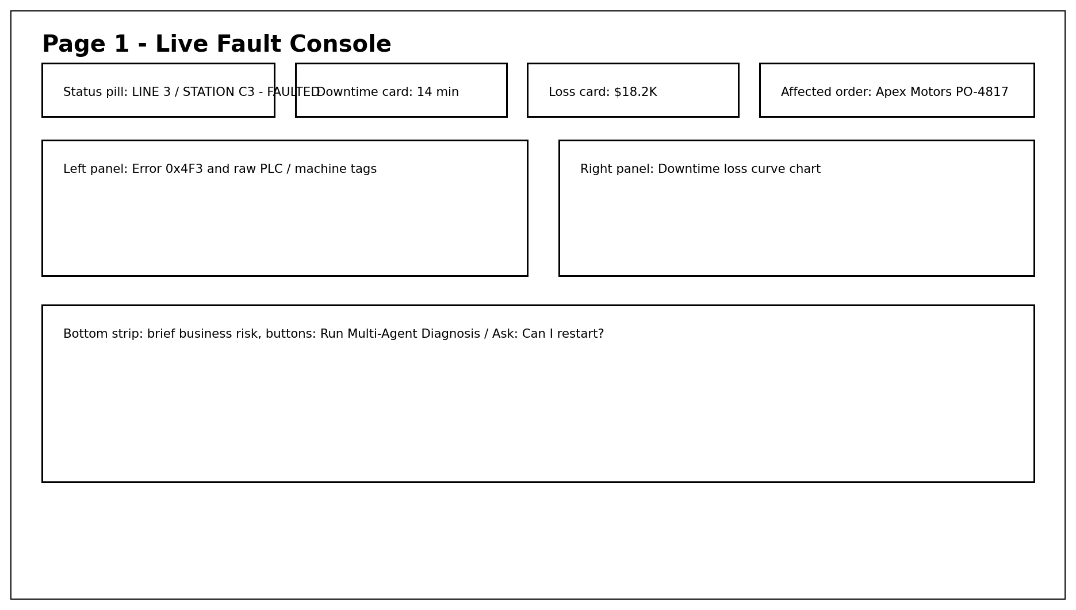
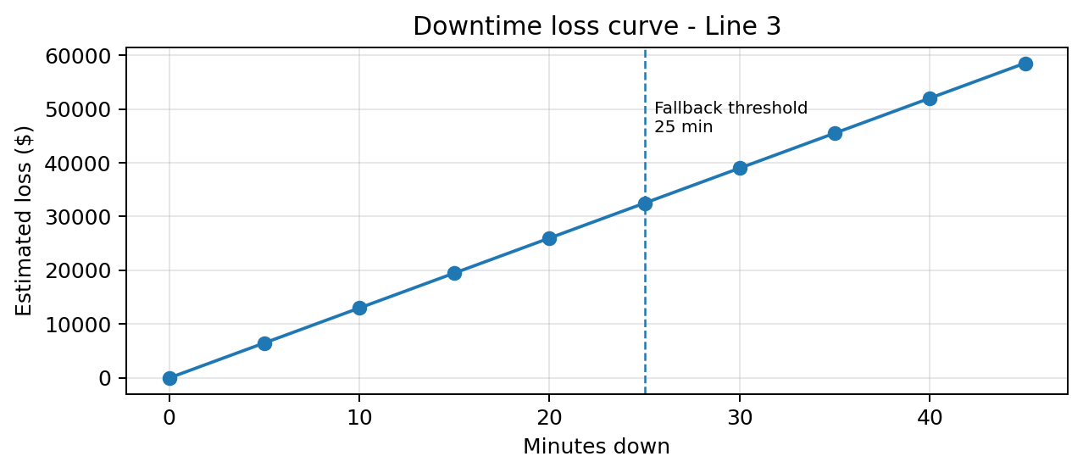
Key interactions:
- Click Run Multi-Agent Diagnosis -> navigates to Page 2 and starts agent cards.
- Click any raw tag -> opens tooltip: tag meaning, normal range, likely causes.
- Click Ask: Can I restart? -> still routes through multi-agent workflow; do not answer from one agent only.
Exact copy to use:
LINE 3 / STATION C3 - FAULTED
Error 0x4F3: Station C3 interlock / torque fault
Apex Motors PO-4817 is at risk. Decision needed before 8:45 AM.
Read-only OT mode: no PLC write-back, no autonomous restart.

Page 2 - Multi-Agent Coordination Board
Purpose: Show that the system is not a chatbot. It coordinates specialized agents that each inspect a different evidence layer.
Must show:
- Six agent cards: Telemetry, Vision/Quality, Maintenance Knowledge, SOP/Safety, Production/Finance, Orchestrator.
- Each card must show status, one-sentence finding, confidence, source count, and action implication.
- Use a progress state: Queued -> Running -> Complete. For demo stability, auto-complete within 4-7 seconds.
- Bottom summary: 5 critical evidence layers captured; decision pack ready.
Chart/visual: Agent evidence confidence bar chart. Use one bar per agent, with percentages shown above bars.
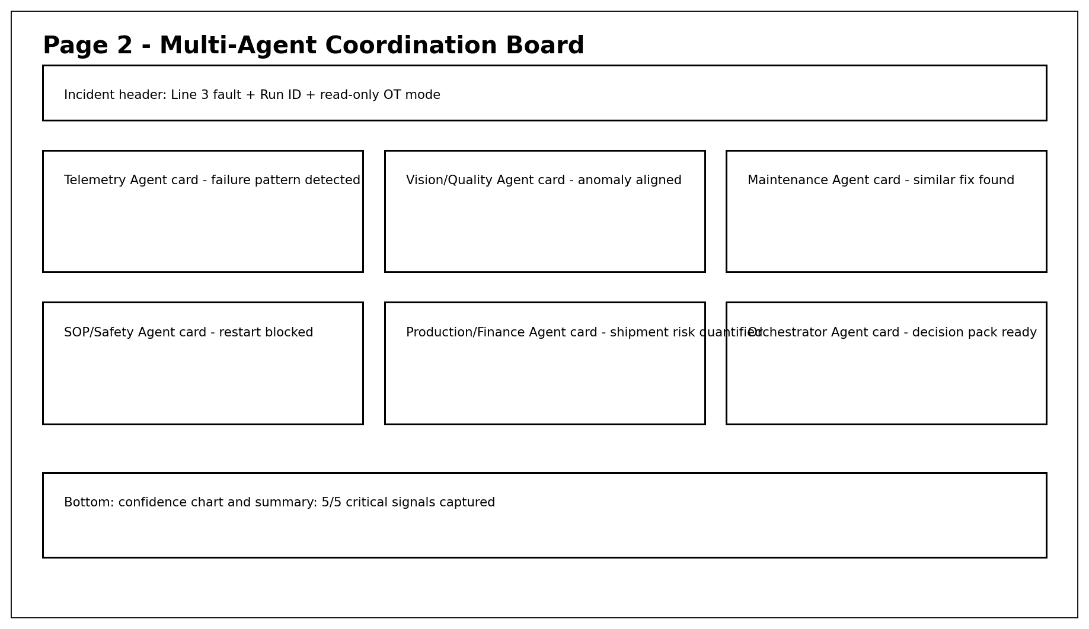
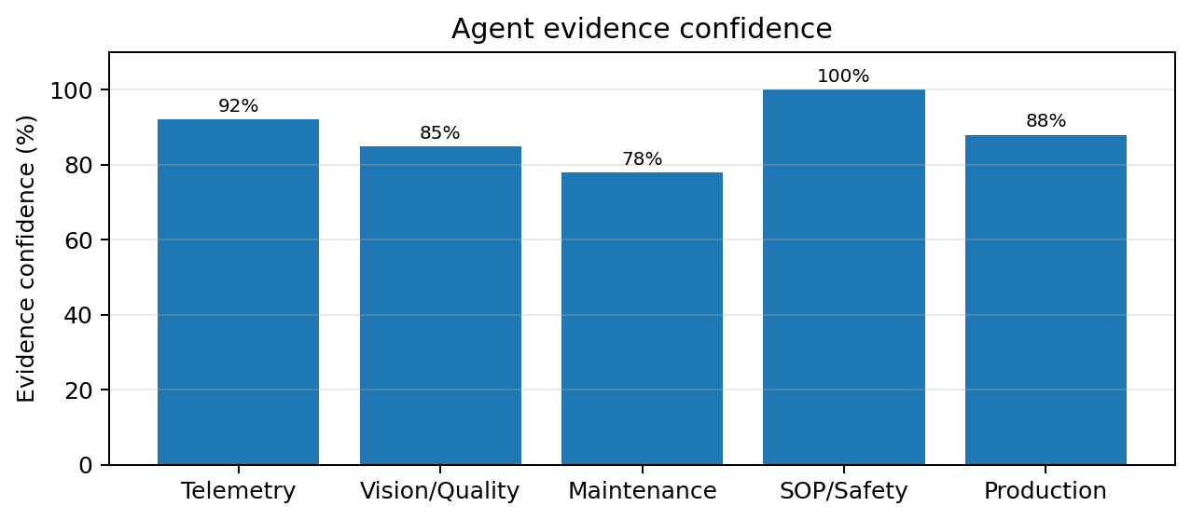
Key interactions:
- Click an agent card -> opens evidence drawer with sources and extracted fields.
- Click Continue to Evidence Timeline -> Page 3.
- If an agent fails, show graceful warning and lower confidence, but still produce decision with missing-data notice.
Exact copy to use:
Telemetry Agent: Failure pattern detected - overstrain / tool-wear risk.
Vision/Quality Agent: Camera anomaly aligned with fault window.
Maintenance Knowledge Agent: Similar prior fix found.
SOP/Safety Agent: Restart blocked pending inspection.
Production/Finance Agent: Shipment risk quantified.
Orchestrator Agent: Decision pack generated.

Page 3 - Incident Evidence Timeline
Purpose: Explain what happened in time order so management trusts the diagnosis.
Must show:
- Main chart with torque index, temperature delta index, and camera anomaly index over the last 16 minutes.
- Vertical marker at the fault timestamp: 8:17 AM / Error 0x4F3.
- Right-side evidence snippets from telemetry, visual anomaly, and historical CMMS logs.
- Plain-English explanation under the chart.
Chart/visual: Multi-series line chart showing torque, temperature delta, and camera anomaly rising before fault. The chart does not need real units; use normalized risk index for demo clarity.
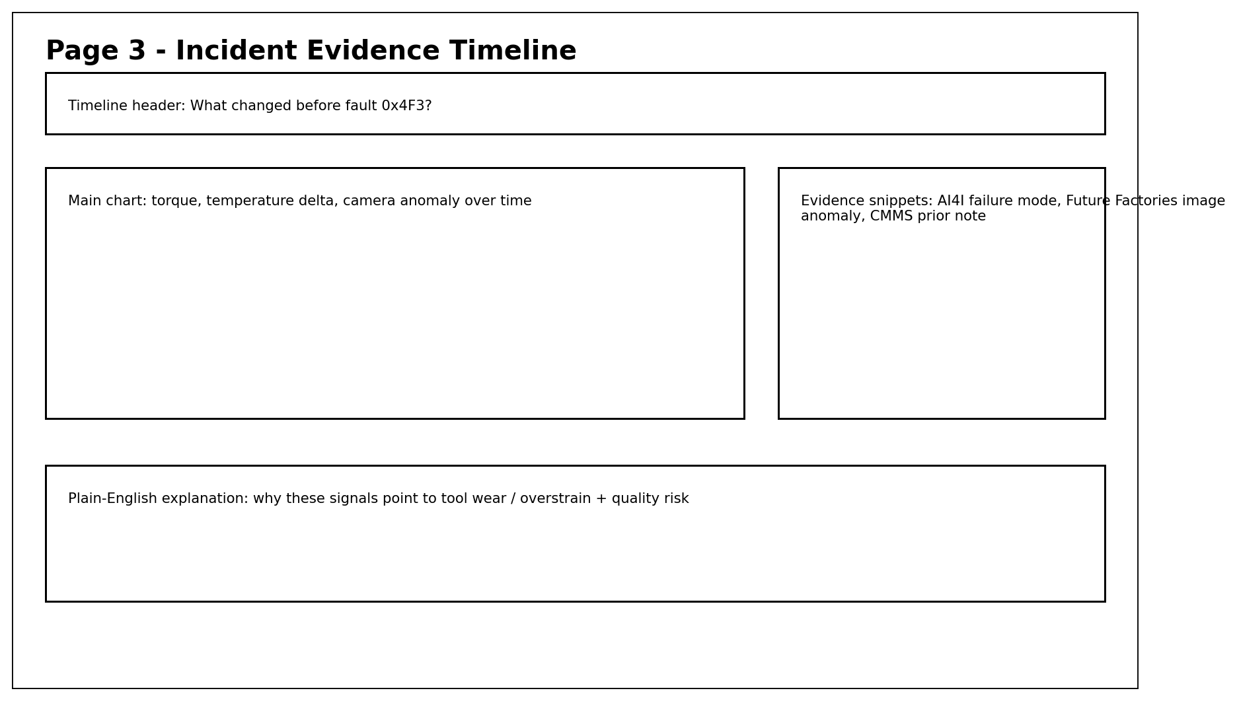
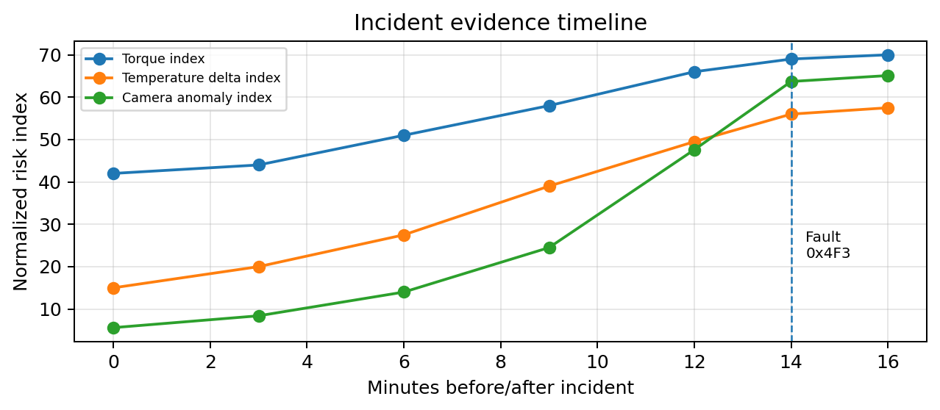
Key interactions:
- Hover over any point -> show timestamp, value, interpretation.
- Click evidence snippet -> highlight corresponding chart region.
- Click Continue to Ground Truth -> Page 4.
Exact copy to use:
Torque and temperature began rising 8-11 minutes before the fault.
Camera anomaly score crossed high-risk threshold shortly before Line 3 stopped.
The pattern is consistent with overstrain / tool-wear risk and potential assembly quality risk.

Page 4 - Ground-Truth Evidence Scoreboard
Purpose: Prove that the agents captured meaningful known facts from the datasets and synthetic rule layer.
Must show:
- A table with rows for telemetry failure mode, image anomaly, similar maintenance note, restart SOP rule, QA hold rule, business impact.
- Columns: Evidence type, Source, Ground truth, Agent captured, Action surfaced.
- Use PASS / REVIEW status labels, not vague confidence language only.
- Add a trust banner: Evidence-backed decision; not free-form hallucination.
Chart/visual: Use a table as the primary visual. Add small source coverage indicators rather than a complex chart.
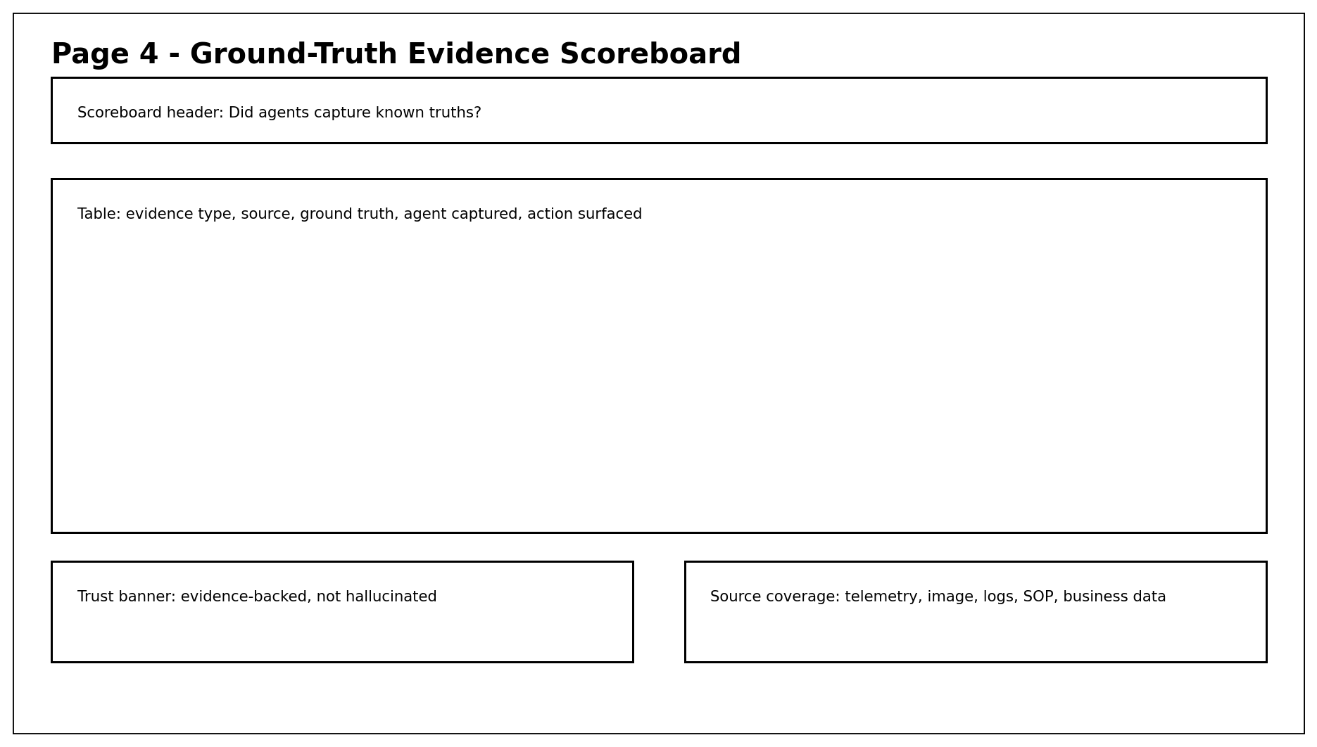
Key interactions:
- Click any row -> opens source preview or synthetic file excerpt.
- Click Continue to Decision Pack -> Page 5.
- If source not available, show Missing / needs validation and do not overclaim.
Exact copy to use:
Ground-truth check: 6 of 6 critical signals captured.
This screen is for executive trust: every decision links to source evidence.
Known truth -> agent capture -> surfaced action.

Ground-truth scoreboard rows to implement
Evidence type | Source | Ground truth | Agent captured? | Action surfaced
Failure mode | AI4I telemetry row | Tool-wear / overstrain risk signal | PASS | Inspect clamp / torque tool before restart
Visual anomaly | Future Factories-style image event | High anomaly near fault window | PASS | Hold last 47 units for QA review
Prior fix | MaintNet-style CMMS note | Clamp binding / air-line issue; reset alone failed | PASS | Do not rely on reset; inspect mechanical cause
Restart rule | SOP-MNT-007 | Inspection required before restart when torque + temp + interlock active | PASS | Restart blocked pending maintenance approval
QA rule | SOP-QA-014 | Camera anomaly above threshold requires containment hold | PASS | Create QA hold notice
Business impact | orders.csv + downtime_cost_model.csv | PO-4817 at risk; fallback threshold 25 minutes | PASS | Prepare Line 2 fallback plan

Page 5 - Safe Restart Decision Pack
Purpose: Deliver the management answer: restart/no-restart decision, why, business impact, next actions, approvals, and fallback threshold.
Must show:
- Decision banner: DO NOT RESTART YET.
- Rationale block: telemetry + visual + prior maintenance + SOP evidence.
- Root-cause contribution chart with top four contributors.
- Three action cards: maintenance inspection, QA hold, Line 2 fallback.
- Approval path: Maintenance Lead + QA Lead + Production Manager.
- Estimated avoidable loss range: $18K-$42K.
Chart/visual: Root-cause contribution horizontal bar chart. Keep it easy to read: tool wear / overstrain, clamp binding, material or assembly anomaly, operator / shift factor.
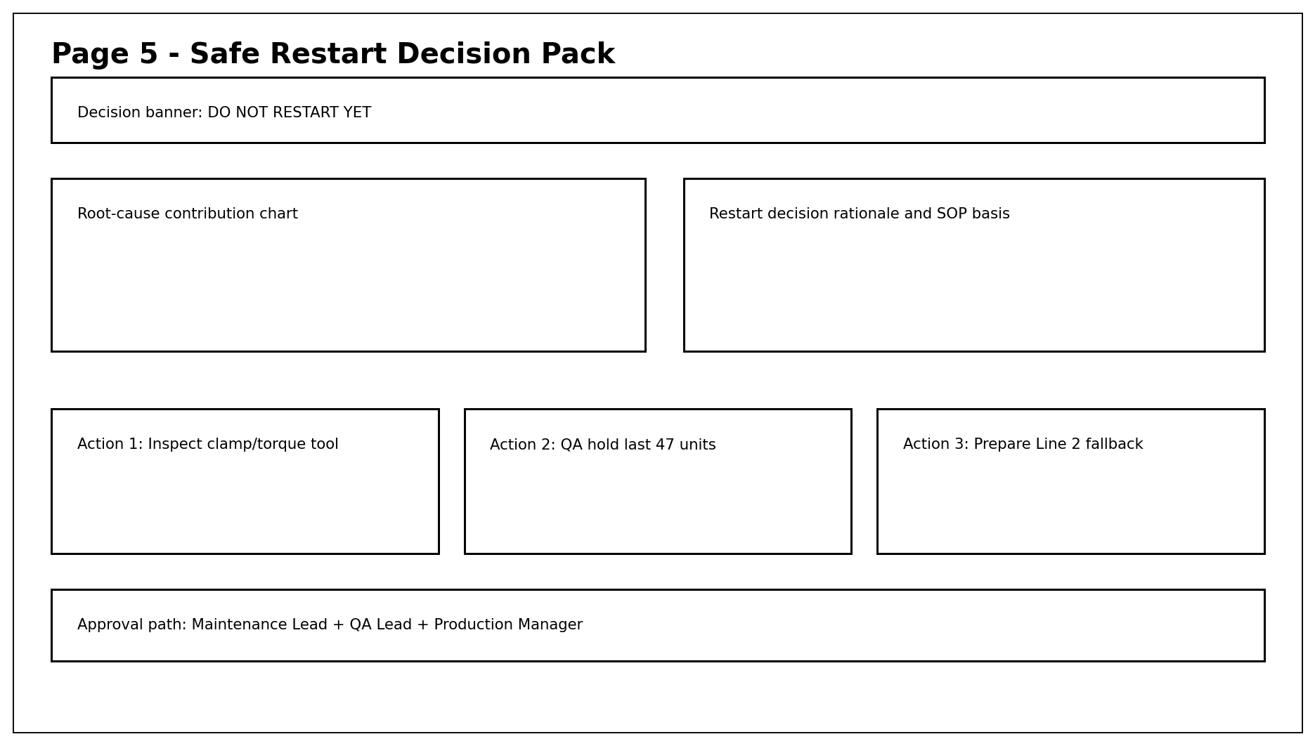
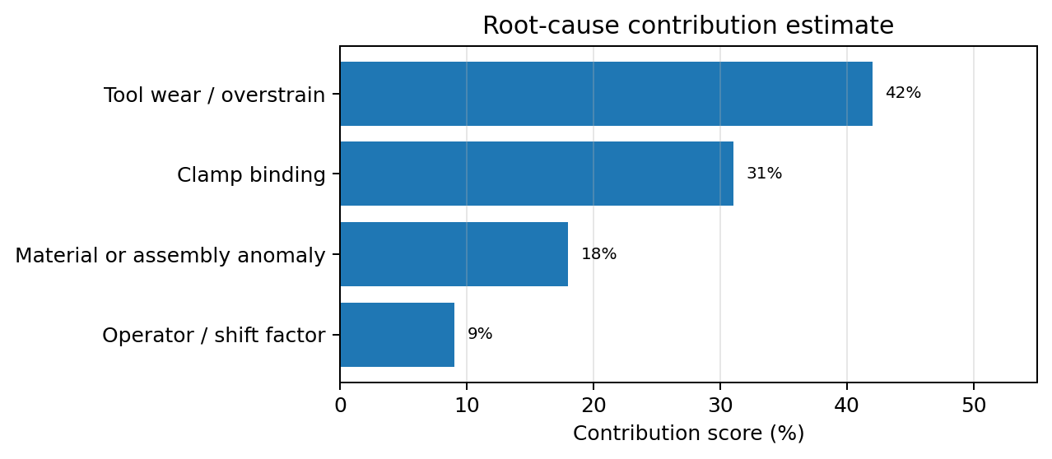
Key interactions:
- Click Create Maintenance Work Order -> opens draft on Page 6.
- Click Create QA Hold Notice -> opens draft on Page 6.
- Click Prepare Line 2 Fallback -> creates planning note but does not modify schedule.
- Click Why not restart? -> evidence drawer with SOP and risk explanation.
Exact copy to use:
Decision: Do not restart immediately.
Reason: active interlock + elevated torque/tool-wear + camera anomaly + prior similar repair pattern.
Required before restart: clamp actuator inspection, torque tool check, QA hold of last 47 units.
Fallback: if inspection exceeds 25 minutes, prepare Line 2 reroute for Apex Motors PO-4817.

Page 6 - Generated Action Drafts and 9 AM Brief
Purpose: Show that the system creates usable operational artifacts, while keeping human approval in control.
Must show:
- Tabs/cards for Maintenance Work Order, QA Hold Notice, Shift Handoff, 9 AM Management Brief, Optional Customer/Supplier Note.
- Each draft includes source evidence, SOP reference, owner, urgency, and approval checkbox.
- Trust banner: Draft only - review required before sending or writing back to systems.
- Export/copy buttons. For the one-week prototype, do not integrate with real CMMS/MES.
Chart/visual: No major chart needed on this page. Use structured document cards. If a visual is needed, show a small action-status checklist.
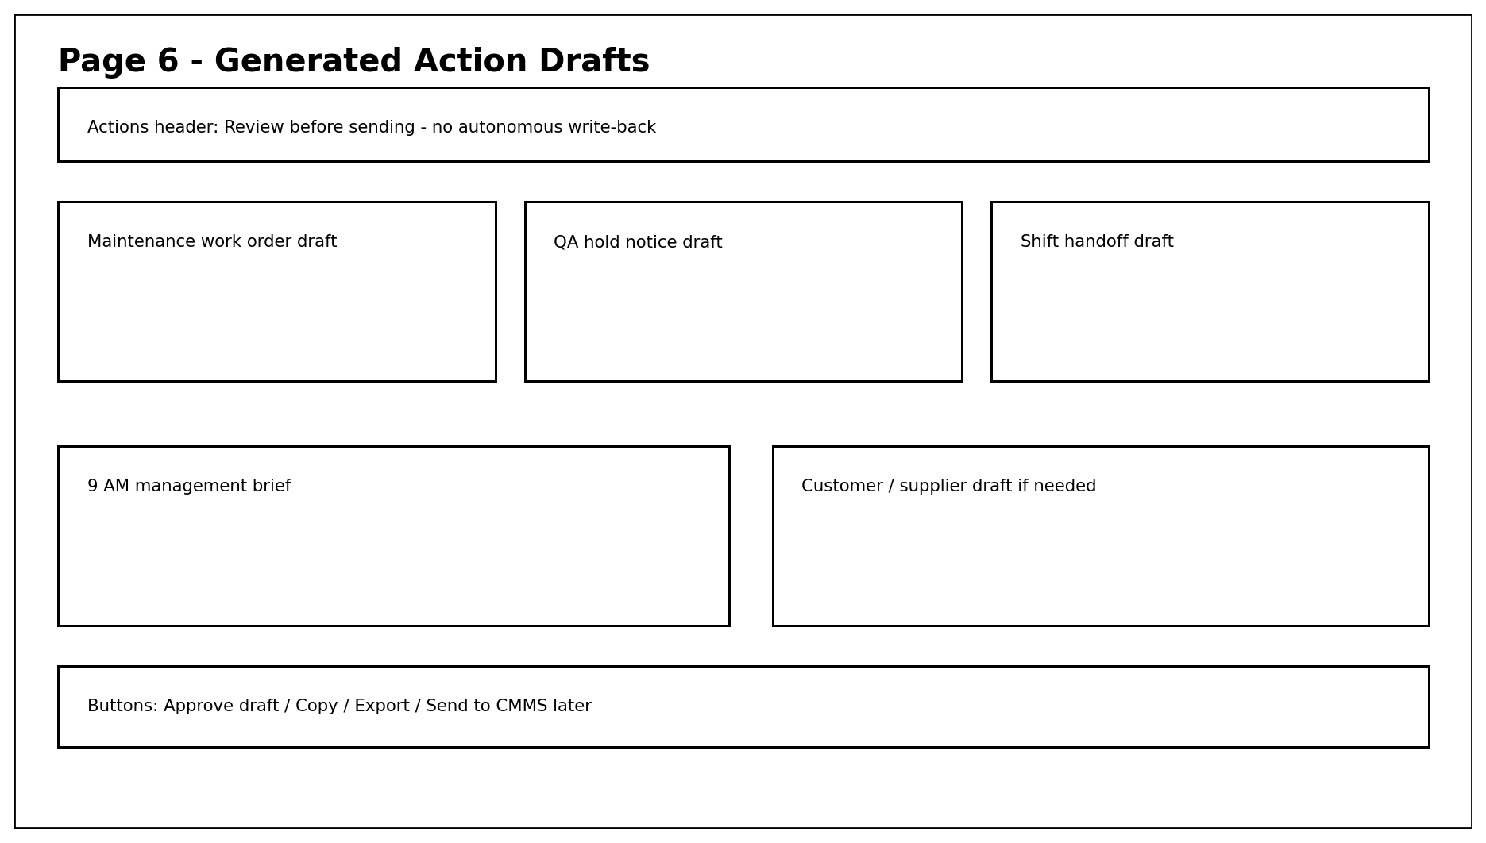
Key interactions:
- Click Approve Draft -> marks as approved in demo state only.
- Click Copy -> copies text to clipboard.
- Click Export -> downloads JSON/Markdown draft.
- Click Ask follow-up -> returns to conversational panel while preserving evidence context.
Exact copy to use:
Maintenance WO: Inspect Station C3 clamp actuator, torque tool calibration, and air-line leak risk. Do not restart until signoff.
QA Hold: Hold last 47 units produced between 8:03-8:17 AM pending visual and dimensional inspection.
9 AM Brief: Line 3 fault affects Apex Motors PO-4817. Current recommendation is inspect + QA hold + prepare Line 2 fallback.

Optional Page - Machine Code Semantic Search
Purpose: Optional but powerful: let users search any error code, PLC register, tag name, or messy symptom and retrieve semantic meaning plus tribal knowledge.
Must show:
- Search bar accepts: Error 0x4F3, DB12.DBX4.3, MTR03_TORQUE, hi trq C3 clamp, restart fail.
- Results grouped into: PLC Tag Dictionary, Prior Maintenance Logs, SOP Rules, Suggested Human Action.
- The result should translate machine code into role-specific language for operator, maintenance, QA, and manager.
- This page should be read-only and retrieval-based, not a free-form action engine.
Chart/visual: No chart required. Use searchable knowledge cards with source previews.
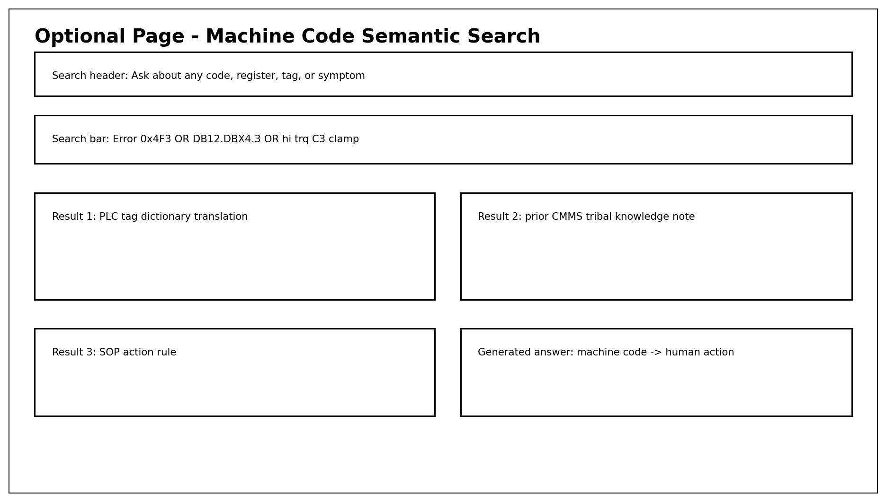
Key interactions:
- Search -> retrieve from tag dictionary + CMMS logs + SOPs.
- Click result -> opens source excerpt and confidence explanation.
- Click Generate Action Card -> routes to SOP/Safety Agent before producing action.
Exact copy to use:
Search: Error 0x4F3
Meaning: Station C3 interlock / torque fault. Likely clamp actuator binding or torque-tool overload.
Tribal knowledge: Prior reset-only attempt failed. Inspection of clamp and air line resolved similar issue.
Safe action: inspect before restart; escalate to maintenance and QA.

8. Exact Demo Data Values to Use
Field | Value | Why this value matters
Line / station | Line 3 / Station C3 | Specific enough to feel real and map to tags, SOPs, maintenance history.
Error code | 0x4F3 | Cryptic machine code creates the semantic-disconnect story.
Affected customer/order | Apex Motors PO-4817 | Makes management care immediately.
Downtime | 14 minutes at page load | Enough to create urgency but still recoverable.
Cost per minute | $1,300/min | Configurable demo value; produces $18.2K loss at 14 minutes.
Fallback threshold | 25 minutes | Decision deadline for reroute to Line 2.
Units at risk | 47 units | Concrete QA containment action.
Tool wear | 226 minutes | Supports tool-wear / overstrain risk story.
Torque | 68.9 Nm / high | Supports mechanical binding / overstrain evidence.
Camera anomaly | 0.91 / high | Supports QA hold and multimodal evidence.
Decision | Do not restart yet | Safety-first product identity.

9. Implementation Notes
- Frontend: Next.js + TypeScript + Tailwind + shadcn/ui. Use a left incident rail, central evidence area, and right-side decision drawer pattern.
- Backend: FastAPI or Next.js API routes are fine for week one. Keep scenario data file-backed; no database required unless already available.
- Agent orchestration: Use deterministic agent functions first. Each function reads data and returns strict JSON. LLM can be used only for narrative summarization and draft generation.
- RAG/search: Use local embeddings or simple BM25 for SOP/CMMS search. For week one, source snippets can be retrieved from curated markdown/CSV files.
- Evaluation: ground_truth.json should contain expected captures. The UI should display pass/fail rows based on agent outputs matching expected fields.
- Trust boundary: Every screen should show read-only OT mode. No PLC write-back. No autonomous restart. Human approval required.

10. One-Week Build Plan
Day | Build focus | Exit criteria
Day 1 | Create scenario data files, SOPs, tag dictionary, and ground_truth.json. | Data loads locally and can trigger one incident.
Day 2 | Build Page 1 and Page 2 with mock agent execution states. | Fault console and agent board look demo-ready.
Day 3 | Implement deterministic agent functions and strict JSON outputs. | Each agent produces evidence, confidence, and action implication.
Day 4 | Build Page 3 timeline and Page 4 ground-truth scoreboard. | Known truths are visible and pass/fail is computed.
Day 5 | Build Page 5 decision pack and approval path. | Safe restart answer is clear and evidence-backed.
Day 6 | Build Page 6 action drafts and optional semantic search if time allows. | Draft artifacts generate from scenario context.
Day 7 | Polish UX, script demo, fix copy, add empty/error states. | 5-7 minute executive demo runs without manual intervention.

11. Definition of Done
- A viewer can understand the business problem in the first 30 seconds without explanation.
- The app answers: Can we safely restart Line 3? with a clear yes/no and evidence.
- At least five agent cards complete and provide evidence-backed outputs.
- Ground-truth scoreboard shows expected dataset/synthetic facts captured and surfaced for action.
- The decision pack includes safety/SOP constraints, business impact, owners, approvals, and action drafts.
- The prototype remains read-only and never implies autonomous control of PLCs or machine restarts.
- Optional semantic tribal-knowledge search works for Error 0x4F3 and DB12.DBX4.3 if included.

12. Out of Scope for Initial Demo
- Real OPC UA, MTConnect, SCADA, PLC, MES, CMMS, or ERP integration.
- Autonomous restart, parameter changes, or PLC write-back.
- Complex schedule optimization or full production planning engine.
- Real computer vision model training. Use existing dataset labels or synthetic anomaly scores for demo.
- Full cybersecurity architecture or compliance package. Only show read-only boundary and audit language.
- A broad KPI dashboard with OEE, scrap, labor, and energy pages. Keep the demo incident-focused.

13. Source References for Developer Context
Reference | URL | Why relevant
UCI AI4I 2020 Predictive Maintenance Dataset | https://archive.ics.uci.edu/ml/datasets/AI4I%2B2020%2BPredictive%2BMaintenance%2BDataset | Features include air/process temperature, rotational speed, torque, tool wear, machine failure and failure modes.
Future Factories Assembly Dataset V2 | https://arxiv.org/abs/2502.05020 | Industry-grade time-series analog and multimodal synchronized system data/images from Future Factories Lab.
MaintNet | https://arxiv.org/abs/2005.12443 | Predictive-maintenance language resources with messy maintenance logbook data and domain-specific terminology.
OSHA 1910.147 Lockout/Tagout | https://www.osha.gov/laws-regs/regulations/standardnumber/1910/1910.147 | Covers servicing and maintenance where unexpected energization or startup could injure employees.
NIST - Testing MTConnect-OPC UA Companion Specification | https://www.nist.gov/publications/testing-mtconnect-opc-ua-companion-specification | MTConnect provides semantic vocabulary for contextualized manufacturing data; OPC UA enables interoperable device/system communication.
CISA Critical Manufacturing Sector | https://www.cisa.gov/topics/critical-infrastructure-security-and-resilience/critical-infrastructure-sectors/critical-manufacturing-sector | Context for cybersecurity and resilience concerns in critical manufacturing.

14. Developer Handoff Summary
Build the demo around one urgent management question: Can we safely restart Line 3 and still ship PO-4817 today? Every UI page, agent output, chart, and action draft should support that story. The strongest demonstration is not predictive maintenance alone; it is coordinated decision orchestration: evidence, safety, business impact, and approved action.

15. Five-Minute Demo Script
Minute | Presenter action | What management should notice
0:00-0:45 | Open Live Fault Console and show Line 3 fault, order risk, downtime timer, and read-only OT banner. | This is operationally specific and safe, not a generic chatbot.
0:45-1:30 | Click Run Multi-Agent Diagnosis and let the six agent cards complete. | The system coordinates specialized reasoning across factory evidence layers.
1:30-2:30 | Open Incident Evidence Timeline and explain torque, temperature, and camera anomaly buildup. | The answer is based on time-aligned evidence, not guesses.
2:30-3:15 | Show Ground-Truth Evidence Scoreboard. | Agents captured known facts from public/synthetic datasets and surfaced them for action.
3:15-4:15 | Ask: Can I safely restart Line 3? Then show Safe Restart Decision Pack. | The system gives a clear safety-governed management decision.
4:15-5:00 | Generate maintenance work order, QA hold notice, and 9 AM management brief. | The system turns diagnosis into reviewable action artifacts immediately.

