Jira progress 27/12/2025
Scrum Workflow in Jira
Backlog → Sprint Planning → Sprint Execution → Review → Retrospective → Next Sprint

Product Backlog: A prioritized list of work to be done
Issues are usually:
- Epics → big features
- Stories → user-level requirements
- Bugs / Tasks
Stored in the Backlog view
Activities
- Add new stories
- Refine stories (description, acceptance criteria)
- Estimate stories (Story Points)
- Reorder by priority
Sprint Planning:
Decide:
- What to build in this sprint
- How the team will build it
Duration (typical)
- 2-week sprint → 2–4 hours
Sprint Execution:
To Do → In Progress → Code Review → Testing → Done
Meetings, Daily Scrum…
Tracking Progress During Sprint:
By reports like Sprint Burndown Chart…
Sprint Review (End of Sprint):
Demonstrate completed work to stakeholders, Get feedback
Sprint Retrospective (After Review):
improve the team’s process
Next Sprint
Role | Responsibility
Product Owner | Manages backlog & priorities
Scrum Master | Facilitates Scrum process
Development Team | Builds and delivers work
Estimation in Agile:
Estimation is predicting:
- Effort required to complete work
- Complexity, risk, and uncertainty involved
What are Story Points?
Story Points are relative units used to estimate:
- Effort
- Complexity
- Risk
- Unknowns
They are not time (not hours or days).
Common Story Point Scale: Fibonacci series
Why Fibonacci?
- Bigger work = more uncertainty
- Forces discussion, not false precision

How to Estimate Using Story Points
Step-by-step
- Pick a baseline story
  - Example: “Change button text” = 1 point
- Compare other stories against it
  - Slightly harder → 2 or 3
  - Much harder → 8 or 13
- Estimate as a team (Planning Poker is common)

Story Points in Jira
In Jira:
- Field used: Story Points
- Estimated during:
  - Backlog refinement
  - Sprint planning
- Jira calculates:
  - Sprint velocity
  - Burndown charts
Names:
Team managed= Story point estimate
Company managed= Story point
Teams commit to points, not hours
Velocity = Total story points completed per sprint
Example:
- Sprint 1: 20 points done
- Sprint 2: 22 points done
- Average velocity ≈ 21 points
Helps plan future sprints realistically
Time-Based Estimation (Hours / Days)
What is it?
Estimating tasks in:
- Hours (e.g., 6h, 12h)
- Days (e.g., 1 day, 2 days)
Used mainly for:
- Task-level planning
- Capacity tracking
- Support or operational work
Time Estimation in Jira
Jira supports:
- Original Estimate
- Remaining Estimate
- Time Spent
Used with:
- Tasks & Sub-tasks
- Time tracking reports
Example:
Original Estimate: 8h
Time Spent: 5h
Remaining: 3h
Story Points vs Time – Clear Comparison
Aspect | Story Points | Time (Hours/Days)
Measures | Effort & complexity | Duration
Accuracy | Relative, flexible | Exact but risky
Pressure | Low | High
Best for | Scrum teams | Ops / support
Jira reports | Velocity, burndown | Time tracking

Daily Standup
A Daily Standup (or Daily Scrum) is a short daily meeting where the Scrum Team syncs on progress and plans the next 24 hours.
What “Managing Flow” Means in Kanban( Kanban board=visual boards and principle of kanbanboard is limit WIP )
In Kanban, the goal is not finishing a sprint (there are none)
The goal is:
Move work smoothly from “To Do” → “Done” with minimum delay
Flow = how fast and smoothly work items travel across the board over time.
Core Kanban Concepts (Quick Recap)
Concept | Meaning
Visualize work | Board shows all work
Limit WIP | Don’t start too much
Manage flow | Reduce waiting time
Make policies explicit | Clear rules
Improve continuously | Small changes

Kanban Board in Jira (Your Daily Workspace)
Typical Jira Kanban columns:
Backlog → To Do → In Progress → Review → Done
Each card = a work item (Task, Bug, Story).

WIP Limits – Controlling Workload
What is WIP?
Work In Progress = items currently being worked on.
Why WIP limits matter
- Prevent overload
- Expose bottlenecks
- Improve quality and speed
In Jira
- Set WIP limits per column
- Jira highlights column in red if limit is exceeded
Example:
In Progress (WIP limit: 3)
If 4 cards enter → problem is visible immediately.

Managing Flow Day-to-Day (How Teams Work)
Daily Kanban Standup (Flow-based)
Instead of “what did you do yesterday?”, teams ask:
- What’s blocked?
- What’s stuck the longest?
- What can we finish today?
Focus is on cards, not people.

Swimlanes – Prioritizing Flow
Swimlanes help separate work:
Common setups:
- Blocked items (top)
- Expedite / Urgent
- Normal work
In Jira (new UI):
Board → Group → Priority / Epic / Custom query
Always pull from top swimlane first.

Policies – Making Work Rules Clear
Examples of explicit policies:
- “No more than 3 items in In Progress”
- “Definition of Done must be met”
- “Blocked items get immediate attention”
In Jira:
- Add policies in Board description or Confluence page

Flow Metrics in Jira (Very Important)
1.Cycle Time
- Time from In Progress → Done
- Lower = faster flow
2.Lead Time
- Time from Created → Done
- Measures customer wait time
3.Throughput
- Number of items completed in a period

Jira Reports Used for Flow
Report | Purpose
Control Chart | Cycle & lead time
Cumulative Flow Diagram (CFD) | Bottlenecks & WIP
Throughput chart | Delivery rate

Handling Blocked Work in Jira
Best practices:
- Use Blocked flag
- Create a Blocked swimlane
- Add reason in comments
- Review blocked items daily
Why Swimlanes are Used
- Separate important work from regular work
- Highlight blocked issues
- Group work by Epic, Assignee, Priority, or Type
- Improve focus during daily standups
Swimlanes are horizontal groupings on a Jira board, and in the new Jira UI they are enabled using the “Group” option on the board.
What is a Cumulative Flow Diagram (CFD)?
A Cumulative Flow Diagram shows how work items move through different stages over time.
It helps teams understand flow, bottlenecks, and stability in Kanban.
Why CFD is Important in Kanban
CFD helps answer:
- Are we starting too much work?
- Where is work getting stuck?
- Is delivery stable or unpredictable?
- Are WIP limits working?
Kanban teams rely on CFD instead of sprint burndown.
How CFD Looks (Conceptually)
- X-axis → Time (days/weeks)
- Y-axis → Number of work items
- Colored bands → Workflow stages (To Do, In Progress, Done)
Each band stacks on top of the previous one.

Bottleneck
- One band widens over time
- Means work is piling up in that stage
Bug/Defect:
A bug is a defect or error in the software where:
- Actual result ≠ Expected result
- The application does not behave as intended
Life cycle of bug:
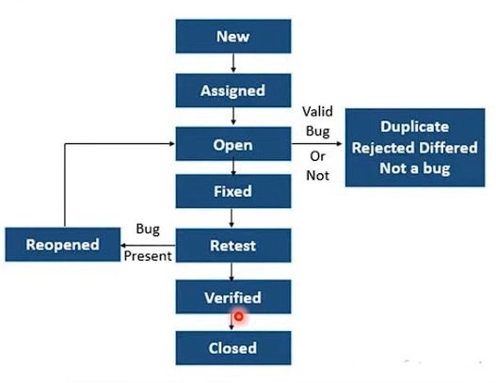
Bug Statuses (Common in Companies)
Status | Meaning
Reopened | Bug still exists after fix
Deferred | Fix postponed
Duplicate | Same bug already exists
Won’t Fix | Accepted risk / not worth fixing
Cannot Reproduce | Bug not reproducible

Sample image of scrum
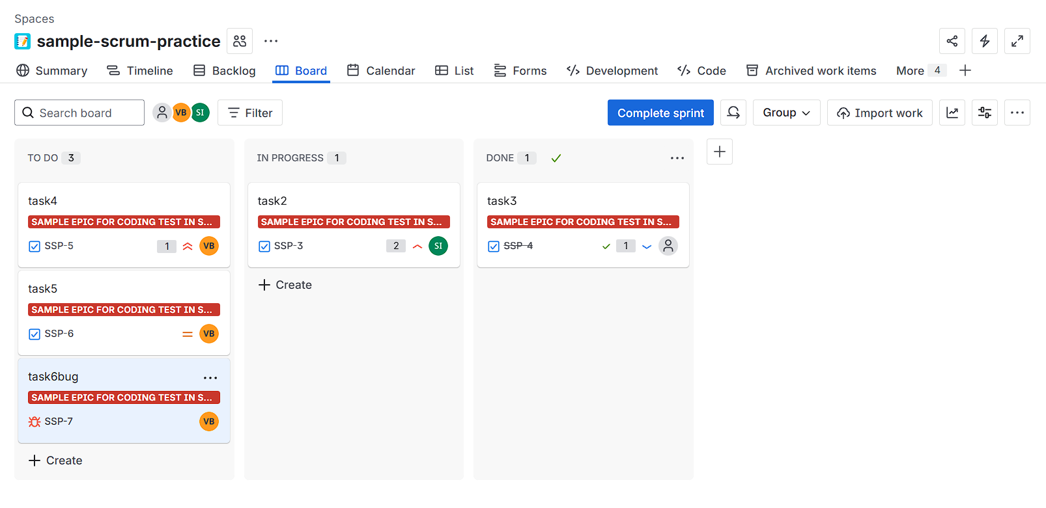
Sample image of kanban
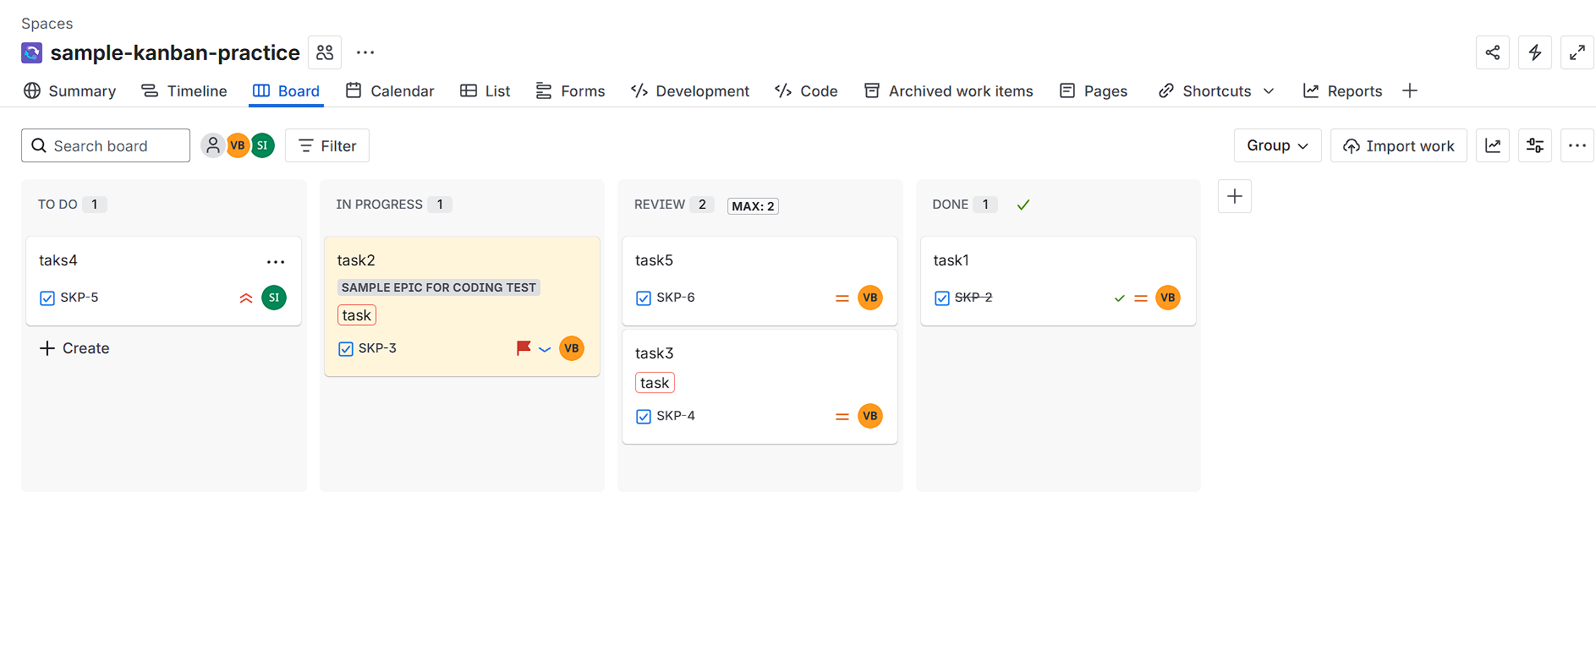
Sample image of kanban Cumulative Flow Diagram

