Sample Jira & Xray Task
Title: Login Task
Description: This task focuses on designing and implementing Register, Login, and Home pages. The work is planned, assigned, and tracked using the Jira Scrum Board to enable effective collaboration among team members. For quality assurance, Xray Test Management is used to create and link both manual and automated test cases to Jira issues, execute them through Test Executions, and track test results. After all test cases are successfully executed and pass, the task is marked as completed.
Activities Included
- Create Register, Login, and Home pages
- Create and assign Jira issues using Scrum methodology
- Collaborate and track progress via Scrum board
- Automatically and manually create Xray test cases
- Link test cases to Jira issues
- Execute tests using Xray Test Execution
- Validate all test cases and close the task after successful execution
Team Members
- Venkateswara Rao B
- Srinu B
Github link:
https://github.com/Venkateswararaobhimasingipractice/login_task_veeva_curriculum.git
Sample image of creating 3 issues and assigning in sprint1.
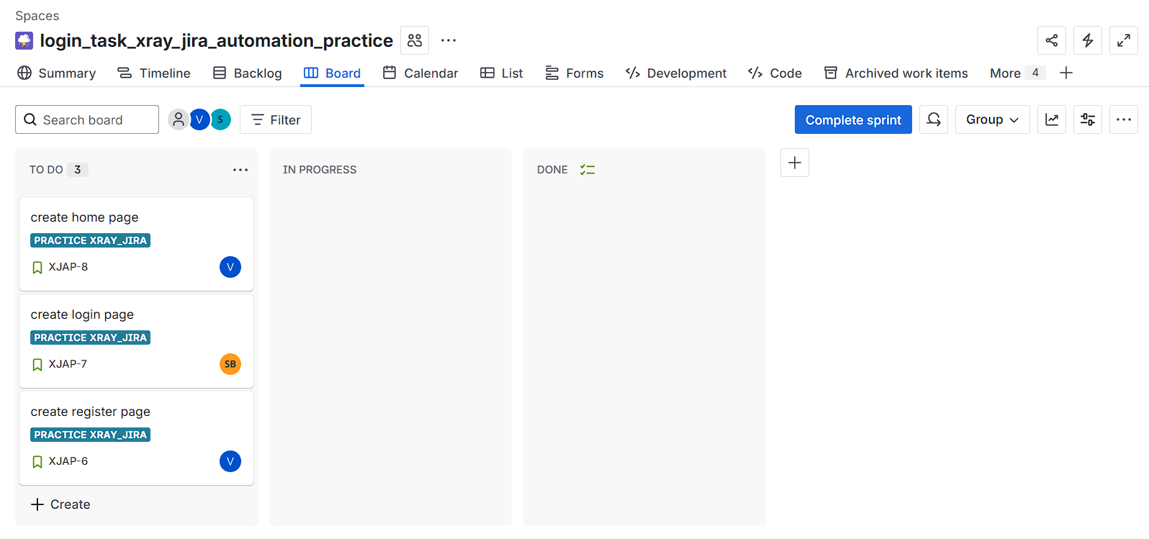
Here register is in-progress by Venkateswara
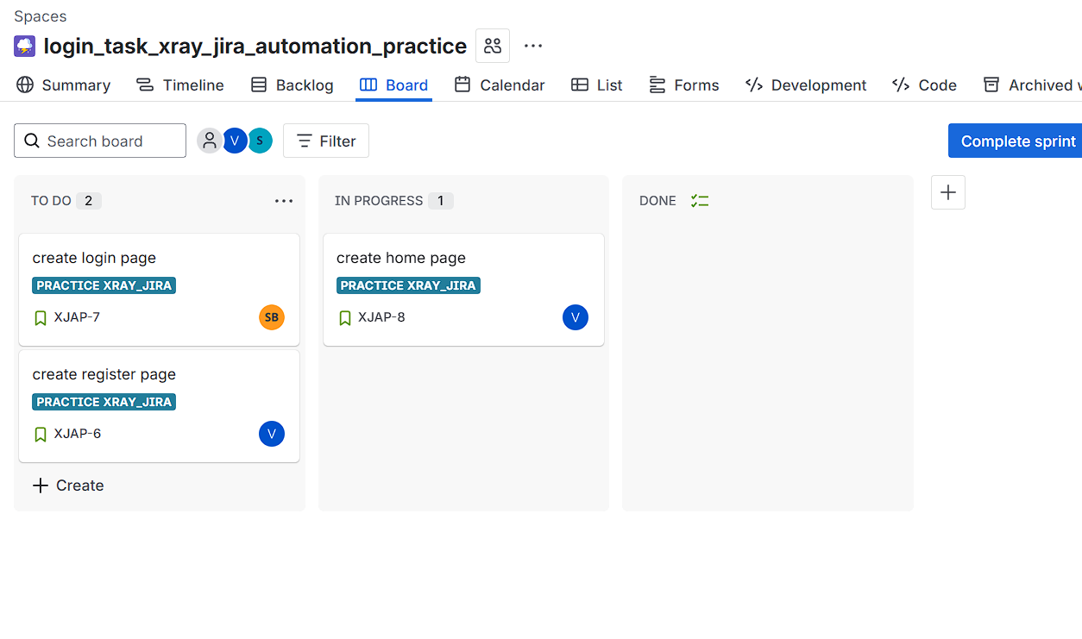
Then an automate trigger is called and create the test and test execution issues
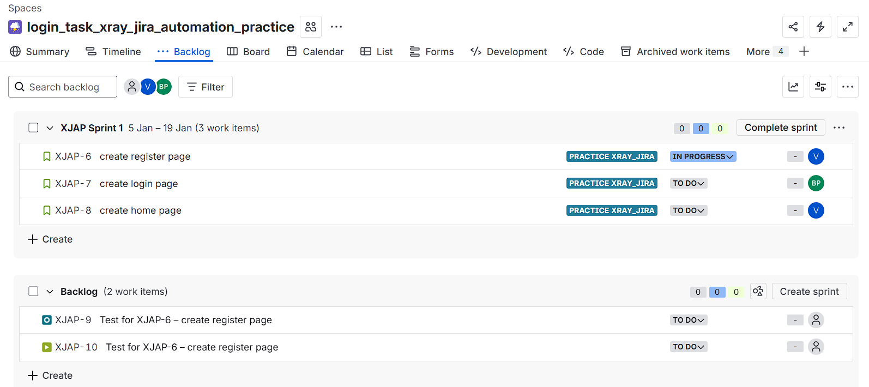
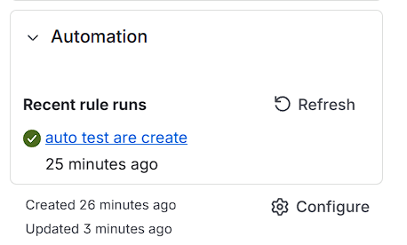
Here manual test case are add by venkateswara
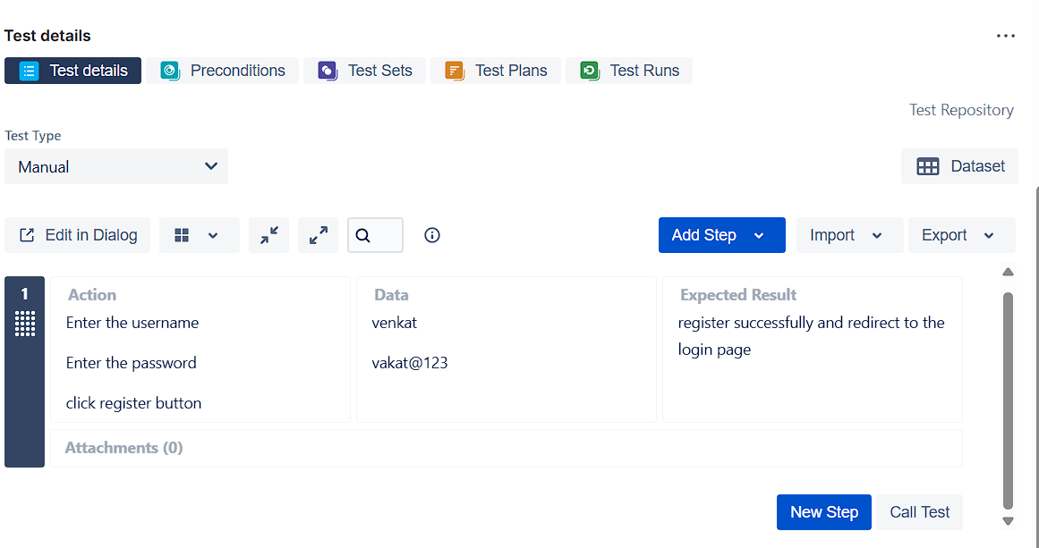
And execution also done by the Venkateswara
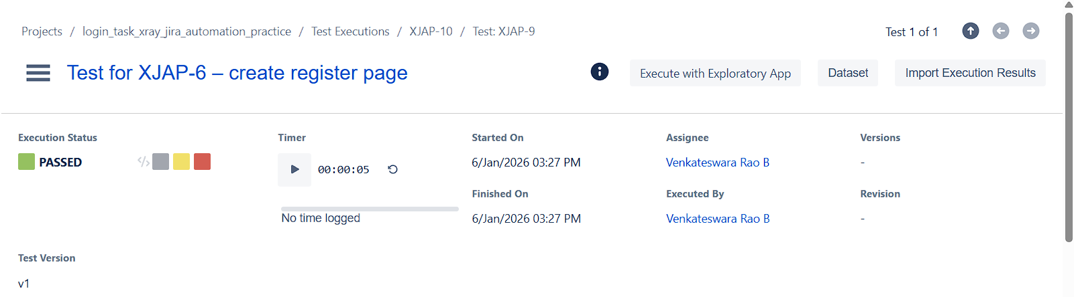

And also in into github
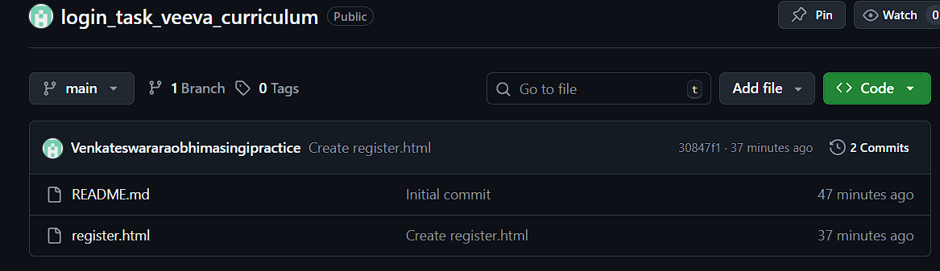

Here srinu also started the work ,the login page issue in progress
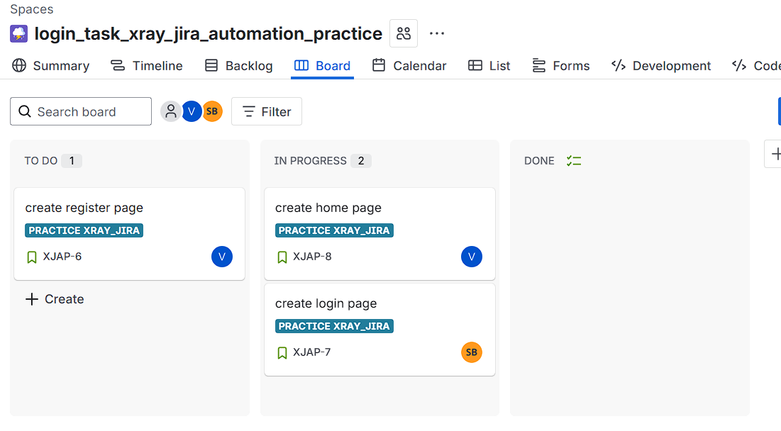
Here automatically the test and test excution are created and here test case are add to the test where that are parameterized test case
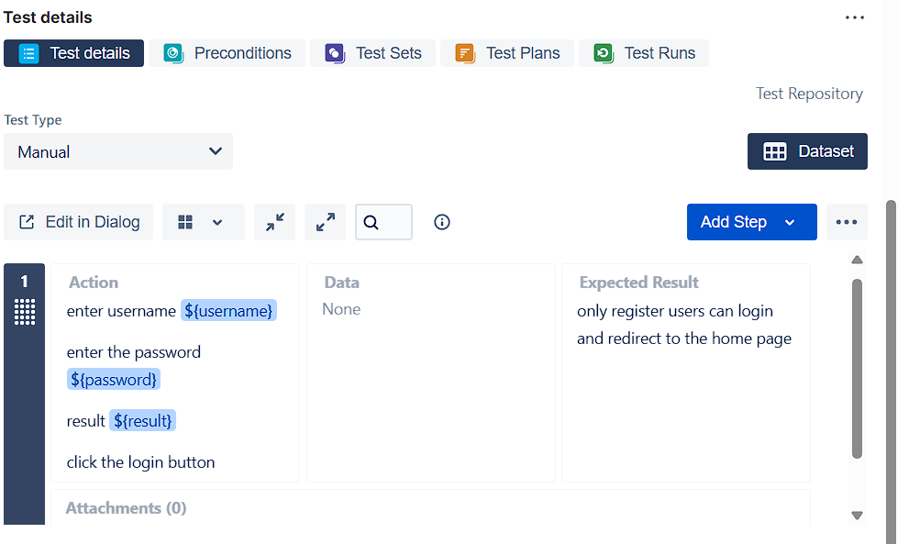

Test execution result are
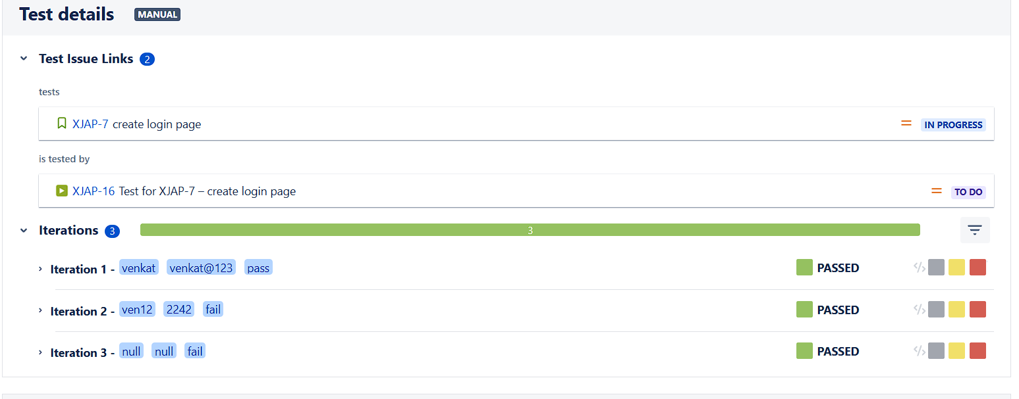
Complete the all the work of login page ,now issues is moved to the done status and also add to github as new branch .

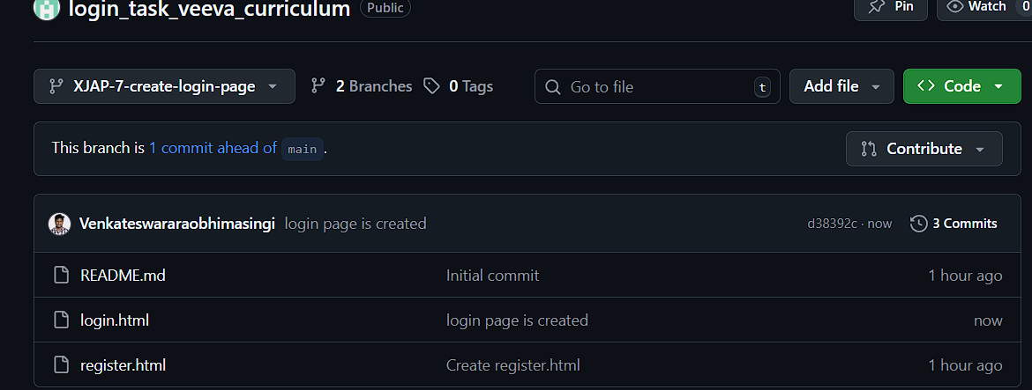

Similar to the home the Venkateswara complete home page issue and sprint all issues are completed
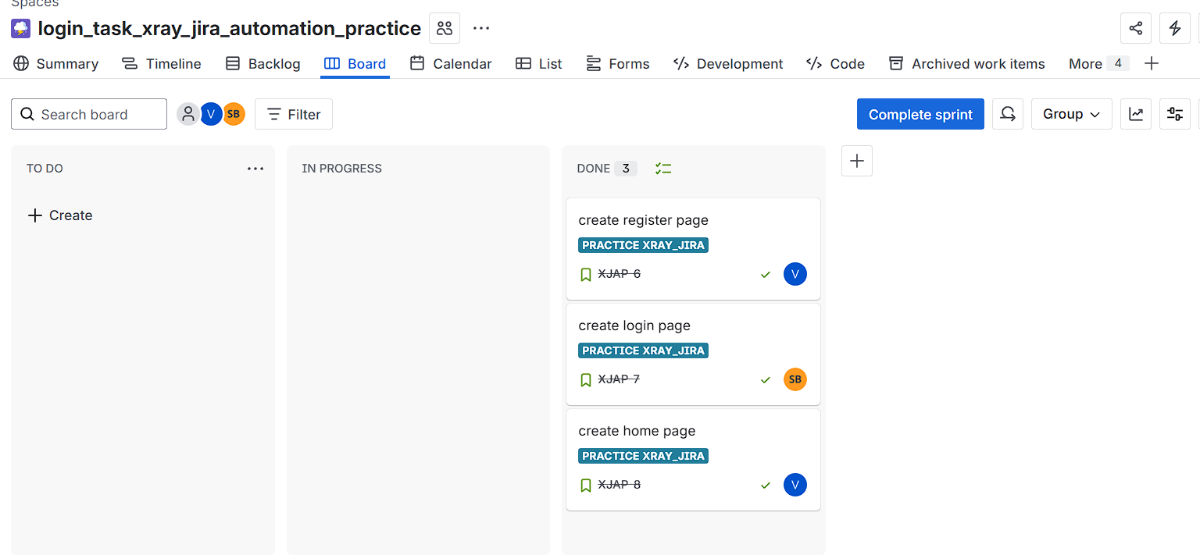
Automation workflow is:
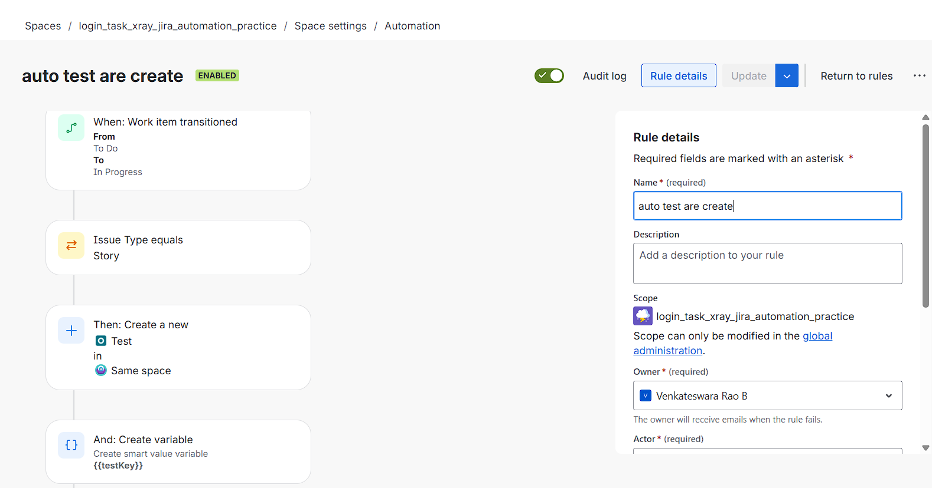
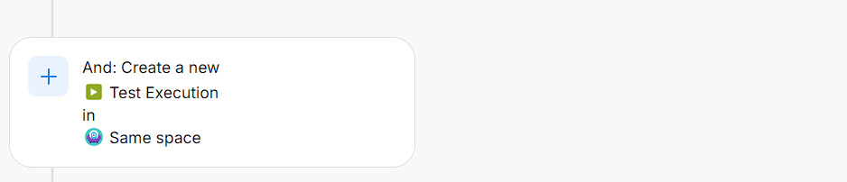

Github:
