Machine Learning

Assignment-1

**Name: Venkat Kalyan Jogu**

**ID: 700755920**

**GitHub Link** :

https://github.com/Venkatkalyan1/ML--assignment1-summer

**Importing the required libraries**

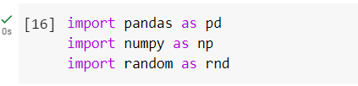

**Question 1**

Read the provided CSV file ‘data.csv’

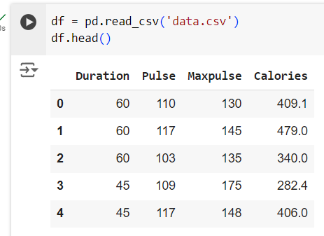

**Question 2**

Show the basic statistical description about the data.

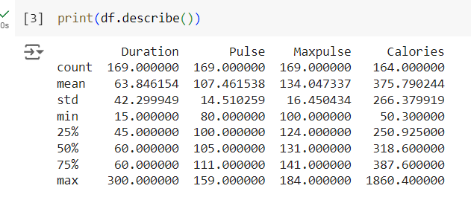

**Question 3**

Check if the data has null values. Replace the null values with the mean

Checking for null values:

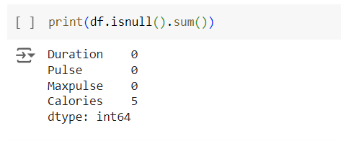

Replacing the null values with the mean :

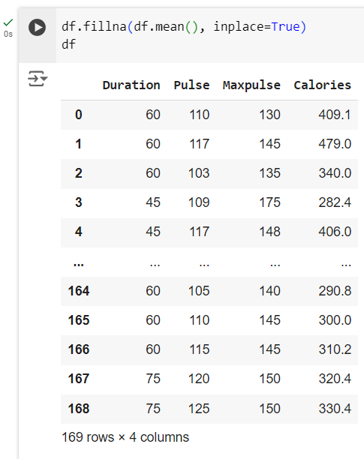

**Question 4**

Select at least two columns and aggregate the data using: min, max, count, mean.

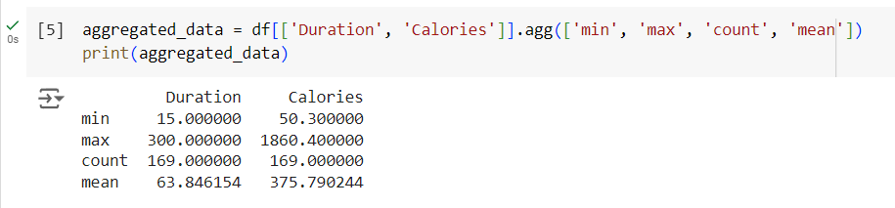

**Question 5**

Filter the dataframe to select the rows with calories values between 500 and 1000.

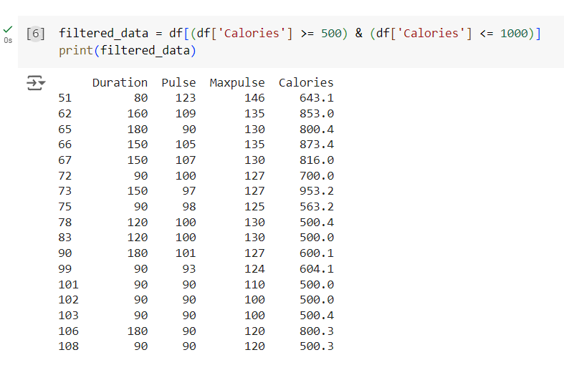

**Question 6**

Filter the dataframe to select the rows with calories values > 500 and pulse < 100.

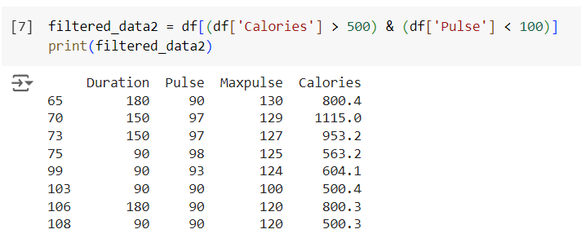

**Question 7**

Create a new “df_modified” dataframe that contains all the columns from df except for “Maxpulse”.

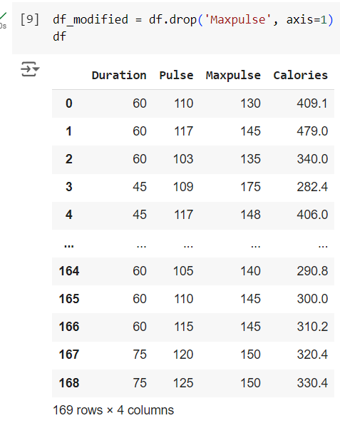

**Question 8**

Delete the “Maxpulse” column from the main df dataframe

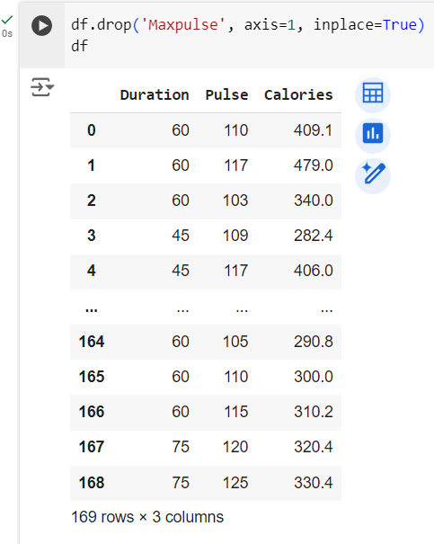

**Question 9**

Convert the datatype of Calories column to int datatype.

