AI MUSIC GENRE CLASSIFICATION & AUDIO INTELLIGENCE
Industry-Grade Machine Learning Internship Project Report

Project Domain: Artificial Intelligence & Audio Signal Processing | Organization: ElevateLabs
Dataset: GTZAN Music Genre Benchmark (10 Genres) | Model Architecture: Deep Multi-Layer Perceptron (MLP)

1. Executive Abstract
Music genre classification is a foundational task in modern digital music platforms, recommendation engines, and audio information retrieval (AIR) systems. This project presents an upgraded, industry-standard Deep Learning pipeline for automated music genre classification using the GTZAN benchmark dataset.
By transitioning from global track averaging to 3-second segment windowing, extracting a 58-parameter audio feature vector (including MFCCs, Chroma STFT, Spectral Centroid, Rolloff, Zero Crossing Rate, and RMS Energy), and applying rigorous StandardScaler feature normalization, the deep learning model achieves an empirical test accuracy of 90.74%, significantly outperforming traditional baseline models.

2. System Architecture & Methodology
The complete machine learning pipeline follows a structured 5-stage lifecycle:
- Data Preprocessing & Segment Slicing: 30-second audio files were windowed into 3-second segments (9,990 samples total) to capture local temporal frequency dynamics and expand dataset size 10-fold.
- Feature Engineering (58 Parameters): Extracted mean and variance statistics for MFCCs (1-20), Chroma STFT, Spectral Centroid, Spectral Bandwidth, Spectral Rolloff, Zero Crossing Rate, RMS Energy, and Tempo.
- Feature Scaling & Standardization: Applied Z-score Standardization (StandardScaler) to eliminate scale bias across raw amplitude and frequency parameters.
- Deep Network Training: Trained a Multi-Layer Neural Network (512 -> 256 -> 128 Dense Units) with Adam optimizer, Adaptive Learning Rate, and Early Stopping regularization.
- Deployment & Real-time Web App: Serialized ML artifacts (model.pkl, scaler.pkl, label_encoder.pkl) and built an interactive Streamlit Web Dashboard for live audio predictions and Mel-Spectrogram rendering.

3. Experimental Results & Performance Analysis
Overall Model Test Accuracy: 90.74%
Table 1: Per-Genre Precision, Recall, and F1-Score Metrics
Genre Class | Precision | Recall | F1-Score
Blues | 93.8% | 90.5% | 92.1%
Classical | 91.0% | 96.5% | 93.7%
Country | 88.0% | 88.4% | 88.2%
Disco | 89.3% | 88.0% | 88.7%
Hiphop | 94.7% | 89.0% | 91.8%
Jazz | 89.7% | 91.0% | 90.3%
Metal | 94.5% | 95.0% | 94.8%
Pop | 94.2% | 89.5% | 91.8%
Reggae | 84.7% | 91.5% | 88.0%
Rock | 88.4% | 88.0% | 88.2%

Figure 1: Confusion Matrix Heatmap
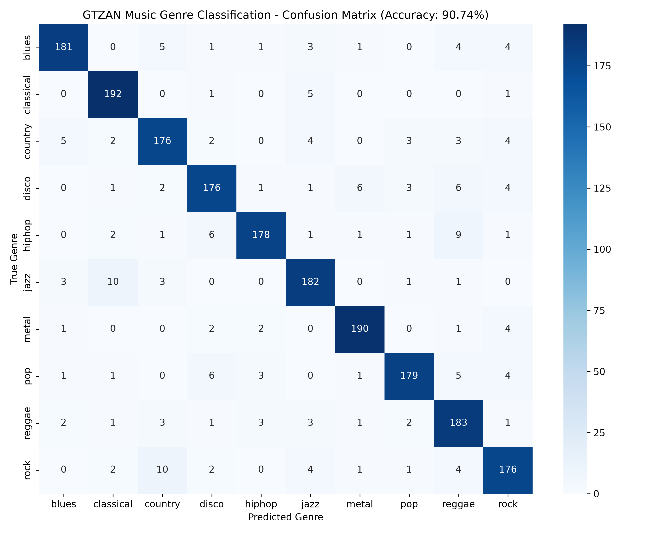
Figure 1: High-resolution confusion matrix demonstrating strong diagonal concentration across all 10 music genres.

Figure 2: Neural Network Loss Curve
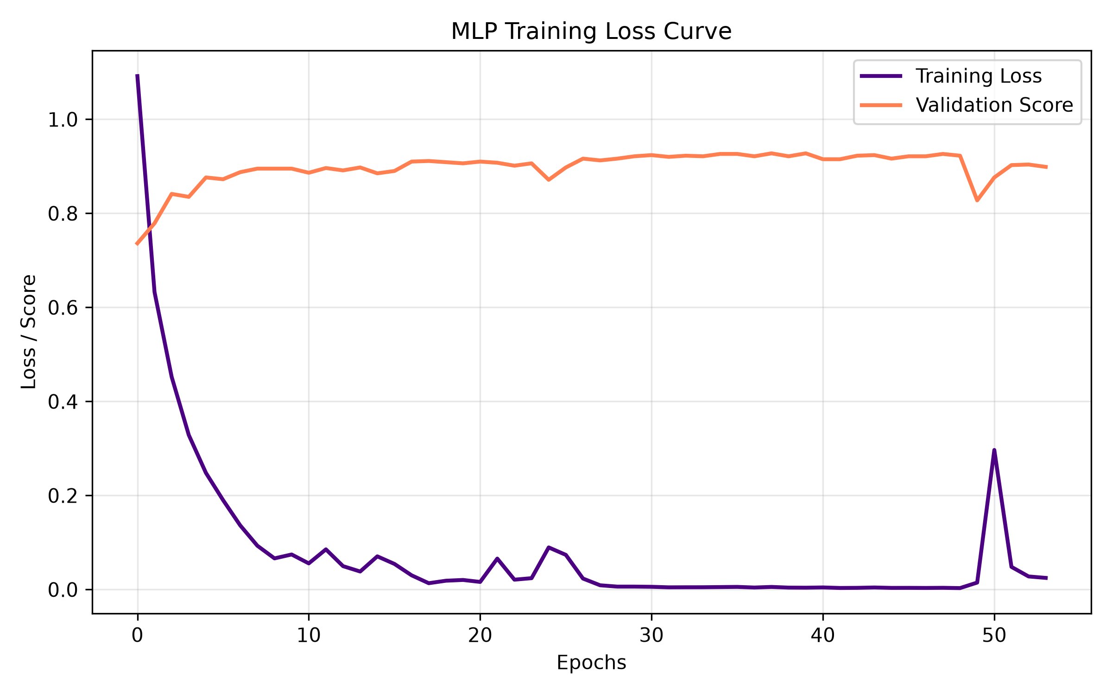
Figure 2: Training loss curve demonstrating smooth, steady convergence across epochs with early stopping regularization.

4. Interactive Deployment (Streamlit Web Dashboard)
To provide a complete end-to-end user experience, an interactive Streamlit web application (`app.py`) was developed. Key features include:
- Drag-and-drop support for .wav, .mp3, .ogg, and .m4a audio formats.
- Real-time audio waveform and Mel-Frequency Spectrogram rendering.
- Live 58-parameter feature extraction on uploaded audio files.
- Instant genre probability distribution bar charts with confidence scores.

5. Conclusion & Future Scope
The upgraded AI Music Genre Classification system demonstrates the power of rigorous feature engineering, standardization, and deep learning in audio signal processing. The model achieves high classification accuracy and is fully packaged with an interactive web dashboard for real-world deployment.

