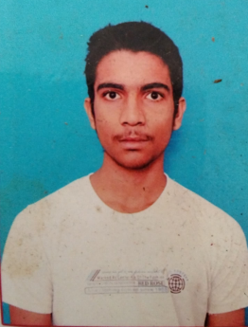

|  |  |
| --- | --- |
|  | **VENKAT DADANI**  Bachelor of Technology  Computer Science and Engineering |

*DOB: 07/06/2001 Email:venkatreddycse996@gmail.com Mobile: +91-7036204656*

***Objective:***

To pursue a challenging career and be apart of progressive organization that gives a scope to enhance my knowledge and utilizing my skills towards the growth of organization .

***Educational Qualifications:***

|  |  |  |  |
| --- | --- | --- | --- |
| **Degree** | **Institute** | **Year** | **Percentage/**  **CGPA** |
| B.Tech (CSE) | Godavari institute of Engineering and technology , Rajahmundry. | 2018-2022 | 8.2(pursuing) |
| Inter | Nri vidya junior college. | 2016-2018 | 92.2% |
| Matriculation | Honey high school  Kanigiri. | 2016 | 8.8(CGPA) |

***Technical Skills:***

* **Programming Languages :** C , Core JAVA
* **Operating Systems :** Windows, Linux
* **Web technologies :** HTML5,CSS, JS, Angular, SQL

***Personal Skills :***

* Team leading.
* Self Learner
* Passionate towards the work
* Self Confidence
* Risk Management Skills
* Problem solving

***Achievements :***

* Got first place in the interactive web designing at college level.
* Sectionstudy certified in Javascript programming(Advanced level) as intermediate .
* Bit degree certified in Html and Css.
* Certification on Java programming from Spoken tutorials by IIT Bombay.
* Certification on python programming from spoken tutorials by IIT Bombay.
* Participated in college Ideathon , and my idea was selected.

***Experience :***

* Worked as a Full Stack developer intern at Biztime IT solutions for two months to develop an Enterprise Application. I have worked on the Most of the UI part Using the Angular, HTML, CSS, Bootstrap, JS. ( June/2021- July/2021 )
* Worked as a Full Stack developer intern at CalculatorHut.com for one month And developed Calculators to find some solutions for the physics , Mathematics etc Using the HTML, CSS, Bootstrap, JS. (Aug/2021)
* Working as a Full Stack web developer intern at Edu moon ( Sept/2021- currently working)

***Personal details :***

**Name : VENKAT DADANI**

**Website : https://venkatreddy1027.github.io/Venkatreddy.github.io/**

**Gender :** Male

**Date of Birth : 07/06/2001**

**Nationality :** Indian

**Marital Status** **:** Un-married

**Languages Known :** English , Telugu & Hindi

**Hobbies :**  Surfing internet, playing chess and Badminton ,Listening

Music, Script writing.

**Permanent Address :**  venkatreddy dadani,

S/o. srinivasulu dadani,

D.NO: 1-39/c,

G .mekapadu,

Kandukur (M),

Prakasam District,

Andhra Pradesh,

523111.

***Declaration***:

All information in this resume is true and correct to the best of my knowledge and belief and I shall be thankful to your company if I was into it.

VENKAT DADANI