**Serverless IoT Data Processing**

**Problem Definition and Design Thinking**

# **Introduction**

Serverless computing is also known as Function as a Service (FaaS) and represents an emerging

category of cloud computing, which allows developers to implement and deploy business

applications as a composition of stateless functions. It does not represent the absence of

physical servers, as they continue to exist. In turn, for developers, it means they do not need

to worry about server management. The main benefit is that developers do not need

to manage underlying services and operating systems, as this is responsibility of the FaaS

platform that also provides transparent scalability mechanisms. Platforms automatically scale to

zero when there is no function running, thus avoiding waste of resources. In turn,

Internet of Things (IoT) comes as another trending concept that is closely related to ubiquitous

computing, which allows physical objects (things) to “talk” to each other while exchanging

information through the Internet . Although originally proposed for the cloud,

serverless computing can be a great ally for IoT as FaaS platforms can be placed physically closer

to sensors and actuators, on edge and fog layers, in order to run functions with lower latency.

This is specially important for mission-critical scenarios that cannot rely on Internet connection.

For other scenarios, when intermittent connection is not a problem, functions can also be

executed on more than a single layer and benefit from traditional cloud serverless platforms,

that provide the illusion of infinite resources for processing huge workloads of IoT data produced

by sensors.

# **Problem Definition**

The problem of serverless IoT data processing involves efficiently handling and analyzing the vast amounts of data generated by Internet of Things (IoT) devices without the need for traditional server infrastructure. Key challenges in this context include:

* ***Scalability****:* IoT generates massive volumes of data, and serverless solutions must be able to scale dynamically to accommodate variable workloads.

* ***Real-time Processing****: Many IoT applications require real-time data processing and decision-making, necessitating low-latency serverless architectures.*

* ***Cost******Management*** *: Serverless computing can help reduce infrastructure costs, but optimizing the costs associated with serverless functions, storage, and data transfer is crucial.*

* ***Data Ingestion****: Efficiently collecting data from diverse IoT devices and protocols while ensuring data integrity and security.*

* ***Data Transformation****: Processing and transforming raw IoT data into actionable insights, including filtering, aggregation, and enrichment.*

* ***Event Triggering****: Setting up event-driven workflows to respond to specific IoT events or anomalies in real time.*

* ***Data Storage****: Choosing the right storage solutions (e.g., NoSQL databases, object storage) for storing IoT data based on access patterns and retention requirements.*

* ***Security and Compliance****: Ensuring the confidentiality, integrity, and availability of IoT data, and compliance with relevant regulations (e.g., GDPR, HIPAA).*

* ***Monitoring and Debugging****: Implementing robust monitoring and debugging mechanisms for serverless functions and data pipelines.*

* ***Integration****: Integrating IoT data processing with other systems, applications, or cloud services for comprehensive IoT solutions.*

*Solving these challenges requires a well-architected serverless framework, appropriate tooling, and a deep understanding of both IoT domain-specific requirements and serverless technologies such as AWS Lambda, Azure Functions, or Google Cloud Functions.*

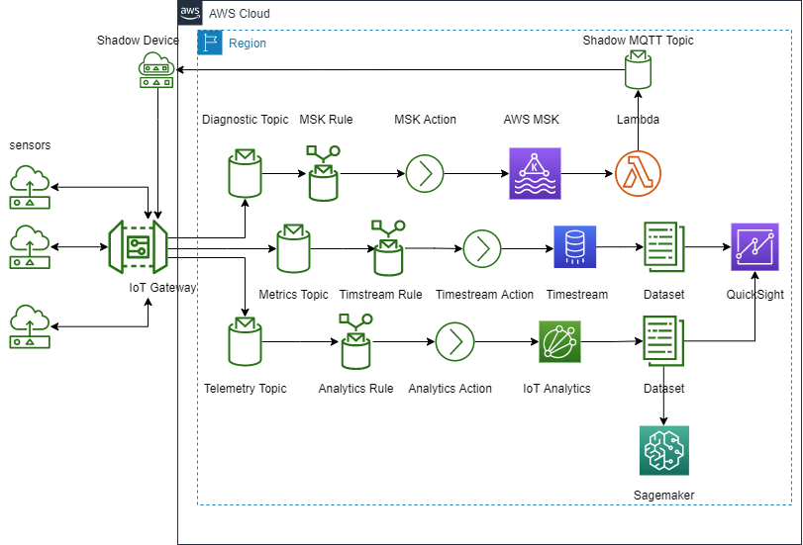

# **Design Thinking**

*Design thinking is a user-centric approach to problem-solving that can be applied to serverless IoT data processing as follows:*

*1.* ***Empathize****:*

*- Understand the needs of IoT stakeholders, such as end-users, operators, and developers.*

*- Identify pain points and challenges in IoT data processing.*

*2.* ***Define****:*

*- Clearly define the problem you’re trying to solve in IoT data processing.*

*- Set specific goals and objectives for your serverless architecture.*

*3.* ***Ideate****:*

*- Brainstorm serverless solutions for IoT data processing, considering scalability, latency, and cost-efficiency.*

*- Encourage creative thinking and consider various serverless technologies like AWS Lambda, Azure Functions, or Google Cloud Functions.*

*4.* ***Prototype****:*

*- Create a small-scale prototype of your serverless IoT data processing system.*

*- Test it with sample IoT data to ensure it meets the defined objectives.*

*5.* ***Test****:*

*- Collect feedback from stakeholders and refine your serverless prototype based on their input.*

*- Ensure that the IoT data processing system is robust, secure, and compliant with regulations.*

*6.* ***Implement****:*

*- Develop the full-scale serverless IoT data processing solution based on the refined prototype.*

*- Choose the appropriate serverless platform and programming languages for your use case.*

*7.* ***Iterate****:*

*- Continuously improve your IoT data processing system based on real-world usage and feedback.*

*- Monitor serverless functions for performance and reliability.*

*8.* ***Deploy****:*

*- Deploy your serverless architecture for IoT data processing to a production environment.*

*- Implement automated scaling and monitoring to handle varying workloads.*

*9.* ***Evaluate****:*

*- Assess the effectiveness of your serverless solution in meeting the defined objectives.*

*- Gather data on its performance, cost savings, and user satisfaction.*

*10.* ***Refine****:*

*- Make necessary refinements to optimize serverless functions, improve data processing, and reduce costs.*

*- Consider future enhancements and innovations in serverless and IoT technologies.*

# **Conclusion**

# 

*Throughout this design thinking process, it’s crucial to involve cross-functional teams, including IoT experts, cloud architects, and end-users, to ensure a well-rounded and user-friendly serverless IoT data processing solution.*