**Serverless IoT Data Processing**

**Innovation to solve the Problem**

# **Introduction**

What is serverless computing? Serverless computing enables developers to build applications faster by

eliminating the need for them to manage infrastructure. With serverless applications, the cloud service

provider automatically provisions, scales, and manages the infrastructure required to run the code.

Make the complexities of data management a thing of the past. Protect and

connect your organization's data without the weight of legacy systems holding

you down. Data-first leaders cut through the tangle of today’s data

management complexities with a cloud operational experience powered by

data-driven, AI-based tools. The upshot: more customer innovation, enterprise

risk mitigation, and happier business stakeholders.

# **Innovation**

Certainly, serverless IoT data processing presents various challenges that can be addressed through innovation. Here are some ideas:

1. **Real-time Data Analysis**: Develop serverless functions that can process IoT data in real-time. Use technologies like AWS Lambda, Azure Functions, or Google Cloud Functions to analyze incoming data streams for anomalies, trends, or critical events.

1. **Auto-Scaling**: Implement auto-scaling mechanisms to handle varying data loads efficiently. Serverless platforms like AWS Lambda can automatically scale functions based on demand, reducing operational overhead.

3. **Edge Computing**: Combine serverless with edge computing to process data closer to the source. This reduces latency and bandwidth requirements, making it suitable for applications requiring rapid response times.

1. **Data Transformation**: Create serverless functions to transform raw IoT data into a structured format, making it easier to store and analyze. Tools like AWS Step Functions can help orchestrate data processing workflows.

1. **Predictive Maintenance**: Use machine learning models within serverless functions to predict equipment failures. These predictions can trigger proactive maintenance, minimizing downtime.

1. **Security and Authentication**: Innovate in security by implementing serverless-based authentication and authorization mechanisms to ensure that only authorized devices can send and receive IoT data.

1. **Data Compression and Aggregation:** Develop serverless functions that compress and aggregate IoT data before storage or analysis. This reduces storage costs and speeds up processing.

1. **Integration with Third-Party Services**: Leverage serverless functions to integrate IoT data with external services like weather APIs, social media platforms, or industry-specific data sources to gain deeper insights.

1. **Serverless Databases**: Explore serverless database options like AWS DynamoDB or Azure Cosmos DB to store and retrieve IoT data efficiently without managing database infrastructure.

1. **Cost Optimization**: Continuously monitor and optimize serverless function usage to minimize costs. Use tools like AWS Cost Explorer or Azure Cost Management for insights.

1. **Data Retention Policies**: Implement policies for automatically archiving or deleting older IoT data to avoid storage cost overruns.

1. **Monitoring and Alerting**: Develop serverless-based monitoring and alerting systems to proactively identify issues or anomalies in IoT data processing.

1. **Blockchain Integration**: Consider using serverless to integrate blockchain technology for secure and immutable IoT data storage and verification.

1. **Serverless** **Frameworks**: Explore serverless frameworks like Serverless Framework or AWS SAM to streamline development, deployment, and management of IoT data processing solutions.

1. **Edge** **AI**: Combine serverless with edge AI capabilities to perform on-device analytics, reducing the need to transmit raw data to central servers.

# **Unlock more value for your data**

How do you unlock the value of your data, even when your data sets are vast,

massively diverse, and entangled across many applications? Unifying your

data, no matter where it lives, makes it more valuable to you. Modernize data

first to open up new opportunities for your business.

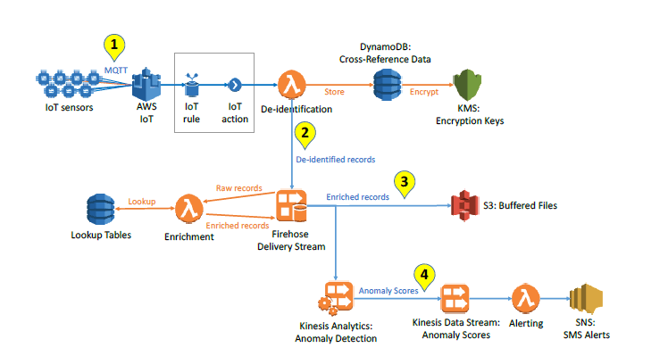

# **Uncover insights hidden in your data**

What percentage of your data never gets analyzed? What vital insights are hidden in your data? Create a single source of truth and turn data into real-time insights for smarter decision making to help your business grow.

Internet of Things (IoT) is a popular expression widely used to encompass the many related

networking and application aspects. It involves the extension of Internet connectivity to objects

beyond traditional computing devices.

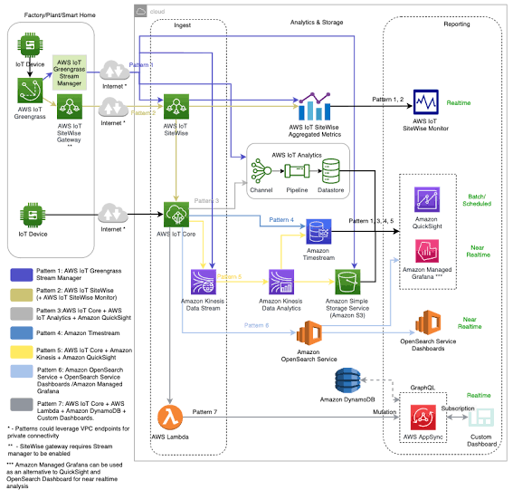

# **Conclusion**

Innovating in these areas can help address challenges in serverless IoT data processing and create more efficient and scalable solutions. Keep in mind that the choice of serverless platform and technologies may vary depending on your specific use case and requirements.

Conclusion, IoT and cloud computing are combined to produce strong, scalable solutions that can

process and analyze the enormous amounts of data produced by IoT devices, empowering businesses to

make better decisions and boost operational effectiveness.