Title: AI-Powered Customer Retention Prediction System
Tools: Used Python Libraries like Numpy, Pandas, Matplotlib
Dataset: /content/WA_Fn-UseC_-Telco-Customer-Churn.csv

1. Introduction

Overview of the Dataset:

This dataset contains information about customers of a telecom company. It includes details like customer ID, gender, whether they are senior citizens, and their personal situation such as having a partner or dependents. The dataset also shows which services the customers use, including phone, internet, streaming, and tech support. It contains information about their payment method, monthly charges, and total charges. Finally, it shows whether the customer has stayed with the company or has left, which is recorded as churn.

The dataset provides a mix of numeric and categorical information, which makes it useful for understanding customer behavior. By exploring this data, we can see patterns in how customers use different services, how long they stay with the company, and what factors might influence their decision to leave or stay. This information is valuable for making business decisions.

Objective / Purpose of the Analysis:

The main goal of this analysis is to understand customer behavior and identify reasons why some customers leave the company. By analyzing the dataset, we can find patterns and factors that influence customer churn. This information can help the company take action to retain customers, improve services, and reduce the number of customers who leave.

In addition, the analysis can help the company segment its customers based on behavior and preferences. This allows the company to create better-targeted offers, improve customer satisfaction, and make more informed decisions about service improvements and marketing strategies.

2. Dataset Information

Source of the Dataset:

The dataset contains customer information collected by a telecom company. It is used to analyze customer behavior, understand service usage, and identify factors that influence whether customers stay or leave.

Number of Rows and Columns:

The dataset has a total of 7,043 rows and 21 columns. Each row represents a single customer, and each column represents a specific detail about the customer, such as personal information, services used, charges, and whether they have churned.

File Format and Size:

The dataset is stored in a CSV file format, which is easy to open and work with in tools like Excel or Python. The file Size is 954 KB and Total Cells in Excel is 147,903, making it manageable for analysis on most computers.
3. Column Details

List of Columns and Data Types of Each Column

customerID | object
gender | object
SeniorCitizen | int64
Partner | object
Dependents | object
tenure | int64
PhoneService | object
MultipleLines | object
InternetService | object
OnlineSecurity | object
OnlineBackup | object
DeviceProtection | object
TechSupport | object
StreamingTV | object
StreamingMovies | object
Contract | object
PaperlessBilling | object
PaymentMethod | object
MonthlyCharges | float64
TotalCharges | float64
Churn | object

Here:

Total list of columns: 21

Object Columns: customerID, gender, Partner, Dependents, PhoneService, MultipleLines, InternetService, OnlineSecurity, OnlineBackup, DeviceProtection, TechSupport, Streaming TV, StreamingMovies, Contract, PaperlessBilling, PaymentMethod, Churn.

Total Object Columns: 17

Numerical Columns: [int64: SeniorCitizen, Tenure]
[Float64: MonthlyCharges,TotalCharges]

Total Numerical Columns: 4

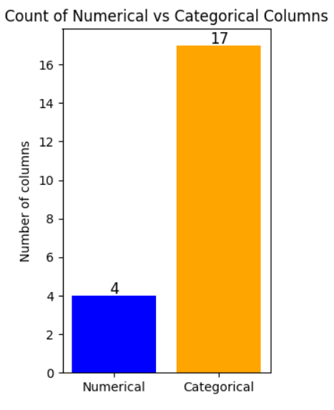

4. Missing Values Analysis

Columns with Missing Data:

In this dataset, only the TotalCharges column has missing values. All other columns have complete data with no missing entries.

Count of Missing Values:

There are a total of 11 missing values in the TotalCharges column. These missing values need to be handled before performing any analysis or model building to ensure accurate results.

Column name: TotalCharges
Count: 11 null count

Visualization of Missing Values:

A bar chart was used to visualize the missing values in the dataset. The chart clearly shows that only the TotalCharges column has missing data, while all other columns have no missing values. This helps to easily identify and confirm where data cleaning is required.

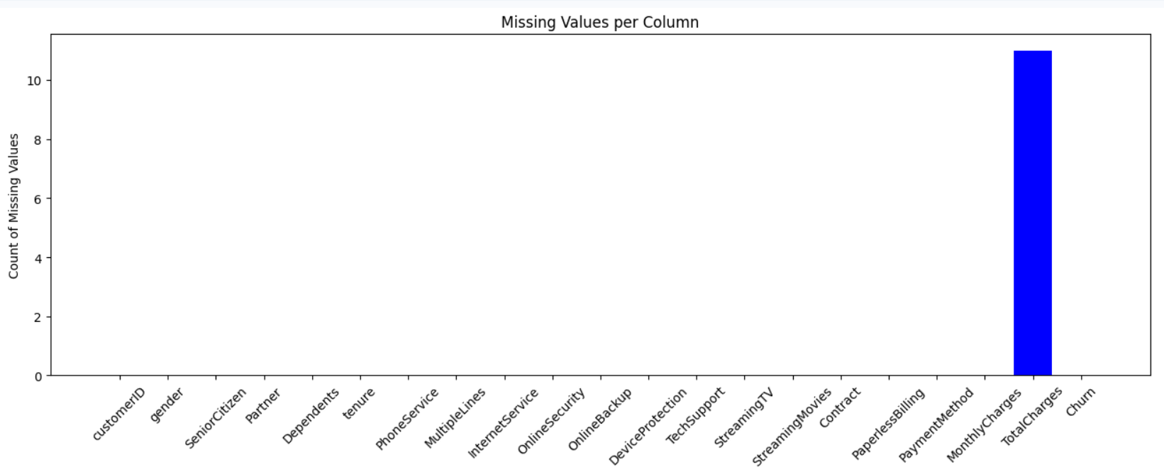

5. Unique Values Analysis
Number of Unique Values in Each Categorical Columns
Column_name and Values: gender and ['Male': 3555, 'Female': 3488]
Column_name and Values: Partner and ['No': 3641, 'Yes': 3402]
Column_name and Values: Dependents and ['No': 4933, 'Yes': 2110]
Column_name and Values: PhoneService and ['Yes': 6361, 'No': 682]
Column_name and Values: MultipleLines and ['No': 3390, 'Yes': 2971, 'No phone service': 682]
Column_name and Values: InternetService and ['Fiber optic': 3096, 'DSL': 2421, 'No': 1526]
Column_name and Values: OnlineSecurity and 'No': 3498, 'Yes': 2019, 'No internet service': 1526]
Column_name and Values: OnlineBackup and ['No': 3088, 'Yes': 2429, 'No internet service': 1526]
Column_name and Values: DeviceProtection and ['No': 3095, 'Yes': 2422, 'No internet service': 1526]
Column_name and Values: TechSupport and ['No': 3473, 'Yes': 2044, 'No internet service': 1526]
Column_name and Values: StreamingTV and ['No': 2810, 'Yes': 2707, 'No internet service': 1526]
Column_name and Values: StreamingMovies and ['No': 2785, 'Yes': 2732, 'No internet service': 1526]
Column_name and Values: Contract and ['Month-to-month': 3875, 'Two year': 1695,
'One year': 1473]
Column_name and Values: PaperlessBilling and ['Yes': 4171, 'No': 2872]
Column_name and Values: PaymentMethod and ['Electronic check': 2365, 'Mailed check': 1612, 'Bank transfer (automatic)': 1544, 'Credit card (automatic)': 1522]
Column_name and Values: Churn and ['No': 5174, 'Yes': 1869]

Gender: Partner:

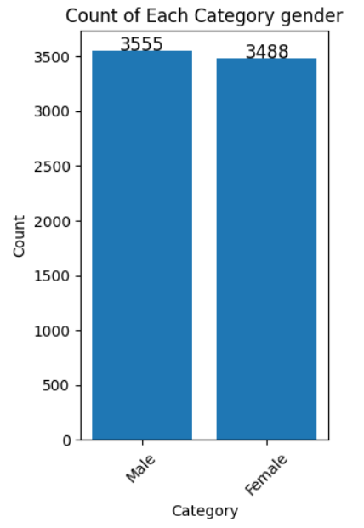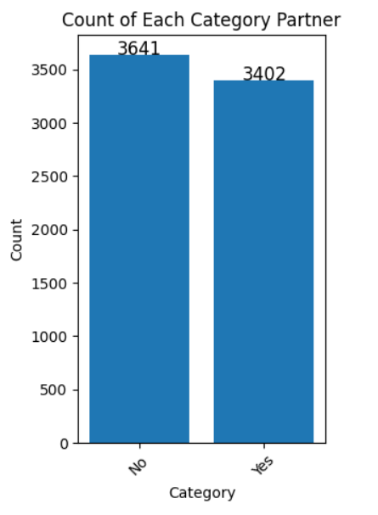

Dependents: PhoneService:

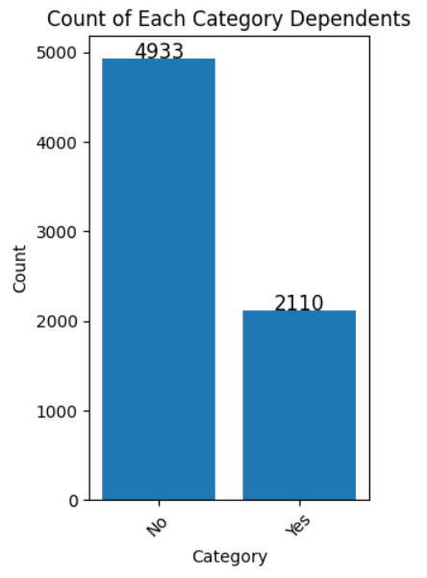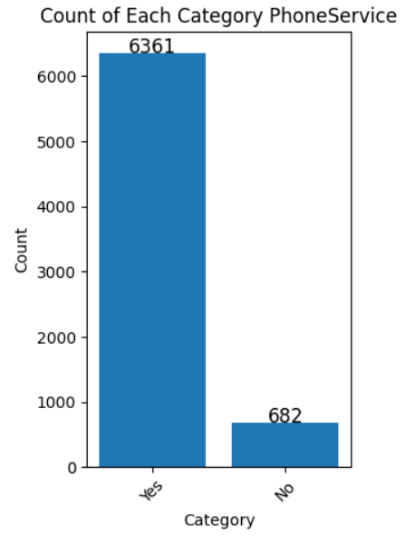

MultipleLines: InternetService:

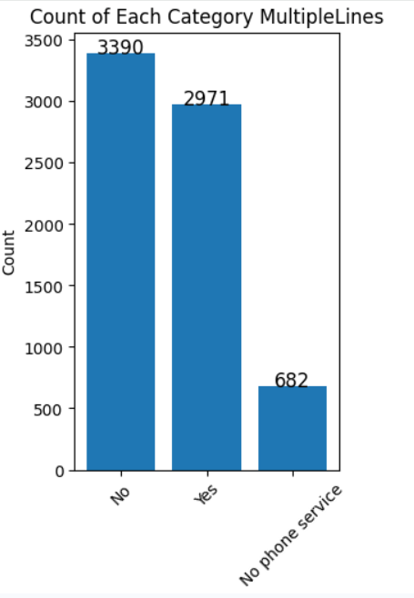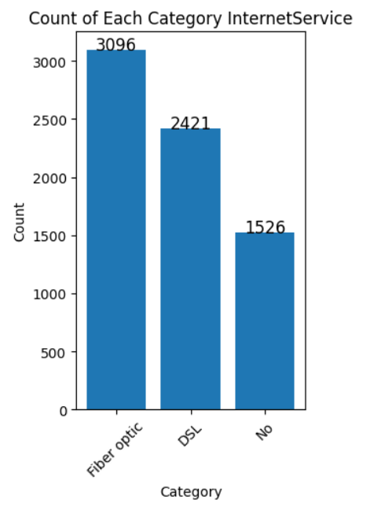

OnlineSecurity: OnlineBackup:

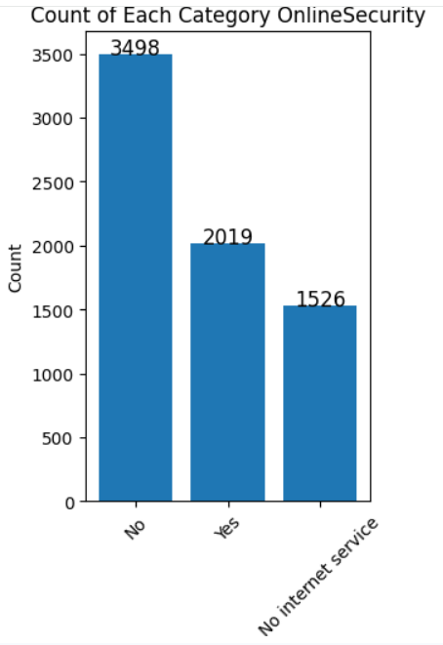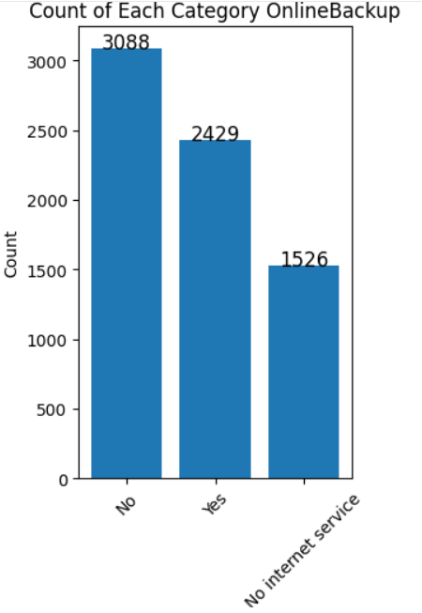

DeviceProtection: TechSupport:

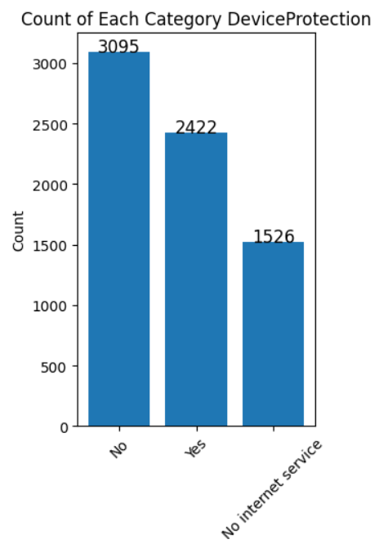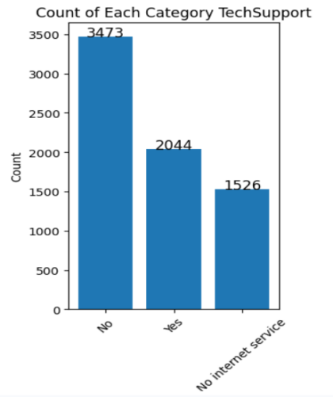

StreamingTV: StreamingMovies:

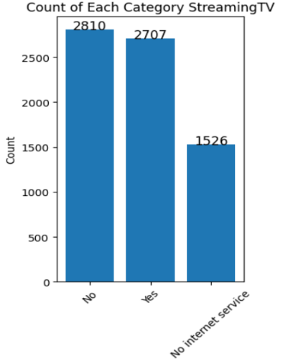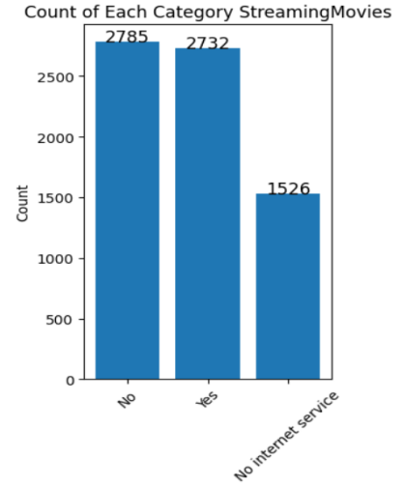

Contract: PaperlessBilling:

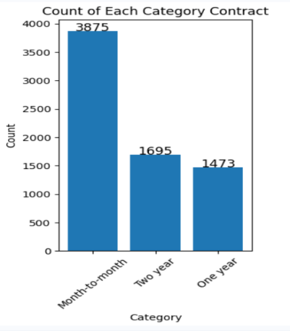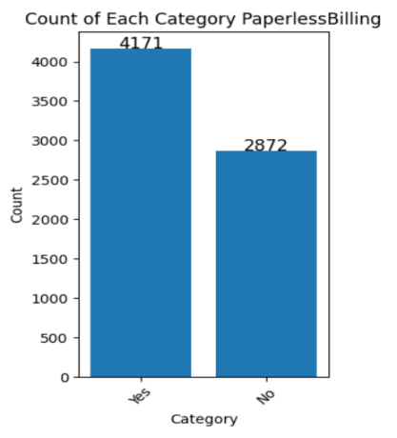

PaymentMethod: Churn:

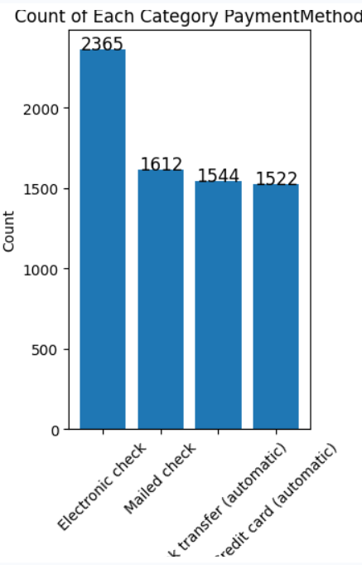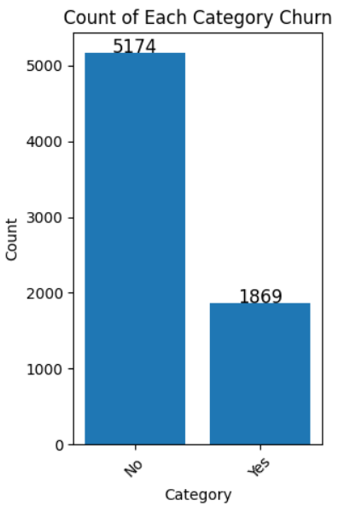

6. Statistics on Numerical Columns

Summary Statistics (Mean, Median, Min, Max, Std)

column Name : SeniorCitizen
count 7043.000000
mean 0.162147
std 0.368612
min 0.000000
max 1.000000
Name: SeniorCitizen, dtype: int64

column Name : tenure
count 7043.000000
mean 32.371149
std 24.559481
min 0.000000
max 72.000000
Name: tenure, dtype: int64

column Name : MonthlyCharges
count 7043.000000
mean 64.761692
std 30.090047
min 18.250000
max 118.750000
Name: MonthlyCharges, dtype: float64

column Name : TotalCharges
count 7032.000000
mean 2283.300441
std 2266.771362
min 18.800000
max 8684.800000
Name: TotalCharges, dtype: float64

7. Numerical Data Insights

Distribution of Numerical Columns

The dataset has four numerical columns: SeniorCitizen, tenure, MonthlyCharges, and TotalCharges. These columns contain numeric data that can be analyzed to understand customer behavior and patterns.

Outlier Detection

Outlier detection was performed for all numerical columns. The SeniorCitizen column has 1142 outliers, while the other numerical columns tenure, MonthlyCharges, and TotalCharges do not have any outliers. This indicates that the SeniorCitizen data contains some extreme values that may need attention during analysis, whereas the other columns are well-behaved.

Visualization:

SeniorCitizen: tenure:

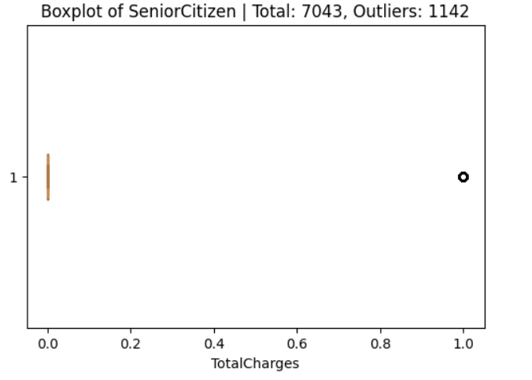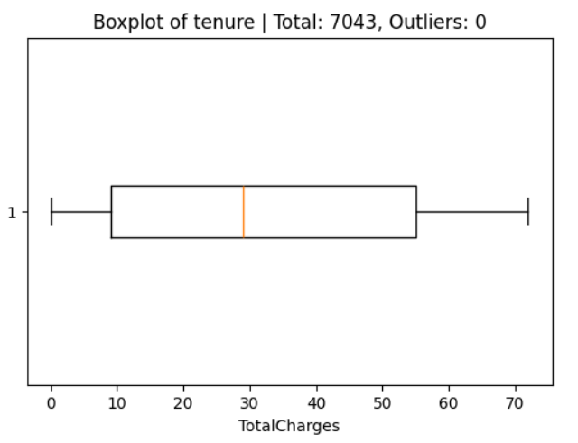

MonthlyCharges: TotalCharges:

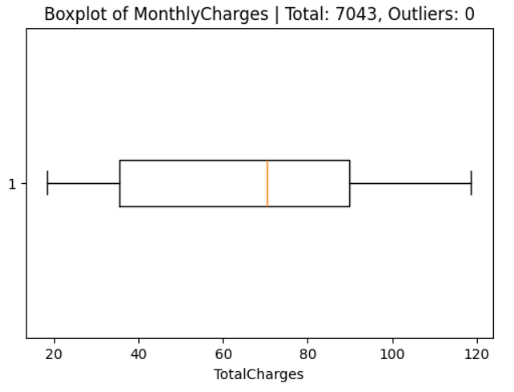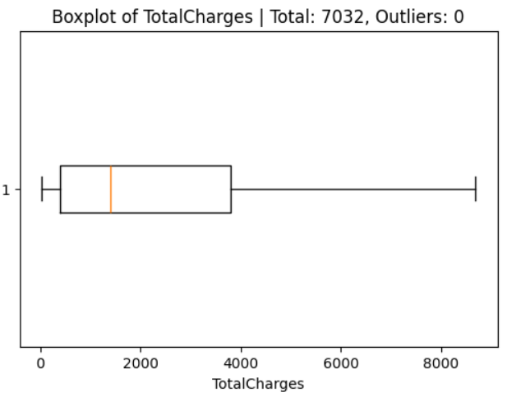

- Churn Distribution Percentage Rate

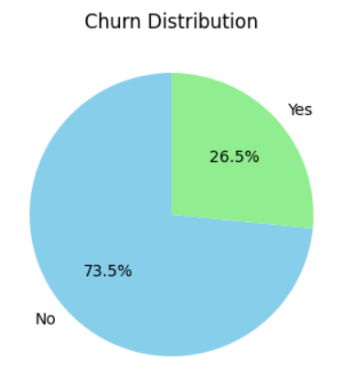

- Churn Count by all values

Churn Count by Gender: Churn Count By Seniorcitizen

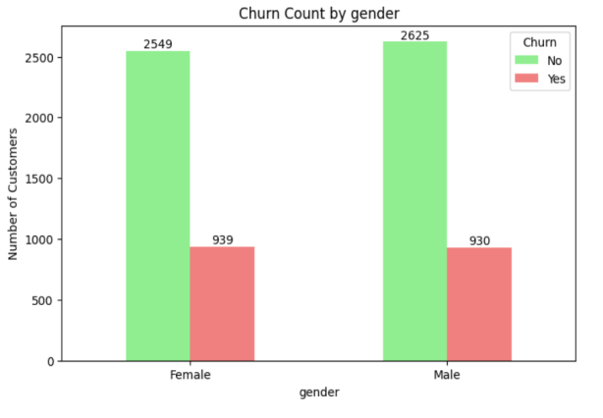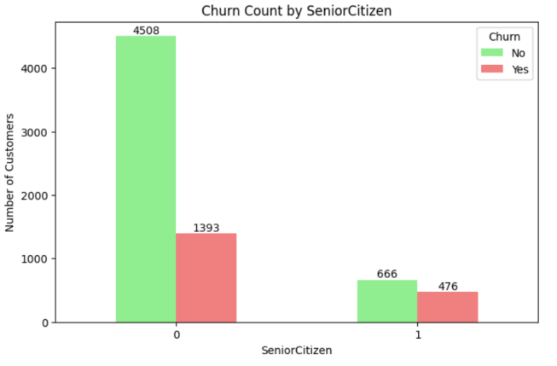

Churn Count by Partner: Churn Count by Dependents:

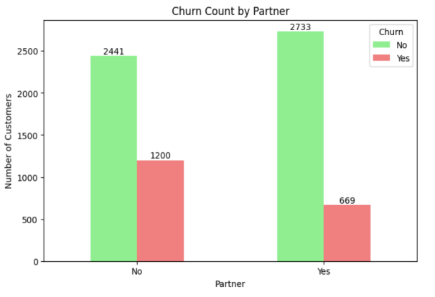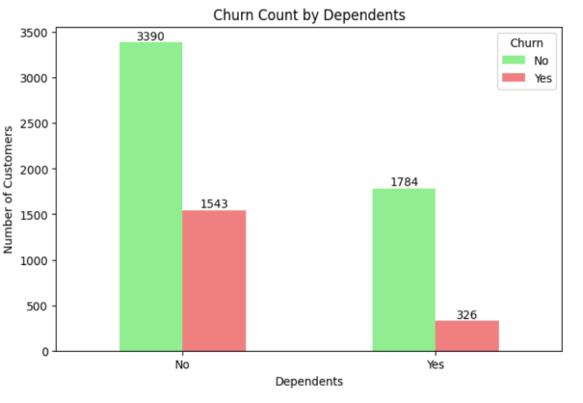

Churn Count by PhoneService: Churn Count by MultipleLines:

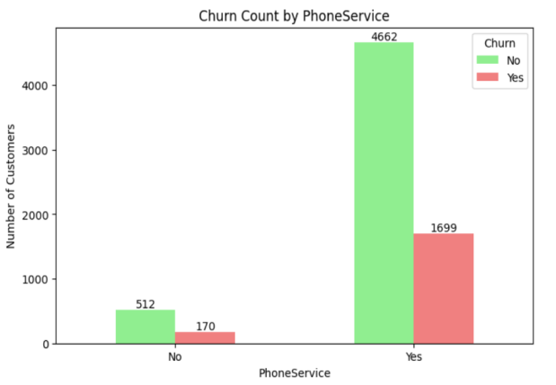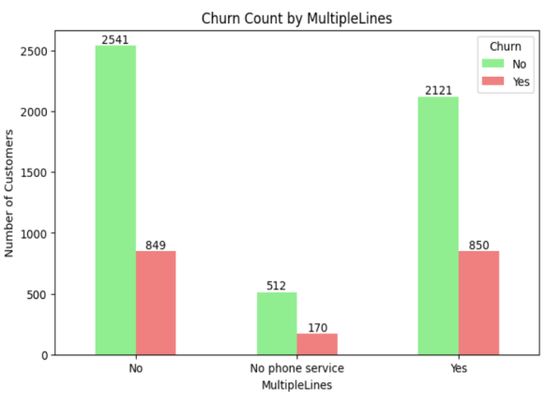

Churn Count by InternetService: Churn Count by OnlineSecurity:

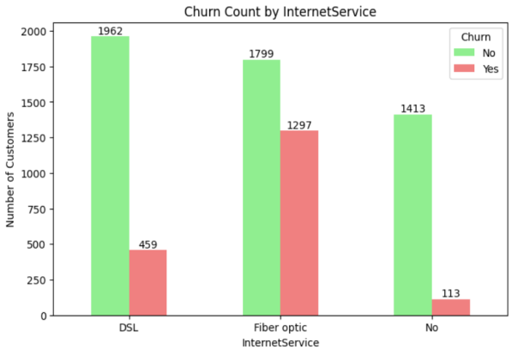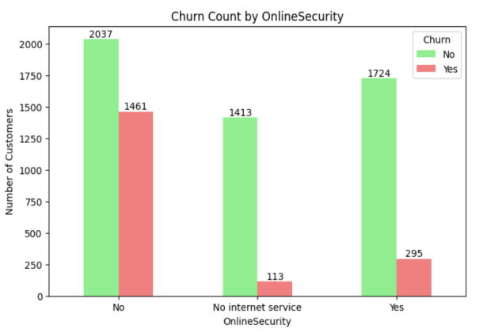

Churn Count by OnlineBackup: Churn Count by DeviceProtection:

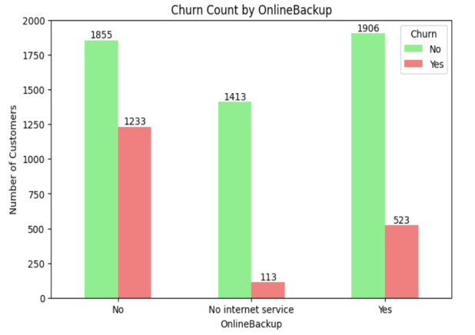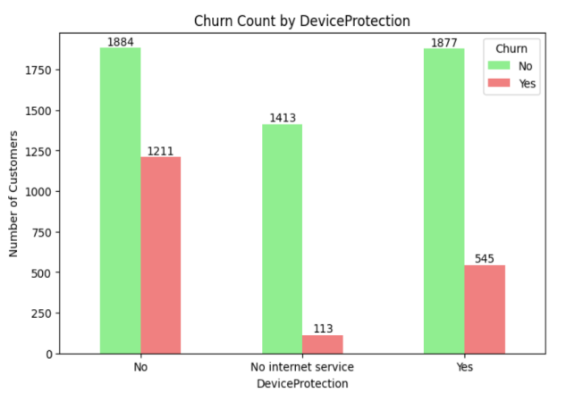

Churn Count by TechSupport: Churn Count by StremmingTv:

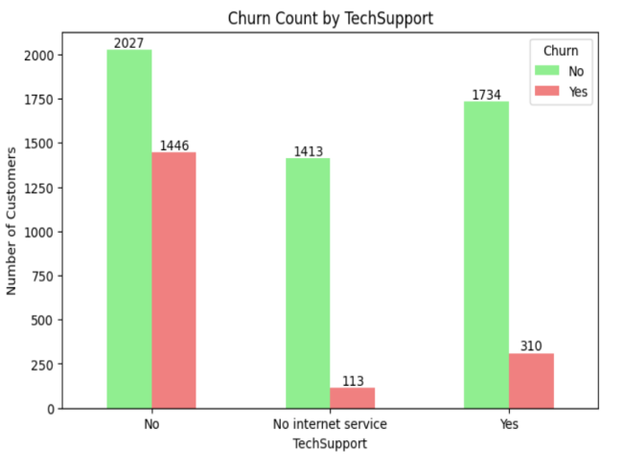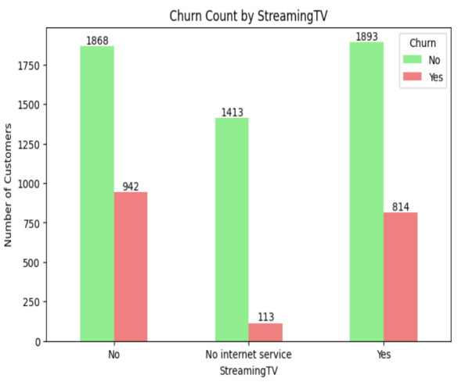

Churn Count by StremmingMovies: Churn Count by Contract:

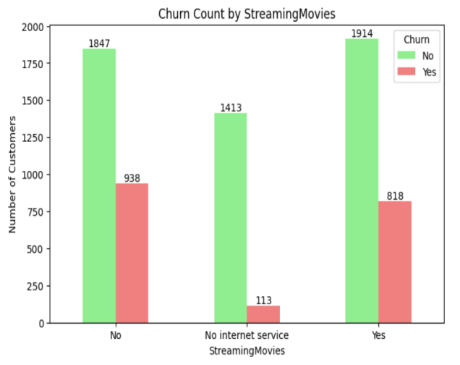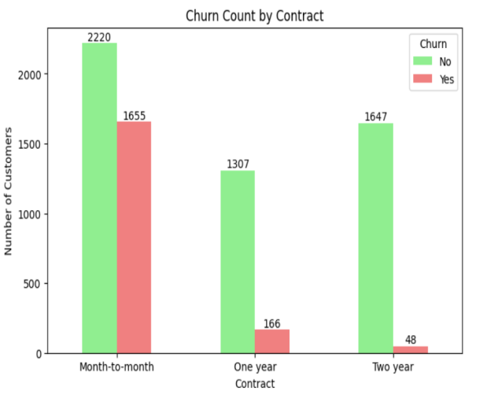

Churn Count by PaperlessBilling:

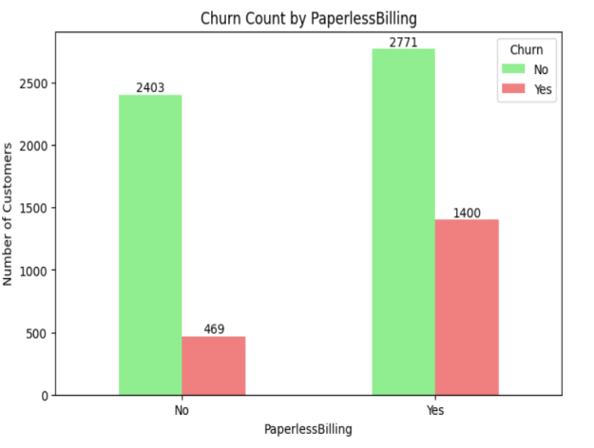

- Important Observations from the Dataset

- Phone and internet services are widely used, while additional services like Online Security, Backup, Device Protection, and Tech Support are less common.

- Streaming TV and Movies are adopted by fewer customers.

- Customer tenure varies, showing a mix of new and loyal customers.

- MonthlyCharges and TotalCharges vary widely, with some high-value outliers.

- Longer-term contracts are associated with higher TotalCharges.

- Most customers use electronic payment methods.

- A portion of customers churn, possibly linked to service usage, contract type, or billing.
- Conclusion

The analysis of the telecom customer dataset helps us understand why some customers leave the company while others stay. Key factors affecting churn include contract type, monthly charges, senior citizen status, and use of additional services. Customers with short-term contracts and higher monthly charges are more likely to leave, while those with long-term contracts and automatic payments tend to stay.

By using these insights, the company can take steps to improve customer retention, such as offering better service packages, encouraging long-term contracts, and paying attention to high-risk groups. Cleaning missing values and handling outliers ensures more accurate analysis and better predictions. Overall, the findings provide practical guidance for reducing churn and keeping customers satisfied.

