DynamoDB

* Traditional application leverage RDBMS databases
* These databases have the SQL query language
* Strong reequipments about how the data should be modeled (tables, rows, columns, joins, indexes, etc)
* Ability to do join, aggregations, computations
* Vertical scaling (means usually getting a more powerful CPU/RAM/IO

NoSQL databases

* The concept of NoSQL databases became popular with internet giants like Google, Facebook, Amazon, etc. who deal with huge volumes of data
* The system response time becomes slow when you use RDBMS for massive volumes of data
* To resolve this problem, we could "scale up" our systems by upgrading our existing hardware. This process is expensive.
* The alternative for this issue is to distribute database load on multiple hosts whenever the load increases. This method is known as "scaling out"

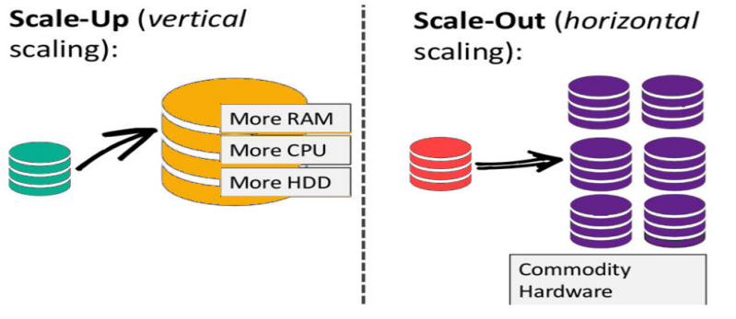

* NoSQL means, Not Only SQL.
* NoSQL databases are non-relational databases (no fixed columns etc)
* and are distributed (horizontal scaling).
* NoSQL databases include MongoDB, DynamoDB etc
* NoSQL databases do not support joins
* All the data that is needed for a query is present in one row
* NoSQL databases don’t perform aggregations such as “SUM”.
* NoSQL databases scale horizontally

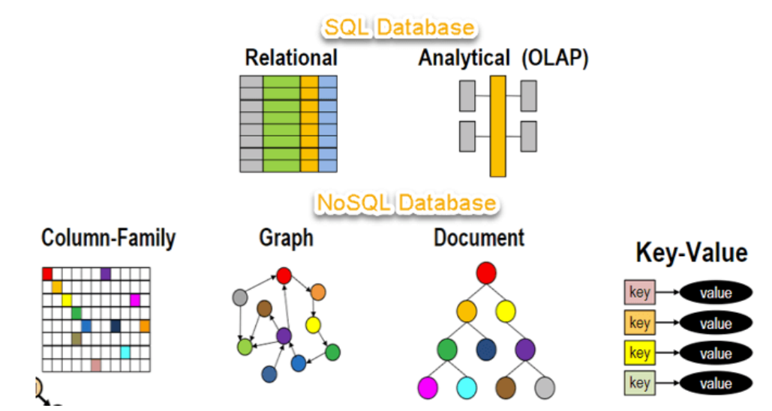

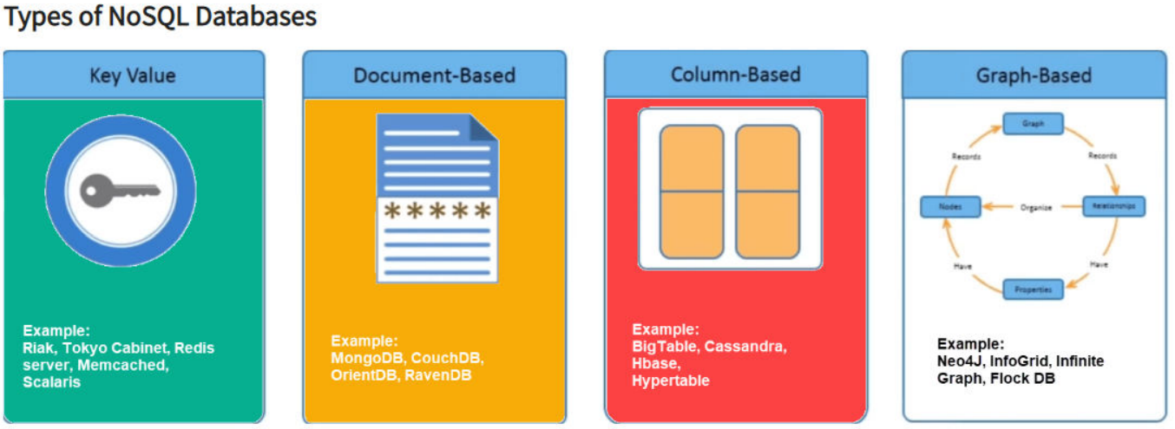

* DynamoDB offers **“push button”** scaling, meaning that you can scale your database on the fly, without any down time.
* **DynamoDB is Serverless**
* RDS is not so easy and you usually have to use a bigger instance size or to add a read replica.
* **Amazon DynamoDB** is a fast and flexible NoSQL database service for all applications that need consistent, single-digit millisecond latency at any scale.
* DynamoDB allows you to create a database table that can store and retrieve any amount of data and serve any level of request traffic.
* It is fully managed database and supports both document and keyvalue data models.
* Its flexible data model and reliable performance make its great fit for mobile, web, gaming, ad-tech, IoT, and many other applications.
* Transactions provide atomicity, consistency, isolation, and durability (ACID) in DynamoDB *.
* **The data in DynamoDB is stored in JSON format. \***
* Fully Managed, highly available with replication across 3 AZ
* NoSQL database – not a relational database.
* Scales to massive workloads, distributed database
* Millions of requests per second, trillions of rows, 100s of TB storage
* Fast and Consistent in Performance (low latency on retrieval)
* Integrated with IAM for security, authorization and administration
* Stored on SSD storage
* Spread across 3 geographically distinct data centers
* **Eventual Consistent Reads (Default)**
* **Strongly Consistent Reads**
* DynamoDB comprises of core basic components that include Tables, Items and Attributes. A Table is a collection of Items, each of which is a collection of one or more attributes. DynamoDB uses primary keys to uniquely identify each item in a table and secondary indexes to provide more querying flexibility.
* **Tables –** DynamoDB stores data in tables which are a collection of data; for example, Students Table to store student information data
* **Items –** Each table contains multiple items, where an item is a group of attributes that uniquely identifies it when compared to other items. Items can be considered similar to rows or records in a relational database system
* **Attributes – Each** item is composed of one or more attributes. Attributes are similar to fields or columns. For example, an item in the students table could be a student’s record, that has attributes including StudentID, FirstName, Last Name etc.
* DynamoDB is made of Tables
* **Each table has a Primary Key (must be decided at creation time)**
* Each table can have an infinite number of items(=rows)
* Each item has attributes (can be added over time – can be null)
* **Maximum size of an item is 400KB**

**Read Consistency of DynamoDB**

When reading an item from DynamoDB, the response may not reflect the results of recently completed writes. This is because DynamoDB maintains multiple copies of the data across multiple availability zones and so it offers eventual consistent reads which are cheaper than strongly consistent reads

**Eventual Consistent Reads**

* Consistency across all copies of data is usually reached within a second. Repeating a read after a short time should return the updated data.
* With Event Consistent Read operations, the response might not reflect the results of a recently completed write operation. The response might include some stale data. However, generally, the lag is no more than one second. If you repeat your read request after a short time, the response should return the latest data.

**Strongly consistent Reads**

* A strongly consistent read returns a result that reflects all writes that received a successful response prior to the read.
* You can request strongly consistent reads and DynamoDB will respond with the most up-to-date data, reflecting the updates from all prior write operations that were successful.
* New Feature from November 2018
* Transaction = Ability to Create / Update / Delete multiple rows in
* different tables at the same time
* It’s an “all or nothing” type of operations
* Write Modes: Standard, Transactional
* Read Modes: Eventual Consistency, Strong Consistency, Transactional
* Consume 2 X of WCU / RCU

**Data Types**

* Unlike traditional relational databases, where you need to specify the columns, their names as well as data types that will be contained in them, DynamoDB only requires specifying a Primary Key field to start with. You do not need to specify all attributes ahead of time of an item; you can add columns on the fly. This gives you There are three categories of data types:
* **Scalar Types:** String, Number, Binary, Boolean, NULL
* **Set Data Types:** String Set, Number Set, Binary Set
* **Document Data Types:** List, Map the flexibility to expand the schema as required over time.
* When you create a table, you need to specify a Primary key which uniquely identifies every item in a database.

**DynamoDB support two types of private keys:**

* Partition Key
* Partition Key and Sort Key (Composite key
* **Partition Key** – The primary key is defined with a single attribute and is known as the partition key.
* DynamoDB uses the partition key’s value to build an unordered hash index which is used to identify the partition in the which the item will be stored.
* The partition key of an item is also known as its hash attribute
* **Note** that if you are only using only a partition key, you cannot have two items on the same table using the same partition key

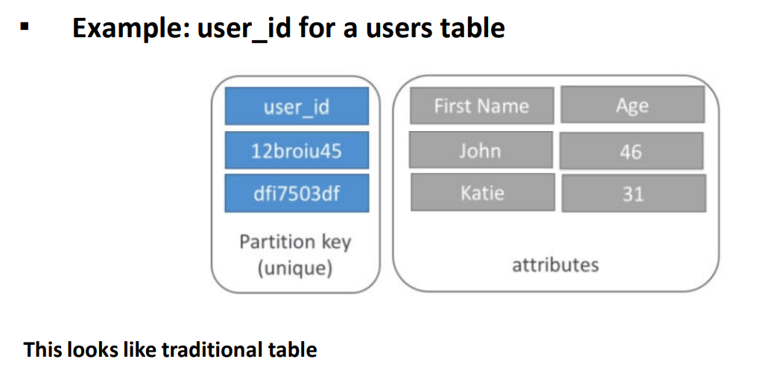

* **Partition Key and Sort Key** – This is known as a composite primary key and is made up of two attributes, namely the primary (partition) key and the sort (range) key.
* The **sort key** of an item is known as a range attribute
* You can uniquely identify and item if you provide both the partition key and sort key. Note that you can have multiple items with the same partition key if they have different sort keys.

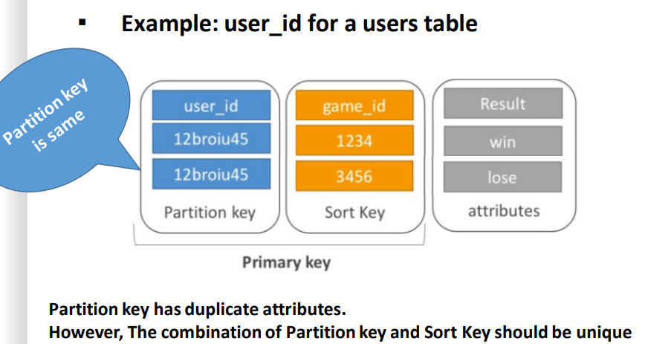

* Amazon DynamoDB enables you to query the data in a table using an optionally defined alternative key know as a Secondary Index.
* **Local Secondary Index**
* **Global Secondary Index**
* **Local Secondary Index** – This is an index that has the same partition key as the table, but a different sort key. These can only be created when the table is created. Furthermore, you cannot modify or delete a Local Secondary Index once created.
* **Global Secondary Index** – this is an index with a partition key and sort key that can both be different from those on the table. Global secondary indexes can be created or deleted on a table at any time
* **LSI (Local secondary indexes) =** Partition Key + Any Column as sort key ▪ GSI **(Global Secondary Indexes) =** Any Column as PK + Any Column as SK

**Provisioning Capacity**

* DynamoDB enables you to write and read from the tables you create a Database. You can create, update and delete individual items. In addition, you can use multiple querying options to search for data in your tables.
* To ensure high availability and low latency responses, you are required to specify you read and write throughput values when you create a table.
* DynamoDB uses this information to reserve sufficient hardware resources and appropriately partitions your data over multiple servers to meet your throughput requirements. When you create a table, you need to specify the following capacity units
* Read Capacity Units (throughput for reads)
* **Readers are rounded to increments of 4KB in size**
* In Eventual Consistent Reads, one read capacity unit is 2 reads per second for items up to 4KB
* For Strongly Consistent Reads, one read capacity unit consist of 1 read per second of up to 4KB in size
* Write Capacity Units (throughputs for writes)
* Number of 1KB writes per second Read Capacity Units
* For ECR, 1 RCU = 2 reads per second for 4KB size
* For SCR, 1 RCU = 1 read per second for 4KB size Write Capacity Units
* 1 WCU = 1 write per second
* **Remember –** One read capacity unit represents one strongly consistent read per second, or two eventually consistent reads per second, for items up to 4 KB in size
* **Remember –** One write capacity unit represents one write per second for items up to 1 KB in size

**Pricing**

* DynamoDB simply asks you to specify the target utilization rate and minimum to maximum capacity that you want for your table. DynamoDB handles the provisioning of resources to achieve your target utilization of read and write capacity, then auto scales your capacity based on usage.
* Optionally you can directly specify read and write capacity if you prefer manual.
* Provisioned Throughput (Write) – One write capacity unit (WCU) provides up to one write per second, enough for 2.5 million writes per month. As low as $0.47 per WCU Provisioned Throughput (Read) – One read capacity unit (RCU) provides up to two reads per second, enough for 5.2 million reads per month as low as $0.09 per RCU Indexed Data Storage – DynamoDB charges an hourly rate per GB of disk space that your table consumes table throughput

**Provisioning Capacity**

**Example**

**Read Capacity Requirements**

If you have a table and you want to read 100 items per second with strongly consistent reads and your items are 8KB in size, you would calculate the required provisioned capacity as follows;

* 8KB/4KB = 2 capacity units
* 2 read capacity units per item x 100 reads per second = 200 read capacity units

Note: Eventual Consistent Reads would require 200/2= 100 read capacity units

Write Capacity Requirements

If you have a table and you want to write 50 items per second and your items are 4KB in size, you would calculate the required provisioned capacity as follows;

* 4KB/1KB = 4 capacity units
* 4 write capacity units per item x 50 writes per second = 200 write capacity units

**Example**

**Read Capacity Requirements**

* 10 strongly consistent reads per seconds of 4 KB each

We need 10 * 4KB / 4KB = 10 RCU (For SCR, 1 RCU= 1 read per second for 4KB)

* 16 Eventually consistent reads per seconds of 12 KB each We need 16/2 * 12KB /4KB = 24 RCU (For ECR, 1 RCU = 2 reads per second for 4KB size)
* 10 Strongly consistent reads per seconds of 6 KB each

We need 10 * 8KB /4KB = 20 RCU (For ECR, 1 RCU = 2 reads per second for 4KB size, 6 rounds off to 8KB because each is 4KB and next size is 8KB)

**Searching / Scan Items**

* You can use a Query or a Scan to search for items in a DynamoDB table.
* Queries are primary search operations to help you search for items in a table or a secondary index using the primary key attribute values.
* You need to provide partition key name and value to search for and you can also provide a sort key name and value and use a comparison operator to refine the search results.

Applications can be designed to keep track of recent changes and they perform some action on the changed record sets.

This method of streaming data is a feature available on DynamoDB and enables you to get a list of item changes for a 24-hour period.

The stream is essentially ordered flow of information about changes to items in an Amazon DynamoDB table. Once enabled, DynamoDB captures information about every modification to data items in the table.

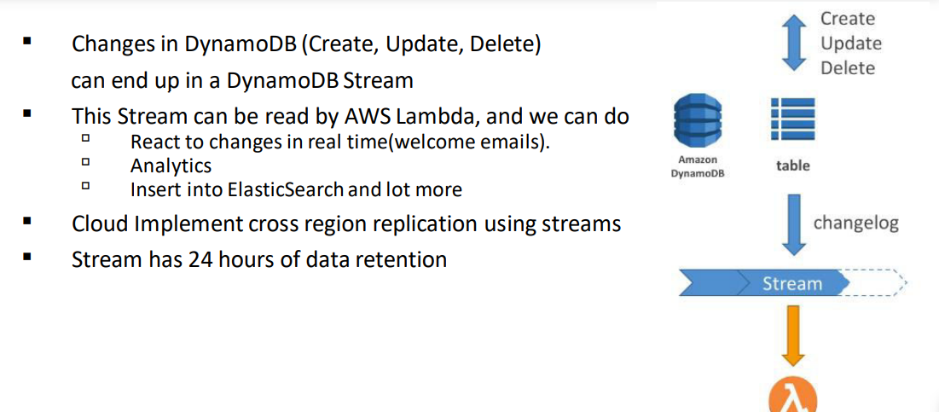

**Amazon DynamoDB TTL**

* TTL = automatically delete an item after an expiry date / time
* TTL is provided at no extra cost, deletions do not use WCU /RCU
* TTIL is a background task operated by the DynamoDB service itself
* Helps reduce storage and manage the table size over time
* TTL is enabled per row (you define a TTL column, and add a date there)
* DynamoDB typically deletes expired items within 48 hours of expiration
* Deleted items due to TTL are also delete in GSI / LSI
* DynamoDB streams can help to recover expired items

**DynamoDB API’s – Writing Data**

* **PutItem :** Write data to DynamoDB(Create data or full replace). It consumes WCU.
* **UpdateItem :** Update data in DynamoDB (partial update of attributes).
* **Conditional Writes:** Accept a write/update only if conditions are respected otherwise reject
  + Helps with concurrent access to items
  + No performance impacts

**DynamoDB API’s – Deleting Data**

**DeleteItem:**

* Delete an individual row
* Ability to perform a conditional delete

**DeleteTable**

* Delete a whole table and all its items
* Much quicker deletion than calling Delete Item on all items

**DynamoDB API’s – Batching Writes**

**BatchWriteItem:**

* Up to 25 Put Item and / or Delete Item in one call
* Up to 16 MB of data written
* Up to 400 KB of data per item
* Batching allows you to save in latency by reducing the number of calls done against DynamoDB:
* Operations are done in parallel for better efficiency
* It’s possible for part of a batch to fail, in which case we have the try the failed item (using exponential back-off algorithm



