**ELASTIC BLOCK STORAGE(EBS)**

* EBS is block based storage
* Hard Disk = Volume = EBS Volume
* Volume can attach and detached to instance
* We can attach multiple volumes to the EC2 instance
* EC2 has default volume and that is called ROOT VOLUME
* The ROOT Volume always has OS(Operating System)
* EC2 Support only Server-side OS not client site
* EC2 can have only 1 ROOT Volume
* EC3 can have multiple Additional Volumes
* Max size for EBS volume is **16TB per account**
* We can’t attach same volume to multiple instances at the same time
* Volume can be pre-provisioned like (Ex 50GB,100GB..etc)
* Volume size can’t be decreased
* ROOT volume always mounted / attached as /dev/sda1
* **Not possible to detach the ROOT Volume while EC2 Running status**.
* Possible to detach the additional volume while EC2 Running status
* EC2 instance and volume should be same region
* We can’t attach ap-south-1a(AZ) volume to EC2 instance different AZ(ap-south-1b)
* We can’t attach ap-south-1a(AZ) volume to EC2 instance same AZ(ap-south-1a)

1.Create EC2 instance using 7 steps

To check how many volumes attached to EC2 instance

Root device /dev/xvda

Block device /dev/xvda

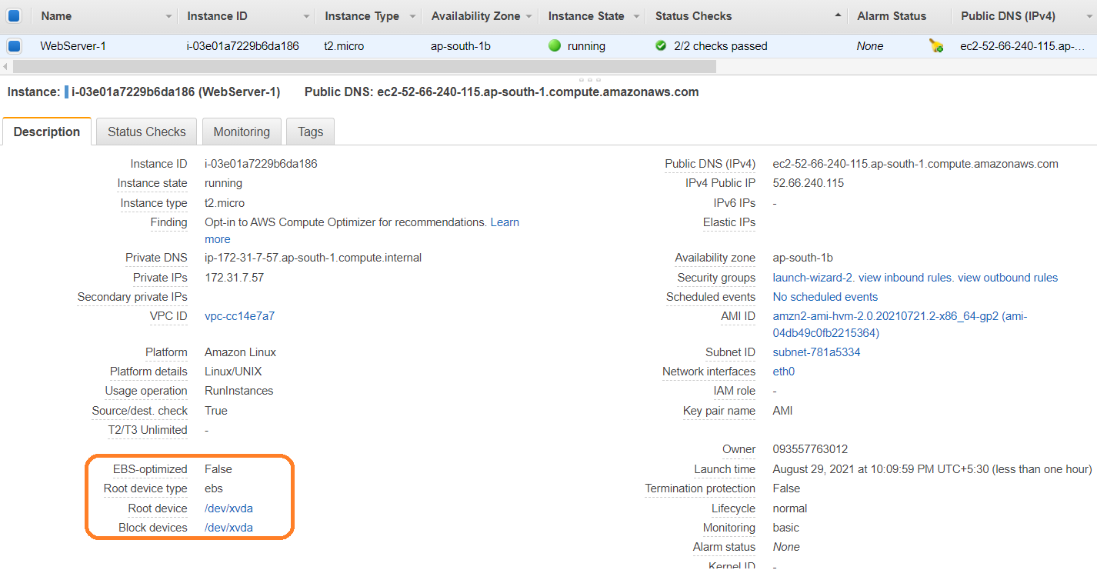

**Create Volume**

Left panel 🡪 Volumes (under ELASTIC BLOCK STORAGE) section 🡪 Create Volume

Additional Volume support below **Volume Types**:

* General Purpose SSD (gp2)
* General Purpose SSD (gp3)
* Provisioned IOPS SSD (io1)
* Provisioned IOPS SSD (io2)
* Cold HDD (sc1)
* Throughput Optimized HDD (st1)
* Magnetic (standard)

Note:

* Up to 30GB free for EBS volumes
* The Availability Zone in which to create the EBS volume. The volume will be available to instances in the same Availability Zone.
* The size of the EBS volume in GiB. Note that 1 GiB = 1024^3 bytes, whereas 1 GB = 1000^3 bytes.
* Min: 1 GiB, Max: 16384 GiB

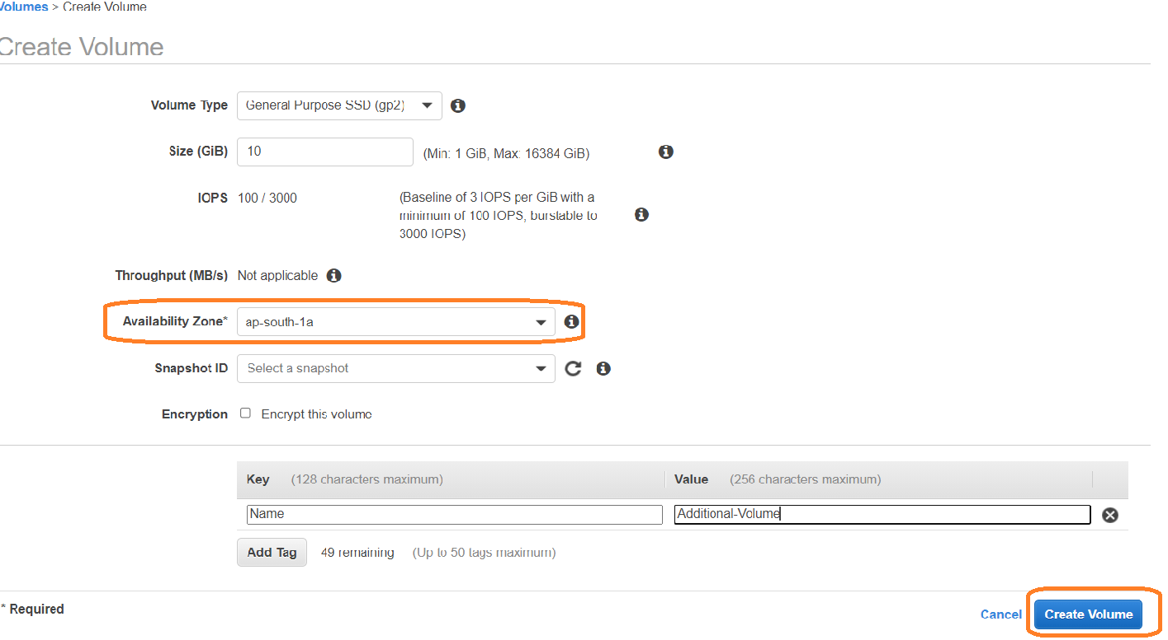

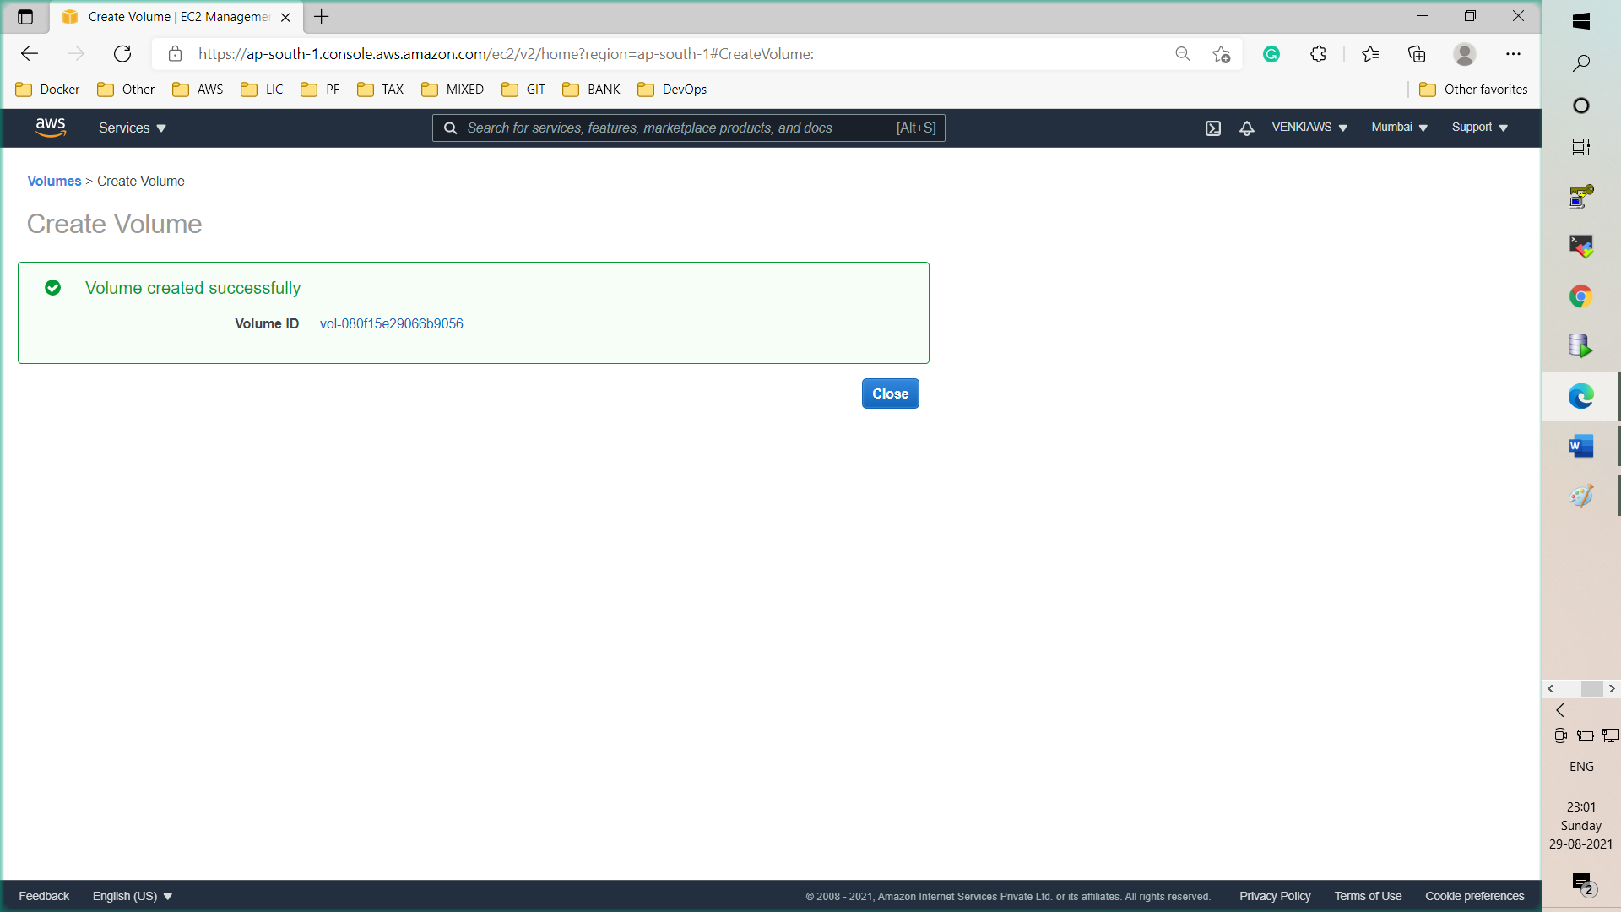

In Volume section existing Volume (root volume) is showing **in use,**

Whereas new additional volume is showing **available**

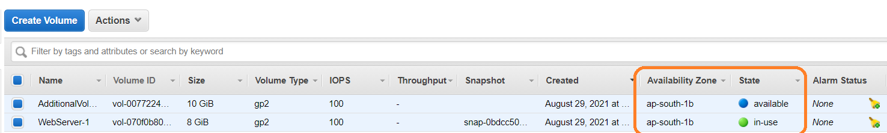

We need to attach additional volume to EC2 instance using below steps

Click on Additional Volume 🡪 Actions 🡪 Attach Volume

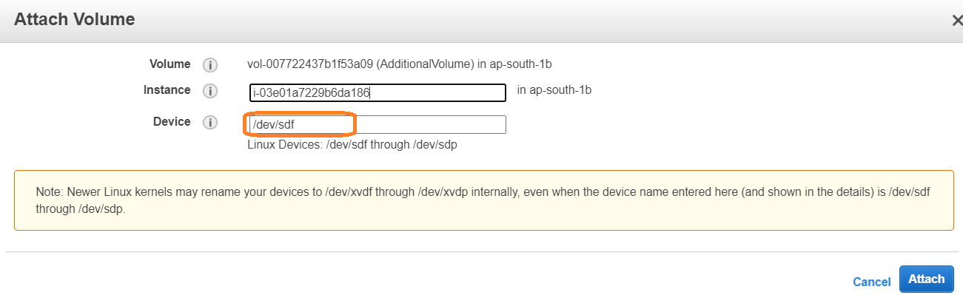

Note: Newer Linux kernels may rename your devices to /dev/xvdf through /dev/xvdp internally, even when the device name entered here (and shown in the details) is /dev/sdf through /dev/sdp.

Once Additional Volume has been attached then status will be change to **in-use**

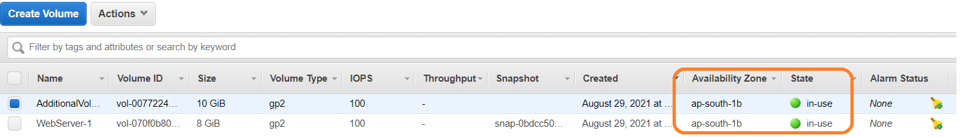

Verify Additional Volume added or not in EC2 dash board

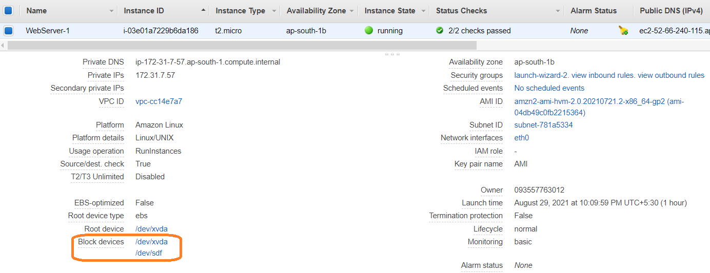

Login into EC2 server and verify Additional volume

To Check Volume status added or not from Console

$ fdisk -l

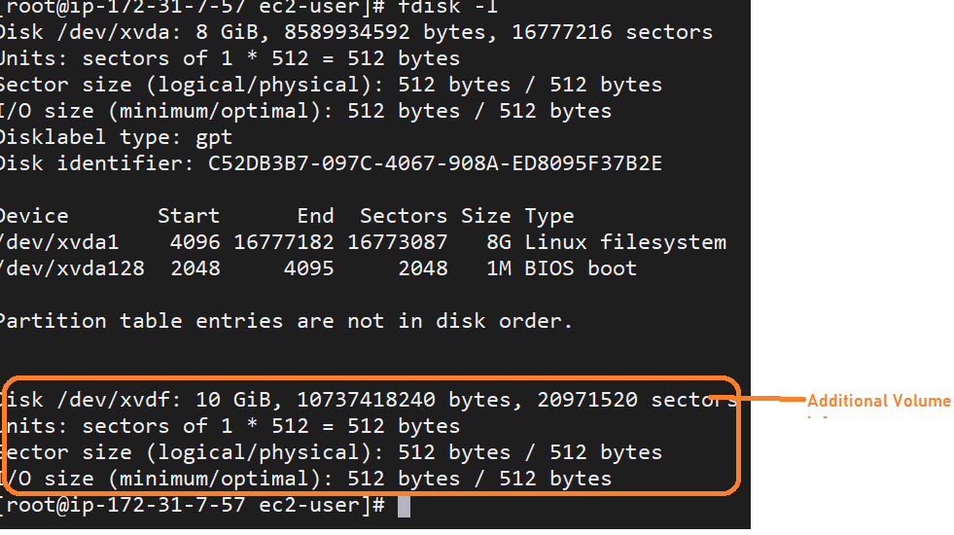

$ df -Ht (Human Readable format)

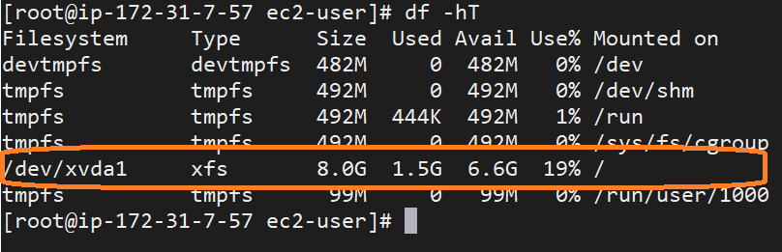

Partition

$ fdisk /dev/xvdf

**Command (m for help) : m**

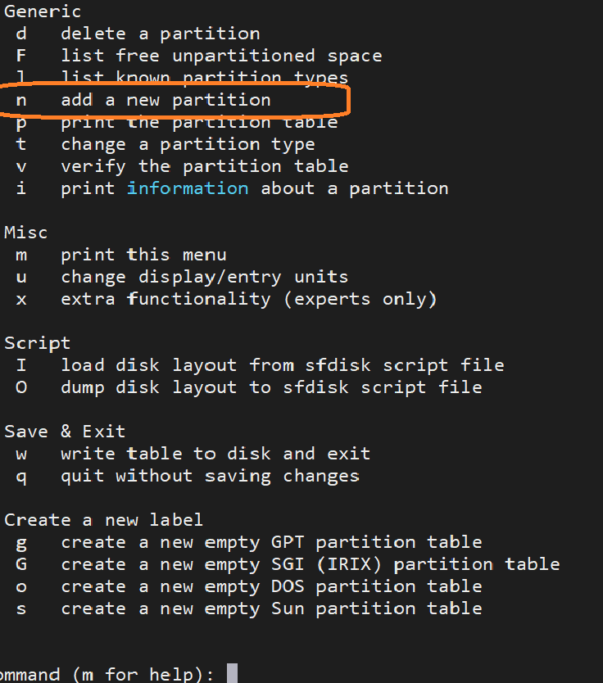

Click on n

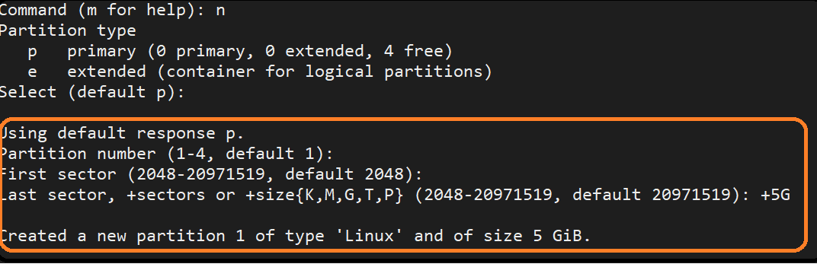

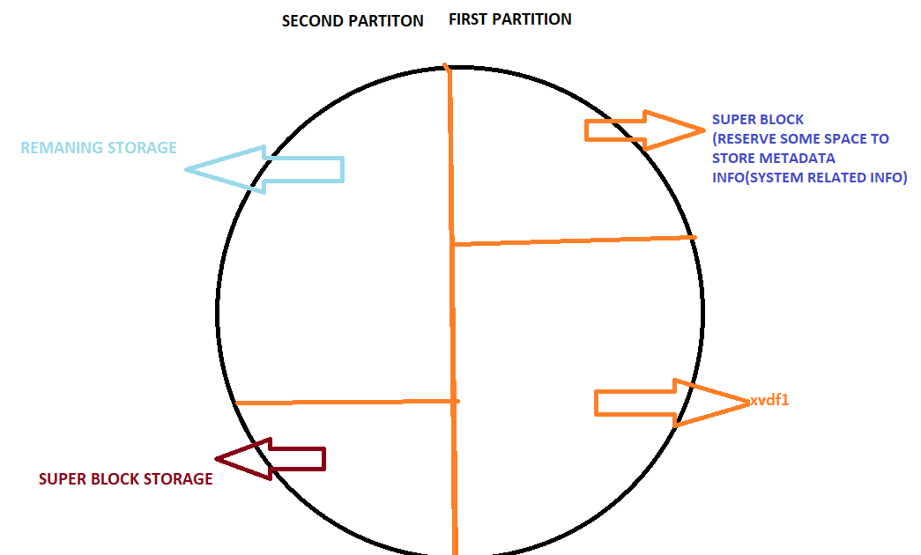

Second partition if we give 5GB, will get **Value out of range (i.e calculation is going to out of range)**

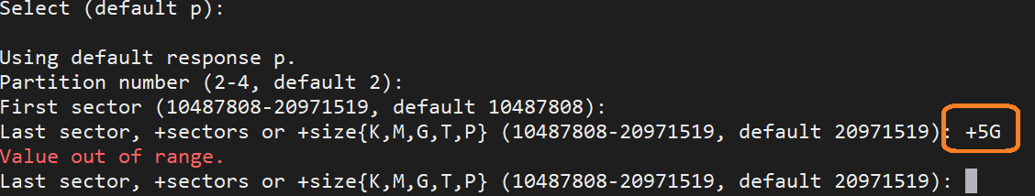

Click on Enter without giving any info so that super block will adjust size

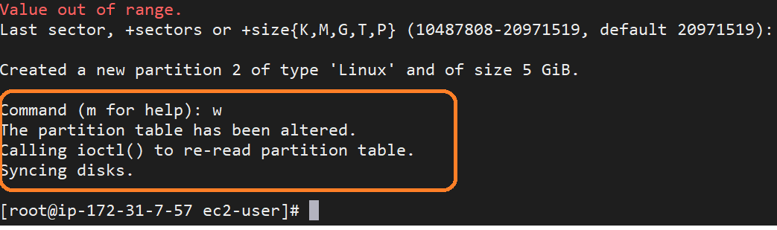

Click on “w” for write the data in disk (save and exit)

To check partition status on server

$ fdisk -l

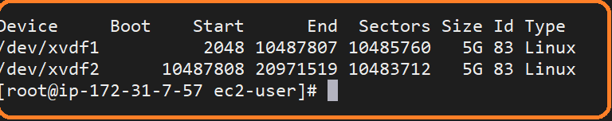

Create mount points

Format each partition

$mkfs -t xfs /dev/xvdf1

$mkfs -t xfs /dev/xvdf2

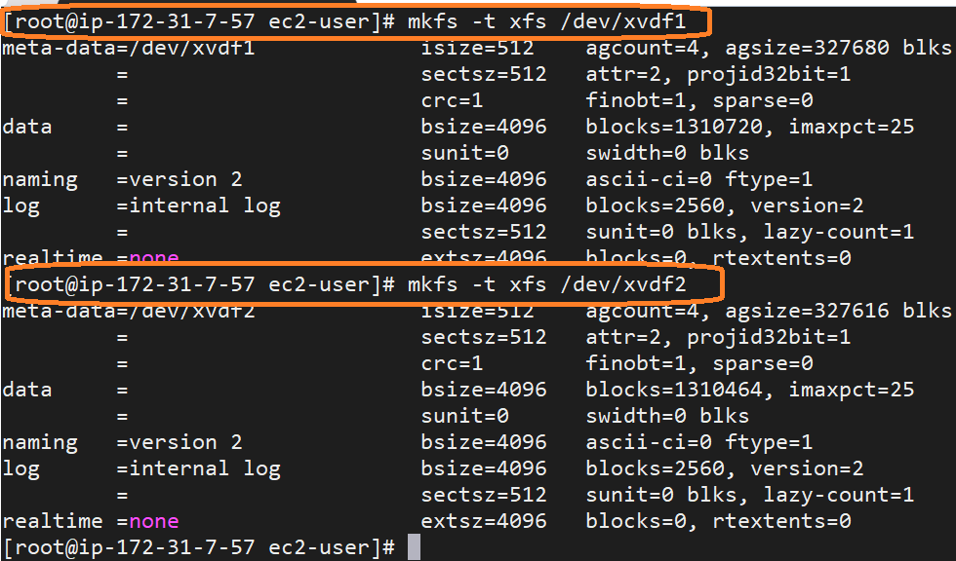

Create directory based on the requirement

$mkdir /amazon /flipkart

$mount /dev/xvdf1 /amazon

$mount /dev/xvdf2 /flipkart

$df -hT

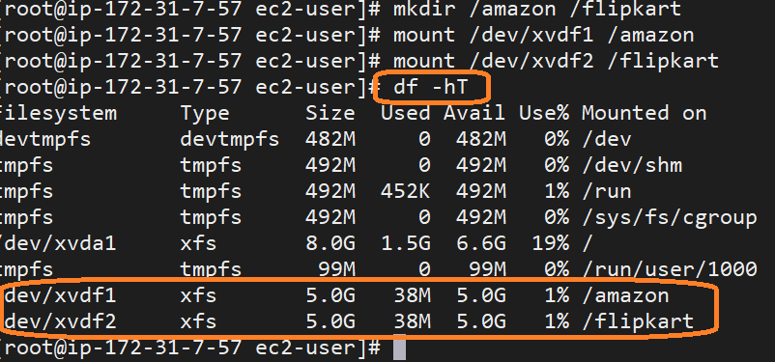

$cd /amazon/

$touch testfile1

$cd /flipkart/

$touch testfile2