**ELASTIC FILE SYSTEM(EFS)**

* By using this service, we can attach single volume to multiple EC2 instance at the same time across multiple AZ’s (*i.e same REGION*)
* EFS is unlimited storage
* EFS will launch only LINUX machine and completely managed by AWS
* EFS is serverless for us
* EFS works with NFSv4.1 Protocol
* Amazon Elastic File System (EFS) is **a file storage service** for Amazon
* EC2 instances is file sharing purpose, we can install any software but not recommended
* EFS doesn’t require any pre-provisioning (i.e it will automatically increase and shrink based on the data you put on EFS)
* Same EFS can be mounted(attached) multiple EC2 instance

Example: Pen drive, separate(device) mount point

* File share concept will use NFS protocol
* We can create a file system, mount the file system on an Amazon EC2 instance, and then read and write to and from file system
* EFS is easy to use and provides a simple interface that allows you to
* create and configure file systems quickly and easily.
* With Amazon EFS storage capacity is elastic, growing and shrinking
* automatically as you add and remove files.
* So your applications have the storage they need, when they need it

ap-south-1a ap-south-1b ap-south-1c

EC2

EC2

EC2

root

root

root

**EFS(Elastic File System)**

* Managed NFS(network file system) that can be mounted on many EC2.
* EFS works with EC2 instances in multi-AZ
* Uses NFSV4.1 protocol.
* Only for Linux

**Key Benefits**

* AWS Managed
* High Throughput
* Scalable / HA : Scale up or down in terms of infrastructure
* Durable 🡪 Data can be stored across multiples AZ
* Concurrent Access
* Shared across multiple EC2 instances
* Low-Cost Storage, Infrequent Access via API's
* Low latency
* SSD Based
* Simple: Easy to setup
* **Elastic:** grow and shrink automatically as you add and removes files
* Less Complex: deploying, patching, and maintaining
* complex file system deployments by AWS
* At a same time one or more than one Amazon EC2 instances

can access an Amazon EFS file system.

**Amazon EFS file systems have two storage classes available:**

* **Infrequent Access –** The Infrequent Access (IA) storage class

is a lower-cost storage class that's designed for storing long lived, infrequently accessed files cost-effectively.

* **Standard –** The Standard storage class is used to store

frequently accessed files.

**There are 2 throughput modes on EFS**

* **Busting**
* **Provisioned**
* It is recommend Busting throughput mode for most file systems.
* use Provisioned throughput mode for applications that require more throughput than allowed by Busting throughput

**There are 2 Performance modes on EFS**

**▪ General Purpose**

**▪ Max I/O**

It is recommended General Purpose performance mode for most file systems.

Max I/O performance mode is optimized for applications where tens, hundreds, or thousands of EC2 instances are accessing the file system

**Enable Encryption**

* If you enable encryption for your file system, all data on your file system will be encrypted at rest

**Note:**

* You only have to pay for the storage you use (No pre provisioning is
* required.)
* Can scale up to petabytes.
* Can support thousands of concurrent NFS connections
* Data is stored across multiple AZ’s within a region
* Read After Write Consistency.
* Number of file systems for each customer account in an
* AWS Region – 1000
* Up to 128 active user accounts for each client can have files
* open at the same time
* Up to 32,768 files open at the same time on the instance

1.Create 2-EC2 instance

While launching EC2 instance we have option to attach/Create EFS under **Configure Instance section**

File systems 🡪 **Add file system (OR) Create new file system**

2.Create EFS

**Services 🡪 Storage 🡪 EFS**

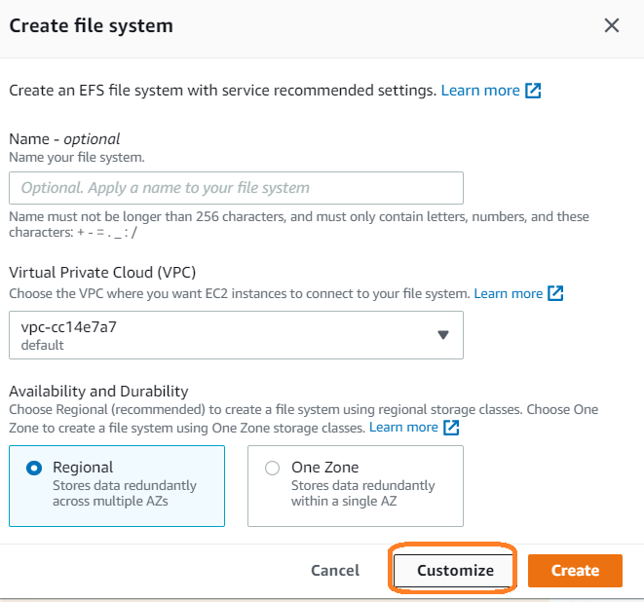

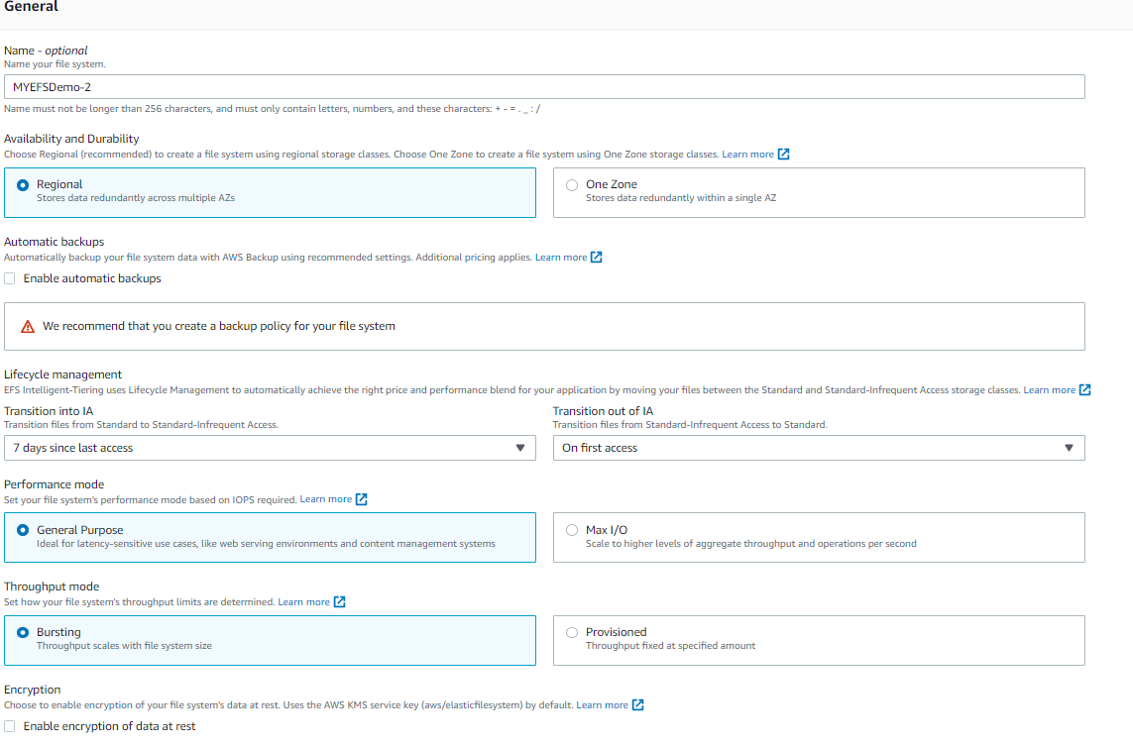

**Select specific region and security group details**

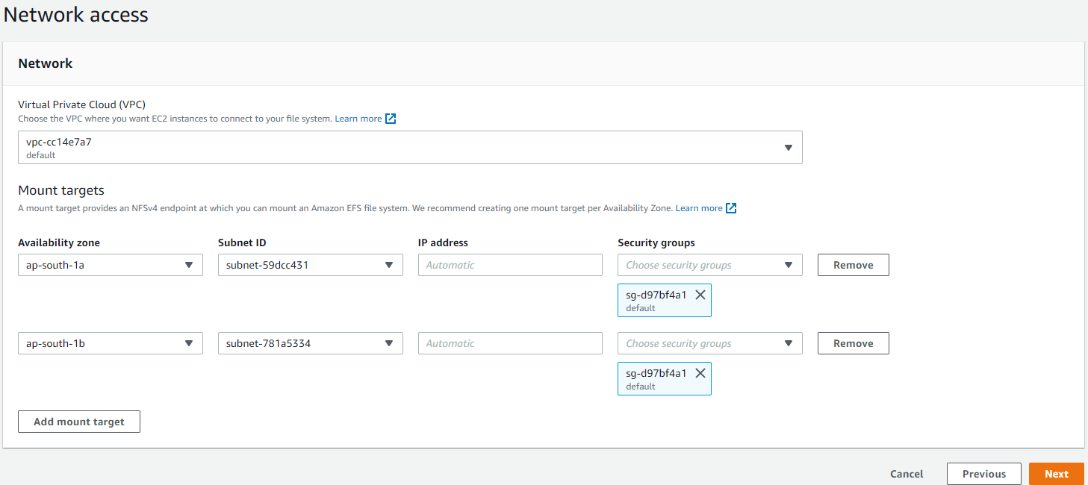

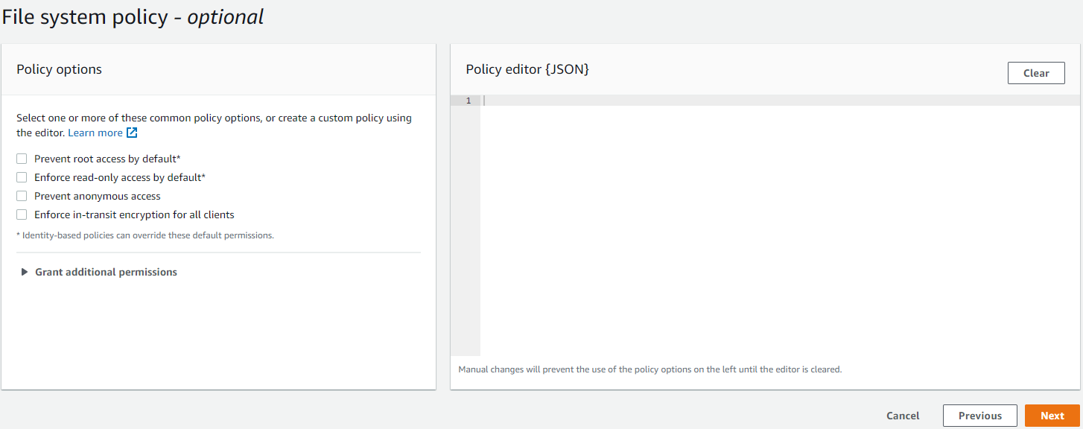

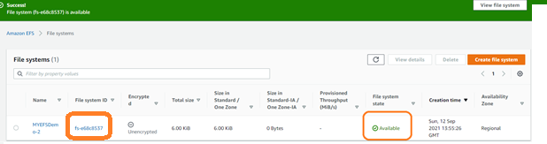

**3. Login into EC2 instance**

Fallow below steps to attach EFS

* cd ..
* yum install -y nfs-utils
* mkdir efs
* mount -t <<File System id>>.efs.ap-south-1.amazonaws.com:/ <<folder-name>>/

mount -t nfs4 fs-e68c8537.efs.ap-south-1.amazonaws.com:/ efs/

cf efs

* df -h

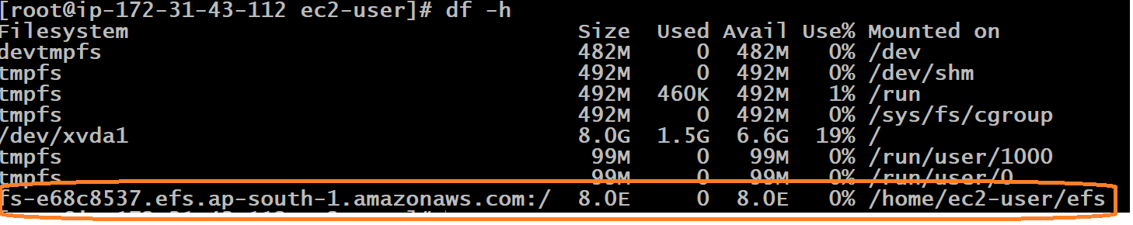

**Un-mount use below command**

* **umount -l /home/ec2-user/efs 🡪 normal**
* **umout -f /home/ec2-user/efs 🡪 forcefully**

Delete EFS system & and Terminate EC2 instance

