You should receive the notification if anyone uploaded an object inside the bucket

Services 🡪 S3

Step 1: Create bucket

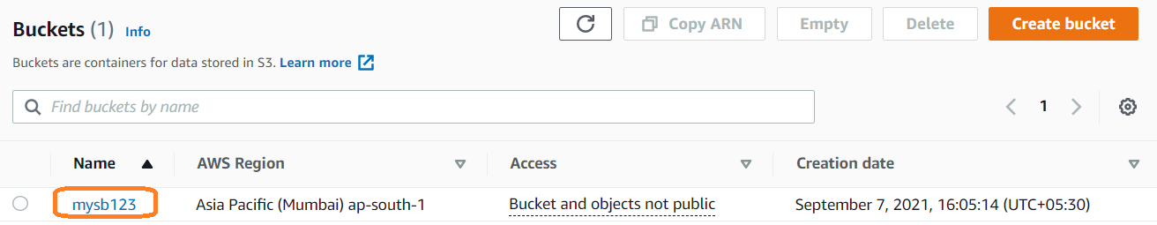

S3Bucket ARN location

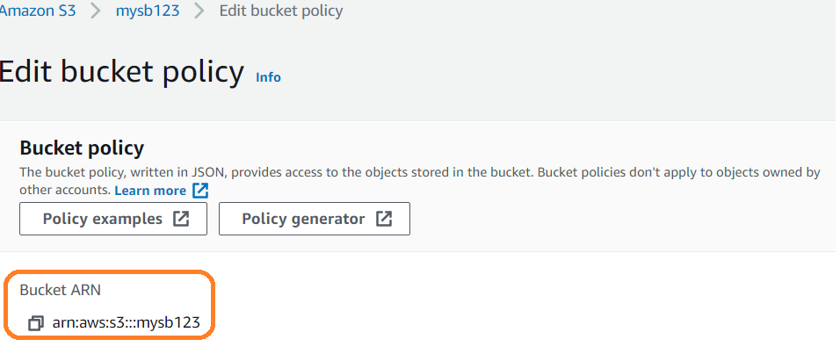

Step 1: Create SNS Topic

Example: **Topic Name:** S3Event

Step 2. Create subscriber and **confirm**

Step 3: Update your Policy with below **SNS Topic policy** and **Save**it

{

"Version": "2008-10-17",

"Id": "__default_policy_ID",

"Statement": [

{

"Sid": "__default_statement_ID",

"Effect": "Allow",

"Principal": {

"AWS": "*"

},

"Action": [

"SNS:GetTopicAttributes", **Auto generated content based on topic**

"SNS:SetTopicAttributes",

"SNS:AddPermission",

"SNS:RemovePermission",

"SNS:DeleteTopic",

"SNS:Subscribe",

"SNS:ListSubscriptionsByTopic",

"SNS:Publish",

"SNS:Receive"

],

"Resource": "arn:aws:sns:ap-south-1:093557763012:S3Event",

"Condition": {

"StringEquals": {

**"aws:SourceArn": "arn:aws:s3:::mysb123"**

}

}

}

]

}

**"aws:SourceArn": "YourS3BucketARN"**

Step 4: select topic while creating notification and try to upload file and verify.

Step 5: we will get notification on email

