**Ansible**

Ansible is open source, a configuration Management Tool and Deployment Tool, maintained by ***Redhat***

**Configuration Management:**

This is process of configuring remote servers from one point of control

Configuration is some tasks, which we want to execute on the server, it can be

* Creating users/Groups
* Installing software or running software
* Creating / updating / copying files
* Start / stop services etc
* Changing permissions/Ownership of files/directory
* Creating and deleting files and folders

It is not replacement tool, the main components of Ansible are playbooks, configuration management, deployment

Ansible uses the playbooks to deploy, manage, build, test and configure anything from full server environments to custom complied source code for applications.

Ansible was written in **Python**

**Open-source configuration tools:**

* Ansible
* Chef
* Puppet
* Saltstack

**Need of Ansible**

If we want to configure multiple system(i.e 100+) with same configuration without anisible we have to configure manually each machine, in this process their may chance of error prone i.e human error and time consumption.

**Advantages**

1. **Provisioning of servers**

The applications that should be installed on server can be done very quickly from a **single centralized location**.

1. **Disaster recovery**

In case of natural disaster, there is a possibility that a complete data center can be lost. Configuration management tools can capture the information about these servers and store them in **simple files called as setup files**. These setup files can be used for re configuring a similar data center at another location.

1. **Idempotent**

Configuration management tools are used to bring the server to a particular state, called as desired state. If a server already in the desired state, configuration management **tools will not reconfigure that server**.

**Note:** Configuration management tools cannot be used for installing OS from the scratch. They can be used only for managing the applications on top of the OS.

**Ansible how different is from Terraform?**

* **Terraform:** Infrastructure as a code
* By using terraform we can create the server once we have a server, we can use Ansible to configure those servers based on our requirement
* Ansible does not maintain state of server, by using Ansible also we can create the server but it is not better Option.

**Ansible Features**

* It is a open source *configuration management tool*, created using Python.
* Main machine in which ansible is installed is called as controller.
* Remote severs that Ansible configures, are called as managed nodes.
* Ansible configure machines in an agent-less manner using SSH
* Ansible uses agent less policy for configures remote server’s i.e Ansible is installed only on 1 machine, and we do not require any client side software to be installed on the remote servers.
* Built it on top of Python and hence provide a lot of Python’s functionality
* YAML – Based Playbooks
* Uses SSH for secure connections
* Follows Push based architecture for sending configurations
* Ansible performs configuration management through password less SSH.

**Two types of configuration tools**

1.Push based

2.Pull based

**Push based**

Master Server (Installed Ansible) have some configuration scripts, then Main server only will connect to different host servers for copying files or install software’s etc

In other words, Center server pushes the configuration information on target servers

Ansible is push based

**Pull based**

Here, target server only pull to **center server**

**Tools like** Puppet and chef and pull based.

This servers are pull based configuration management tools

Agents on the server periodically checks for the configuration information from central server (Master)

**Note:**

**We cannot install ansible in window machine**

**We can configure windows machine using Ansible**

Ansible is not master slave architecture, host machine can be anything for

example installed Jenkins, installed Docker, installed Kubernetes.

**Why Ansible?**

* Predefined module/functionality
* No need to write everything from scratch
* Ansible scripts basically YAML based
* Not required to learn scripting language, because everything will be **YAML**
* It will save the time
* Ansible Modules are idempotent

Idempotent: If configuration already done for that server, it will not change anything

* Lot of predefined functionality available in Ansible
* Agent less and push based
* Manage the machine using SSH protocol

**What can Ansible do?**

* Configuration management tool
* Application Deployment
* Continuous Delivery

**Ansible Architecture**

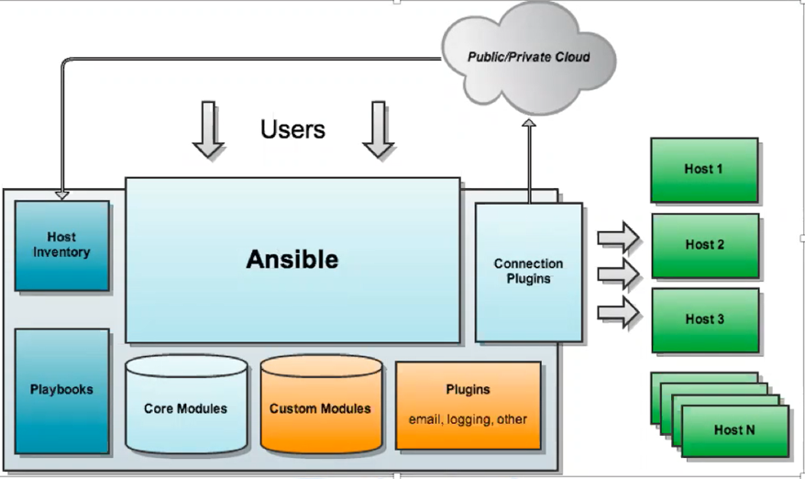

**Ansible Modules**

1.Host Inventory

2.Playbooks

3.Core Modules

4.Custom Modules

5.Plugins (email,logging,other)

6. Connection Plugins

**Host Inventory file**

Ansible’s inventory hosts file is used to list and group your servers Which we want to configure using ansible

Its default location is

* **etc/ansible/hosts**

**I**

See the content of the host file

# cat /etc/ansible/hosts (default inventory file path)

# 192.168.122.1 This is one of the node IP

**In Inventory file we can mentioned IP address or hostname also**

**Note:** We can create our own inventory for that we need to mentioned in below path The ansible* command will use a different host inventory file when they are used with the

**--inventory PATHNAME option, -I PATHNAME for shot**

Some important points in inventory file

* Comments begin with the ‘#’ character
* Blank lines are ignored
* Groups of hosts are delimited by [header] element
* You can enter hostnames or IP multiple groups
* A hostname/IP can be a member of multiple groups
* Ungrouped hosts are specifying before any group headers, like below

**Host Inventory**

It will maintain the details for HOST machine (server) to configure, it can be list and group of servers (Host)

1. Static Inventory

2. Dynamic Inventory

**Static Inventory**

It is file in which we can list host(server) details like (host name, password details etc and we can group the servers

Default location of host inventory

* /etc/ansible/hosts

**Dynamic Inventory**

If any changes in infrastructure like remove ***server add some servers or terminate server*** We need to update the inventory file based on the changes

It is script (like python, shell scripts) which will fetch host details dynamically from external source like cloud Provider etc

No need to update the details manually

**When we can go for Static and Dynamic Inventory?**

If our requirement is not dynamic (like not creating server / deleting servers / terminating / modifying server very frequently then we can go for **static inventory** or else we can use dynamic inventory

**Connection Plugin**

To connect windows or Linux it will use some connection plugin

For Linux 🡪 SSH

For window 🡪 WINRM(windows remote machine)

**Playbooks**

Playbook is a script which we want to execute(configuration) YAML based scripts

It contains task which we want to perform on the servers

**Sample script**

host: all 🡪 all the machine going to perform below task

name: create a user

user:

name: rajesh

createHome: yes

password: abc123

**Module**

Modules are the programs that perform the actual work of the tasks of a play

**Core Module**

Ansible comes with lot of predefined modules we will use ansible module to write task There are 400 core modules

**Tasks**

The goal of play is to map a group of hosts to some well-defined roles, represented by things ansible calls tasks. At a basic level, a task is nothing more than a call to an ansible module

**Custom Module**

If expected module which is not available in the core module, in this case we will create our own module and will publish same will called as Custom Module

**Playbook:**

Ansible playbooks are written using the YAML it’s Markup Language (YAML) language.

We can create a file with .yml or yaml extension

* YAML files optionally begin with a three dash (---)
* Next immediate line starts with single dash (-). Name is optional
* hosts expect value like all or group
* Do you want to become a root on target server uses **become**
* What action do you want to perform? specify under tasks

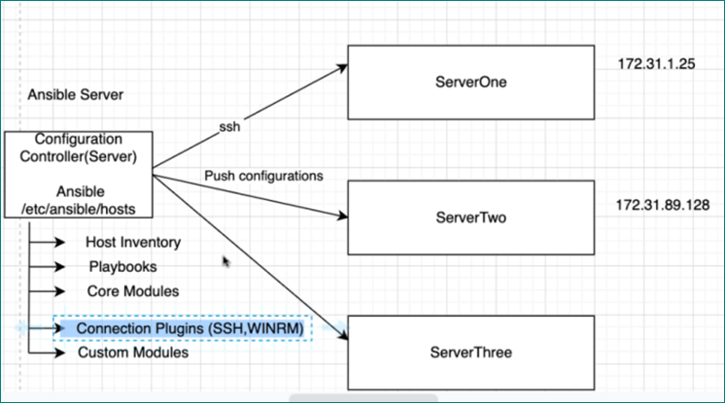

**Syntax of adhoc command**

# ansible all/host_name/ip_address -i path_of_inventory_file -m module_name -a arguments

**Default Inventory host location:**

**Default Location: /etc/ansible/hosts**

To open Default inventory file:

**# sudo vim /etc/ansible/hosts**

If you want you ansible host file in another location, then we need to set this environment variable

**export ANSIBLE_HOSTS=/home/ansible/custom_inventory_path**

(OR)

We can specify the ansible host while running command with the --inventory –file or (-i) flag:

**ansible all --inventory-file=/home/ ansible/custom_inventory_path -m ping**

**ansible all –i /home/ansible/custom_inventory_path –m ping**

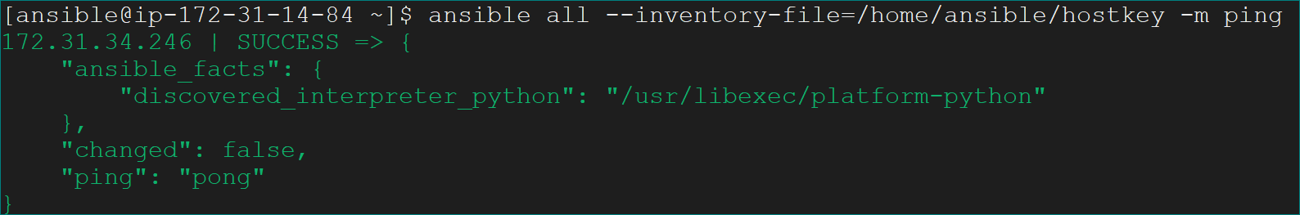

**Note:**

If we don’t mentioned any file/module name default will be inventory file/command module

ansible all -m free

ansible all -m ‘free’

**Command Module**

This module is used for executing basic Linux commands on managed nodes

The default module is module. When using command module we need not use -m option

* **ansible all -a free**
* ansible all -m command -a 'free' or ansible all -m command -a free
* ansible all -m command -a df –h

**User Module**

Command to create user and set home directory, user id, default working shell etc

**ansible all -m user -a 'name=minu password=mani uid=133 comment=userinfo home=/home/ansible/ shell=/bin/bash' -b**

**-b become for higher privileges on managed nodes**

**Yum Module(install software into managed nodes)**

ansible all -m yum -a ‘name=git state=present’ –b

ansible all -m **apt**  -a ‘name=git state=present’ –b (in UBUNTU Operating System)

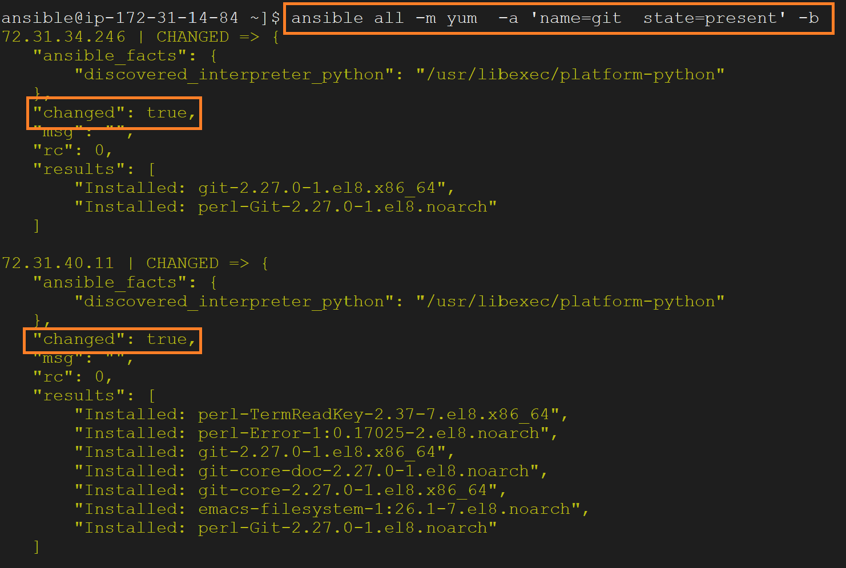

Note:

**“Changed : true which means expected command successfully executed in managed nodes**

**We get "changed": false**

**That means git is already installed on it. The command has no effect in the nodes**

**File Module**

**ansible all -m file -a 'name=/home/ansible/file1.txt state=touch' -b**

state=touch is to create files

state=directory is to create directory

state=absent is for deleting file/directory

**Copy Module**

This is used for copying the files from controller into managed nodes.

We know in the file **/etc/passwd** we have all the information about users

Now I want to copy the file into all nodes

**ansible all -m copy -a 'src=/etc/passwd dest=/tmp'**