Cherry-Pick

Picking specific commit from other branch bringing those changes into master branch.

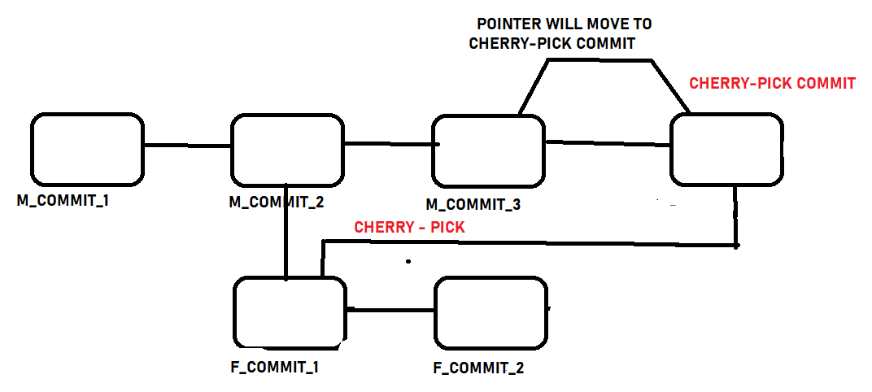

In other words, copying a commit from one branch to another branch

$ cd Masters

$ touch m_file_1.txt

$ git add .

$ git commit -m “Master commit -1”

$ touch m_file_2

$ git add .

$ git commit -m “Master commit -2”

$ touch m_file_3

$ git add .

$ git commit -m “Master commit -3”

$ git branch feature

$ git checkout feature

$ touch f_file_1

$ git add .

$ git commit -m “**Feature commit -1**”

$ touch f_file_2

$ git add .

$ git commit -m “**Feature commit -2”**

$ git checkout master

$ git cherry-pick <**commit-id>**

Picking <commit-id> from future branch

$ git log –-oneline

**<new commit id will be generated with cherry pick commit id>**