**REBASE:**

**Re-arrange the commit history**

**Requirement: There is 3 commits**

* + - **704bf8f (HEAD -> master) c commit**
    - **61bb7a3 b commit**
    - **bc7aa7b a commit**

**Note:**

* First commit we can’t change (“*i.e a commit*”)
* If we want to change the commit order **b** after **c**

as per client requirement we can use below command.

$ git rebase -i HEAD <TotalCommitnumber -1>

$ git rebase -I HEAD 2

Check status

$git log –oneline

* + - **704bf8f (HEAD -> master) b commit**
    - **61bb7a3 c commit**
    - **bc7aa7b a commit**

**Merging the commits**

**Client Requirement:** Client has given requirement to developer and developer has develop the code and marked as a commit b commit, c commit etc, like keep on client giving

Requirement and developer is doing changes at certain point of time developer had understand the few commits are not requirement we can achieve this by using rebase.

* Merging the commits means removing un-necessary commits.

$git rebase -i HEAD~4

Replace ***Pick*** to ***squash*** *which we want to remove commit.*

**Changing the message of older or multiple commit messages**

**If you need to amend the message for multiple commits or an older commit, you can use interactive rebase, and then force push to change the commit history.**

1. **On the command line, navigate to the repository that contains the commit you want to amend.**
2. **Use the git rebase -i HEAD~n command to display a list of the last n commits in your default text editor**

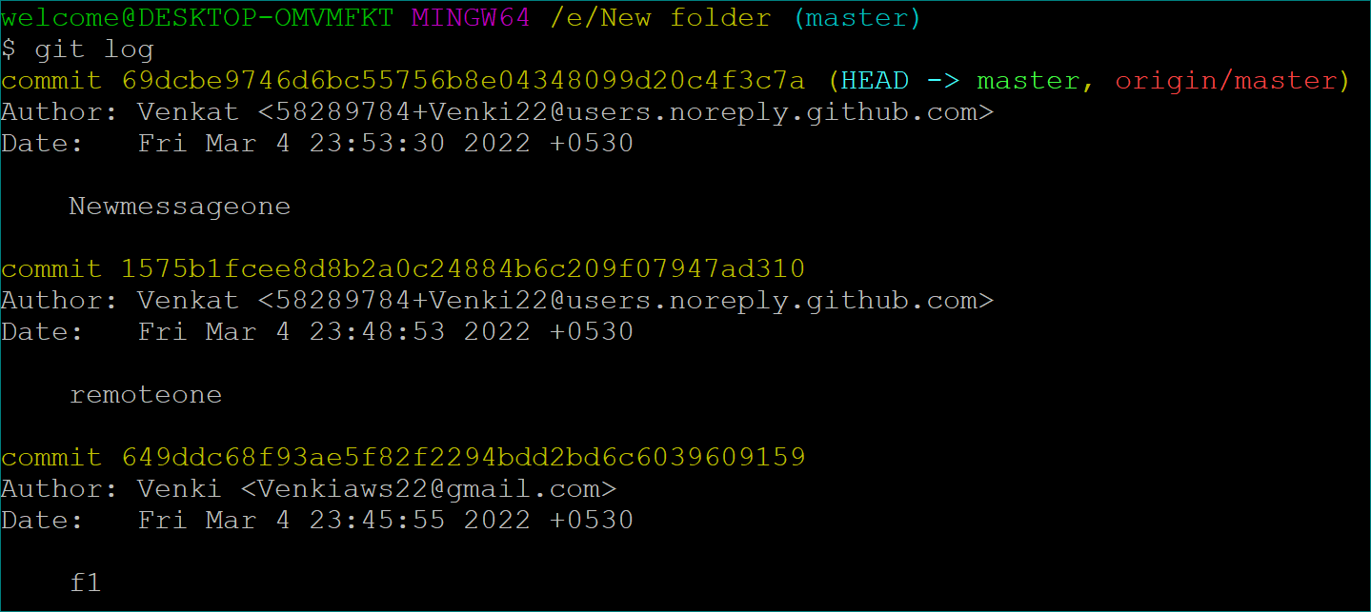

**# Displays a list of the last 2 commits on the current branch**

**git rebase -i HEAD~2**

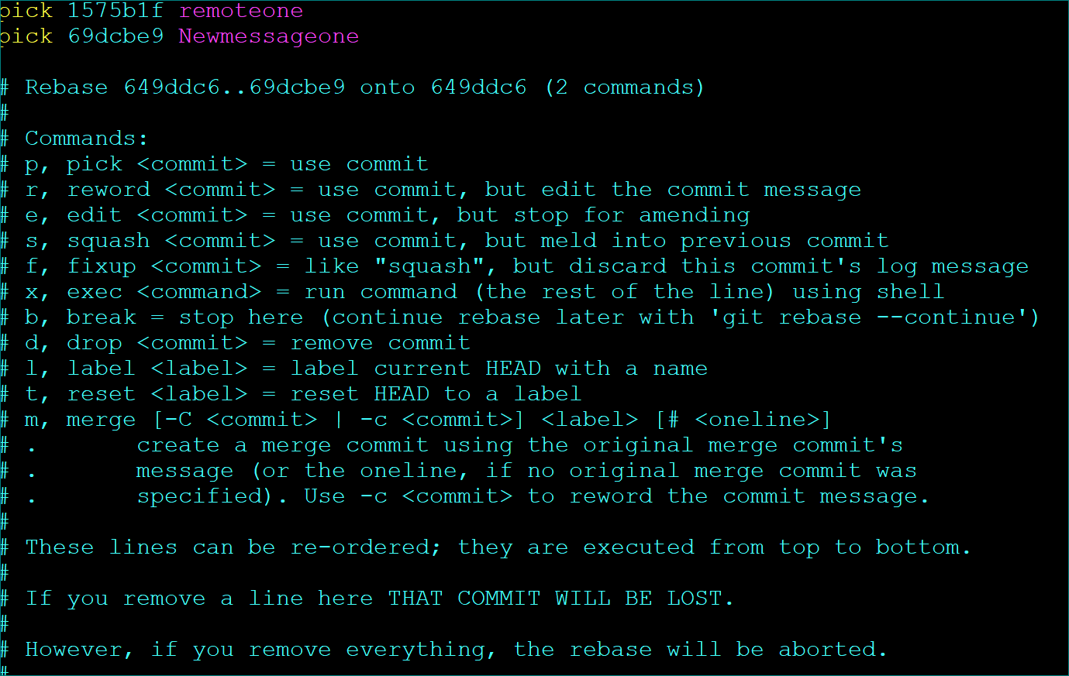

**Replace pick with reword before each commit message you want to change.**

**Save and close the commit list file**

**In each resulting commit file, type the new commit message, save the file, and close it**

**When you're ready to push your changes to GitHub, use the push --force command to force push over the old commit.**

**$ git push --force origin *example-branch***

**$ git push –force origin master**

