**GIT-REVERT**

revert is the command we use when we want to take a previous commit and add it as a new commit, keeping the log intact.

It is also same as reset but it is not moving the master commit to previous commit history, it will be going to create new commit id (i.e what ever changes done from commit-3 to commit-4 based revert it commit-3 and create new commit id with those changes.

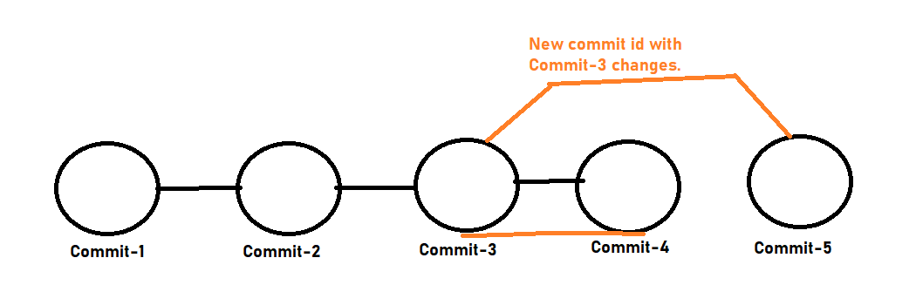

revert the latest commit:

$ git revert HEAD

$ git revert HEAD~1

revert the latest commit, skipping the commit message editor:

$ git revert HEAD --no-edit

Revert the particular commit id

$ git revert <commit-id>