**GIT – TAG**

Tag is nothing but release points & giving tag name to specific code base

Tags are identifying the specific release point

We have two types of tag

1. Annotation based tag
2. Lightweight tag

**Annotation based tag**

It will contain author name, email address, release notes all the details will be included.

If we publishing open platform, we will use this annotation-based tag.

**Lightweight tag**

It will store # code of the specific commit

git tag // It will displays the tags

git tag <tag-name> // It will create the tag

git tag ver-1.0

git tag ver-2.0

git tag

git tag –-delete <tag-name> // deleting tag name in local repository

git tag --delete ver-2.0

git tag -a <tag-name> -m <commit-message>

git tag -a ver-2.0 -m "This is Annotation based tag"

git tag

git status //To check status

git push <allies-name> <tag-name> // pushing files in repository

git push origin ver-1.0.0

git tag

git push origin ver-1.0.0

git push origin ver-2.0.0

1 🡪 Indicates major version

0 🡪 Indicates minor version

0 🡪 Indicates patches

git push origin <tag-name>

git push origin ver-2.0.0

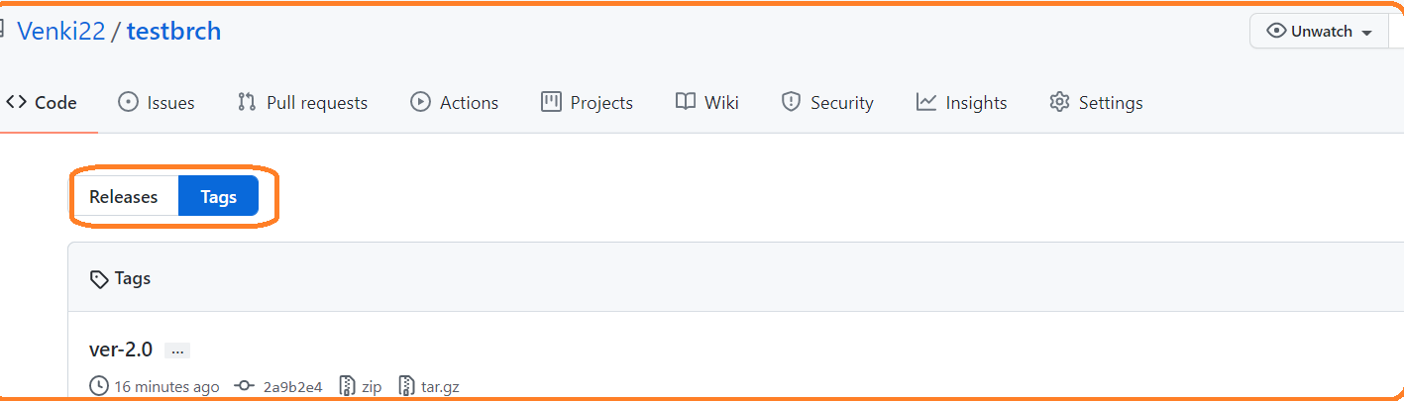

git tag --d <tag-name>

git tag –-d ver-1.0.0 ver-2.0.0 //deleting from local

git push <allies-name> :<tag-name> // Deleting tag from remote repo

git push --delete origin <tag-name> //Deleting tag from remote repo

git show <tag-name>

git tag <allies-name> -d <tag-name-1> <tag-name-2>

git tag origin -d ver-1.0.0 ver-2.0.0

git checkout -b <branch-name> <tag-name>

git status

git tag –-delete <tag-name>

git tag --delete ver-1.0

git push <allies-name> –-delete <tag-name>

git push origin --delete ver-1.0

git tag ver-2.1.0

git tag -d ver-2.1 ver-2.2