**JENKINS DIRECOTRY STRUCUTRE**

**1.Users.xml**

It contains all the users information, whatever we have created

**<Jenkins-Home-directory>/**users/<filename-name>

**Root/.jenkins**/users/users.xml

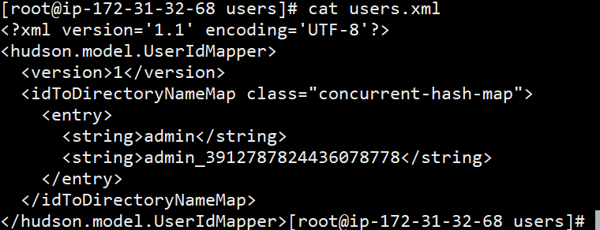

**2.plugins**

What ever plugin install those install plugin will store

**<*Jenkins-Home-directory*>/**plugins

***#root/.jenkins***/plugins

**3.nodes**

Default node name is **“Master”**

Slave configuration

**<*Jenkins-Home-directory*>/**nodes

***#root/.jenkins***/nodes

**4.config.xml**

Contains all job configuration details

Each job will have one config.xml file

**<*Jenkins-Home-directory*>/**config.xml

***#root/.jenkins***/config.xml

**5.secrets**

Initial admin password will be store

**#root/.jenkins/secrets**

**6.tools**

**7.updates**

All plugin updates will be available

**#root/.jenkins/updates**

**8.logs**

Jobs related logs info will be store

**#root/.jenkins/logs/tasks**

**9.workspace**

Working directory for version control system

**#root/.jenkins/workspace**