**Discard Old builds**

If we have more build in this case server hard disk space will be filled in order to avoid space issue we can delete the old builds from Jenkins and want to maintain only recent build we can achieve this using Discard Old build option in Jenkins.

**Click on Project 🡪 Configure**

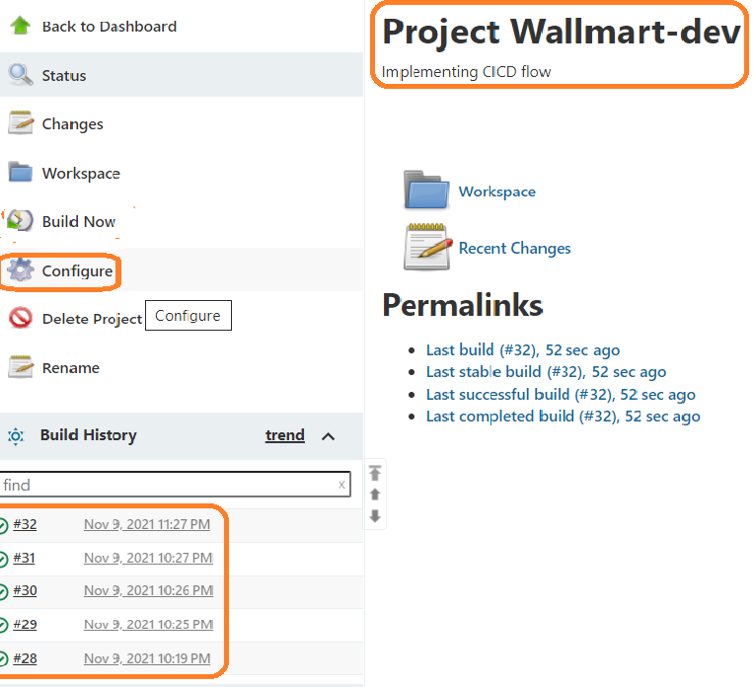

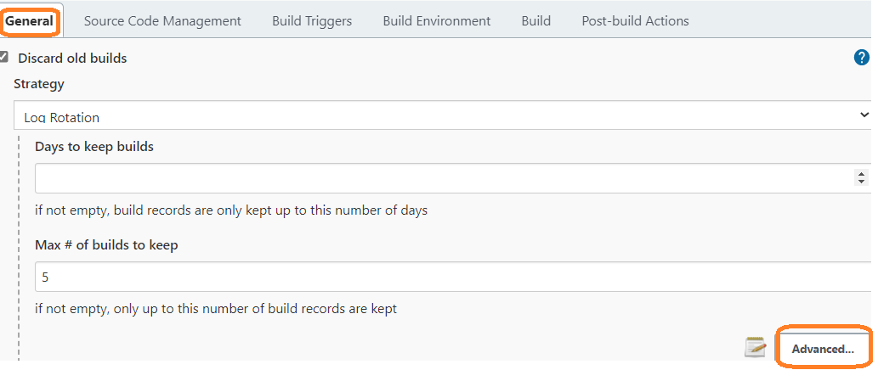

**Days to keep builds:** if you want to maintain last 5 days builds we can give number of days here

**Max # of builds to keep:** if you want to maintain last few builds, no of builds we can update here

Along with the build if we want to maintain artifacts, we can click **Advanced** button

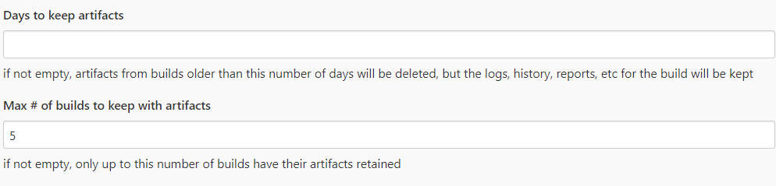

Click and apply and save button

Go to Jenkins dash board and trigger job again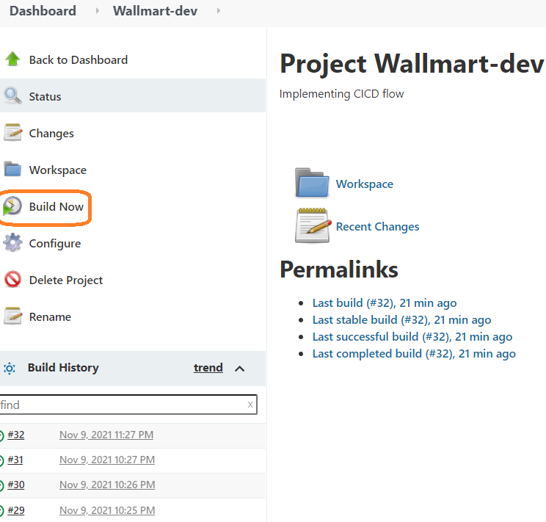

Refresh and check we can see last 5 builds only.

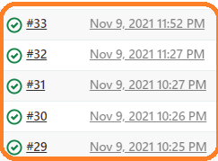

Real time we can maintain only last 50 builds alone

Delete workspace before build start:

It will delete the work space before build trigger

**Building in workspace** C:\ProgramData\**Jenkins\.jenkins\workspace**\Wallmart-dev

Click on project 🡪 Configure

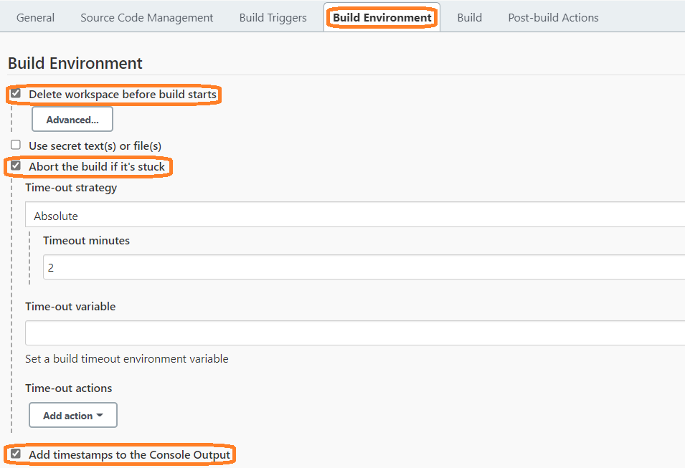

Click on save and apply button

**Before build console output:**

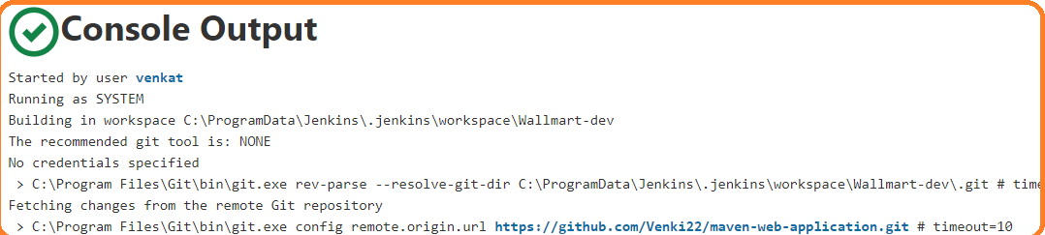

**Observation:** we are not able to see timestamp in console

Click on **Build Now** button

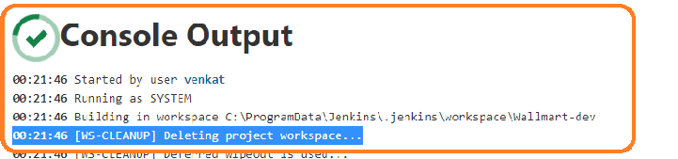

Here, we can see timestamp after build

**About the build if its stuck:** some time job has trigger and waiting response from other server

**example: sonerqube** if this server is not responding within time job will be marked as failed

by default time out is 3 mininutes

In this senario, if want to increase or decrease timeout value we can achive by selecting

**About the build if its stuck option**.

**Disable this project:**

During the schedule maintenance we can use **Disable this project** option form project level

This is handi option where our servers are maintance mode

Using this option we can stop the job tempararly

We don’t have option to disable multiple projects at a time

We have disable each jobs individually no other option

