**PASSSWORD LESS CONNETION BETWEEN MASTER AND SLAVE**

Connect Slave machine

Install java

*#yum install java-1.8.0-openjdk -y*

Verify java install or not

*Java -version*

We need to establish connection between master and slave machine

Connect slave machine

Check username

**#whoami**

root

We need to create password for root user using below steps

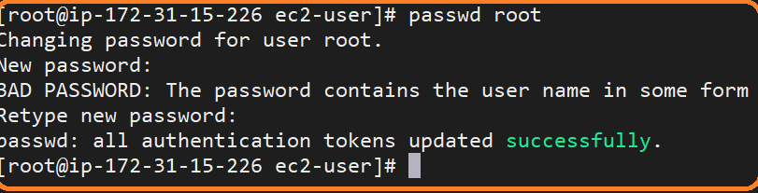

Go to ssh directory in slave machine

*#cd /etc/ssh*

We need to modify the file **sshd_config** file usner /**etc/ssh** directory using vi editor

*#vi sshd_config*



‘

By default, it will no **no**, we have to change **yes**

Restart the SSHD server

***#systemctl restart sshd.service***

**Test connection from Master to Slave machine**

Connect to master server

***#ssh <slave-username>@<privateIP-Address of Slave machine>***

***#ssh*** [***root@172.31.44.114***](mailto:root@172.31.44.114)

**Ip Address ending with 114 is slave**

**IP Address ending with 211 is master**

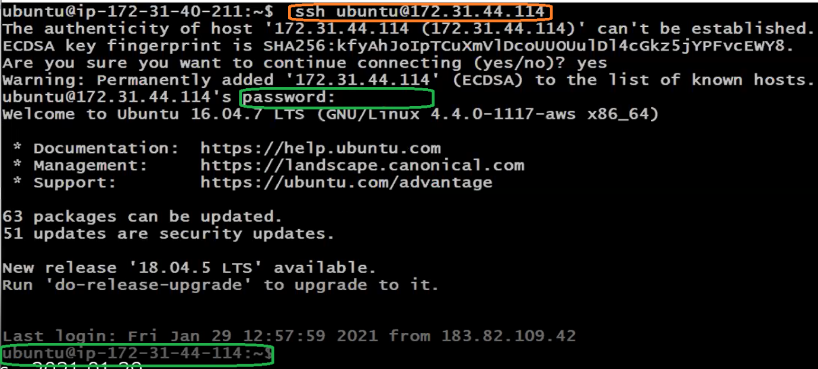

Jenkins need to communicate slave machine without password for that we need generate keys

In order to generate keys we have to fallow below steps

Generate key in ***master*** machine and copy same in ***slave*** machine

#Exit and come back to master

Using below command we can generate keys

***#ssh-keygen***

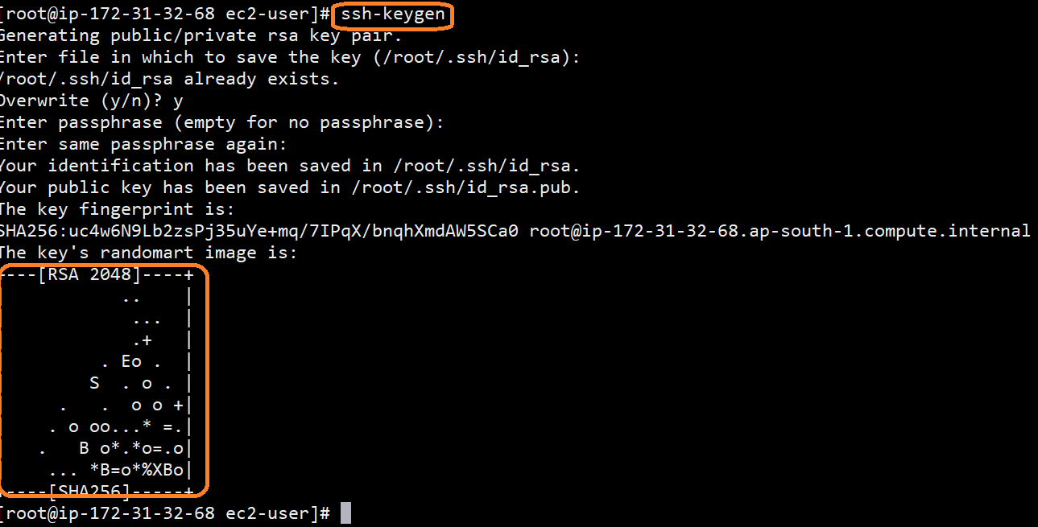

Copy keys into the slave machine

#ssh-copy-id root@<private IP of slave machine>

#ssh-copy-id [root@172.31.44.114](mailto:root@172.31.44.114)

First time it will ask you to password

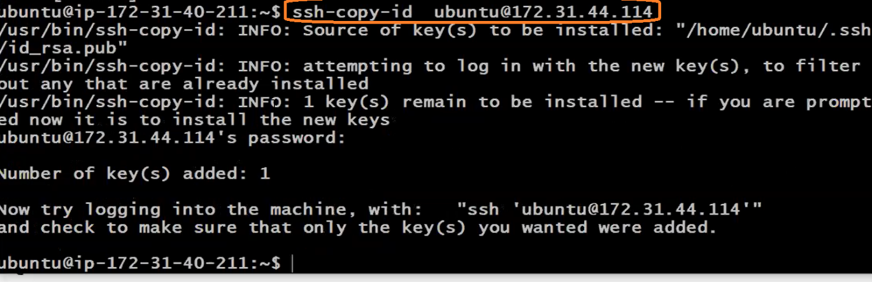

Now, keys has been copied from master to slave

Nee to test connection again

Connect master machine

***#ssh*** [***root@172.31.44.114***](mailto:root@172.31.44.114)

Now, we are able to connect slave machine without password.

