**Install NodJS Application in Jenkins**

**NodeJS Installation in Linux:**

**Steps to Install NodeJS in Linux (RedHat and Ubuntu)**

**Method -1**

**#sudo su -**

**Install the NodeJS package as follows.**

**In RedHat distribution**  
#yum install nodejs -y

#yum install npm –y

**In Ubuntu distribution**

#apt-get install nodejs –y

 #apy-get install npm -y

**Method -2 (Install the specific version)**

Login into Linux server and switch to the root user using below command.

#sudo su -

#cd /opt

Download the node js specific version of software and extract.

yum install wget tar -y ---> RHEL  
apt-get install wget tar -y --> Ubuntu

wget **https://nodejs.org/dist/v10.15.1/node-v10.15.1-linux-x64.tar.xz  
tar -xvf node-v10.15.1-linux-x64.tar.xz**

**Create a soft link.**

ln -s /opt/node-v10.15.1-linux-x64/bin/node /usr/bin/node  
ln -s /opt/node-v10.15.1-linux-x64/bin/npm /usr/bin/npm  
ln -s /opt/node-v10.15.1-linux-x64/bin/npx /usr/bin/npx  
  
**Check the version**

node --version  
#node -v  
npm --version  
#npm –v

Reference: <https://github.com/nodejs/help/wiki/Installation>

**Deploy NodeJS Application in Jenkins using Pipeline Script**

* Checkout code from SCM
* Build the Application using npm(NodePackageManager)
* Execute the application using SonarQube server
* Upload artifact in artifact repository (i.e nexus)
* Run NodeJS Application

**Code Snippet**

node{

stage('NodeJs-SCM Checkout') {

git 'https://github.com/Venki22/nodejs-app-mss.git'

}

stage('NodeJs-Build'){

nodejs(nodeJSInstallationName: 'NodeJs17.1.0'){

sh "npm install"

}

}

stage('NodeJs-ExecuteSonarQube Report'){

nodejs(nodeJSInstallationName: 'NodeJs17.1.0'){

sh "npm run sonar"

}

}

stage('NodeJs-UploadArtifactinto Nexus'){

sh "npm publish"

}

stage('NodeJs-Run NodeJS Application'){

sh "chmod u+x ./scripts/runApp.sh"

sh "./scripts/runApp.sh"

}

}

**Launch EC2 instances**

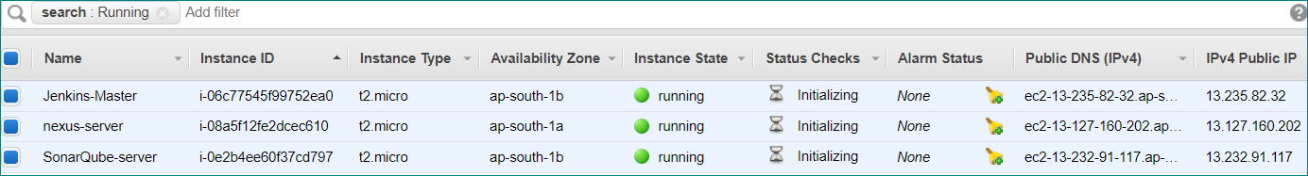

**Note: Instance Type = t2.medium**

**Install NodeJS Plug-in in Jenkins server:**

**Jenkins Dashboard 🡪 Manage Jenkins 🡪 Manage Plugins 🡪 Available**



Once installation done, we could see plug-in in Jenkins server

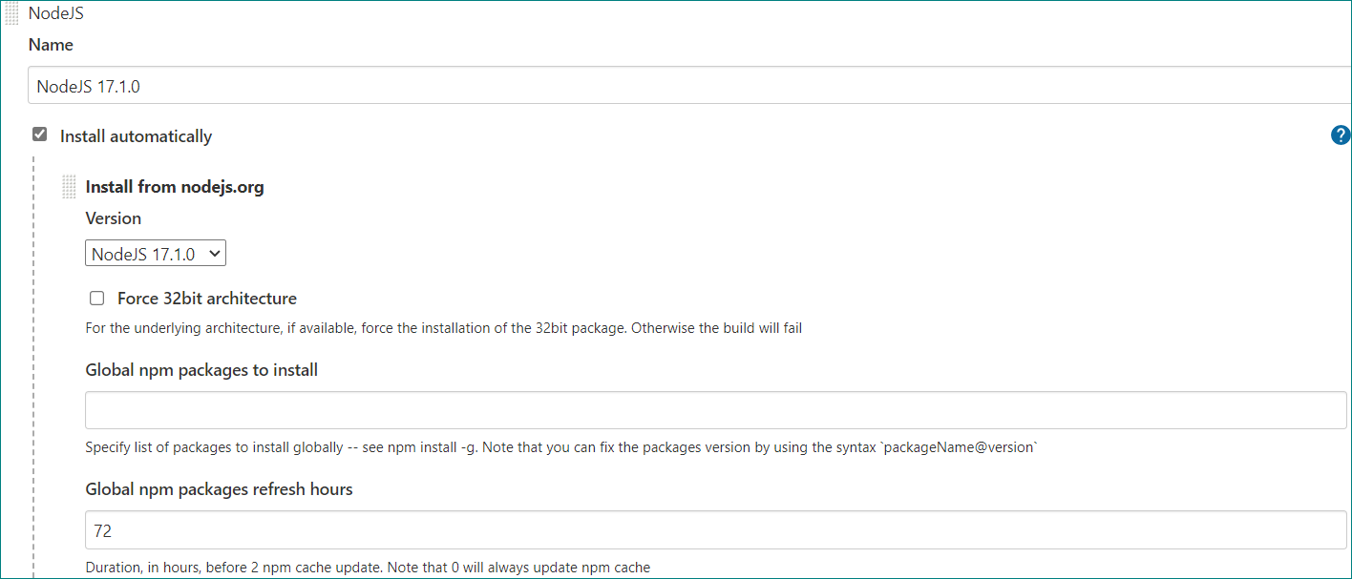

**We can select version and click on install automatically**

**Click on Apply and Save**

If we want to build the application for java we will use maven

**# mvn clean package**

If we want to build the application for NodeJS we will use npm

**# npm install**

**If we want to update NodeJS plugin path in script level if NodeJS application**

nodejs(**nodeJSInstallationName**: 'NodeJs17.1.0')

nodejs() is method name

**Note:** **nodeJSInstallationName** is keyword

**If we want to update Maven plug-in path in script level if Java application**

**def** mavenHome = **tool name**: "maven3.8.3"

**Run application using SonarQube tool**

If it is Java we will use **mvn sonar:sonar**

If it is NodeJS application we will use **npm run sonar**

**Update sonarqube details in sonar-project.js under project folder:**

If it is java application with maven will update sonarqube details in **pom.xml**

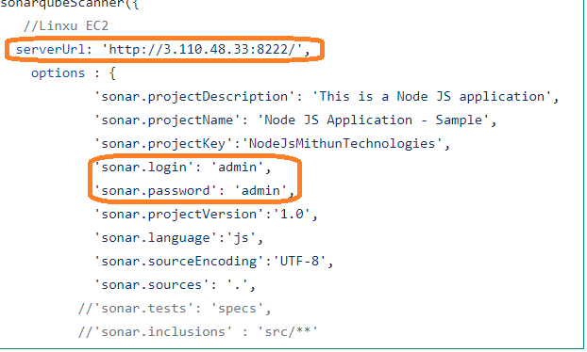

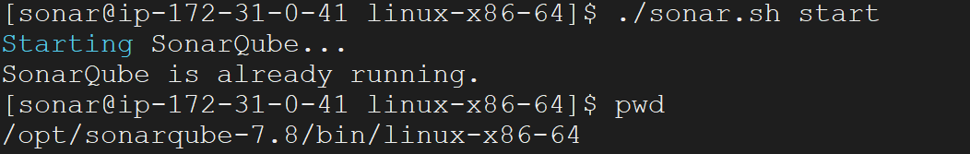

**After Jenkins Build report will show in SonarQube Server**

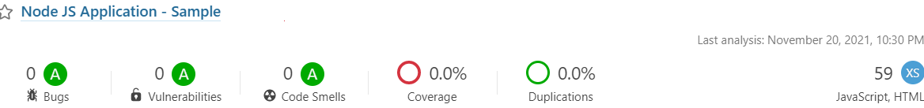

**Upload artifact in Nexus repository**

If it is Java application we will use **mvn deploy**

If it is NodeJS application we will **npm publish**

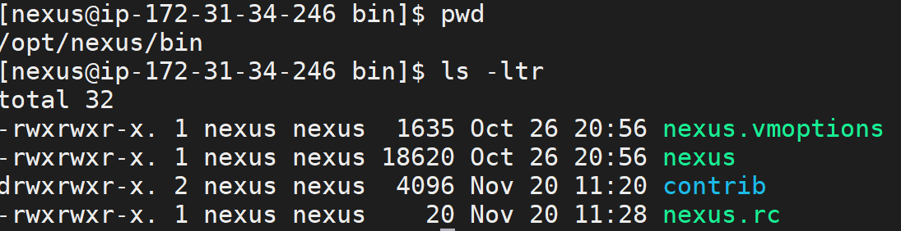

**#start nexus server**

systemctl start nexus

**Create repository and update in package.json file**

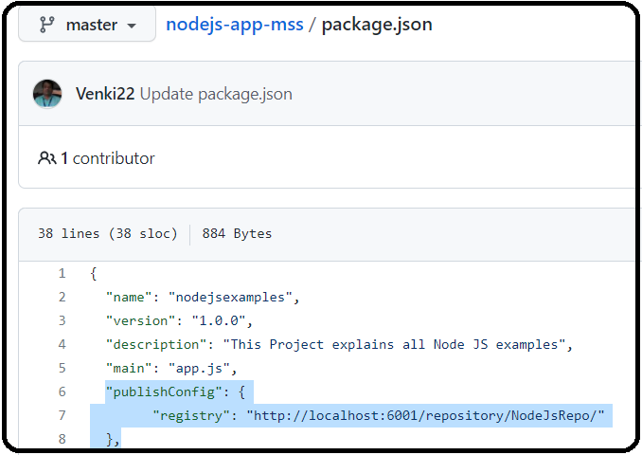

If it is **java application** we will update in **pom.xml** under ***distributionManagemen****t* tag

**We have to update nexus server details in .npmrc file**

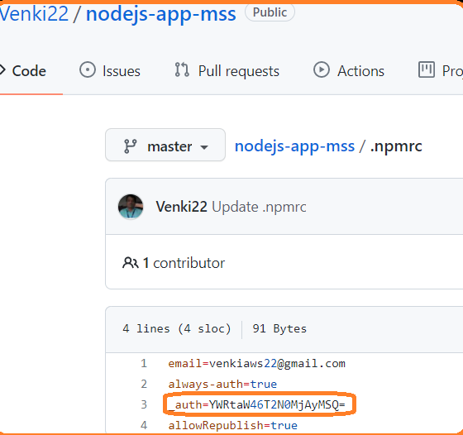

Update **auth token** using below command

**echo -n "username:password" | openssl base64**

**Note: username and password for Nexus server**

If it is java Application we will update in **setting.xml** file

We can run the application using below code

stage('NodeJs-Run NodeJS Application'){

sh "chmod u+x ./scripts/runApp.sh"

sh "./scripts/runApp.sh"

}

By default application will be deployed in below location

/var/lib/jenkins/workspace/<project-name>/

**/var/lib/jenkins/workspace/NodeJS-Demo/scripts/runApp.sh**

Once NodeJS server started we can visit application using below path

Visit **http://Jenkins-PublicIP:portNumber/context-path** to see your Node.js application