Jenkins Master-Slave setup

If we create 100 jobs and assign to Master node, in order to run all 100 jobs to master node alone will take lot of time and time consuming process instead of that master node can assign all jobs to node/slaves machines so that task will be done without any delay

- By using Master/slave architecture we will improve the performance
- We will install Java/Jenkins/git/maven in Master node
- We will not install Jenkins in slave machines
- Master is running in LINUX Machine
- Slaves we can call as nodes/servers, these nodes will create in different LINUX/WINDOWS machines In real time we will not create master and slave same machine
- Most of time we will create master/slave in Linux server only and protocol will be TCP/IP and connection type will be SSH
- All jobs information will be available in MASTER NODE
- Source code information will be store in SLAVE MACHINE where your job is running
- Slave machine we need to install the JAVA/GIT

Setup on Linux machine:
- Create EC2 instance and we can call as slave machine or node
- Install Java and GIT in Slave machine

- Start the Jenkins

- Create the node
- Manage Jenkins → Manage Nodes →New Node
Provide the node name and click on OK button

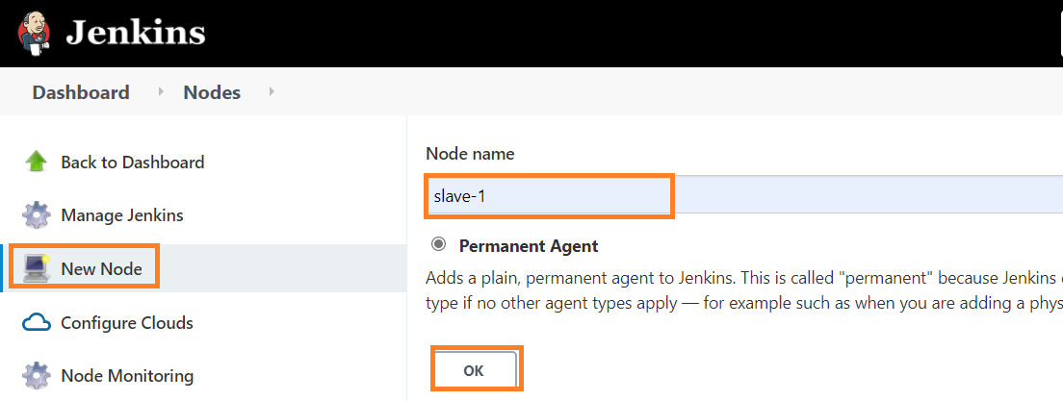

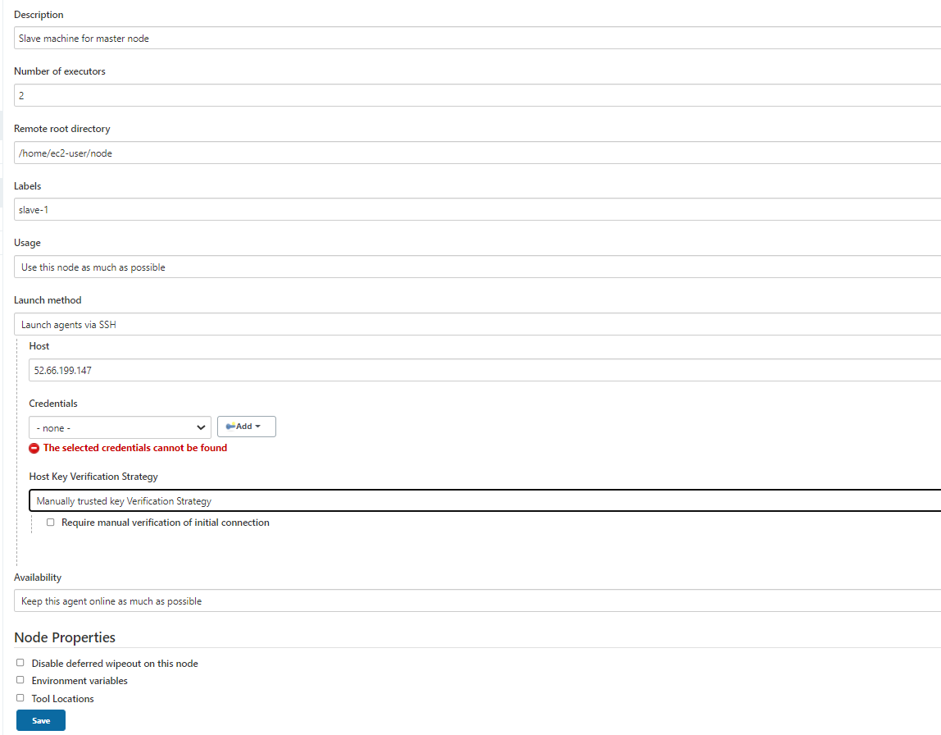

Number of executors:
The maximum number of concurrent builds that Jenkins may perform on this node

Remote root directory:
An agent needs to have a directory dedicated to Jenkins. Specify the path to this directory on the agent. It is best to use an absolute path, such as /var/jenkins or c:\jenkins. This should be a path local to the agent machine. There is no need for this path to be visible from the master.
Remote root directory where all Jenkins releated files will be store for slave machine

Labels:
Labels (or tags) are used to group multiple agents into one logical group.
For example, if you have multiple Windows agents and you have a job that must run on Windows, then you could configure all your Windows agents to have the label windows, and then tie that job to this label.
This would ensure that your job runs on one of your Windows agents, but not on any agents without this label.

Labels do not necessarily have to represent the operating system on the agent; you can also use labels to note the CPU architecture, or that a certain tool is installed on the agent.

Multiple labels must be separated by a space. For example, windows docker would assign two labels to the agent: windows and docker.

Labels may contain any non-space characters, but you should avoid special characters such as any of these: !&|<>(), as other Jenkins features allow for defining label expressions, where these characters may be used.

Usage:
Controls how Jenkins schedules builds on this node.
Use this node as much as possible
This is the default setting.
In this mode, Jenkins uses this node freely. Whenever there is a build that can be done by using this node, Jenkins will use it.
Only build jobs with label expressions matching this node
In this mode, Jenkins will only build a project on this node when that project is restricted to certain nodes using a label expression, and that expression matches this node's name and/or labels.
This allows a node to be reserved for certain kinds of jobs. For example, if you have jobs that run performance tests, you may want them to only run on a specially configured machine, while preventing all other jobs from using that machine. To do so, you would restrict where the test jobs may run by giving them a label expression matching that machine.
Furthermore, if you set the # of executors value to 1, you can ensure that only one performance test will execute at any given time on that machine; no other builds will interfere

Launch method
Controls how Jenkins starts this agent.
Launch agent by connecting it to the master
Allows an agent to be connected to the Jenkins master whenever it is ready.
In one mode, Java Web Start is used. In this case, a JNLP file must be opened on the agent machine, which will establish a TCP connection to the Jenkins master. (Other launch methods use a JNLP file but not Java Web Start, or do not use a JNLP file at all.)
This means that the agent need not be reachable from the master; the agent just needs to be able to reach the master. If you have enabled security via the Configure Global Security page, you can customize the port on which the Jenkins master will listen for incoming agent connections.
By default, the agent will launch a GUI, but it is also possible to run an agent without a GUI, for example as a Windows service.
Launch agent via execution of command on the controller
Starts an agent by having Jenkins execute a command from the controller. Use this when the controller is capable of remotely executing a process on another machine, e.g. via SSH or RSH.
Launch agents via SSH
Starts an agent by sending commands over a secure SSH connection. The agent needs to be reachable from the Jenkins controller, and you will have to supply an account that can log in on the target machine. No root privileges are required.

Availability
Controls when Jenkins starts and stops this agent.
Keep this agent online as much as possible
In this mode, Jenkins will keep this agent online as much as possible.
If the agent goes offline, e.g. due to a temporary network failure, Jenkins will periodically attempt to restart it.

Bring this agent online according to a schedule
In this mode, Jenkins will bring this agent online at the scheduled time(s), remaining online for a specified amount of time.
If the agent goes offline while it is scheduled to be online, Jenkins will periodically attempt to restart it.

After this agent has been online for the number of minutes specified in the Scheduled Uptime field, it will be taken offline.
If Keep online while builds are running is checked, and the agent is scheduled to be taken offline, Jenkins will wait for any builds that may be in progress to complete.

Bring this agent online when in demand, and take offline when idle
In this mode, Jenkins will bring this agent online if there is demand, i.e. there are queued builds which meet the following criteria:
They have been in the queue for at least the specified In demand delay time period
They can be executed by this agent (e.g. have a matching label expression)
This agent will be taken offline if:
There are no active builds running on this agent
This agent has been idle for at least the specified Idle delay time period

Give slave machine public IP under Host
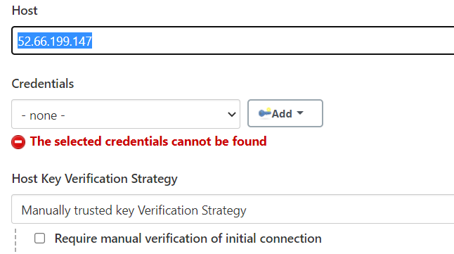

Click on Add button providing credentials for slave machine

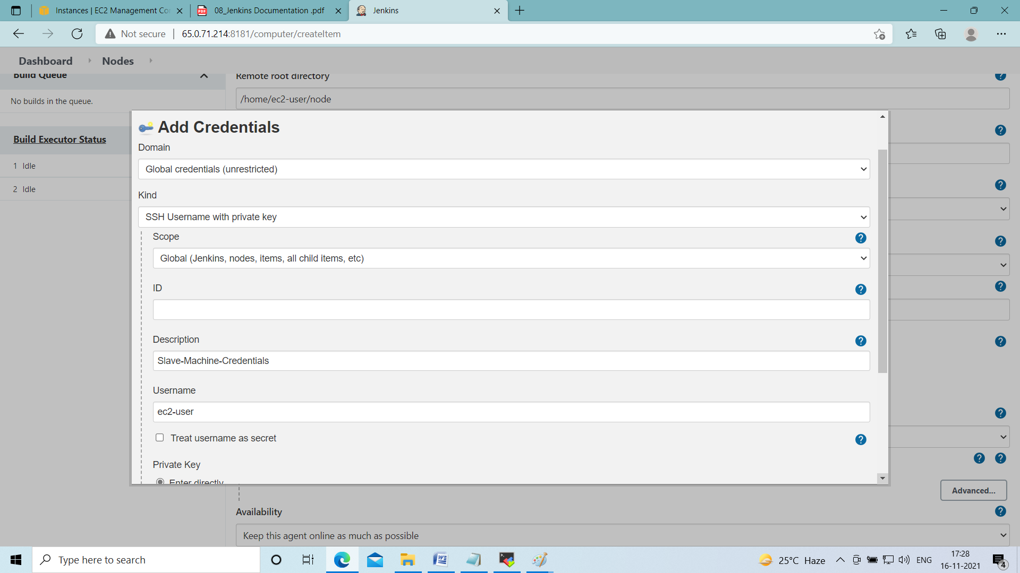

Click on Add button

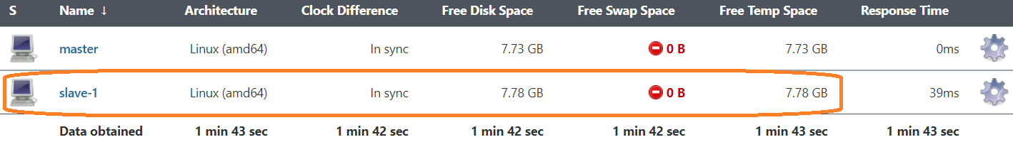

Now Agent has been connected successfully

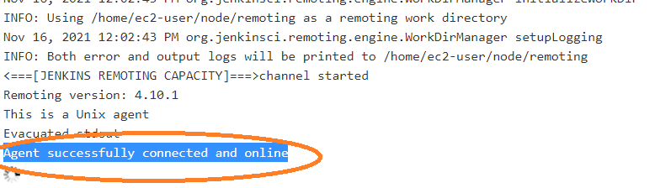

Now slave become communicating to node and it is live
Now we can use this slave for job creation

Once Agent connected successfully under root directory below 2 files will be generated
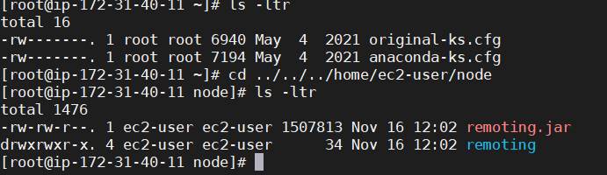

create one Freestyle project/any kind of project and select Restrict where this project can be run option and select node which you have created
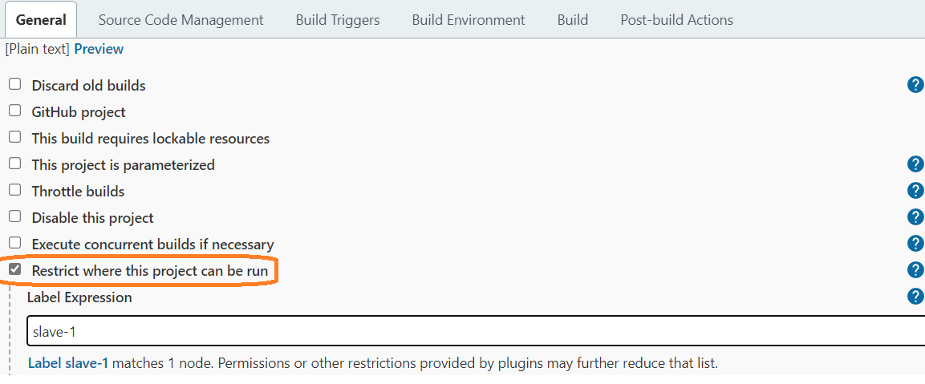

Click on Apply and Save button
Click on Build Now button

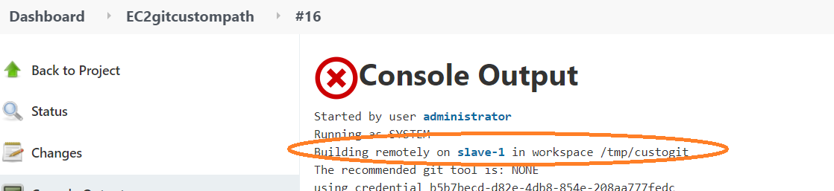

Creating and Configuring Slaves/Nodes in WINDOWS

- Create the node
- Manage Jenkins → Manage Nodes →New Node
Provide the node name and click on OK button

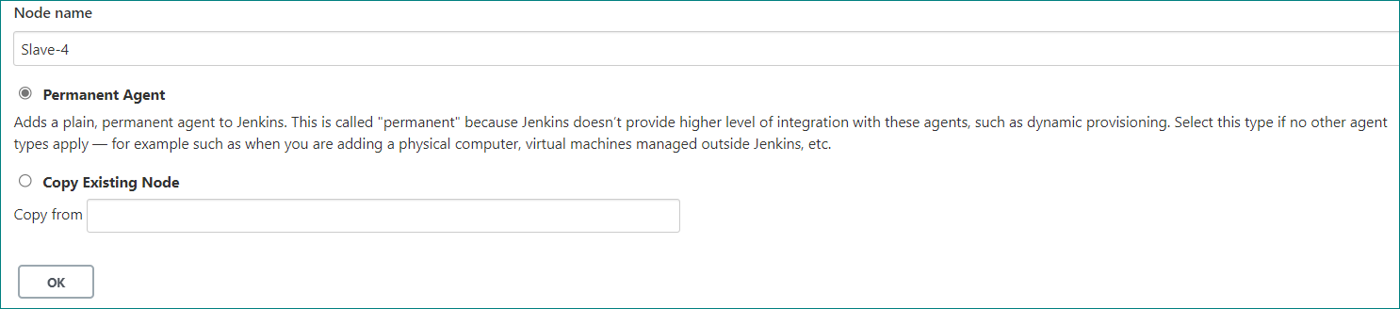

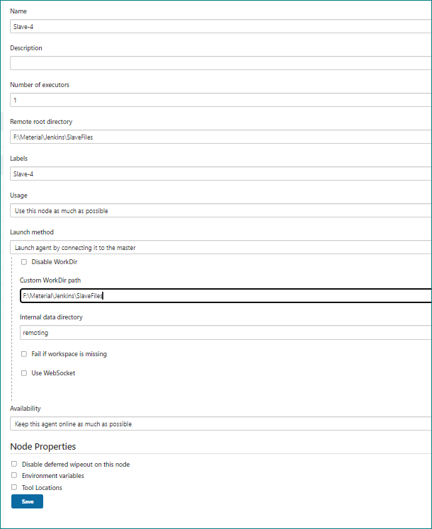

Download agent.jar file from below path and save into other location
From that location run below command for connecting master node
For reference, i have downloaded agent.jar file in Downloaded folder

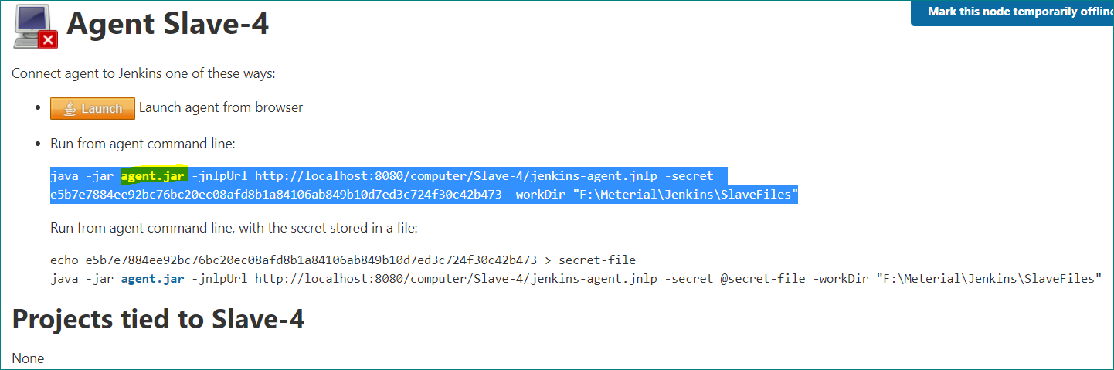

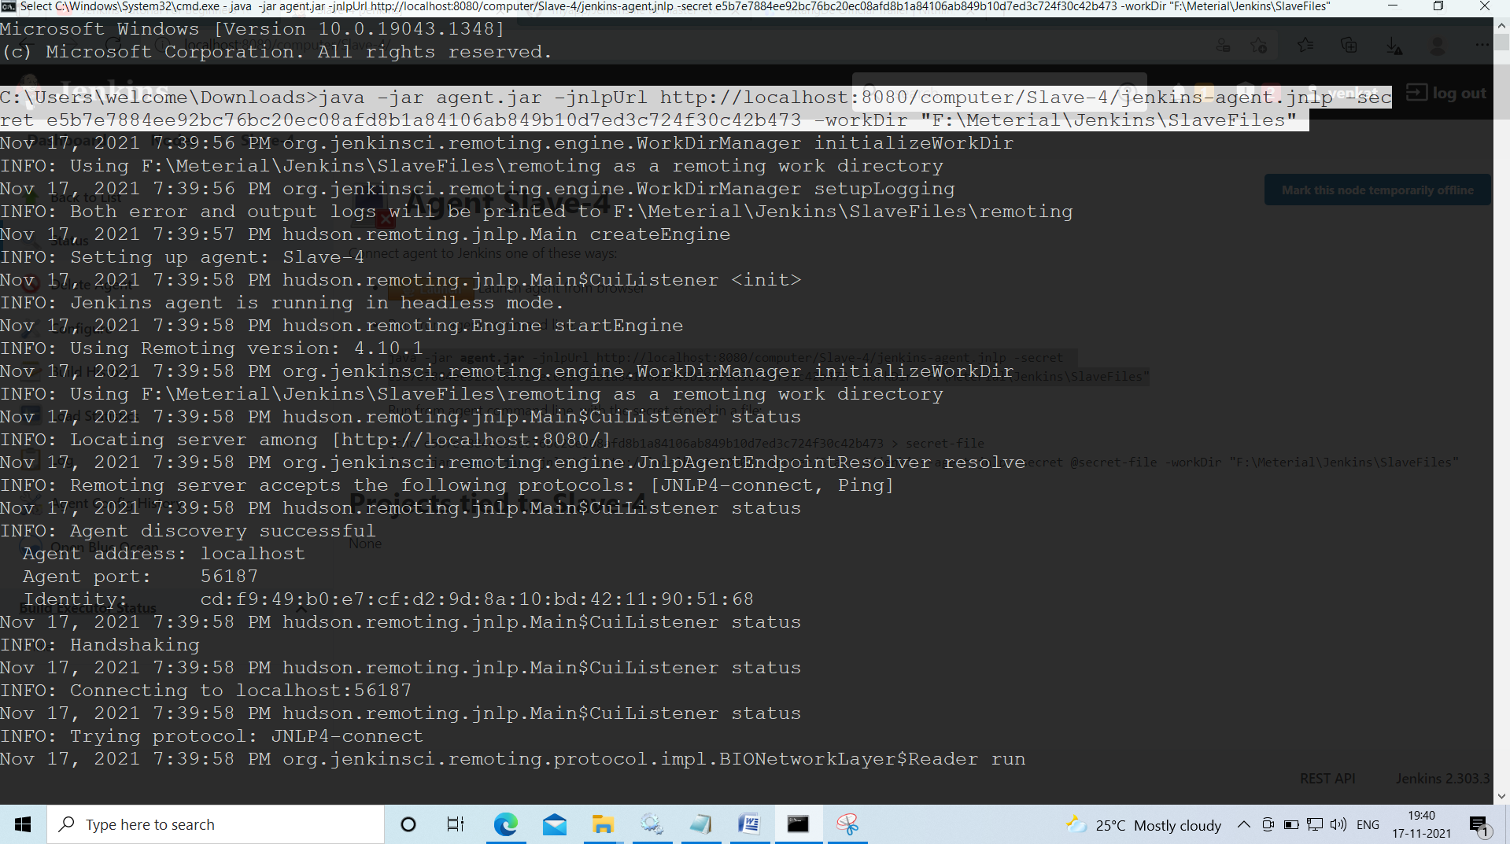

From console we could see below message
