Sending Email-Notification using Jenkins

We can send Email Notification 2 ways
1. E-mail Notification
2. Extended E-mail Notification

Manage Jenkins → Configure System
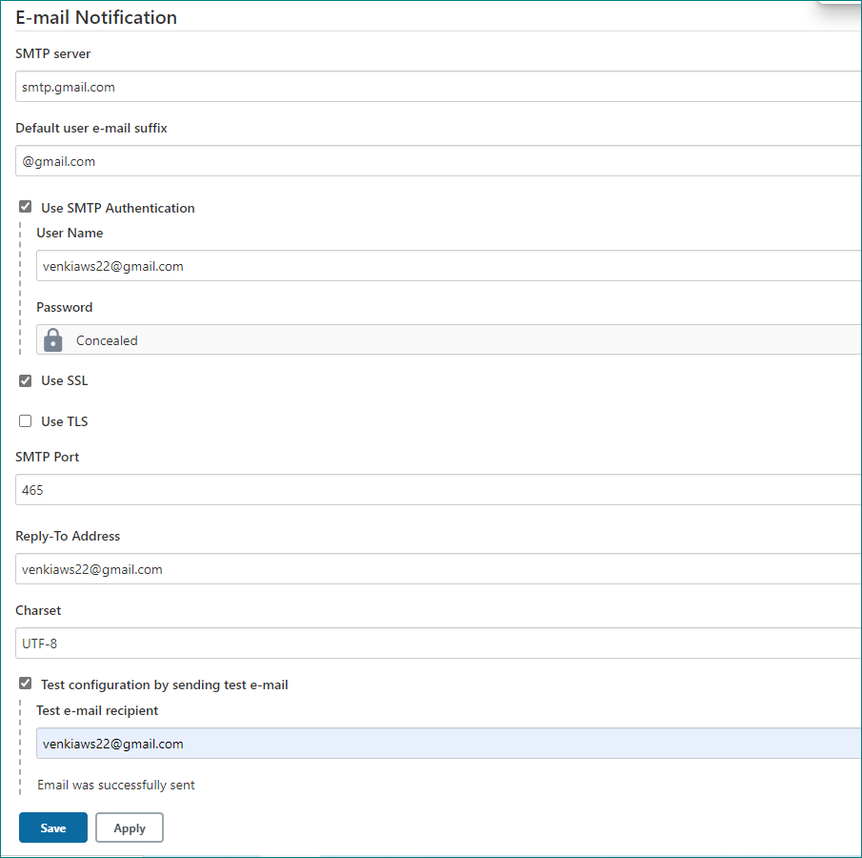

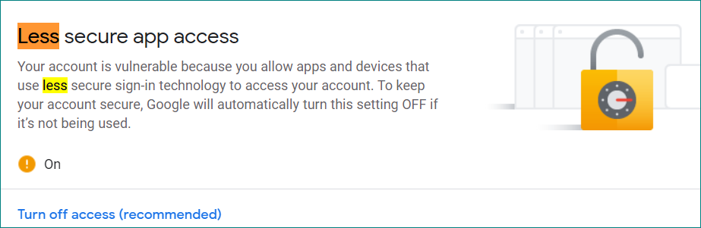

We have to ON the Less Secure app access from gmail Account.
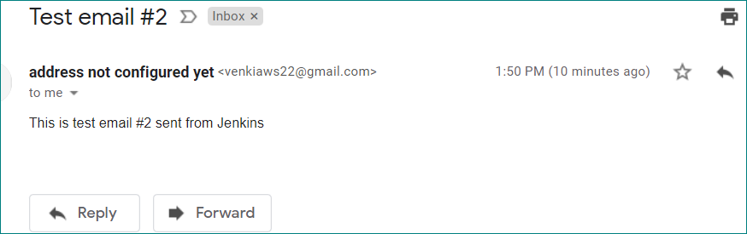

We can configure Email Notification from job level
Go to that Job and click on Configure

Go to Build Environment session and choose E-mail Notification under drop down
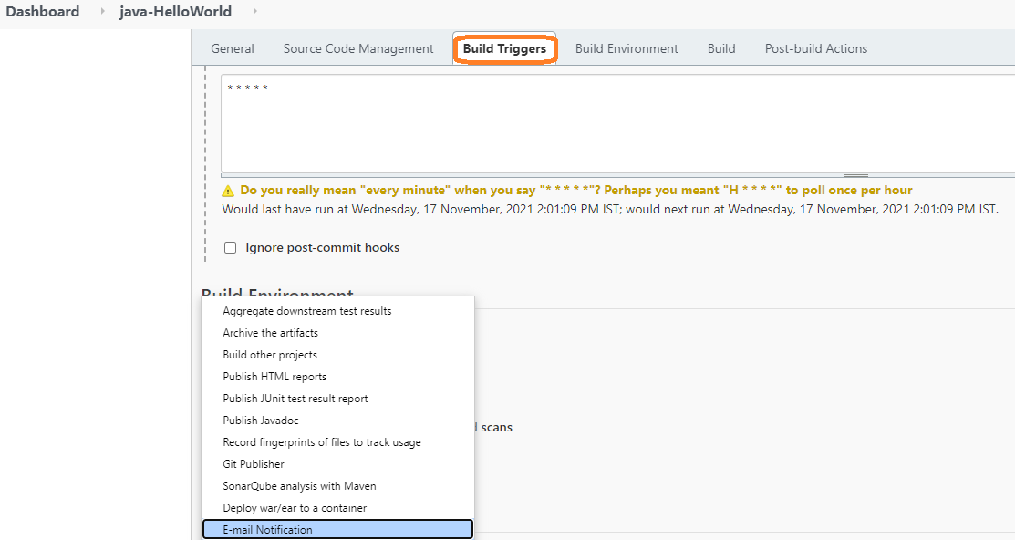

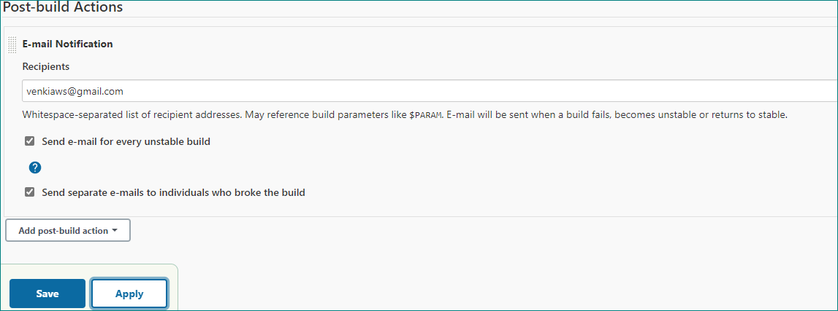

When build failed we will get email notification
