Jenkins Installation in EC2 Machine

Login in AWS console
Create EC2 instance

Login as root user
sudo su –

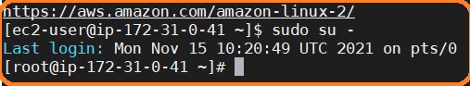

Install Java
yum install java-11-openjdk-devel -y
yum install java-1.8* -y

Install wget
yum install wget -y

Install Jenkins
Go to /opt folder
cd /opt/

run below command
wget -O /etc/yum.repos.d/jenkins.repo https://pkg.jenkins.io/redhat-stable/jenkins.repo
sudo rpm --import https://pkg.jenkins.io/redhat-stable/jenkins.io.key

sudo amazon-linux-extras install epel –y
yum install jenkins -y

once installation completed,we can check the Jenkins status using below commands

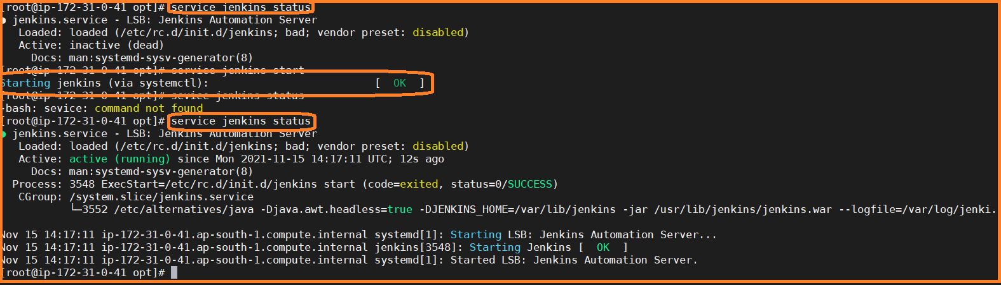

#Check Jenkins status
service jenkins status
#start the Jenkins
service jenkins start

#restart the Jenkins
service jenkins restart

Note:
The service command supports only basic LSB actions (start, stop, restart, try-restart, reload, force-reload, status). For other actions, please try to use systemctl.

systemctl enable Jenkins
Note:
Once the Linux system started automatically Jenkins service will be available

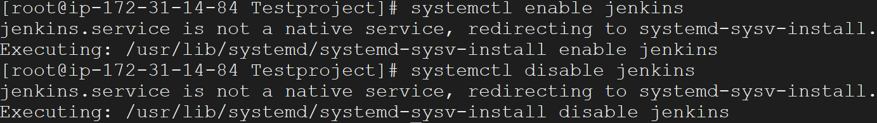

By default build workspace path
Building in workspace
/var/lib/jenkins/workspace/<custom-project-name>
/var/lib/jenkins/workspace/Testproject

We can change the default workspace path

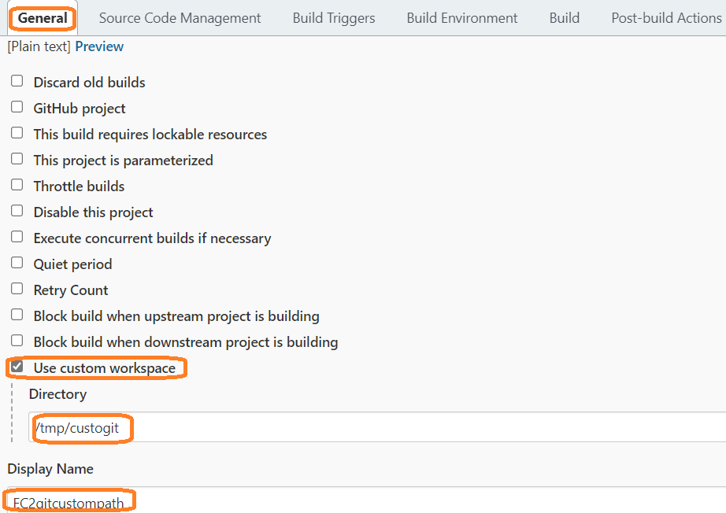

Once build success we can see source code under below path
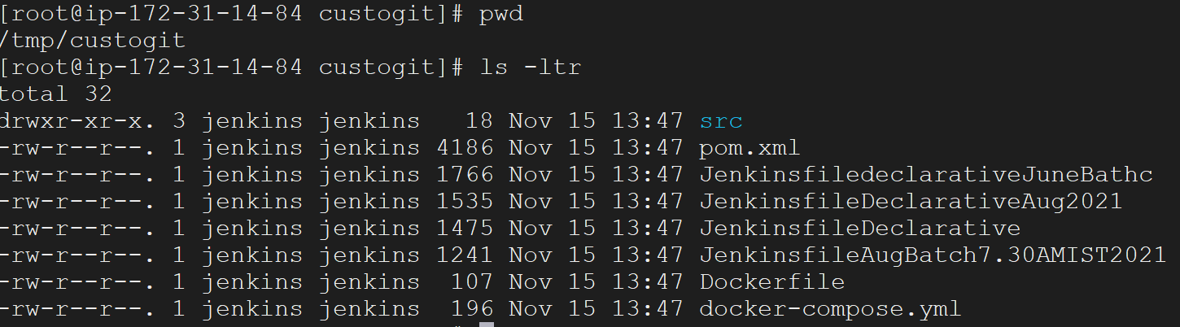

JENKINS PORT NUMBER CHANGE

- Go to the directory where you installed Jenkins (by default, it's under Program Files/Jenkins)
- Open the Jenkins.xml configuration file

Windows C:\Program Files\Jenkins\jenkins.xml
RHEL /etc/sysconfig/Jenkins
UBUNTU /etc/default

- Search --httpPort=8080 and replace the 8080 with the new port number that you wish
- Restart Jenkins for changes to take effect

Jenkins Security:

