#Delete all the object in that namespace
kubectl delete all --all -n <name-space>
Stop your worker node and start your worker node

kubectl delete all –all -n <name_space>
kubectl delete all rs
kubectl delete all rc

Default deployment strategy rollingupdate (or) rollingdeployment
Order doestnt matter indendation is mandatory

kubectl apply -f Deployment.yaml --dry-run=client
#Request will go to the apiServer directly
kubectl apply -f Deployment.yaml --dry-run=server

we created a deployment and deployment internally created replicaset and replicaset internally created pods

#Deployment syntax
apiVersion: apps/v1
kind: Deployment
metadata:
name: <Deployment-name>
namespace: <name-space-name>
spec:
replicas: <NumberOfReplicas>
strategy:
type: Recreate
selector:
matchLabels:
<key>: <value>
template:
metadata:
name: <NameOfthe-Pod>
namespace: <name-space-name>
labels:
<label-key>: <label-value>
spec:
containers:
name: <container-name>
image: <image-name>
ports:
- containerPort: <portNumber>

apiVersion: apps/v1
kind: Deployment
metadata:
name: javawebappdeployment
namespace: test-ns
spec:
replicas: 2
selector:
matchLabels:
app: javawebapp
strategy:
type: Recreate
template:
metadata:
name: javawebapppod
labels:
app: javawebapp
spec:
containers:
- name: javawebappcontainer
image: venki22/maven-web-application:1
ports:
- containerPort: 8080
---
apiVersion: v1
kind: Service
metadata:
name: javawebappsvc
namespace: test-ns
spec:
type: NodePort
selector:
app: javawebapp
ports:
- port: 80
targetPort: 8080

kubectl get all -n test-ns
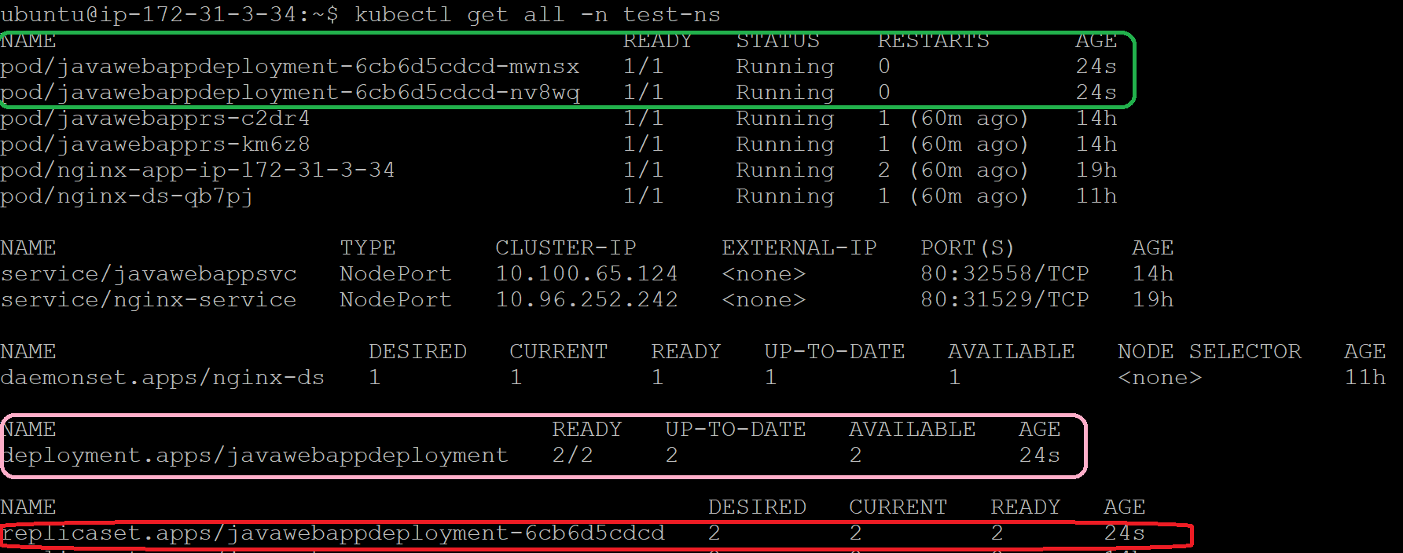

- #only deployment all namespaces
- kubectl get deployment --all-namespaces
- kubectl get deployment –A

- #rollout history details
- kubectl rollout history deployment javawebappdeployment -n test-ns
- kubectl rollout history deployment javawebappdeployment
- kubectl rollout history deployment javawebappdeployment -n test-ns --revision 1
- kubectl apply -f <filename.yaml> --record=true
- #rollback without any downtime
- kubectl rollout undo deployment <deployment-name> --to-revision 1
- #To check deployment status
- kubectl rollout status deployment <deployment-name>

Note:
All information will be stored in ETCD
By default history will maintain only 2 revision but we can customize revision history size

Blue Green deployment
- Take copy of latest release production code (complete setup)
- Copy setup environment is called green
- Take testing team(UAT Team) to test the latest release functionality in green environment code
- Once testing provide signoff in green environment we can move traffic to blue to green using Target Port(this case green deployment will be change to blue environment)

Canary deployment:
- Slowly injecting deployment to new code
- Some part of traffic move to latest code and majority of part traffic move to old code
- If no issues reported, slowly decrease the traffic to old code and increase the traffic to new code
- This is manual process
- Kubernetes service will follow rounrabin algorithm

State full
- we need to maintain the state of the application
- Statefull set is the recommended way to deploy state full application

Stateless

