NodePort:(Machine/Server)

- Expose the service on each Node's IP at a static port.A clusterIP service, to which the NodePort service will route,is automatically created.
- You will be able to contact the NodePort service,from outside the cluster by using
- "<NodeIP><NodePort>".

- if we create NodePort service, each and every node on port will be allocated that service
- NodeIP is nothing but Server-IP
- If both node and kubernates server will be same VPC/same network then we can use private IP
- If both node and kubernates server will be different network then we cna use publicIP
- Within cluster we can communicate service-name/service Port
- Outside the cluster we can communicate using NodePort
- NodePort is service port, which port expose the server
- NodePort range is 300000 to 32767
- if we dont mentioned NodePort range K8s will assign

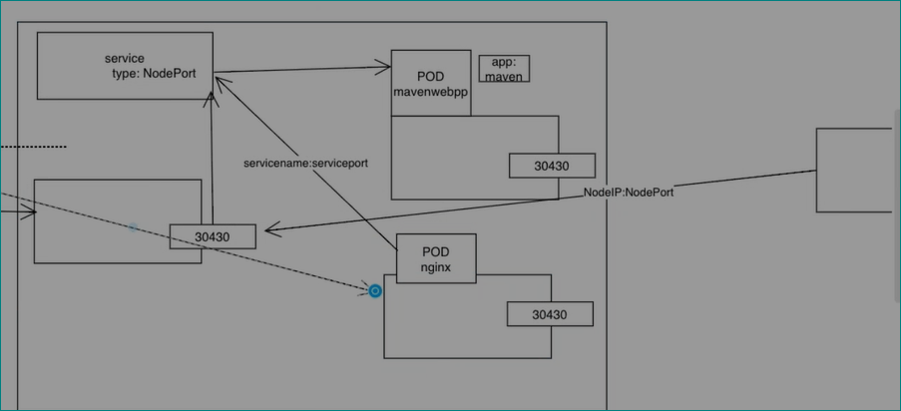

apiVersion: v1
kind: Pod
metadata:
name: nginx-pod
labels:
app: nginx-app
namespace: test-ns-1
spec:
containers:
- name: nginx-container
image: nginx
ports:
- containerPort: 80
---
apiVersion: v1
kind: Service
metadata:
name: nginx-service
namespace: test-ns-1
spec:
ports:
- port: 80
targetPort: 80
selector:
app: nginx-app

