If directly create the pod if something goes wrong with that pod we can’t get the pod again in kubernetes cluster
Instead of that if we use below controller then pods will be recreated and rescheduled
Replicaiton Controller
ReplicaSet
DemonSet
Deployment
StatefulSet

Static POD:
Static pods are directly managed by KUBLET
KUBELET is responsible/monitor each static pod
Static pods running on the node to visible to the API-SERVER
Static pods will not have any associated controller

KUBELET:
Kubelet is a node agent and agent process which is running on each on every node.
Kubelet is watch the static pods and it will be recreate if something goes wrong

kubectl get all -n kube-system
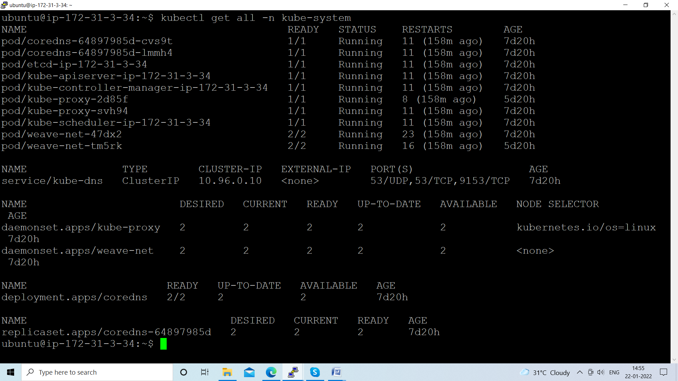

SIDCAR:
One utility container along with main container
Helps and enhance the functionality to main container

Can we create the STATIC PODS?
Yes, we can create
We need to h ave POD Manifest file and /etc/kubernetes/manifest directory
Keep the manifest file inside the server
apiVersion: v1
kind: Pod
metadata:
name: nginx-app
labels:
app: nginx-lable
namespace: test-ns
spec:
containers:
- image: nginx
name: nginx
ports:
- containerPort: 80

Kubectl apply –f nginx-static-pod.yml
Kubectl get pods –n test-ns
Kubeclt delete pod nginx-app
Pod will be create automatically

Managed files under below path is called static pods

