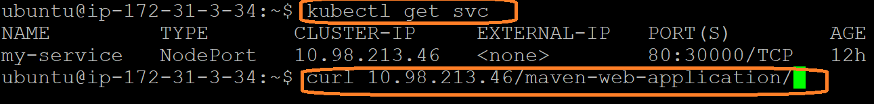
If we are using CLUSTER-IP no need to give PORT number

Kubectl config --help
kubectl config current-context
we can get the information from below path
cat .kube/config
Note: All the cluster details will be available in this folder
Using kubectl we can able to talk to multiple cluster using config

We can change the current context name space using below command
kubectl config set-context --current --namespace=test-ns
cat .kube/config
kubectl config view
it will disply all cluster details and namespace details.

We can reset the default namespace using below command
kubectl config set-context --current --namespace=default
kubectl config –-minify
kubectl config get-users
kubectl config get-contexts
kubectl config get-clusters

service doesn’t have endpoint because withat labels service doesnot found any pods
in this case ep will be empty

current-context Display the current-context
delete-cluster Delete the specified cluster from the kubeconfig
delete-context Delete the specified context from the kubeconfig
delete-user Delete the specified user from the kubeconfig
get-clusters Display clusters defined in the kubeconfig
get-contexts Describe one or many contexts
get-users Display users defined in the kubeconfig
rename-context Rename a context from the kubeconfig file
set Set an individual value in a kubeconfig file
set-cluster Set a cluster entry in kubeconfig
set-context Set a context entry in kubeconfig
set-credentials Set a user entry in kubeconfig
unset Unset an individual value in a kubeconfig file
use-context Set the current-context in a kubeconfig file
view Display merged kubeconfig settings or a specified kubeconfig file

one pod can able to communicate to other pod using service name

kubectl get pods
kubectl get svc
kubectl exec -it mvnapp-pod /bin/sh
curl my-service/maven-web-application/
exit

with in the cluster application(POD) can access other application(PODS) using Service name
service can talk to other service with diff namespace:

apiVersion: v1
kind: Pod
metadata:
name: nginx-pod
labels:
name: nginx-app
namespace: default
spec:
containers:
- image: nginx
name: nginx-container
ports:
- containerPort: 80

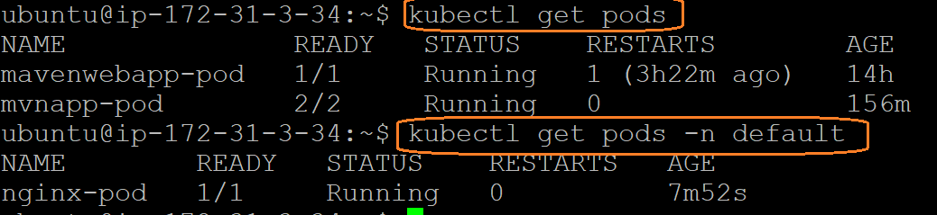

Both are different name space

Communication with different namespace:
What is FQDN?
Fully Qualified Domain Name
If one POD need access to service & which are in different names space we have to use FQDN of the service
Syntax:
<ServiceName>.<nameSpace>.svc.cluster.local
example: mavenwebappservice.test-ns.svc.cluster.local

kubectl get pods -n default
kubeclt exec -it nginx-pod /bin/sh -n default
curl my-service/maven-web-applicaiton/
curl: (6) Could not resolve host: my-service
curl my-service.test-ns-1.svc.cluster.local:/maven-web-application/
curl my-service.test-ns-1.svc.cluster.local:80/maven-web-application/

