**NEXUS-ADMINISTRATIVE ACTIVITIES**

**🡪**As a admin we can create multiple users and give permissions to other users as well

**🡪**🡪Login as admin user

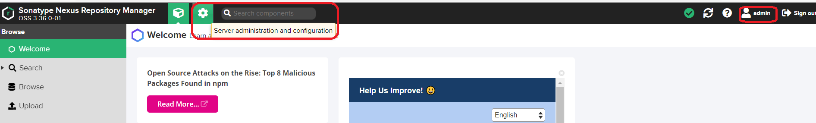

🡪Change the existing password

🡪Click on admin tab right side corner, we will get below page

🡪Update proper details and proceed to change the existing password

🡪We can change only password and we can’t change username

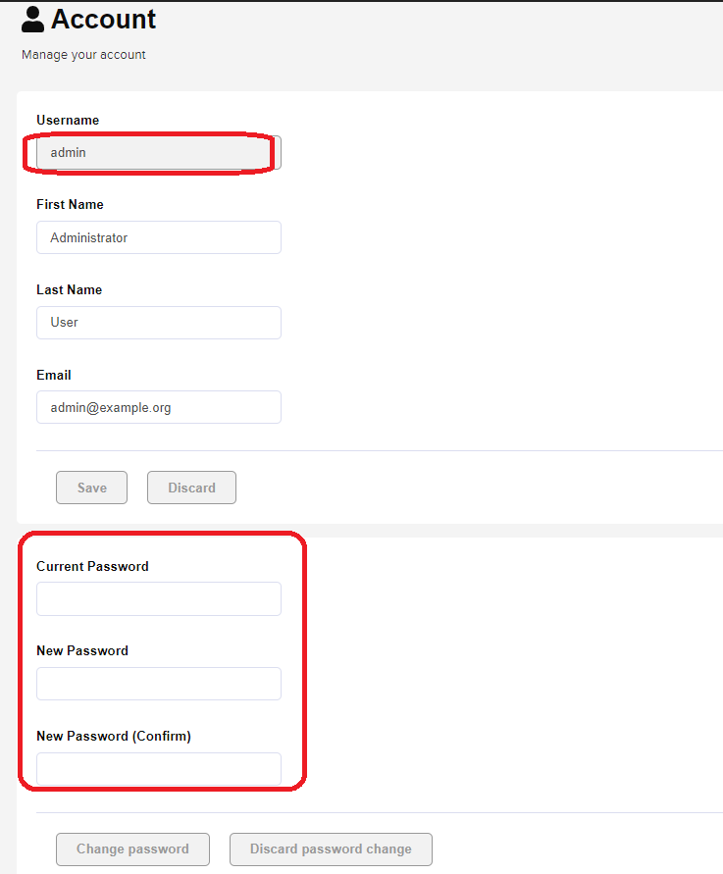

**Creating users:**

🡪Login as admin user

🡪**Click on Server administration and configuration🡪 Security 🡪 Users**

🡪Click on **Create local user**

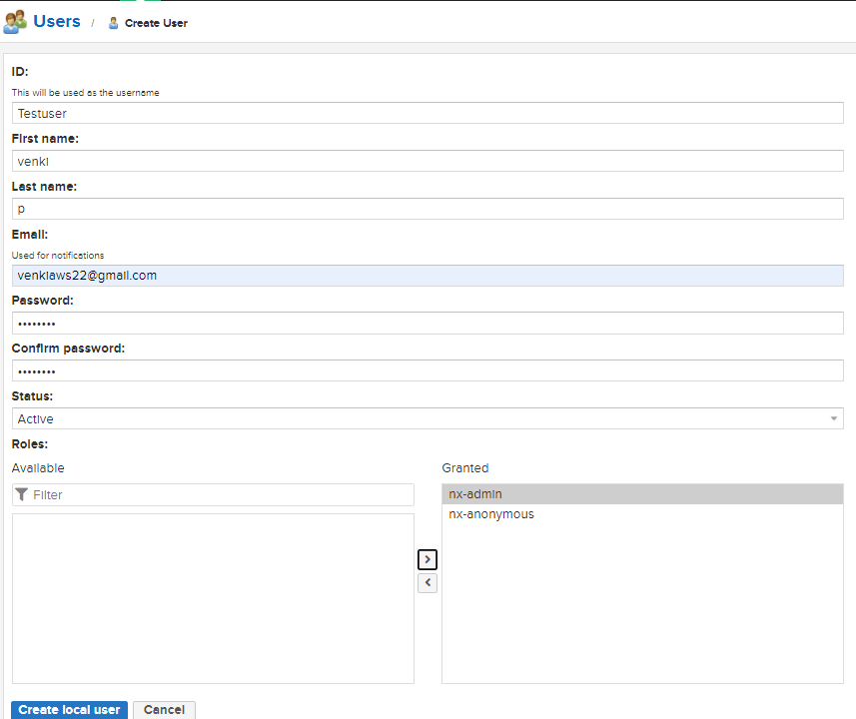

🡪if we select **nx-anonymous** in this case admin privileges will get that particular user

🡪if we need admin privileges we need to select **nx-amdin**

**🡪**Click on **Create local user**

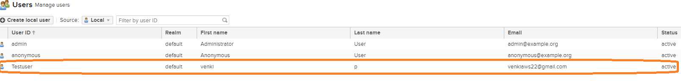

🡪**Testuser** has been created

🡪Logout and login as **Testuser**

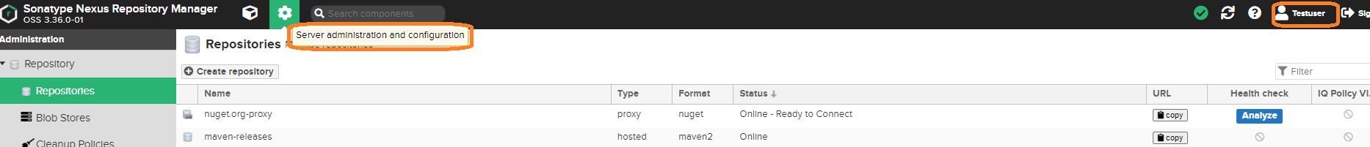

**Anonymous Access:**

Without login we are able to see all repository details by default in nexusUI using **Browse button**

if we want to disable this activity we have to fallow below steps

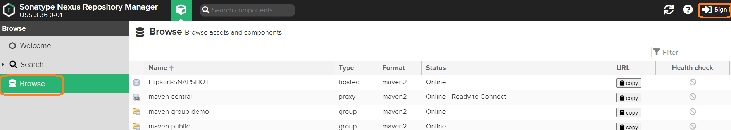

**Server Administration and configuration 🡪 Anonymous Access**

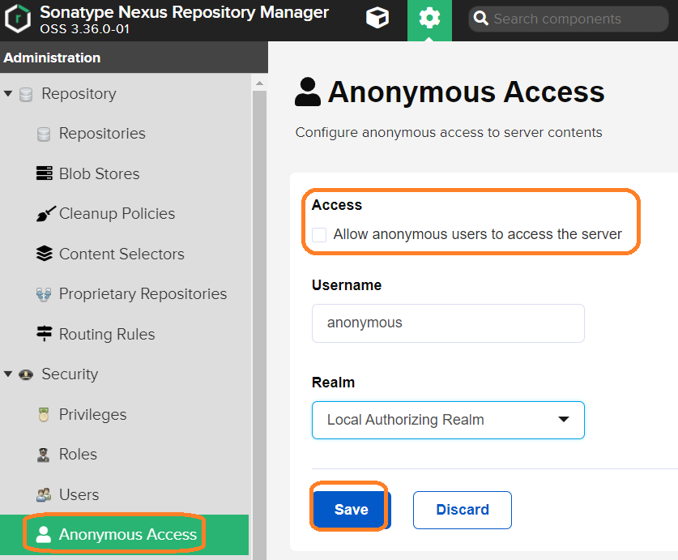

* Uncheck Access and Click on save button
* Once logout, we can’t able see **Browse button**

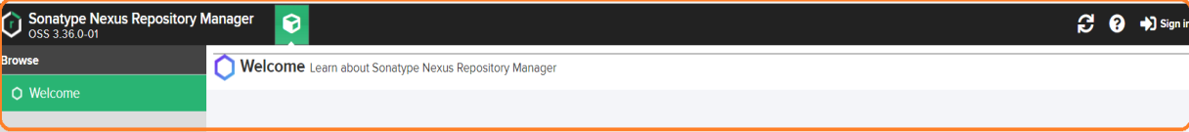

* **LDAP (Light Weight Directory Access Protocol)**
* Each company they have they own LDAP server or AD(Active Directory)
* It will maintain employee information like username, password, emp no details
* We can integrate the LDAP server with nexus Server, SonarQube, Jenkins all other servers
* If we integrate LDAP server we no need to create users manually in server side
* What are the credentials are their in LDAP server with those credentials we can login into all other integrated serves.
* Advantage of integrate LDAP server with other servers, without creating users from server we can able to login multiples servers with same user name password (SSO)
* We can get the LDAP details from LDAP Admin team

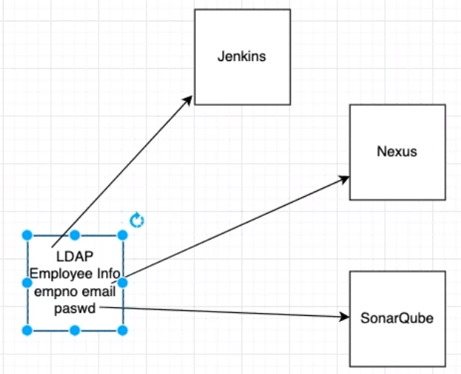

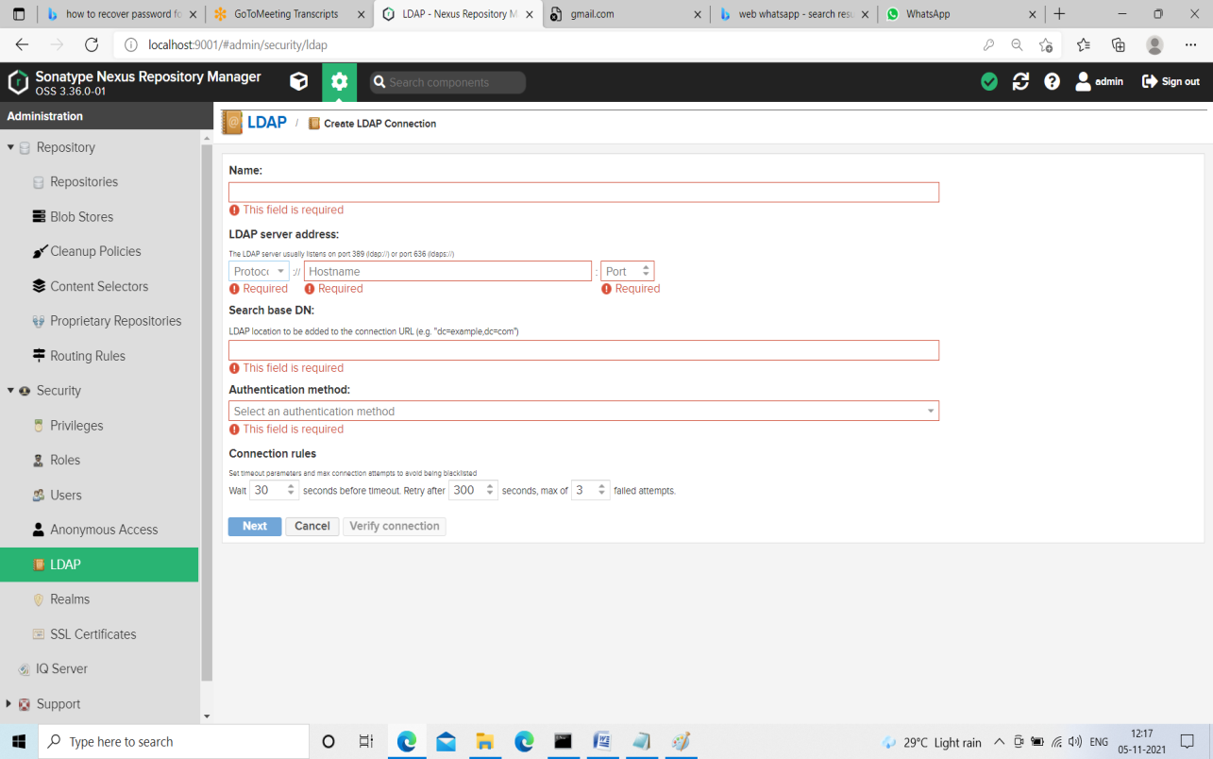

**Blob Stores:**

If we want to store large objects like images we will configure Blob Store

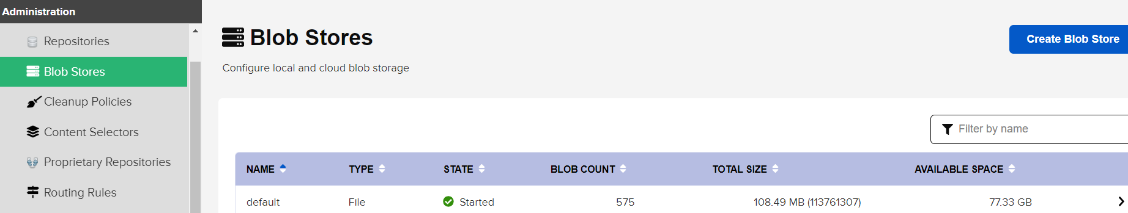

We can store our object in two places S3 and File.

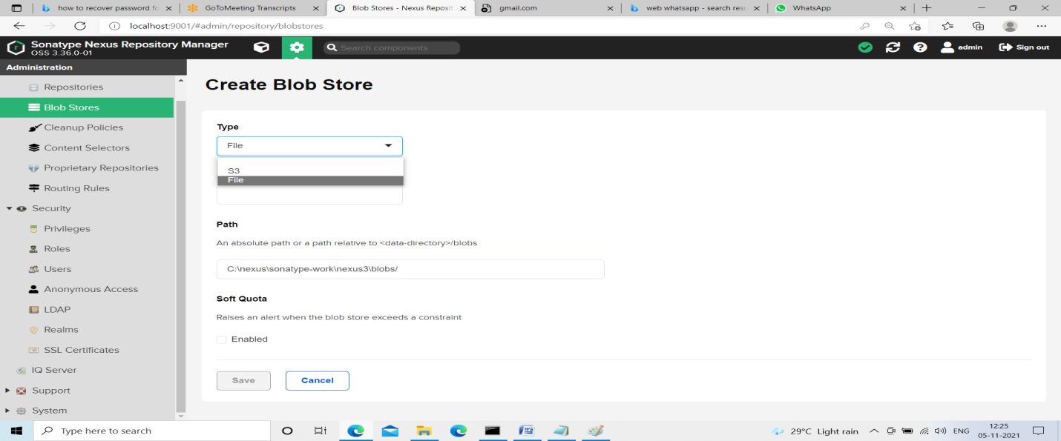

**Clean up policies:**

* Will use to remove content from repositories
* Based on requirement we have uploaded ‘n’ number of artifacts in nexus Server due to this hard disk utilization will be more
* We need to remove old packages, here instead of deleting manually we can delete automatically once criteria matched
* Delete the arficats

API:

Port Change: