**Maven-Group**

If we want to get the dependencies from multiple repositories we will use recipe type as **maven2 (group)**

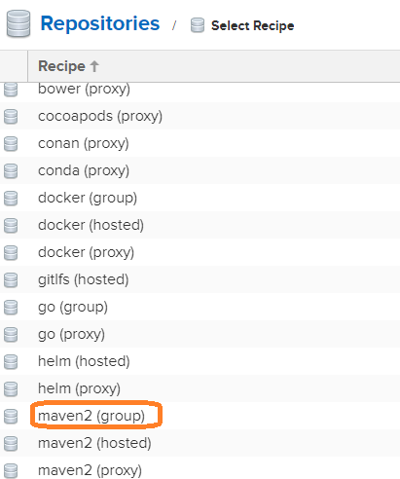

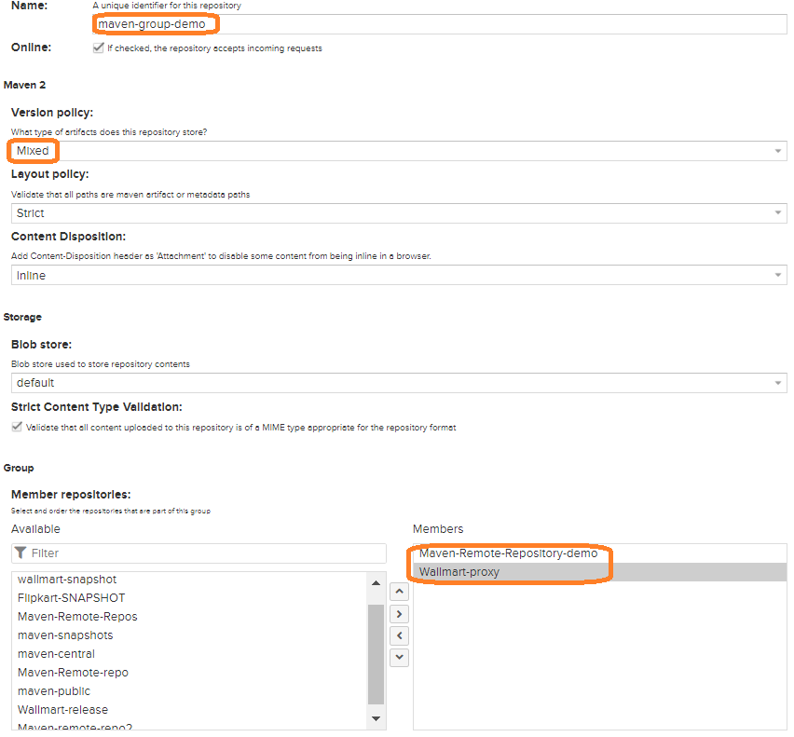

🡪Here, we are configuring maven-remote-repository and maven-proxy will be one repository

🡪like this, we can configure multiple repositories add/remove into one group

🡪once configuration completed, we can delete the dependencies from pom.xml file

Click on **Createrepository** button for group repository creation.

Copy group url from UI and configure in project **pom.xml file**

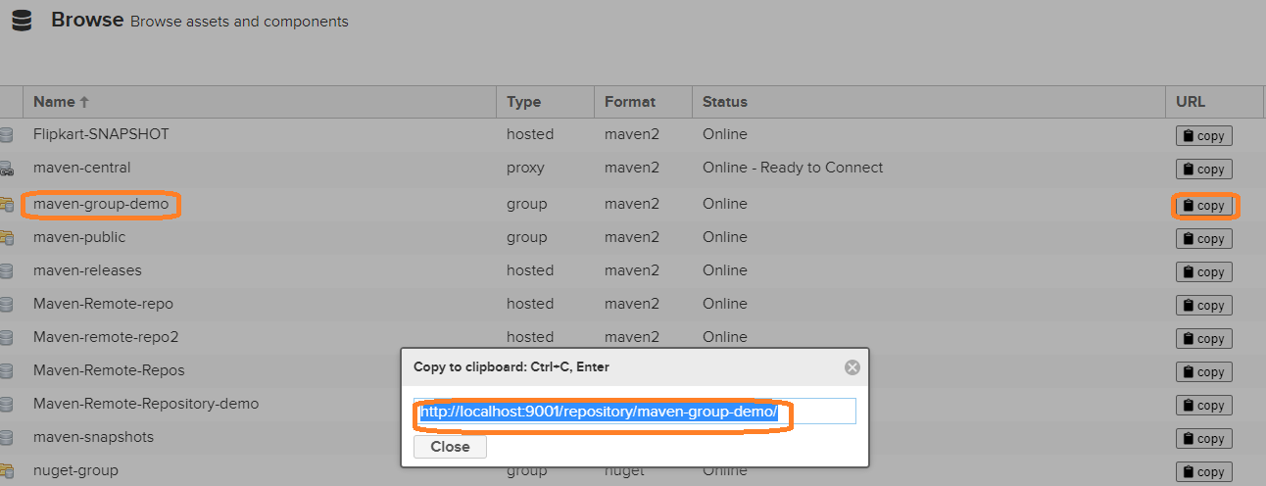

**F:\***\*** \maven-web-application\pom.xml**

<repositories>

<repository>

<id>mavengroupid</id>

<name>Maven group</name>

<url>http://localhost:9001/repository/maven-group-demo/</url>

</repository>

</repositories>

**C:\Program Files\apache-maven-3.6.1\conf\settings.xml**

<mirror>

<id>nexusmavengroup</id>

<mirrorOf>*</mirrorOf>

<name>Maven group</name>

<url>http://localhost:9001/repository/maven-group-demo/</url>

</mirror>

Run below command for getting dependencies from maven group

**mvn group package**

**I**t will download the packages from maven repository and maven proxy

