VENKITTU SRINIVASAN
  56/2,middle street,
  Eraiyur (po),
  Tittagudi(Tk),
  Cuddalore(Dt)-606111
  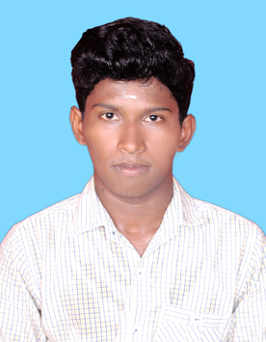
  DOB | 30th-NOV-1994
  MOBILE | +91-8940317720
  MAIL | venkatjara30@gmail.com
  GIT HUB ID | https://github.com/VenkittuS

CAREER OBJECTIVES
To work in a healthy, innovative and challenging environment extracting the best out of me, which is conducive to learn and grow at professional as well as personal level thereby directing my future endeavors as an asset to the organization.

PERSONAL SKILL
Comprehensive problem solving abilities, ability to deal with people diplomatically, willingness to learn, team facilitator

COMPUTER PROFICIENCY
Operating System | Windows8,7,Xp
Language | Java.,Android
Web Technologies | HTML, CSS,JAVASCRIPT,MYSQL,PHP,JQUERY
Packages | MS-Office.

EDUCATIONAL STATUS
COURSE | INSTITUTION | BOARD/UNIVERSITY | PERCENTAGE | YEAR OF PASSING
B.E(CSE) | Dr.Navalar Nedunchezhiyan College of Engineering,  Tholudhur | Anna university | 6.38(CGPA) | 2016
HSC | Aruna Higher Secondary school, Eraiyur | State | 65 | 2012
SSLC | Aruna Higher Secondary school, Eraiyur | State | 84 | 2010

FIELD OF INTEREST
- Web designing

PROJECT:
REGION BASED REGISTRATION USING K-MEANS CLUSTERING ALGORITHM FOR VIDEO INPAINTING

SOFTWARE | MAT LAB
DESCRIPTION | The Project is mainly aimed to video background reconstruction

STRENGTH
- Self-Confidence
- Honesty
- Self-motivation

CO-CURRICULAR ACTIVITIES
Attended one day workshop on “ANDROID” in our college
- I am pursuing “payilagam software training institute”(CORE JAVA,HTML,CSS)

LEADERSHIP SKILLS
- Being Representative for one year from”2013-2014”- Academic year

HOBBY
- I like to play cricket.
- Watching news
PERSONAL PROFILE
GENDER | MALE
MARITIAL STATUS | SINGLE
FATHER’S NAME | N SRINIVASAN
MOTHER NAME | S MARAGATHAM

DECLARATION
I here declare that the information furnished above is true to the best of my knowledge.

DATE: | SIGNATURE
PLACE: | VENKITTU S

