## horizontal line



JDBC Project Report

13.03.2020

**─**

Vyanktesh Chandurkar

A00268808

Athlone Institute of Technology

# Overview

This application can be used by International Sports committee to apply CRUD (Create, read, update & Delete) operations. It can be very useful to maintain the record for athletes who participate in the Sport competition. It also creates a csv file using java and shows the required output in csv file. Necessary information is provided to the User about the athlete who has won a medal in the Sports competition.

# Learnings

Learned about

* Triggers,
* Stored Procedure and,
* Saving the data into a CSV file.

# GUI

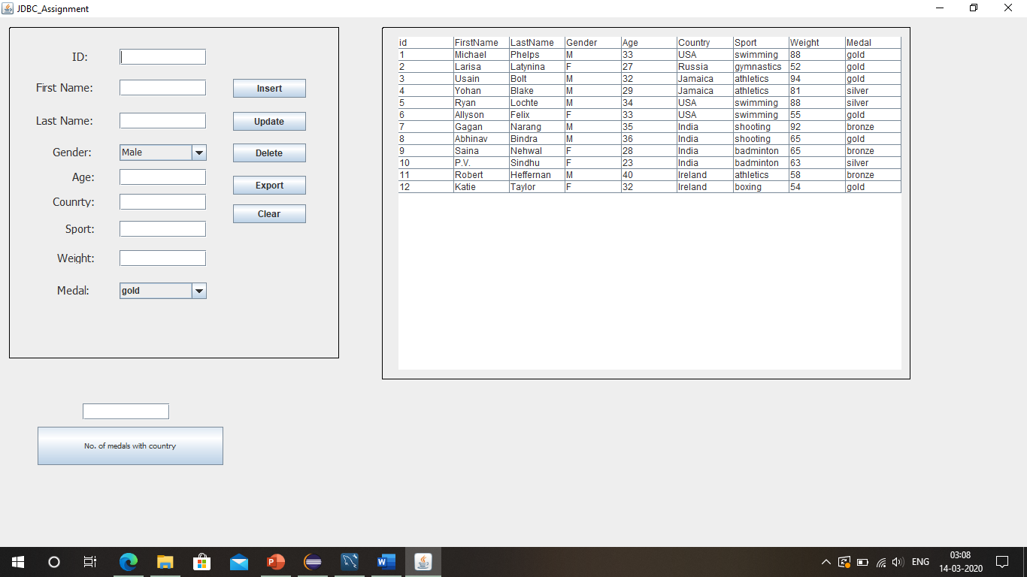

# TRIGGER

To Insert all the deleted Values

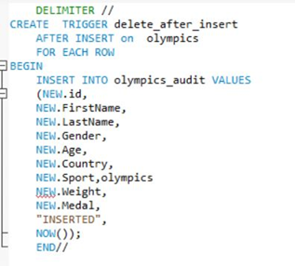

To Convert input to lower case values :

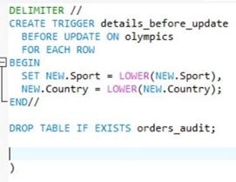

# Extra Features

Implemented two different types of triggers.

* One of the triggers converts the elements that are added as a country or sport it converts them into lower case and then stores them inside the table.
* The second trigger inserts all the values that are deleted from the Players table into a new table.

Created a csv file using java.

Stored procedures are used to export some data to the csv file

# Benefits of the System:

* It allows the user to manipulate the table using the JDBC Application.
* It Exports the data from the table to a csv file.

## CSV File

