Image Healer
A Project report submitted for the fulfillment of the requirement for the
Degree of Bachelor of Science in Information Technology

Submitted by

M.VENKATESH (2020ITC039)

Under the Guidance of
Prof. R.LAKSHAPRIYA M.Sc., M.Phil.,
ASSISTANT PROFESSOR

Department of Information Technology
The Madura College (Autonomous)
(Self-Financed Stream)
Re-Accredited (3rd cycle) with 'A' grade by NAAC
Madurai – 11.

April 2023

THE MADURA COLLEGE (Autonomous)
(Self-Financed Stream)
Re-Accredited with 'A' grade by NAAC
MADURAI - 625011.

DEPARTMENT OF INFORMATION TECHNOLOGY

CERTIFICATE

This is to certify that the Project work entitled “Image Healer” is a bonafide record work done by M.VENKATESH, 2020ITC039 and submitted to the Department of Information Technology, The Madura College, Madurai, for the fulfillment of the requirement for the Degree of Bachelor of Science in Information Technology. The VIVA-VOCE examination held in the Department of Information Technology, The Madura College, Madurai on _____________.

Project Guide Internal Examiner Coordinator

External Examiner Controller of Examinations

DECLARATION
DECLARATION

I am hereby declared that this project work entitled “IMAGE HEALER” submitted to Information Technology. The Madura College is the record original work done by me partial fulfillment of the requirement of the Degree of Bachelor of Science in Information Technology.

This project report is originally prepared by me and carried out under the guidance of Prof. R.LAKSHAPRIYA M.Sc., M.Phil., The Madura College, Madurai for the award of the Bachelor Degree of Science in Information Technology and this has not been submitted elsewhere for any other Degree.

Place : MADURAI M.VENKATESH (2020ITC039)

Date :

ACKNOWLEDGEMENT

ACKNOWLEDGEMENT

I first thank the almighty for giving strength to us to do this project work. Through this acknowledgment, I express my sincere gratitude to all those people who have been associated with this assignment and have helped me with it and made it a worthwhile experience.
I would like to express my wholehearted respect and thanks to our Principal Dr. J. Suresh, M.Sc., M.Phil. P.B.D.C.A., B.Ed., Ph.D., and also, my sincere thanks to Chief Coordinator Dr. S.SURIANARAYANAN M.Sc., M.Phil., Ph.D., who gave me the golden opportunity to do this wonderful project on the topic “IMAGE HEALER“ Which also helped using doing a lot of Research and I came to know about many new things.
I would like to express my gratitude and sincere thanks to our Coordinator Mr. K.RAJASARAVANAKUMAR M.Sc., M.Phil., of Information Technology department for his help and sincere advice that helped me to complete this project work successfully.
I am so elaborated to place on record our gratitude and heartfelt thanks to my project guide and in-charge Prof. R. LAKSHAPRIYA M.Sc., M.Phil., Assistant Professor and also, my sincere thanks to my project in-charge Prof. S.SARANYA M.Sc., M.Phil. Assistant Professor of Information Technology Department, The Madura College for the valuable, guidance, inspiration, with care and of friendly affection which instilled optimistic idealism that could be converted into practicalities.
I thank all our staffs forgiving us timeliness help and moral support to complete our project. I have taken efforts in this project. However, it would not have been possible without the kind support and help of my family and friends. I would like to extend my sincere thanks to all of them. I made this project not only for marks but also increase my knowledge.

SYNOPSIS

SYNOPSIS

The Image Healer Tool is a software application that allows users to modify and edit images with five main functionalities: image cropping, height and width changing, image compression, and image to PDF conversion, image filters changer.
Image healer tool have become an integral part of our daily lives, as we increasingly rely on digital media for communication, entertainment, and business. In this synopsis, we will explore four popular image healer tools - cropper, compressor, resizer, filter changer, and image to PDF converter.
The cropper tool allows you to trim unwanted parts of an image by adjusting the edges. It's a handy feature for removing unwanted background elements or to focus on a specific part of an image. You can choose from several crop ratios, including custom crop ratios, to give your image a more professional look.
The compressor tool helps reduce the size of an image file without significantly reducing its quality. This feature is useful when you need to upload an image to a website or send it via email, where large file sizes can cause issues.
The resizer tool allows you to change the size of an image without affecting its aspect ratio. You can increase or decrease the dimensions of an image to fit specific requirements or to optimize it for a particular device or platform.
The filter changer tool enables you to apply various effects to an image, such as brightness, contrast, saturation, and more. It's a quick and easy way to enhance an image's overall look and feel.
The image to PDF converter tool helps you convert your images into a PDF document. You can combine multiple images into a single PDF file, which is useful when you need to share images as a document or for printing.

CONTENT
Table of Contents Format

S.No. | Content | Page No.
1 | Introduction | 1
2 | Problem Definition and Description | 2
3 | System Environment | 3
 | 3.1. Hardware Requirement | 3
 | 3.2. Software Requirement | 3
4 | System Analysis | 10
 | 4.1. Existing System | 11
 | 4.2. Proposed System | 12
5 | System Design | 14
 | 5.1. Data Flow Diagram | 14
 | 5.2. Database Design | 19
6 | Coding | 20
7 | System Testing | 80
8 | Screen Shots | 84
 | 8.1. (Forms with sample data) | 84
 | 8.2. Simulated Reports | -
9 | Conclusion | 92
10 | Future Enhancement | 93
11 | Bibliography | 94
12 | Appendices (if any) | -

INTRODUCTION

- INTRODUCTION
Image healer tools have become an essential part of our lives, as we are increasingly reliant on visuals to communicate our ideas and thoughts. The Image Healer Tool is a comprehensive software application that allows users to modify and edit images with five main functionalities: image cropping, height and width changing, image compression, image to PDF conversion, and filter changing.
The image cropper functionality enables users to crop images to a specific size, allowing them to focus on a particular area of the image or adjust its overall composition. The height and width changer functionality allows users to adjust the dimensions of the image while maintaining its aspect ratio. The compressor functionality reduces the image file size without significantly affecting the image quality.
The image to PDF converter functionality converts modified images into a PDF file, making it easier to share or store. The filter changer functionality enables users to apply different filters to the image, such as black and white, sepia, or color correction, to enhance the visual appeal of the image.
The Image Healer Tool is user-friendly and has a simple and intuitive interface, making it accessible to users with varying levels of technical knowledge. The tool is ideal for personal, professional, and educational purposes, allowing users to create visually appealing content quickly and easily.
Overall, the Image Healer Tool provides a range of functionalities that enable users to modify and edit images to meet their specific needs. With its various functionalities and ease of use, the Image Healer Tool has become a popular choice for image healer needs..
PROBLEM DEFINITION
AND
DESCRIPTION

2.PROBLEM DEFINITION & DESCRIPTION

The problem that an image healer toolkit aims to solve is the need for an efficient and accessible means of modifying and enhancing digital images. With the increasing importance of visual content in various industries, there is a growing demand for software that makes it easy for people with a range of skill levels to produce high-quality images. The toolkit must provide a range of features that address common challenges in image healer, such as color correction, removing blemishes or distracting elements, and adjusting lighting and contrast. At the same time, it must also be intuitive and user-friendly, so that users can quickly and easily perform the tasks they need to produce the desired results.

DESCRIPTION

Image Cropping : This module allows the user to crop an image to a desired size.
Image Resizing : This module allows the user to resize an image to a specified size or aspect ratio.
Image Brightness and Contrast Adjustment: This module allows the user to adjust the brightness and contrast of an image to suit their preference.
Image Filters: This module allows the user to apply various filters to the image to enhance its appearance.
Image Compressor : This module allows the user to reduce the quality of the image. For example, 2MB image to 500KB
Image To PDF Converter: An image to PDF converter is a software tool that converts one or more image files (such as JPEG, PNG, BMP, or GIF) into a single PDF document. This conversion allows the images to be viewed, shared, or printed as a single file rather than multiple separate image files.
SYSTEM ENVIRONMENT

3.SYSTEM ENVIRONMENT

3.1. HARDWARE REQUIREMENT

    - Processor type Intel core 2 duo processor
    - Mother Board Intel 810E
    - Monitor 19 inch TFT Monitor
    - Keyboard 104 Keys
    - Pointing Devices 3 Buttons Optical Wheel Buttons
    - Hard Disk 250 GB
    - RAM 1 GB

3.2. SOFTWARE REQUIREMENT

    - Platform Windows 10
    - Front-End HTML, CSS, JAVASCRIPT
    - Back-End PHP, MYSQL

HTML

The Hyper Text Markup Language or HTML is the standard markup language for documents designed to be displayed in a web browser. It can be assisted by technologies such as Cascading Style Sheets (CSS) and scripting languages such as JavaScript.
Web browsers receive HTML documents from a web server or from local storage and render the documents into multimedia web pages HTML describes the structure of a web page semantically and originally included cues for the appearance of the document.
HTML elements are the building blocks of HTML pages. With HTML constructs, images and other objects such as interactive forms may be embedded into the rendered page. HTML provides a means to create structured documents by denoting structural semantics for text such as headings, paragraphs, lists, links, quotes and other items.

Advantage of HTML

- HTML helps to build structure of a website and is a widely used Markup language.
- It is easy to learn.
- Every browser supports HTML Language.
- HTML is light weighted and fast to load.
- Storage of big files are allowed because of the application cache feature.
- Do not get to purchase any extra software because it’s by default in every window.
- Loose syntax (although, being too flexible won’t suit standards).
- HTML is simple to edit as being a plain text.

JAVASCRIPT
JavaScript often abbreviated JS, is a programming language that is one of the core technologies of the World Wide Web, alongside HTML and CSS. As of 2022, 98% of websites use JavaScript on the client side for web page behavior, often incorporating third- party libraries. All major web browsers have a dedicated JavaScript engine to execute the code on user’s devices
.
JavaScript is a high-level, often just-in-time compiled language that confirms to the ECMAScript standard. It has dynamic typing, prototype-based object-orientation, and first- class functions. It is multi-paradigm,supporting event-driven, functional, and imperative programming styles. It has application programming interfaces (APIs) for working with text, dates, regular expressions, standard data structures, and the Document Object Model (DOM).
JavaScript engines were originally used only in web browsers, but are now core components of some servers and a variety of applications. The most popular runtime system for this usage is Node.js.

Advantage of Javascript

- Less server interaction − You can validate user input before sending the page off to the server. This saves server traffic, which means less load on your server.
- Immediate feedback to the visitors − They don't have to wait for a page reload to see if they have forgotten to enter something.
- Increased interactivity − You can create interfaces that react when the user hovers over them with a mouse or activates them via the keyboard.
- Richer interfaces − You can use JavaScript to include such items as drag-and-drop components and sliders to give a Rich Interface to your site visitors.

CSS
Cascading Style Sheets (CSS) is a style sheet language used for describing the presentation of a document written in a markup language such as HTML. CSS is a cornerstone technology of the World Wide Web, alongside HTML and JavaScript.

CSS is designed to enable the separation of presentation and content, including layout, colors, and fonts. This separation can improve content accessibility; provide more flexibility and control in the specification of presentation characteristics; enable multiple web pages to share formatting by specifying the relevant CSS in a separate “.css” file, which reduces complexity and repetition in the structural content; and enable the “.css” file to be cached to improve the page load speed between the pages that share the file and its formatting.

Advantage of CSS

- CSS saves a lot of time.
- It helps to make consistent and spontaneous changes.
- It improves the loading speed of the page.
- CSS has the ability to re-position.
- It has better device compatibility.

PHP

PHP is a general-purpose scripting language geared toward web development. It was originally created by Danish-Canadian programmer Rasmus Lerdorf in 1994. The PHP reference implementation is now produced by The PHP Group. PHP

originally stood for Personal Home Page but it now stands for the recursive initialism PHP: Hypertext Preprocessor.

PHP code is usually processed on a web server by a PHP interpreter implemented as a module, a daemon or as a Common Gateway Interface (CGI) executable. On a web server, the result of the interpreted and executed PHP code – which may be any type of data, such as generated HTML or binary image data – would form the whole or part of an HTTP response. Various web template systems, web content management systems, and web frameworks exist which can be employed to orchestrate or facilitate the generation of that response. Additionally, PHP can be used for many programming tasks outside the web context, such as standalone graphical applications and robotic drone control. PHP code can also be directly executed from the command line.

Advantages of PHP

- Most important advantage of PHP is that it’s open source and freed from cost. It are often downloaded anywhere and readily available to use for event of web applications.
- It is platform independent. PHP based applications can run on any OS like UNIX, Linux and windows, etc.
- Application can easily be loaded which are based on PHP and connected to database.
- It has less learning curve, because it is straightforward and straightforward to use. If a private knows C programming can easily work on PHP.
- It is more stable from a few years with assistance of providing continuous support to various versions.
- It helps in reusing an equivalent code and no got to write lengthy code and sophisticated structure for event of web applications.

SQL

Structured Query Language is a domain-specific language used in programming and designed for managing data held in a relational database management system (RDBMS), or for stream processing in a relational data stream management system (RDSMS). It is particularly useful in handling structured data, i.e. data incorporating relations among entities and variables. SQL offers two main advantages over older read–write APIs such as ISAM or VSAM. Firstly, it introduced the concept of accessing many records with one single command. Secondly, it eliminates the need to specify how to reach a record, e.g. with or without an index.

Originally based upon relational algebra and tuple relational calculus, SQL consists of many types of statements, which may be informally classed as sublanguages, commonly: a data query language (DQL), a data definition language (DDL), a data control language (DCL), and a data manipulation language (DML). The scope of SQL includes data query, data manipulation (insert, update and delete), data definition (schema creation and modification), and data access control. Although SQL is essentially a declarative language (4GL), it also includes procedural elements.

SQL was one of the first commercial languages to use Edgar F. Codd’s relational model. The model was described in his influential 1970 paper, "A Relational Model of Data for Large Shared Data Banks". Despite not entirely adhering to the relational model as described by Codd, it became the most widely used database language.

Advantage of SQL

  - Faster Query Processing – Large amount of data is retrieved quickly and efficiently. Operations like Insertion, deletion, manipulation of data is also done in almost no time.
  - No Coding Skills – For data retrieval, large number of lines of code is not required.
  - Standardised Language – Due to documentation and long establishment over years, it provides a uniform platform worldwide to all its users.
  - Portable – It can be used in programs in PCs, server, laptops independent of any platform (Operating System, etc). Also, it can be embedded with other applications as per need/requirement/use.
  - Interactive Language – Easy to learn and understand, answers to complex queries can be received in seconds.
SYSTEM ANALYSIS

4. SYSTEM ANALYSIS
System analysis in image healer tools involves a comprehensive review of the software's features, functions, and workflows to identify strengths and areas for improvement. The following are the steps involved in system analysis in image healer tools:
- Requirements gathering: The first step in system analysis is to gather requirements from users to understand their needs and expectations from the image healer tool. This can be done through surveys, interviews, or feedback forms.
- Analysis of the existing system: The next step is to analyze the existing image healer tool to understand its features, functions, and workflows. This includes evaluating the user interface, navigation, and feature set, as well as testing the tool's performance, stability, and reliability.
- Identifying areas for improvement: Based on the analysis of the existing system, the analyst will identify areas for improvement, such as adding new features or enhancing existing ones, improving the user interface, or optimizing the tool's performance.
- Design and development: After identifying the areas for improvement, the design and development team will create a plan to implement the changes and develop a prototype for testing.
- Testing and evaluation: Once the prototype is developed, it will be tested under various conditions to ensure that it functions correctly, meets user requirements, and addresses any issues identified during the analysis.
- Implementation: After testing and evaluation, the updated image healer tool will be deployed to users, and any necessary training or support will be provided to ensure a smooth transition.
Overall, system analysis in image healer tools is essential for identifying areas for improvement and ensuring that the software meets the needs and expectations of users. It can help to enhance the tool's functionality, usability, and performance and ultimately improve the userexperience.

4.1. EXISTING SYSTEM

When working with an existing image healer tool, several challenges and problems may arise. One significant challenge is the performance and speed of the tool. Image healer often involves resource-intensive operations like filters, transformations, and rendering. If the tool is not optimized, it may experience slow processing times or lagging user interfaces, leading to frustration and decreased productivity. Improving performance requires optimizing algorithms, utilizing hardware acceleration when available, and efficiently handling memory usage.

Another challenge lies in the user interface design of the image healer tool. Striking the right balance between functionality and usability can be difficult. The tool needs to provide a wide range of editing options and features while maintaining simplicity and ease of use. Designing an intuitive and user-friendly interface that allows users to easily navigate through tools, apply edits, and access advanced features can significantly impact the overall user experience. Thorough user testing and feedback collection are essential in identifying areas for improvement and enhancing the user interface design.

Compatibility and file format support are additional problems faced by image healer tools. These tools need to support a wide range of image file formats commonly used in the industry, such as JPEG, PNG, GIF, and TIFF. Ensuring compatibility with various file formats requires careful implementation of parsing, decoding, and encoding algorithms. Additionally, handling different color spaces, compression techniques, and metadata associated with different file formats can pose technical challenges that need to be addressed.

Data loss prevention and error handling are critical aspects of an image healer tool. Users rely on these tools to preserve their work and prevent accidental loss of edits. Implementing mechanisms for automatic file backup, recovery options, and error detection can help mitigate data loss risks. Proper handling of errors, such as notifying users about potential data corruption or providing mechanisms to revert to a previous state, is crucial for maintaining user trust and satisfaction.

Finally, security and privacy concerns must be addressed. Image healer tools may handle sensitive information or personal data. Implementing secure data handling practices, encrypting data at rest and in transit, and providing user authentication and access controls are vital to protecting user data and maintaining privacy.

In summary, challenges faced by existing image healer tools include performance optimization, user interface design, compatibility with various file formats, data loss prevention, error handling, and security considerations. Overcoming these challenges requires a combination of technical expertise, user-centered design principles, and a commitment to providing a seamless and secure user experience.

4.2. PROPOSED SYSTEM

To rectify the challenges in the proposed image editing system, several steps can be taken to enhance its functionality and user experience.

Firstly, optimizing the system's performance is crucial. This can be achieved by implementing efficient algorithms and data structures, utilizing multi-threading or parallel processing techniques, and leveraging hardware acceleration when available. Additionally, optimizing memory management and minimizing unnecessary computations can significantly improve processing times and overall performance.

Improving the user interface design is equally important. Conducting user research and usability testing can provide valuable insights into users' needs and preferences. Based on this feedback, the interface can be redesigned to prioritize commonly used features, simplify complex editing operations, and enhance the overall user experience. Incorporating intuitive controls, providing helpful tooltips or tutorials, and organizing editing tools in a logical manner can make the system more user-friendly.

Ensuring compatibility with various file formats requires implementing robust parsing, decoding, and encoding algorithms. Conducting thorough testing with different file formats, color spaces, and compression techniques can help identify and address any compatibility issues. Regularly updating the system to support new file formats and industry standards is also crucial to keep the tool relevant and versatile.

Implementing data loss prevention mechanisms is vital for an image editing system. This includes incorporating automatic file backup options, allowing users to save their work in different stages, and providing an undo/redo functionality. Additionally, error handling should be robust, with clear error messages and mechanisms to handle unexpected errors gracefully. Regularly testing the system's error handling capabilities and collecting user feedback can help identify and resolve any issues.

Addressing security concerns involves implementing industry-standard security measures. This includes encrypting user data at rest and in transit, implementing secure user authentication and access controls, and following secure coding practices to prevent common vulnerabilities like cross-site scripting or SQL injection. Regular security audits and updates are essential to stay ahead of emerging threats and protect user privacy.

In summary, rectifying the challenges in the proposed image editing system involves optimizing performance, improving user interface design, ensuring compatibility with file formats, implementing data loss prevention mechanisms, and addressing security concerns. By focusing on these areas and incorporating user feedback throughout the development process, the image editing system can be refined to provide a seamless and secure editing experience for users

SYSTEM DESIGN

5. SYSTEM DESIGN

5.1. DATA FLOW DIAGRAM

- Data Flow Diagram (DFD) is a design tool constructed to show how data within the system. It is designed from the data which is collected during data collection phase. DFD is otherwise called as “BUBBLE CHART”
- There are four symbols used in DFD. They are Rectangle, Open Rectangle, Circle, Arrow
- Each one has its own meaning

Source and destination

Data Flow

Process

Data Storage

Checking

Forms

User

5.1.1 SIGN-UP

Enter Username & Passwrod
Sign-Up

Authentication

False

True

Sign-Up
Done

Login Page

5.1.2 LOGIN

login
Username and
password
False
True
modules

5.1.3 DATA FLOW DIAGRAM FOR ACCESS THE MODULES

Home

Login

True
Img Height/Width Changer

Img Cropper

Edit

Img Filters Changer

Img To PDF Converter

Download

Logout

5.1.4 OVER ALL STRUCTURES IN IMAGE HEALER

Images

Choose Select
Cropper
Height/Width
Changer

Image Cropping

Cropped Image Cropped Image
with new dimensions

Apply Apply
Filter Changer
Filters Changer
Filters applied

Selected
Filter

Image with applied filters Image with all modification
Img To PDF
Converter
Image with all mods
applied
Modified PDF File

Save Save

Modified PDF File
Image

Modified Image Saved Modified Image Saved Modified Image Saved

5.2. DATABASE DESIGN

A database is a collection of inter-related data with minimum redundancy to server the user quickly and efficiently. To design an application, it is necessary to design the database files. Files in grade called tables. Data are stored in tables. Each record is stored in a sing row of that table and each column refers to the particular field of that table. Proper care been taken in designing the database to achieve objectives listed below

- Data integration
- Data consistency
- Data independence
- Easy of learning anduse
- More information at low cost
- Privacy and Security
- Performance

5.2.1 Sign-Up & Login Table

Field Name | Field  Type | Field  Size | Constraints | Description
id | Integer | 5 | Primary key,auto increment | It is used to store the unique id
username | Varchar | 100 | Not Null | It is used to store the usertname
password | Varchar | 20 | Not Null | It is used to store the password

CODING
6. CODING

IMAGE HEALER

INDEX PAGE

index.php

<!DOCTYPE html>
<html lang="en">
<head>
<meta charset="UTF-8">
<meta http-equiv="X-UA-Compatible" content="IE=edge">
<meta name="viewport" content="width=device-width, initial-scale=1.0">
<title>Welcome To Image Healer</title>
<link rel="stylesheet" href="https://maxcdn.bootstrapcdn.com/bootstrap/3.4.1/css/bootstrap.min.css">
<script src="https://ajax.googleapis.com/ajax/libs/jquery/3.6.1/jquery.min.js"></script>
<script src="https://maxcdn.bootstrapcdn.com/bootstrap/3.4.1/js/bootstrap.min.js"></script>
<link rel="stylesheet" href="https://cdn.jsdelivr.net/npm/bootstrap@4.0.0/dist/css/bootstrap.min.css" integrity="sha384-Gn5384xqQ1aoWXA+058RXPxPg6fy4IWvTNh0E263XmFcJlSAwiGgFAW/dAiS6JXm" crossorigin="anonymous">
<link rel="shortcut icon" type="text/css" href="http://youtube.local/assets/favicon.ico">
<link rel="stylesheet" href="https://cdn.jsdelivr.net/npm/bootstrap@4.0.0/dist/css/bootstrap.min.css" integrity="sha384-Gn5384xqQ1aoWXA+058RXPxPg6fy4IWvTNh0E263XmFcJlSAwiGgFAW/dAiS6JXm" crossorigin="anonymous">
<link rel="stylesheet" href="https://cdnjs.cloudflare.com/ajax/libs/font-awesome/4.7.0/css/font-awesome.min.css">
<link href="https://maxcdn.bootstrapcdn.com/bootstrap/4.1.1/css/bootstrap.min.css" rel="stylesheet" id="bootstrap-css">
<link rel="stylesheet" href="https://cdnjs.cloudflare.com/ajax/libs/font-awesome/4.7.0/css/font-awesome.min.css">
<script src="https://maxcdn.bootstrapcdn.com/bootstrap/4.1.1/js/bootstrap.min.js"></script>
<script src="https://cdnjs.cloudflare.com/ajax/libs/jquery/3.2.1/jquery.min.js"></script>
<style>
.container {
width: 100%;
}

.container-1,
.container-2,
.container-3,
.container-4 {
float: left;
width: 50%;
height: 300px;
}

.container-1 {
background-color: red;
}

.container-2 {
background-color: blue;
}

.container-3 {
background-color: green;
}

.container-4 {
background-color: yellow;
}
.nav-link{
font-size: 20px;
}
.head{
padding-left: 480px;
color: white;
font-weight: bold;
font-family: Cambria, Cochin, Georgia, Times, 'Times New Roman', serif;
font-size: 30px;
}
#icon{
padding-bottom: 14px;
}
.back{
background-image: linear-gradient(to right bottom, #051937, #004d7a, #008793, #00bf72, #a8eb12);
display: block;
}

</style>
</head>
<body class="back">

<nav class="navbar navbar-expand-lg navbar-dark bg-dark">
<a class="navbar-brand" href="#"><img src="gifs/icon.jpg" alt="" height="60px" width="60px" id="icon"></a>
<h2 class="head">Image Healer</h2>
<button class="navbar-toggler" type="button" data-toggle="collapse" data-target="#navbarNav" aria-controls="navbarNav" aria-expanded="false" aria-label="Toggle navigation">
<span class="navbar-toggler-icon"></span>
</button>
<div class="collapse navbar-collapse" id="navbarNav">
<ul class="navbar-nav ml-auto">
<!-- <li class="nav-item active">
<a class="nav-link" href="#">Home</a>
</li>
<li class="nav-item">
<a class="nav-link" href="#">About</a>
</li>
<li class="nav-item">
<a class="nav-link" href="#">Services</a>
</li>
<li class="nav-item">
<a class="nav-link" href="#">Contact</a>
</li> -->
<li class="nav-item">
<a class="nav-link" href="login_form/Login.php"><b>Login</b></a>
</li>
<li class="nav-item">
<a class="nav-link" href="login_form/LogReg.php"><b>Sign up</b></a>
</li>
</ul>
</div>
</nav>

<div class="container">
<div class="container-1">
<div class="thumbnail">
<a href="login_form/LogReg.php" target="_blank">
<img src="gifs/crop.gif" alt="Lights" style="width:63%">
<div class="caption">
<p><center><b>Cropper</b></center></p>
</div>
</a>
</div>

</div>
<div class="container-2">
<div class="thumbnail">
<a href="login_form/LogReg.php" target="_blank">
<img src="gifs/hw.gif" alt="Lights" style="width:78%" height="100px" width="100px">
<div class="caption">
<p><center><b>Resizer</b></center></p>
</div>
</a>
</div>
</div>
<div class="container-3">
<div class="thumbnail">
<a href="login_form/LogReg.php" target="_blank">
<img src="gifs/filters.gif" alt="Lights" style="width:74%" height="100px" width="100px">
<div class="caption">
<p><center><b>Filters</b></center></p>
</div>
</a>
</div>
</div>
<div class="container-4">
<div class="thumbnail">
<a href="login_form/LogReg.php" target="_blank">
<img src="gifs/jpgtopdf.gif" alt="Lights" style="width:100%" >
<div class="caption">
<p><center><b>JPG To PDF</b></center></p>
</div>
</a>
</div>
</div>
</div>

</body>
</html>

LOGIN & SIGN-UP

LogReg.php

<html>
<head>
<title>User Login Registration</title>
<link rel="stylesheet" type="text/css" href="logstyle.css">
<link rel="stylesheet" type="text/css" href="https://cdn.jsdelivr.net/npm/bootstrap@4.6.2/dist/css/bootstrap.min.css">
<style>
#back{
margin-left:750px;
}
</style>
</head>
<body>
<div class="one">
<div class="col-md-6 login-right">
<a href="../index.php" class="btn btn-primary" id="back">Back</a>
<h2>Register Here</h2>
<form action="Registration.php" method="post">
<div class="form-group">
<label for="">Username</label>
<input type="text" name="user" class="form-control" required>
</div>
<div class="form-group">
<label for="">Password</label>
<input type="password" name="password" class="form-control" required>
</div>
<button type="submit" class="btn btn-primary">Register</button>

</form>

</div>
</div>
</div>
</div>
<div class="three">
<a class="two" href="Login.php">Login</a>
</div>
</div>
</body>
</html>

Login.php

<html>
<head>
<title>User Login Registration</title>
<link rel="stylesheet" type="text/css" href="logstyle.css">
<link rel="stylesheet" type="text/css" href="https://cdn.jsdelivr.net/npm/bootstrap@4.6.2/dist/css/bootstrap.min.css">
</head>
<body>
<div class="one">
<div class="container">
<div class="login-box">
<div row="row">
<div class="col-md-6 login-left">
<h2>Login Here</h2>
<form action="validation.php" method="post">
<div class="form-group">
<label for="">Username</label>
<input type="text" name="user" class="form-control" required>
</div>
<div class="form-group">
<label for="">Password</label>
<input type="password" name="password" class="form-control" required>
</div>
<button type="submit" class="btn btn-primary">Login</button>
</form>
</div>
</div>
</body>
</html>

logstyle.css

body{
background: linear-gradient(rgba(0,0,50,0.5),rgba(0,0,50,0.5)),url(Pic1.jpg);
background-size: cover;
background-position: center;
}
.login_box{
max-width: 700px;
float: none;
margin: 150px auto;
}
.login-left{
background: rgba(211,211,211,0.5);
padding-top: 30px;
padding-bottom: 20px;
}
.login-right{
background: #fff;
padding:30px;
}
.form-control{
background-color: transparent !important;

}
a{
color: #fff !important;
margin-top: -200px !important;
display: inline-block;
border: 1px solid transparent;
padding: 5px 20px;
transition: 0.6s ease;
color: black;
}
h1{
color: #fff !important;
margin-top: 200px !important;
text-align: center;
text-transform: uppercase;
padding-top: 120px;
}
.one{
justify-content: center;
align-items: center;
padding-top: 200px;
padding-left: 470px;
}
.two{
padding-left: 660px;
}
.three{
padding-top: 30px;
}

Registration.php

<?php
session_start();
header('location:Login.php');
$con=mysqli_connect('localhost','root','');
mysqli_select_db($con,'img_healer_db');
$name=$_POST['user'];
$pass=$_POST['password'];
$s="select * from logreg_tb where name = '$name'";
$result=mysqli_query($con,$s);
$num=mysqli_num_rows($result);
if($num == 1){
echo "Username Already Taken";
}else{
$reg="insert into logreg_tb (name,password) values ('$name','$pass')";
mysqli_query($con,$reg);
echo "Registration successfully";
}
?>

Validation.php

<?php
session_start();
$con=mysqli_connect('localhost','root','');
mysqli_select_db($con,'img_healer_db');
$name=$_POST['user'];
$pass=$_POST['password'];
$s="select * from logreg_tb where name = '$name' && password='$pass'";
$result=mysqli_query($con,$s);
$num=mysqli_num_rows($result);
if($num == 1){
$_SESSION['username'] = $name;
header('location:Home.php') ;
}else{
header('location:Login.php');
}
?>

Home.php

<?php
session_start();
if(!isset($_SESSION['username'])){
header('location:Login.php');
}
?>

<!-- <html>
<head>
<title>Home Page</title>
<link rel="stylesheet" type="text/css" href="logstyle.css">
<link rel="stylesheet" type="text/css" href="https://cdn.jsdelivr.net/npm/bootstrap@4.6.2/dist/css/bootstrap.min.css">
</head>
<body>
<div class="container">

<a class="float-right" href="Logout.php">LOGOUT</a>
<h1>Welcome <?php echo $_SESSION['username']; ?></h1>

</div>
</body>
</html> -->
<!DOCTYPE html>
<html lang="en">
<head>
<meta charset="UTF-8">
<meta http-equiv="X-UA-Compatible" content="IE=edge">
<meta name="viewport" content="width=device-width, initial-scale=1.0">
<title>Welcome To Image Healer</title>
<link rel="stylesheet" href="https://maxcdn.bootstrapcdn.com/bootstrap/3.4.1/css/bootstrap.min.css">
<script src="https://ajax.googleapis.com/ajax/libs/jquery/3.6.1/jquery.min.js"></script>
<script src="https://maxcdn.bootstrapcdn.com/bootstrap/3.4.1/js/bootstrap.min.js"></script>
<link rel="stylesheet" href="https://cdn.jsdelivr.net/npm/bootstrap@4.0.0/dist/css/bootstrap.min.css" integrity="sha384-Gn5384xqQ1aoWXA+058RXPxPg6fy4IWvTNh0E263XmFcJlSAwiGgFAW/dAiS6JXm" crossorigin="anonymous">
<link rel="shortcut icon" type="text/css" href="http://youtube.local/assets/favicon.ico">
<link rel="stylesheet" href="https://cdn.jsdelivr.net/npm/bootstrap@4.0.0/dist/css/bootstrap.min.css" integrity="sha384-Gn5384xqQ1aoWXA+058RXPxPg6fy4IWvTNh0E263XmFcJlSAwiGgFAW/dAiS6JXm" crossorigin="anonymous">
<link rel="stylesheet" href="https://cdnjs.cloudflare.com/ajax/libs/font-awesome/4.7.0/css/font-awesome.min.css">
<link href="https://maxcdn.bootstrapcdn.com/bootstrap/4.1.1/css/bootstrap.min.css" rel="stylesheet" id="bootstrap-css">
<link rel="stylesheet" href="https://cdnjs.cloudflare.com/ajax/libs/font-awesome/4.7.0/css/font-awesome.min.css">
<script src="https://maxcdn.bootstrapcdn.com/bootstrap/4.1.1/js/bootstrap.min.js"></script>
<script src="https://cdnjs.cloudflare.com/ajax/libs/jquery/3.2.1/jquery.min.js"></script>
<style>
.container {
width: 100%;
}

.container-1,
.container-2,
.container-3,
.container-4 {
float: left;
width: 50%;
height: 300px;
}

.container-1 {
background-color: red;
}

.container-2 {
background-color: blue;
}

.container-3 {
background-color: green;
}

.container-4 {
background-color: yellow;
}
.nav-link{
font-size: 20px;
}
.head{
padding-left: 480px;
color: white;
font-weight: bold;
font-family: Cambria, Cochin, Georgia, Times, 'Times New Roman', serif;
font-size: 30px;
}
#icon{
padding-bottom: 14px;
}
.back{
background-image: linear-gradient(to right bottom, #051937, #004d7a, #008793, #00bf72, #a8eb12);
display: block;
}

</style>
</head>
<body class="back">

<nav class="navbar navbar-expand-lg navbar-dark bg-dark">
<a class="navbar-brand" href="#"><img src="gifs/icon.jpg" alt="" height="60px" width="60px" id="icon"></a>
<h2 class="head">Image Healer</h2>
<button class="navbar-toggler" type="button" data-toggle="collapse" data-target="#navbarNav" aria-controls="navbarNav" aria-expanded="false" aria-label="Toggle navigation">
<span class="navbar-toggler-icon"></span>
</button>
<div class="collapse navbar-collapse" id="navbarNav">
<ul class="navbar-nav ml-auto">
<!-- <li class="nav-item active">
<a class="nav-link" href="#">Home</a>
</li>
<li class="nav-item">
<a class="nav-link" href="#">About</a>
</li>
<li class="nav-item">
<a class="nav-link" href="#">Services</a>
</li>
<li class="nav-item">
<a class="nav-link" href="#">Contact</a>
</li> -->
<li class="nav-item">
<a class="nav-link" href="Login.php"><b>Login</b></a>
</li>
<li class="nav-item">
<a class="nav-link" href="LogReg.php"><b>Sign-up</b></a>
</li>
<li class="nav-item">
<a class="nav-link" href="Logout.php"><b>Logout</b></a>
</li>
</ul>
</div>
</nav>

<div class="container">
<div class="container-1">
<div class="thumbnail">
<a href="../Img_cropper/crop.php" target="_blank">
<img src="gifs/crop.gif" alt="Lights" style="width:63%">
<div class="caption">
<p><center><b>Cropper</b></center></p>
</div>
</a>
</div>

</div>
<div class="container-2">
<div class="thumbnail">
<a href="../HW_changer/hw_changer.php" target="_blank">
<img src="gifs/hw.gif" alt="Lights" style="width:78%" height="100px" width="100px">
<div class="caption">
<p><center><b>Resizer</b></center></p>
</div>
</a>
</div>
</div>
<div class="container-3">
<div class="thumbnail">
<a href="../Img_editor/filters.php" target="_blank">
<img src="gifs/filters.gif" alt="Lights" style="width:74%" height="100px" width="100px">
<div class="caption">
<p><center><b>Filters</b></center></p>
</div>
</a>
</div>
</div>
<div class="container-4">
<div class="thumbnail">
<a href="../Img_to_pdf/index.php" target="_blank">
<img src="gifs/jpgtopdf.gif" alt="Lights" style="width:100%" >
<div class="caption">
<p><center><b>JPG To PDF</b></center></p>
</div>
</a>
</div>
</div>
</div>

</body>
</html>

Logout.php

<?php
session_start();
session_destroy();
header('location:Login.php');
?>

HEIGHT ,WIDTH & COMPRESSOR

hw_changer.php

<html>
<head>
<title>Image Resize</title>
<link rel="stylesheet" href="Tsksty.css">
<script src="resz.js" defer></script>
</head>
<body>
<div class="wrapper">
<div class="upload-box">
<input type="file" accept="image/*" hidden>
<img src="pic1.jpg" alt="Upload" height="170px" width="170px">
<p>Browse file to Upload</p>
</div>
<div class="content">
<div class="row sizes">
<div class="column width">
<label>Width</label>
<input type="number">
</div>
<div class="column height">
<label>Height</label>
<input type="number">
</div>
</div>
<div class="row checkboxes">
<div class="column ratio">
<input type="checkbox" id="ratio" checked>
<label for="">Lock Aspect Ratio</label>
</div>
<div class="column quality">
<input type="checkbox" id="quality">
<label for="">Reduce quality</label>
</div>
</div>
<button class="download-btn">Download Image</button>
</div>
</div>
</body>
</html>

Tsksty.css

* {
margin: 0;
padding: 0;
box-sizing: border-box;
font-family: 'Franklin Gothic Medium', 'Arial Narrow', Arial, sans-serif;
}

body {
display: flex;
align-items: center;
justify-content: center;
min-height: 100vh;
background: #8c48b9;
}

.wrapper {
width: 450px;
height: 288px;
background: #fff;
padding: 30px;
border-radius: 9px;
transition: height 0.2s ease;
}
.wrapper.active{
height: 537px;
}

.wrapper .upload-box{
height: 225px;
display: flex;
cursor: pointer;
align-items: center;
border-radius: 5px;
border: 2px dashed #afafaf;
justify-content: center;
flex-direction: column;
}

.wrapper.active .upload-box {
border: none;
}

.upload-box p {
font-size: 1.06rem;
margin-top: 20px;

}

.wrapper.active .upload-box p {
display: none;
}

.wrapper.active .upload-box img {
width: 100%;
height: 100%;
object-fit: cover;
border-radius: 5px;
}
.wrapper .content{
opacity: 0;
margin-top: 28px;
pointer-events: none;
}
.wrapper.active .content{
opacity: 1;
pointer-events: auto;
transition: opacity 0.5s 0.05s ease;
}

.content .row {
display: flex;
justify-content: space-between;
}

.content .row .column {
width: calc(100% / 2 - 15px);
}

.row .column label {
font-size: 1.06rem;
}

.sizes .column input {
width: 100%;
height: 49px;
outline: none;
margin-top: 7px;
padding: 0 15px;
font-size: 1.06rem;
border-radius: 4px;
border: 1px solid #aaa;
}

.sizes .column input:focus {
padding: 0 14px;
border: 2px solid #8c48b9;
}

.content .checkboxes {
margin-top: 20px;

}

.checkboxes .column {
display: flex;
align-items: center;
}

.checkboxes .column input {
width: 17px;
height: 17px;
margin-right: 9px;
accent-color: #8c48b9;
}

.content .download-btn {
width: 100%;
padding: 15px 0;
margin: 30px 0 10px;
color: #fff;
outline: none;
border: none;
background: #8c48b9;
border-radius: 5px;
font-size: 1.06rem;
cursor: pointer;
text-transform: uppercase;
}

resz.js

const uploadBox=document.querySelector(".upload-box"),
previewImg=uploadBox.querySelector("img"),
fileInput=uploadBox.querySelector("input"),
widthInput=document.querySelector(".width input"),
heightInput=document.querySelector(".height input"),
ratioInput=document.querySelector(".ratio input"),
qualityInput=document.querySelector(".quality input"),
downloadBtn=document.querySelector(".download-btn");

let ogImageRatio;

const loadFile=(e)=>{
const file=e.target.files[0]; //getting first user selected image
if(!file) return; //return if user hasn't selected any file
previewImg.src = URL.createObjectURL(file); //passing selected file url to preview img src
previewImg.addEventListener("load",()=>{
widthInput.value=previewImg.naturalWidth;
heightInput.value=previewImg.naturalHeight;
ogImageRatio= previewImg.naturalWidth / previewImg.naturalHeight ;
document.querySelector(".wrapper").classList.add("active");
});

}

widthInput.addEventListener("keyup",()=> {
//getting height according to the ratio checkbox status

const height=ratioInput.checked ? widthInput.value / ogImageRatio:heightInput.value;

heightInput.value=Math.floor(height);
});

heightInput.addEventListener("keyup",()=> {
//getting width according to the ratio checkbox status

const width=ratioInput.checked ? heightInput.value * ogImageRatio:widthInput.value;

widthInput.value=Math.floor(width);
});
const resizeAndDownload = () => {
console.log("downloaded");
const canvas = document.createElement("canvas");
const a = document.createElement("a");
const ctx = canvas.getContext("2d");

//if quality checkbox is checked, pass 0.7 to imgQuality else pass 1.0
//1.0 is 100% quality where 0.7 is 70% of total. you can pass from 0.1 - 1.0

const imgQuality = qualityInput.checked ? 0.7 : 1.0;
//setting canvas height and width according to the input values
canvas.width = widthInput.value;
canvas.height = heightInput.value;

//drawing user selected image onto the canvas
ctx.drawImage(previewImg, 0 , 0, canvas.width,canvas.height);

//passin canvas data url as href value of <a> element
a.href =canvas.toDataURL("image/jpeg",imgQuality);
a.download=new Date().getTime(); // passing current time as download value
a.click();// clicking <a> element so the file download
}

downloadBtn.addEventListener("click", resizeAndDownload);
fileInput.addEventListener("change",loadFile);
uploadBox.addEventListener("click",()=>fileInput.click());

CROPPER
crop.php

<!DOCTYPE html>
<html lang="en">
<head>
<meta charset="UTF-8">
<meta http-equiv="X-UA-Compatible" content="IE=edge">
<meta name="viewport" content="width=device-width, initial-scale=1.0">
<title>Image Cropper</title>
<link rel="stylesheet" href="main-style.css">
<link rel="stylesheet" type="text/css" href="https://cdnjs.cloudflare.com/ajax/libs/cropper/2.3.4/cropper.css">
<!-- for demo only -->
<script src="../../../assets/js/script.demo.v0.06.js" defer></script>
<!-- Global site tag (gtag.js) - Google Analytics -->
<script async src="https://www.googletagmanager.com/gtag/js?id=G-GCFCN7G09K"></script>
<script>
window.dataLayer = window.dataLayer || [];
function gtag() { dataLayer.push(arguments); }
gtag('js', new Date());
gtag('config', 'G-GCFCN7G09K');
</script>
</head>
<body>
<div class="container">
<div class="image-container">
<div class="image-workspace">
<img src="" alt="">
<span>Image Work Space</span>
</div>
</div>
<div class="preview-container">
<div class="preview-cover">
<div class="img-preview" style="height: 9rem; width:16rem"></div>
<span>Image Preview</span>
</div>
</div>
<div class="side-control-shifter">
<svg class="active" xmlns="http://www.w3.org/2000/svg" height="24" width="24"><path d="M14.575 18.375 8.2 12 14.575 5.625Z"/></svg>
<svg xmlns="http://www.w3.org/2000/svg" height="24" width="24"><path d="M9.425 18.375V5.625L15.8 12Z"/></svg>
</div>
<div class="side-control-pg1">
<div class="zoom">
<span>Zoom In-Out</span>
<li><svg xmlns="http://www.w3.org/2000/svg" width="24" height="24" fill="currentColor" class="bi bi-zoom-in" viewBox="0 0 16 16"> <path fill-rule="evenodd" d="M6.5 12a5.5 5.5 0 1 0 0-11 5.5 5.5 0 0 0 0 11zM13 6.5a6.5 6.5 0 1 1-13 0 6.5 6.5 0 0 1 13 0z"/> <path d="M10.344 11.742c.03.04.062.078.098.115l3.85 3.85a1 1 0 0 0 1.415-1.414l-3.85-3.85a1.007 1.007 0 0 0-.115-.1 6.538 6.538 0 0 1-1.398 1.4z"/> <path fill-rule="evenodd" d="M6.5 3a.5.5 0 0 1 .5.5V6h2.5a.5.5 0 0 1 0 1H7v2.5a.5.5 0 0 1-1 0V7H3.5a.5.5 0 0 1 0-1H6V3.5a.5.5 0 0 1 .5-.5z"/> </svg></li>
<li><svg xmlns="http://www.w3.org/2000/svg" width="24" height="24" fill="currentColor" class="bi bi-zoom-out" viewBox="0 0 16 16"> <path fill-rule="evenodd" d="M6.5 12a5.5 5.5 0 1 0 0-11 5.5 5.5 0 0 0 0 11zM13 6.5a6.5 6.5 0 1 1-13 0 6.5 6.5 0 0 1 13 0z"/> <path d="M10.344 11.742c.03.04.062.078.098.115l3.85 3.85a1 1 0 0 0 1.415-1.414l-3.85-3.85a1.007 1.007 0 0 0-.115-.1 6.538 6.538 0 0 1-1.398 1.4z"/> <path fill-rule="evenodd" d="M3 6.5a.5.5 0 0 1 .5-.5h6a.5.5 0 0 1 0 1h-6a.5.5 0 0 1-.5-.5z"/> </svg></li>
</div>
<div class="rotate">
<span>Image Rotate</span>
<li><svg xmlns="http://www.w3.org/2000/svg" width="24" height="24" fill="currentColor" class="bi bi-arrow-clockwise" viewBox="0 0 16 16"> <path fill-rule="evenodd" d="M8 3a5 5 0 1 0 4.546 2.914.5.5 0 0 1 .908-.417A6 6 0 1 1 8 2v1z"/> <path d="M8 4.466V.534a.25.25 0 0 1 .41-.192l2.36 1.966c.12.1.12.284 0 .384L8.41 4.658A.25.25 0 0 1 8 4.466z"/> </svg></li>
<li><svg xmlns="http://www.w3.org/2000/svg" width="24" height="24" fill="currentColor" class="bi bi-arrow-counterclockwise" viewBox="0 0 16 16"> <path fill-rule="evenodd" d="M8 3a5 5 0 1 1-4.546 2.914.5.5 0 0 0-.908-.417A6 6 0 1 0 8 2v1z"/> <path d="M8 4.466V.534a.25.25 0 0 0-.41-.192L5.23 2.308a.25.25 0 0 0 0 .384l2.36 1.966A.25.25 0 0 0 8 4.466z"/> </svg></li>

</div>
<div class="flip">
<span>Image Flip</span>
<li><svg xmlns="http://www.w3.org/2000/svg" width="24" height="24" fill="currentColor" class="bi bi-arrow-left-right" viewBox="0 0 16 16"> <path fill-rule="evenodd" d="M1 11.5a.5.5 0 0 0 .5.5h11.793l-3.147 3.146a.5.5 0 0 0 .708.708l4-4a.5.5 0 0 0 0-.708l-4-4a.5.5 0 0 0-.708.708L13.293 11H1.5a.5.5 0 0 0-.5.5zm14-7a.5.5 0 0 1-.5.5H2.707l3.147 3.146a.5.5 0 1 1-.708.708l-4-4a.5.5 0 0 1 0-.708l4-4a.5.5 0 1 1 .708.708L2.707 4H14.5a.5.5 0 0 1 .5.5z"/> </svg></li>
<li><svg xmlns="http://www.w3.org/2000/svg" width="24" height="24" fill="currentColor" class="bi bi-arrow-down-up" viewBox="0 0 16 16"> <path fill-rule="evenodd" d="M11.5 15a.5.5 0 0 0 .5-.5V2.707l3.146 3.147a.5.5 0 0 0 .708-.708l-4-4a.5.5 0 0 0-.708 0l-4 4a.5.5 0 1 0 .708.708L11 2.707V14.5a.5.5 0 0 0 .5.5zm-7-14a.5.5 0 0 1 .5.5v11.793l3.146-3.147a.5.5 0 0 1 .708.708l-4 4a.5.5 0 0 1-.708 0l-4-4a.5.5 0 0 1 .708-.708L4 13.293V1.5a.5.5 0 0 1 .5-.5z"/> </svg></li>
</div>
<div class="move"style="border-bottom:0px;">
<span style="margin-bottom:20px;">Image Move</span>
<li><svg style="left:44px;" xmlns="http://www.w3.org/2000/svg" width="24" height="24" fill="currentColor" class="bi bi-arrow-up" viewBox="0 0 16 16"> <path fill-rule="evenodd" d="M8 15a.5.5 0 0 0 .5-.5V2.707l3.146 3.147a.5.5 0 0 0 .708-.708l-4-4a.5.5 0 0 0-.708 0l-4 4a.5.5 0 1 0 .708.708L7.5 2.707V14.5a.5.5 0 0 0 .5.5z"/> </svg></li><br>
<li><svg xmlns="http://www.w3.org/2000/svg" width="24" height="24" fill="currentColor" class="bi bi-arrow-left" viewBox="0 0 16 16"> <path fill-rule="evenodd" d="M15 8a.5.5 0 0 0-.5-.5H2.707l3.147-3.146a.5.5 0 1 0-.708-.708l-4 4a.5.5 0 0 0 0 .708l4 4a.5.5 0 0 0 .708-.708L2.707 8.5H14.5A.5.5 0 0 0 15 8z"/> </svg></li>
<li><svg xmlns="http://www.w3.org/2000/svg" width="24" height="24" fill="currentColor" class="bi bi-arrow-right" viewBox="0 0 16 16"> <path fill-rule="evenodd" d="M1 8a.5.5 0 0 1 .5-.5h11.793l-3.147-3.146a.5.5 0 0 1 .708-.708l4 4a.5.5 0 0 1 0 .708l-4 4a.5.5 0 0 1-.708-.708L13.293 8.5H1.5A.5.5 0 0 1 1 8z"/> </svg></li><br>
<li><svg style="left:44px;" xmlns="http://www.w3.org/2000/svg" width="24" height="24" fill="currentColor" class="bi bi-arrow-down" viewBox="0 0 16 16"> <path fill-rule="evenodd" d="M8 1a.5.5 0 0 1 .5.5v11.793l3.146-3.147a.5.5 0 0 1 .708.708l-4 4a.5.5 0 0 1-.708 0l-4-4a.5.5 0 0 1 .708-.708L7.5 13.293V1.5A.5.5 0 0 1 8 1z"/> </svg></li>

</div>
</div>
<div class="side-control-pg2" style="display:none;">
<div class="aspect">
<span>Aspect Ratio</span>
<li>16:9</li>
<li>4:3</li>
<li>1:1</li>
<li>2:3</li>
<li>Free</li>
</div>
</div>
<div class="action-btn">
<button class="upload">Upload</button>
<input type="file" class="hidden-upload" style="display:none;" accept="image/*">
<button class="download">Download</button>
</div>
<div class="bottom-ctrl">
<div class="ctrl-cropper">
<span>Control Cropper</span>
<li><svg xmlns="http://www.w3.org/2000/svg" width="24" height="24" fill="currentColor" class="bi bi-sliders" viewBox="0 0 16 16"> <path fill-rule="evenodd" d="M11.5 2a1.5 1.5 0 1 0 0 3 1.5 1.5 0 0 0 0-3zM9.05 3a2.5 2.5 0 0 1 4.9 0H16v1h-2.05a2.5 2.5 0 0 1-4.9 0H0V3h9.05zM4.5 7a1.5 1.5 0 1 0 0 3 1.5 1.5 0 0 0 0-3zM2.05 8a2.5 2.5 0 0 1 4.9 0H16v1H6.95a2.5 2.5 0 0 1-4.9 0H0V8h2.05zm9.45 4a1.5 1.5 0 1 0 0 3 1.5 1.5 0 0 0 0-3zm-2.45 1a2.5 2.5 0 0 1 4.9 0H16v1h-2.05a2.5 2.5 0 0 1-4.9 0H0v-1h9.05z"/> </svg></li>
<li><svg xmlns="http://www.w3.org/2000/svg" width="24" height="24" fill="currentColor" class="bi bi-crop" viewBox="0 0 16 16"> <path d="M3.5.5A.5.5 0 0 1 4 1v13h13a.5.5 0 0 1 0 1h-2v2a.5.5 0 0 1-1 0v-2H3.5a.5.5 0 0 1-.5-.5V4H1a.5.5 0 0 1 0-1h2V1a.5.5 0 0 1 .5-.5zm2.5 3a.5.5 0 0 1 .5-.5h8a.5.5 0 0 1 .5.5v8a.5.5 0 0 1-1 0V4H6.5a.5.5 0 0 1-.5-.5z"/> </svg></li>
</div>
<div class="lock">
<span>Lock Cropper</span>
<li><svg xmlns="http://www.w3.org/2000/svg" width="24" height="24" fill="currentColor" class="bi bi-lock" viewBox="0 0 16 16"> <path d="M8 1a2 2 0 0 1 2 2v4H6V3a2 2 0 0 1 2-2zm3 6V3a3 3 0 0 0-6 0v4a2 2 0 0 0-2 2v5a2 2 0 0 0 2 2h6a2 2 0 0 0 2-2V9a2 2 0 0 0-2-2zM5 8h6a1 1 0 0 1 1 1v5a1 1 0 0 1-1 1H5a1 1 0 0 1-1-1V9a1 1 0 0 1 1-1z"/> </svg></li>
<li><svg xmlns="http://www.w3.org/2000/svg" width="24" height="24" fill="currentColor" class="bi bi-unlock" viewBox="0 0 16 16"> <path d="M11 1a2 2 0 0 0-2 2v4a2 2 0 0 1 2 2v5a2 2 0 0 1-2 2H3a2 2 0 0 1-2-2V9a2 2 0 0 1 2-2h5V3a3 3 0 0 1 6 0v4a.5.5 0 0 1-1 0V3a2 2 0 0 0-2-2zM3 8a1 1 0 0 0-1 1v5a1 1 0 0 0 1 1h6a1 1 0 0 0 1-1V9a1 1 0 0 0-1-1H3z"/> </svg></li>
</div>
<div class="drag-mode">
<span>Drag Mode</span>
<li><svg xmlns="http://www.w3.org/2000/svg" width="24" height="24" fill="currentColor" class="bi bi-crop" viewBox="0 0 16 16"> <path d="M3.5.5A.5.5 0 0 1 4 1v13h13a.5.5 0 0 1 0 1h-2v2a.5.5 0 0 1-1 0v-2H3.5a.5.5 0 0 1-.5-.5V4H1a.5.5 0 0 1 0-1h2V1a.5.5 0 0 1 .5-.5zm2.5 3a.5.5 0 0 1 .5-.5h8a.5.5 0 0 1 .5.5v8a.5.5 0 0 1-1 0V4H6.5a.5.5 0 0 1-.5-.5z"/> </svg></li>
<li><svg xmlns="http://www.w3.org/2000/svg" width="24" height="24" fill="currentColor" class="bi bi-arrows-fullscreen" viewBox="0 0 16 16"> <path fill-rule="evenodd" d="M5.828 10.172a.5.5 0 0 0-.707 0l-4.096 4.096V11.5a.5.5 0 0 0-1 0v3.975a.5.5 0 0 0 .5.5H4.5a.5.5 0 0 0 0-1H1.732l4.096-4.096a.5.5 0 0 0 0-.707zm4.344 0a.5.5 0 0 1 .707 0l4.096 4.096V11.5a.5.5 0 1 1 1 0v3.975a.5.5 0 0 1-.5.5H11.5a.5.5 0 0 1 0-1h2.768l-4.096-4.096a.5.5 0 0 1 0-.707zm0-4.344a.5.5 0 0 0 .707 0l4.096-4.096V4.5a.5.5 0 1 0 1 0V.525a.5.5 0 0 0-.5-.5H11.5a.5.5 0 0 0 0 1h2.768l-4.096 4.096a.5.5 0 0 0 0 .707zm-4.344 0a.5.5 0 0 1-.707 0L1.025 1.732V4.5a.5.5 0 0 1-1 0V.525a.5.5 0 0 1 .5-.5H4.5a.5.5 0 0 1 0 1H1.732l4.096 4.096a.5.5 0 0 1 0 .707z"/> </svg></li>
</div>
</div>
</div>
<script src="cropp.js"></script>
<script src="main-script.js"></script>
</body>
</html>

main-style.css

@import url('https://fonts.googleapis.com/css2?family=Maven+Pro:wght@600&display=swap');
html{
height: 100%;
}
body{
display: flex;
align-items: center;
justify-content: center;
font-family: 'Maven Pro',sans-serif;
background:#9900FB;
}
.container{
background-color: rgba(255, 255, 255, 0.229);
position: relative;
width: 76%;
height: 570px;
border-radius: 4px;
box-shadow: rgba(99, 99, 99, 0.2) 0px 2px 8px 0px;
margin-top: 15px;
padding-bottom: 40px;
}
/* image area and preview */
.image-container{
padding: 20px;
width: 677px;
/* change */
height: 450px;
border-right: 1px solid rgba(255, 255, 255, 0.239);
border-bottom: 1px solid rgba(255, 255, 255, 0.239);
}
.image-workspace{
height: 100%;
display: flex;
align-items: center;
justify-content: center;
}
.container img{
max-width: 100%;
max-height: 100%;
display: block;
}
.preview-container{
border: 2px solid rgba(255, 255, 255, 0.239);
position: absolute;
top: 20px;
right: 20px;
width: 263px;
min-height: 150px;
display: flex;
align-items: center;
justify-content: center;
}
.preview-cover{
overflow: hidden;
}
.preview-container span{
position: absolute;
top: 66px;
left: 70px;
}
/* shift buttons */
.side-control-shifter{
position: absolute;
right: 20px;
top: 177px;
user-select: none;
}
.side-control-shifter svg{
display: inline-block;
background-color: rgba(255, 255, 255, 0.129);
border-bottom: 1px solid transparent;
border-radius: 3px;
fill: white;
}
.side-control-shifter .active{
border: 1px solid rgba(255, 255, 255, 0.4);
}
/* side control */
.side-control-pg1,
.side-control-pg2{
position: absolute;
right: 20px;
bottom: 116px;
user-select: none;
width: 267px;
}
.side-control-pg1 span,
.side-control-pg2 span{
display: block;
font-size: 13px;
}
.side-control-pg1 li,
.side-control-pg2 li{
list-style: none;
display: inline-block;
height: auto;
margin-left: 40px;
margin-top: 6px;
position: relative;
}
.side-control-pg1 li svg{
position: relative;
display:inline;
border-radius: 50%;
padding: 4px;
transition-duration: 4s;
margin-left: 10px;
border: 1px solid transparent;
fill: white;
background-color: rgba(255, 255, 255, 0.129);
}
.side-control-pg1 li svg:active{
border: 1px solid rgba(255, 255, 255, 0.4);
}
.side-control-pg1 .zoom,
.side-control-pg1 .rotate,
.side-control-pg1 .flip,
.side-control-pg1 .move{
padding-left: 20px;
margin-bottom: 0px;
margin-top: 10px;
border-bottom: 1px solid rgba(255, 255, 255, 0.239);
height: 64px;
}
.side-control-pg2{
top: 205px;
}
.side-control-pg2 .aspect{
margin-left: 2px;
}
.side-control-pg2 .aspect span{
padding-left: 19px;
}
.side-control-pg2 li{
font-size: 15px;
margin-left: 0px;
padding: 10px;
background-color: rgba(255, 255, 255, 0.129);
color: rgb(234, 234, 234);
border-radius: 3px;
border: 1px solid transparent;
transition-duration: .4s;
}
.side-control-pg2 li:active{
border: 1px solid rgba(255, 255, 255, 0.4);
}
/* action button */
.action-btn{
display: inline-block;
position: absolute;
bottom: 0px;
border-right: 1px solid rgba(255, 255, 255, 0.239);
}
.action-btn .upload,
.action-btn .download{
display: block;
width: 170px;
height: 35px;
margin: 10px;
margin-left: 20px;
margin-right: 20px;
background-color:rgba(255, 255, 255, 0.129) ;
color: white;
border-radius: 3px;
outline: none;
transition-duration: .2s;
font-family: 'Maven Pro',sans-serif;
cursor: pointer;
box-shadow: rgba(99, 99, 99, 0.2) 0px 2px 8px 0px;
border: 1px solid rgba(255, 255, 255, 0.2);
}
.action-btn .upload:active,
.action-btn .download:active{
border: 1px solid rgba(255, 255, 255, 0.4);
}
/* bottom control */
.bottom-ctrl{
user-select: none;
display: inline-block;
margin-left: 211px;
}
.bottom-ctrl .ctrl-cropper,
.bottom-ctrl .lock,
.bottom-ctrl .drag-mode{
display: inline-block;
width: 165px;
height: 99px;
border-right: 1px solid rgba(255, 255, 255, 0.239);
}
.bottom-ctrl span{
display: block;
text-align: center;
padding: 10px;
font-size: 16px;
padding-bottom: 16px;
}
.bottom-ctrl li{
list-style: none;
display: inline;
margin-left: 18%;
}
.bottom-ctrl li svg{
position: relative;
display: inline;
border-radius: 50%;
padding: 4px;
transition-duration: .4s;
background-color: rgba(255, 255, 255, 0.129);
border: 1px solid transparent;
fill: white;
}
.bottom-ctrl li svg:active{
border: 1px solid rgba(255, 255, 255, 0.4);
}

main-script.js

var image_workspace = document.querySelector('.image-workspace img')
var side_control_shifter = document.querySelectorAll('.side-control-shifter svg')
var side_control_page_1 = document.querySelector('.side-control-pg1')
var side_control_page_2 = document.querySelector('.side-control-pg2')
var actionButton = document.querySelectorAll('.action-btn button')
var hiddenUpload = document.querySelector('.action-btn .hidden-upload')
var image_workspaceSpan = document.querySelector('.image-workspace span')
var preview_containerSpan = document.querySelector('.preview-container span')
var zoom = document.querySelectorAll('.side-control-pg1 .zoom svg')
var rotate = document.querySelectorAll('.side-control-pg1 .rotate svg')
var flip = document.querySelectorAll('.side-control-pg1 .flip svg')
var move = document.querySelectorAll('.side-control-pg1 .move svg')
var aspectRatio = document.querySelectorAll('.side-control-pg2 .aspect li')
var controlCropper = document.querySelectorAll('.bottom-ctrl .ctrl-cropper svg')
var lockCropper = document.querySelectorAll('.bottom-ctrl .lock svg')
var dargMode = document.querySelectorAll('.bottom-ctrl .drag-mode svg')

// shift control pages

side_control_shifter[0].onclick = () =>{
console.log("function called");
side_control_page_1.style.display = 'block'
side_control_page_2.style.display = 'none'
side_control_shifter[0].classList.add('active')
side_control_shifter[1].classList.remove('active')
}
side_control_shifter[1].onclick = () =>{
side_control_page_1.style.display = 'none'
side_control_page_2.style.display = 'block'
side_control_shifter[0].classList.remove('active')
side_control_shifter[1].classList.add('active')
}

// upload image
actionButton[0].onclick = () => hiddenUpload.click()
hiddenUpload.onchange = () =>{
console.log("function called");
var file = hiddenUpload.files[0]
var url = window.URL.createObjectURL(new Blob([file],{type : 'image/jpg'}))
image_workspace.src = url
image_workspaceSpan.style.display = 'none'
preview_containerSpan.style.display = 'none'

var options = {
dragMode:'move',
preview:'.img-preview',
viewMode:2,
modal:false,
background:false,
ready:function(){
console.log('cropper ready...')

// zoom for img
zoom[0].onclick = () => cropper.zoom(0.1)
zoom[1].onclick = () => cropper.zoom(-0.1)

//rotate img
rotate[0].onclick = () => cropper.rotate(45)
rotate[1].onclick = () => cropper.rotate(-45)

// flip img
var flipX = -1
var flipY = -1
flip[0].onclick = () =>{
cropper.scale(flipX,1)
flipX = -flipX
}
flip[1].onclick = () =>{
cropper.scale(1,flipY)
flipY = -flipY
}

// move image
move[0].onclick = () => cropper.move(0,-1)
move[1].onclick = () => cropper.move(-1,0)
move[2].onclick = () => cropper.move(1,0)
move[3].onclick = () => cropper.move(0,1)

// set aspect ratio

aspectRatio[0].onclick = () => cropper.setAspectRatio(1.7777777777777777)
aspectRatio[1].onclick = () => cropper.setAspectRatio(1.3333333333333333)
aspectRatio[2].onclick = () => cropper.setAspectRatio(1)
aspectRatio[3].onclick = () => cropper.setAspectRatio(0.6666666666666666)
aspectRatio[4].onclick = () => cropper.setAspectRatio(0) // free

// cropper control
controlCropper[0].onclick = () => cropper.clear()
controlCropper[1].onclick = () => cropper.crop()

// lock cropper
lockCropper[0].onclick = () => cropper.disable()
lockCropper[1].onclick = () => cropper.enable()

// drag mode
dargMode[0].onclick = () => cropper.setDragMode("crop")
dargMode[1].onclick = () => cropper.setDragMode("move")

// download cropped image
actionButton[1].onclick = () => {
actionButton[1].innerText = '...'
cropper.getCroppedCanvas().toBlob((blob) => {
var downloadUrl = window.URL.createObjectURL(blob)
var a = document.createElement('a')
a.href = downloadUrl
a.download = 'cropped-image.jpg' // output image name
a.click()
actionButton[1].innerText = 'Download'
})
}
}
}
var cropper = new Cropper(image_workspace,options)
}

IMAGE EDITOR

filter.php

<!DOCTYPE html>
<html lang="en">
<head>
<meta charset="UTF-8">
<meta http-equiv="X-UA-Compatible" content="IE=edge">
<meta name="viewport" content="width=device-width, initial-scale=1.0">
<title>Image Editor</title>
<link rel="stylesheet" href="https://cdnjs.cloudflare.com/ajax/libs/font-awesome/6.2.1/css/all.min.css">
<link rel="stylesheet" href="https://unpkg.com/boxicons@2.1.2/css/boxicons.min.css">
<link rel="preconnect" href="https://fonts.gstatic.com">
<link href="https://fonts.googleapis.com/css2?family=FAMILY_NAME:wght@WEIGHT_OR_RANGE&display=swap" rel="stylesheet">
<link rel="stylesheet" href="edit2.css">
</head>
<body>
<div class="container">
<h2 id="txt2">Image Editor</h2>
<div class="wrapper">
<div class="editor-panel">
<h3 id="txt1">Filters <span></span><i class="fa fa-sliders" aria-hidden="true"></i></h3>
<div class="filter disabled">
<button id="brightness" type="button" class="active">Brightness</button>
<button id="contrast" type="button">Contrast</button>
<button id="invert" type="button">Invert</button>
<button id="hue" type="button">Hue</button>
<button id="saturation" type="button">Saturation</button>
<button id="blur" type="button">Blur</button>
</div>
<div class="slider">
<div class="filter-info">
<div class="name">Brightness</div>
<div class="value">100%</div>
</div>
<input type="range" class="disabled" value="100" min="0" max="200">
</div>
<h3 id="txt3">Rotate & Flip</h3>
<div class="rotate disabled">
<button id="left" type="button"><i class="fa fa-rotate-left"></i></button>
<button id="right" type="button"><i class="fa fa-rotate-right"></i></button>
<button id="horizontal" type="button"><i class="bx bx-reflect-vertical"></i></button>
<button id="vertical" type="button"><i class="bx bx-reflect-horizontal"></i></button>
</div>
</div>
<div class="preview-img">
<img src="pic5.png" alt="Placeholder image">
<!-- <i class="fa fa-cloud-upload" aria-hidden="true"></i> -->
</div>
</div>
<div class="control">
<button type="button" class="reset-filter disabled">Reset Filter</button>
<div class="row">
<input type="file" id="file" hidden>
<button type="button" class="choose-img">Upload</button>
<button type="button" class="save-img">Download</button>
</div>
</div>
</div>
<script src="edit3.js"></script>
</body>
</html>

edit2.css

@import url('https://fonts.googleapis.com/css2?family=FAMILY_NAME:wght@WEIGHT_OR_RANGE&display=swap');

:root{
--theme-color:#6352d3;
}
*{
margin: 0;
padding: 0;
box-sizing: border-box;
font-family: Arial, Helvetica, sans-serif;
}
body{
min-height: 100vh;
display: flex;
justify-content: center;
align-items: center;
padding: 15px;
background-color: var(--theme-color);
}
.container{
width: 100%;
max-width: 900px;
padding: 15px;
border-radius: 5px;
background-color: #fff;
}
.container h2{
text-align: center;
margin-bottom: 10px;
}
.wrapper{
display: flex;
align-items: center;
gap: 10px;
}
.wrapper > *{
width: 100%;
}
.wrapper h3, .slider{
margin: 10px 0;
}
.editor-panel{
border: 1px solid #ddd;
border-radius: 5px;
padding: 10px;
}
.filter{
display: grid;
grid-template-columns: repeat(3,1fr);
gap: 6px;
}
.filter button, .rotate button{
border: 1px solid var(--theme-color);
background-color: #fff;
color: var(--theme-color);
padding: 3px;
border-radius: 5px;
cursor: pointer;
}
.filter button.active{
background-color: var(--theme-color);
color: #fff;
}
.preview-img img{
width: 100%;
height: 100%;
}
.slider .filter-info, .control{
display: flex;
justify-content: space-between;
}
.slider input{
width: 100%;
}
.rotate button{
width: calc(25% - 4px);
}
.control button{
background-color: #fff;
padding: 5px 10px;
font-size: 18px;
cursor: pointer;
border-radius: 5px;
margin-top: 10px;
}
.reset-filter{
border: 1px solid #999;
color: #999;
}
button.choose-img{
background-color: #999;
border: none;
color: #fff;
}
button.save-img{
background-color: var(--theme-color);
border: none;
color: #fff;
}
.filter.disabled, .slider input.disabled, .rotate.disabled, .reset-filter.disabled{
opacity: 0.4;
pointer-events: none;
}

/* responsive design */
@media(max-width:830px){
.filter{
grid-template-columns: repeat(2, 1fr);
}
}
@media(max-width:720px){
.wrapper{
flex-direction: column;
}
.filter{
grid-template-columns: repeat(3, 1fr);
}
}
@media(max-width:520px){
.filter{
grid-template-columns: repeat(2, 1fr);
}
.control{
flex-direction: column;
}
.control .row button{
width: calc(50% - 3px);
}
}
@media(max-width:420px){
.filter{
grid-template-columns: 1fr;
}
}
#txt1{
font-weight: bold;
font-size: 25px;
font-family: 'cooper';
}
#txt2{
font-family: 'comic sans ms';
font-size: 40px;

}
#txt3{
font-weight: bold;
font-size: 25px;
font-family: 'cooper';
}

edit3.js

let fileInput = document.getElementById('file'),
chooseImg = document.querySelector('.choose-img'),
saveImg = document.querySelector('.save-img'),
previewImg = document.querySelector('.preview-img img'),
resetFilter = document.querySelector('.reset-filter'),
filterOptions = document.querySelectorAll('.filter button'),
filterSlider = document.querySelector('.slider input'),
filterName = document.querySelector('.filter-info .name'),
filterValue = document.querySelector('.filter-info .value'),
rotateOptions = document.querySelectorAll('.rotate button'),
filter = document.querySelector('.filter'),
rotate = document.querySelector('.rotate');

let brightness = 100, contrast = 100, invert = 0, hue = 0, saturation = 100, blurred = 0;
let rotateImg =0, flipHorizontal = 1,flipVertical = 1;

chooseImg.addEventListener('click', () => fileInput.click());

function showImage(){
let file = fileInput.files[0];
if(!file) return;
previewImg.src = URL.createObjectURL(file);
resetFilter.classList.remove('disabled');
filter.classList.remove('disabled');
filterSlider.classList.remove('disabled');
rotate.classList.remove('disabled');
}

fileInput.addEventListener('change',showImage);

function applyFilter(){
console.log("colored");
previewImg.style.transform = `rotate(${rotateImg}deg) scale(${flipHorizontal},${flipVertical})`;
previewImg.style.filter = `brightness(${brightness}%) contrast(${contrast}%) invert(${invert}%) hue-rotate(${hue}deg)
saturate(${saturation}%) blur(${blurred}px)`;
}

filterOptions.forEach(option => {
option.addEventListener('click', () => {
document.querySelector('.filter button.active').classList.remove('active');
option.classList.add('active');
filterName.innerText = option.innerText;
if (option.id == 'brightness') {
console.log("colored");
filterSlider.min = 0;
filterSlider.max = 200;
filterSlider.value = brightness;
filterValue.innerText = `${brightness}%`;
}
else if (option.id == 'contrast'){
filterSlider.min = 0;
filterSlider.max = 200;
filterSlider.value = contrast;
filterValue.innerText = `${contrast}%`;
}
else if (option.id == 'invert'){
filterSlider.min = 0;
filterSlider.max = 100;
filterSlider.value = invert;
filterValue.innerText = `${invert}%`;
}
else if (option.id == 'hue'){
filterSlider.min = -180;
filterSlider.max = 180;
filterSlider.value = hue;
filterValue.innerText = `${hue}deg`;
}
else if (option.id == 'saturation'){
filterSlider.min = 0;
filterSlider.max = 200;
filterSlider.value = saturation;
filterValue.innerText = `${saturation}%`;
}
else if (option.id == 'blur'){
filterSlider.min = 0;
filterSlider.max = 20;
filterSlider.value = blurred;
filterValue.innerText = `${blurred}px`;
}
});
});

function updateSlider(){
filterValue.innerText = `${filterSlider.value}%`;
let selectedFilter = document.querySelector('.filter .active');
if(selectedFilter.id == 'brightness'){
console.log("colored");
brightness = filterSlider.value;
filterValue.innerText = `${filterSlider.value}%`;
}
else if(selectedFilter.id == 'contrast'){
console.log("colored");
contrast = filterSlider.value;
filterValue.innerText = `${filterSlider.value}%`;
}
else if(selectedFilter.id == 'invert'){
invert = filterSlider.value;
filterValue.innerText = `${filterSlider.value}%`;
}
else if(selectedFilter.id == 'hue'){
hue = filterSlider.value;
filterValue.innerText = `${filterSlider.value}deg`;
}
else if(selectedFilter.id == 'saturation'){
saturation = filterSlider.value;
filterValue.innerText = `${filterSlider.value}%`;
}
else if(selectedFilter.id == 'blur'){
blurred = filterSlider.value;
filterValue.innerText = `${filterSlider.value}px`;
}
applyFilter();
}

rotateOptions.forEach(rotateOptions => {
rotateOptions.addEventListener('click',() => {
if(rotateOptions.id == 'left'){
rotateImg -= 90;
}
else if(rotateOptions.id == 'right'){
rotateImg += 90;
}
else if(rotateOptions.id == 'horizontal'){
flipHorizontal = flipHorizontal === 1 ? -1 : 1;
}
else if(rotateOptions.id == 'vertical'){
flipVertical = flipVertical === 1 ? -1 : 1;
}
applyFilter();
});
});

function resetFilters(){
brightness = 100, contrast = 100, invert = 0, hue = 0, saturation = 100, blurred = 0;
rotateImg =0, flipHorizontal = 1,flipVertical = 1;
filterOptions[0].click();
applyFilter();
}

function saveImage(){
console.log("saved");
let canvas = document.createElement('canvas');
let ctx = canvas.getContext('2d');
canvas.width = previewImg.naturalWidth;
canvas.height = previewImg.naturalHeight;
ctx.translate(canvas.width / 2, canvas.height / 2);
ctx.filter = `brightness(${brightness}%) contrast(${contrast}%) invert(${invert}%) hue-rotate(${hue}deg)
saturate(${saturation}%) blur(${blurred}px)`;
if(rotateImg !== 0){
ctx.rotate(rotateImg * Math.PI / 180);
}
ctx.scale(flipHorizontal,flipVertical);
ctx.drawImage(previewImg, -canvas.width / 2, -canvas.height / 2, canvas.width, canvas.height);
let link = document.createElement('a');
link.download = 'image.png';
link.href = canvas.toDataURL();
link.click();
}

saveImg.addEventListener('click',saveImage);

resetFilter.addEventListener('click',resetFilters);

filterSlider.addEventListener('input', updateSlider);

IMAGE TO PDF CONVERTER

index.php

<!DOCTYPE html>
<html lang="en">
<head>
<meta charset="utf-8">
<meta name="viewport" content="initial-scale=1.0, maximum-scale=1.0, user-scalable=1">
<title>Image To PDF Converter</title>
<link rel="stylesheet" type="text/css" href="style.css">
</head>
<body>

<div class="container">
<div class="upload-file">
<input type="file" onChange="loadFile(event)" name="" accept=".png, .jpg, .jpeg">
Upload Image
</div>
<img id="showImg" src="images/img.png">
<button onClick="pdfDown()">Image To PDF</button>
</div>

<script src="https://cdnjs.cloudflare.com/ajax/libs/jspdf/1.5.3/jspdf.debug.js"></script>
<script type="text/javascript" src="script.js"></script>
</body>
</html>

style.css

*,*:after,*:before{
-webkit-box-sizing: border-box;
-moz-box-sizing: border-box;
-ms-box-sizing: border-box;
box-sizing: border-box;
}
body{
font-family: arial;
font-size: 16px;
margin: 0;
background: linear-gradient(133deg, #4abeb2, #3c57d2);
color: #000;

display: flex;
align-items: center;
justify-content: center;
min-height: 100vh;
}

.upload-file{
width: 300px;
margin: 0 auto 30px;
text-align: center;
position: relative;
padding: 15px;
font-size: 22px;
color: #fff;
background-color: #000;
border-radius: 25px;
}
.upload-file input{
position: absolute;
left: 0;
top: 0;
width: 100%;
height: 100%;
opacity: 0;
z-index: 1;
}
#showImg{
display: block;
margin: 0 auto;
max-width: 400px;
border-radius: 25px;
}
button{
width: 300px;
margin: 30px auto ;
text-align: center;
position: relative;
padding: 15px;
font-size: 22px;
color: #fff;
background-color: #000;
border-radius: 25px;
display: block;
}

script.js

var newImage, showImg;
function loadFile(event) {
showImg = document.getElementById('showImg');
showImg.src = URL.createObjectURL(event.target.files[0]);

newImage = document.createElement('img');
newImage.src = URL.createObjectURL(event.target.files[0]);

showImg.onload = function() {
URL.revokeObjectURL(showImg.src) // free memory
}
};

function pdfDown(){
console.log(newImage)
var doc = new jsPDF();
doc.addImage(newImage,10,10);
doc.save('ImgToPDF.pdf')
}
SYSTEM TESTING

7. SYSTEM TESTING

System testing is a type of software testing that evaluates the overall performance and behavior of a software system or application as a whole. This type of testing is usually performed after unit testing, integration testing, and acceptance testing have been completed.
The main objective of system testing is to validate the entire system's compliance with specified requirements and to identify any defects or issues that may affect its functionality, reliability, usability, performance, security, and other quality attributes.
Thereby the forms are standardized involves two kind of activites:
- Integration Testing
- Acceptance Testing

INTEGRATION TESTING

Integration testing is a type of software testing that aims to test the interfaces and interactions between different software components or modules. The purpose of integration testing is to ensure that the integrated components work together correctly, and that they meet the functional and non-functional requirements specified in the design phase.
During integration testing, different modules or components of the software are combined and tested together. This process helps to identify any defects or issues that may arise when the components are integrated and ensures that they work as expected.

The Integration Testing classified into three types:
  - Unit Testing
  - Subsystem Testing
  - Entire System Testing
- UNIT TESTING
Unit testing is a software testing technique in which individual units or components of a software system are tested in isolation to verify their functionality and ensure that they meet the specified requirements. A unit can be a small piece of code, such as a function, method, or class.
The primary objective of unit testing is to detect and isolate defects in individual units of code before they are integrated into a larger system. This helps to identify and fix defects early in the development process, which can save time and resources in the long run.
- SUB SYSTEM TESTING
A subsystem is a smaller system that is part of a larger system. It is a self-contained part of a larger system that has specific functionality and interacts with other subsystems to achieve the overall system's goals.
In software engineering, a subsystem is a group of classes or components that work together to perform a specific task or set of tasks. The subsystem may have its own internal architecture, data structures, and interfaces that enable it to interact with other subsystems in the larger software system

- ENTIRE SYSTEM TESTING
An entire system is a complete software system that has been designed, developed, tested, and deployed to meet specific requirements and goals. It includes all the subsystems, components, and modules that make up the system and all the data and resources required to run the system.
In software engineering, an entire system can be thought of as a collection of subsystems that work together to achieve a specific purpose or set of goals. The subsystems may interact with each other to exchange data, share resources, and perform specific functions that contribute to the overall system's functionality.
ACCEPTANCE TESTING
There are four categories of tests that a programmer can typically perform on a program unit

  - Functional Test
  - Performance Test
  - Security Test
  - Usability Test
- Functional Testing:
This type of testing focuses on verifying that the software system meets its functional requirements and performs as expected. Functional testing involves testing different scenarios and use cases to ensure that the system behaves correctly under various conditions.

- Performance Testing:
This type of testing evaluates the system's performance and scalability under different loads and stress levels. It involves testing the system's response time, throughput, resource utilization, and other performance-related metrics.
- Security Testing:
This type of testing focuses on identifying and mitigating potential security vulnerabilities and risks that may expose the system to unauthorized access, data breaches, and other security threats.
- Usability Testing:
This type of testing evaluates the system's ease of use and user-friendliness. It involves testing the system's navigation, user interface, and overall user experience.
SCREENSHOTS

8. SCREEN SHOTS
8.1 Forms with Sample Data
8.1.1 Home Page
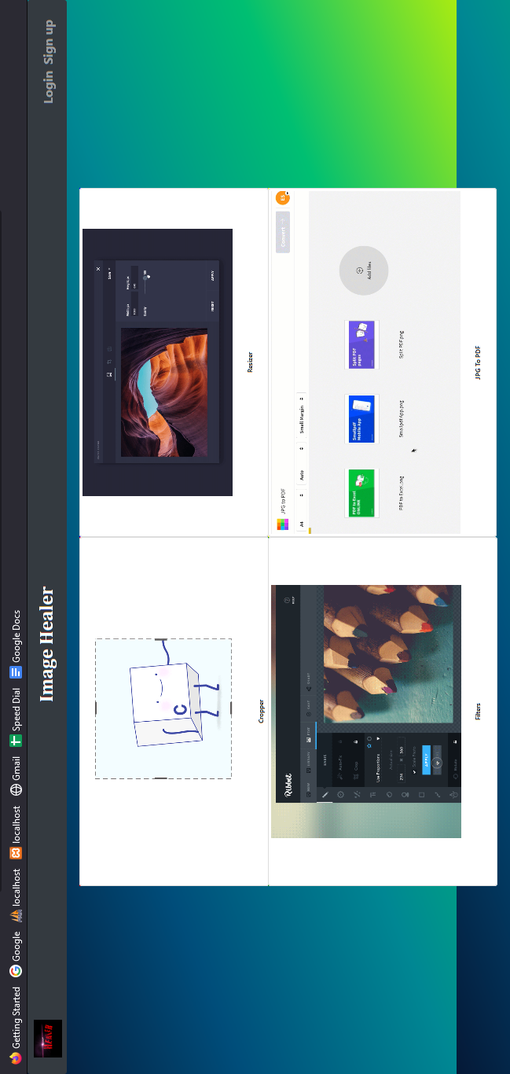
8.1.2 Registration

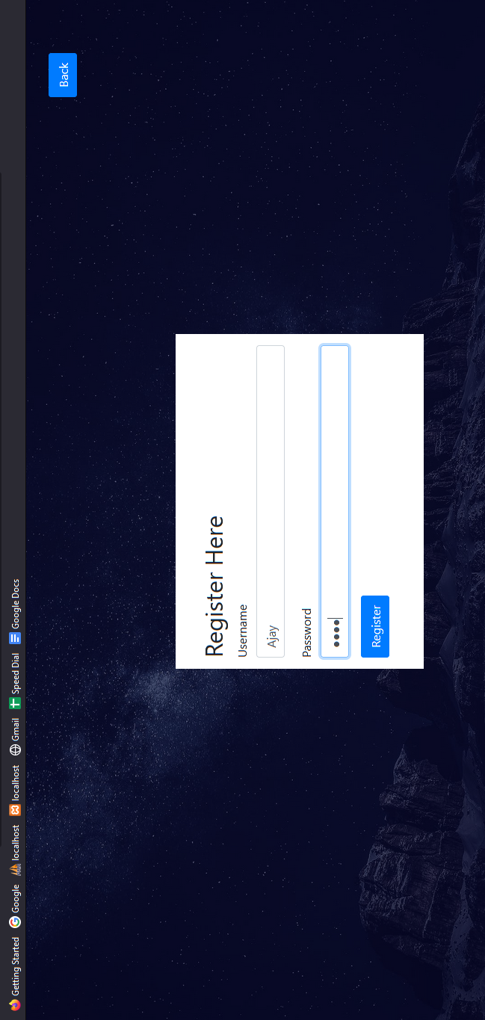

8.1.3 Login

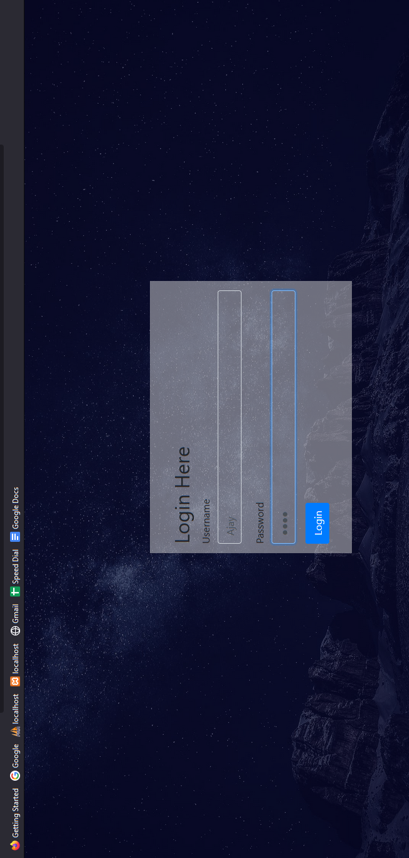

8.1.4 Cropper

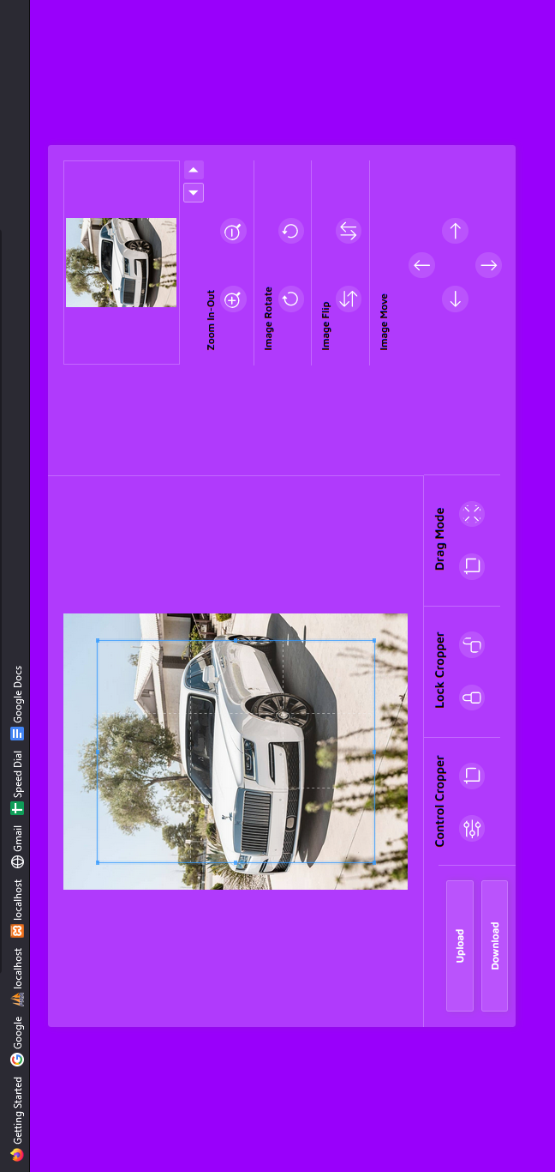

8.1.5 Height/Width Changer & Compressor

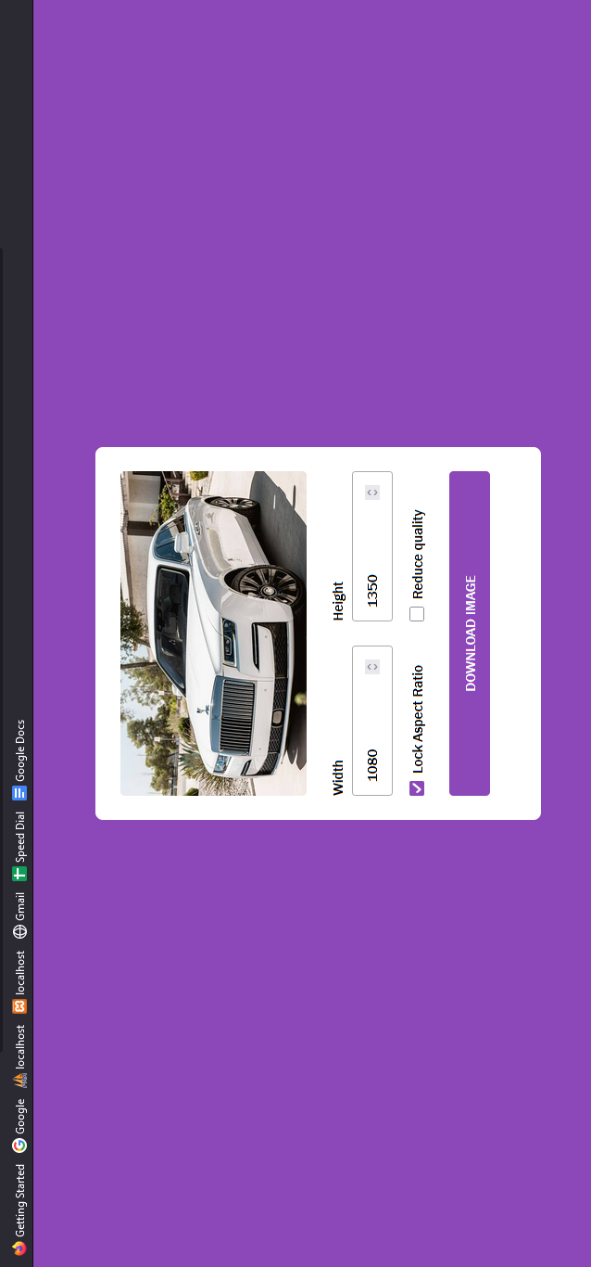

8.1.6 Filters Changer

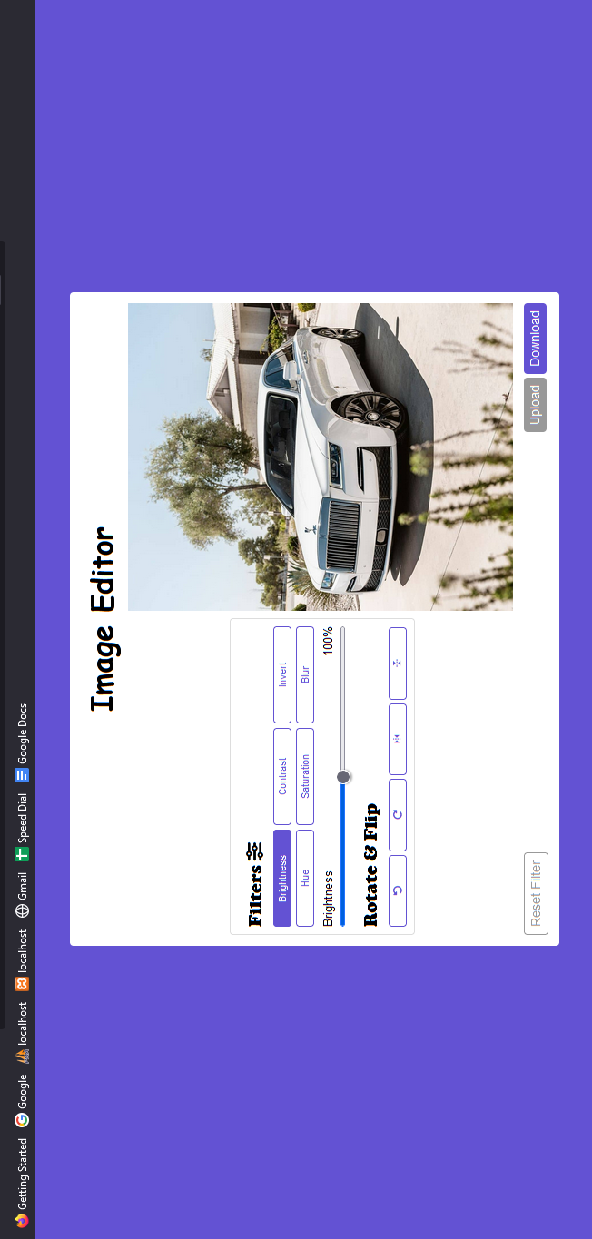
8.1.7 Image To PDF Converter

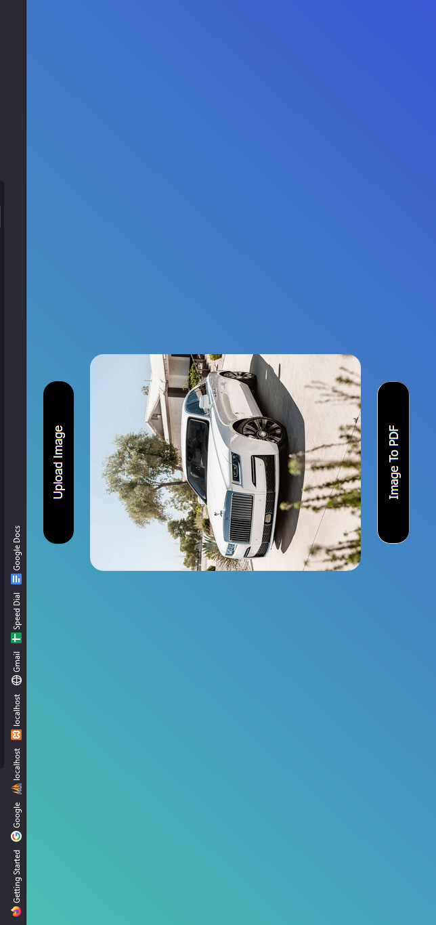
8.1.8 Download Image

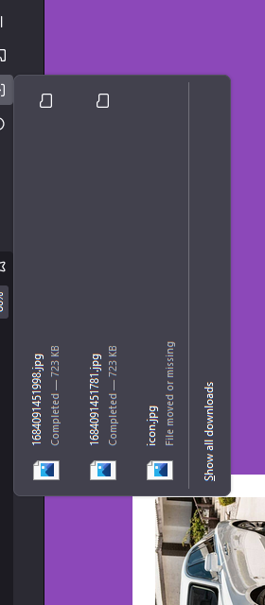

CONCLUSION

9. CONCLUSION
In conclusion, an image healer tool that includes features such as cropper, filters, image to PDF conversion, compressor, and height and width changer is a powerful and versatile software application that enables users to perform a wide range of tasks related to image manipulation and management.
The cropping feature allows users to select and remove unwanted parts of an image, while the filters feature provides users with a range of options to adjust the colors, contrast, and other attributes of the image to achieve the desired look and feel. The image to PDF conversion feature allows users to convert multiple images into a single PDF file, making it easier to organize and share images in a more professional and efficient manner.
The compressor feature allows users to reduce the size of an image file without losing too much quality, which can be useful for users who need to upload or share images on the web or via email. The height and width changer feature allows users to resize images according to their specific requirements, which is particularly useful for users who need to create images for different platforms or devices.
The development of an image healer tool with these features involves a range of activities, including requirements gathering, design, coding, testing, and deployment. These activities are typically performed by a team of developers, testers, and other professionals who work together to ensure that the tool meets the requirements and goals of the stakeholders.
Testing is an important part of the development process for an image healer tool, and may involve unit testing, integration testing, and other types of testing to ensure that the tool functions correctly and meets the requirements and expectations of users.
Overall, an image healer tool with features such as cropper, filters, image to PDF conversion, compressor, and height and width changer is a powerful and versatile tool that can be useful in a range of industries, including photography, graphic design, and web development. The ongoing development and improvement of image healer tools with these features will continue to be an important area of focus for software developers and designers.

FUTURE ENHANCEMENT

10. FUTURE ENHANCEMENT

In the future, there are several enhancements that could be made to image healer tools that include cropper, filters, image to PDF conversion, compressor, and height and width changer features. Some potential enhancements could include:
- Artificial intelligence (AI) features: AI-powered image healer tools could provide users with more advanced and automated options for cropping, filtering, and resizing images based on user preferences and trends in the industry.
- Cloud-based services: Future image healer tools could be designed to take advantage of cloud-based services to store, share, and edit images from anywhere with an internet connection.
- Improved compression algorithms: Image healer tools could be enhanced to use more advanced compression algorithms that reduce file sizes without sacrificing image quality, making it easier to share images online or via email.
- Real-time collaboration: Image healer tools could be designed to allow multiple users to collaborate on the same image in real-time, making it easier to share ideas and make changes on the fly.
- 3D image editing: With the rise of 3D imaging technology, future image healer tools could be enhanced to support the manipulation and healer of 3D images, making it easier for designers and developers to create engaging and interactive digital content.
These enhancements, along with others that may emerge in the future, will continue to push the boundaries of what is possible with image healer tools and provide users with more powerful and versatile tools to create and manipulate digital images.

BIBLOGRAPHY

11. BIBLOGRAPHY

BOOKS

- The Complete reference HTML and CSS fifth edition by Thomas A. powell

- The Complete reference PHP by Steve Holzner

- Database System Concepts by Abraham Silberschatz, Henry F. Korth and S. Sudarshan

- Beginning HTML,XHTML,CSS & JavaScript by Jon Duckett

WEBSITES

- https://www.w3schools.com/php/
- https://getbootstrap.com/docs/4.0/getting-started/introduction/
- https://stackoverflow.com/
- https://www.w3schools.com/sql/
- https://www.w3schools.com/js/default.asp
- https://www.youtube.com/

