1. How do you list files in a directory using the Linux command line? with syntax

ls

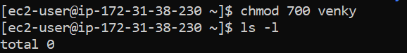

2. How to list hidden file?

ls -a



3. What's the command to create a new directory in Linux?

mkdir directory_name

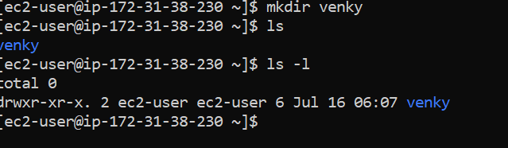

4. How do you change the permissions of a file in Linux? with explanation what is xrwxrx diff way of giving permissions?

using chmod

RWX RWX WRX

OWNER PERMISSION GROUP PERMISSION PERMISSIONS FOR OTHER/INDUVIDUALS

NUMERICAL rwx

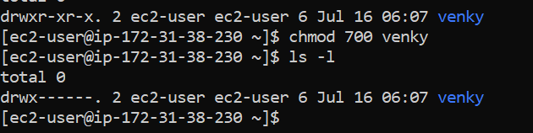

5. How could you search for a specific string within a file using the Linux command line?

grep "search_string" filename

grep -i "hello" file.txt

grep -w "hello" file.txt excat match

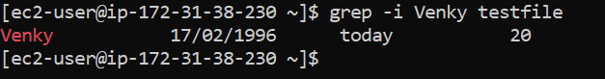

6. What command could you use to display the contents of a text file in the Linux terminal?

cat command

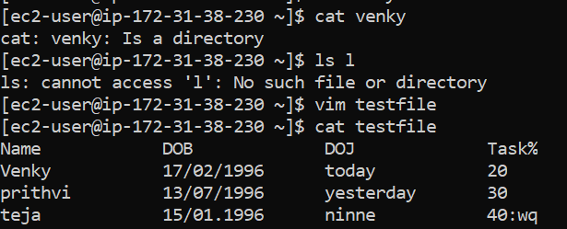

7. differnce between cat and vi?

CAT to display content of file, Vi is used to write/edit the content in file

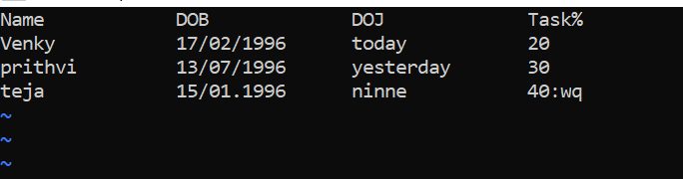

8. diff between cat and tac?

CAT - display files in same order

TAC- in reverse

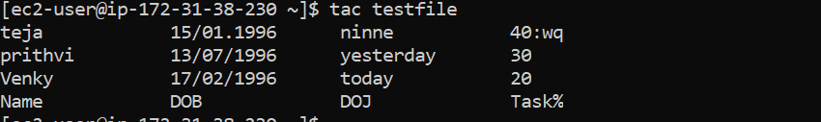

9. how to redirect a out of a command to file instead of console?

command >> filename

echo "New entry" >> log.txt

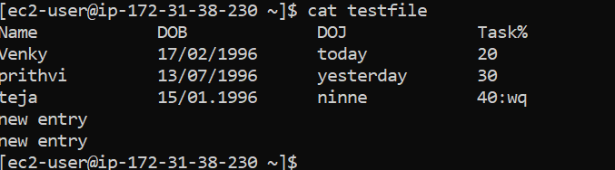

10. file redirect and append symbols?

overwriting the file if it already exists.

Redirect - command >> filename example - ls > directory_list.txt

adding the output to the file if it already exists.,

Append - command >> filename

11. What's the difference between the grep and awk commands?

Gerp - search the word through the files

-i: Case-insensitive search.

-v: Invert match (show lines that do not match).

-n: Show line numbers of matches.

-r: Recursively search in directories.

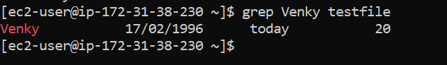

AWK: Search a word in a file by filtering the column or rows

awk '{ print $3 }' data.txt which print third column in a file

NF and NR for last column and last row

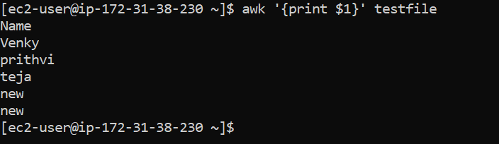

12. diff awk and cut?

CUT can support specified delimiters but not for complex data

AWK uncoditially based on tasks

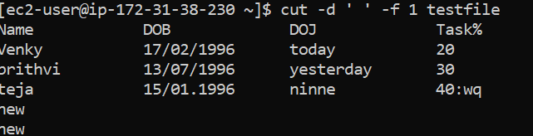

13. How do you kill a running process in Linux?

First we need to find the PID

steps :

using pgrep/top

then using Kill command

kill PID

force kill - kill -9

Find the PID using ps, top, or pgrep.

Use kill PID to terminate the process.

Use kill -9 PID to forcefully kill it if necessary.

Use pkill or killall for killing by name

14. howto check running processes?

ps aux: Detailed process list.

top: Real-time process monitoring.

htop: Interactive process viewer (if installed).

pgrep: Find process IDs by name.

pstree: Display processes in a tree format.

systemctl: Manage and check system services

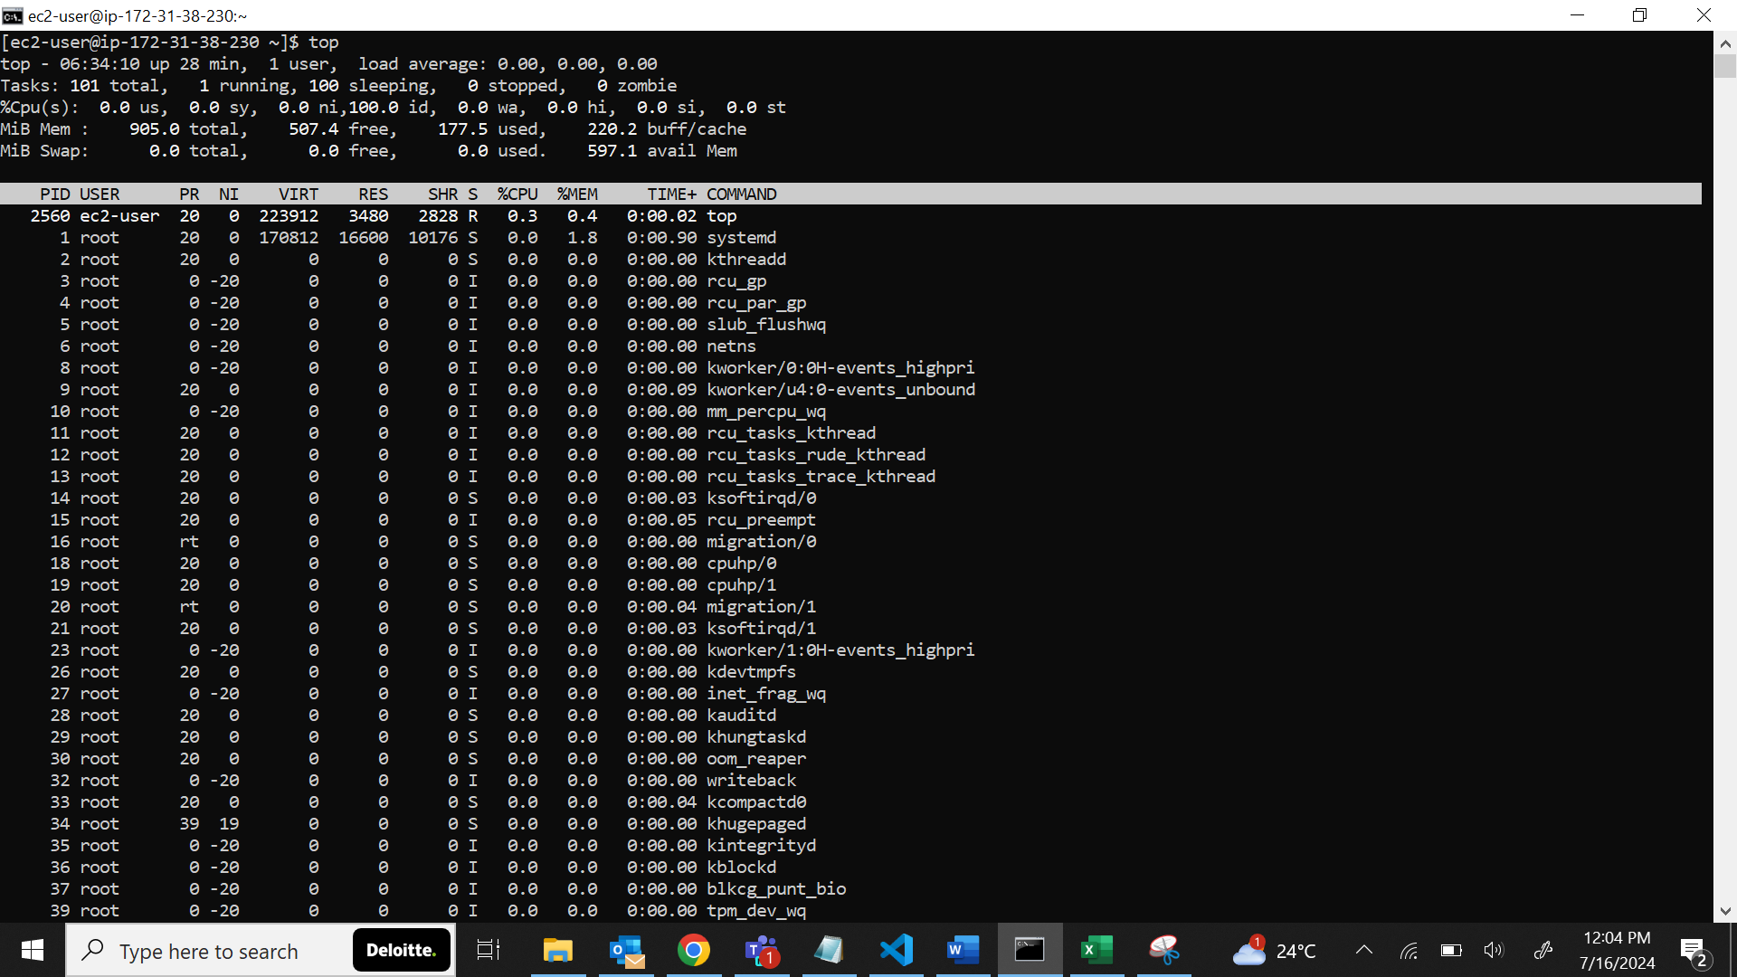

15. how to get PID of a process?

using ps, top, or pgrep

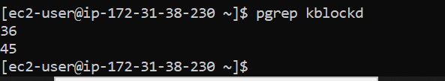

16. What's the command to check the disk space usage on a Linux system?

df - diskfree

17. diff bw df -h and du -h? what is -h?

Use df -h to check overall filesystem usage.

Use du -h /path/to/directory to check how much space a specific directory and its contents are using.

The -h option in both commands makes the output easier to read by converting sizes into human-friendly units.

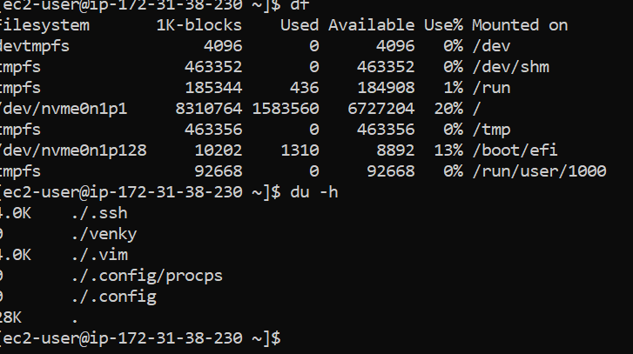

18. what is port used for ssh?

port 22

19. diff bw cp and scp? how scp works? syntax?

cp - copy command - used to copy a file and one dir to another dir

Purpose: Used to copy files and directories within the local filesystem.

Usage: Does not support copying files over a network.

syntax: cp source.txt destination.txt

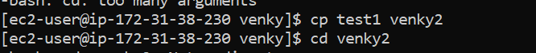

SCP ( Secured Copy Protocal):

Purpose: Used to securely copy files between hosts on a network over SSH.

Usage: Supports copying files between local and remote systems.

Syntax : scp localfile.txt user@remotehost:/path/to/destination/

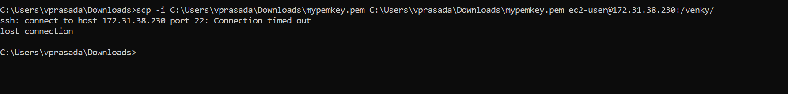

20. What's the Linux terminal command to find out your current working directory?

PWD

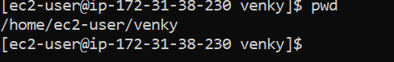

21. How do you move a file from one directory to another using Linux commands?

Move Command ( mv)

mv /path/to/source/file.txt /path/to/destination/

mv -i (confirms before overwriting)

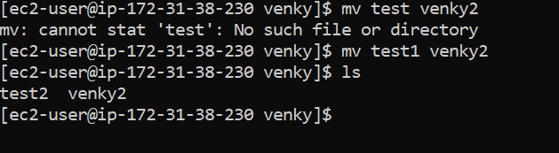

22. how to rename a file?

mv [old_filename] [new_filename]

mv /path/to/oldname.txt /path/to/newname.txt

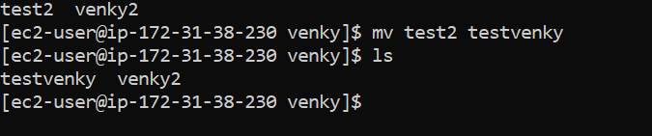

23. diff bw mv and cp?

mv - move files or dir from source to dest without

cp copy files or dir leaving the original file unchanged.



24. How would you check the network connectivity between your machine and a remote server using the Linux terminal?

Use "ping" for basic connectivity testing.

Use "traceroute" to see the path to the server.

Use "telnet" or "nc" to check connectivity to specific ports.

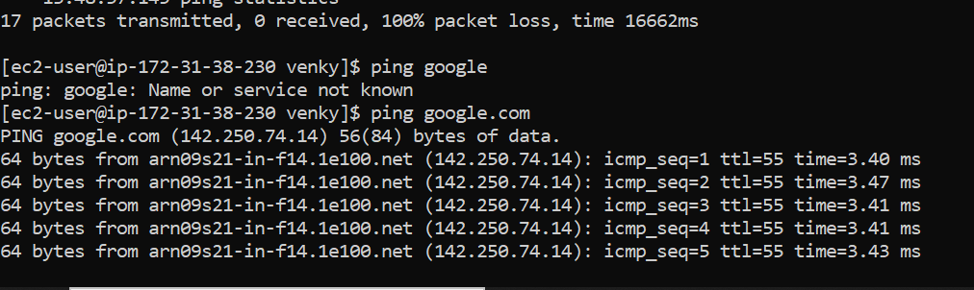

25. What Linux command could you use to display the list of users currently logged into the system?

who - command

Use who to see a list of logged-in users.

Use w for more detailed information.

Use users for a simple list of usernames.

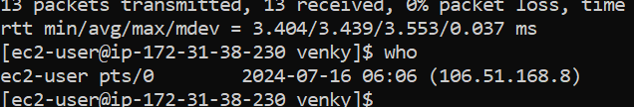

Linux_part1.txt

https://github.com/Venky02189/AWSinterview-questions/blob/6761ec17a292e150c316acbb349995ebeb5e0046/Linux_part1.txt