PROJECT DOCUMENTATION
FitTrack AI - Personalized Fitness Recommendations Powered by AI

Introduction

Project Title : AI FitTrack
Team ID : 6ab4be69b5170a9b58b49ea1
Team Leader : Venkatesh M
Mail ID : ncas2427sz1221@ncas.in
NM ID : F6975FCFAA46BA4800A4C0D25F8EEBA7

Team Members
1. Vishal R
Mail ID : ncas2427sz1141@ncas.in
NM ID : A9A31F5FB8E000DA29B4969B543FC021
2 . Yuvan raj V
Mail ID : ncas2427sz1301@ncas.in
NM ID : 89E08809A75AB15B0CA4FBFF566BC306
3. Sabarinathan C
Mail ID : ncas2427sz1033@ncas.in
NM ID : 4DB61A8D634F01AAFF64FC16C83392DA

The FitTrack AI backend is a secure, scalable RESTful application for workout tracking and intelligent fitness recommendations. It provides secure authentication, workout management, workout search, and AI-assisted fitness guidance.
The application uses MVC architecture. JWT protects secured APIs and bcrypt.js securely hashes passwords before storage in MongoDB. Google Gemini AI generates personalized workout recommendations from age, fitness goals, and experience, and produces insights from workout statistics.
1.1. Project Overview
- Secure registration and login
- JWT authentication
- Workout CRUD operations
- Workout search
- Google Gemini recommendations
- AI fitness insights
- MongoDB persistence
- Validation and centralized error handling
  - Team Information
Team-member names, IDs, and contact details are not included in the supplied AI FitTrack document.

3. Scenario-Based Case Study

3.1. Background
Rahul is a fitness enthusiast who records workouts manually using notebooks and spreadsheets. He finds it difficult to organize history, monitor progress, and decide which workouts suit his fitness level.

3.2. Problem
- No centralized workout record.
- Manual tracking may produce inaccurate history.
- No secure authentication for personal fitness records.
- Previous workouts are difficult to search.
- No personalized recommendations or performance insights.
- Manual calculation of calories and duration is time-consuming.

3.3. Solution
FitTrack AI provides secure registration, authentication, workout creation, update, deletion, retrieval, and search. Gemini AI analyzes user information and workout statistics to generate recommendations and personalized fitness insights.

3.4. Usage
- Users create accounts, manage workouts, search history, and request AI guidance.
- AI processes age, fitness goal, experience level, and workout statistics.
- Clients consume REST APIs and receive JSON responses.

3.5. Outcome
The system reduces manual record keeping, protects personal workout data, and provides intelligent suggestions. Its modular architecture supports maintenance and future extension.

4. Software Requirements
- Windows 10/11, macOS, or Linux
- Node.js v16+
- npm v8+
- Express.js
- MongoDB + Mongoose
- Google Gemini AI
- Postman / Thunder Client
- Visual Studio Code

5. Hardware Requirements
- Intel Core i5 8th Gen+ / AMD Ryzen 5 equivalent
- 8 GB RAM minimum; 16 GB recommended
- At least 1 GB available storage

6. System Architecture
FitTrack AI uses layered MVC architecture. Requests enter through Express, pass authentication middleware when required, reach controllers and services, interact with MongoDB or Gemini, and return structured JSON responses.

6.1. Architecture Components
- Client: React / Mobile App / Postman
- Express Server Gateway
- API Routes
- JWT Authentication Middleware
- Controllers
- Services
- Google Gemini AI Service
- Mongoose Models
- MongoDB Database
Figure 6.1: System Architecture of AI FitTrack
<b>Client</b> | → | <b>Express</b> | → | <b>Routes</b>
React / Mobile / Postman |  | Middleware + CORS |  | Auth / Workout / AI
 | ↓ | <b>Controllers</b> | → | <b>Services</b>
 |  | Business Logic |  | Gemini / JWT
 |  | ↓ |  | ↓
 |  | <b>Mongoose</b> | → | <b>MongoDB</b>

7. Entity-Relationship Model
The backend contains two primary collections, User and Workout, connected through a one-to-many relationship: one User can create multiple Workouts and each Workout belongs to one authenticated User.

7.1. User Entity
Stores authentication and profile information.
- _id: ObjectId, Primary Key
- name: String, mandatory
- email: String, unique
- password: String, encrypted using bcrypt.js
- createdAt and updatedAt: Date

7.2. Workout Entity
Stores workout information for each authenticated user.
- _id: ObjectId, Primary Key
- user: ObjectId referencing User
- workoutName: String
- category: String
- duration: Number (minutes)
- caloriesBurned: Number
- workoutDate: Date
- createdAt / updatedAt

7.3. Relationship
<b>User → Workout | One-to-Many</b><br/>A user can create multiple workout records. Each workout belongs to only one authenticated user. The user field stores the related User ObjectId.

8. Key Features
- Secure authentication: registration, login, password encryption, JWT generation, protected APIs.
- Workout management: add, view, update, and delete records.
- Workout search by name, category, or date.
- Gemini AI recommendations: weekly plan, exercises, training tips, and safety recommendations.
- AI fitness insights: performance analysis, improvement suggestions, motivation, and progress summary.
- Centralized JSON error handling.
- RESTful GET, POST, PUT, DELETE APIs.
- Modular models, controllers, routes, middleware, services, and configuration.

9. Roles and Responsibilities
The AI FitTrack backend supports one primary role: Authenticated User.

9.1. Authenticated User
- Register an account
- Login securely
- View profile
- Add workout records
- View workout history
- Search workouts
- Update workouts
- Delete workouts
- Request AI workout recommendations
- Request AI fitness insights

9.2. Permissions
<b>Operation</b> | <b>Permission</b>
Register | Yes
Login | Yes
View Profile | Yes
Add Workout | Yes
Get Workouts | Yes
Search Workouts | Yes
Update Workout | Yes
Delete Workout | Yes
AI Recommendation | Yes
Fitness Insights | Yes

10. User Flow
- Register using the authentication API.
- Login with email and password.
- Receive a JWT token.
- Use the token for protected requests.5. Create and manage workout records.
- Search workout history.
- Submit fitness details to AI recommendation API.
- Receive personalized recommendations and fitness insights.

11. MVC Architecture
The project separates application logic into Model, View/API Interface, and Controller layers. This separation improves organization, maintainability, testing, and scalability.

11.1. Model Layer
- User and Workout schemas
- Schema definition and validation
- CRUD operations
- MongoDB collection mapping

11.2. View / API Interface
Because AI FitTrack is a backend REST API, the View layer is represented by React, mobile applications, or Postman clients that send HTTP requests and receive JSON responses. 11.3. Controller Layer
- Request validation
- Business logic execution
- Database interaction
- AI service invocation
- Response generation

12. Project Setup and Configuration

12.1. Project Initialization
1. Create folder: AI-FitTrack-API 2. Open it in Visual Studio Code.
- Create the server folder.
- Run npm init -y.
- Install required packages.
- Configure .env variables.

12.2. Commands
npm init -y
npm install express mongoose dotenv bcryptjs jsonwebtoken cors npm install --save-dev nodemon
12.3. Project Folder Structure
The backend separates configuration, models, controllers, routes, middleware, services, and entry-point files so each responsibility remains modular.

12.4. Environment Configuration
Sensitive information is stored in environment variables instead of source code.
PORT=5000 MONGO_URI=mongodb://localhost:27017/aifittrack
JWT_SECRET=your_secret_key
GEMINI_API_KEY=your_google_gemini_api_key

13. Backend Development
Backend development implements authentication, workout management, AI integration, database operations, middleware, and error handling.
- Server Configuration
- Database Configuration
- Authentication
- Workout Management
- AI Recommendation
- Middleware
- Error Handling

14. Database Configuration
MongoDB stores user credentials and workout information. Mongoose provides schema validation, relationships, middleware support, and CRUD operations.

14.1. Collections
- Users Collection
- Workouts Collection
14.2. MongoDB Connection
config/db.js establishes the MongoDB connection at application startup, handles errors, displays connection status, and exports the connection.

14.3. Mongoose Schemas
- User schema: name, unique email, mandatory password, bcrypt hashing, timestamps, JWT support.
- Workout schema: required name/category/date, positive duration, non-negative calories, and authenticated-user relationship.

15. API Testing
API testing verifies endpoint behavior, authentication, database operations, and AI integration. The supplied project uses Postman / Thunder Client.

15.1. Register User
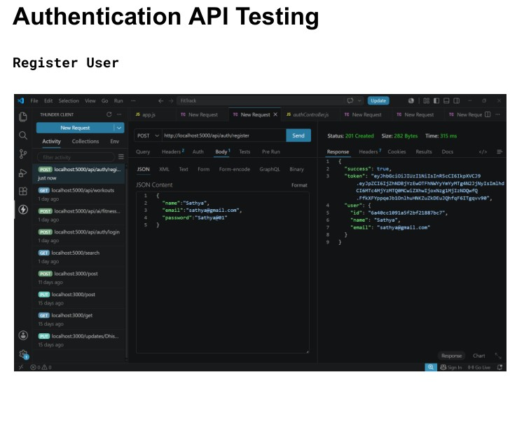
Figure 15.1: Register User API testing

15.2. Authentication
Registration creates a user record and returns a successful response. The login endpoint verifies credentials and provides authentication information used for protected requests.

15.3. Login User and Get Profile
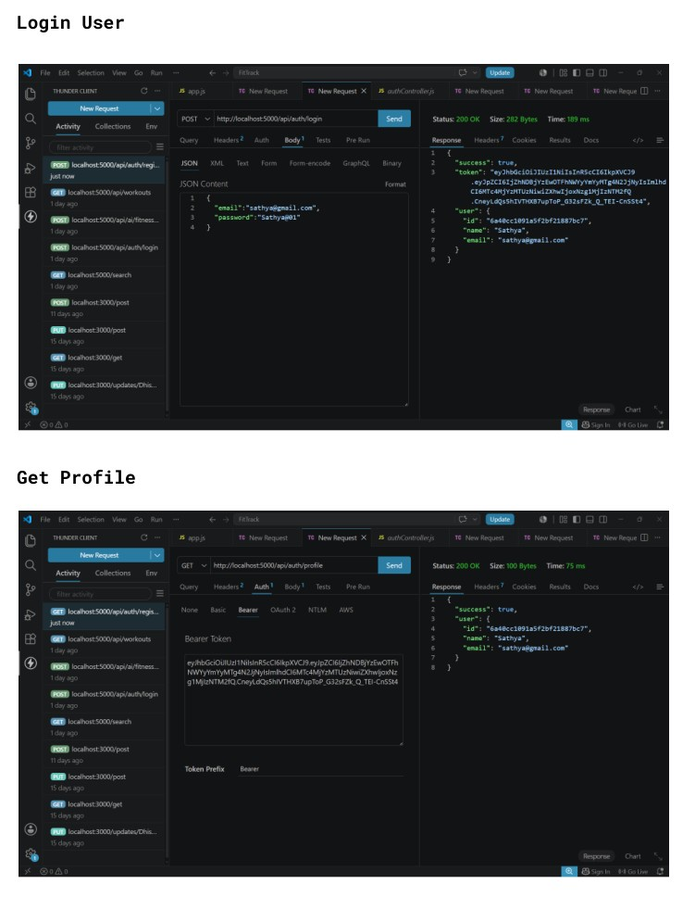
Figure 15.2: Login and Get Profile API testing

15.4. Workout API Testing
Authenticated users can add, retrieve, search, update, and delete workout records. Workout data is linked to the authenticated user.

Add Workout
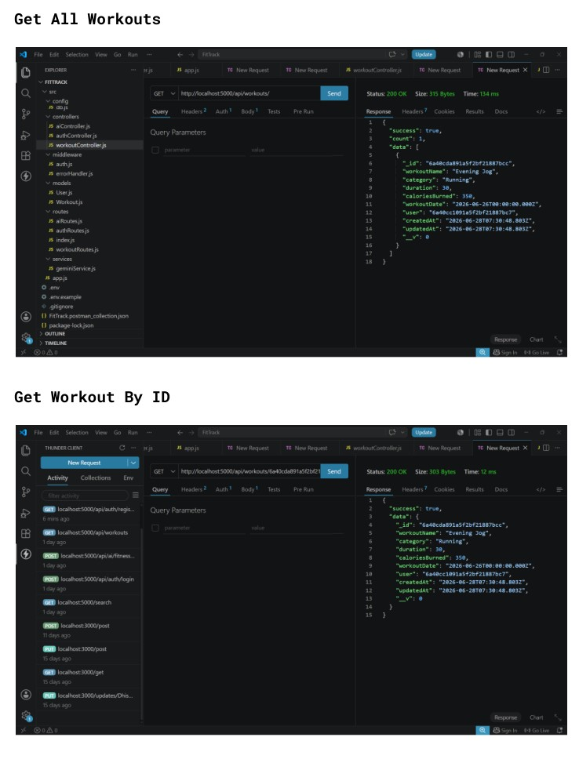
Figure 15.3: Add Workout API testing Workout retrieval and update/delete operations are tested through the corresponding endpoints.

15.5. AI API Testing
The AI endpoints use Google Gemini through the dedicated service layer. Workout Recommendation uses age, fitness goal, and experience level. Fitness Insights analyzes total workouts, average duration, and calories burned.

Workout Recommendation / Fitness Insights
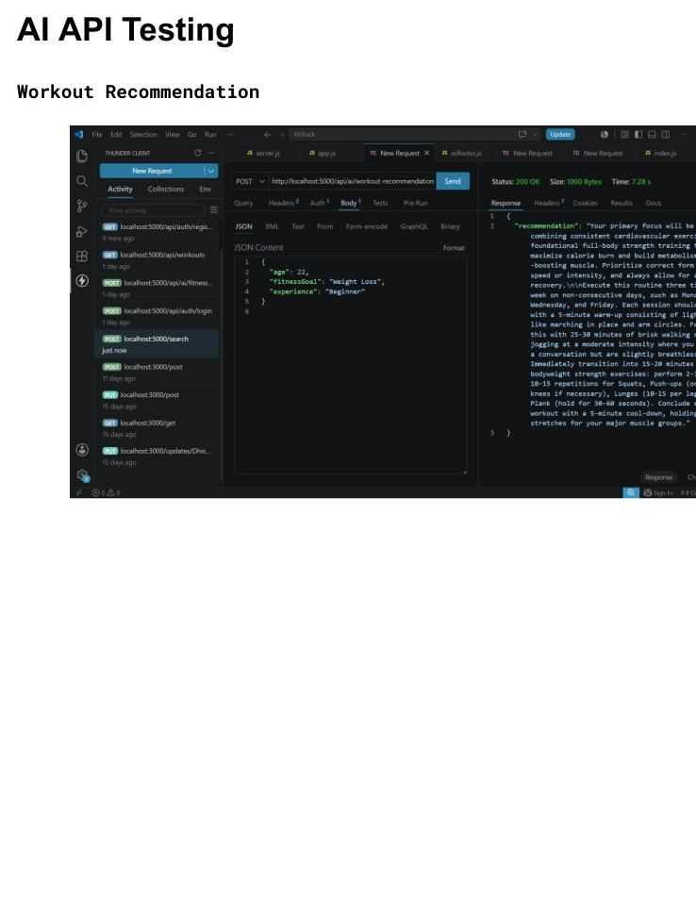
Figure 15.4: AI API testing

16. Testing Summary
- Authentication APIs: Register, Login, Get Profile
- Workout APIs: Add, Get All, Get By ID, Update, Delete
- AI APIs: Workout Recommendation, Fitness Insights

17. Authentication and Security
- JWT authentication protects secured APIs.
- Passwords are hashed using bcrypt.js.
- Protected routes validate authentication tokens.
- Input validation and centralized error handling are included.
- Database credentials, JWT secrets, and Gemini API keys are stored outside source code.

18. Known Limitations
- AI-related functions depend on external service availability and configuration.
- The supplied project is primarily a backend REST API and has no conventional frontend interface.
- The current data model focuses on users and workouts.

19. Project Links
Demo Video: https://drive.google.com/file/d/1KswrctSaPI0eOYyJ3GkbbVHvHsU3EfZJ/view?usp=sharing
API Testing Video: https://drive.google.com/file/d/1TCXG48a-78ryxF3gipdRMwRBwuhAgPaa/view?usp=drive_link Code Drive: https://drive.google.com/drive/folders/1hwmKxkHQkUI62JR1svI3xCQ2ShZ6Lj9y

20. Future Enhancements
- Nutrition tracking
- BMI calculation
- Wearable device integration
- Workout reminders
- Fitness analytics dashboards
- Richer personalized AI guidance

21. Conclusion
AI FitTrack is a modular RESTful backend combining secure authentication, workout tracking, database persistence, search, and AI-assisted fitness guidance. Its MVC architecture and service-based design support maintainability and future expansion.

22. Final Project Summary
- Project: AI FitTrack
- Database: MongoDB + Mongoose
- Authentication: JWT + bcrypt.js
- AI: Google Gemini
- Core Features: Authentication, Workout CRUD, Search, AI Recommendation, Fitness InsightsSource basis: AI FitTrack project documentation supplied with this request.

23.project Repository and Code
- Public GitHub Repository: https://github.com/Venkygoat/AI-FitTrack.git
2.Demo video link :
https://drive.google.com/file/d/1XV8wAaNaXt5ctEsW4luu1B7T3dct2usQ/view?usp=drivesdk
3.code drive link :https://drive.google.com/drive/folders/1hwmKxkHQkUI62JR1svI3xCQ2ShZ6Lj9y.

