Sonarqube Setup
Download Community Edition : https://www.sonarqube.org/downloads/
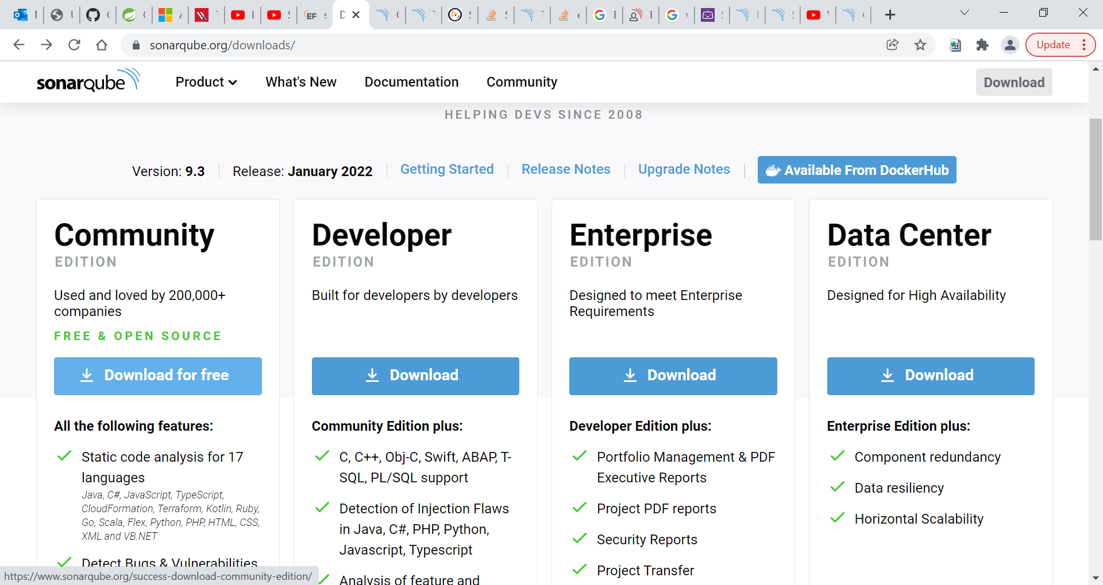

Update the wrapper.conf file: C:\sonarqube-9.3.0.51899\conf
wrapper.java.command=C:/Program Files/AdoptOpenJDK/jdk-15.0.0.36-hotspot/bin/java
Update the sonar.properties file : C:\sonarqube-9.3.0.51899\conf
sonar.search.port=0
Run the StartSonar.bat file : C:\sonarqube-9.3.0.51899\bin\windows-x86-64
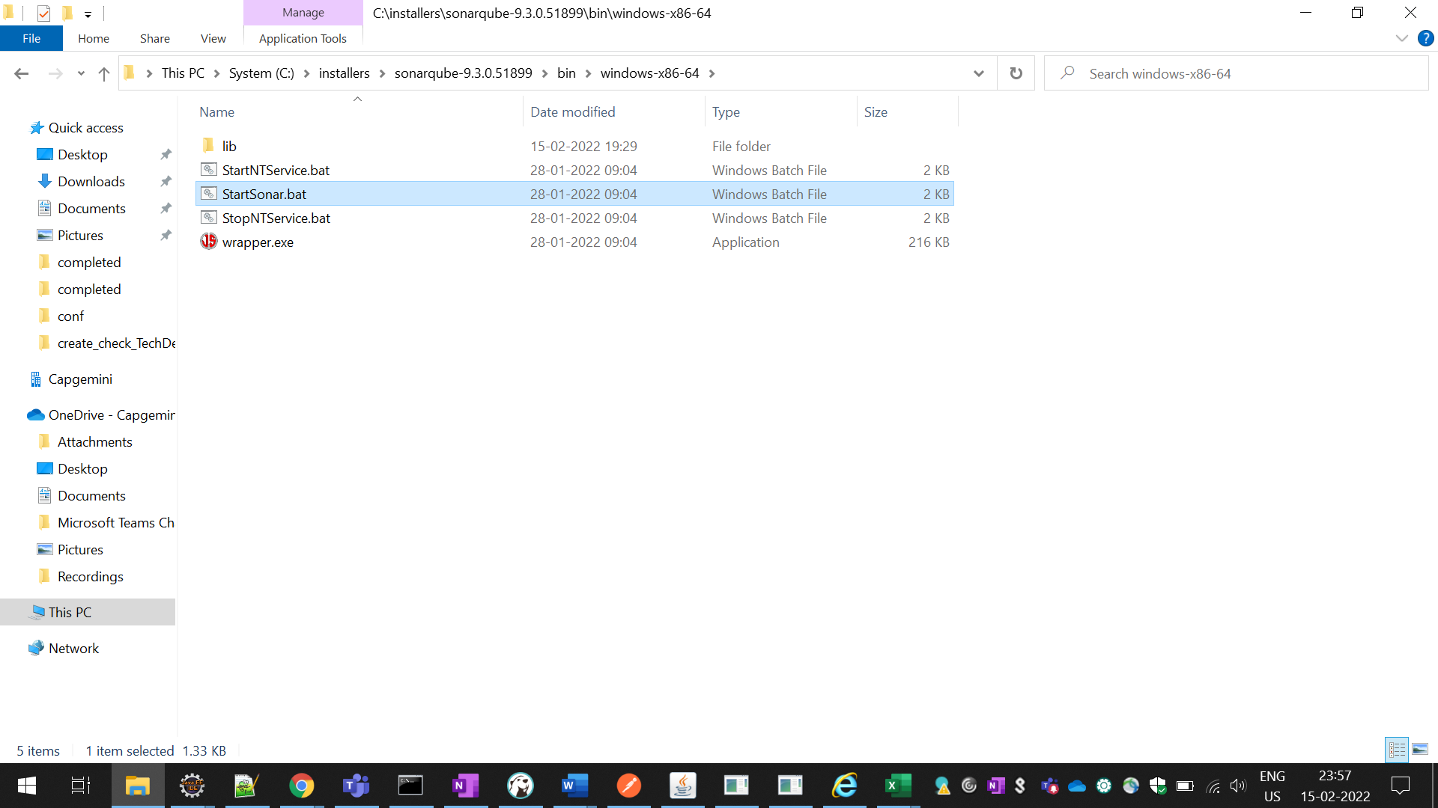
Sonar server started :
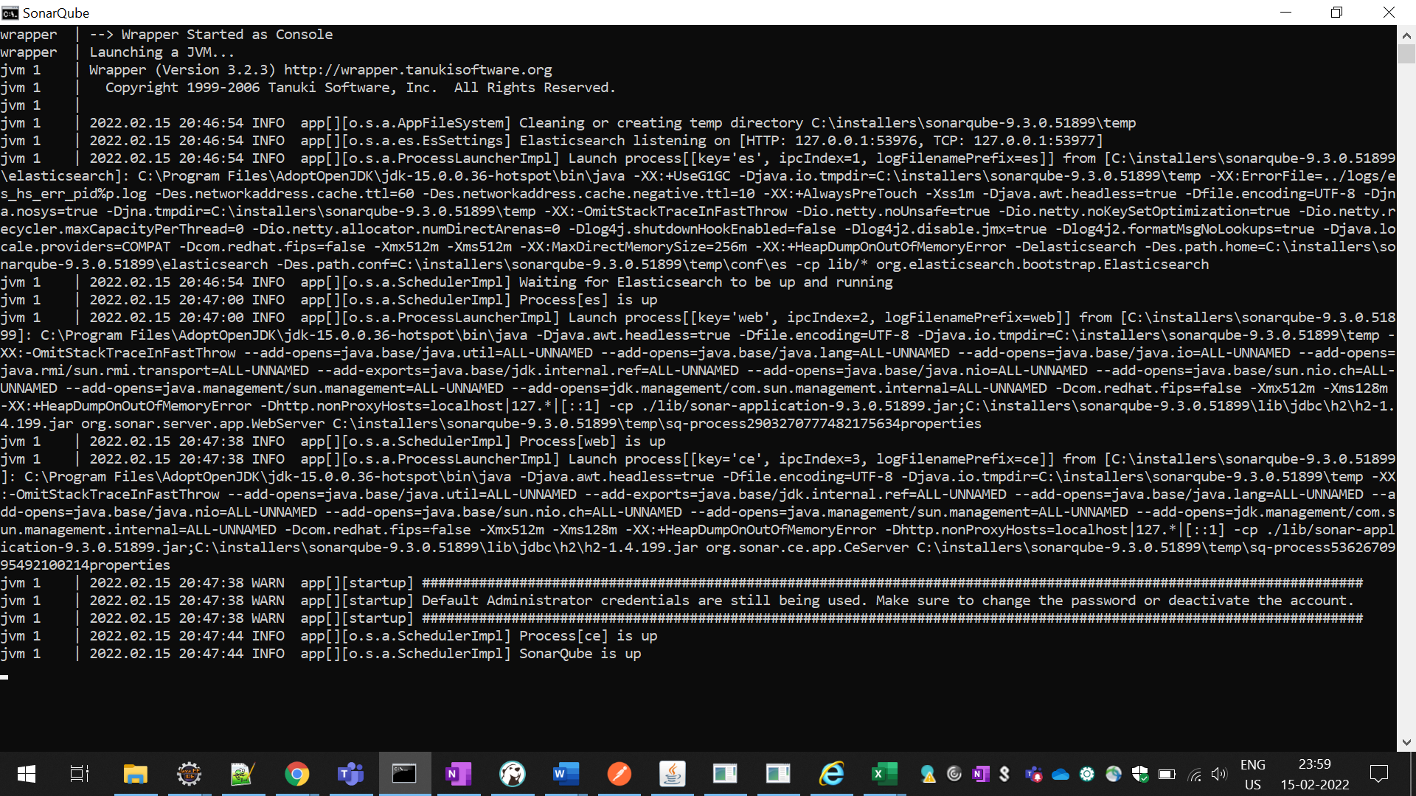

Open the url and give the username = admin & password = admin after that reset the password.
http://localhost:9000/
login the sonarqube.
Now create the project manually.
Give your project name in project display name.
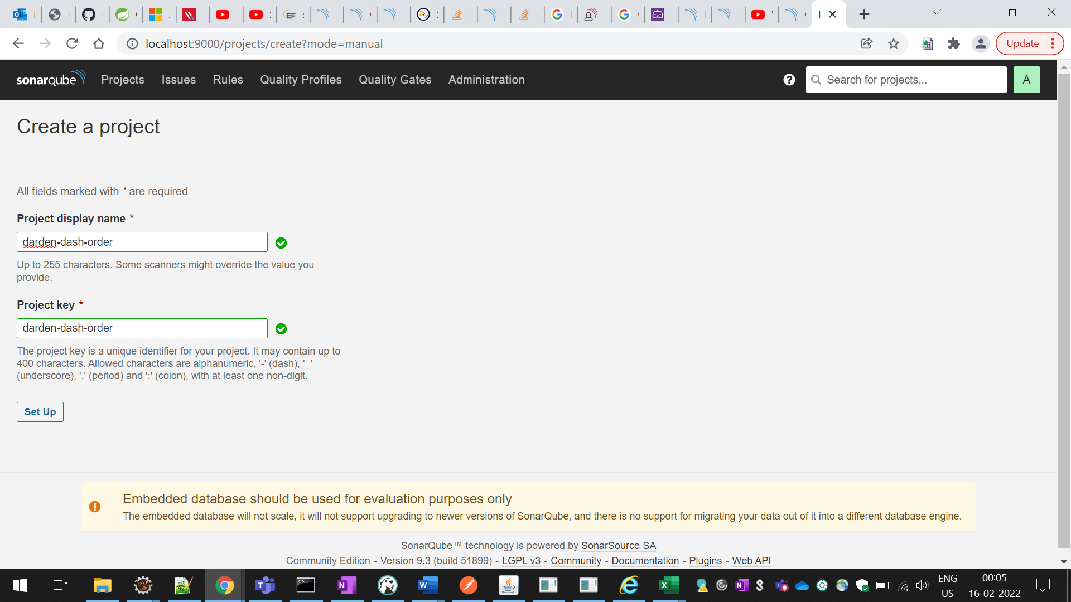
Select the locally tab.
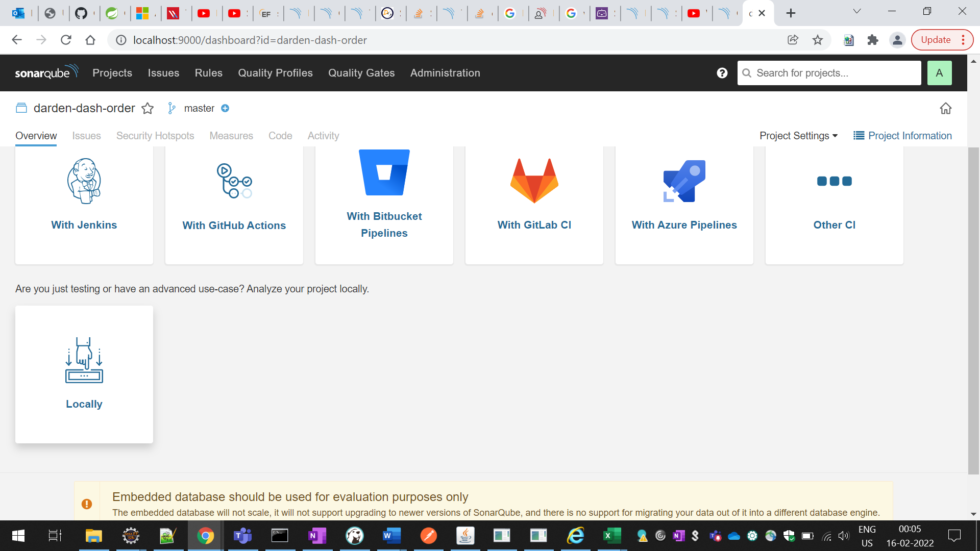
Generate the token, give any key which you want to give

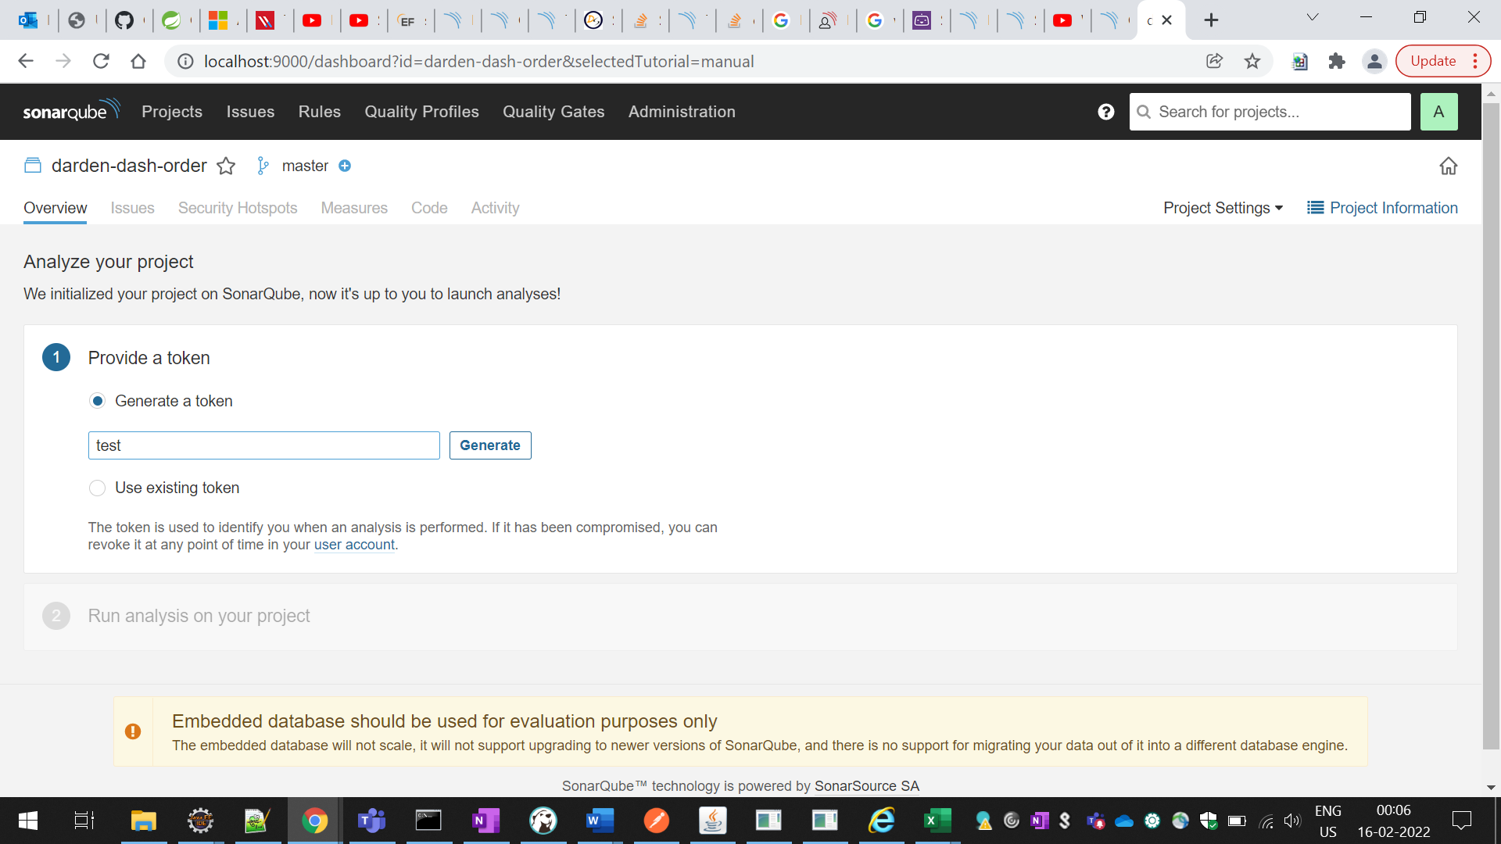

Click on continue.
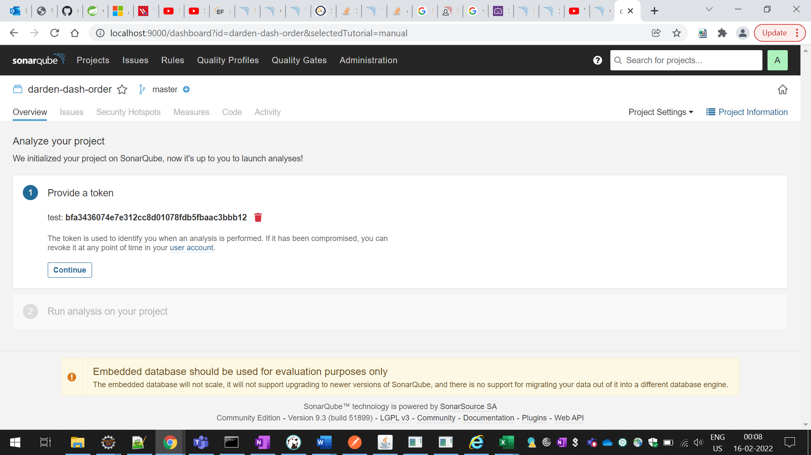
Select the maven .
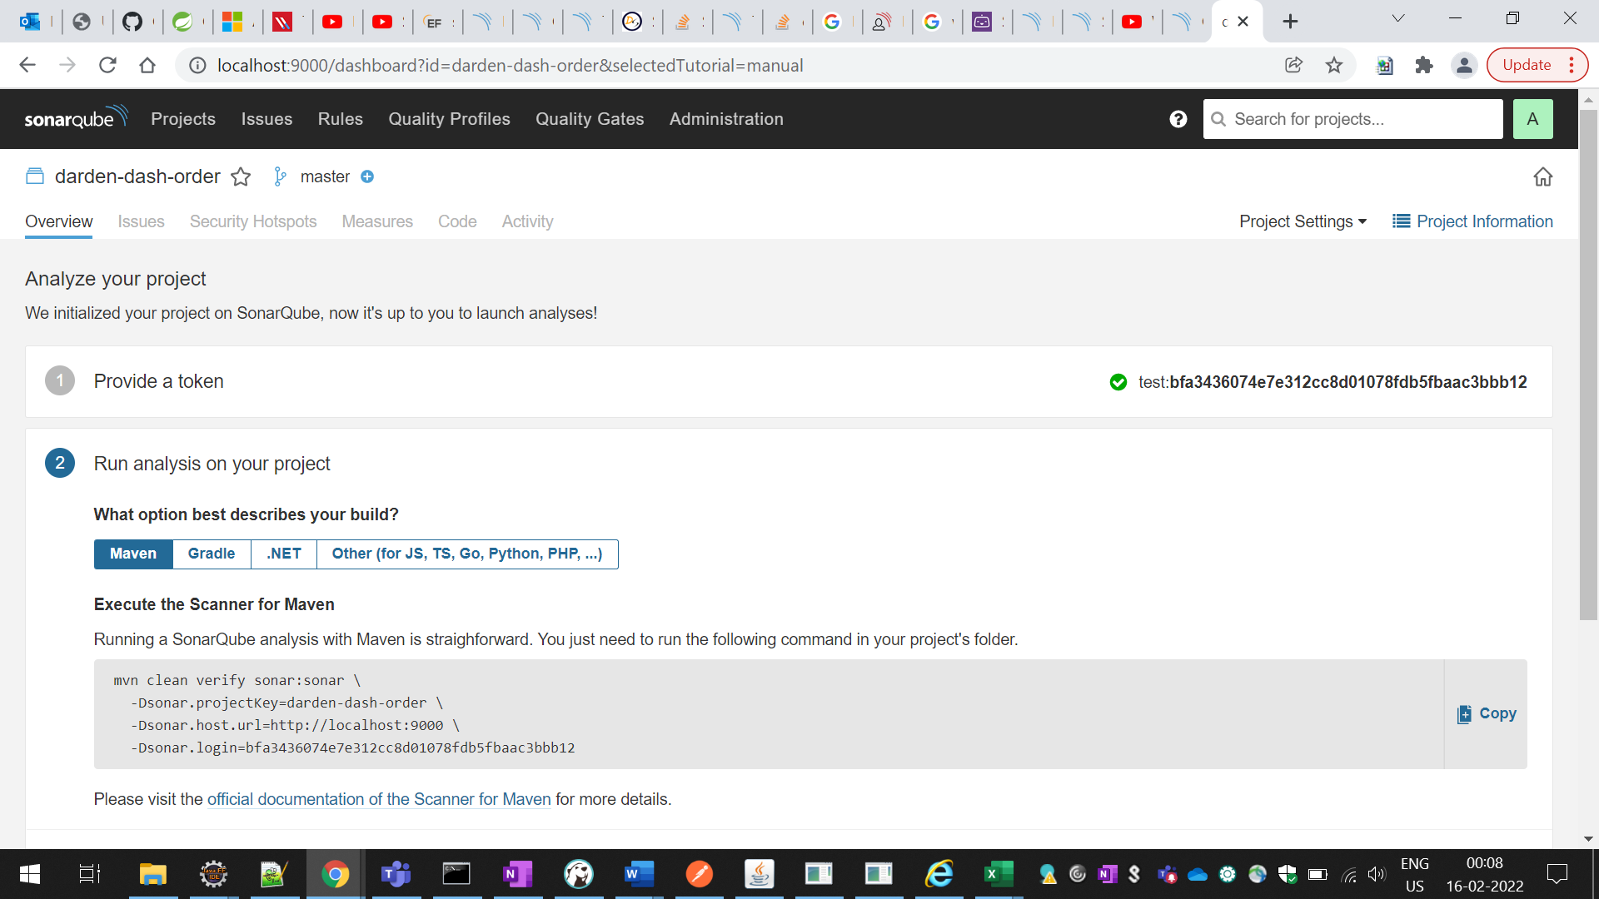

Copy the -dsonarlogin key
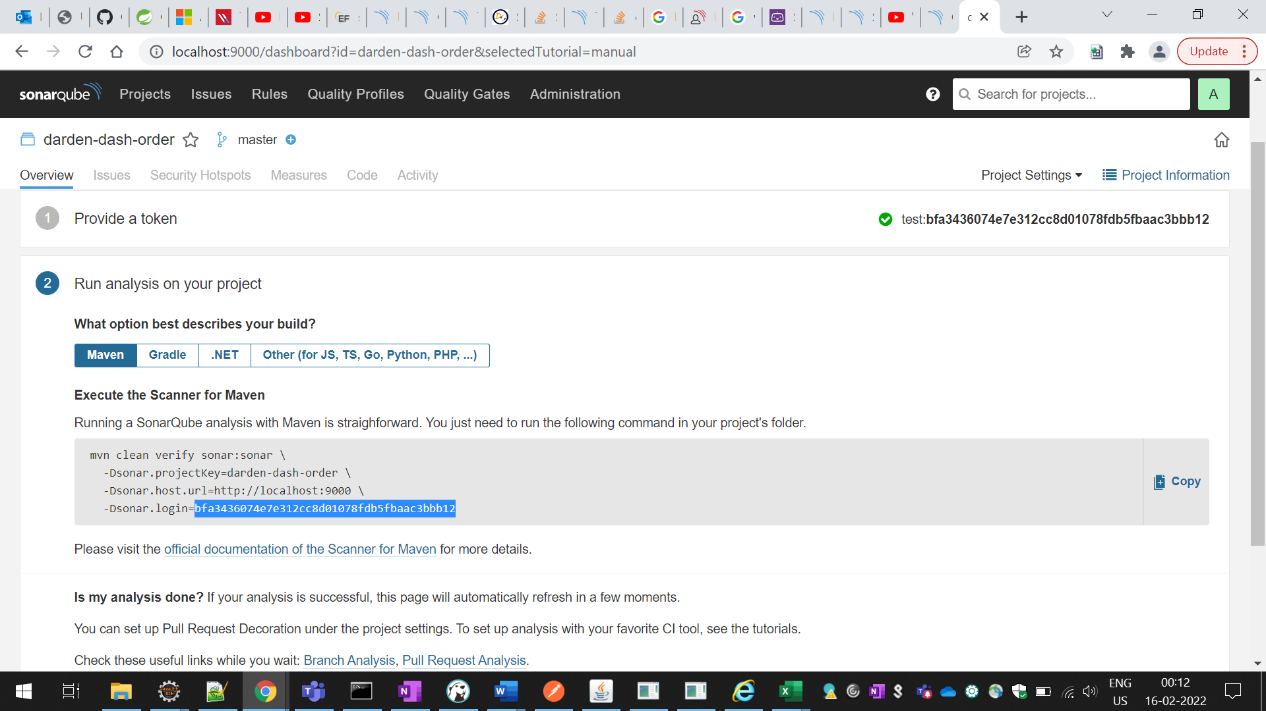
You need to install the Apache Maven, copy the settings.xm file from \apache-maven-3.8.4\conf and paste it in C:\Users\NEHAJARE\.m2 folder.
Now paste the above key in settings.xml like below
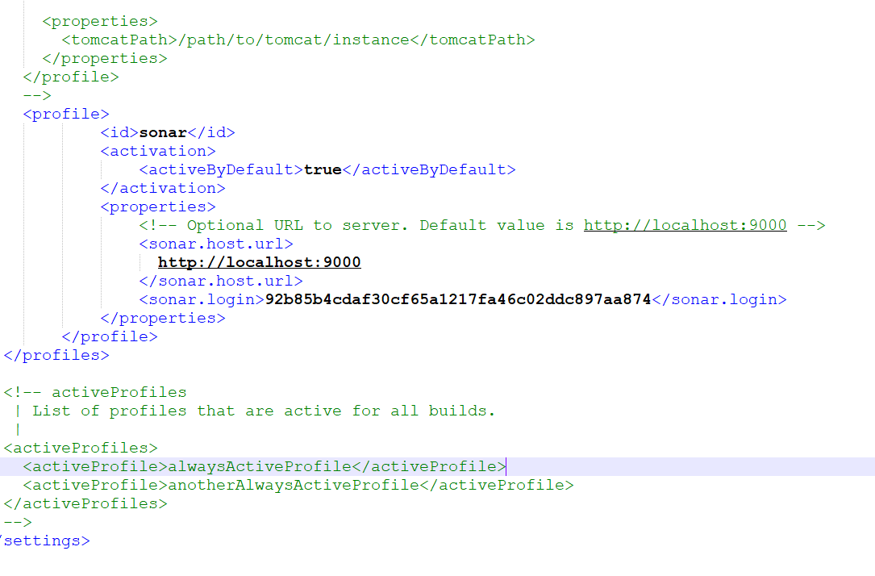
Set the environment variable in your system as:
M2_HOME = C:\apache-maven-3.8.4
M2= %M2_HOME%\bin
Last run the command sonar:sonar like below.
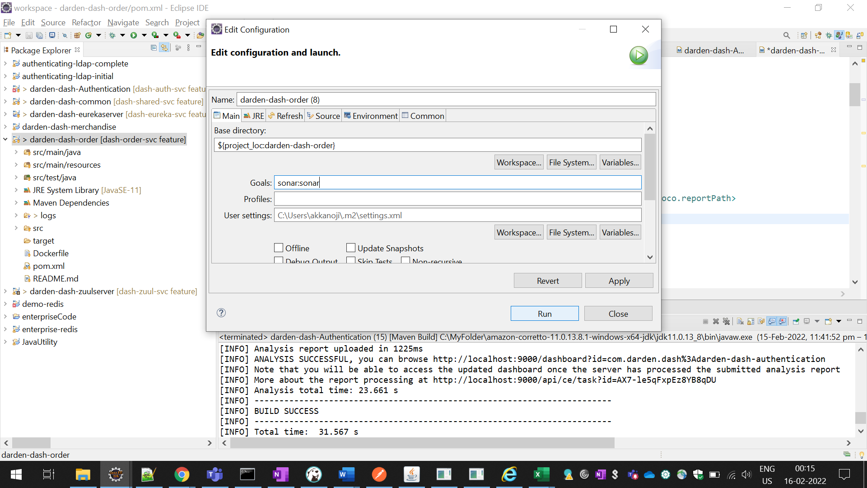

Now you will be available to see the sonar report.

