OS PRACTICAL
Q.3
CODE:
#include <stdio.h>
#include <stdlib.h>
#include <unistd.h>
#include <sys/wait.h>
#include <string.h>
void show_process_info(const char *name)
{
char path[100];
char line[256];
FILE *file;
char state[50] = "Unknown";
snprintf(path, sizeof(path), "/proc/%d/status", getpid());
file = fopen(path, "r");
if (file == NULL)
{
perror("Unable to open process status");
return;
}
while (fgets(line, sizeof(line), file))
{
if (strncmp(line, "State:", 6) == 0)
{
sscanf(line, "State:\t%49[^\n]", state);
break;
}
}
fclose(file);
printf("%s:\n", name);
printf("PID : %d\n", getpid());
printf("PPID : %d\n", getppid());
printf("State: %s\n\n", state);
}
int main()
{
pid_t pid;
printf("Parent process before fork:\n");
show_process_info("Parent");
pid = fork();
if (pid < 0)
{
perror("fork failed");
return 1;
}
if (pid == 0)
{
printf("Child process created:\n");
show_process_info("Child");
printf("Child is running...\n");
sleep(15);
printf("Child woke up and is running again.\n");
show_process_info("Child");
printf("Child terminating...\n");
exit(0);
}
else
{
printf("Parent after fork:\n");
show_process_info("Parent");
printf("Parent waiting for child...\n");
wait(NULL);
printf("Parent: Child has terminated.\n");
show_process_info("Parent");
}
return 0;
}
OUTPUT:
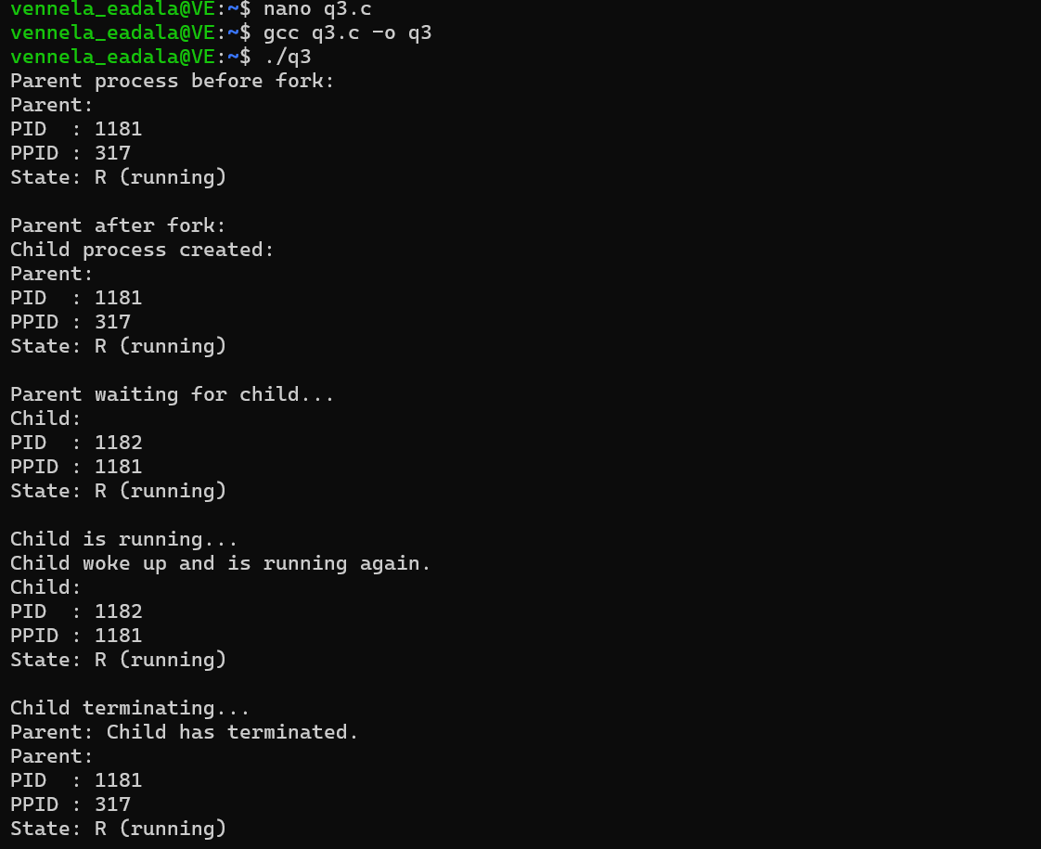
Q.4
Part 1
CODE:
#include <stdio.h>
#include <stdlib.h>
#include <unistd.h>
#include <sys/wait.h>
int main()
{
pid_t child1, child2, child3;
int status;
child1 = fork();
if (child1 == 0)
{
printf("Child 1: PID = %d\n", getpid());
sleep(2);
printf("Child 1 completed.\n");
exit(10);
}
child2 = fork();
if (child2 == 0)
{
printf("Child 2: PID = %d\n", getpid());
sleep(4);
printf("Child 2 completed.\n");
exit(20);
}
child3 = fork();
if (child3 == 0)
{
printf("Child 3: PID = %d\n", getpid());
sleep(1);
printf("Child 3 completed.\n");
exit(30);
printf("\nParent PID = %d\n", getpid());
printf("Waiting using wait()...\n");
wait(&status);
printf("A child completed using wait().\n");
printf("\nWaiting specifically for Child 2 using waitpid()...\n");
waitpid(child2, &status, 0);
printf("Child 2 completed using waitpid().\n");
wait(NULL);
printf("All child processes completed.\n");
return 0;
}
OUTPUT:
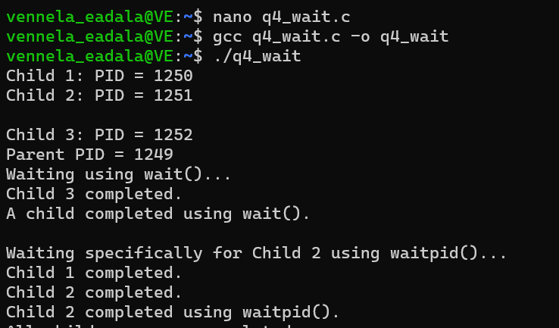

Part 2:
CODE:
#include <stdio.h>
#include <stdlib.h>
#include <unistd.h>
int main()
{
pid_t pid = fork();
if (pid < 0)
{
perror("fork failed");
return 1;
}
if (pid == 0)
{
printf("Child process: PID = %d\n", getpid());
printf("Child is terminating...\n");
exit(0);
}
else
{
printf("Parent process: PID = %d\n", getpid());
printf("Child PID = %d\n", pid);
printf("Parent is sleeping without calling wait().\n");
printf("The child will become a zombie.\n");
sleep(20);
printf("Parent terminating.\n");
}
return 0;
}
OUTPUT:
