OS PRACTICAL
Q.5
CODE:
#include <stdio.h>
#include <stdlib.h>
#include <unistd.h>
#include <sys/wait.h>
#include <time.h>
#define NUM_ITEMS 100000
int main()
{
int pipefd[2];
pid_t pid;
int i;
int value;
struct timespec start, end;
if (pipe(pipefd) == -1)
{
perror("pipe failed");
return 1;
}
clock_gettime(CLOCK_MONOTONIC, &start);
pid = fork();
if (pid < 0)
{
perror("fork failed");
return 1;
}
if (pid == 0)
{
/* Consumer */
close(pipefd[1]);
for (i = 0; i < NUM_ITEMS; i++)
{
if (read(pipefd[0], &value, sizeof(value)) != sizeof(value))
{
perror("read failed");
exit(1);
}
}
close(pipefd[0]);
printf("Consumer received %d items.\n", NUM_ITEMS);
exit(0);
}
else
{
/* Producer */
close(pipefd[0]);
for (i = 0; i < NUM_ITEMS; i++)
{
value = i;
if (write(pipefd[1], &value, sizeof(value)) != sizeof(value))
{
perror("write failed");
exit(1);
}
}
close(pipefd[1]);
wait(NULL);
clock_gettime(CLOCK_MONOTONIC, &end);
double elapsed =
(end.tv_sec - start.tv_sec) +
(end.tv_nsec - start.tv_nsec) / 1e9;
printf("Producer sent %d items.\n", NUM_ITEMS);
printf("Communication time: %.6f seconds\n", elapsed);
printf("Communication rate: %.2f items/second\n",
NUM_ITEMS / elapsed);
}
return 0;
}

OUTPUT:
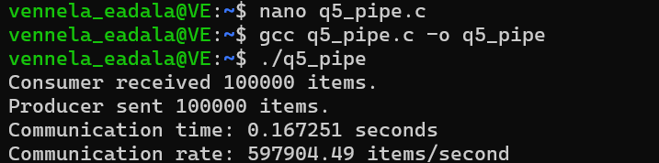

Part 2:
CODE:
#include <stdio.h>
#include <stdlib.h>
#include <unistd.h>
#include <sys/wait.h>
int main()
{
int pipefd[2];
pid_t pid1, pid2;
if (pipe(pipefd) == -1)
{
perror("pipe failed");
return 1;
}
pid1 = fork();
if (pid1 < 0)
{
perror("fork failed");
return 1;
}
if (pid1 == 0)
{
/* First child: ls -l */
close(pipefd[0]);
dup2(pipefd[1], STDOUT_FILENO);
close(pipefd[1]);
execlp("ls", "ls", "-l", NULL);
perror("exec ls failed");
exit(1);
}
pid2 = fork();
if (pid2 < 0)
{
perror("fork failed");
return 1;
}
if (pid2 == 0)
{
/* Second child: grep .c */
close(pipefd[1]);
dup2(pipefd[0], STDIN_FILENO);
close(pipefd[0]);
execlp("grep", "grep", ".c", NULL);
perror("exec grep failed");
exit(1);
}
close(pipefd[0]);
close(pipefd[1]);
waitpid(pid1, NULL, 0);
waitpid(pid2, NULL, 0);
printf("Pipeline execution completed.\n");
return 0;
}

OUTPUT:
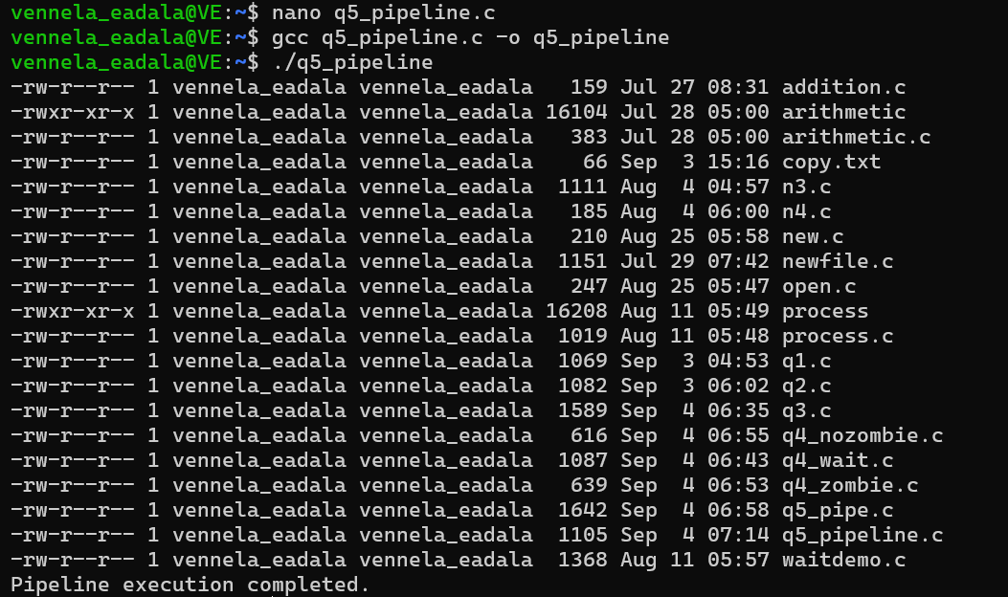

Q.6
Part a
CODE:
#include <stdio.h>
#include <stdlib.h>
#include <string.h>
#include <unistd.h>
#include <fcntl.h>
#include <sys/stat.h>
#define SERVER_FIFO "/tmp/server_fifo"
#define MAX_MSG 256
struct request
{
int client_pid;
char message[MAX_MSG];
};
int main()
{
int server_fd;
struct request req;
char response[300];
char client_fifo[100];
mkfifo(SERVER_FIFO, 0666);
printf("Server started.\n");
printf("Waiting for client messages...\n");
while (1)
{
server_fd = open(SERVER_FIFO, O_RDONLY);
if (server_fd < 0)
{
perror("open");
exit(1);
}
while (read(server_fd, &req, sizeof(req)) > 0)
{
printf("\nReceived from Client PID %d: %s\n",
req.client_pid, req.message);
snprintf(response, sizeof(response),
"Server processed your message: %s",
req.message);
snprintf(client_fifo, sizeof(client_fifo),
"/tmp/client_%d_fifo", req.client_pid);
int client_fd = open(client_fifo, O_WRONLY);
if (client_fd >= 0)
{
write(client_fd, response, strlen(response) + 1);
close(client_fd);
}
printf("Response sent to Client PID %d.\n",
req.client_pid);
}
close(server_fd);
}
unlink(SERVER_FIFO);
return 0;
}

CLIENT CODE:
#include <stdio.h>
#include <stdlib.h>
#include <string.h>
#include <unistd.h>
#include <fcntl.h>
#include <sys/stat.h>
#define SERVER_FIFO "/tmp/server_fifo"
#define MAX_MSG 256

struct request
{
int client_pid;
char message[MAX_MSG];
};
int main()
{
int server_fd;
int client_fd;
pid_t pid;
struct request req;
char client_fifo[100];
char response[300];
pid = getpid();
snprintf(client_fifo, sizeof(client_fifo),
"/tmp/client_%d_fifo", pid);
mkfifo(client_fifo, 0666);
printf("Client PID: %d\n", pid);
printf("Enter message: ");
fgets(req.message, MAX_MSG, stdin);
req.message[strcspn(req.message, "\n")] = '\0';

req.client_pid = pid;
server_fd = open(SERVER_FIFO, O_WRONLY);
if (server_fd < 0)
{
perror("Unable to connect to server");
unlink(client_fifo);
return 1;
}
write(server_fd, &req, sizeof(req));
close(server_fd);
client_fd = open(client_fifo, O_RDONLY);
if (client_fd < 0)
{
perror("Unable to open client FIFO");
unlink(client_fifo);
return 1;
}
read(client_fd, response, sizeof(response));
printf("Server response: %s\n", response);
close(client_fd);
unlink(client_fifo);
return 0;
}
OUTPUT:
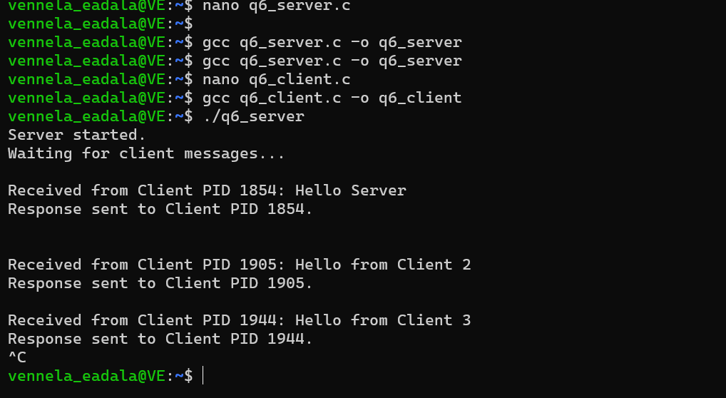

Part b
CODE:
#include <stdio.h>
#include <stdlib.h>
#include <unistd.h>
#include <signal.h>
volatile sig_atomic_t sigint_received = 0;
volatile sig_atomic_t sigterm_received = 0;
volatile sig_atomic_t sigusr1_received = 0;
void handle_sigint(int sig)
{
sigint_received = 1;
}
void handle_sigterm(int sig)
{
sigterm_received = 1;
}
void handle_sigusr1(int sig)
{
sigusr1_received = 1;
}
int main()
{
struct sigaction sa_int;
struct sigaction sa_term;
struct sigaction sa_usr1;
sa_int.sa_handler = handle_sigint;
sigemptyset(&sa_int.sa_mask);
sa_int.sa_flags = 0;
sigaction(SIGINT, &sa_int, NULL);
sa_term.sa_handler = handle_sigterm;
sigemptyset(&sa_term.sa_mask);
sa_term.sa_flags = 0;
sigaction(SIGTERM, &sa_term, NULL);
sa_usr1.sa_handler = handle_sigusr1;
sigemptyset(&sa_usr1.sa_mask);
sa_usr1.sa_flags = 0;
sigaction(SIGUSR1, &sa_usr1, NULL);
printf("Signal handling program started.\n");
printf("PID: %d\n", getpid());
printf("Waiting for signals...\n");
while (1)
{
pause();
if (sigusr1_received)
{
printf("SIGUSR1 received: User-defined event handled.\n");
sigusr1_received = 0;
}
if (sigint_received)
{
printf("SIGINT received: Interrupt event handled.\n");
sigint_received = 0;
}
if (sigterm_received)
{
printf("SIGTERM received: Termination event handled.\n");
break;
}
}
printf("Program terminating safely.\n");
return 0;
}

OUTPUT:
