**DATA STRUCTURES AND ALGORITHMS**

**Question 3**

**Exercise 2: E-commerce Platform Search Function**

**Scenario:**

You are working on the search functionality of an e-commerce platform. The search needs to be optimized for fast performance.

**Steps:**

* **Understand Asymptotic Notation:**
  + Explain Big O notation and how it helps in analyzing algorithms.
  + Describe the best, average, and worst-case scenarios for search operations.
* **Setup:**
  + Create a class **Product** with attributes for searching, such as **productId, productName**, and **category**.
* **Implementation:**
  + Implement linear search and binary search algorithms.
  + Store products in an array for linear search and a sorted array for binary search.
* **Analysis:**
  + Compare the time complexity of linear and binary search algorithms.
  + Discuss which algorithm is more suitable for your platform and why.

**ANSWER:**

**Understanding Asymptotic Notation:**

Asymptotic notation specifically Big O notation is a mathematical way to describe how the performance of an algorithm scales as the size of the input grows. It helps us analyze algorithms independently of hardware or implementation details by giving us a general idea of how fast or slow an algorithm will be. Big O notation focuses on the upper bound of time or space complexity with how bad things can get as the input size increases. This is crucial for comparing algorithms and choosing the most efficient one for a particular scenario especially in systems like e-commerce platforms where quick searches and responses are vital. Alongside Big O, we also consider best, average, and worst-case scenarios to fully understand the behavior of a search algorithm under different conditions.

|  |  |  |  |  |
| --- | --- | --- | --- | --- |
| | Case Type | | --- | | Description | Linear Search Time | Binary Search Time |
| Best Case | The target element is found at the first (or optimal) location. | O(1) | O(1) |
| Average Case | The target is somewhere in the middle of the data structure. | O(n/2) → O(n) | O(log n) |
| Worst Case | The target is not present, or it's at the very end of the structure. | O(n) | O(log n) |

**Setup and Implementation:**

**Product.java**

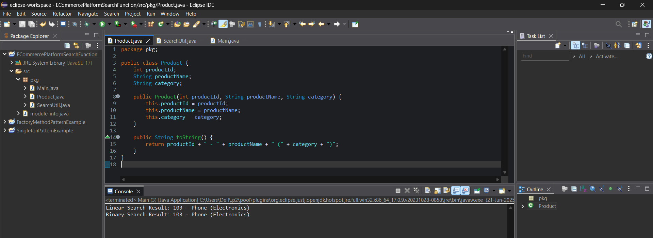

**SearchUtil.java**

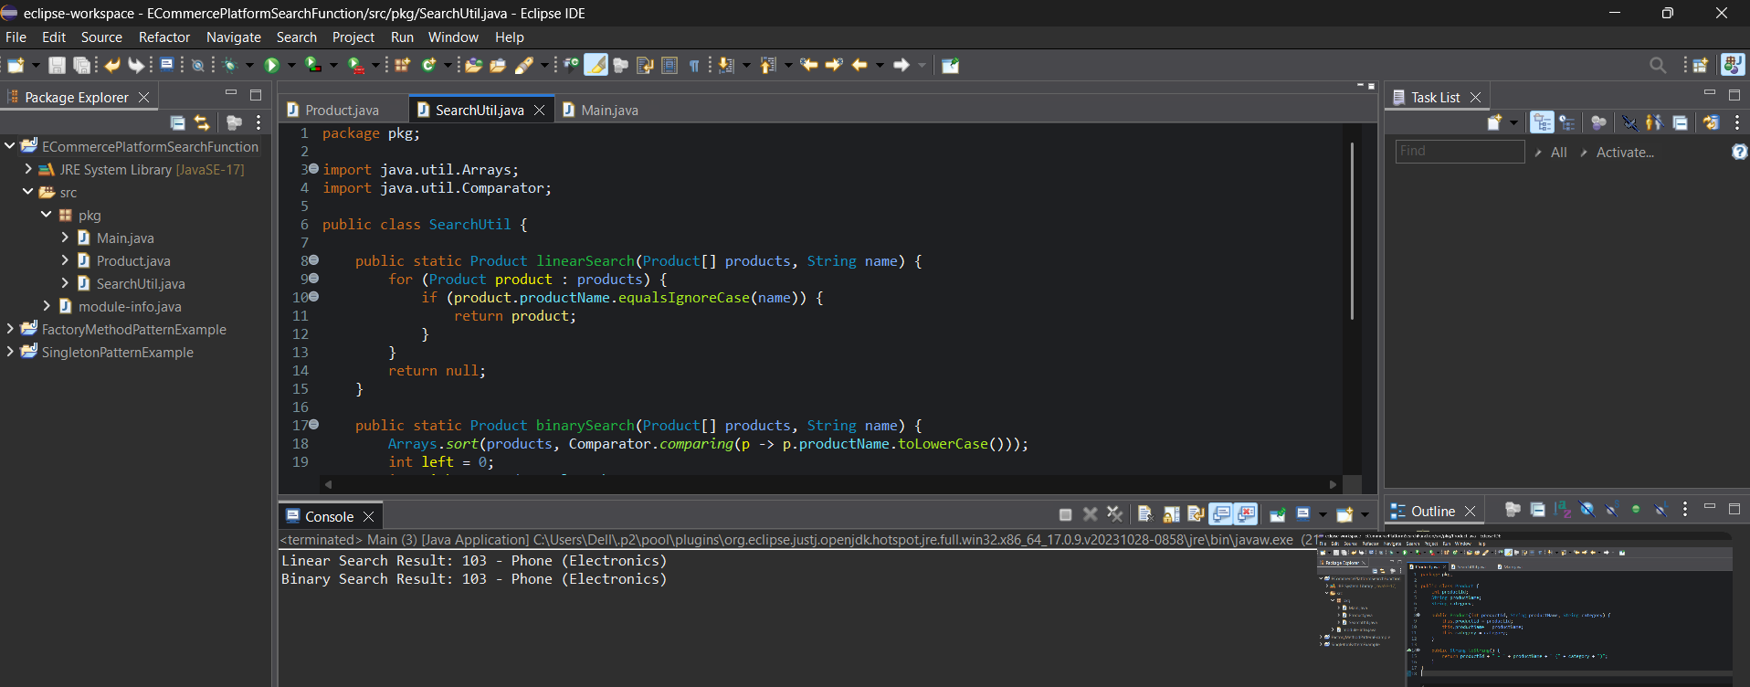

**Main.java**

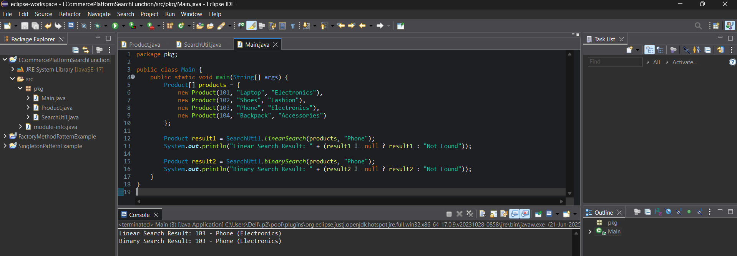

**OUTPUT:**



**Analysis:**

When comparing linear search and binary search, the primary difference lies in their time complexity and performance with varying data sizes. Linear search has a time complexity of O(n) in the worst and average cases, which means that as the number of products increases, the time it takes to search through them increases linearly. In contrast, binary search has a time complexity of O(log n), making it significantly faster for large datasets. This is because binary search eliminates half of the remaining elements with each comparison, whereas linear search checks each element one by one.

Another key difference is that binary search requires the data to be sorted, while linear search does not. This means that before performing a binary search, some sorting is needed if the data isn't already sorted, which can add overhead initially. However, in an e-commerce platform, product data such as names or IDs is often stored in sorted form for better organization and faster querying.

For an e-commerce platform, binary search is generally more suitable. The platform needs to handle large volumes of products and serve fast, efficient search results to users. Binary search offers much better scalability and performance under these conditions. Linear search might still be useful in limited cases, such as searching through a small user's cart or a temporary list that isn't sorted. But for core search functionality across the product catalog, binary search is the better choice due to its speed and efficiency, especially when combined with sorted data structures like arrays or binary search trees.

**Question 4**

**Exercise 7: Financial Forecasting**

**Scenario:** You are developing a financial forecasting tool that predicts future values based on past data. **Steps:**

* **Understand Recursive Algorithms:**
  + Explain the concept of recursion and how it can simplify certain problems.
* **Setup:**
  + Create a method to calculate the future value using a recursive approach.
* **Implementation:**
  + Implement a recursive algorithm to predict future values based on past growth rates.
* **Analysis:**
  + Discuss the time complexity of your recursive algorithm.
  + Explain how to optimize the recursive solution to avoid excessive computation.

**Answer:**

**Understanding Recursive Algorithms:**

Recursion is a programming technique where a function calls itself to solve a smaller instance of the same problem. It simplifies complex problems by breaking them down into base cases and recursive steps. Recursive algorithms are especially useful in problems that have a naturally repetitive or nested structure, such as mathematical sequences, tree traversals, or compound interest calculations. However, recursion must be carefully designed to avoid infinite loops or redundant calculations.

In the context of financial forecasting, recursion can be used to predict the future value of an investment based on a series of growth rates, allowing each year's value to build on the previous one.

**Setup and Implementation:**

**Implementation.java**

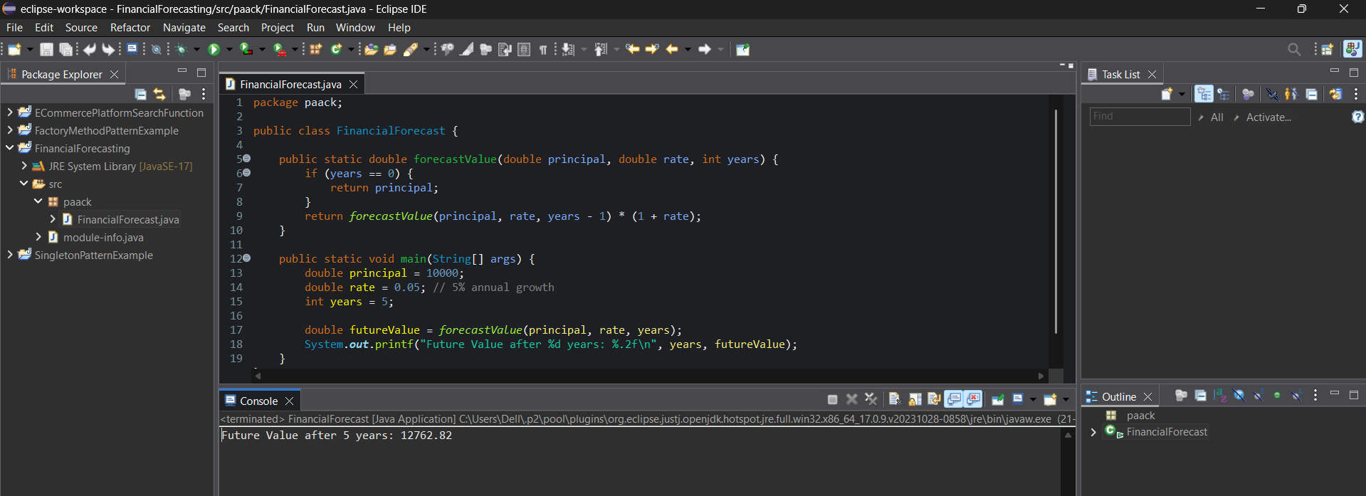

**OUTPUT:**

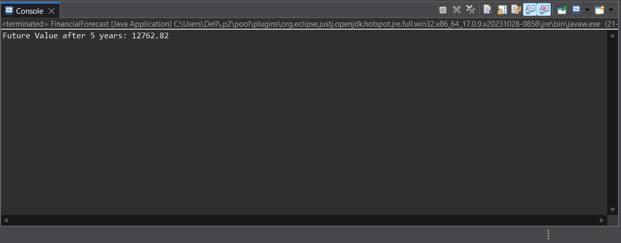

**Analysis:**

The time complexity of this recursive algorithm is O(n), where n is the number of years. This is because the method makes one recursive call per year until it reaches the base case (years == 0). While this is manageable for small values, it can become inefficient if the number of years is very large.

To optimize the solution, we can use memoization to store previously computed values or, more appropriately in this case, switch to an iterative approach, which avoids the overhead of recursive calls and stack usage. Here’s a quick iterative alternative:

|  |
| --- |
| public static double forecastValueIterative(double principal, double rate, int years) {  for (int i = 0; i < years; i++) {  principal *= (1 + rate);  }  return principal;  } |

This version has the same O(n) time complexity but is more efficient in terms of space (O(1) vs. recursive call stack space of O(n)).