**REACTJS-HOL**

**MANDATORY HANDS-ON QUESTIONS**

**Question 1**

## **Objectives**

* Define SPA and its benefits
* Define React and identify its working
* Identify the differences between SPA and MPA
* Explain Pros & Cons of Single-Page Application
* Explain about React
* Define virtual DOM
* Explain Features of React

In this hands-on lab, you will learn how to:

* Set up a react environment
* Use create-react-app

## **Prerequisites**

The following is required to complete this hands-on lab:

* Node.js
* NPM
* Visual Studio Code

## **Notes**

Estimated time to complete this lab: **30 minutes.**

Create a new React Application with the name “myfirstreact”, Run the application to print “welcome to the first session of React” as heading of that page.

1. To create a new React app, Install Nodejs and Npm from the following link:

<https://nodejs.org/en/download/>

1. Install Create-react-app by running the following command in the command prompt:



1. To create a React Application with the name of “myfirstreact”, type the following command:



1. Once the App is created, navigate into the folder of myfirstreact by typing the following command:



1. Open the folder of myfirstreact in Visual Studio Code
2. Open the App.js file in Src Folder of myfirstreact
3. Remove the current content of “App.js”
4. Replace it with the following:

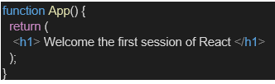

1. Run the following command to execute the React application:



1. Open a new browser window and type “localhost:3000” in the address bar

Answer and Output:

Definations:

1. Define SPA and its Benefits

SPA (Single-Page Application): A web application that loads a single HTML page and dynamically updates the content without reloading the entire page.

Benefits:

* Faster user interactions.
* Better performance and user experience.
* Smooth navigation.
* Efficient use of bandwidth.

2. Define React and Identify Its Working

React: A JavaScript library for building user interfaces, developed by Facebook.

How It Works:

* Uses a component-based architecture.
* Implements a virtual DOM for efficient UI updates.
* Handles user interactions and state changes effectively.

3. Differences between SPA and MPA

|  |  |  |
| --- | --- | --- |
| Feature | SPA | MPA |
| Page Load | Loads one page | Loads multiple pages |
| Navigation | Client-side routing | Server-side routing |
| Speed | Faster | Slower due to reloads |
| Complexity | More complex JavaScript | Easier to manage |

1. Pros & Cons of SPA

Pros:

* Fast and responsive.
* Better user experience.
* Less server load.

Cons:

* Poor SEO by default.
* Initial load can be slow.
* Can be complex to build.

5. Explain About React

React is a declarative, component-based library used to build interactive UIs. It simplifies the development process by breaking the UI into reusable pieces called components.

6. Define Virtual DOM

The virtual DOM is an in-memory representation of the real DOM elements.

React uses it to:

* Detect changes efficiently.
* Update only the parts of the DOM that changed.
* Improve performance.

7. Explain Features of React

* JSX - JavaScript + HTML like syntax.
* Reusable pieces of UI.
* Virtual DOM.
* Unidirectional Data Flow.
* Functional components with state and lifecycle.

CODE:

Creating a new React Application with the name “myfirstreact” and Running the application.

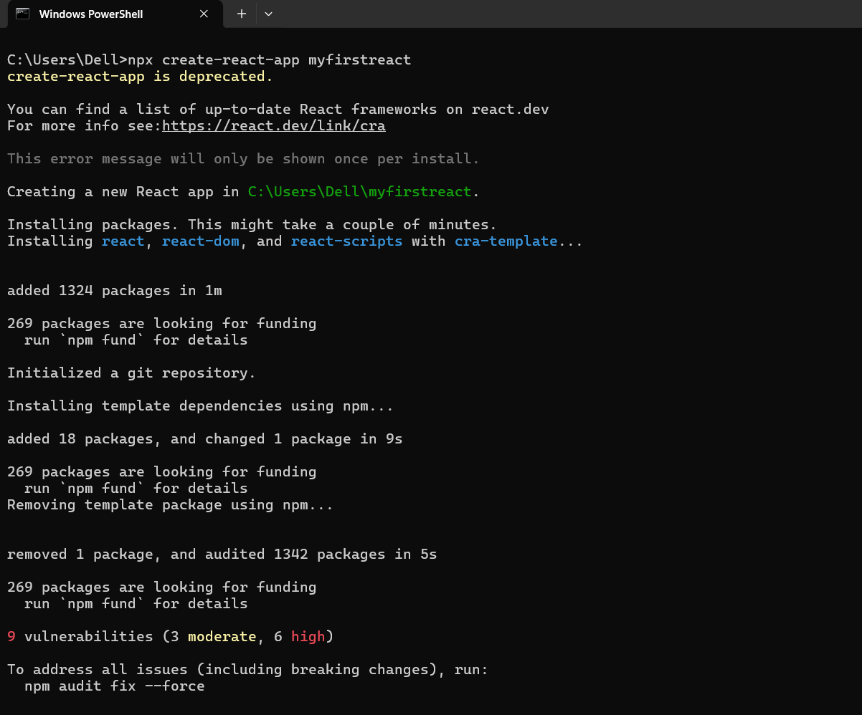

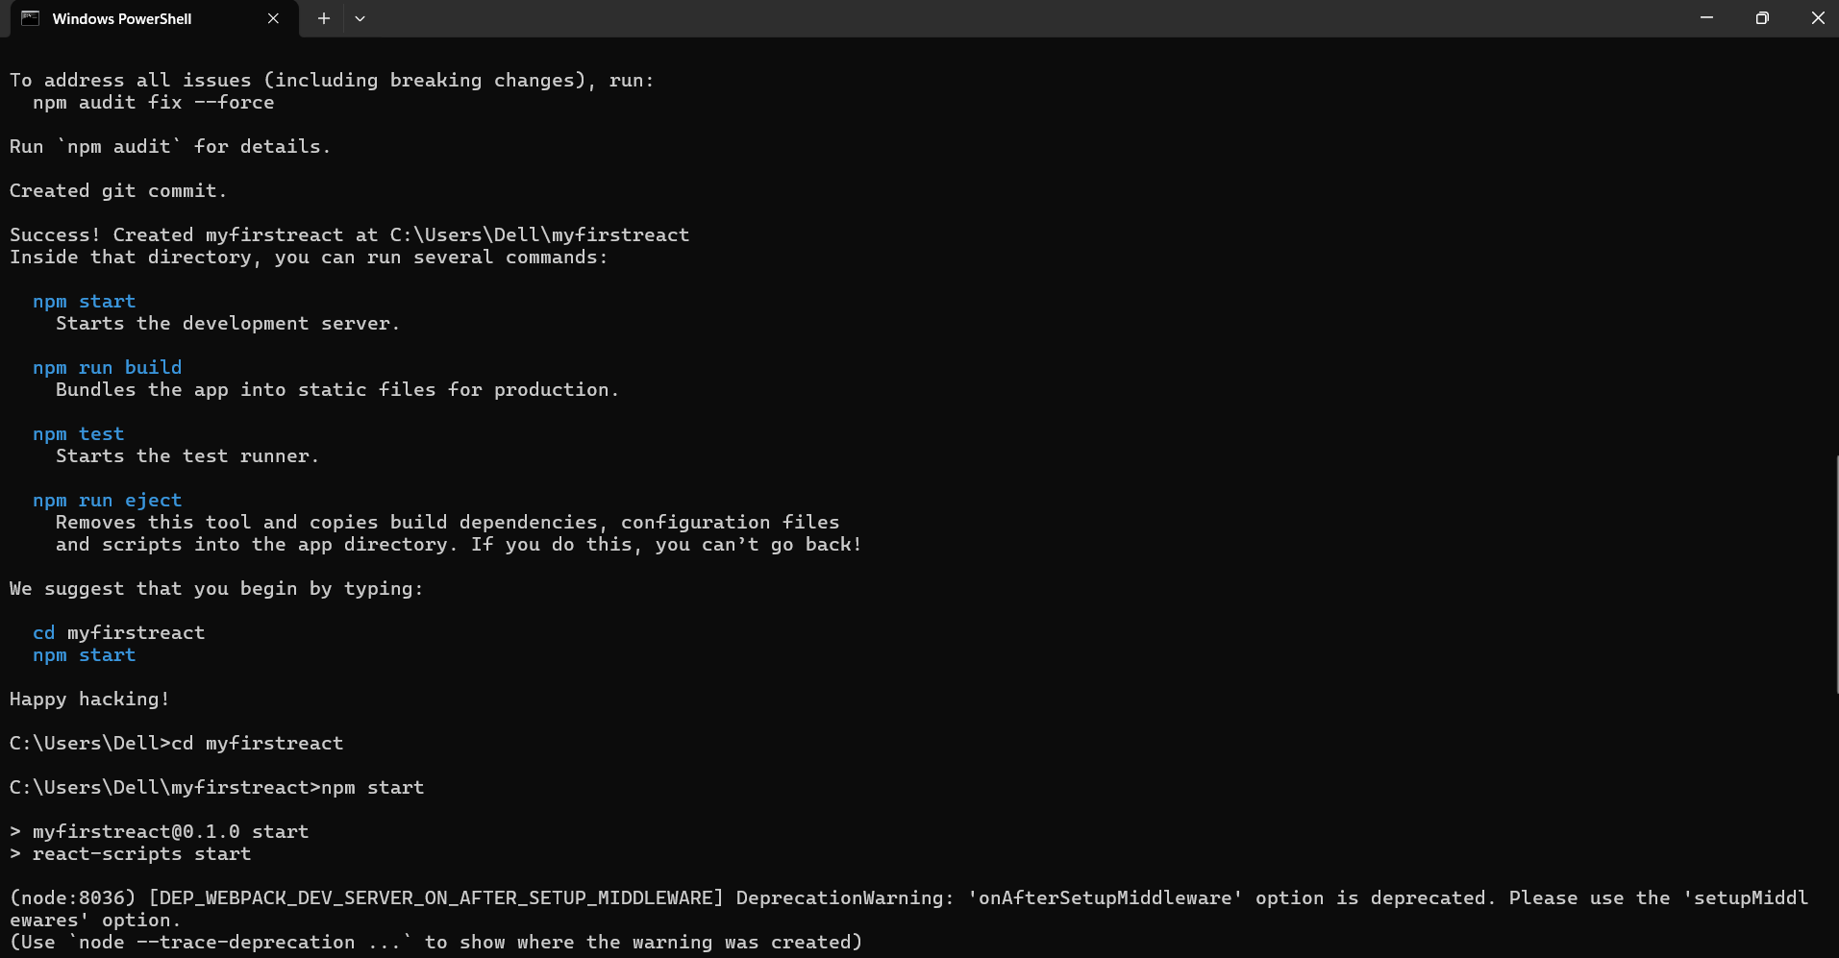

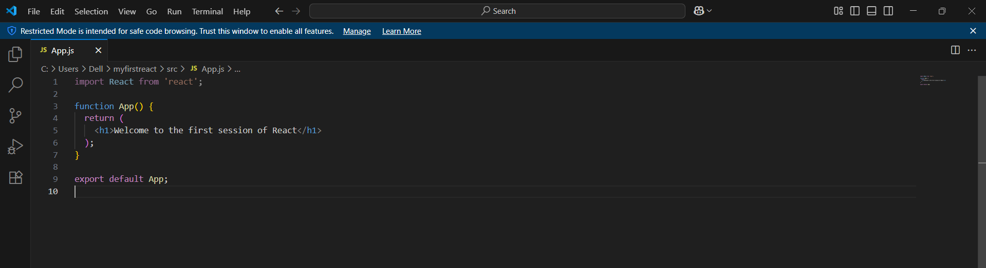

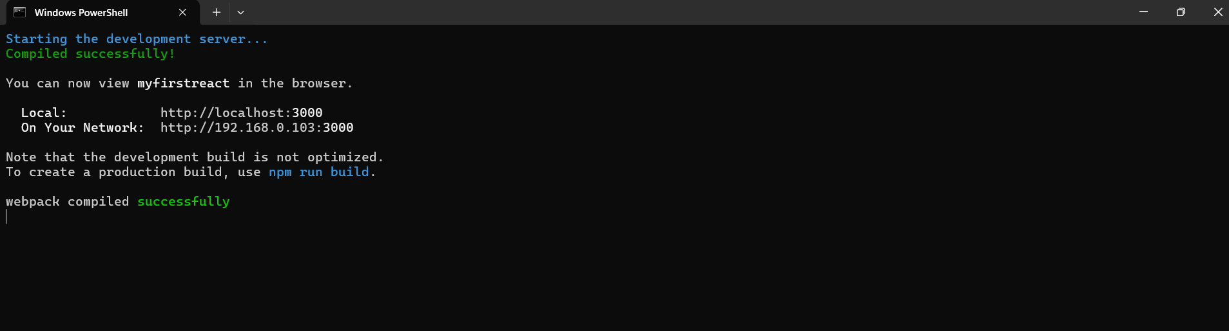

OUTPUT:

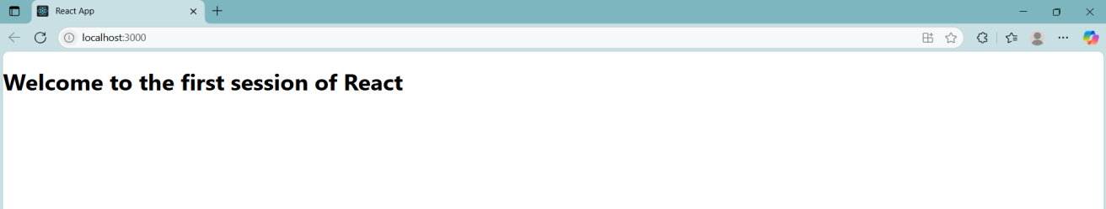

**Question 2**

Objectives

•Explain React components

•Identify the differences between components and JavaScript functions

•Identify the types of components

•Explain class component

•Explain function component

•Define component constructor

•Define render() function

In this hands-on lab, you will learn how to:

•Create a class component

•Create multiple components

•Render a component

Prerequisites

The following is required to complete this hands-on lab:

•Node.js

•NPM

•Visual Studio Code

Notes

Estimated time to complete this lab: 30 minutes.

Create a react app for Student Management Portal named StudentApp and create a component named Home which will display the Message “Welcome to the Home page of Student Management Portal”. Create another component named About and display the Message “Welcome to the About page of the Student Management Portal”. Create a third component named Contact and display the Message “Welcome to the Contact page of the Student Management Portal”. Call all the three components.

Answer and Output:

Definations:

1. React components are like small building blocks of a webpage. Think of them as individual LEGO pieces you can put together to build a website. Each component represents a part of the user interface like a header, a button, or a section on the page.
2. While both components and JavaScript functions can take inputs and return outputs, React components are special. They return JSX, which is a syntax that looks like HTML and is used to describe what the UI should look like. Normal JavaScript functions return data or perform calculations, but React components return visual elements.
3. There are two main types of React components:

Class Components – These use ES6 classes and include more features like lifecycle methods.

Function Components – These are simpler and are often used with React Hooks for managing state or effects.

1. A class component is a JavaScript class that extends React.Component. It must include a render() method that returns JSX. This was the original way of creating components in React.

Example:

|  |
| --- |
| import React, { Component } from 'react';  class Home extends Component {  render() {  return <h1>Welcome to the Home page of Student Management Portal</h1>;  }  }  export default Home; |

1. Function components are JavaScript functions that return JSX. They are now the most common way to write components because they are shorter and easier to use with React Hooks.

Example:

|  |
| --- |
| import React from 'react';  function Home() {  return <h1>Welcome to the Home page of Student Management Portal</h1>;  }  export default Home; |

1. A constructor is a special function in class components that is used to initialize state or bind methods. It’s the first function called when the component is created.
2. The render() function is required in class components. It tells React what the component should display on the screen. It must return JSX.

CODE:

Creating a react app for Student Management Portal.

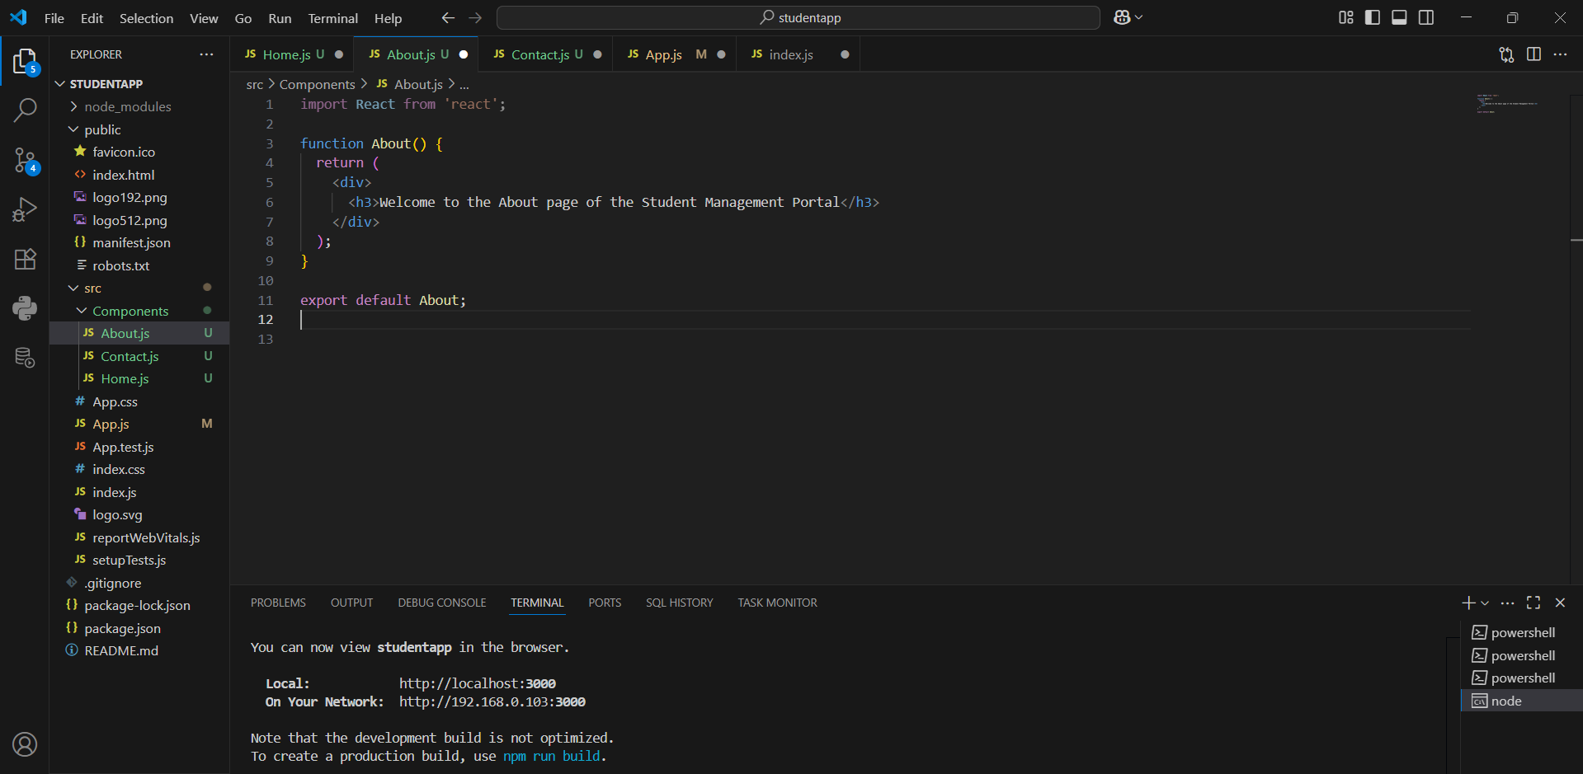

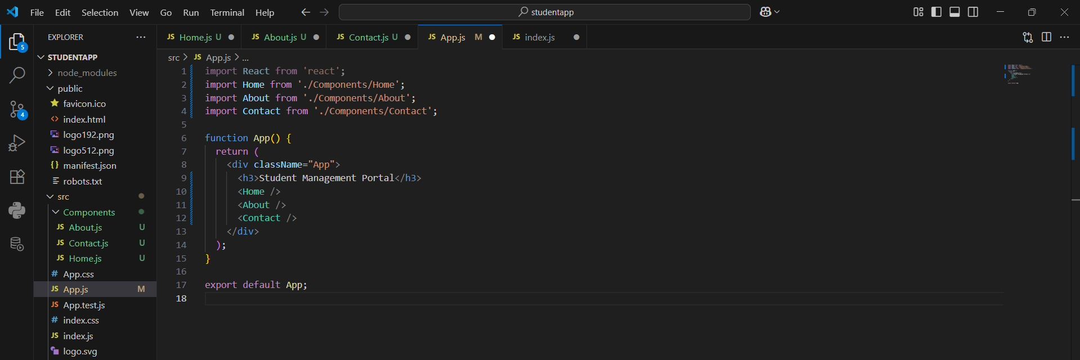

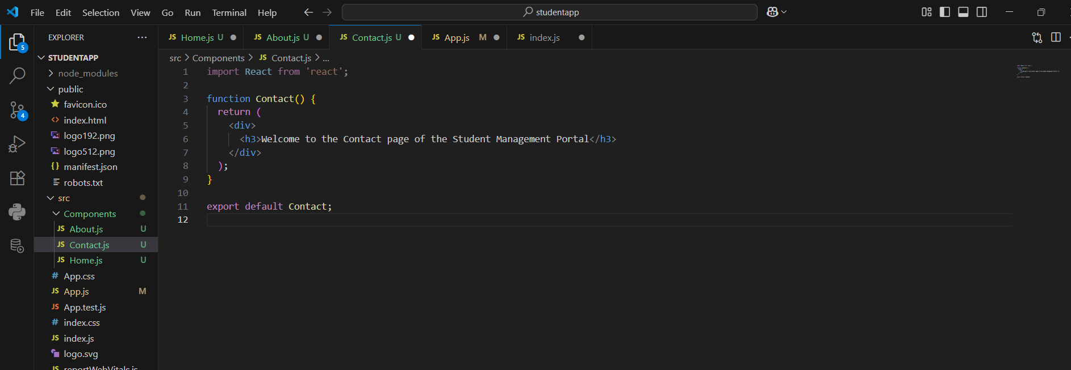

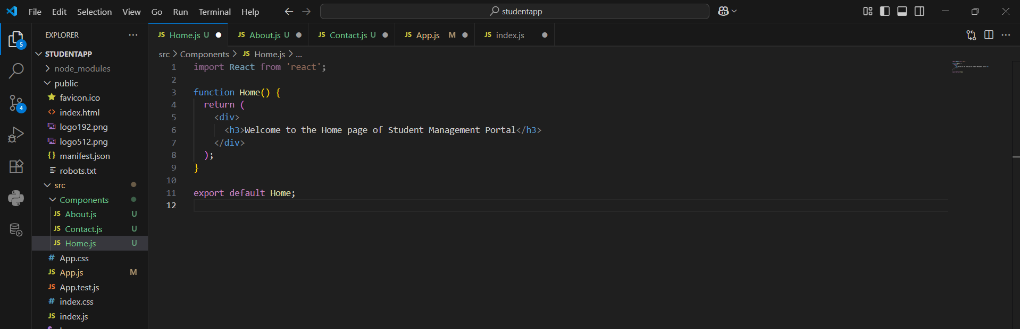

OUTPUT:

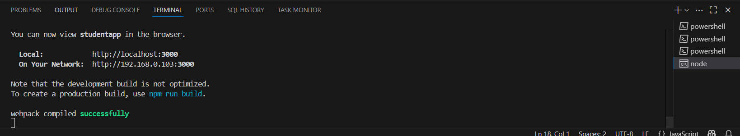

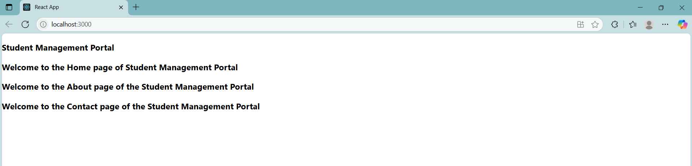

**Question 3**

Objectives

•Explain React components

•Identify the differences between components and JavaScript functions

•Identify the types of components

•Explain class component

•Explain function component

•Define component constructor

•Define render() function

In this hands-on lab, you will learn how to:

•Create a function component

•Apply style to components

•Render a component

Prerequisites

The following is required to complete this hands-on lab:

•Node.js

•NPM

•Visual Studio Code

Notes

Estimated time to complete this lab: 30 minutes.

Create a react app for Student Management Portal named scorecalculatorapp and create a function component named “CalculateScore” which will accept Name, School, Total and goal in order to calculate the average score of a student and display the same.

1.Create a React project named “scorecalculatorapp” type the following command in terminal of Visual studio:

2.Create a new folder under Src folder with the name “Components”. Add a new file named “CalculateScore.js”

3.Type the following code in CalculateScore.js

Answer and Output:

Definitions: All the answers were answered in Question 2.

CODE:

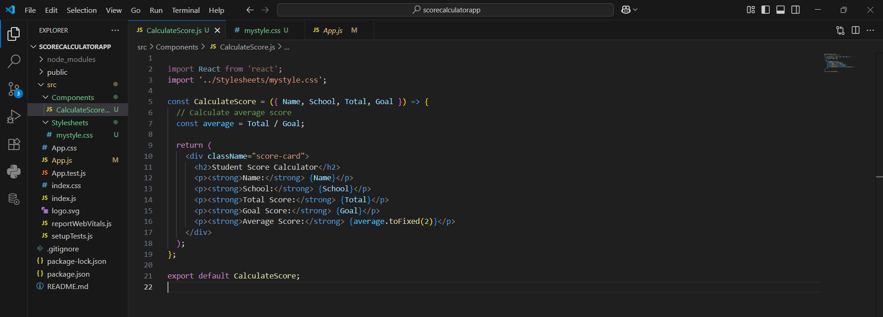

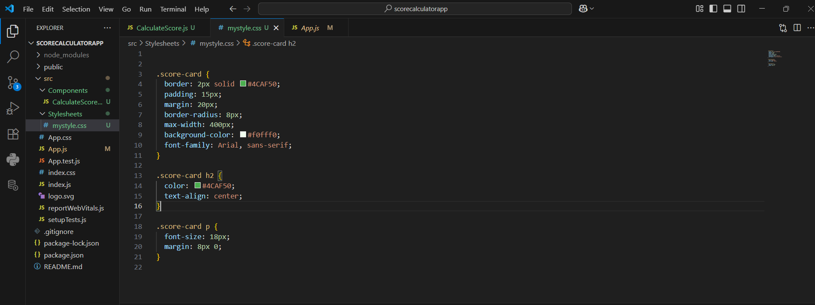

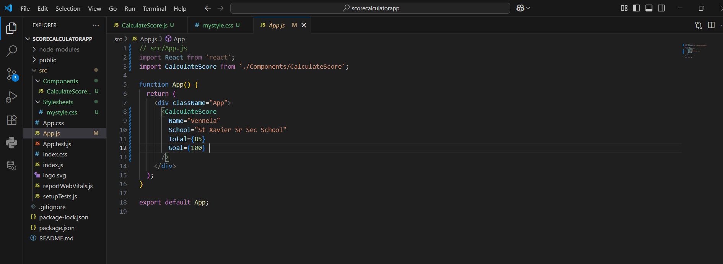

OUTPUT:

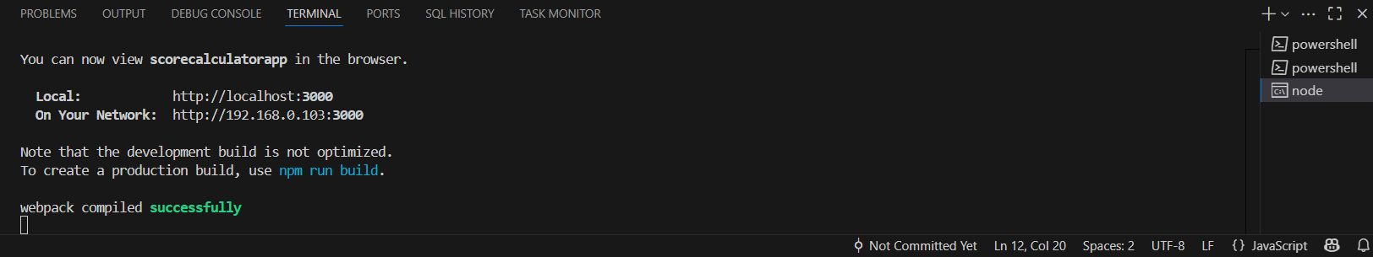

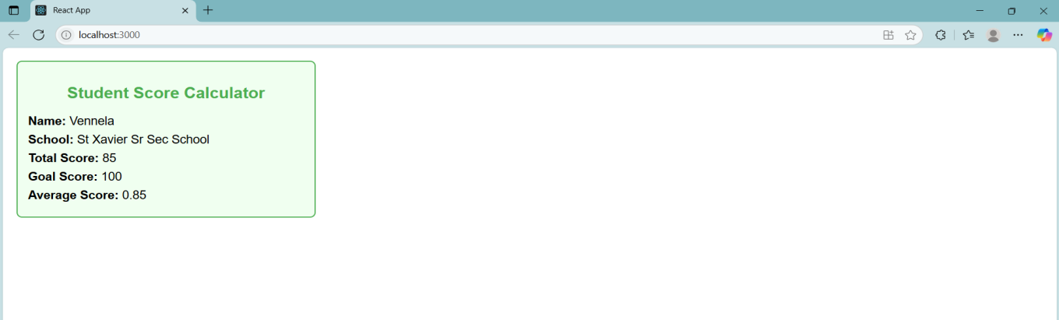

**Question 4**

Objectives

•Explain the need and Benefits of component life cycle

•Identify various life cycle hook methods

•List the sequence of steps in rendering a component

In this hands-on lab, you will learn how to:

•Implement componentDidMount() hook

•Implementing componentDidCatch() life cycle hook.

Prerequisites

The following is required to complete this hands-on lab:

•Node.js

•NPM

•Visual Studio Code

Notes

Estimated time to complete this lab: 60 minutes.

1.Create a new react application using create-react-app tool with the name as “blogapp”

2.Open the application using VS Code

3.Create a new file named as Post.js in src folder with following properties

Answer and Output:

Definitions:

1. Explain the need and Benefits of component life cycle.

When you create a React component, it consists of three stages:

Mounting - It appears on the screen.

Updating - It updates when needed.

Unmounting - It’s removed from the screen.

React gives us special methods called lifecycle hook to do something at each of these stages.

1. Identify various life cycle hook methods.

In React class components, lifecycle hook methods are special functions triggered at different stages of a component’s life. These include constructor(), componentDidMount(), shouldComponentUpdate(), componentDidUpdate(), componentWillUnmount(), and componentDidCatch(). They are grouped into phases: mounting (constructor, componentDidMount), updating (shouldComponentUpdate, componentDidUpdate), unmounting (componentWillUnmount), and error handling (componentDidCatch). These hooks help manage initialization, updates, cleanup, and error handling in a component.

1. List the sequence of steps in rendering a component.

When a React class component renders for the first time (mounting), the sequence of steps is: first, the constructor() is called to initialize state and bindings, then getDerivedStateFromProps() if defined, followed by the render() method which returns the JSX, and finally componentDidMount() runs after the component is added to the DOM. On updates, the sequence includes getDerivedStateFromProps(), shouldComponentUpdate(), render(), getSnapshotBeforeUpdate(), and finally componentDidUpdate(). This order ensures the component behaves predictably during its lifecycle.

CODE:

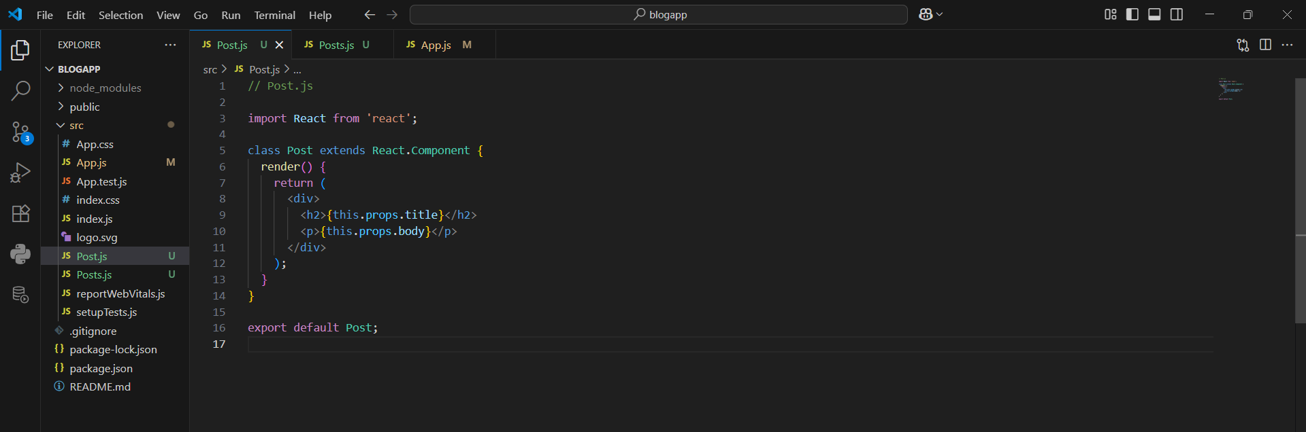

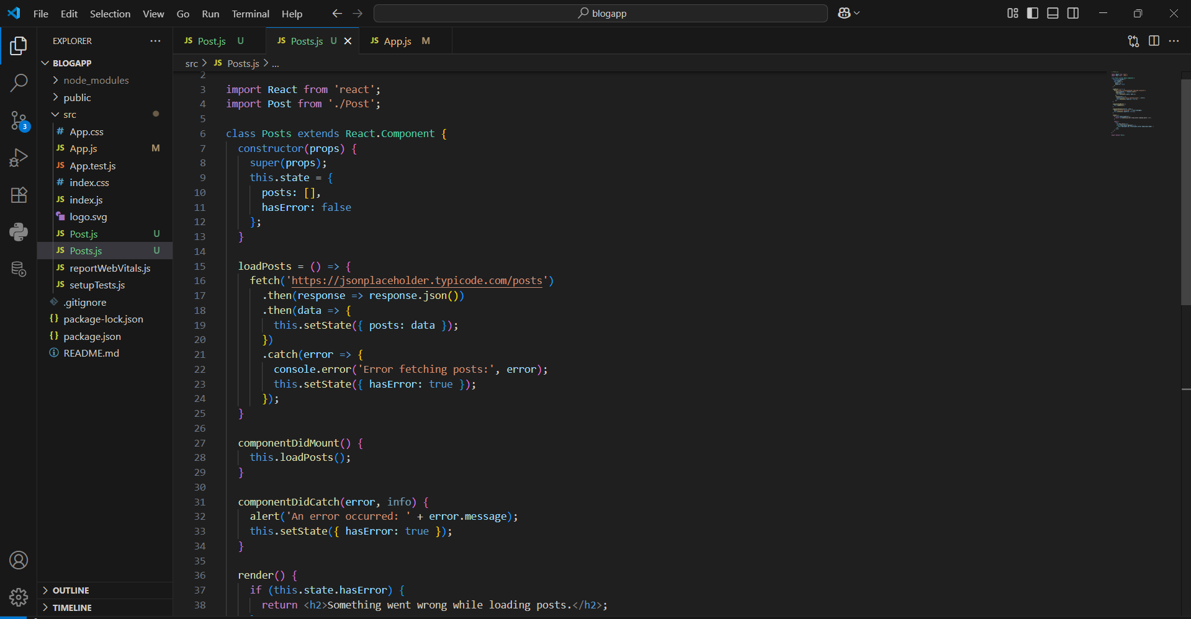

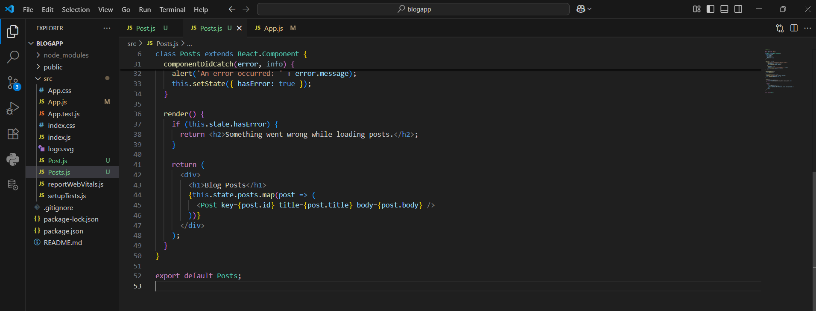

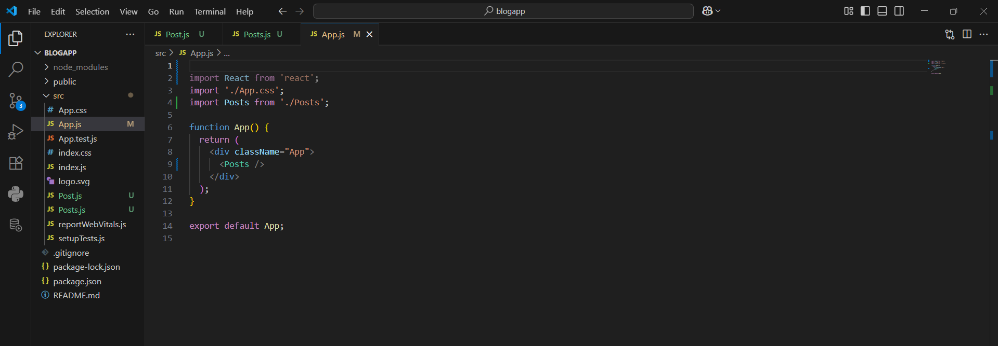

OUTPUT:

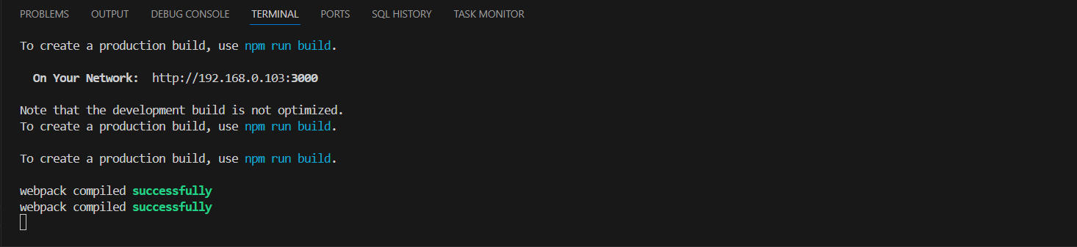

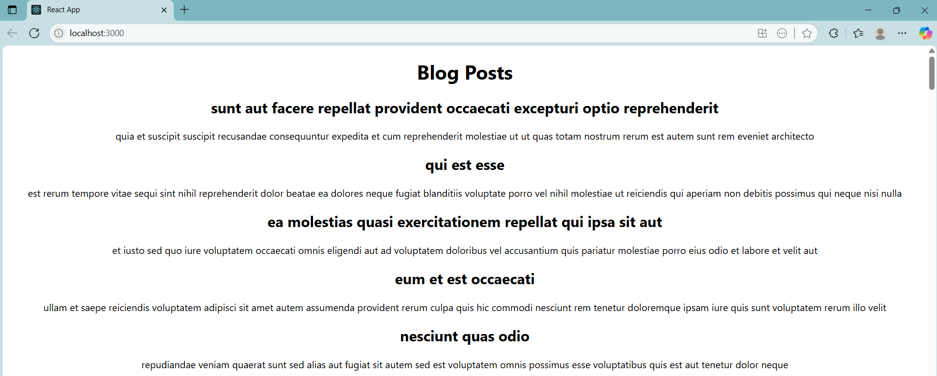

**Question 5**

Objectives

•Understanding the need for styling react component

•Working with CSS Module and inline styles

In this hands-on lab, you will learn how to:

•Style a react component

•Define styles using the CSS Module

•Apply styles to components using className and style properties

Prerequisites

The following is required to complete this hands-on lab:

•Node.js

•NPM

•Visual Studio Code

Notes

Estimated time to complete this lab: 30 minutes.

My Academy team at Cognizant want to create a dashboard containing the details of ongoing and completed cohorts. A react application is created which displays the detail of the cohorts using react component. You are assigned the task of styling these react components.

Answer and Output:

CODE:

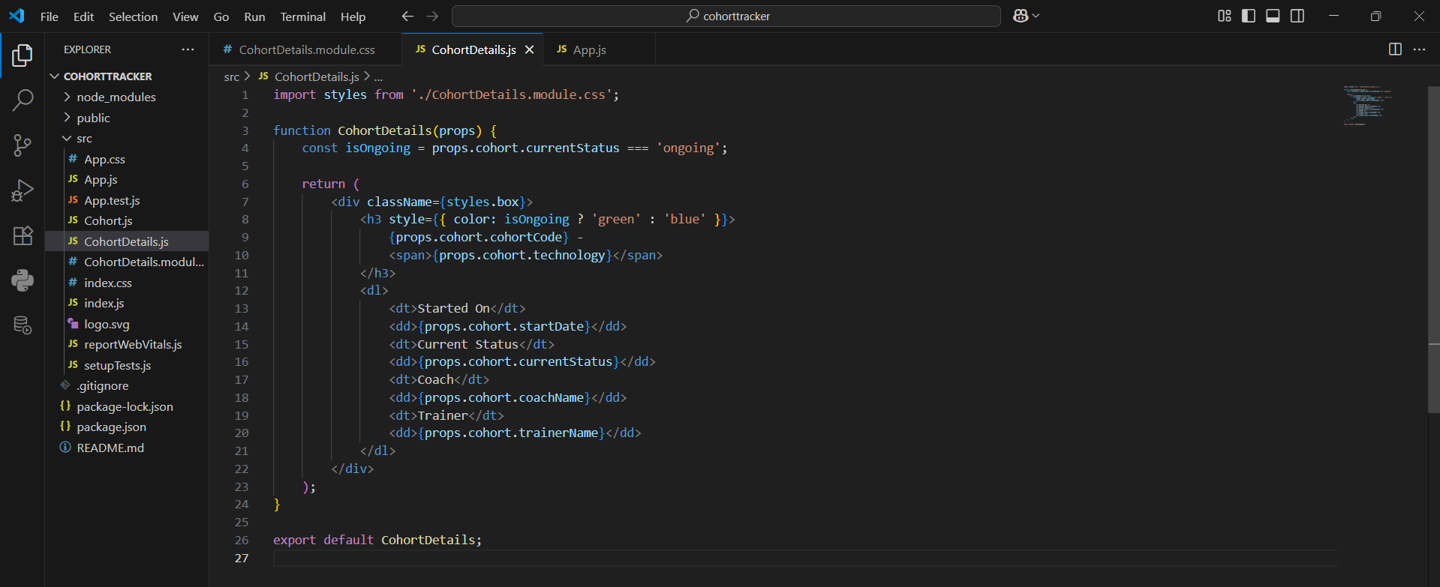

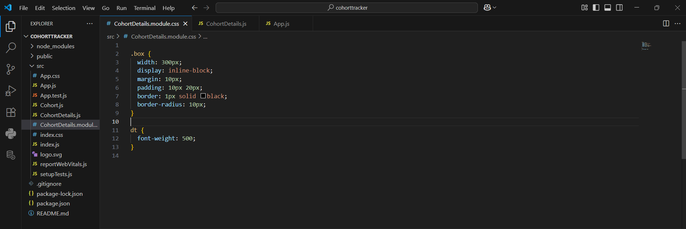

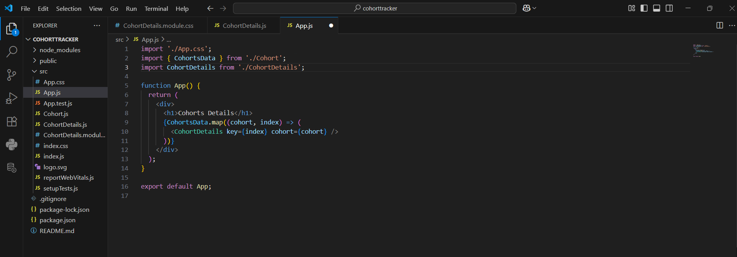

OUTPUT:

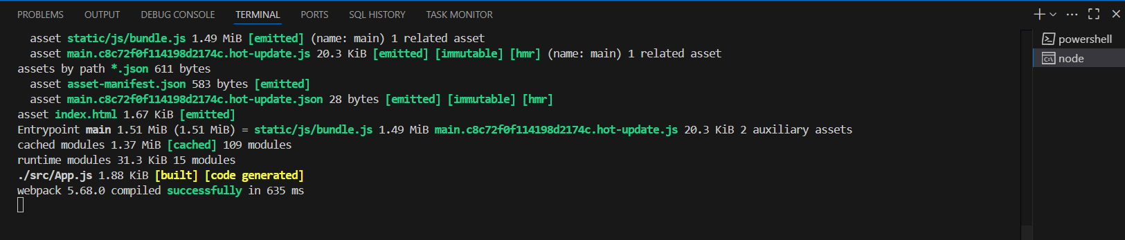

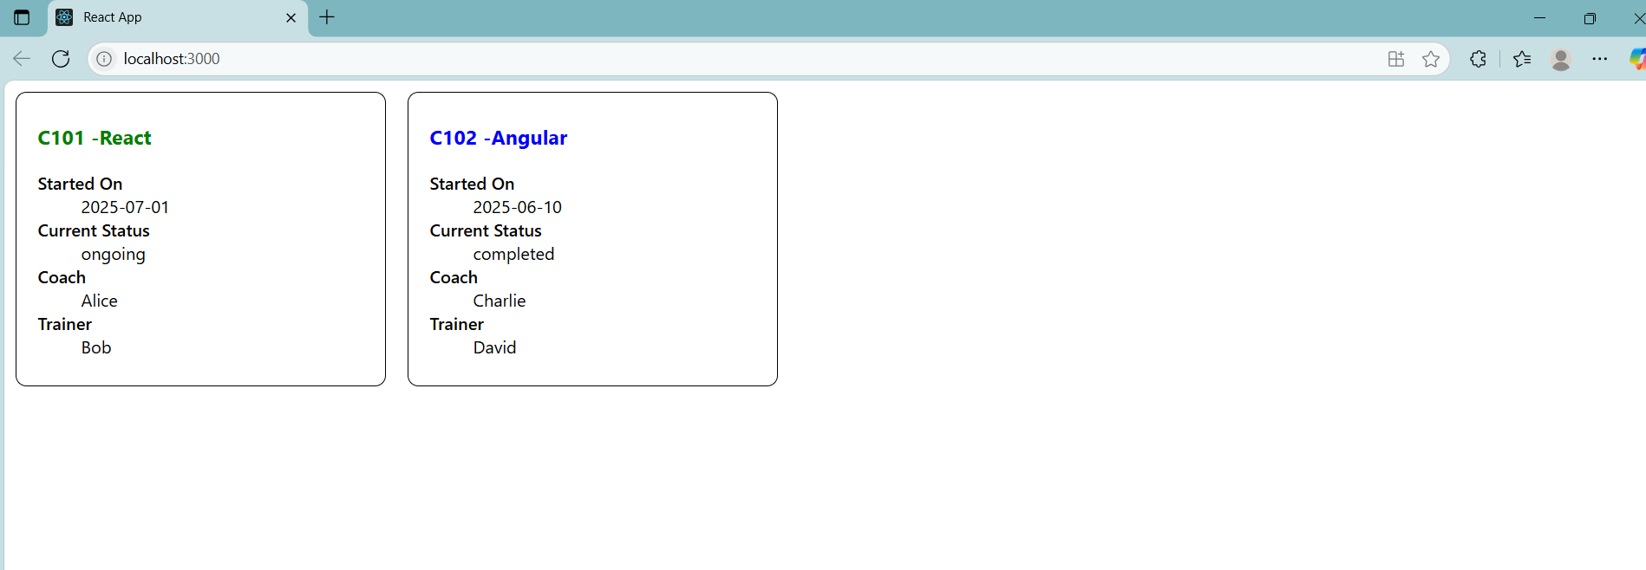

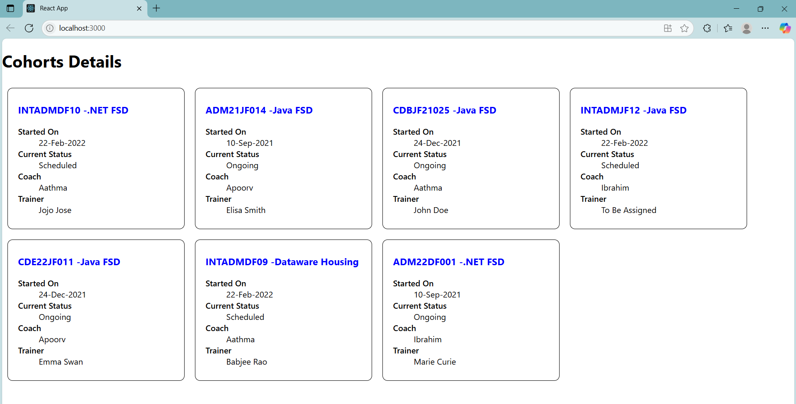

**ADDITIONAL HANDS-ON QUESTIONS**

**Question 6**

Objectives

•Explain the need and benefits of React Router

•Identify the Components in React Router

•List the types of Router Components

•Parameter passing via url

In this hands-on lab, you will learn how to:

•Implement a Simple Navigation Menu

•Add Basic Routes (install, configure)

•Use Routes in React Applications

Prerequisites

The following is required to complete this hands-on lab:

•Node.js

•NPM

•Visual Studio Code

Notes

Estimated time to complete this lab: 60 minutes.

Cognizant Academy teams want to maintain a list of trainers along with their expertise in a SPA using React as the technology. You are assigned the task of creating this React app.

The following trainers’ data application will deal.

1.T-ID

2.Name

3.Phone

4.Email

5.Stream

6.Skills

1.Create a new React app using create-react-app tool with the as “TrainersApp”

2.Open the application using the VS Code

3.Add a new file called trainer.js inside the src folder and define a class named as “Trainer” with the following properties

a.TrainerId

b.Name

c.Email

CODE:

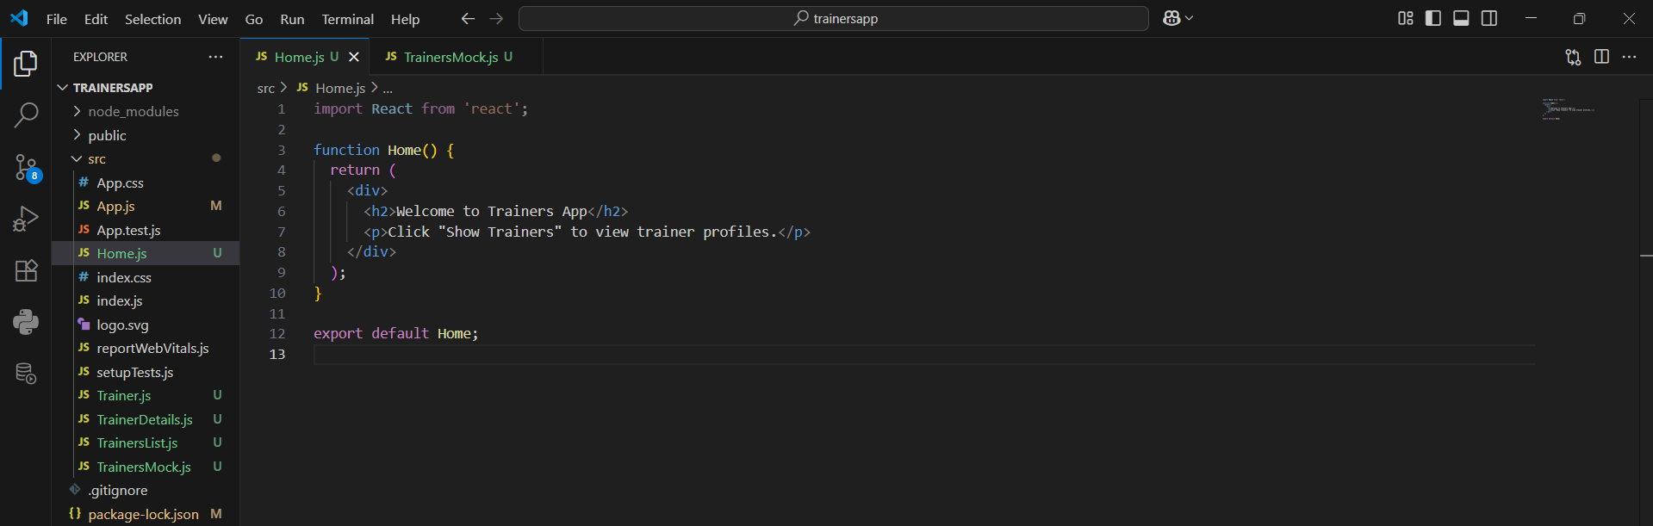

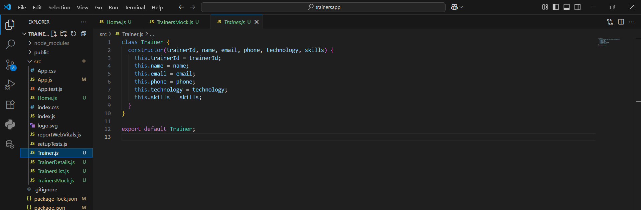

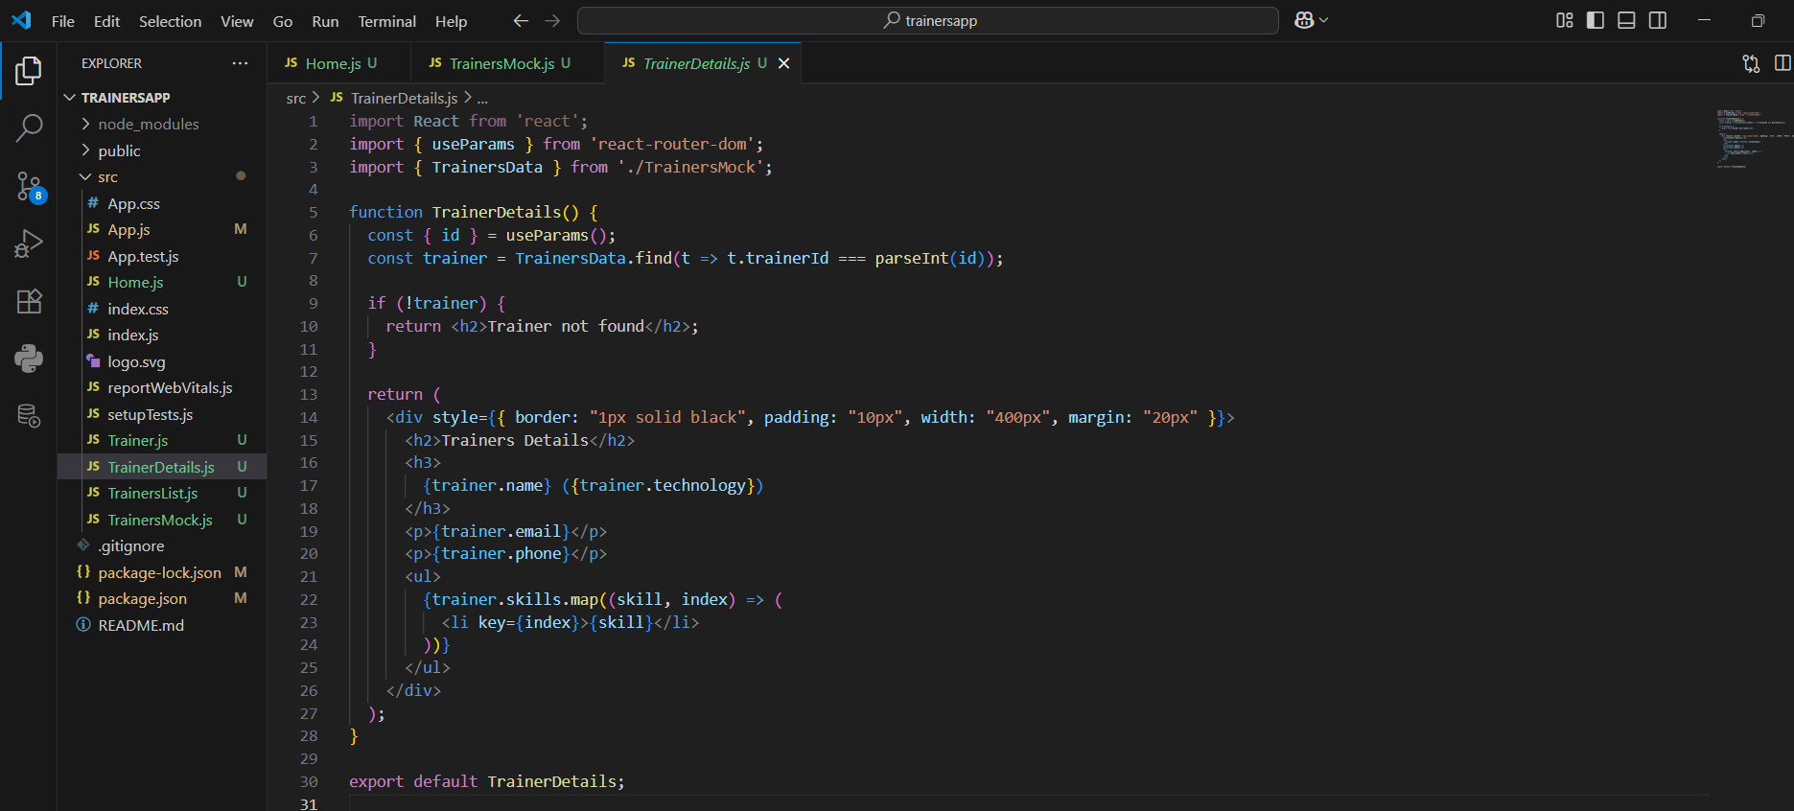

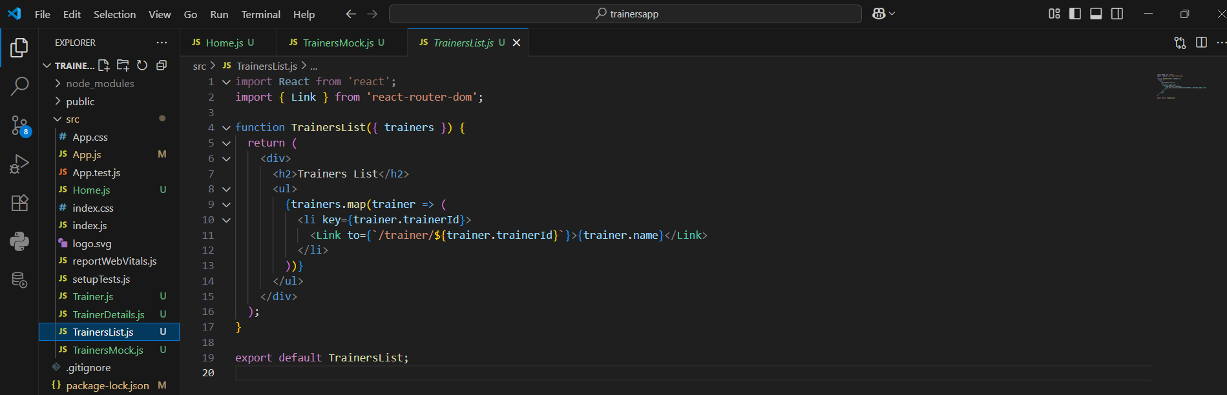

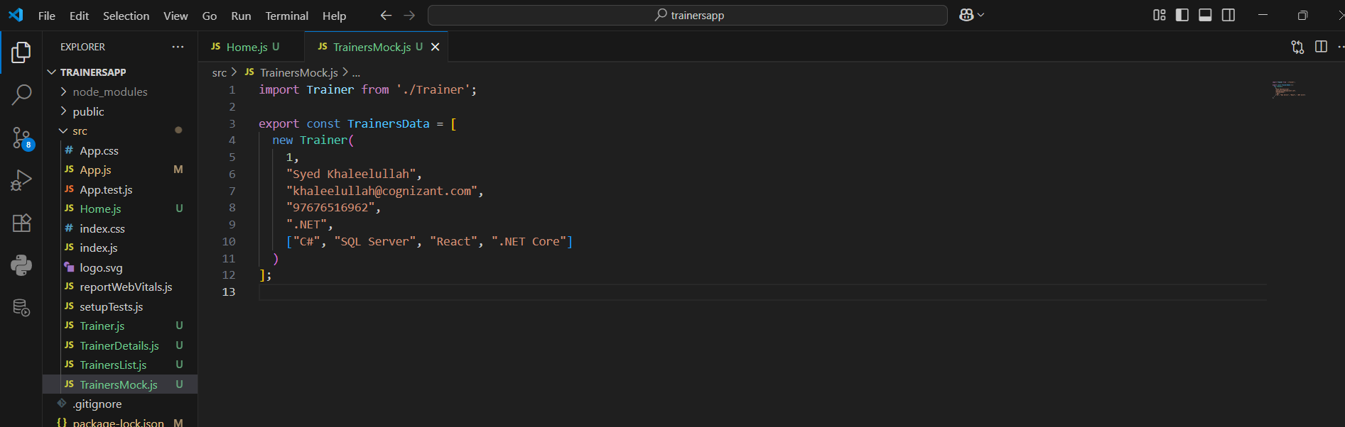

OUTPUT:

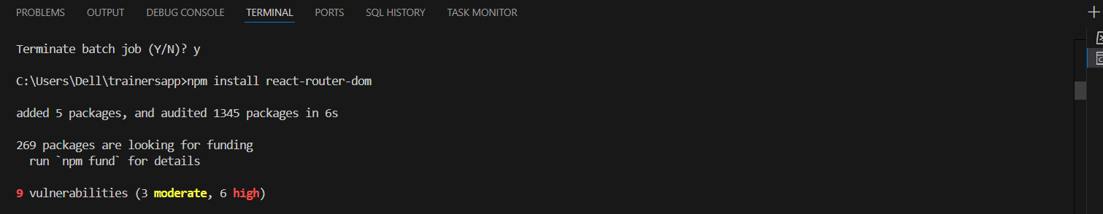

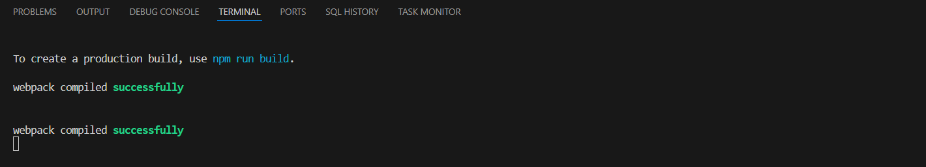

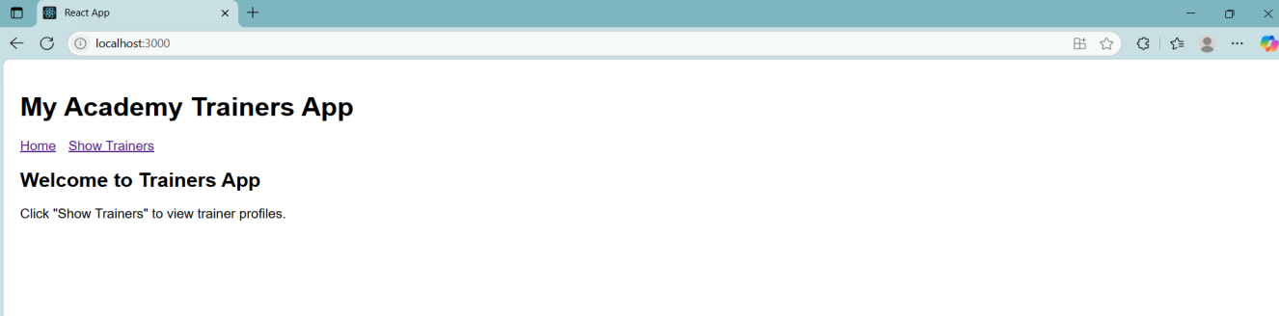

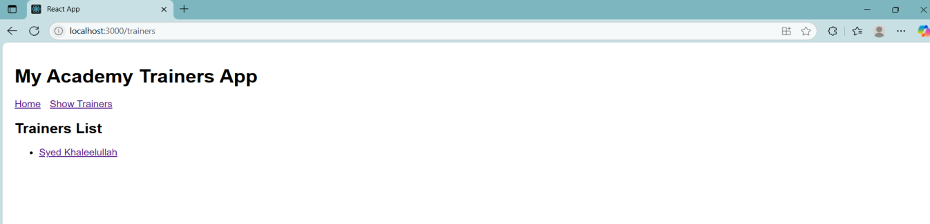

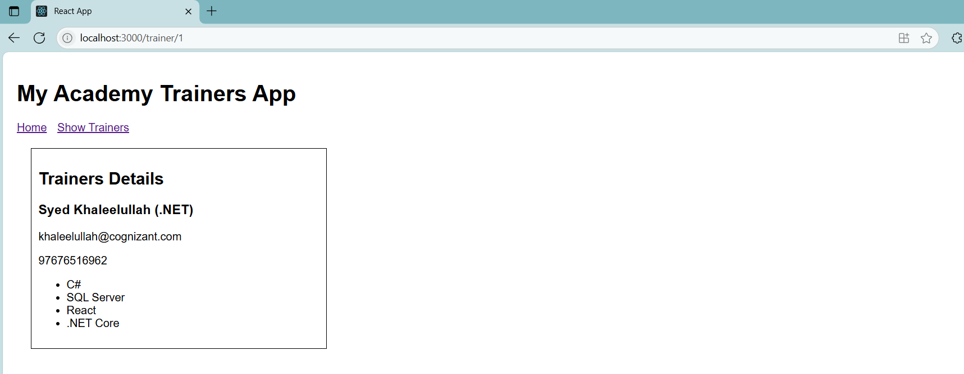

**Question 7**

Objectives

•Define Props

•Explain Default Props

•Identify the differences between State and Props

•Explain reactDOM.render()

In this hands-on lab, you will learn how to:

•Use Props

•Apply reactDOM.render()

Prerequisites

The following is required to complete this hands-on lab:

•Node.js

•NPM

•Visual Studio Code

Notes

Estimated time to complete this lab: 60 minutes.

Create a React Application named “shoppingapp” with a class component named “OnlineShopping” and “Cart”.

1.In Cart class, create 2 properties as mentioned below:

•Itemname, Price

Answer and Output:

Definitions:

1. Define Props - Short for properties. They are passed from parent to child components.
2. Explain Default Props - If a prop is not provided, defaultProps provides a fallback.
3. Identify the differences between State and Props

State vs Props:

props = data passed from parent to child, read-only

state = data inside the component, can change

1. ReactDOM.render(): This renders your React app into the root DOM node, usually id="root" in index.html.

CODE:

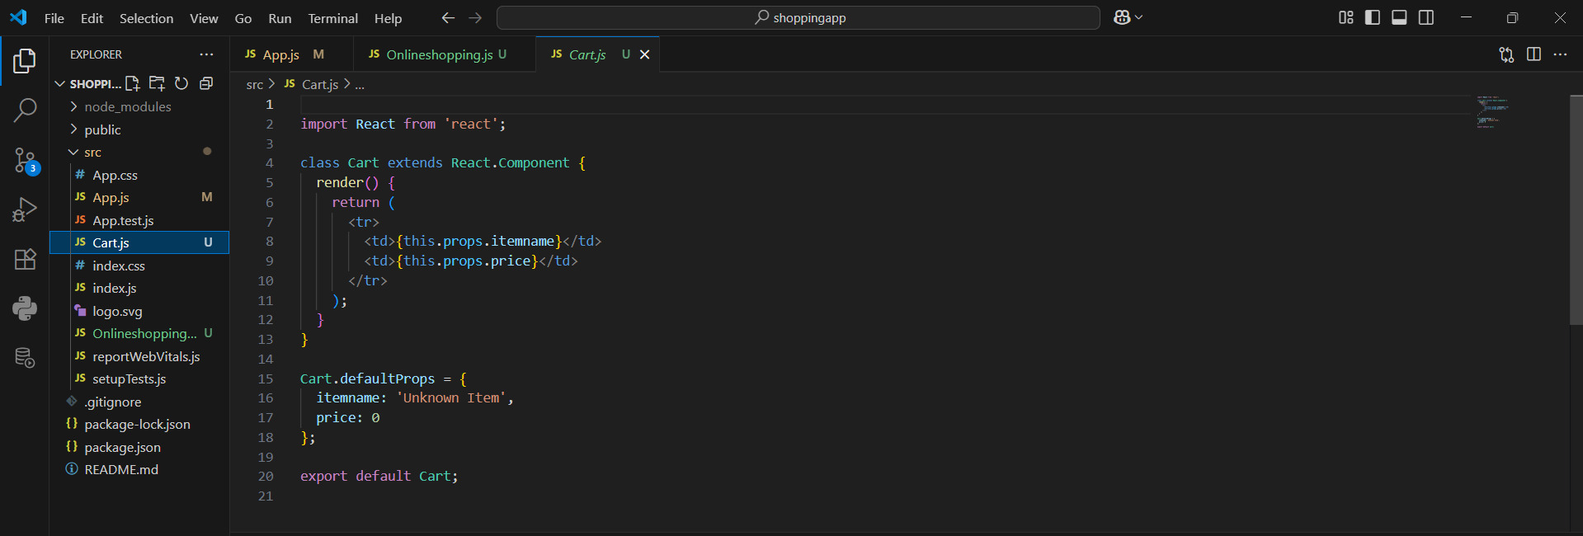

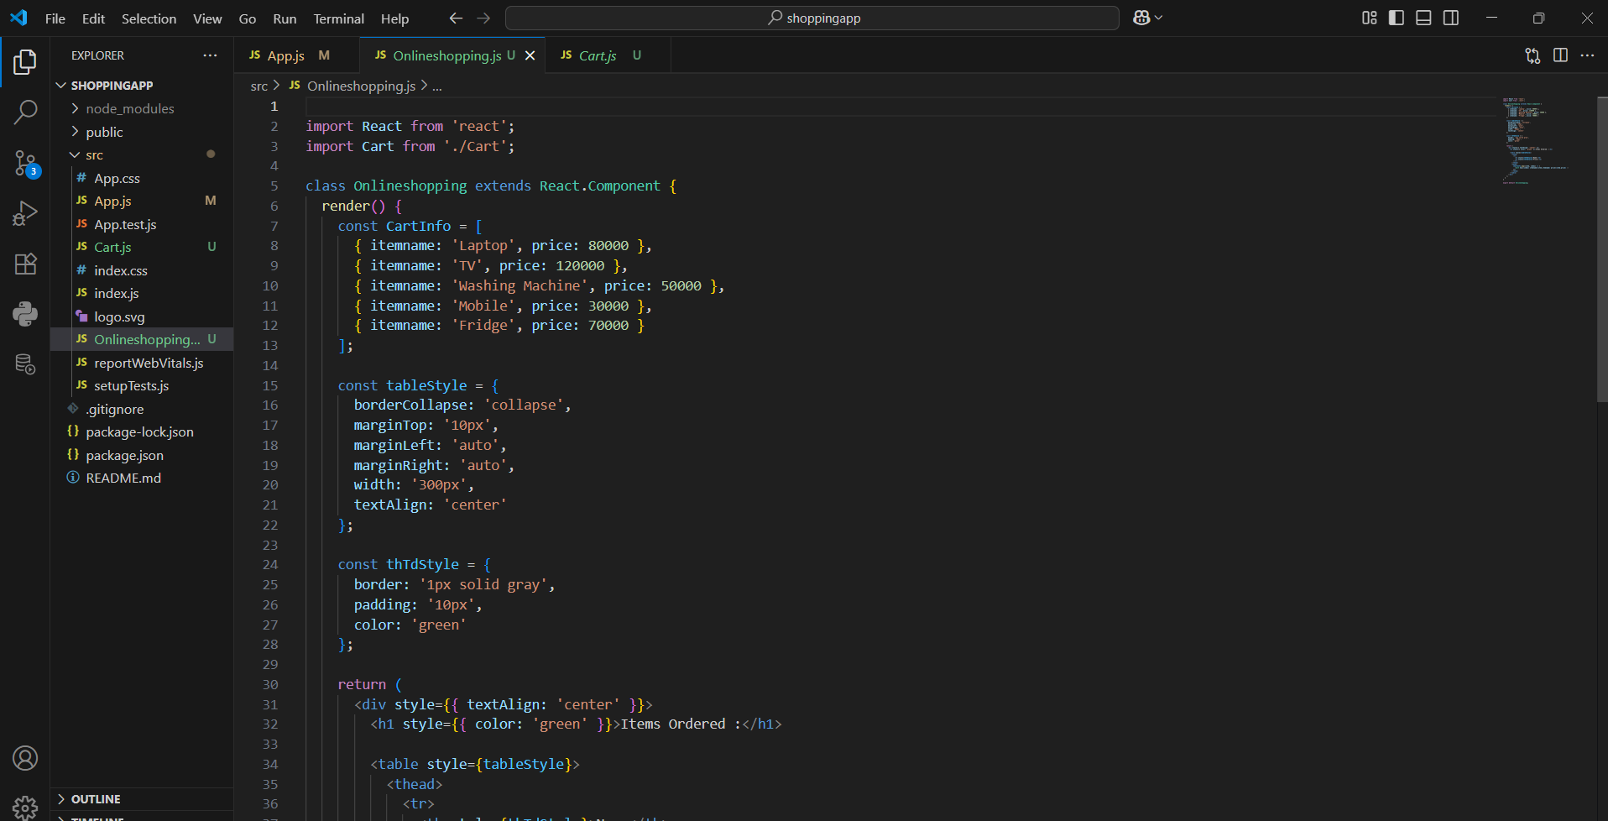

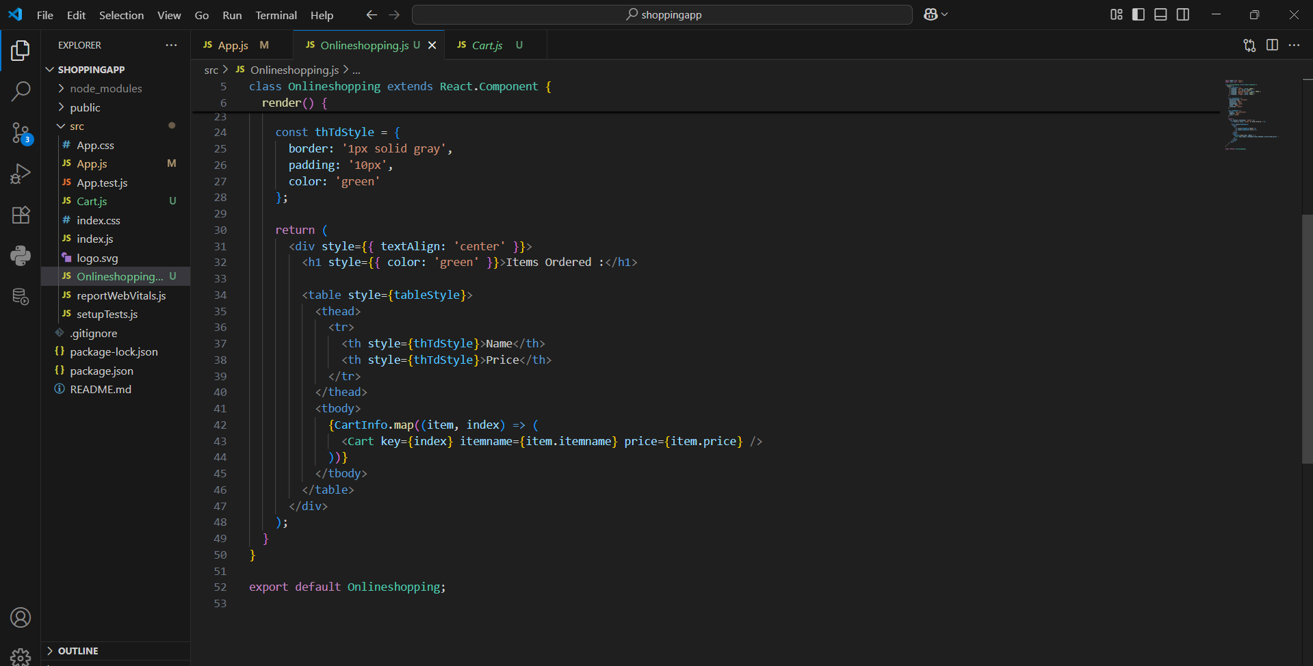

OUTPUT:

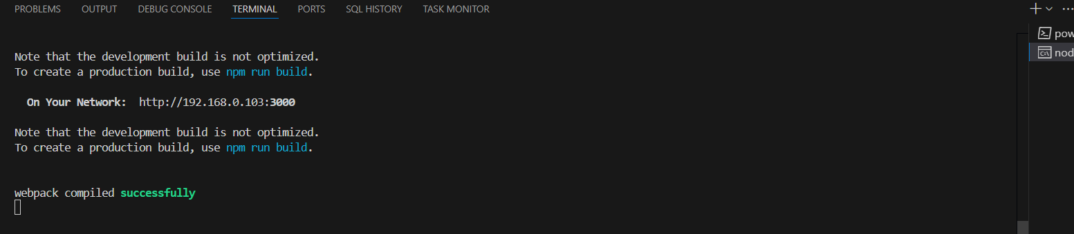

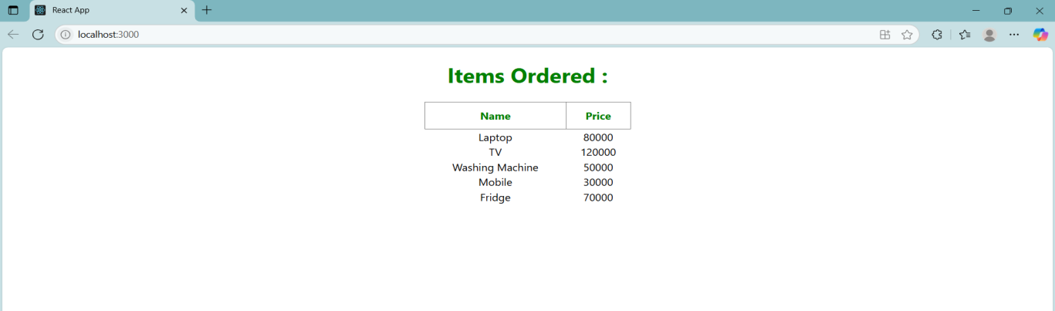

**Question 8**

Objectives

•Explain React State

In this hands-on lab, you will learn how to:

•Use React State object

Prerequisites

The following is required to complete this hands-on lab:

•Node.js

•NPM

•Visual Studio Code

Notes

Estimated time to complete this lab: 60 minutes.

Create a React App “counterapp” which will have a component named “CountPeople” which will have 2 methods.

UpdateEntry() which will display the number of people who entered the mall.

UpdateExit() which will display the number of people who exited the mall.

Use Constructor and state to Store the entrycount and exitcount.

The component has 2 buttons

1.Login when clicked, the entrycount should get incremented by 1

2.Exit when clicked, the exitcount should get incremented by 1

Definitions:

Explain React State

State is like a memory box inside your component.

CODE:

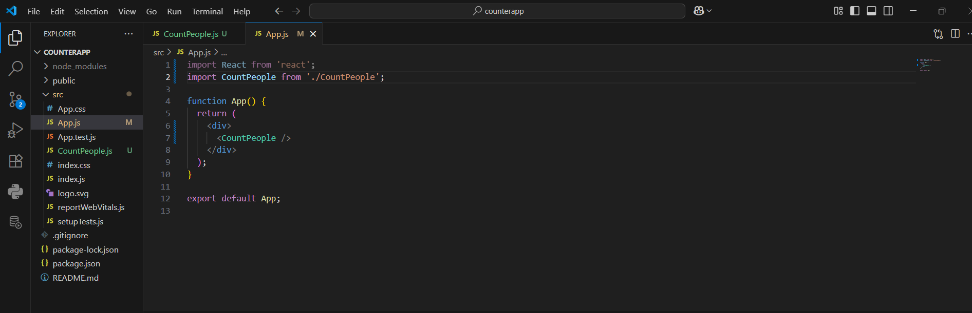

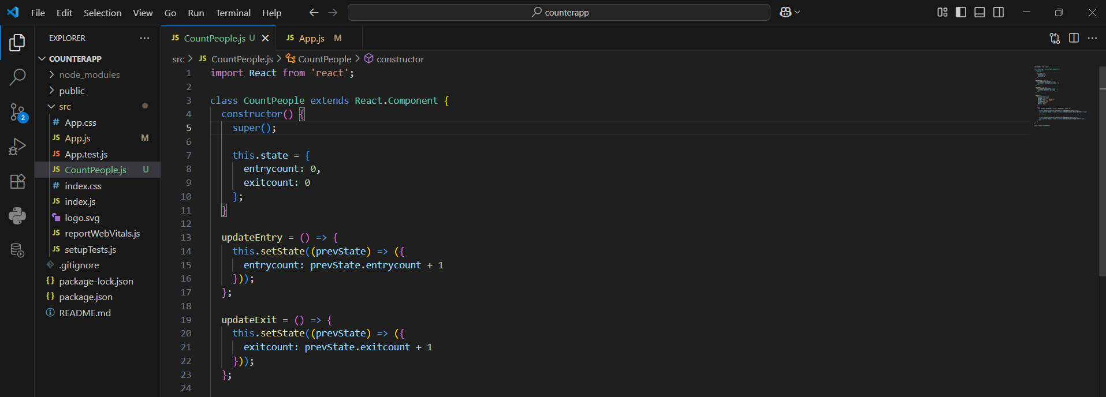

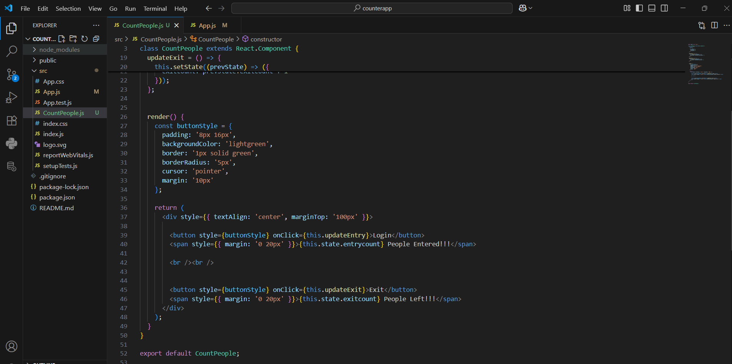

OUTPUT:

