Flavour Fusion: AI-Driven Recipe Blogging
Team ID: LTVIP2026TMIDS52346
Project Overview:
Flavour Fusion is an AI-powered web platform designed to automatically create detailed recipe blogs based on user input. Users can provide a recipe topic along with the desired word count, and the system generates a complete blog post that includes ingredients, preparation steps, cooking tips, and an engaging introduction.
The application utilizes Google Generative AI (Gemini API) for content creation and Streamlit to build an interactive and user-friendly web interface. This project highlights how Generative AI can be integrated into real-world applications to automate content generation efficiently.
Problem Statement:
Manual recipe blog writing is time-consuming and requires consistent formatting and creativity.
There is a growing need for:
- Automated content generation
- Structured and SEO-friendly blog creation
- Faster blog production
- User-friendly interface
- AI-based intelligent writing support
Objectives:
The primary objectives of this project are:
- To develop an AI-powered recipe blog generator.
- To integrate Google Gemini API for intelligent content generation.
- To design a clean and responsive UI using Streamlit.
- To allow users to specify recipe topic and word count.
- To generate structured and engaging blog content automatically.

System Architecture:
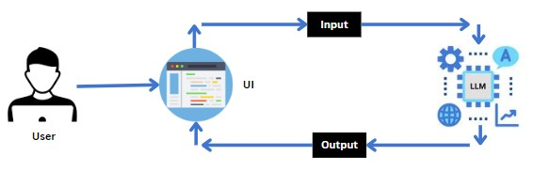
Architecture Flow:
User Input → Streamlit Interface → Gemini API → AI Content Generation → Output Display
Components:
- Frontend – Streamlit
- Backend – Python
- AI Model – Google Gemini 1.5 Flash
- Environment Variables – Dotenv
This modular architecture ensures smooth communication between user input and AI-generated output.
Technologies Used:
Technology | Purpose
Python | Core programming
Streamlit | Web interface
Google Gen AI | Content generation
Dotenv | API key management

Folder Structure:

Flavour-Fusion/
│
├── app.py
├── .env
├── requirements.txt
├── README.md
└── assets/
└── chatbot_image.png

Methodology:
Step 1: User Input User enters:
- Recipe Topic
- Word Count
Step 2: Prompt Engineering
A structured prompt is created such as:
“Write a detailed, engaging, SEO-friendly blog post about Malai Kofta including ingredients, preparation steps, cooking tips, and conclusion.”
Step 3: API Request
The prompt is sent securely to the Gemini 1.5 Flash model.
Step 4: Content Generation
The AI model generates:
- Introduction
- Ingredients
- Preparation Steps
- Pro Tips
- Conclusion
Step 5: Output Display
The generated blog is displayed in the Streamlit web interface.
Implementation:
1)Installing Required Libraries:
pip install google-generativeai pip install python-dotenv pip install streamlit 2) Main Code Structure: import streamlit as st import google.generativeai as genai import os
import random from dotenv import load_dotenv
- Load API Key:
load_dotenv() api_key = os.getenv("GOOGLE_API_KEY") genai.configure(api_key=api_key)
- Model Configuration: generation_config = {
"temperature": 0.75,
"top_p": 0.95,
"top_k": 64,
"max_output_tokens": 2048,
}
- Creating Model:
model = genai.GenerativeModel( model_name="gemini-1.5-flash-latest", generation_config=generation_config
)
- Generate Recipe Function:
def generate_recipe(topic, word_count):
prompt = f"""
Write a detailed recipe blog about {topic}.
The blog should be approximately {word_count} words.
Include:
    - Introduction
    - Ingredients
    - Step-by-step preparation
    - Tips
    - Conclusion
"""response = model.generate_content(prompt) return response.text
- User Interface Design:
Features:
  - Clean heading
  - Chatbot-style introduction
  - Input fields: o Recipe topic o Word count
  - Generate button
  - Joke section while generating
  - Styled background
- Output:
When user enters:
Topic: Malai Kofta ,Word Count: 500
The system generates:
  - Introduction
  - Ingredients list
  - Cooking steps
  - Pro tips
  - Conclusion
Output Screenshots:

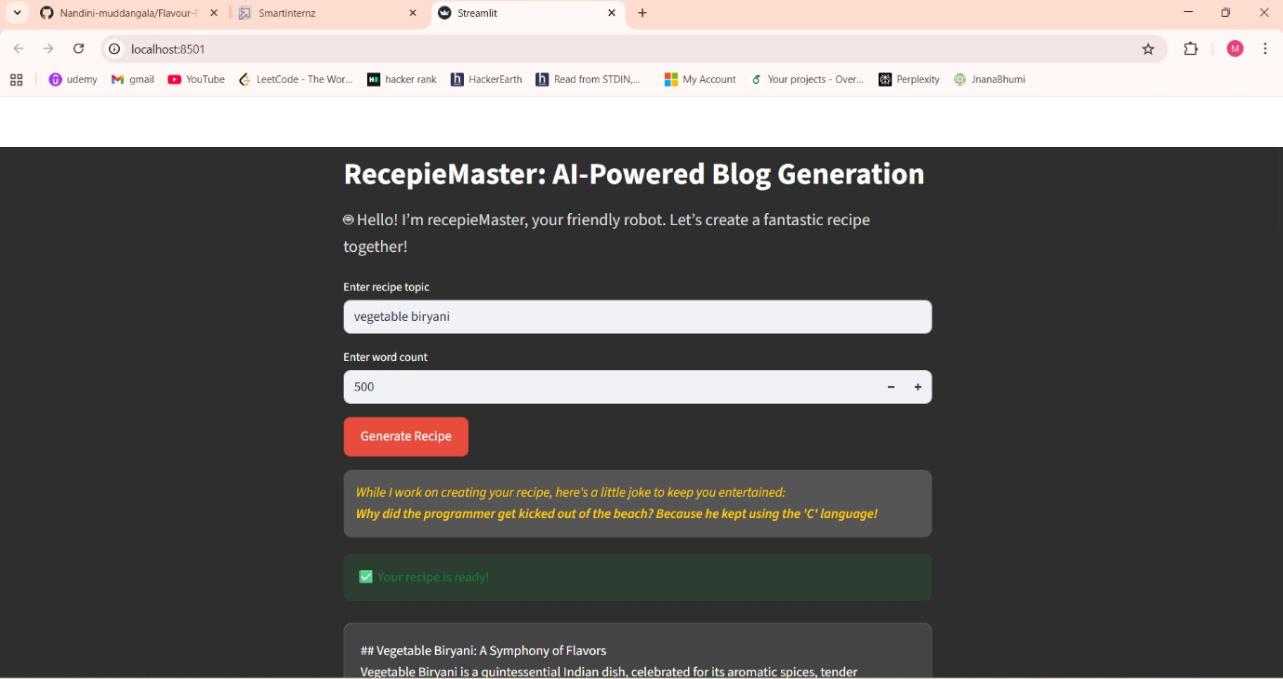

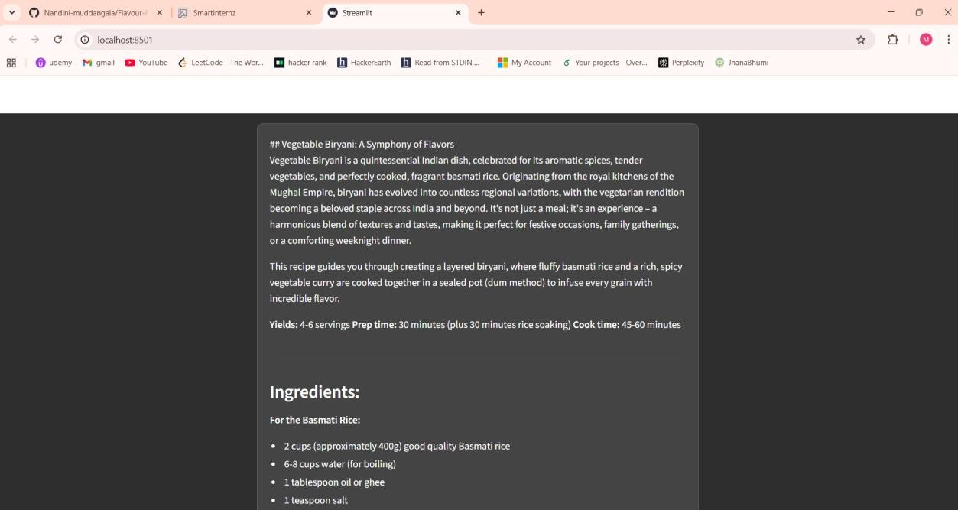

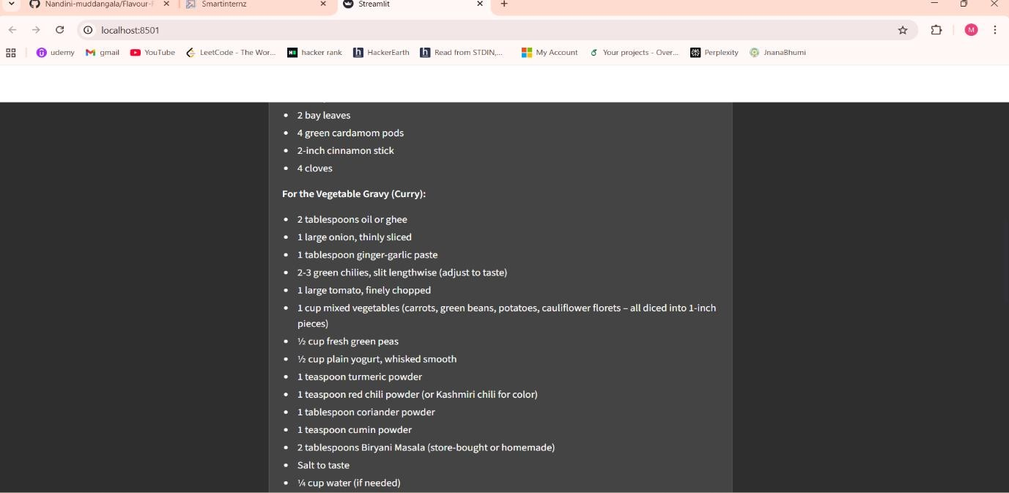
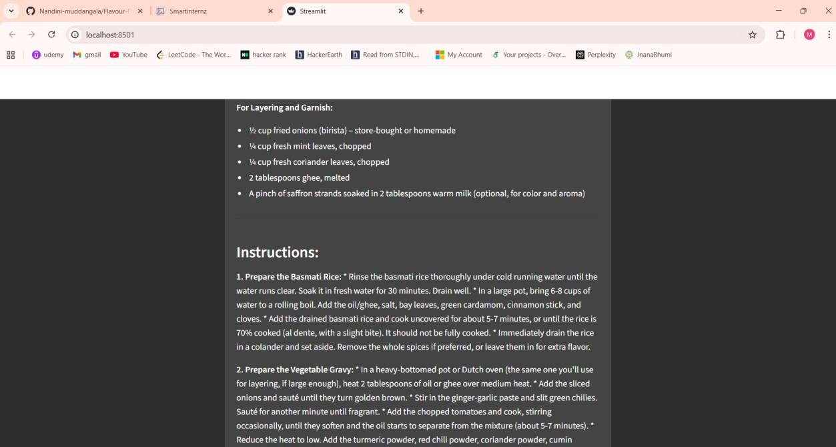
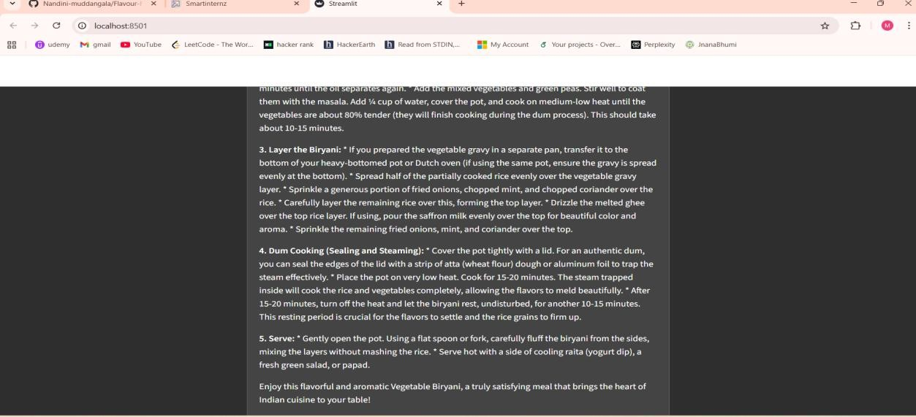
Advantages:
  - Saves time
  - AI-powered automation
  - Easy to use
  - No writing skills required
  - Customizable word count
Future Enhancements
- Multi-language blog generation
- SEO keyword optimization support
- Direct publishing to blogging platforms
- Blog export in PDF/Word format
- Personalized tone selection
- AI-generated recipe images

Run the Application:
Inside the project folder, run:“ streamlit run app.py ”
Conclusion:
Flavour Fusion demonstrates the effective integration of Generative AI into a real-world content automation system. By combining Streamlit with the Gemini 1.5 Flash model, the application generates customized and structured recipe blogs instantly. The project highlights the growing potential of AI-powered solutions in digital content creation. With future enhancements, the system can evolve into a comprehensive blogging assistant platform.

